

Name: Gabriela Arapu
Student ID: 2311889
Module Code: BMHP5023
Module: Introduction to Physiology
Lecturer: G1 and G2: Shaila Hussain
(module leader)

Submitted on 03/12/25

Table of Contents
Introduction 3
Control of Blood Sugar Levels 4
Energy Generation: The Role of Glucose and Oxygen in Cell Metabolism 5
Recording and Tracking Blood Sugar Levels for Type 2 Diabetes 7
Recommendations 8
Conclusion 9
Reference: 10

Case study 1

Introduction

This study examines Type 2 Diabetes (T2D) and outlines evidence-based ways that practice nurses can use to support patients in understanding their disease and controlling their blood glucose levels efficiently. The definition of diabetes, how the body controls blood sugar, the function of insulin in energy production, and the significance of lifestyle choices like diet, exercise, and quitting smoking in the long-term management of diabetes are all covered in the paper.
Diabetes is a chronic metabolic disorder marked by increased blood glucose levels. There are two primary types: Type 1 diabetes, an autoimmune disorder where the pancreas produces little or no insulin, and Type 2 diabetes, where the body grows resistant to insulin or does not generate enough of it. Understanding these disparities is vital for offering appropriate education and management techniques.
Excessive blood glucose levels lead to the development of diabetes. The liver produces glucose, which is the body's primary energy source. The hormone insulin, which the pancreas produces, allows glucose to enter cells from the bloodstream and be used for energy. The immune system kills the pancreatic cells that produce insulin in people with Type 1 diabetes, which leaves the body producing little or no insulin. Because of this, people with Type 1 diabetes, which is often identified in childhood or early adulthood, need daily insulin to survive (Bessesen, 2023).
On the other hand, Type 2 diabetes is a chronic, progressive illness that arises from insufficient or ineffective insulin production. Elevated blood glucose levels as a result might progressively harm the kidneys, eyes, feet, and cardiovascular system. Type 2 diabetes is intimately associated with lifestyle factors like nutrition, body weight, and physical activity, even though it can strike at any age (Diabetes UK, 2023). Type 2 diabetes is also more likely to occur in people with specific ethnic backgrounds, obesity, metabolic syndrome, poor diet, low physical activity, and family history (NICE, 2024).
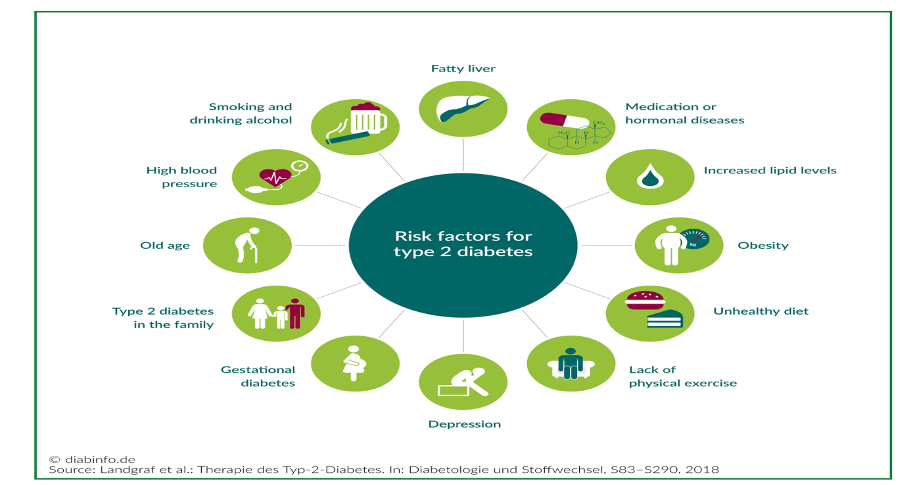
Diagram 2: This is a summary of Risk factors T2D (Diabinfo.de, 2019)

Various factors raise the chance of developing Type 2 diabetes, including obesity, sedentary lifestyle, poor diet, ageing, family history, and certain ethnic origins. The diagnosis and treatment of Type 2 diabetes in an adult female patient exhibiting symptoms of persistent hyperglycemia are examined in this case study. Blood sugar regulation, energy metabolism, monitoring, and evidence-based lifestyle suggestions will all be covered in the study. Each section's incorporation of the patient's circumstances shows how physiological knowledge aids in clinical judgement and self-management in practical settings.

Control of Blood Sugar Levels
To guarantee that cells have a steady source of energy, the body keeps blood sugar levels within a certain range. This regulation is largely controlled by the hormone’s glucagon and insulin. The pancreas releases insulin to facilitate the uptake of glucose into cells when blood glucose levels increase following meals. The liver and muscles store extra glucose as glycogen. Glucagon causes the liver to turn glycogen back into glucose when blood glucose levels fall, bringing them back to normal (BBC Bitesize, 2020). Cells need glucose for cellular respiration, which generates energy, maintaining stable blood sugar levels is crucial.
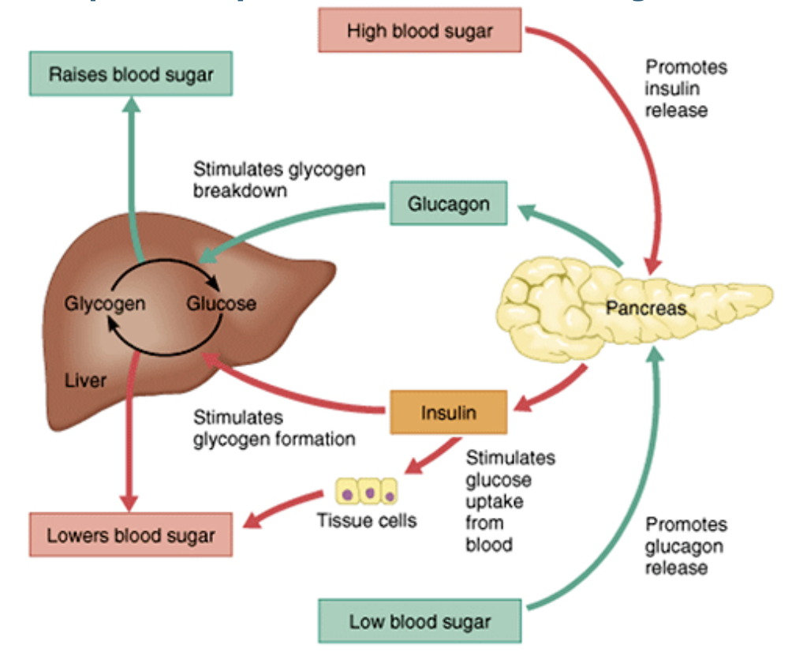 Diagram 2: This is a summary of Roles of Insulin and Glucagon (A Train Education, 2020)
Patients can identify symptoms like fatigue, thirst, and frequent urination when blood glucose levels are inadequately managed by understanding how insulin and glucagon maintain these levels. The patient's cells' resistance to insulin, glucose stays in the bloodstream rather than successfully entering the cells. Her pancreas tries to make extra insulin to make up for the high blood glucose. Her condition may worsen over time because of pancreatic exhaustion and additional insulin production reduction (NHS, 2023). Uncontrolled hyperglycemia can lead to long-term harm to blood vessels and organs, raising the risk of neuropathy, renal failure, cardiovascular disease, and eye issues (Cleveland Clinic, 2023).
Both short-term symptoms like exhaustion, excessive thirst, and delayed wound healing, as well as long-term consequences, can be avoided by maintaining steady blood glucose. For this patient, improving insulin sensitivity and achieving better glucose control can be achieved with lifestyle modifications such dietary adjustments and frequent exercise, together with medication if necessary (NHS, 2017). To prevent long-term harm, her diagnosis necessitates ongoing monitoring and well-informed decisions regarding medication, exercise level, and food consumption.

Energy Generation: The Role of Glucose and Oxygen in Cell Metabolism
The process by which cells use glucose and oxygen to create energy in the form of adenosine triphosphate (ATP) is known as cellular respiration. Additionally, this process produces water and carbon dioxide as waste. Insulin is required to carry glucose into cells once it enters the body through eating. Once inside the cells, glucose is broken down to create ATP, which supports metabolic activities important for development, repair and cellular function (University of California Museum of Paleontology, 2024).

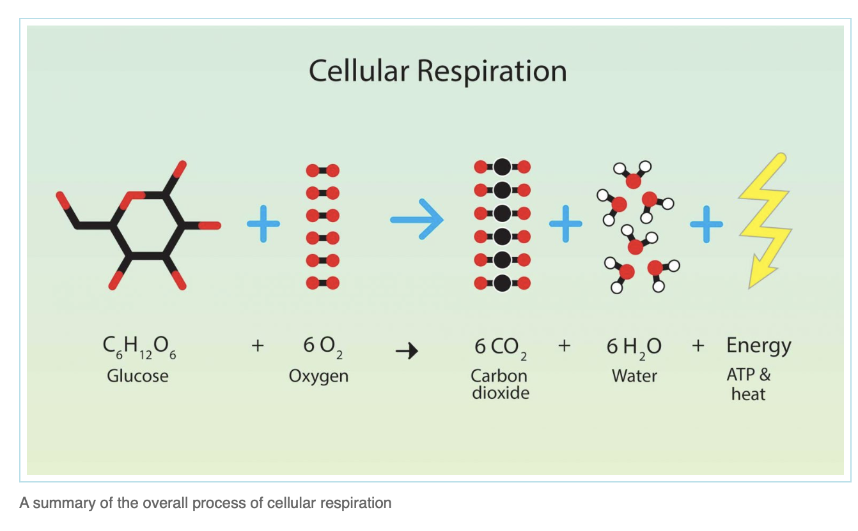Diagram 3: This is a summary of cellular respiration (University of California Museum of Paleontology, 2024).

As indicated in the picture above, glucose must enter the cells to be used for energy. When insulin is ineffective or insufficient, glucose stays in the bloodstream, leading to elevated blood sugar and impaired cellular energy generation.
For cells to acquire glucose and generate energy, insulin is consequently necessary. Insulin production may be inadequate or ineffective in individuals with Type 2 diabetes, such as the patient in this instance. High blood sugar and decreased energy output come from glucose staying in the circulation rather than being utilized by cells (Diabetes UK, 2023). This contributes to the explanation of the patient's persistent exhaustion; despite her elevated blood glucose levels, her muscles and organs are not getting enough fuel for metabolism.

While too much blood glucose damages cells and organs, this lack of energy can cause weakness and exhaustion. The kidneys, nerves, vision, and cardiovascular system may eventually be harmed by high blood sugar (Better Health Channel, 2021). The kidneys, eyes, nerves, and cardiovascular system are among the tissues and organs that are eventually harmed by high blood glucose levels (Better Health Channel, 2021). Furthermore, poor diet, alcoholism, smoking, sleep deprivation, and physical inactivity all lower insulin sensitivity, which further impacts cellular metabolism (Galaviz et al., 2019). For instance, low insulin sensitivity and compromised cellular energy production are directly caused by the patient's sedentary lifestyle and diet high in refined sugars.

On the other hand, a balanced diet and regular exercise enhance glucose absorption and promote a healthier metabolism (Murphy, 2024). Increased activity helps naturally lower blood sugar by enabling muscles to absorb glucose without using as much insulin. According to the National Institute of Diabetes and Digestive and Kidney Diseases (2023), this illustrates the significance of lifestyle changes in lowering long-term problems and boosting energy levels.

Recording and Tracking Blood Sugar Levels for Type 2 Diabetes

One of the most important aspects of managing diabetes is blood glucose monitoring. Monitoring levels enables people to comprehend how their blood sugar is impacted by food, medicine, and exercise. Regular monitoring is crucial for individuals like the patient in this case study to identify hyperglycemia early and avoid long-term problems. Finger prick tests and continuous glucose monitors (CGMs), which measure blood sugar levels several times during the day, are two methods of monitoring (Diabetes UK, 2017).

Frequent monitoring facilitates the identification of trends, allowing people to make well-informed decisions regarding medication and nutrition (Information Site, n.d.). Additionally, it enables medical practitioners to modify treatment regimens to better meet the needs of their patients. This is especially crucial because the patient has just received a diagnosis, and early monitoring will help her understand how her lifestyle choices affect her blood sugar levels.

The possibility of reaching target blood sugar ranges is increased by routine monitoring. They can see trends and react appropriately, patients who regularly check tend to maintain healthy levels. Monitoring is particularly crucial for people on insulin or sulphonyl Reas like gliclazide to avoid hypoglycemia, which occurs when blood sugar falls too low (National Health Service Inform, 2023). Even though many patients with Type 2 diabetes do not usually experience hypoglycemia unless they take these drugs, it is nevertheless crucial to educate people on how to recognize signs.

According to research by Diouri et al. (2021), patients may underdose on insulin because of fear of hypoglycemia, which results in insufficient management of hyperglycemia. Therefore, to maximize treatment, sufficient education and routine monitoring are essential. In this patient's case, an organized monitoring plan will prevent both high and low glucose episodes and provide her confidence in managing her condition.

Long-term health problems, including as cardiovascular illness, nerve damage, vision problems, renal disease, foot ulcers, sexual health issues, and poor wound healing, might result from inadequate blood sugar management (National Health Service Inform, 2023). The risk of these consequences is significantly decreased by reaching target HbA1c levels, lowering cholesterol, giving up smoking, and controlling blood pressure. Therefore, monitoring is a life-saving tool rather than just a regular chore.

Recommendations
One of the most crucial strategies to control Type 2 diabetes and reduce complications is to have a healthy lifestyle. Maintaining a nutritious diet, getting regular exercise, controlling weight, quitting smoking, and consuming alcohol in moderation are all advised tactics (Nice.org.uk, 2015). Long-term success for the patient in this situation will depend on making small, durable adjustments.

Walking, cycling, or moderate exercise are examples of the minimum 150 minutes of physical activity per week that the UK Chief Medical Officers propose (NHS, 2024). Walking or choosing an active mode of transportation, like cycling, can help the patient lose weight, increase energy, and enhance her insulin sensitivity. Frequent exercise also helps regulate blood sugar, decreases blood pressure, and lowers cholesterol (Harvard Health Publishing, 2020).
Dietary adjustments should focus on reducing processed foods, sugars and refined carbohydrates, replacing them with whole grains, lean protein, vegetables and healthy fats. Structured education programmed such as DESMOND’s Let’s Prevent Diabetes offer support in developing healthier habits by delivering education tailored to lifestyle change and cultural needs (DESMOND, 2023). These programmed teach patients skills such as meal planning, portion control and physical activity strategies, which directly benefit newly diagnosed individuals such as in this case study as a practice nurse.
Frequent consultations with medical specialists assist establish reasonable objectives that are specific to each patient's circumstances and further encourage motivation. To reduce long-term health hazards, blood pressure control, weight management, and quitting smoking should all be promoted. People with Type 2 diabetes can better control their condition and maintain a high quality of life with continued assistance and healthy behavior changes.

Conclusion
In conclusion, impaired insulin function and elevated blood glucose are the hallmarks of Type 2 diabetes, a chronic metabolic illness that requires long-term, proactive therapy. It is crucial for practicing nurses to comprehend and communicate the significance of blood sugar regulation, the function of insulin in cellular energy production, and the necessity of regular monitoring. Effective diabetes care is built on these components.
Frequent monitoring helps identify hyperglycemia early and supports prompt medication and care plan modifications. Changes in lifestyle, such as eating a balanced diet, getting more exercise, managing weight, giving up smoking, and limiting alcohol consumption, can greatly lower the chance of problems. As a practicing nurse, giving clear education and continuing support empowers persons with Type 2 diabetes to take an active role in managing their illness. With systematic advice, self-management skills, and healthier everyday choices, persons with Type 2 diabetes can stabilize their blood glucose levels, prevent long-term problems, and improve their overall quality of life.

Reference:
- A Train Education (2020). Regulation of Blood Glucose. [online] Available at: https://www.atrainceu.com/content/4-regulation-blood-glucose.

- Better Health Channel (2021). Diabetes - long-term effects. [online] Available at: https://www.betterhealth.vic.gov.au/health/conditionsandtreatments/diabetes-long-term-effects.

- Bessesen, D. (2023). What is diabetes? [online] National Institute of Diabetes and Digestive and Kidney Diseases. Available at: https://www.niddk.nih.gov/health-information/diabetes/overview/what-is-diabetes.

- Cleveland Clinic (2023). Hyperglycemia (High Blood Sugar). [online] Available at: https://my.clevelandclinic.org/health/diseases/9815-hyperglycemia-high-blood-sugar.

- DESMOND (2023). DESMOND. [online] Available at: https://www.desmond.nhs.uk.

- Diabinfo.de (2019). What increases the risk of type 2 diabetes? [online] Available at: https://www.diabinfo.de/en/prevention/diabetes/am-i-at-risk/what-increases-the-risk-of-type-2-diabetes.html.

- Diabetes UK (2017). How to check your blood sugar levels. [online] Available at: https://www.diabetes.org.uk/about-diabetes/looking-after-diabetes/blood-sugar-levels.

- Diabetes UK (2023). Type 2 diabetes. [online] Available at: https://www.diabetes.org.uk/about-diabetes/type-2-diabetes.

- Diabetes UK (2023). What causes type 2 diabetes? [online] Available at: https://www.diabetes.org.uk/about-diabetes/type-2-diabetes/causes.

- Diouri, O., Cigler, M., Vettoretti, M., Mader, J.K., Choudhary, P., Renard, E. and HYPO‐RESOLVE Consortium (2021). ‘Hypoglycaemia detection and prediction techniques: A systematic review on the latest developments’, Diabetes/Metabolism Research and Reviews, 37(7), p.e3449.

- Galaviz, K.I., Narayan, K.M.V., Lobelo, F. and Weber, M.B. (2019). ‘Lifestyle and the Prevention of Type 2 Diabetes: A Status Report’, American Journal of Lifestyle Medicine, 12(1), pp.4–20.

- Harvard Health Publishing (2020). Exercising to relax. [online] Available at: https://www.health.harvard.edu/staying-healthy/exercising-to-relax.

- Information Site (n.d.). Monitoring Diabetes. [online] Available at: https://mydiabetesmyway.scot.nhs.uk/know-more/my-glucose/monitoring-diabetes/.

- Murphy, N. (2024). The Role of Diet and Exercise in Preventing and Managing Diabetes. [online] CPD Online College. Available at: https://cpdonline.co.uk/knowledge-base/care/diet-exercise-preventing-managing-diabetes/.

- NHS (2017). Complications of type 2 diabetes. [online] Available at: https://www.nhs.uk/conditions/type-2-diabetes/complications/.

- NHS (2023). What is type 2 diabetes? [online] Available at: https://www.nhs.uk/conditions/type-2-diabetes/.

- NHS (2024). Benefits of Exercise. [online] Available at: https://www.nhs.uk/live-well/exercise/exercise-health-benefits/.

- National Health Service Inform (2023). Type 2 Diabetes Symptoms and Treatments. [online] Available at: https://www.nhsinform.scot/illnesses-and-conditions/diabetes/type-2-diabetes/.

- National Institute of Diabetes and Digestive and Kidney Diseases (2023). Healthy Living with Diabetes. [online] Available at: https://www.niddk.nih.gov/health-information/diabetes/overview/healthy-living-with-diabetes.

- NICE (2024). What are the risk factors? [online] Available at: https://cks.nice.org.uk/topics/diabetes-type-2/background-information/risk-factors/.

- Nice.org.uk (2015). Diet and lifestyle | Type 2 diabetes in adults: management. [online] Available at: https://www.nice.org.uk/guidance/ng28/ifp/chapter/diet-and-lifestyle.

- University of California Museum of Paleontology (2024). Respiration. [online] Available at: https://ugc.berkeley.edu/background-content/respiration/.

