AssessMENT 2: FOOD AND BEVERAGE OPERATIONS
BMIH4002
OLADIPUPO FABODE
2207288
MODULE LEADER: TRISTAN HAWKINS

Trinity Hotel
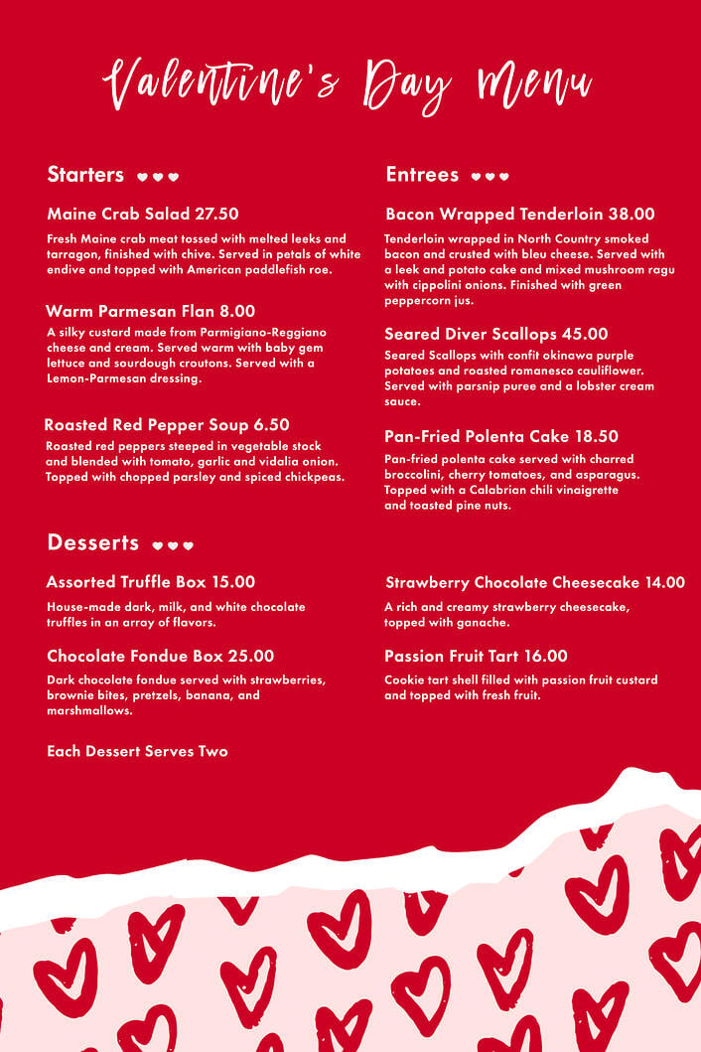
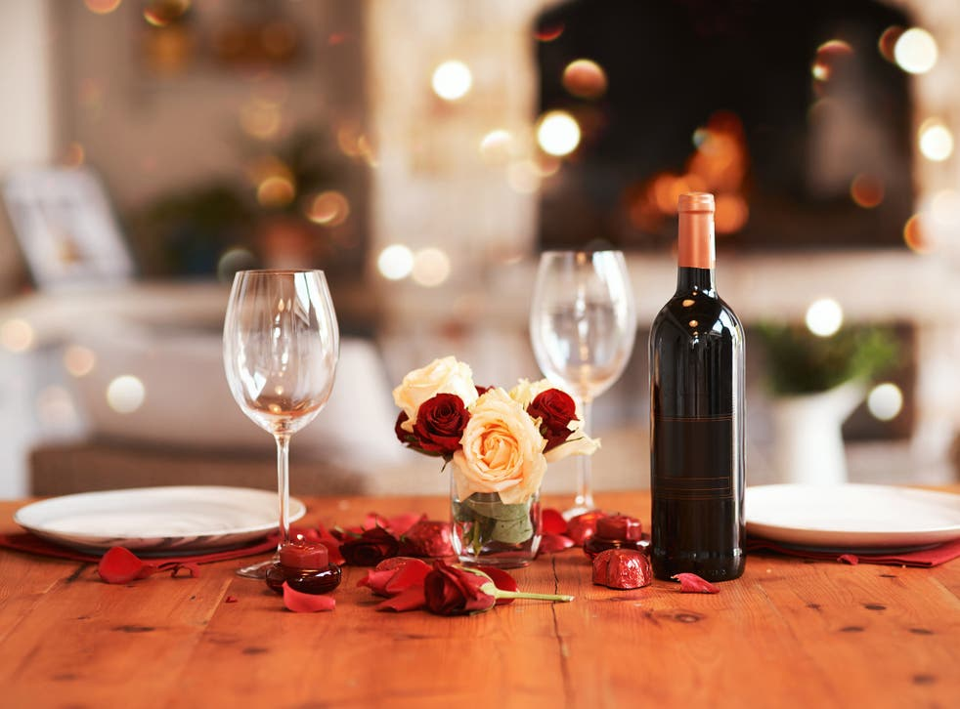

Deluxe - £95 per person
- Amuse-bouche
(Oyster and Champagne sabayon with caviar - A delightful and decadent small bite to start your meal, featuring fresh oysters floating in a velvety Champagne sabayon, topped with a dollop of salty and luxurious caviar.)
- Starter: Foie gras terrine with raspberry sauce and brioche
(A sumptuous and indulgent starter, made with the finest foie gras and elegantly presented in a terrine. The rich and buttery flavor of the foie gras is complemented by a sweet and tangy raspberry sauce and slices of lightly toasted brioche.)
- Main Course: Pan-seared duck breast with cherry and port wine reduction, served with gratin dauphinois and glazed carrots
(A classic and refined French dish, featuring a tender and juicy duck breast seared to perfection, served with a sweet and savory cherry and port wine reduction. Accompanied by a creamy and cheesy gratin dauphinois and colorful and vibrant glazed carrots.)
- Dessert: Chocolate fondant with vanilla ice cream and raspberry coulis
(A decadent and luscious dessert, featuring a rich and velvety chocolate fondant with a soft and gooey center, served with a scoop of smooth and creamy vanilla ice cream and a bright and tangy raspberry coulis.)

- Coffee or Tea with petit fours
(Conclude your meal with a luxurious cup of coffee or tea, paired with a delightful selection of bite-sized sweets, such as macarons, truffles, and petit fours.)

Premium - £135 per person
- Amuse-bouche: Lobster bisque with truffle oil and chives
(A luxurious and fragrant soup, featuring the succulent and delicate meat of fresh lobster, combined with a creamy and velvety bisque, infused with the deep and earthy flavor of truffle oil and finished with a sprinkle of aromatic chives.)
- Starter: Seared scallops with cauliflower puree and crispy pancetta
(A refined and elegant starter, featuring plump and juicy scallops seared to perfection, served on a bed of smooth and creamy cauliflower puree, and topped with crispy and savory pancetta bits for a delightful contrast of textures and flavors.)

- Fish Course: Pan-seared sea bass with saffron risotto, cherry tomatoes, and basil oil
(A light and flavorful fish course, featuring a tender and flaky fillet of sea bass, served on a bed of creamy and aromatic saffron risotto, and accompanied by juicy and sweet cherry tomatoes and a drizzle of fragrant basil oil.)
- Main Course: Roasted venison loin with blackberry sauce, sweet potato puree, and roasted root vegetables
(A rich and hearty main course, featuring a succulent and tender venison loin, roasted to perfection and served with a luscious and tart blackberry sauce, a smooth and velvety sweet potato puree, and a colorful and flavorful mix of roasted root vegetables.)
- Dessert: Strawberry and Champagne mousse with macarons
(A delicate and sophisticated dessert, featuring a light and airy mousse made with fresh and juicy strawberries, infused with the sparkling and bubbly flavor of Champagne, and served with a charming and colorful array of macarons.)
- Cheese Course: Selection of French cheeses with crackers and grapes
(A luxurious and indulgent cheese course, featuring a carefully curated selection of premium French cheeses, served with crisp and buttery crackers.)
- Coffee or Tea with petit fours
(Conclude your meal with a luxurious cup of coffee or tea, paired with a delightful selection of bite-sized sweets, such as truffles, macarons, and petit fours.)
We also offer an extensive wine list, featuring a variety of French and international wines, as well as a full bar with a wide selection of cocktails and spirits to complement your meal.

- Chateau Margaux- This legendary Bordeaux red is renowned for its elegant, complex, and long-lasting character, featuring notes of blackcurrant, graphite, leather, and spice. It would pair beautifully with the Beef Wellington or the cheese course. Price: £80.00 per bottle.
- Dom Perignon, 2008 - This iconic Champagne is a symbol of luxury and celebration, featuring a bright and lively character, with notes of white flowers, citrus, and brioche. It would be a perfect accompaniment to the lobster ceviche or the sorbet. Price: £199.99 per bottle.
- Sassicaia, 2004 - This exceptional Super Tuscan red from Italy is a benchmark of quality and style, with a rich and powerful character, featuring notes of black cherry, cedar, tobacco, and vanilla. It would pair beautifully with the grilled king prawns or the Beef Wellington. Price: £250 per bottle.
- House Red/White Price: £50.00

As for entertainment options, Included in each package:
- Live music and candlelight dinner - A romantic and sophisticated touch to your dining experience, with a variety of talented musicians performing classic jazz, soul, or French chansons.
- Personalized flower arrangements - Surprise your partner with a stunning and bespoke bouquet of flowers, designed by a professional florist according to your preferences and tastes.

References
Hart, K., 2022. Valentine's Day. Early Years Educator, 23(7), pp.S6-S7.
Hollows, J., 2021. Enthusing about green peppers: the Europeanisation of British food culture in post-war Britain, 1960-1975. Contemporary British History, 35(3), pp.392-416.
Michael, N. and Fusté‐Forné, F., 2022. Marketing of luxurious gastronomic experiences on social media: The visual storytelling of luxury hotels. International Journal of Tourism Research, 24(6), pp.827-838.
Richardson, L., 2020. Platforms, markets, and contingent calculation: The flexible arrangement of the delivered meal. Antipode, 52(3), pp.619-636.
Tranter, S., 2020. Column: A guide to Valentine's Day. UWIRE Text, pp.1-1.
Yost, E., Zhang, T. and Qi, R., 2021. The power of engagement: Understanding active social media engagement and the impact on sales in the hospitality industry. Journal of Hospitality and Tourism Management, 46, pp.83-95.

