Nicola brain
1811898
Developing relationships and workplace achievement
Brynach Heffernan

Introduction
This essay will give an overview on how performance management benefits the organization and the individual, I will be looking at how they do things at McDonald’s, you will see how the training McDonald’s offer benefits the organization and their employees by applying maslow’s hierarchy theory and also hezberg’s two way theory it will provide insight on how they keep their employees motivated, what motivates and what doesn’t motivate them also what employee engagement means and what McDonald’s do to keep their employees engaged.

Organization of applying performance management
. Benefits to organization

With McDonalds being a high growth business, they need high-performing employees. Performance management at McDonalds is made of up of several things, including the performance of employees, reviews and appraisals as well as career guidance, professional development, training, clear career paths, and more. Developing their employees by investing performance management is one of the most important things McDonald’s as a business can do to build a strong foundation for success.
Techfunnel.com (2020)
.Good documentation
With McDonalds being a fast food chain Employee reviews and other employee performance documentation will help protect their business, by doing this it will ensure that they are following all necessary and relevant laws, as they will have regular environmental checks to make sure their paperwork up to date, more so now with COVID as its for their safety and that of their customers.
. Better productivity
McDonalds won’t be able to identify the gaps that are hindering their employees work from doing their best work without consistent and formal reviews of employee performance, It’s not necessary for McDonalds to hire perfect employees, those who have a solid skillset, good experience, and a personality and work ethic that fits in McDonald’s culture can be incredible assets to their company, If they lack certain training or need motivation it’s possible to address these things as part of their performance management process and create the strongest team possible for their organization.
.promote high performers.

performance management helps to identify any employees who would be suited to leadership, management or additional responsibilities if McDonalds can promote internally they would be able to save on recruiting costs, employees who feel valued and recognized are likely to keep working there and better employee retention is good news for the business.
.cost efficient
It doesn’t matter how much training and guidance is offered to employees, they simply won’t excel in their positions and meet the criteria of their job title. Performance management processes help to identify these issues and confirm that your efforts to help improve their performance aren’t successful. This allows McDonalds to let go of these employees and save the business money on benefits, salary and other expenses rather than spend them on an unproductive employee.

McDonald’s will have better communication with their employees, better employee retention, improved productivity, and more engaged, effective work contributing to the goals of their business by having a solid employee performance management process in place.
Finding the right performance management technique is an important first step in cultivating the best performance management experience possible. Making sure it’s a regular part of their HR process and built into the fabric of their human resource management policies that can help the business see continued success and employee engagement.
Techfunnel.com (2020)

.benefits to the employee

.Reduced stress
Regular feedback can improve the relationship between employer and the employee, enhance communication, and reduce employee anxiety, when employees who have a clearer understanding of what is expected of them, what metrics they’re being reviewed on, and how the overall business is effected on their performance, they will experience less stress and be more engaged in their day to day work.
2. Enhanced skillset
Another benefit of employee management for the employee is that they can be trained to help expand their skillset. This sets them up for greater success in their current position and can also be a bonus if and when they look for a new job at a new organization.
3. Higher morale
Employees will feel more engaged in their jobs and have higher morale when they feel confident with their performance or if they are aware of what needs improving, increased morale and positivity can lead to more productive work culture and reduce certain issues that management would otherwise have to address, such late work, or poor attitude.

4. Promotion possibilities
If managers are having regular conversations with their employees about their job, their responsibilities, and their performance, employees have more opportunities to showcase their work and communicate the value of their contributions to their employer, they can also express a desire for advancement. Management, in turn, will be able to regularly see a high performance from employees and be more likely to promote them to higher positions.
Techfunnel.com (2020)
At McDonalds they review their employee’s performance at least three times during the first year and then every six months thereafter, they will review their pay annually based on their performance.
McDonald’s (2021)

. Motivation.
Employees will feel motivated and give their best when they know that they are being treated right, however, when your employee’s needs are being ignored they are likely feel demotivated or disengaged.

Theories of motivation
Looking at Maslow’s theory of what motivates people.

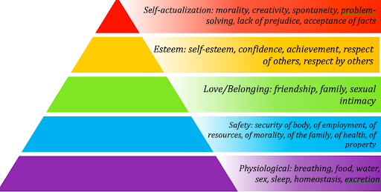

Physiological- these are just basic things we need in life, Consider the impact of working excessively long hours, in a dark and airless environment, such careless or cruel treatment of team members does little for productivity in the long run.
Safety- we may not be acutely aware of security needs until a crisis arises, as a manager you need to be aware of these situations.
Love/belonging- Once the need for safety is somewhat met, the need for a sense of belonging becomes evident. Maslow states that people seek to overcome feelings of loneliness and alienation by nurturing relationships.
Esteem needs- Once the first three classes of needs are largely met, the need for esteem arises. This comprises both the respect and recognition a person gets from others, and their own sense of worth, competence and independence.
Self-actualization needs- According to Maslow, self-actualization is when a person can do what they feel they are "meant" to do and be who they are "meant" to be. The need for self-actualization is present in all of us, but can only be met once all of the lower needs are sufficiently satisfied.
Mindtools.com (2021)
Then you have hezburg’s two factor theory,
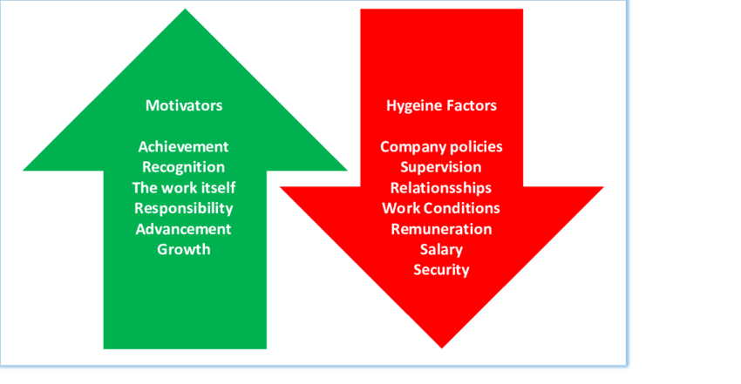

Motivators.
Motivating factors relate to the job content and consist of the need for achievement, the interest of the work, responsibility and the opportunities of advancement.
Hygiene factors.
Hygiene factors relate to the job context which include things like poor working conditions, salary, hygiene factors neither satisfy nor motivate and they serve primarily to prevent job dissatisfaction.
Even now hezburg’s two factor theory still continues to thrive partly because it’s easy to understand,
(Armstrong, 2020,p251)

.employee engagement.
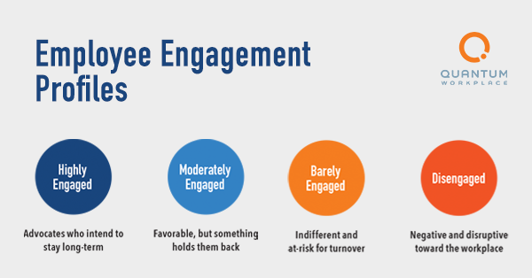
Employee engagement is a workplace approach resulting in the right conditions for all employees of an organisation to give of their best each day, committed to their organisation’s goals and values, motivated to contribute to organisational success, with an enhanced sense of their own well-being.

Employee engagement is based on trust, integrity, two way commitment and communication between an organisation and its employees, it is an approach that increases the chances of the businesses success, contributing to organisational and individual performance, productivity and well-being, it varies from poor to great.
Engageforsuccess (2021)
Stairs and Galpin claim that high levels of engagement result in:
- Lower absenteeism and higher employee retention.
- Productivity increased.
- Quality improved.
- Sales increased.
- Enhanced customer satisfaction.
- Faster business growth.
- Likelihood of higher business success.
(Armstrong, 2020, p275)

It’s important to have high levels of engaged employees at McDonalds due to them being so very busy so there day to day running of the business can go smoothly, McDonalds strive to keep their employees engaged by offering flexible hours to work around family life, they offer discounts in retail shops as a reward for their hard work, they also do performance review’s which could lead to a pay rise.
However on the other side to this is the disengaged employees, to which don’t tend to have the motivation so they sometimes get things wrong or make mistakes, they have no interest in their role or the company’s values and are only there for the salary, even though McDonald’s offer a range of benefits to their employees there are downsides as they offer a zero hour contract which can sometimes mean unpredictable hours, working night shifts when this isn’t convenient for some members of staff which will also include minimum pay.

.Training and development

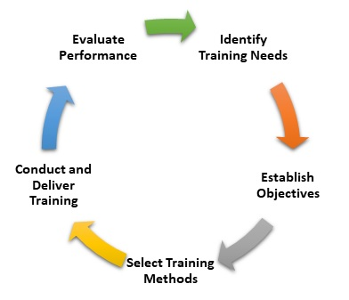

Training is a process of gaining knowledge and improving skills which the productivity and performance of the employees can be enhanced, efficient training of employees can help with their skills & knowledge development, which eventually will help a business improve its productivity leading to overall growth.
Training is about knowing where you are in the present and after some time where you will reach with your abilities, people learn new information by training and refresh their existing knowledge and skills, employees get offered training as a skill development for individuals and groups.
Training and development benefits the employer because when an employee is skilled and trained enough, the amount of wastage will be less, as well as the learning time will be reduced, and the work will be performed in very less time, It also improves the performance of the employee which results in increased profitability.
Employees develops a positive attitude towards their work and to the organization, as well as boosts their morale, which helps them adapt themselves to the changing environment in their workforce.
Employees are more likely to take on challenges in a better way when they are trained enough and being trained opens up better career opportunities.
Businessjargons (2021)
There are two different ways of training there is on the job training and off the job training.
.Advantage of on the job training.
- It’s cheap, no cost of travel and no paying for training facilities and training is done by another employee.
- Easy to organise and can be completed in a shorter time frame.
- And if specific machinery used it’s an advantage that it’s already there.

.Disadvantages of on the job training.
- Employees may be unlikely to bring new ideas into the business.
- More people unavailable to work due to the training, as the training is usually provided by other employees.
- The employee providing the training will be ineffective as they will be too busy.
. Advantage of off the job training.
- Employees are likely to bring in new ideas.
- They may feel more valued and therefore motivated as the business is paying for the training and can be expensive.
- The trainer is likely to provide a high standard of training.

. Disadvantages of off the job training.
- Can be expensive
- Once they are trained up that employee could leave the business.
- Lost productivity while the employee is away from the business.
- Training may not be tailored to the specific type of business.

McDonald’s offer great opportunity’s with training to their employees, every year they invest over £43 million in developing their people, all the employees working for McDonald’s has the opportunity to take part in structured training, whether it’s in customer service, team work or financial management. Plus, you can achieve an array of qualifications with us, many of them nationally recognised.
McDonald’s (2021)
McDonald’s help their employees by paying their tuition fees at university.
Since 2009 the company has given teenage employees in England and Wales the chance to study for an apprenticeship in hospitality and catering, equivalent to five GCSEs at A* to C grades. This includes help with maths or English where this standard has not already been achieved.
Bbc news (2015)

Back in 2019 McDonald’s won the large youth friendly employer of the year at the Youth Employment UK Awards in recognition of their commitment to youth employment.
Youth Employment UK helps UK organisations build and maintain a youth friendly culture by helping organisations overcome barriers young people in to employment and to ultimately create accessible opportunities for them.
Achieving this award recognises the opportunities McDonald’s offer and the training they have in place to help maximise the potential of all the people working at McDonald’s.
McDonald’s (2021)

Personal development plan

Objective/Area of Development | Measure | Priority | Support and Development.  Internal/External | Review Dates | Other comments
health and safety training | on a training course | high | external/ training centre | Every 6 months
allergy training to gain confidence with customers with allergies | on a training course | high | external/ training centre | every 6 months
time management | on the job | moderate | internal | regularly
Objective/Area of Development | Measure | Priority | Support and Development.  Internal/External | Review Dates

Providing health and safety training is important all employees at McDonald’s regardless of their position, they are required to take a proactive approach to maintaining a safe and healthy workplace, accordingly, we are committed to providing the necessary information and training to achieve this objective, they will have to do many courses online or at a training centre as the will need food hygiene certificates, managers are also committed to reviewing their health and safety policies annually.
Food allergies affect many people in our society today, and the food service industry must keep up with the demand for allergen-free food from their customers. The objective of this research is to gain insight from the employee’s perspective of the importance of food allergies and what training method would help them learn best. Through this research we intend to learn how we can engage employees during training, increase training retention, and stress the
Importance to change their behaviours and utilize safe practices in regard to allergens.
Time management at McDonald’s, employees need to have good time management as they are a very busy establishment with things moving very fast.

References

Techfunnel. 2021. Benefits of Performance Management for Organization and Employees. [online] Available at: https://www.techfunnel.com/hr-tech/benefits-of-performance-management-for-organization-and-employees/ [Accessed 15 December 2021].
Mindtools.com. 2021. Maslow's Hierarchy of Needs: A Model for Supporting Your People Toward Self-Actualization. [online] Available at: https://www.mindtools.com/pages/article/newldr_92.htm
[Accessed 15 December 2021].
UK, M., 2021. McDonald's Careers UK Crew Member. [online] McDonald's Careers UK. Available at: https://people.mcdonalds.co.uk/restaurant-opportunities/crew-member/ [Accessed 15 December 2021].
Armstrong.m (2020) handbook of human resource management practice 15th Edn London
Engage for Success. 2021. What is Employee Engagement - Engage for Success. [online] Available at: https://engageforsuccess.org/what-is-employee-engagement/ [Accessed 15 December 2021].
Armstrong,M (2020) handbook of human resource management practice 15th Edn London
Business Jargons. 2021. What is Training and Development? definition, importance and inputs - Business Jargons. [online] Available at: https://businessjargons.com/training-and-development.html [Accessed 15 December 2021].
UK, M., 2021. McDonald's Careers UK Our brand. [online] McDonald's Careers UK. Available at: https://people.mcdonalds.co.uk/why-mcdonalds/our-brand/ [Accessed 15 December 2021].
BBC News. 2021. What's it really like to work at McDonald's?. [online] Available at: https://www.bbc.co.uk/news/magazine-32283560 [Accessed 15 December 2021].
UK, M., 2021. McDonald's Careers UK Our brand. [online] McDonald's Careers UK. Available at: https://people.mcdonalds.co.uk/why-mcdonalds/our-brand/ [Accessed 16 December 2021].

