Unit 1- Becoming an independent learner
Unit 1- Written Summary
During this unit, I was given several different resources to help me become an independent learner during my time at university. I think the following skills are useful and essential for study and employment. Firstly, having good communication skills is very useful as it makes you sound more professional. Secondly, being able to work as a team is crucial in a working environment as you’ll be able to build positive relationships with others and achieve goals. Being part of a team also means you need to be able to solve problems, being able to solve problems shows others that you can approach issues from different angles. Being able to work as an individual is also important as you need to be able to do work on your own but getting advice from others is also good. To develop useful study skills, you need to firstly be able to find time to study, managing your time is useful as it will put you in a motivated mindset. Being able to source the right information is also a study skill you need; students should get their research from library books and valid websites. Taking notes is also useful as you can keep all your main keywords in one place for future reference. Finally, while studying at university, being able to ask for feedback from lecturers is helpful for your future as you are able to use the information to improve next time.

Information sources-
https://www.skillsyouneed.com/learn/study-skills.html
https://targetjobs.co.uk/careers-advice/career-planning/273051-the-top-10-skills-thatll-get-you-a-job-when-you-graduate
https://career-ready.blogs.latrobe.edu.au/2013/08/16/8-essential-employability-skills/
https://www.ucas.com/file/130381/download?token=zXu/_9

To improve next time, I think I could make more of an effort to ask for guidance as multiple times ive been confused and too nervous to ask for help. I would award myself about 75% as ive been able to figure out and understand the majority of the work but not enough that will get me a mark any higher.
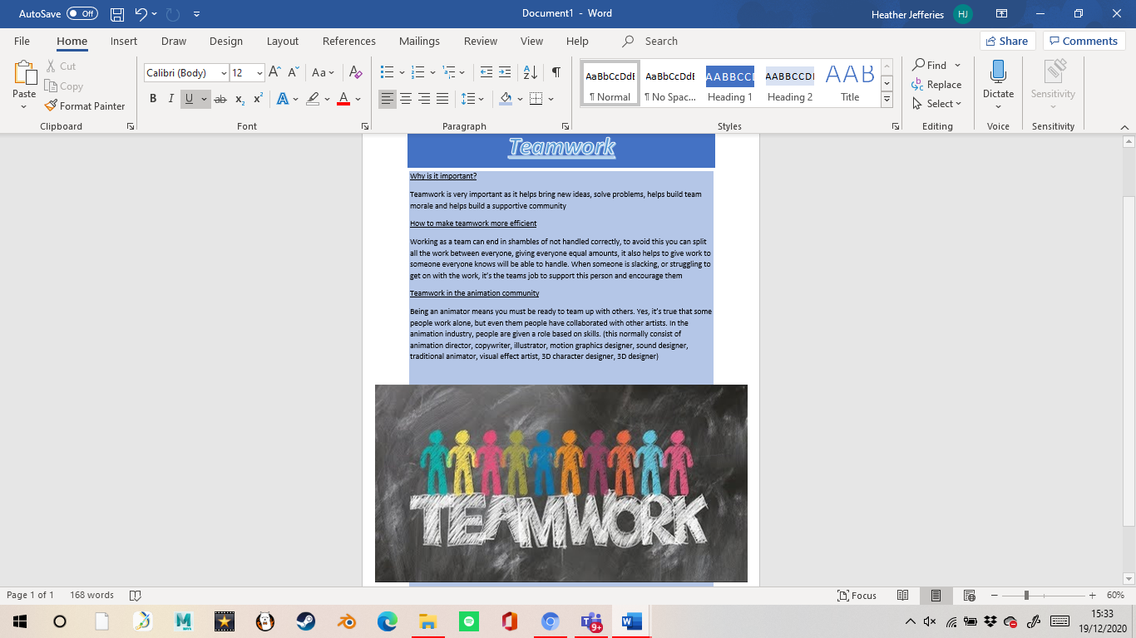
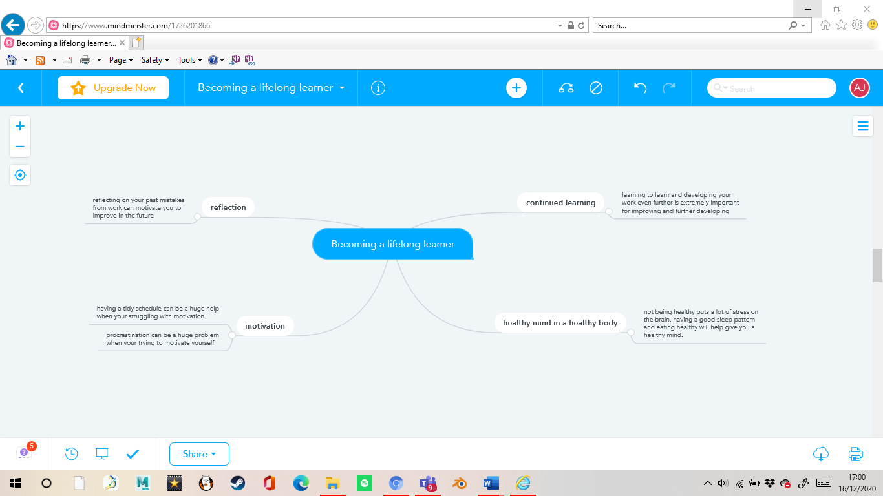
Unit 2- Mind Map

Unit 4- Poster

