


Small and Medium sized Enterprises

STUDENT NAME: Suraya Begum
STUDENT NUMBER: 1712135
MODULE NUMBER: BMSK6104
MODULE TITLE: Strategic Management for SMEs
LECTURER: Paul Bocij
Contents
No table of contents entries found.

Executive Summary

This case study will be based on a retail company called “Pets at Home” group plc. In this report I will be carrying out an analysis of what their vision and mission is, what’s good or bad, look at their current strategy of their business, looking at their strengths and weaknesses, who their share and stakeholders are and how they plan to stay successful. To help me find my findings I will be using tools such as VRIO, pestle, swot, and other strategic management tools. I will also recommend ways of ensuring future developments for the organisation to continue to grow in the right direction.

Introduction
Pets at home is an established retail company, they offer the ultimate pet shop experience to their customers. They have all the pets supplies such as pet food, toys, bedding, medicines and all the pet accessories that the customers need. Pets at home are UKs leading pet care business. They are also a grooming salon, offering grooming for cats and dogs, they offer surgeries, and they also provide veterinary care and provide all pet owners advise on how to ensure their pets have a happy, healthy life. They will help their customers choose the right food with nutritious consultation. Pets at home are a online store where their customers can order their pets products and have it delivered or get it collected at store.
All pets at home staff are trained to standards and are certified in this profession.

Pets at home -Strategic Direction
What is strategic direction? Strategic direction is refers to the plans that needs to be implemented for an organisation to progress towards its vision and fulfil its goals. Its owners and management can communicate the importance of employees work and their contribution to achieving business objectives. (Wellerbusinessoxygen) (online)
Strategic direction - why you need it to achieve growth (wellersaccountants.co.uk)
The importance of strategy implementation, as Ansoff, Declerk, and Hayes (1976) point out “the outcome of strategic planning is only a set of plans and intentions. By itself strategic planning produces no actions, no visible change in the firm. To effect the changes the firm needs appropriated capabilities; trained and motivated managers, strategic information, fluid and responsive systems and structure!” (H. Macmillan 2000, p185)
Becoming the best pet care business in the world
Our pet care strategy was launched in 2018 and is based around four strategic pillars designed to put the pet owner at the heart of everything we do.
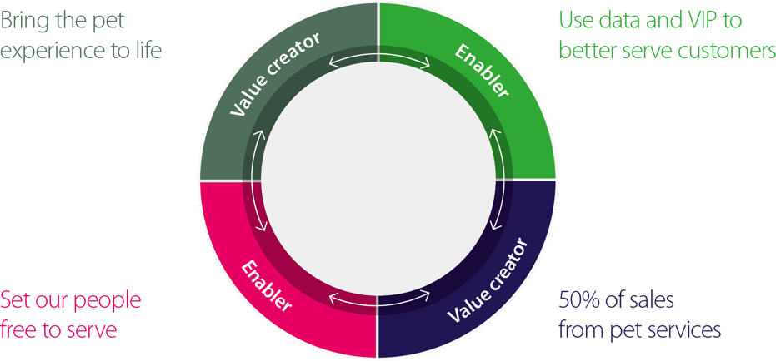

Source Google image (pets at home)

Pets at Home Mission Statement
Pets at home store represents a Unique environment and provides a practical, fun and unique experiences for pet owners. Because they put pets at the heart of everything they do , they believe who ever is part of the group has a special responsibility to help keep the pets happy, healthy and safe. https://investors.petsathome.com

Their Values
- They put pets first- pets are their business and their passion. 93% of their colleagues have pets themselves. They invest heavily in staff training and follow to higher welfare standards to ensure that the pets in their care are cared for properly.
- They make it fun- the management ensures that all their colleagues are happy coming to work, and they provide an outstanding customer, friendly, fun working environment in their workplace.
- They work as a team- to ensure their customers have a fantastic shopping experience in store and receive a professional and friendly service in the vets and grooming department.
- They live their values day in and day out
- They take pride in their work- the hard-working staff is the reason for their company’s success. They all take great pride in being part of the business that caters for the community. This success has got them the votes in achieving the Sunday Time’s Best Big Company to work for in 2013 by their colleagues. As their company continues to grow their dedicated teams are taking more and more pride in every part of their business.
They get better every day, the company has grown at a phenomenal rate over the last few years, as they have opened more stores. The staff are learning and gaining more experience and knowledge in pet care through their learning development opportunities that’s available to all staff. They review their learning performance to get better at what they are doing every day.
They do what they say they will do, they are ethical. The staff are dedicated in providing a excellent customer service. They are honest with their customers in achieving the best quality services and products. They are also very honest with each other as colleagues and this honesty makes their workplace a great place to work in. (Petsathome) (online)
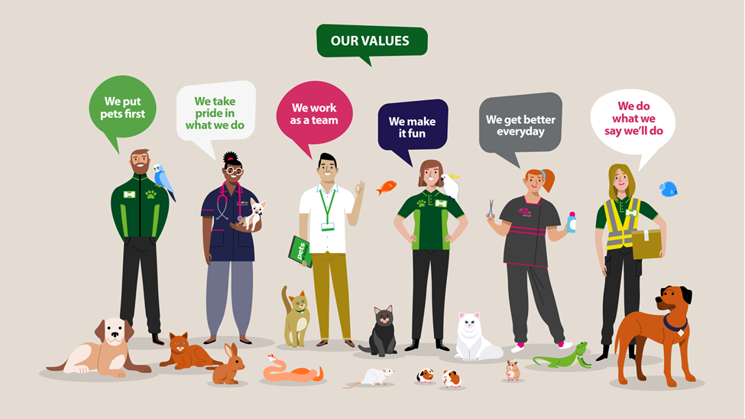

Source Google image Pets at home group plc

Pets at home have a very strong mission and vision statement for their company strategic direction which is helping them achieve their business goals and moving forward. They have dedicated staff and they take pride in everything they do because its their passion for animals and they put the animals at the heart of their business. This nature of their business will be very easy to meet their targets and goals of a successful business in the near future, having a strong mission and vision makes a company what it is and most importantly implementing what you say you will do. Being ethical is very important, no point having a statement and then not following it, this will look bad on your business. (L. Wolfe 2019) (online)
A good statement will make the company standout and different to their competitors and without a mission statement in a business can make it difficult and struggle when it comes to planning.

Porters Five Forces -Pets at Home
Michael Porters Five Forces is a tool that shapes out a business strategy, it gives you an understanding of the impact it can have on a business in terms of competitors, suppliers, new commers etc. The Model looks at five forces that define the market: how easy it is for new commers to enter the businesses, how easy it is for customers to substitute the product or service, how much power suppliers and buyers have in the market, and overall, the degree of the competitors within the market. (K.Williams 2009)
This tool will help in focusing on how Pets at Home Group Plc can grow a sustainable competitive advantage in Retail market.

The five forces are as below:
- Threat of New Entrants – New entrants mean threats as they bring in new innovative ideas, and this puts pets at home under pressure. They will have to come up a way to challenge all these new entrants and build an effective barrier to protect its competitive edge.

- Pets at home can start to innovate new products and services which will help new customers and old customers to continue to buy from them.
- They can lower their fixed prices of products and have offers to keep their customers interested.
- Pets at home are an old growing business therefore new entrants will take time to get to that level.

- Bargaining Power of Suppliers – most industries buy their goods from different suppliers. Strong suppliers can demand higher prices from the firms. The overall impact of higher supplier bargaining power is that it lowers the overall profitability of retail.

- Pets at home can build a strong relationship with multiple suppliers
- Experimenting on product designs and using different materials can help with prices.
- Having trusted suppliers that replies on the firms for business.

- Bargaining Power of Buyers – buyers are quite demanding, they would want the best offers available, and pay the cheapest possible. This can put pressure on the business as they will lose out on profits in the long run.

- Having a large number of customers, will be helpful in reducing the bargaining power of the buyers and also help with providing an opportunity in streamlining the sales and production process.
- By coming up with new ideas and offering discounts on existing products and introducing new will limit the bargaining power of buyers.

- Threat from Substitute Products- having a new product at satisfies a customer needs in a different way the industry will face profitability loss. E.g., when the same product works out differently or benefits another in a different way.

- Pets at home came be more services orientated rather than product.
- Focusing on the core needs of the customer instead of focusing on what they are buying.

- Rivalry Among the existing Players- when there is a competition between two competitors then the industry will see a down fall on profitability. Pets at home are already operating in a very competitive retail industry. This competition can cause a lot of downfalls for the company in a long term.

- Pets at home can build a sustainable differentiation
- Can build a scale to compete better
- Try and collaborate with its competitors to increase the size of the market.
By analysing the five forces, Pets at home group plc can gain a complete image of what impacts the profitability of the business in this retail industry. This will help to identify the moving trends quickly and can immediately implement with new opportunities. By identifying and understanding the five forces carefully pets at home group plc can shape these forces in their favour.

Internal and External Environment

To keep a business in the surviving position a good strategy is needed. In order to be an effective business it needs to achieve some degree of match between the two which is what the business can offer and what the business needs. (K. Williams 2009)
Analysing the business environment, the first step is to create a strategic direction, you need to start off with a business strategy, a plan. There are number of factors in the environment that can have impacts on a business.
Here we will be looking at a scanning tool called VRIO. VRIO stands for Value, Rareness, Imitability, Organisations.
This scanning tool is an analytical technique which is brilliant for evaluating a company ‘s resources and the competitive advantage. www.managementmania.com/en/vrio-analysis
VRIO analysis of Pets at Home group plc will critically assess each of its Internal resources to see whether these provide sustained competitive advantage.
VRIO Analyse will also show each stage whether these resources could be improved in order to create a larger competitive advantage.
We will also find out from the analysis whether they offer sustained competitive advantage has an unused competitive advantage, temporary competitive advantage, competitive parity or competitive disadvantage.
VALUABLE
- The Financial resources show they are highly valuable as they help in investing into external opportunities that arise. These will also benefit combating external threats.

- Another valuable resource are the local food products as these are greatly differentiated. Due to the differentiation of the product these are also valued more than the competition by customers.

- The employees of pets at home group plc are a valuable resource to their business, as most of their employees are highly trained, and this leads to more productive improvement for the business. Their employee’s loyalty and retention levels are high in the organisation which all leads to greater value for pets at home.

- Its patents are a valuable resource as these allow the organisation to sell its products without competitive interference. This results pets at home group plc a greater revenue.

- According to research there’s a disadvantage in the cost structure as the methods of products leads to greater costs than the competition.

- The research and development are costing more than the benefits, it provides in the form of innovation therefore it’s not a valuable resource. In the past few years there have been little innovative features and breakthrough products, so in order to gain advantage pets at home group plc will have to reduce their costs for research and development as this is a competitive disadvantage.

RARE
- Pets at home group plc financial resources are found to be rare, strong financial resources are only possessed by a few companies in the industry.

- What’s found to be not rare is the local food products as these are available in the markets by other competitors. These resources can be used in the same way by other competitors which then means its competitive disadvantage for pets at home group plc. This will also lead the local food products as a competitive parity for the company.

- What’s also is rare is the employees of pets at home group plc, as their employees are highly trained and skilled in their firm, whereas in other firms this is not the case.

- Having a great working environment and compensation, these added benefits ensures the employees that they do not leave their workplaces for other firms.

- Another advantage for pets at home is the patents, as these resources are rare and are not easily available and are not possessed by competitors. This allows them to ensure these without any competitive interference.

- Pets at home’s distribution network is also identified as a rare resource, because it will require a lot of investment and time for the competitors to come up with a better distribution network. This is also possessed by very few firms in the industry.

IMITABLE
- Pets at home group plc financial assets are expensive to emulate as per the VRIO Analysis. The assets have been gained by the organization through delayed benefits throughout the long term. New contestants and contenders would require comparable benefits for an extensive stretch of time to aggregate these measures of monetary assets.

- The local foods products are not that costly to imitate as identified by the analysis. The competitors can easily acquire these products if they invest a larger amount in the research and development.

- The employees are not costly to imitate as other firms can also train their staff to that level and offer training to improve their employers’ skills. The competitors can also hire employees from pets at home group plc by offering them better benefits, compensation, better workplace environment and growth opportunities. This will provide a temporary competitive advantage.

- The patents are very difficult to imitate because it is not legally allowed to imitate a patented product. Similar resources will be costly to be developed for the competitors.

- this distribution network is additionally exorbitant to emulate by competition as this has been created throughout the years progressively by pets at home group plc. Competitors would need to contribute a critical sum in case, they are to imitate a comparable appropriation framework.

ORGANISATION
- the financial resources are organised to capture the value as the resources are utilised strategically to invest in the correct places. Making use of opportunities and fighting threats. Therefore, these resources have proven to be a source of sustained competitive advantage.

- The licenses are not efficient which implies that the association isn't utilizing these licenses to their maximum capacity. An unused upper hand exists that can be changed into a feasible upper hand if pets at home begins selling licensed items before the licenses lapse.

- The distribution network is organised, they use the network to reach out to its customers by ensuring that products are available on all of its outlets. Therefore, these resources prove to be a source of sustained competitive advantage.

so here what we have found from the analysis is that pets at home was identified that the financial resources and distribution network provides a sustained competitive advantage. The patents are a source of unused competitive advantage. There exists a temporary competitive advantage for employees. There exists a competitive parity for local food products, and lastly the cast structure of pets at home group plc is a competitive disadvantage. Research and development have also shown to be a competitive disadvantage.

We also will be looking at a scanning tool called SWOT. SWOT stands for Strength, Weakness, opportunities and threats.
SWOT analysis tool helps with understanding the organisations market and environment by contrasting its strengths and weaknesses with the opportunities and threats in the market.

STRENGTHS  - Pets at home is one of the largest pet supplies retailer in the UK.  - Over 6000 employees  - Diversified workforce with people of many different backgrounds  - 370 stores  - Highly trained and skilled employees  - Offers complete guide to your pets  - They sell pets, food, bedding, toys and accessories.  - Offers other services such as, grooming, vets, nutrition checks, health checks and surgeries.  - Offers special discounts and deals to customers  - Strong brand | WEAKNESSES  - Rumours of alleged mistreatment of pets.  - Consumers cut back on spending due to bad economic conditions, sales get hurt.  - Research and development- spending too much than average  - High day sales inventory – time taken for products to be purchased and sold are higher that the industry average.
OPPORTUNITIES  - More young professional people wanting pets due to living alone  - Increasing purchasing power parity leading to improved lifestyles e.g. – more spending on discretionary items.  - Expand network  - Animals selection and reach to people by opening up more flagship stores and subway brands along the lines of their growth strategy currently being pursued.  - Involved in CSR activities by their programs – buying homeless pets’ food  - New deals and new exciting discounts  - Offer more grooming and treatments for pets. | THREATS  - Health and disease risk of animals  - Cutbacks on spending due to bad economic conditions  - Cuts on sales  - More pets shops offering similar services,  - New entrants  - Supplier’s demand  - Competitor’s such as PetSmart INC  - Armitage’s Pet Products Limited  - PETCO Animal supplies stores
(MBa Skoolteam April 2020)
from the SWOT analysis you can see there are more strengths than the others and very few weaknesses. The strengths give Pets at home a better chance of surviving in the competitive market industry.

Stakeholders
Stakeholders are individuals or organisations that have an interest in how your organisation is run. The ready availability of information, especially through the media and the internet, means that stakeholders have an increasingly strong voice, some may seek to influence the strategy. It is vital, therefore, to identify and manage the most important stakeholders of a business. (K. Williams 2009 p42)
Pets at home group Plc stakeholders are as follows:

- Directors
- Managers
- Customers
- Product suppliers
- Van suppliers for deliveries
- competitors
- Training departments
- Professional Veteran’s
- Media
- Grooming services
- Charity of rehoming pets
- Staff
- Suppliers of food
- Banks
- Investors
- Government
- Media
- Animals health and wellbeing
- Waste

Pets at home have strong stakeholder’s group. The group is in a strong financial position with returns potential. The market Pets at home operate in are resilient and have growth potential. They are the unique proposition of pet care solutions which makes them standout from the competitors. Their strong governance and commitment to sustainability through their better world pledge strategy ensure that the success of the business benefits all of their shareholders. The business is propositioned to deliver sustainable profit and cashflow growth in the long term.
The directors and managers have the most involvement in the business as they are the ones that make the main decisions of which way, they want to pursue their business. However, their power and control may not always be right, and this can cause the business a loss. The customers and staff also play an important part in the business as without happy customers the business will have a downfall on revenue. The staff are all highly trained and also have a strong position in the business as they have a caring side towards the animals, and this provides good customer service and performance. However, if they are not happy in their workplace then this will negatively impact the business too. Below is a table of stakeholder management plan of pets at home.

Stakeholder Mapping

Where to map Stakeholders
Keep Satisfied  Customers  Staff  Suppliers  Managers directors  Investors | Manage closely  Customers  Staff  Managers  Directors  Competitors  Investors  Waste  Animals health and wellbeing
Monitor (minimum contact)  Trainings  Suppliers  Competitors  Industry associations | Keep informed  Suppliers  Banks  van services  Suppliers grooming services  Veteran’s  Charity’s  Media  Government

Power

Interests
Above is a table showing how closely pets at home should keep their stakeholders.
Keeping customers and staff satisfied will give the business a good chance of survival, as without these a business cannot run on it own therefore its important to keep them close and keep them satisfied. Keeping suppliers, charities, deliveries and other services informed of changes is also important to keep them up to date and the best of interest as they are your business partners.

Strategic Growth choices of Pets at home.
The pet care market remains in solid growth, Pets at Home Group Plc vision is to become the best pet care industry in the world. They provide excellent customer service to their customers ensuring that the customers an become the best pet care owners. Pts at home report their retail and vet group business separately but in the eyes of their customers they are highly complementary to each other, which allows them to provide complete pet care to their customers in a way that the competitors cannot replicate.
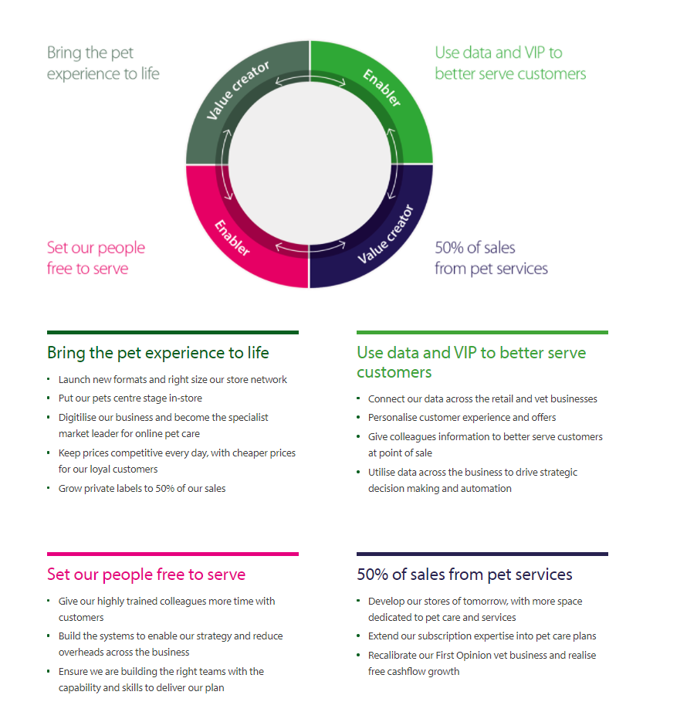
Below is a screenshot of the current strategy towards the growth of Pets at Home group Plc.

Pets at home also focussed on ensuring the wellbeing and safety of the colleagues, vet partners, suppliers, customers, and pets, the safe ongoing of the business in this current pandemic. Pets at home have a significant role to play in contributing to society and is creating value for the stakeholders through how they operate the business on a day to day basis. What makes the unique is that being united by the shared love of pets and being able to provide support and experience throughout the pet ownership journey.
Another way the continue to grow is by they deeply care about the role they play in their career and in society and they share the value they create as a business. therefore, the executive business management team, in consultation with their stakeholders will implement in ways to operate their 10 years promise that makes at least 10 years quantified commitments across their three pillars of Pets, people and planet.

Strategy Choices

A good strategy acts as a road map, it should clearly navigate you to where you want be or get to. Setting goals and then implementing these goals into action by giving yourself a realistic time frame.
So far Pets at home have proven to be a sustainable business and are working on continue to grow.
- Pets at home should continue to provide training to all their employees and get them highly trained professionals to continue to provide the best possible pet care and services as they do already. This strategic plan has already proven to be rare and unique as not all pet shops employees are fully trained or have the skills. Majority of the employees have pets of their own and working in this field is not just a job for them, they work here because they love what they do and they deeply care about their pets and animals. Which make their workplace environment a happy place and where they want to be. This strategy does not need to new as its already in place but however they can continue to improve their learning skills and continue to provide the best service.
- At the moment Pets at home are spending far to much on research and development which is considered at a disadvantage therefore they can reduce the cost of investment into research and try and save more. They can use that money to open up more grooming sessions for other animals such a s rabbits, guineapigs etc as at the moment they wash and groom dogs. They can hire more skilled staff to do this which will make them more popular and unique compare to the competitors in the same business field.
- Another way they can continue to grow is by collaborating or working in partnership with other pet industries which will make them bigger and stronger in the pet market industry. This will bring advantages in terms of new innovative ideas and services, new skilled staff and knowledge, workload is shared, better decision-making, more partners and more capital and will reduce competitive disadvantages. However, working with partners can also have some disadvantages such as not agreeing to the same vision or mission of the company and have conflicts.
Out of the three strategy’s, the best strategy to go with for pets at home would be to offer new services and focus on reducing cost in one section and investing that revenue into creating new innovation or service. This strategy will continue to help the company grow and make them more unique as they will be offering more than the competitors will in the pet’s industry.

Recommendation
An innovation strategy refers to a plan that creates new sources of earnings for e.g product improvements, service improvements, boosting of earnings by reducing cost in research and increasing revenue.
After analysing the current strategic direction of pets at home group plc, I would recommend they take up new innovative ideas and invest in offering other pet services such as grooming services for other pet animals instead of just cats and dogs.
They should also look at the cost implications and try and reduce their costs in other areas not necessary. Try in increase in revenue and offer more discounts to their loyal customers etc.

Conclusion
This report has critically analysed the strategic structure and planning of pets at Home group plc. To help me find my findings I had used many tools such as swot, porters five forces, VRIO and stakeholder mapping. I have looked some strategies that can be carried forward with some new improvements to help the company to continue to grow and recommended a way forward for pets at home group plc.
This report shows pets at home is a strong sustainable company and has some competitive competitors that could cause a risk for them if the competitors offered the same services as pets at home. However, if pets at home come up with new ideas or new services then they will be hard to compete against as already pets at home has proven to be strong in the pet market industry.

Reference

here?, F., Book, D., Resources, S. and MASTERCLASS, O., 2021. Innovation Strategy - Strategy for Executives. [online] Strategy for Executives. Available at: <https://strategyforexecs.com/innovation-strategy/> [Accessed 4 August 2021].

Korchak, J., 2021. Advantages and disadvantages of a partnership business - Inform Direct. [online] Inform Direct. Available at: <https://www.informdirect.co.uk/business-management/partnership-business-advantages-and-disadvantages/> [Accessed 18 July 2021].

Team, M., 2021. Pets at Home SWOT Analysis | Detailed SWOT Analysis of Pets at Home | Top Competitors, STP & USP | MBA Skool-Study.Learn.Share.. [online] MBA Skool-Study.Learn.Share. Available at: <https://www.mbaskool.com/brandguide/lifestyle-and-retail/9316-pets-at-home.html> [Accessed 20 July 2021].

Pets at Home Group plc. 2021. Our strategy. [online] Available at: <https://investors.petsathome.com/our-company/our-strategy> [Accessed 27 July 2021].

Case48. 2021. Pets At Home Group Plc PESTEL Analysis. [online] Available at: <https://www.case48.com/pestel-analysis/9074-Pets-At-Home-Group-Plc> [Accessed 2 August 2021].

The Balance Careers. 2021. Why You Need Mission Statement. [online] Available at: <https://www.thebalancecareers.com/the-importance-of-having-a-mission-statement-3515710> [Accessed 1 August 2021].

Pets at Home Group plc. 2021. Pets at home plc - UK's leading pet care business. [online] Available at: <https://investors.petsathome.com> [Accessed 3 August 2021].

Demiralay, E., 2021. Strategic direction - why you need it to achieve growth. [online] Wellersaccountants.co.uk. Available at: <https://www.wellersaccountants.co.uk/blog/strategic-direction-why-you-need-it-to-achieve-growth> [Accessed 4 August 2021].

Fern Fort University. 2021. Pets At Home Group Plc Porter Five (5) Forces & Industry Analysis [Strategy]. [online] Available at: <http://fernfortuniversity.com/term-papers/porter5/lse/457-pets-at-home-group-plc.php> [Accessed 4 August 2021].
Pets At Home Group Plc Porter Five (5) Forces & Industry Analysis [Strategy] (fernfortuniversity.com)

Books
Williams, K., 2009. Strategic management. London: Dorling Kindersley.
9781405336918

Alon, I., Jones, V. and McIntyre, J., 2013. Innovation in Business Education in Emerging Markets. Basingstoke,: Palgrave Macmillan.

Macmillan, H. and Tampoe, M., 2000. Strategic management. Oxford: Oxford University Press.

