Module Code BMIH5006
Module Title: Sustainability for Hospitality Industry

Assignment Title:
Green Practice Implementation in The Ritz-Carlton, London

Student Name: Katerina Hristova
Student Number: 2232205
Lecturer’s Name: Lisa-Marie Bassler, Giulia Chifari, Lisa Knight

Executive Summary
This report examines the process of introducing a green practice initiative at The Ritz-Carlton, London, without limiting it to the identification and targeting of a gap in sustainability initiatives at the hotel. The hotel is associated with luxurious service and attention to environmental responsibility, though a certain discrepancy is evident in the operational aspect of food waste management. Although many efforts are already being made, including local sourcing and the provision of seasonal menus, the hotel does not have a structured and data-driven approach towards food waste tracking and reduction. As a policy recommendation, this report suggests implementing a smart food waste tracking system to combat the problem. The initiative is a technology-based food waste monitoring program that allows the kitchen team to understand the main sources of waste and optimise operations. The report measures the value of this solution based on its ability to reduce its impact on the environment, its ability to operate more efficiently and to position the hotel according to global sustainability standards and certifications like the Green Key certification. Difficulties, such as cost and staff training, are also addressed in the report, which concludes that the initiative is realistic and cost-effective over the long term. Altogether, the solution has provided a feasible means through which The Ritz-Carlton can seal a significant sustainability loophole and strengthen its standing as an eco-friendly hotel.

Table of Contents
Executive Summary ii
1.0 Introduction 1
2.0 Main Findings 2
2.1 What is Green Practice? 2
2.2 Overview of Selected Hotel: The Ritz-Carlton, London 2
2.3 Identified Sustainability Gap 3
2.4 Chosen Green Practice Initiative: Food Waste Management 4
2.5 Advantages to the Hotel 5
2.6 Environmental Benefits 6
2.7 Implementation Challenges 7
2.8 Cost Effectiveness and Feasibility 8
3.0 Conclusion and Recommendations 9
4.0 References 10

Table of Figures
Figure 1: The Ritz-Carlton, London (Dimitrakaki, 2023) 3
Figure 2: Smart Food Waste Tracking System (Huang et al., 2021) 4
Figure 3: Food Waste Reduction Over 6 Months at The Ritz-Carlton (Bhatia et al., 2023) 5

1.0 Introduction
Green practices within the hospitality sector can be described as environmentally friendly operations to minimise the harmful effects on the earth. Such practices are water conservation, energy-saving practices, waste reduction, and sustainable sourcing. Through these kinds of strategies, hotels will be able to run their operations more responsibly and attract a rising number of eco-conscious travellers. Climate change, customer demand, and governmental policies have now put the hotel industry under pressure to perform regarding sustainability expectations. Hotels that have attained some environmental standards are awarded eco-certifications such as the Green Key award. Green practices have become a requirement rather than an option to succeed in the long run (de Almeida Oroski and da Silva, 2023). The report is devoted to the investigation of The Ritz-Carlton, London, a five-star hotel that offers high-value services and cares about the satisfaction of its customers. The hotel has made some progress towards achieving sustainability, but there is still a big gap when it comes to food waste management. This report is a proposal for a green initiative to ensure this problem is solved and analyses the impacts it would have on both the hotel and the environment.

2.0 Main Findings

2.1 What is Green Practice?
Green practices have been defined as environmentally conscious operations which contribute to mitigating environmental degradation. These practices in the hotel and hospitality industry are meant to curtail the adverse effects of the daily operations of preparing food, cleaning, consuming energy and disposing of waste. The use of green techniques will ensure sustainability and preservation of natural resources (Sloan, Legrand and Chen, 2017). Some of the green initiatives that are common in hotels are LED lights, energy-efficient appliances, and green cleaning products. Most hotels also have recycling schemes, reduce disposable plastics, and put in place water-saving devices such as low-flow faucets and dual-flush water closets. Hotels are also becoming more reliant on renewable resources like solar and wind power to lessen their carbon footprint (Bhatia et al., 2023). Food waste reduction is another significant area. Hotels can respond to this by designing menus cautiously, controlling portions, composting organic wastes and giving surplus foods to charities. Such initiatives not only secure environmental safety but also are likely to save money and make the hotel's image publicly positive.

2.2 Overview of Selected Hotel: The Ritz-Carlton, London
The Ritz-Carlton, London is a five-star traditional hotel situated in the heart of London that offers superior services. Being a member of the world-renowned Marriott International chain, the hotel follows the standards of luxury and service. It caters to luxury customers such as foreign visitors, business travellers, and premium clients, and provides them with high-standard rooms, cuisine, and private events (Dimitrakaki, 2023). The hotel has implemented some sustainability measures such as energy-efficient appliances, water-conserving amenities, linen reuse systems, and decreased single-use plastics. Food waste, however, is a major problem. The numerous restaurants and regular massive events lead to the overproduction of food. Most of this waste is invisible without an official food waste tracking system, which is one of the main aspects to improve in the sustainability work of the hotel.
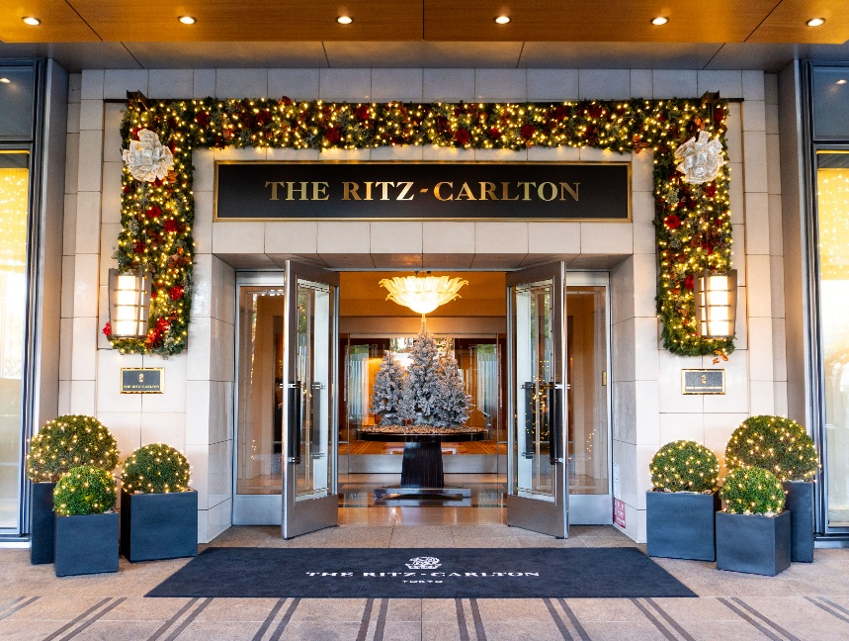
Figure 1: The Ritz-Carlton, London (Dimitrakaki, 2023)

2.3 Identified Sustainability Gap
The primary gap found in the sustainability strategy of The Ritz-Carlton concerns the absence of a systematic and technology-grounded food waste management framework. Although the hotel might have in place some informal practices aimed at minimising wastage, the lack of an appropriate tracking system means that food wastage cannot be measured, monitored, and analysed (Robertson, 2021). This has led to the waste of food with no sense of responsibility and without strategic thinking. The Ritz-Carlton is not the only one to have this problem. Most luxury hotels encounter such issues since they put their focus on the satisfaction of their guests, which, in most cases, results in them producing more food than is necessary. Nevertheless, negligence of this problem leads to redundant spending, increased waste management charges, and serious environmental damage (Management Association, 2018). Food waste also implies a waste of resources like water, electricity, fuel, and labour that were used in producing the food. The unavailability of data also reduces the opportunity for the hotel to optimise its kitchen performance (Ramakrishna and Jose, 2022). It is hard to train workers, develop menus more efficiently, or make decisions when one does not know what is being wasted and why. This sustainability gap should be covered to enhance the environmental responsibility of the hotel, as well as to increase the efficiency of its operations.

2.4 Chosen Green Practice Initiative: Food Waste Management
This report proposes the implementation of a smart food waste tracking system in The Ritz-Carlton, London, to curb the problem of food waste. This eco-friendly habit entails real-time monitoring and recording of food waste using cutting-edge technologies in the kitchen (Huang et al., 2021). This is the purpose of leading systems such as Winnow and Leanpath, which are widespread in the hospitality industry. They assist chefs and kitchen managers in realising how much food is wasted, at what time, and what can be done to minimise the wastage. This system is operated by digital weighing stations or smart bins in the kitchen. The devices automatically detect the nature and amount of food disposed of. Employees are also able to choose the cause of the waste, including overproduction, spoilage, or plate returns. This system can then analyse this data and give visual reports to the management. Hotels, such as Accor Group and Hilton, have experienced a decrease of up to 50 per cent in food waste in the initial year of application (IGI Global, 2019). The resulting insights enable chefs to optimise portion sizes, enhance purchasing and reformat menus to reflect actual consumption habits. Implementation of such technology in The Ritz-Carlton, London would help to increase kitchen efficiency, reduce costs, and improve the sustainability image of the hotel. It would also satisfy the environmental aims of Marriott International and serve as an example to other Ritz-Carlton sites.
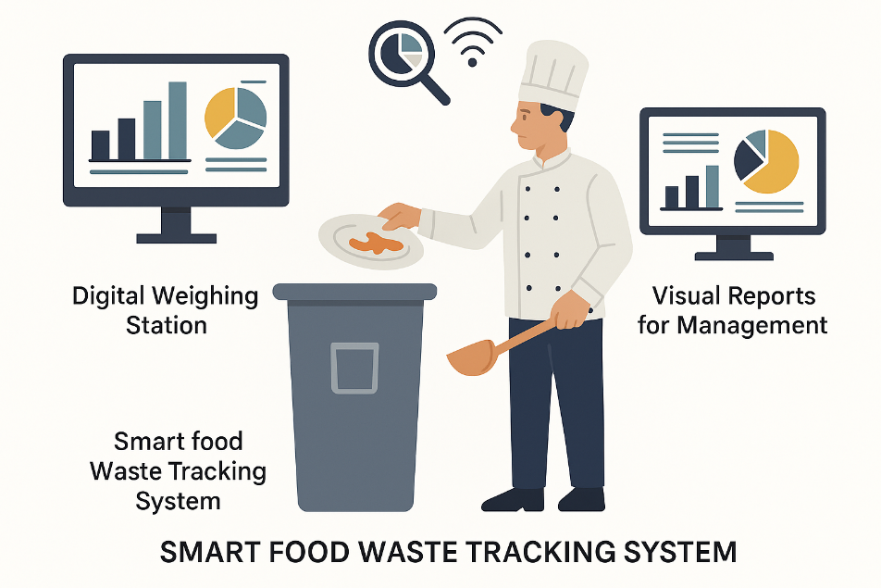
Figure 2: Smart Food Waste Tracking System (Huang et al., 2021)

2.5 Advantages to the Hotel
The graph below demonstrates that the implementation of a food waste tracking system can lead to a substantial and steady decrease in kitchen waste. The waste decreased by 45% in more than half a year, which means that the kitchen has become more efficient and can make better predictions.
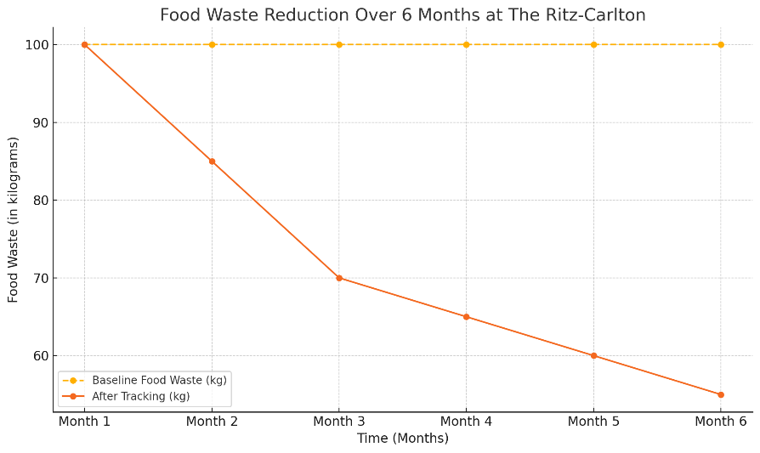
Figure 3: Food Waste Reduction Over 6 Months at The Ritz-Carlton (Bhatia et al., 2023)
Implementing an intelligent food waste monitoring system can offer numerous value propositions to The Ritz-Carlton, London, both functionally and strategically:
- Operational Efficiency: The kitchen team will be able to make more informed decisions as FoodTech analyses real-time data on food waste, highlighting problem areas (Jauhari, 2021). This can help in better management of inventory and cut overproduction.
- Cost Savings: It is evident that reduced food waste means less money spent on purchasing food and less money paid on disposal (Read and Muth, 2021). This can result in large savings, particularly in the case of a large hotel that has numerous dining facilities.
- Awareness and Staff Engagement: Kitchen staff will be more conscious of their contribution towards sustainability (Haski-Leventhal, 2018). The data-based system would foster responsibility and prompt them to implement more effective cooking and storage solutions.
- Guest Satisfaction and Brand Image: Contemporary guests are pleased with enterprises which practice environmental responsibility. By informing customers about the efforts of the hotel on websites, menus, or in-room materials, they are likely to increase repeat business and appeal to environmentally minded travellers (Cooper, 2021).
- Eco-Certification: The adoption of such a system enhances the suitability of the hotel to attain green certifications like the Green Key or EarthCheck that are relevant in a modern competitive market.
All these advantages turn food waste tracking not only into a sustainability measure but also into a wise business choice.

2.6 Environmental Benefits
The environmental benefits of food waste reduction are extensive and in line with the global sustainability agenda:
- Decreased Greenhouse Gas emissions: When food waste is deposited in a landfill, it decomposes and releases methane, which is a dangerous greenhouse gas. The hotel can help to reduce emissions by cutting the quantity of food that is delivered to landfills.
- Resource Conservation: The amount of water, land, and energy that is needed to produce food is high (Batabyal, 2018). When food is thrown away, all these resources go to waste as well. Food waste reduction is a resource saver and encourages sustainable agriculture.
- Reduced Landfill: By diverting less material to landfill sites, we can reduce the pollution of the soil as well as prolong the life of local landfills. This is of consideration in urban centres such as London that have limited space.
- Circular Economy Support: The tracking system can also be used to track down the excessive food that can be donated or used as compost (Korstanje, George and Nedelea, 2020). This helps to support a circular economy as resources are not wasted.
Through the implementation of this initiative, The Ritz-Carlton will have the opportunity to be a pioneer in the luxury hotel industry in terms of environmental responsibility.

2.7 Implementation Challenges
Though the proposed green practice is associated with numerous benefits, the hotel can experience the following challenges during the implementation:
- Initial Capital: The acquisition of smart food waste tracking systems may be expensive (Thakkar, 2021). The cost involves hardware costs, software costs, installation costs and license fees. This cost is, however, normally reimbursed by savings in the long run.
- Training Requirements: The kitchen personnel will require training on how to use the system properly. That requires being taught to input data, read reports, and take actionable steps based on knowledge (Inkson and Minnaert, 2018). There is also the problem of staff resistance to new procedures.
- Time and Resource Requirements: The implementation of the system and its subsequent monitoring require time and imply the participation of managers and IT support teams.
- Maintenance Requirements: Like any digital system, the food waste tracking tools would need regular technical maintenance (Costa and Costa, 2022). Such issues as software updates, calibration, and troubleshooting should be managed quickly and not cause any disruptions.
- Cultural Change: Shifting the culture in the kitchen might be the most significant obstacle (IGI Global, 2022). The employees accustomed to doing things the old-fashioned way may not accept the new method unless they observe its tangible merits and receive encouragement.
Such obstacles notwithstanding, the long-term benefits render the venture worth undertaking. The transition can be made with minimal disruption and achieve success with effective leadership and planning.

2.8 Cost Effectiveness and Feasibility
Although the implementation of a food waste tracking system can be seen as an expensive venture initially, it is cost-efficient in the long term. Industry reports show that numerous hotels attain a complete payback of investment in the range of 12 to 24 months. The savings are in the form of savings on purchased food costs, improved inventory management, and savings on waste disposal costs (Edgell, 2020). The Ritz-Carlton, London, is already working with high-end technological equipment and skilled personnel. This enhances the ability to embrace digital tools and accommodate them within the current systems. The hotel also has access to corporate partnerships and shared procurement networks, which can reduce the cost of installation and training as part of Marriott International. Implementation can be even more possible with a staged process (Wickham, Donnelly and French, 2021). As an illustration, the system can be launched in the main kitchen or one restaurant first. It can be subsequently spread to other areas based on outcomes and employee suggestions. This gives room for adjustment and makes sure that the staff are at ease with the changes. Overall, the given initiative is quite realistic and sustainable. It promotes the financial objective, environmental beliefs, and the brand image of the hotel.

3.0 Conclusion and Recommendations
The report has examined the significance of green practices within the hotel sector within the context of the Ritz-Carlton, London. Although the hotel already implements certain sustainable practices, there is an obvious gap in food waste management. As a solution, the report suggests implementing a smart food waste tracking system. The initiative proposed is in line with the business and environmental objectives. It can save money, increase kitchen efficiency and be used for eco-certification. Other problems that may be encountered include the costs of investment and training of staff members; however, these are solved with the necessary planning and backup. It is suggested that The Ritz-Carlton should start a pilot project in one of its restaurants. Training of staff should be carried out and progress checked regularly. Awareness campaigns and menu redesign can also engage the guests to prevent food wastage. This is a viable and accountable measure in providing a more sustainable future for the hotel.

4.0 References
Batabyal, A.A. (2018). Managing Sustainable Tourism Resources. Hershey, PA: IGI Global.
Bhatia, L. et al. (2023) ‘Food waste utilisation for reducing carbon footprints towards sustainable and cleaner environment: a review’, International Journal of Environmental Research and Public Health, 20(3), p.2318. https://doi.org/10.3390/ijerph20032318
Cooper, C. (2021). Essentials of tourism. 3rd ed. London: SAGE.
Costa, C. and Costa, R. (2022). Sustainability and competitiveness in the hospitality industry. Hershey, PA: Business Science Reference.
De Almeida Oroski, F. and da Silva, J.M. (2023) ‘Understanding food waste-reducing platforms: A mini-review’, Waste Management & Research, 41(4), pp.816–827. https://doi.org/10.1177/0734242X221135248
Dimitrakaki, I. (2023) ‘Management of customer experiences: case of Ritz-Carlton hotel’, Global Research Review in Business and Economics, 9(4), pp.165–175. https://doi.org/10.56805/grrbe
Edgell, D.L. (2020). Managing sustainable tourism: A legacy for the future. 3rd edn. Abingdon: Routledge.
Haski-Leventhal, D. (2018). Strategic corporate social responsibility: Tools & theories for responsible management. London: SAGE.
Huang, I.Y. et al. (2021) ‘Food waste management: A review of retailers’ business practices and their implications for sustainable value’, Journal of Cleaner Production, 285, p.125484. https://doi.org/10.1016/j.jclepro.2020.125484
IGI Global (2019). Sustainable tourism: breakthroughs in research and practice. Hershey, PA: IGI Global.
IGI Global (2022). New governance and management in tourist destinations. Hershey, PA: IGI Global.
Inkson, C. and Minnaert, L. (2018). Tourism management: an introduction. 2nd ed. London: SAGE.
Jauhari, V. (2021). Managing Sustainability in the Hospitality and Tourism Industry: Paradigms and Directions for the Future. 9th edn. Oakville: Apple Academic Press, Inc.
Korstanje, M., George, B. and Nedelea, A. (2020). Strategies for promoting sustainable hospitality and tourism services. Hershey, PA: IGI Global.
Management Association (2018). Sustainable Tourism. Hershey, PA: IGI Global.
Ramakrishna, S. and Jose, R. (2022) ‘Addressing sustainability gaps’, Science of the Total Environment, 806, p.151208. https://doi.org/10.1016/j.scitotenv.2021.151208
Read, Q.D. and Muth, M.K. (2021) ‘Cost-effectiveness of four food waste interventions: Is food waste reduction a “win–win”?’, Resources, Conservation and Recycling, 168, p.105448. https://doi.org/10.1016/j.resconrec.2021.105448
Robertson, M. (2021). Sustainability principles and practice. Abingdon: Routledge.
Sloan, P., Legrand, W. and Chen, J.S. (2017). Sustainability in the hospitality industry: principles of sustainable operations. 3rd edn. London: Butterworth-Heinemann.
Thakkar, R. (2021) ‘Green marketing and sustainable development challenges and opportunities’, International Journal of Management, Public Policy and Research, 1(1), pp.15–23.
Wickham, D., Donnelly, T. and French, L. (2021) ‘Strategic Sustainability Management in the Event Sector’, Event Management, 25(3), pp.279–296.

