Young people’s mental health and well-being in UK
Needs analysis

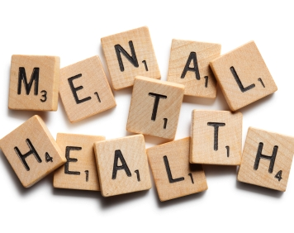

Sultana Bibi
Contents Page

Introduction Page 3

General Statistics on Mental Health Page 4

How common are Mental Health problems? Page 5-6

Assessment of young people’s well-being Page 6-7

Signs of anxiety and depression by gender Page 7

Causes of Mental Health Page 8

National well-being measures in 2015 Page 8-9

Conclusion Page 9

References Page 10

Introduction
This needs analysis will focus on mental health problems that young people suffer from in the UK. It will consist of some statistics and data that have been looked at nationally. This needs analysis will also consist of relevant information of mental health in the UK. The relevant information will consider the causes of mental health and the outcome of how many of those who suffer from the different types, how many are receiving appropriate care and how many that are not. This could be due to the fact that the mental health has not been recognised or even neglected. It will also consider potential issues and possible reasons to why people suffer from these problems. The purpose of this needs analysis is to identify gaps in order to figure out what currently exists and what should exist for young people with mental health. It is essential to consider what needs to be resolved in order to close this gap and provide these people with an opportunity at a healthier lifestyle.

Furthermore, In the UK it has been identified that the rates of young people drinking, smoking and having teenage pregnancies have decreased over the years. However, according to Bedell (2016) it is evident that mental health in young people is growing and instead of acting out on these habits, they are turning on themselves. There are many potential issues and gaps with mental health and it is important to identify and recognise the reasons and causes to why young people usually suffer from mental health. This is will provide a suitable way to help resolve occurring problems and prevent future issues.

Figure 1: General statistics on Mental health overall

(Mental Health Foundation, 2018)

This graph shows that 20% of young people might experience a mental health issue in any given year. It is also shows that 50% of mental health problems are usually established by age 14 and then an increase of 15% which results in 75% by age 24. Furthermore, it is seen that 10% of children and young people aged 5-16 have a mental health problem that is clinically diagnosable. However, 70% of those who suffer from mental health problems have not had appropriate help at a suitable age (Mental Health Foundation, 2018).

Although these are the general national statistics of those who suffer from mental health, it is important to gain a better sense of understanding on how quality of life is improving for young people within this situation in the UK. It is also vital to look at how common different types of mental health problems are as there is more than one type.

How common are Mental Health problems?
As mentioned before there are many different forms of mental health and it is essential that these types are identified in order to help an individual meet their specific needs. These are some statistics to show how common each type of mental health is within the UK in 2016:

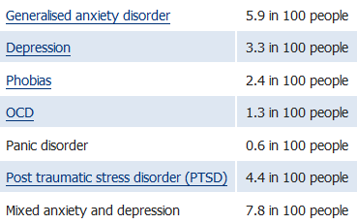
Figure 2

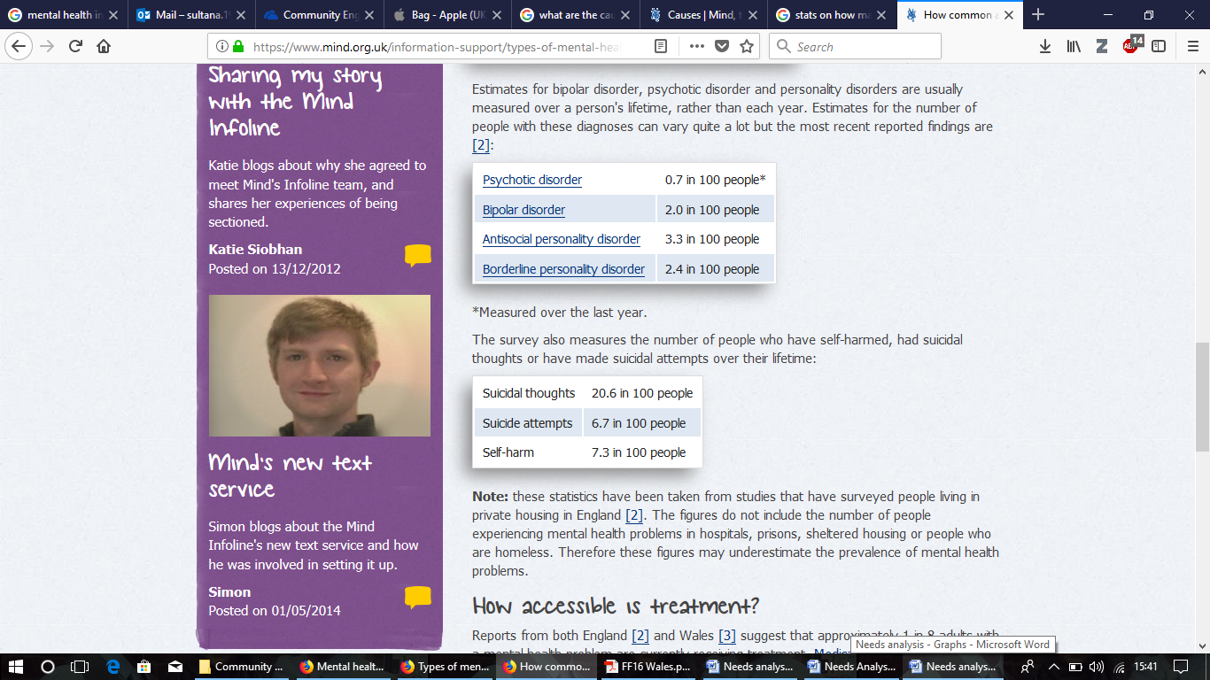

(*Measured over one year)

(Mind, 2017, p. 1)
These tables show that there are a great number of people, not just children and young people that suffer from various different mental health problems. Some of these people may be seen to suffer from more than just one of these illnesses.

Figure 3: Assessment of well-being in young people over 1 and 3 years.
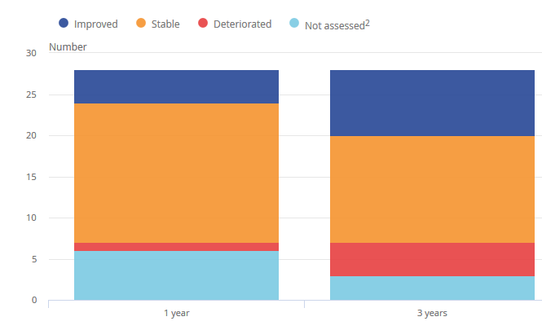
The graph below shows whether each of these indicators have improved, deteriorated or remained unchanged. This comparison has been made from what it was like over a 3 year period to what it was like over a 1 year period (Beardsmore, 2017).
(Beardsmore, 2017, p. 1)

It is evident that over a 1 year period 17 indicators remained unchanged, four improved and six indicators were not assessed. It also shows that over a 3 year period that eight indicators of young people’s quality of life improved, 13 remained unchanged, four deteriorated and instead of six only 3 indicators were not assessed.

According to Beardsmore (2017) from the Office of National Statistics, the overall image is one of improvement or stability in young people’s quality of life. With exceptions it was particularly in relation to the amount of young people in households that were at risk of poverty based young people’s well-being and mental health based on the social support that is available to them (Beardsmore, 2017).

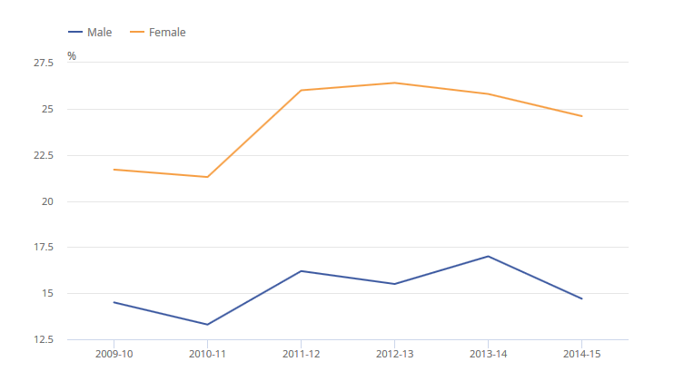
Figure 4: Percentage of young people showing signs of anxiety or depression by gender in 2009 to 2010 through 2014 to 2015

(Beardsmore, 2017, p. 1)

It is evident that according to these measures that young people’s well-being and mental health deteriorated between 2009 to 2010 and 2012 to 2013. Which was an average score 25.0 to 24.2. It was also seen that young women’s well-being results were much lower than young men’s in both years and it was noticeable that it declined more than men’s. In the years 2012 to 2013 the average score for young men was 24.6 compared with 23.8 for young women. However, it is essential to take into consideration that this may not reflect the current situation in the UK as the most recent estimates are from 2012 to 2013 (Beardsmore, 2017). However, it has also been identified that a higher percentage of females showed signs of depression or anxiety than the percentage of male.

Causes of Mental Health
It has been acknowledged that many young people suffer from mental health problems. It is important to be familiar with the different causes to why they suffer from these illnesses. These types of mental health issues can result in a wide range of causes. According to Mind (2017) it is likely that for many people there is a complicated mixture of factors although some may be more deeply affected by certain things than others.

Furthermore, Mind (2017) believes that these causes of mental can vary from going through childhood trauma, abuse or neglect to being socially isolated or feeling generally lonely. This could also result in social disadvantages such as being in debt or poverty. Some may also experience stigma and discrimination. Others may go through bereavement which results in the having a mental health illness, especially when they lose someone who is close to them. It is seen that suffering from severe of long term stress and also suffering from long term physical health condition can result in an individual feeling stuck. With a complex combination of these different cause, some may lose their jobs or being unemployed. Another potential cause could be and individual who is a carer for someone over a long period of time which may have a detrimental effect. The misuse of drug and alcohol also plays a huge role when considering mental illness (Mind, 2017).

National well-being measures of children and young people in 2015
These are some reasons and general statistics from the Office of National Statistics (2018) that measure the well-being of children and young people. These are a few gaps and issues of many that occur and possibly may be over looked.

- It was seen that 1 in 8 children aged 10-15 in 2011 to 2012 had signs of mental ill-health. The reason for this was based on those who were being bullied, which resulted in mental ill-health. Those who were frequently bullied were seen as 4 times likely to report either high or very high scores (ONS, 2018).

- It was also acknowledged that those who argued with their mother more than once a week, they were 3 times more likely to report either high or very high scores than those who argued less frequently (ONS, 2018).

- One in third children who were somewhat unhappy with their appearance reported high or very high scores, compared to 1 in 12 children who were quite happy with their appearance (ONS, 2018).

- It was evident that children who spent 3 hours or more on social websites on a school night were more than twice as likely to report higher than the children who were spending less time on social websites (ONS, 2018).

Conclusion
In conclusion, there is clear evidence which show that there are many potential issues and gaps identified and that are seen as detrimental to children and young people that suffer with mental health. This is partly due to the fact that there are many types of mental health problems which come hand in hand with the different causes. This could include things such as socialising with peers and family, unable to get a job and possibly underachieving within education. It was also evident that in the UK young people’s well being has improved. However, it was also identified tha the percentage of females where a lot higher when showing symptoms of mental ill-health than males. It is essential to make comparisons in order to create a suitable and appropriate plan of action that will provide those who suffer from mental health with a better understanding on how to live a positive lifestyle regardless of the issues that arise.

References
Beardsmore, R. (2017). Young people's well-being - Office for National Statistics. [online] Ons.gov.uk. Available at: https://www.ons.gov.uk/peoplepopulationandcommunity/wellbeing/articles/youngpeopleswellbeingandpersonalfinance/2017 [Accessed 11 Jan. 2018].

Bedell, G. (2016). Rates of depression have soared in teenagers. What are we doing wrong?. [online] The Independent. Available at: http://www.independent.co.uk/life-style/health-and-families/features/teenage-mental-health-crisis-rates-of-depression-have-soared-in-the-past-25-years-a6894676.html [Accessed 11 Jan. 2018].

Mental Health Foundation (2018). Mental health statistics: children and young people. [online] Available at: https://www.mentalhealth.org.uk/statistics/mental-health-statistics-children-and-young-people [Accessed 11 Jan. 2018].

Mind (2017). Causes | Mind, the mental health charity - help for mental health problems. [online] Mind.org.uk. Available at: https://www.mind.org.uk/information-support/types-of-mental-health-problems/mental-health-problems-introduction/causes/ [Accessed 11 Jan. 2018].

Mind (2017). How common are mental health problems? | Mind, the mental health charity - help for mental health problems. [online] Mind.org.uk. Available at: https://www.mind.org.uk/information-support/types-of-mental-health-problems/statistics-and-facts-about-mental-health/how-common-are-mental-health-problems/ [Accessed 11 Jan. 2018].

ONS (2018). Measuring National Well-being - Office for National Statistics. [online] Ons.gov.uk. Available at: https://www.ons.gov.uk/peoplepopulationandcommunity/wellbeing/articles/measuringnationalwellbeing/2015-10-20 [Accessed 11 Jan. 2018].

