University of wales trinity saint david
Developing Professional Practice
M2X8986
BOWEN N.
11/16/2017

Contents
1.0 Activity 1 – Being a HR Professional 2
2.0 Activity 2 – Group Dynamics 4
3.0 Activity 3 – Project Management 7
4.0 Activity 4 – Professional Development Plan 8
5.0 Appendices 11
6.0 References and Bibliography 18

1.0 Activity 1 – Being a HR Professional

  - What is a HR Professional?
One of the key attributes of a profession according to Farndale and Brewster (2005) is ‘the ownership of standards that not only go beyond, but actually override, those of the organisation.’ Historically, HR’s purpose was a series of basic tasks such as job adverts, absence and training records, appraisals, and drawing up policy statements. Nowadays the focus is far more comprehensive (Taylor, 2016).
This broadening or ‘professionalisation’ of HR has been a gradual one which Banning (1999) proposes is something that the industry is still adjusting to; ‘professional techniques usually develop gradually before professions attain the highest levels of professional status’. This comment suggests that HR Professionals are involved in Continual Professional Development (CPD) as the industry grows as a whole. HR Professionals are in the ‘position of having superior knowledge’ accordingly to Khurana et al (2004) who have ‘a responsibility not to use that knowledge to gain unfair advantage’.
Being a HR professional therefore comes with great responsibility, something which is faced on a daily basis with difficult situations such as redundancy and cost management decisions. These situations ‘raise competing moral choices’, where HR professionals must ‘simultaneously balance organisational, professional and personal ethics’ Wooten (2001).
The CIPD is in the process of building a new professional standards framework due to be launched in 2018. One of the members on the advisory group Sharron Pamplin wrote in Woolnough’s (2017) article that the focus of HR will change and will require individuals to acquire ‘different behaviours and values’. She continues to confirm the change of the HR profession (individuals and organisations) commenting that ‘it requires behaviours such as ‘How do you act as a professional?’ HR needs to take a more holistic view of organisations, rather than just having a people-focused approach”.
By embarking upon a regular CPD program, HR Professionals are actively improving themselves and their organisation. Taylor (2016) suggests an alternative way to describe the function of modern day HR is they add value, not only to individuals/teams, but to the organisation as a whole. They continue to identify factors that can add value such as performing continuous improvement activities.

  - CIPD Profession Map
Albert Einstein once said “Education is not the learning of facts, but the training of the mind to think”. HR professionals are frequently put in this position with Taylor (2016) seemingly solidifying this by referring to them as ‘thinking performers’ and state they are ‘consciously contributing to an organisations objectives and bringing about change by diplomatically challenging others’.
CPD (2017) stress that learning should be progressed in a ‘structured, practical and relevant way to guarantee that there are applied efficiencies in learning’. They offer more insight by adding that an individual’s CPD should be tailored towards them allowing them to ‘focus on what specific skills and knowledge they require’.
The CIPD Profession Map is a tool from which CPD can be based upon. It identifies different areas of effective people management across ten professional specialisms. Within this it describes eight fundamental behaviours that underline good practice across all the specialisms.
Figure 1 CIPD Professional Map (CIPD 2015)
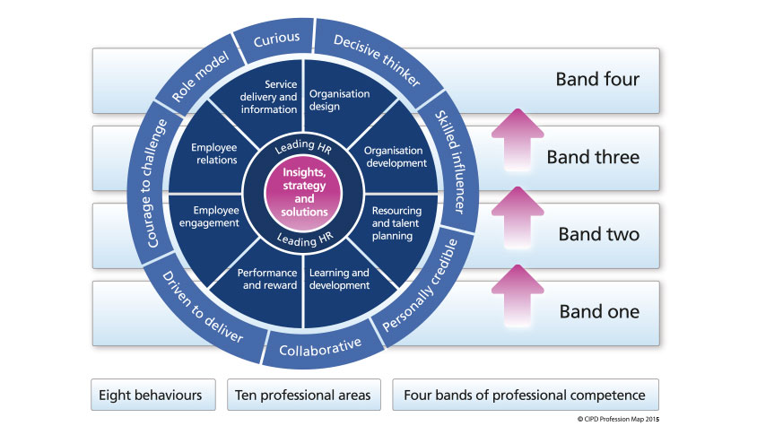
The map contains 4 Bands of professional competence which identifies the contributions that HR professionals make during the different stages of their career. This section of the map also includes guidelines for users to progress into higher bands. There is an obvious link between progression into higher bands and an individual’s CPD.
The Profession Map and CPD link is summarised by HR Manager Domenic Ceraldi on the CIPD website as he believes ‘major part of my CPD is the CIPD Profession Map’. He continues stating that it ‘provides me with the knowledge, skills, and tools to deliver a sustained business success within the organisation’ (CIPD, 2017)

  - Profession Map Self-Assessment
To identify my own strengths and areas to improve, I completed a self-assessment. The three professional areas concentrated on were insights, strategy and solutions, leading HR (both core areas), and employee engagement. Alongside the two main core areas the reason for choosing Employee engagement is due to my current role involving line management of numerous staff with the introduction of new organisational goals.
Figure 2 Screenshot taken from CIPD Profession Map indicating the 3 professional areas and behaviours chosen (CIPD 2017)
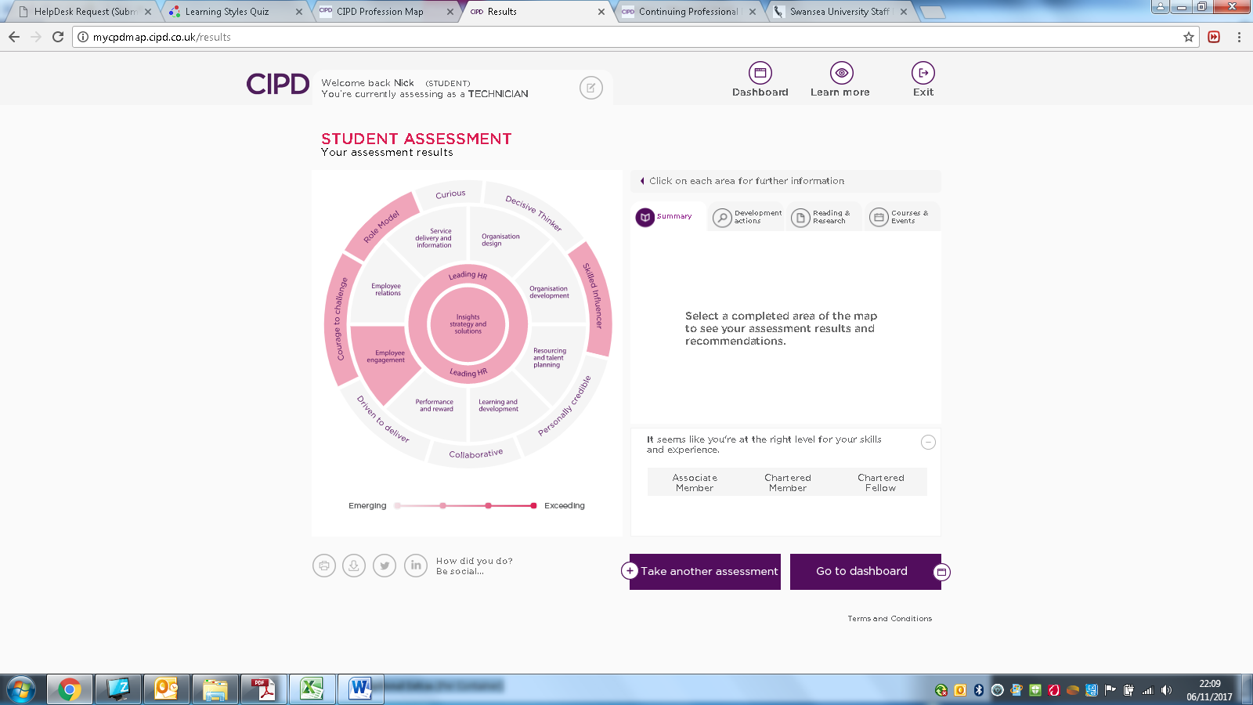
Upon completion of my self-assessment my competencies and knowledge gaps from the three professional areas were identified, this is seen in Appendix A. This information will provide the foundation for my Professional Development Plan (PDP) which can be found in Appendix D.

2.0 Activity 2 – Group Dynamics

  - 2.1 Group dynamics
Within almost all organisations, individuals are required to work in collaboration with one another. This is especially true of HR professionals as they can be ‘members of different teams at the same time’ (Taylor, 2016). Not all groups are successful with Kahn (2010) highlighting that ‘many intervening factors can help or hinder group performance and dynamics under particular prevailing circumstances’.
Levi (2017) stresses the importance of knowing what a group is prior to it being formed as they are ‘more than just collections of people’. He continues to explain that they ‘have goals, interdependent relationships, interactions, structured relations, and mutual influence ‘.
Taylor (2016) identified factors that can affect the dynamics of a group:
- The nature of the individuals in the group
- Leadership
- The structure of the group or team
- Power and status issues
- Communication structures or processes
In 1965, Dr. Bruce Tuckman introduced his model of team development (figure 3) which clearly shows the five different stages involved in the process (forming, storming, norming, performing, adjourning).
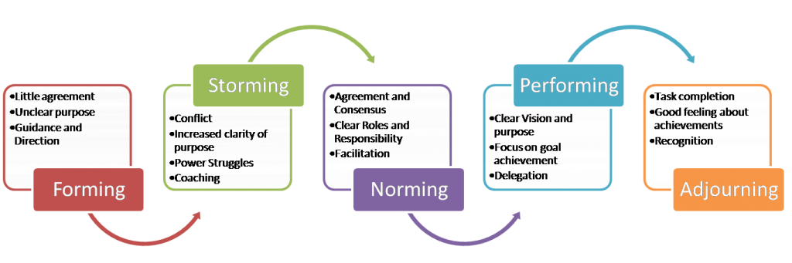
Figure 3 Tuckmans Team Development Model (taken from http://margarethillary.com/team-work/)
Tuckmans model is useful for those who have to lead teams as it not only illustrates the different stages of group formation, but the behaviours associated with it. It is inevitable that a group may disagree on occasions which could cause conflict; therefore the way it is managed is of paramount importance.
  - 2.2 Conflict Resolution
Forsyth (2014) suggests that conflict can arise when ‘individuals have competing agendas or requirements’ but it could also arise due to a difference in personalities, expectations or results (Ohlendorf, 2001).
The main purpose of conflict resolution is to ‘determine when it is appropriate to resolve conflict and how the conflict will be resolved’ (Dunlop et al, 2003). In a Forbes article, Mike Myatt embraces the inevitability that conflict will arise from those in a leadership position with his ethos of ‘don’t fear conflict; embrace it - it's your job’ (Forbes, 2012). With this in mind, Dunlop et al conclude that one of the goals of conflict resolution is to ‘decide how to resolve the actual or potential conflict in an appropriate manner’.

  - 2.2.1 Influencing and Persuading Skills
In order to be successful at influencing and ultimately persuading others, Yemm (2008) stresses the importance of effective communication stating ‘HR professionals must spend time thinking about their broad message and how they wish to convey it’. This message is also confirmed by Doyle (2017) who adds ‘Much unnecessary conflict can be avoided simply with clear, accurate written and verbal communication’.
Along with communication, there are a numerous other personal skills required to be effective in resolving group conflict like active listening. Doyle affirms the impact of being a good listener can often ‘inspire trust and resolve hurt feelings’ (Doyle, 2017).
Influencing others is something which Taylor (2016) states HR professionals must do ‘in order to bring about some sort of change’. They view the process of influencing others as an ‘emotional process balancing your own feelings and those of others.
Successful persuasion requires ‘good emotional intelligence’ according to Mortensen (2008) and those who have ‘high emotional intelligence are good at identifying and meeting the needs of others, while taking responsibility for their own needs and feelings’ (Doyle, 2017). Emotional intelligence requires reading the situation and involves demonstrating empathy where appropriate. In Doyle’s opinion displaying empathy ‘is critical to effective conflict management’.
Being effective in influencing and persuading is the ability to draw upon all these different skills at the right moment. Mortensen summarises this when he stated the skills required include ‘keeping promises, being reliable and taking responsibility, being sincere, genuine, and honest, knowing the subject, and building rapport’.
  - 2.3 Conflict Resolution in a HR Context
I have previously used both influencing and negotiating skills when dealing with an issue between two members of my staff. Both employees made informal complaints about one another and as their line manager it was my responsibility to investigate this further. Employee (1) complained that employee (2) never worked as part of the team and did their own thing, whilst employee (2) complained that employee (1) never engaged when they were working on shift together.
I arranged a meeting with both employees separately to ascertain what the problem was. Here I utilised ‘active listening’ to appreciate what the real issues were along with empathy towards each situation. This not only illustrated to both members of staff how serious this matter was being taken, but also allowed a rapport to be built.
The next stage involved persuading both parties to engage with mediation. Despite being apprehensive at first, both employees agreed as a result of how serious they felt this issue was being taken and the trust that had been built. During the meeting both parties discussed their issues and at times emotions ran high. By focusing on agreed goals and targets for the team, I influenced the outcome as both members of staff recognised their actions were affecting more than just themselves. After the meeting I continued to monitor the situation periodically to ensure relations remained amicable.

3.0 Activity 3 – Project Management

  - 3.1 Project Management
‘Project management is the application of processes, methods, knowledge, skills and experience to achieve the project objectives’ (APM, 2017). Hueman et al (2004) reported the trend towards a more project management orientated climate in their paper that stated ‘a change towards a project-oriented society is observable, with projects becoming more widely used (Lundin and Söderholm, 1998).
There are varying ways of structuring a project however Taylor (2016) and the Project Management Institute (2017) both agree that the project management process falls into five groups:
- Initiating
- Planning
- Executing
- Monitoring and Controlling
- Closing

Having an awareness of project management is critical for HR professionals, especially when working on numerous projects all at once; for example learning and development policies, mass recruitment drives etc. Taylor (2016) confirms this importance stating ‘Alongside time management, HR professionals must also possess the ability to manage specific projects’. Software tools such as Gantt charts, Asana, and PRINCE 2, provide a vital link between time and project management. Another key ingredient to a successful project is the implementation of a clear strategy from those in leadership and management positions.
The first task I was involved with as Operations Manager at Swansea University was being part of a large project. The project was the recruitment of all Campus Service staff at the newly built Bay campus. The project format followed that from Taylor (2016) where relevant personnel initially discussed and determined the broad idea and as a consequence, agreed aims and objectives were established. The second stage then involved the planning and designing of the different tasks with timescales and subsequently individuals assigned to them. The execution of these tasks promptly followed ranging from local advertising of ‘information days’ organised for the public, organising meetings with the local community to discuss potential issues, devising and arranging the interview process, to finally the selection and training process of successful candidates.
As with a project of this size there was constant monitoring to establish whether the key milestones were going according to plan, with those in leadership and management positions making adjustments where necessary.
An example of the planning involved with the assessment days can be found in Appendix B.
  - 3.2 Problem solving techniques
During the entire project at Bay there were numerous examples of influencing, persuading and negotiating. Senior Management explained during the initial discussions regarding the interview process that a new method would be adopted involving observing behaviours within a group environment. There were some objections to the new approach; however this was handled by establishing some common goals. Despite a lot of anxiety and apprehension, staff with previous experience came in and explained the procedure and its benefits. This approach was successful in persuading all those involved as it helped to build alliances and trust amongst all those involved in the interview process through a combination of the friendly delivery and the expertise and knowledge demonstrated.
Another issue which arose during project of recruitment was that of line manager and HR responsibilities. The new staffing structure involved two University departments working in conjunction, Campus Services, and Catering. Although the staff would be under Campus Services, many of their duties would be Catering and therefore needed that department’s expertise. Campus Services wanted the Catering department to take daily management responsibility but maintain overall line management responsibility, whereas Catering wanted to take all of the responsibility.
A meeting with the relevant personnel was called and a subsequent SWOT analysis took place. Here the strengths, weaknesses, opportunities and threats were discussed of the current situation and proposed plans going forwards. After the process a common understanding was established after negotiations which produced an agreement. The agreement was that I would continue overall line management responsibility for the staff which included all HR duties; however the daily management would be that of the assistant managers from catering. The negotiations concluded that I would now include the assistant managers into the annual PDR, thus a providing a ‘win-win’ scenario for both departments. An overview sheet of the newly structured PDR is in Appendix B.

4.0 Activity 4 – Professional Development Plan

4.1 Learning Styles
Before devising my own Personal Development Plan (PDP) it is important to understand and appreciate how an individual learns. There are many different learning style models available with Coffield, Moseley, Hall, and Ecclestone (2004) identifying 71 models. Kayes (2005) has described Kolb’s learning style model as ‘the most influential’ and in it he identifies four distinct learning styles with individuals favouring a particular one.
The choice in learning style is based on the individual’s inner cognitive make up, social influence, and educational background. Their learning preference is the product of two conflicting variables: The Processing Continuum which is a choice in the way of approaching and tackling a task and the Perception Continuum which is an emotional response to the task, including thoughts and feelings (University of Leicester, 2017).
Honey and Mumford (1982) devised a learning style questionnaire which helps to identify an individual’s learning style. My own results are shown below:
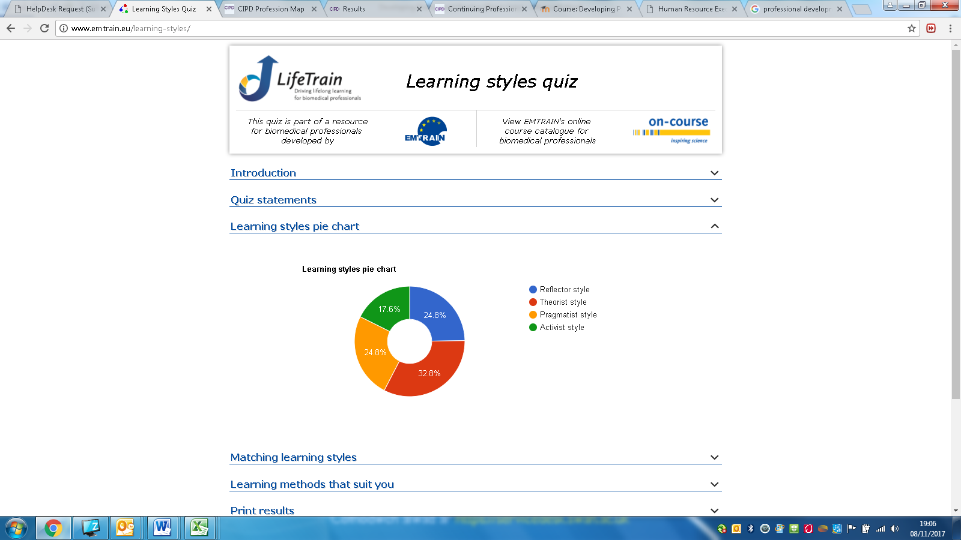
Figure 4 – My results of Honey & Mumford learning style questionnaire (Emtrain.eu. 2017).
‘Theorists’ like to understand the theory behind the actions in order to engage in the learning process. They favour models, concepts and facts in order to analyse and synthesise information into a systematic and logical way (University of Leicester 2017). Having an understanding of this will enable for more accurate and realistic targets to be set during my PDP.

  - 4.3 Reflective Practice
Within a HR context, the CIPD (2017) define reflective practice as a process which ‘involves deconstructing experience in order to externalise our thoughts, be honest with our feelings, analyse our patterns of behaviour, become aware of our values, question our assumptions and challenge our perceptions’.
In Ashmore and Robinson’s book, Dewey (1933) identifies that reflective practice refers to ‘the active, persistent and careful consideration of any belief or supposed form of knowledge in the light of the grounds that support it’. Dewey also identified in his paper 3 characteristics which individuals require when engaging in reflective practice: being open-minded, responsible and wholehearted in order to be able to think something through and to effectively action change
Conversely, Schon (1983) presents a slightly different view to Dewey. He regards reflection as having two aspects: reflection-in-action and reflection-on-action.

Figure 5 – Gibbs Reflective Cycle Model 1988 Image taken from Businessballs.com (2017).
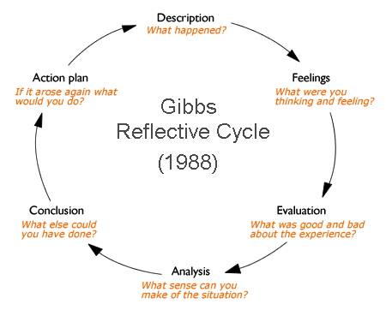

  - 4.4 Professional Development Plan (PDP)
Completion of the profession map helped provide the foundation for my PDP. The map identified the general areas for improvement; however this must be in conjunction with my own experiences and views on ultimately what areas I would like to improve. With this in mind the areas of improvement I have chosen are based on:
- My current role
- Future roles I hope apply for; and
- My own feelings regarding my areas of improvement
I have an interest in employment law not only on a personal level, but also for my role at the university, therefore this was an easy choice. The next two choices evolve around improving and refining personal skills and behaviours in order to be able to influence senior management and improve employee relations. CIPD (2017) state those who engaged in CPD were better equipped to ‘challenge and influence stakeholders and gave them the confidence and credibility to do so’.
Due to my role involving line management of numerous staff, improvements in performance management techniques will again ultimately improve employee relations. Understanding my learning style has helped to identify my methods of how to achieve my goals. I envisage my best results coming from situations where I can utilise stories, quotes and background information therefore courses and e-learning are used frequently. I also intend to use reflective practice going forwards as it improves critical thinking, deepens self-awareness and improves communication skills (CIPD, 2017).

5.0 Appendices

  - Appendix A
Self-Assessment taken from CIPD Profession Map
Professional Areas & Behaviours | Competent Areas | Knowledge Gaps
Insight, Strategy and Solutions | - Providing reports on relevant project and / or organisation information  - Supporting the administration and delivery of HR programmes and projects  - The organisation’s performance (including basic financial performance) | - Relevant law for own role (or where to access legal information if required)  - Principles and basic practice of project management  - HR practice to spot potential trends and risks for the organisation
Leading HR | - Providing advice using sound knowledge of HR policy and practice  - Seeking out and acting on feedback and development opportunities to develop own HR expertise and capability  - Ensuring own objectives are in line with the team’s and function’s objectives | - Providing accurate financial data to support HR budgeting and financial planning  - Accurately recording HR measures (such as service level agreements, financial data, Key Performance Indicators etc)  - Different working styles and preferences
Employee Engagement | - The main factors which influence people’s behaviour at work  - Assisting in designing and conducting surveys and other employee research  - Encouraging employees to get involved in resolving engagement issue | - Collating data regarding employee engagement from a variety of sources (such as employee surveys, benchmarking data, focus groups etc)  - Analysing employee engagement data using a variety of techniques  - Administering the roll out of regular employee engagement initiatives

  - Appendix B
Planning Swansea University Assessments Days
The key to running successful Assessment days is to be organised to ensure the day runs smoothly and efficiently. Being prepared shows that:
We are Professional – we are a professional organisation
We Care – we respect our colleagues and individuals
We Work Together – we work together to achieve high standards – we choose the best colleagues
The above helps us retain candidates who may apply to other vacancies across the university and maintain our brand image.

- How long will an Assessment take?
The Assessment day process takes one day but may go into two days depending upon number of applicants and vacancies.
The full process must be followed and it is important that timings are adhered to and that all paperwork is collated throughout the session(s) as evidence that the process has been clear and transparent. This ensures that we can defend any cases which may end up in a tribunal.
- The Assessors
Choosing your assessors is vital to the universities success. Make sure you have the right people (this includes the facilitator, observers and interviewers) in the recruitment panel. The team should consist of:
- A balance of manager and colleagues
- Managers who are actively recruiting for the vacancy to be filled
- Have completed Marshall Training and Recruitment and Selection Training.
- That the team reflects our diverse range of staff.
- Ensure that the team is rotated between facilitating and observing.

- Running the Assessment days
The assessment(s) have been designed to run in one session (one day). This includes group exercises and interviews where appropriate. The reasons for this are as follows:
- This creates a much better candidate experience. Candidates only have to attend once instead of numerous times.
- More costs effective to the University.
Tips:
- Invite a maximum of 10 to 12 candidates per group. (This means you can split the candidates into manageable groups, and to ensure consistency in assessment, the groups can be swapped around.
- 3 to 4 trained assessors per group
- You will need to ensure the room(s) are adequate is size/space to accommodate this number of people, and also to ensure that these are easily accessible for anyone with a disability.

- Day of the Event
Our colleagues make us stand out as the employer of choice. They add the critical Values that the university beholds and why we have such a strong brand and people want to work for us.
This is why the colleagues we recruit are so important – they are the future of the University. This means we show our candidates the same respect as we would a customer/student/colleague.

- Pre Event Checklist.

- Provide reception with a list of candidate names and the time they are expected to arrive. If there is no reception facility make arrangements for a colleague to be available at the entrance to greet candidates.
- Have a name badge ready for the candidate.
- Make sure you have someone to ‘open’ the assessment day by providing a presentation.
- Prepare you paperwork – observations sheets, pens/paper, name badges, checklists interview forms and candidate summary sheets.
- Make sure you have made reasonable adjustments for candidates with a disability where applicable.
- Ensure that observers/assessors arrive at least 15 minutes before the start.
- Prepare the room – literature about the university /showcasing the university.
- Set up the recruitment room – in a horse shoe shape.
- Choose your icebreaker group exercise – have your material ready.
- Decide who is observing each candidate at each stage of the process.
- Equipment checklist – do you have everything?

- Equipment checklist
- Materials for group exercises
- Paper
- Pencils/pens
- Observer matrix and forms
- Timer

- What does the university assessments include?
- Icebreakers
- 2.Group exercise
- 3.Interview

8. Overcoming personal bias
- 1.Be aware of your own personal bias
- Keep an open mind
- Pay attention to the candidate
- Listen objectively what the candidate is saying
- Always use notes to help maintain objectivity.

- Tips for observing an exercise
- Pay attention
- Don’t let your mind wander
- Keep focussed on what is happening during the exercise
- Suspend your judgement
- Candidates are often nervous and may take time to warm up
- Do not write candidates off after the first few minutes
- Focus on their behaviour throughout the exercise.
Tips for recording behaviour
- Know who your candidates are before the exercise starts
- Record continuously: Write accurate notes throughout the exercise
- Record both verbal and non-verbal behaviours e.g. a candidate might show signs of annoyance, raising eyes towards the ceiling.
- To be able to observe you need to be able to see and hear your candidate so make sure you position yourself in a good position.
- Don’t put the candidate off – sit away from them but in direct line of sight.

Classifying Behaviours
- This happens once the exercise had finished
Are there examples of positive or negative evidence of successful performance?
Classify these positive and negative behaviours into the attitude/behaviours for the role
- When we recruit colleagues we want to make sure they have the right values, attitude and behaviours to perform well in the role. To do this we observe all candidates against a consistent set of criteria.
- The criteria we use relates to our Values. This is vital as it provides a consistent approach for the observer. By basing our recruitment process on our Values we can identify candidates who share and demonstrate those Values and who will perform well in their role.
  - Appendix C

Campus Service Staff Management Responsibilities
First names | First Aid | Food Safety | Personal Licence | Anti- Bribery Training | Money Laundering | Data Protection | Catering Assistant Manager | Line Manager for PDR
Claire Denise |  |  |  | YES | YES | YES | Stuart Hemmings | Nick Bowen
Scott Christian |  | YES |  | YES | YES | YES | Chris Greenaway | Nick Bowen
Jodie Marie | YES | YES |  |  |  |  | Gareth Jones | Nick Bowen
Tania |  | YES | YES | YES | YES | YES | Gareth Jones | Nick Bowen
Andrea Catherine |  | YES |  | YES | YES | YES | Stuart Hemmings | Nick Bowen
Scott James |  |  |  |  |  |  | Stuart Hemmings | Nick Bowen
Gareth |  |  |  | YES | YES | YES | Gareth Jones | Nick Bowen
Claire Louise |  |  | YES | YES | YES | YES | Chris Greenaway | Nick Bowen
Rosina |  | YES |  | YES | YES | YES | Victoria Evans | Nick Bowen
Samantha Harriet |  | YES |  | YES | YES | YES | Chris Greenaway | Nick Bowen
Carol |  | YES |  | YES | YES | YES | Chris Greenaway | Nick Bowen
Yvonne Ann |  |  | YES | YES | YES | YES | Victoria Evans | Nick Bowen
Andrea | YES | YES |  | YES | YES | YES | Gareth Lewis | Nick Bowen
Melanie Janine |  |  |  | YES | YES | YES | Stuart Hemmings | Nick Bowen
Adam Gordan | YES | YES |  | YES | YES | YES | Stuart Hemmings | Nick Bowen

  - Appendix D
My Professional Development Plan
What do I want/need to learn? | What will I do to achieve this? | What resources or support will I need? | What will my success criteria be? | Target dates for review and completion
Relevant law for own role (or where to access legal information if required) | Attend relevant CIPD courses  Advice for colleagues  Advice from HR Dept  Self-learning  E-Learning (ACAS etc) | Support from CIPD lecture  Time and support to attend relevant courses run by CIPD etc  Internet access | Increased knowledge and confidence when providing advice to issues / queries.  Completion of Level 5 CIPD course | Attend relevant courses (November 14th for example)  Review on quarterly basis.  Course completion in May
Build and refine a range of interpersonal skills including communication, listening, relationship management, and influencing | Courses  Shadow relevant people  Colleague advice  Peer reviews  Reflection | Time and support to attend relevant courses run by CIPD etc  Colleague support and engagement  Institutional support | 360 feedback  Self-Reflection  Completion of Level 5 CIPD course | PDR Review (November 2018)  April 2018  Course completion in May
Improve courage to challenge senior management | Attend CIPD courses relevant to my role and subject matter  Seek out relevant information using appropriate resources (e-learning, internal resources etc)  Seek advice from those in positions of leadership | Time and support to attend relevant courses run by CIPD etc  Institutional support and internet access  Mentorship via institution | Increased knowledge in relevant areas  Self-Reflection  Completion of Level 5 CIPD course | Numerous courses booked onto in November 2017 , April and May 2018  April 2018  Course completion in May
Performance management techniques aligned with annual reviews | Attend relevant CIPD courses  Advice for colleagues  Advice from HR Dept  Self-learning  E-Learning (ACAS etc) | Support from CIPD lecture  Time and support to attend relevant courses run by CIPD etc  Institutional support  Internet access | Increased knowledge and confidence when providing advice to issues / queries.  360 feedback  Completion of Level 5 CIPD course | Numerous courses booked onto in November 2017 , April and May 2018  PDR Review (November 2018)  Course completion in May
Complete CIPD Level 5Intermediate Certificate in Human Resource Management course | Attend lessons every Tuesday  Complete assignments  Use CIPD website for information  Networking with fellow students. | Time to attend  Cost (payment from work)  Support from work  Support from CIPD lecturer and fellow students  Use of resources (internet, books etc) to research information | Completing of course  Increase knowledge and skills to take back to my role in work | July 2018

6.0 References and Bibliography

APM. (2017). What is project management? | APM. [online] Available at: https://www.apm.org.uk/resources/what-is-project-management/ [Accessed 14 Nov. 2017].
Ashmore, L. and Robinson, D. (n.d.). Learning, teaching & development.
BANNING, S.A. (1999) The professionalization of journalism: a nineteenth-century beginning. Journalism History. Vol 24, No 4. p157.
Businessballs.com. (2017). Reflective practice. [online] Available at: https://www.businessballs.com/self-awareness/reflective-practice-1824/ [Accessed 14 Nov. 2017].
CIPD. (2017). Beyond training hours: reflections on CPD | In a Nutshell article | CIPD. [online] Available at: https://www.cipd.co.uk/news-views/nutshell/issue-71/reflections-cpd [Accessed 14 Nov. 2017].
CIPD. (2017). CPD Cycle Stages | CIPD. [online] Available at: https://www.cipd.co.uk/learn/cpd/cycle [Accessed 14 Nov. 2017].
CIPD. (2017). Using the Profession Map | CIPD. [online] Available at: https://www.cipd.co.uk/learn/career/profession-map/user-guide [Accessed 14 Nov. 2017].
CPD (2017). The Importance of Continuing Professional Development (CPD). [online] Available at: https://cpduk.co.uk/news-articles/view/importance-of-cpd [Accessed 14 Nov. 2017].
D.C. Kayes (2005) Internal validity and reliability of Kolb's learning style inventory version 3 (1999) Journal of Business and Psychology, 20 (2) (2005), pp. 249-257
Doyle (2017). Conflict Management Skills List and Examples. [online] Available at: https://www.thebalance.com/conflict-management-skills-2059687 [Accessed 14 Nov. 2017].
Dunlop, N., Indulska, J. and Raymond, K. (2003). Methods for Conflict Resolution in Policy-Based Management Systems.
Emtrain.eu. (2017). Learning Styles Quiz. [online] Available at: http://www.emtrain.eu/learning-styles/ [Accessed 14 Nov. 2017].
F. Coffield, D. Moseley, E. Hall, K. Ecclestone (2004) Learning styles and pedagogy in post-16 learning: A systematic and critical review Learning and Skills Research Centre, London
FARNDALE, E. and BREWSTER, C. (2005) In search of legitimacy: personnel management associations worldwide. Human Resource Management Journal. Vol 15, No 3. pp33–48.
Forbes(2017). Forbes Welcome. [online] Available at: https://www.forbes.com/sites/mikemyatt/2012/02/22/5-keys-to-dealing-with-workplace-conflict/#3f68f9031e95 [Accessed 14 Nov. 2017].
Forsyth, D. (2014). Group dynamics. Belmont, Calif.: Wadsworth Cengage Learning.
Huemann, M., Turner, J. R., & Keegan, A. E. (2004). The role of human resource management in project-oriented organizations. Paper presented at PMI® Research Conference: Innovations, London, England. Newtown Square, PA: Project Management Institute.
HURD, H.G. (1967) Who is a professional? Journal of Cooperative Extension. pp77–84.
Khan, Tariq M; Clear, Fintan; Al-Kaabi, Ahmed; Pezeshki, Vahid. Team Performance Management; Bradford Vol. 16, Iss. 5/6, (2010): 289-308.
KHURANA, R., NOHRIA, N. and PENRICE, D. (2004) Management as a profession. Working papers. Cambridge, MA: Center for Public Leadership, pp4–14
LACHMAN, V.D., MURRAY, J.S., ISEMINGER, K. and GANSKE, K.M. (2012) Doing the right thing: pathways to moral courage. American Nurse Today. Vol 7, No 5. pp24–9.
Levi, D. (2017). Group dynamics for teams. Los Angeles [etc.]: Sage.
Lundin, R.A. and Söderholm,.A., 1998, “Conceptualizing a projectified society – discussion of an eco-institutional approach to a theory on temporary organizations”, in Lundin, R.A. and Midler, C. (eds.), Projects as arenas for renewal and learning processes, Boston: Kluwer Academic Publisher.
Mortensen, K. (2008). Persuasion IQ. New York: AMACOM/American Management Association.
Ohlendorf, A. (2017). Conflict Resolution in Project Management. [online] Available at: https://www.umsl.edu/~sauterv/analysis/488_f01_papers/Ohlendorf.htm [Accessed 14 Nov. 2017].
Schön, D. (1983). The Reflective Practitioner: How professionals think in action. London: Temple Smith
Stephen Taylor. (2016). Studying human resource management. [S.l.]: Chartered Inst Of Person, pp.68-87.
University of Leicester. (2017). Honey and Mumford — University of Leicester. [online] Available at: https://www2.le.ac.uk/departments/gradschool/training/eresources/teaching/theories/honey-mumford [Accessed 14 Nov. 2017].
Woolnough, R. (2017). What does the CIPD's new professional standards framework mean for HR? - Personnel Today. [online] Personnel Today. Available at: https://www.personneltoday.com/hr/what-does-the-cipds-new-professional-standards-framework-mean-for-hr/ [Accessed 14 Nov. 2017].
WOOTEN, K.C. (2001) Ethical dilemmas in HRM: an application of a multidimensional framework, a unifying taxonomy, and applicable codes. Human Resource Management Review. Vol 11, No 1–2. pp159–75.
Yemm, G. (2008). "Influencing others - a key skill for all". Management Services. Vol. 52, Iss. 2, pg. 21-24.

