Skills for the Workplace
Module Assignment Submission
Student Name: | Rebecca jenkins
Student Number: | 22112538
Module No: | BMSK5011
Module Title: | Critical Thinking

Statement of Confirmation of Authenticity
By the act of making this submission, the student declares that this is the work of the student named above. The work has not, in whole or in part, been knowingly presented elsewhere for assessment, or where assessment has been built on a previous assessment, this has been identified. Where materials have been used from other sources it has been properly acknowledged. If this statement is untrue, the student acknowledges that an assessment offence has been committed.
Attention is drawn to the plagiarism and unfair practice policies of UWTSD.

Contents
Introduction………………………………………………………………………………………………………………..1
The difference between values, beliefs and attitudes…………………………………………………2
Values
Beliefs
Attitudes
Management theories………………………………………………………………………………………………..3
Critical thinking…………………………………………………………………………………………………………..4
Influence of your actions in the workplace depends on management style………………..5
My own values, beliefs, attitude and behaviours ……………………………………………………….6
Conclusion
References

Introduction
Values, attitudes, and perspectives change over time as a result of influences from friends, family, society, and personal experiences. As a result, I sought to assess management and scientific theories throughout this assignment in both my professional and personal lives by recognising distinct approaches and methodologies, identifying the numerous management theorists of classical, behavioural, and current management theories, and analysing beliefs, attitudes, and values.

The difference between values, beliefs and attitudes
Our underlying basic values and beliefs give rise to our attitudes. Beliefs are presumptions and convictions we hold to be true based on prior experiences. Values are admirable notions based on things, ideas, and individuals. In order to express these internalised systems (attitudes, beliefs, and values), behaviours are used. For someone to be motivated and interested in an activity, they need to have a positive attitude. Our underlying basic values and beliefs give rise to our attitudes.
Although beliefs are based on genuine experiences, we occasionally forget that previous experiences are distinct from the current circumstances of our lives. Because what we think affects how we feel, the quality of our work and all our relationships are influenced by the values and beliefs we hold as human beings. Even though our ideas shape our experiences, we have a tendency to think that they are based in reality. The beliefs we have affect who we are. They could be ethical, cultural, or spiritual. Beliefs are important since they reflect our identity and way of life. Logical beliefs and irrational beliefs are the two main kinds of beliefs.

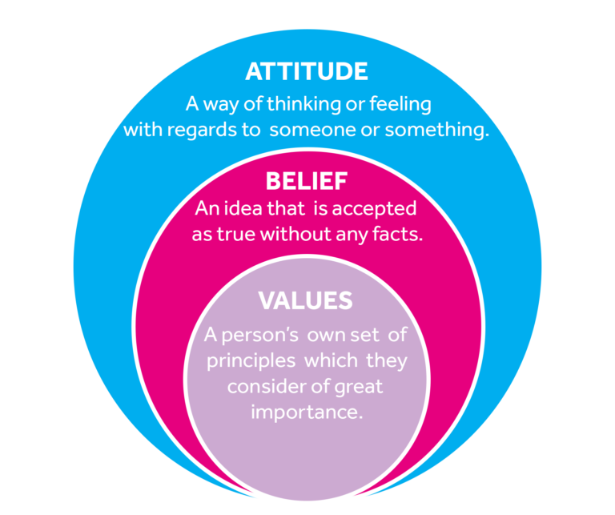
(Values, beliefs and attitudes 2022)
Learning concepts like beliefs, values, attitudes, and behaviour can be challenging. But once I discovered this diagram, the ideas were far less abstract and much easier to comprehend and shape into a narrative.
(
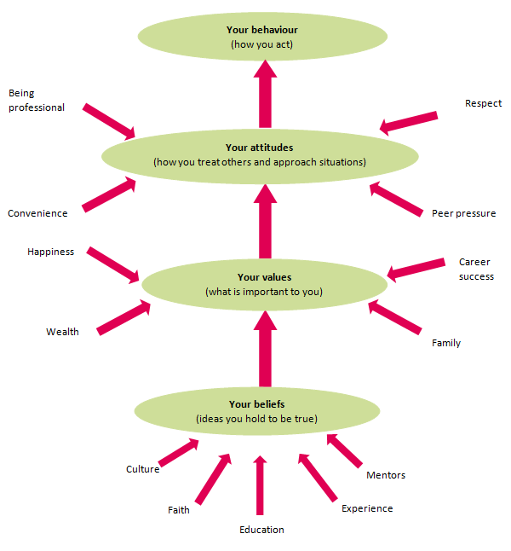

What is an attitude?
Attitudes are the mental dispositions people have towards others and the current circumstances before making decisions that result in behaviour. People primarily form their attitudes from underlying values and beliefs.

What is a personal value?
Values are stable long-lasting beliefs about what is important to a person. They become standards by which people order their lives and make their choices.
A belief will develop into a value when the person’s commitment to it grows and they see it as being important.
It is possible to categorise beliefs into different types of values – examples include values that relate to happiness, wealth, career success or family.

What is a belief?
A belief is an idea that a person holds as being true.
A person can base a belief upon certainties (e.g. mathematical principles), probabilities or matters of faith.
A belief can come from different sources, including:
- a person’s own experiences or experiments
- the acceptance of cultural and societal norms (e.g. religion)
- what other people say (e.g.education or mentoring).
A potential belief sits with the person until they accept it as truth, and adopt it as part of their individual belief system.
Each person evaluates and seeks sound reasons or evidence for these potential beliefs in their own way.
Once a person accepts a belief as a truth they are willing to defend, it can be said to form part of their belief system.
A person must be able to articulate their values in order to make clear, rational, responsible and consistent decisions.
(Classroom, Teaching...beliefs, values, attitudes, behaviour 2022)
In terms of traits like honesty, integrity, openness, etc., values are about how we have come to think about how things should be or how people should behave.
However, factors which may not have been internalised as beliefs and values can still influence a person’s attitudes at the point of decision-making. Typical influences include the desire to please, political correctness, convenience, peer pressure, and psychological stressors.

If you have different beliefs from someone else at work, you might treat them differently, which will create tension in the workplace.
In my place of employment, a popular sandwich restaurant, we are required to respect any customers who we serve and value their opinions and beliefs when speaking with them because, as humans, we tend to prioritise our own values and beliefs above those of others.
Although having an attitude at work may seem reasonable, it can sometimes be perceived negatively. Other people may not share your belief that your attitude characterizes you.
This may then turn into a for-or-against discussion at work, in which case it would be difficult to determine who was correct because both sides would have strong arguments.

Management theories

In modern businesses, frameworks and guidelines can be used as tools in management theories to support preferred management techniques. In general, professionals will not rely entirely on one management theory but will instead introduce a number of elements from many management theories that best suit their workforce and corporate culture.
The goal at my job is to advance in my role and eventually manage others, so I'll apply these management theories to the best of my ability to get there.
To succeed in the workplace, I will need managerial abilities, technology skills, and similar qualities. To fit the manager profile, you must have management skills. The ideas of management help boost organisational productivity and service quality.

Scientific
Scientific Management Theory: What Is It? Scientific management theory is a strategy for raising employee productivity. As suggested by its name, this management philosophy evaluates work processes using scientific techniques. Three parts make up the scientific process: observation, experimentation, and analysis.
American mechanical engineer Frederick Taylor, who was one of the earliest management theorists, pioneered the scientific management theory. He and his associates were among the first individuals to study work performance scientifically. Taylor’s philosophy emphasized the fact that forcing people to work hard wasn’t the best way to optimize results. Instead, Taylor recommended simplifying tasks so as to increase productivity.
The strategy was a bit different from how businesses were conducted beforehand. Initially, a factory executive enjoyed minimal, if any, contact with his employees. There was absolutely no way of standardizing workplace rules and the only motivation of the employees was job security.
According to Taylor, money was the key incentive for working, which is why he developed the “fair day’s wages for a fair day’s work” concept. Since then, the scientific management theory has been practiced worldwide. The resulting collaboration between employees and employers evolved into the teamwork that people now enjoy. (Management theories 2023)

Modern
The current management theory gives recommendations for methods you can use inside your company to successfully manage people and processes. This theory offers numerous methods you can employ to comprehend your company and how it functions. When you comprehend these strategies, you can apply them to recognise and deal with the various internal and external issues that have an impact on firms.
Not all managers adopt methods in the workplace based on the same idea or theory. The managers utilise a variety of concepts depending on the workforce, goal, and working environment. Chaos theory, contingency theory, and system theory are some of the common management theories employed at work. To boost employee productivity, management practises from Theory X and Theory Y that target employee motivation are also used.

The only way to determine whether management theory is appropriate and helpful given the circumstances at your place of employment is to understand them. Determine whether a single theory is sufficient to handle the problem on its own or whether a combination of theories would be more beneficial, But, you could only accomplish this if you really understood and had studied management theory.

Advantages of contemporary management theory
The advantages of applying contemporary management theories are as follows:

Productivity is increased because modern management theory evaluates organisational performance using statistical and quantitative techniques. Employers who want to make the most of their workforce's potential should use the data provided by managers to better understand employee behaviour. For instance, they might put in place procedures that streamline employees' tasks or provide training courses to help them develop their abilities.
Making decisions is made easier by modern management theories, which frequently give managers insights into the variables they should consider while assessing their department or business. Knowing what to look for can help managers spot issues and start brainstorming potential fixes. They can use data to back up their conclusions and choices thanks to the usage of mathematical tools.

Enhances employee engagement: As was previously said, current management philosophy looks at employees' motivations for working beyond monetary gain. This idea enables managers to recognise and put into practise processes or procedures that consider the various demands of employees. Employee engagement and morale can increase if they are happy in their jobs, which will encourage them to stay with the company.

enables adaptability: According to modern management theory, firms nowadays frequently operate in quickly changing circumstances. This idea encourages managers to employ a variety of tactics and ways to deal with internal and external problems by emphasising how important it is to understand how they affect a firm. For instance, managers can apply statistical modelling while creating solutions or use new technologies to improve workflows.
(Modern theory of management: Definition, benefits and types - indeed)

The idea that a manager’s attitude has an impact on employee motivation was originally proposed by Douglas McGregor, a management professor at the Massachusetts Institute of Technology during the 1950s and 1960s. In his 1960 book, The Human Side of Enterprise, McGregor proposed two theories by which managers perceive and address employee motivation. He referred to these opposing motivational methods as Theory X and Theory Y management. Each assumes that the manager’s role is to organize resources, including people, to best benefit the company. However, beyond this commonality, the attitudes and assumptions they embody are quite different.

Theory X
According to McGregor, Theory X management assumes the following:
- Work is inherently distasteful to most people, and they will attempt to avoid work whenever possible.
- Most people are not ambitious, have little desire for responsibility, and prefer to be directed.
- Most people have little aptitude for creativity in solving organizational problems.
- Motivation occurs only at the physiological and security levels of Maslow’s hierarchy of needs.
- Most people are self-centered. As a result, they must be closely controlled and often coerced to achieve organizational objectives.
- Most people resist change.
- Most people are gullible and unintelligent.
Essentially, Theory X assumes that the primary source of employee motivation is monetary, with security as a strong second. Under Theory X, one can take a hard or soft approach to getting results.
The hard approach to motivation relies on coercion, implicit threats, micromanagement, and tight controls— essentially an environment of command and control. The soft approach, however, is to be permissive and seek harmony in the hopes that, in return, employees will cooperate when asked. However, neither of these extremes is optimal. The hard approach results in hostility, purposely low output, and extreme union demands. The soft approach results in a growing desire for greater reward in exchange for diminished work output.
It might seem that the optimal approach to human resource management would lie somewhere between these extremes. However, McGregor asserts that neither approach is appropriate, since the basic assumptions of Theory X are incorrect.
Drawing on Maslow’s hierarchy of needs, McGregor argues that a need, once satisfied, no longer motivates. The company uses monetary rewards and benefits to satisfy employees’ lower-level needs. Once those needs have been satisfied, the motivation disappears. Theory X management hinders the satisfaction of higher-level needs because it doesn’t acknowledge that those needs are relevant in the workplace. As a result, the only way that employees can attempt to meet higher-level needs at work is to seek more compensation, so, predictably, they focus on monetary rewards. While money may not be the most effective way to self-fulfillment, it may be the only way available. People will use work to satisfy their lower needs and seek to satisfy their higher needs during their leisure time. However, employees can be most productive when their work goals align with their higher-level needs.
McGregor makes the point that a command-and-control environment is not effective because it relies on lower needs for motivation, but in modern society those needs are mostly satisfied and thus are no longer motivating. In this situation, one would expect employees to dislike their work, avoid responsibility, have no interest in organizational goals, resist change, etc. creating, in effect, a self-fulfilling prophecy. To McGregor, a steady supply of motivation seemed more likely to occur under Theory Y management.

Theory Y
The higher-level needs of esteem and self-actualization are ongoing needs that, for most people, are never completely satisfied. As such, it is these higher-level needs through which employees can best be motivated.
In strong contrast to Theory X, Theory Y management makes the following assumptions:
- Work can be as natural as play if the conditions are favourable.
- People will be self-directed and creative to meet their work and organizational objectives if they are committed to them.
- People will be committed to their quality and productivity objectives if rewards are in place that address higher needs such as self-fulfillment.
- The capacity for creativity spreads throughout organizations.
- Most people can handle responsibility because creativity and ingenuity are common in the population.
- Under these conditions, people will seek responsibility.
Under these assumptions, there is an opportunity to align personal goals with organizational goals by using the employee’s own need for fulfillment as the motivator. McGregor stressed that Theory Y management does not imply a soft approach.
McGregor recognized that some people may not have reached the level of maturity assumed by Theory Y and may initially need tighter controls that can be relaxed as the employee develops.
If Theory Y holds true, an organization can apply the following principles of scientific management to improve employee motivation:
- Decentralization and delegation: If firms decentralize control and reduce the number of levels of management, managers will have more subordinates and consequently need to delegate some responsibility and decision making to them.
- Job enlargement: Broadening the scope of an employee’s job adds variety and opportunities to satisfy ego needs.
- Participative management: Consulting employees in the decision-making process taps their creative capacity and provides them with some control over their work environment.
- Performance appraisals: Having the employee set objectives and participate in the process of self-evaluation increases engagement and dedication.
If properly implemented, such an environment can increase and continually fuel motivation as employees work to satisfy their higher-level personal needs through their jobs. (Learning, Introduction to business)

Classical
In accordance with the classic management theory, work is done in an environment modelled after an assembly line, where big jobs are divided into manageable chunks. Employees often have a narrow area of expertise and are aware of their tasks.
an ideal illustration of traditional management The Maslow Hierarchy of Needs Triangle theory.
As shown below;
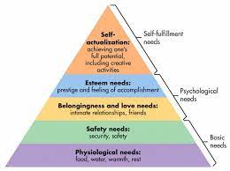
(Author, 5 tips to apply Maslow's hierarchy of needs in the workplace 2023)
Maslow's Hierarchy of Needs Theory: What is it?
This is a motivational hypothesis in psychology. The hierarchy, also known as Maslow's theory of motivation, is sometimes depicted as a pyramid to illustrate the necessity of completing the lower levels before moving up to the next level. Without completing the current level first, you won't have the incentive to move on to the next one, which is impossible.

Maslow asserts that we start by attempting to meet our most basic wants. When all levels of need have been met, we then want to satisfy the higher levels of those needs. A person can feel satisfied depending on their amount of wants. Many businesses use them at the workplace to ascertain the best ways to engage staff members and meet their needs.

By applying this hierarchy, businesses can assess whether or not their objectives are being reached and learn how to better serve the needs of their staff.
If these requirements are satisfied, a worker will wish to address higher-level wants, like those related to self-esteem. These requirements are connected to a person's reputation and his or her desire for other employees' respect and recognition. Even if the employee has no desire to become a manager, he probably has no desire to continue performing the same position for another ten years.

1 Physiological requirements
Maslow understood that before addressing any higher level of requirements, people must attend to their basic needs for survival. They won't be concerned about learning new skills to prepare themselves for future tasks if they don't have access to the necessary water, food, clothing, and shelter for survival. Basic amenities like coffee, fresh water, and snacks will go a long way in satisfying employees' physiological needs at work.

Physiological requirements are the most fundamental human needs according to this hierarchy. In order for employees to feel as though their most fundamental needs are being addressed, they need have access to crucial services and opportunities at work.

They require a relaxing working atmosphere, meal breaks, access to restrooms, and somewhere to obtain drinks. A stable income to pay for food, clothing, a place to live, and other necessities is also one of the most crucial physiological needs at work.

2 Needs for safety
Safety is a further essential need. Your overall workplace satisfaction may be impacted by it.

It's normal to be concerned about your own and your loved ones' security. For instance, you might place a high priority on giving your loved ones a safe place to live and put a lot of effort into doing so. It's crucial to believe that your physical safety is a top priority at work. Your private property ought to be safeguarded.

Providing ergonomic office equipment that lowers the chance of harm and safeguarding the premises to fend off outside dangers are two ways to ensure workplace safety. Also, a sense of safety and support on the emotional level could be experienced at work. You shouldn't worry about losing your job due to layoffs all the time. It would be challenging to drive yourself to climb the corporate ladder and deliver your best work if you feel uncomfortable.

3 social needs
The acceptance, friendship, love, and companionship levels of Maslow's hierarchy of needs in the workplace are covered at this level. By fostering a work atmosphere that fosters possibilities for participation and connection with co-workers, you as a business owner may meet the need that most employees have to socialise and feel like they belong to a group.

Networking events might begin before or after business hours. Happy hour doesn't have to be held at a bar to be an excellent time for socialising and networking. Also, recognising birthdays and anniversaries can encourage interaction and relationship-building among your staff member.
4 Esteem needs
In this level of Maslow's hierarchy, the emphasis is on one's own ego, including accomplishment, self-respect, and getting credit for one's efforts. Employees want to be recognised and valued by both their bosses and coworkers. This need can be met in a learning workplace by praising achievements, highlighting a person's skills, and acknowledging achievements.

Moreover, awards can be given out during training, and participants can applaud the winners' meritorious accomplishments. To satisfy this fundamental need, a brief round of applause would be suitable. A workplace with goals will also be produced via employee awards.

5 self-fulfilment needs
This is at the top of the food chain. Employee self-actualization programmes, training, and mentoring help people reach their full potential.

By scheduling routine talent planning meetings with HR and managers, having career conversations with employees, and offering choices like fast-track management programmes, your business can meet the demands of its employees for self-actualization.

By doing this, you'll provide your employees a chance to thrive and equip them with the knowledge they need to fill openings in the future. Employers should be encouraged to look for methods to progress their careers by focusing on their talents and abilities rather than forcing people into positions they are not qualified for.

Critical thinking
(Kishore, Examples of personal values 2021)
In the workplace, critical thinking is sifting between pertinent and irrelevant data in order to develop a broad perspective that results in an effective choice or resolution of a dilemma.
Almost everyone needs to be a critical thinker because the workplace is undergoing so many changes. Critical thinking abilities will assist your workforce retain more employees and go up the corporate ladder.
While deciding what to believe or do in a particular scenario, people engage in critical thinking. Critical-thinking skills make for introspective, independent, and capable workers.
(Critical thinking: What it is and why it's important | indeed.com)
By rationally connecting concepts, scrutinising and analysing arguments, looking for inconsistencies and flaws in your own work and the work of others, solving challenging issues, and engaging in reflective practise, critical thinking is a skill that can be developed.
Not only does a critical thinker have good knowledge retention skills, but they also understand how to apply that information to infer truths and predict outcomes. Critical thinkers typically solve problems more effectively than persons who only recall facts because they conceptualise the results.

Employers place a high value on critical thinking as a result, particularly in positions where developing a plan is a crucial component of the job. Although critical thinking is seen as a soft skill, it is a personality trait that all people possess. Yet, this ability may be learned.

Influence of your actions in the workplace depends on management style
I am confident that I fully comprehend the management theory used at my place of employment because my workplace is often more of a fun environment, yet when things get hectic, it may turn into a stressful environment. Staff members do their best to raise morale, and we all believe that other people's needs and wants should always be satisfied, whether things are busy or quiet at work.
The management theory we use is like the Douglas McGregor Theory X, Theory Y management, while some of us are resistant to change, if the circumstances are right, work may be as enjoyable as play.
our boss will use a more diversified technique, which allows us to spread the responsibility. We can be ourselves with him because they appreciate our effort, he doesnt mind socializing with all of us, and will even help at the counter if we get too busy. In a way that keeps us engaged, we must also offer meal deals and a drink with their food. It keep employees inspired to put forth hard work to accomplish their objectives.

My own values, beliefs, attitude and behaviours
My life events, outlook, and beliefs all contribute to who you are. They have an impact on your thoughts, actions, and methods. My perspective on things will be influenced by your history, upbringing, experiences, and connections, among other things.
Values are represented via acts, words, and behaviours even though they are not always obvious to others.
Living a more genuine and satisfying life can be facilitated by understanding your values. Finding our purpose, making wise decisions, and navigating difficult situations are all made simpler with greater self-assurance and confidence.
I consider myself to be a strong individual who is focused and likes to accomplish as many objectives as possible while still appreciating other individuals and their belief systems.
I observe that many of my beliefs tend to centre on having a strong mind. I have the compassion to support anyone in need, but once a bridge has been burned, I will no longer care about that person or their requirements.
Although we are all one big family at work, we all have a tendency to continually argue for or against things while maintaining a respectful demeanour.

Conclusion
You can get closer to understanding what's essential to you by identifying, prioritising, and pursuing values. These ideals might help you develop objectives and realise your lifelong dreams. Look for opportunities in life that will help you develop self-awareness, recognise your abilities, and advance towards your career objectives and dreams.
The findings from the research suggest that all assumptions and models, irrespective of their source, are legitimate. They must be careful to prevent any of these contemporary developments from having an impact on the organisation as a whole or the beliefs, principles, or behaviour of their employees. As a result of the widespread belief that management is both an art and a science as we move closer to a technology revolution, organisations must use science and critical thinking much more to further their objectives. Because management has through numerous modifications recently, it is crucial to comprehend the various models and tactics that are currently available to engage and motivate personnel for the advantages of the organisations as well as their clients.

References
Values, beliefs and attitudes (2022) FutureLearn. Available at: https://www.futurelearn.com/info/courses/supporting-learning-secondary/0/steps/58621 (Accessed: March 22, 2023).

Classroom, ~ T.E. (2022) Teaching...beliefs, values, attitudes, behaviour, The English Classroom. Available at: https://theenglishclassroom.blog/2020/05/18/teaching-beliefs-values-attitudes-behaviour/ (Accessed: March 22, 2023).

Management theories (2023) Corporate Finance Institute. Available at: https://corporatefinanceinstitute.com/resources/management/management-theories/ (Accessed: March 22, 2023).

Modern theory of management: Definition, benefits and types - indeed (no date). Available at: https://www.indeed.com/career-advice/career-development/modern-theory-of-management (Accessed: March 22, 2023).

Learning, L. (no date) Introduction to business, Lumen. Available at: https://courses.lumenlearning.com/wmintrobusiness/chapter/reading-douglas-mcgregors-theory-x-and-theory-y-2/ (Accessed: March 22, 2023).

Author, T. (2023) 5 tips to apply Maslow's hierarchy of needs in the workplace, Techfunnel. Available at: https://www.techfunnel.com/hr-tech/maslows-hierarchy-workplace/#:~:text=According%20to%20Maslow's%20theory%2C%20an,now%20focus%20on%20social%20needs. (Accessed: March 22, 2023).

Kishore, K. (2021) Examples of personal values, Harappa. Available at: https://harappa.education/harappa-diaries/examples-of-personal-values/#:~:text=Personal%20values%20are%20those%20beliefs,choose%20to%20prioritize%20and%20adapt. (Accessed: March 22, 2023).
Critical thinking: What it is and why it's important | indeed.com (no date). Available at: https://www.indeed.com/career-advice/career-development/importance-of-critical-thinking (Accessed: March 22, 2023).

