Module: LCBB5014
DATA HANDLING & BUSINESS INTELLIGENCE
Component 1: Coursework: Individual Report

Student Name: Ionel Costea
Student ID: 2422706

Executive Summary
This study focuses on the role of BI, DW, and DM within chosen organisation, in healthcare sector, Spire Healthcare Group Plc. Here, key technologies which have been examined are several predictive analytics tools, such as Power BI, IBM SPSS, as well as data visualisation platforms, like Tableau. Findings have indicated that DW enhances the data integration, while DM and predictive analytics further have improved clinical and operational decision-making. BI dashboards further have allowed real-time performance monitoring. This report further recommends the continuous investment in the integrated BI systems, stronger data governance, and adoption of advanced analytics to strengthen the efficiency, strategic performance for long-term and patient outcomes.

Table of Contents
Introduction 4
Trends in BI, DW, and DM 4
• Definition of BI, DW, and DM 4
• Critical Discussion on Current Trends 4
• Application of Theoretical Frameworks/Models 5
Data Warehousing in the Organisation Applications 6
• Definition of Data Warehousing 6
• Improving Data Access and Efficiency through DW 6
• Supporting Strategic Decision-Making by DW and Using Organisation-Specific Examples 7
Data Mining Techniques 7
• Identification and Explanation of Two Techniques 7
• Relevance to Organisation’s Data and Goals 8
• Tools or Platforms Supporting These Techniques 8
Predictive Analysis 9
• Recommended Predictive Analysis Tools Suitable in Healthcare Sector 9
• Comparison 9
• Discussion on Reporting Automation or Forecasting Capabilities 9
Ethical and Data Security Considerations 10
• Addressing GDPR and Other Legal Compliance Aspects 10
• Discussion on Data Ownership, Consent, and Transparency 10
• Mentioning Access Controls, Encryption, and Other Safeguards 10
• Internal and External Threats 10
Reporting and Dashboard Solutions 11
• Suggested BI Dashboards 11
• Explanation of Its Value for Real-Time Monitoring and Decision-Making 11
• Metrics/KPIs Relevant to Chosen Organisation 11
Conclusion 12
Reference list 13

Introduction
Here, the chosen organisation is Spire Healthcare Group Plc, which is considered a leading healthcare service providing company, operating within the private healthcare sector, based in the UK (spirehealthcare.com, 2026). This organisation is the second-largest healthcare service provider across the UK, and it delivers a broad range of medical services through its hospitals, clinics, and diagnostic centres. Spire Healthcare Group Plc focuses on high-quality patient care, operational efficiency, and data-driven decision-making within a competitive and regulated environment.
The key aim of this report is to examine the way “Business Intelligence (BI)”, “Data Warehousing (DW)”, and “Data Mining (DM)” could support the strategic decision-making within Spire Healthcare Group Plc. It also analyses the ethical and security considerations associated with data usage.
This report will cover the concept of BI, application of DW and DM in the organisational context, implementing predictive analytics, visual reporting tools, ethical considerations, and other key organisational implications.

Trends in BI, DW, and DM

Definition of BI, DW, and DM
Business Intelligence (BI): It refers to the technology-driven processes that analyse the data to support the decision-making process (Adewusi et al. 2024).
Data Warehousing (DW): It involves the centralised storage of structured organisational data for evaluation purposes.
Data Mining (DM): It is the process of discovering patterns, trends, and relationships within large datasets by using statistical and machine learning techniques (Chen et al. 2023).

Critical Discussion on Current Trends
It can be stated that current trends in BI, DW, and DM highlight a transformation towards real-time and intelligent analytics. Real-time BI further allows organisations to process the live data streams, while improving responsiveness in the context of dynamic sectors, such as healthcare (Alkhwaldi, 2024). Cloud-based data warehousing further strengthens the flexibility, scalability, and cost efficiency by supporting the large-scale storage and parallel data processing.
In the context of Spire Healthcare Group Plc, a data warehouse could consolidate the patient records, clinical outcomes, and operational data from multiple hospitals into a unified repository. This kind of scenario further supports the consistent reporting, while improving the patient care decisions and enhancing the operational efficiency, by providing original and authentic scenarios (Ramalingam et al. 2024). Modern architecture of data warehousing (DW) further supports the real-time dashboards and predictive analytics for the purpose of resource planning and patient demand forecasting.

Application of Theoretical Frameworks/Models
From a theoretical perspective, applying “Kimball’s Data Warehouse Architecture” further emphasises the dimensional modelling and data marts for efficient querying (Savitri et al. 2025).
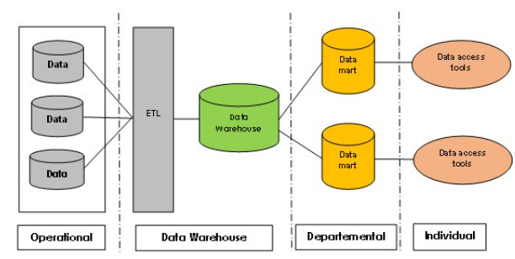
Figure 1: Kimball’s Data Warehouse Architecture
(Source: researchgate.net, 2026)
For example, in this way, organisations in healthcare sector, like Spire Healthcare Group Plc, could support their departmental decision-making.
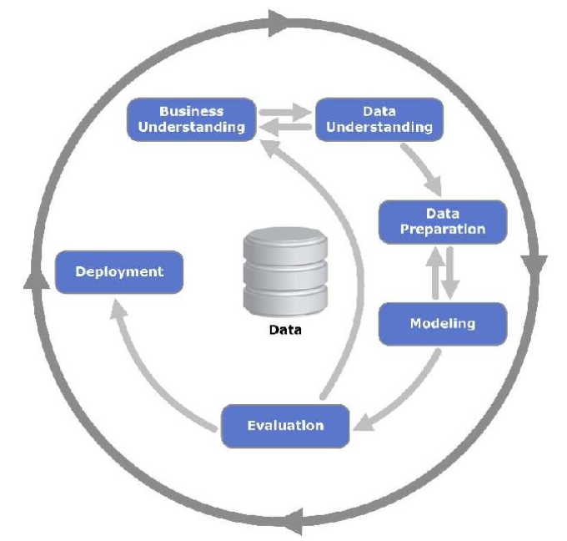
Figure 2: CRISP-DM Model
(Source: researchgate.net, 2026)
On a similar note, by applying “CRISP-DM Model”, healthcare organisations, for example, Spire Healthcare Group Plc, can structure their data mining into different phases, like understanding the business, preparation of data, modelling, and evaluation, while ensuring the systematic implementation of analytics (Kannengiesser and Gero, 2023).

Data Warehousing in the Organisation Applications

Definition of Data Warehousing
Data Warehousing (DW) defines the process of collecting, integrating, and storing large volumes of structured data from different organisational sources into a centralised repository to support the reporting and analysis (Nambiar and Mundra, 2022). In the context of healthcare organisations, such as Spire Healthcare Group Plc, DW therefore plays an important role in managing the complex operational, clinical, and administrative data more effectively.

Improving Data Access and Efficiency through DW
DW further improves the data access and operational efficiency by integrating fragmented datasets, such as patient records, diagnostic results, and hospital operations into a single platform. For example, Spire Healthcare has utilised advanced diagnostic technologies, like capsule endoscopy (PillCam) at its Cheshire hospital, which has allowed this organisation to diagnose critical conditions, such as Crohn's disease, faster and more accurately (spirehealthcare.com, 2026). Therefore, it can be stated that a data warehouse could consolidate this kind of diagnostic data with the histories of the patients and their treatment outcomes. This has allowed clinicians and administrators to access real-time and consistent information. This further reduces duplication, hence, improves the quality of the data, while strengthening the workflow efficiency across different departments.

Supporting Strategic Decision-Making by DW and Using Organisation-Specific Examples
It can be stated that DW has significantly supported its strategic decision-making by allowing comprehensive data analysis and performance monitoring. At Spire Healthcare, in their St. Anthony's Hospital, investment has been made in advanced robotic surgery systems, such as "da Vinci Xi," which has enabled highly precise and minimally invasive procedures with improved patient outcomes and quick recovery times (spirehealthcare.com, 2026). Hence, by storing and evaluating data from these procedures, such as surgical rates, the durations of recovery, and utilisation of the resources, a data warehouse, in this regard, could provide some valuable insights for the strategic planning, which consists of investment decisions, service expansion, and cost optimisation.
Along with this, DW facilitates organisational intelligence by supporting the key applications, such as, performance dashboards, patient flow management, and capacity planning. For example, integrating data from the diagnostic tools, outpatient services, as well as patient flow management further enables Spire Healthcare to forecast the demand of the patients, optimise the allocation process of the staff, while reducing the waiting times (spirehealthcare.com, 2026). This is therefore of specific significance in the context of their collaboration with the NHS for managing the large volumes of the patients, while improving the overall delivery of the services. Thus, it can be stated that data warehousing (DW) could strengthen the ability of Spire Healthcare to transform the raw clinical and operational data into actionable insights (theguardian.com, 2026). This can improve both patient care quality and organisational efficiency in this context.

Data Mining Techniques

Identification and Explanation of Two Techniques
Here, two highly relevant techniques are clustering and classification.
Clustering: It is an unsupervised learning technique which groups similar data points based on the shared characteristics (Oyewole and Thopil, 2023). In the healthcare sector, clustering is specifically useful for improving the delivery of the services and operational planning across multiple hospitals.
Classification: It is a supervised learning technique which has been used to categorise the data into some predefined groups, based on historical patterns. In this healthcare sector, this technique particularly aligns with the organisational goals, through which high-quality and patient-centred care can be delivered, while adverse outcomes and costs can be reduced (Dogra et al. 2022).

Relevance to Organisation’s Data and Goals
It can be seen that, in the context of Spire Healthcare, classification can be applied to predict the risk levels of the patients, such as identifying individuals at a higher risk of post-surgical complications or hospital readmissions (spirehealthcare.com, 2026). By evaluating the demographics of the patients, medical histories, and treatment data, this technique supports Spire Healthcare with early intervention strategies while enhancing clinical decision-making.
On the other side, clustering can be used by Spire Healthcare to segment the patients into distinct groups based on factors such as treatment needs, behaviour patterns, or recovery rates. For example, clustering could help Spire Healthcare identify the patterns in patients undergoing some robotic surgeries or diagnostic procedures (spirehealthcare.com, 2026). This kind of scenario further enables Spire Healthcare with personalised treatment plans and efficient allocation of resources.

Tools or Platforms Supporting These Techniques
Based on the above discussion, it can be stated that these specified techniques are appropriately supported by the advanced analytical tools and platforms, like Microsoft Power BI, Tableau, and IBM SPSS (Ramancha, 2025). Along with this, different cloud-based platforms, like Microsoft Azure, further enable scalable data processing while integrating with the machine learning models.

Predictive Analysis

Recommended Predictive Analysis Tools Suitable in Healthcare Sector
In the context of healthcare sector, for Spire Healthcare, it can be stated that predictive analytics could significantly enhance patient care, operational efficiency, and strategic planning by forecasting several trends, such as patient admissions, treatment outcomes, and utilisation of the resources (Srivastava et al. 2023). Among these different predictive analysis tools, Power BI is highly appropriate for Spire Healthcare, due to its ease of use and seamless integration with the existing IT infrastructure. On the other side, SPSS and RapidMiner can be suitable for more advanced predictive modelling tasks.

Comparison
The comparison between different predictive analysis tools, relevant to organisational context, Spire Healthcare, is as follows:
Key Predictive Tools | Key Features | Usability | Integration with Organisational Systems
Microsoft Power BI | Interactive dashboards, AI-driven insights, real-time analytics (Atobatele et al. 2022) | It is user-friendly interface, appropriate for non-technical users. | Strong integration with Spire Healthcare in terms of Microsoft systems and cloud platforms
IBM SPSS | Advanced statistical modelling and predictive algorithms | It is moderately complex, requiring analytical expertise (Gupta et al. 2022). | Integrates with Spire Healthcare in the area of healthcare datasets and databases
RapidMiner | Machine learning workflows and predictive modelling | It is moderate to advanced usability. | Support integration in Spire Healthcare with cloud and enterprise data systems (Mumtaz et al. 2024)
Table 1: Comparisons

Discussion on Reporting Automation or Forecasting Capabilities
It can be stated that predictive analytics tools could enable automated reporting and forecasting, such as predicting the patient demand, optimising the staff scheduling, and evaluating the recovery trends. For example, Power BI further supports the automated dashboard updates and real-time reporting, while both SPSS and RapidMiner could offer some advanced forecasting models (Hungbo et al. 2024). These capabilities therefore allow Spire Healthcare to appropriately manage the resources, improve the patient outcomes, while supporting the data-driven strategic decision-making.

Ethical and Data Security Considerations

Addressing GDPR and Other Legal Compliance Aspects
In Spire Healthcare, ethical and data security considerations are critical due to the sensitive nature of the patient data. Compliance with “General Data Protection Regulation (GDPR)” ensures that personal health information has been processed securely, lawfully, and more transparently (gov.uk, 2026). Patients, therefore, need to provide informed consent, and Spire Healthcare needs to clearly communicate the way data has been collected, stored, and used. This can further ensure trust and accountability.

Discussion on Data Ownership, Consent, and Transparency
It can be stated that data ownership, consent, and transparency in the healthcare sector are necessary. The patients at Spire Healthcare can therefore retain their rights over their data, which include correction and access.

Mentioning Access Controls, Encryption, and Other Safeguards
It should be noted that, to safeguard data, Spire Healthcare needs to implement some strong access controls, such as role-based permissions, which ensure only authorised staff, who can view some sensitive information (spirehealthcare.com, 2026). On the other side, encryption techniques could further protect data both at rest and in transit. This kind of scenario, therefore, could help Spire Healthcare to reduce the risk of breaches.

Internal and External Threats
It can be stated that external threats, like employee misuse and external cybersecurity risks, such as hacking or ransomware attacks, should be addressed through regular audits, staff training, and advanced security systems (Prasuna and Rachh, 2023). In this way, Spire Healthcare can ensure robust protection regarding its healthcare data.

Reporting and Dashboard Solutions

Suggested BI Dashboards
In Spire Healthcare, BI dashboard solutions, such as Microsoft Power BI and Tableau, are highly efficient for transforming the complex data in the healthcare sector into actionable insights (Adeshina, 2023).
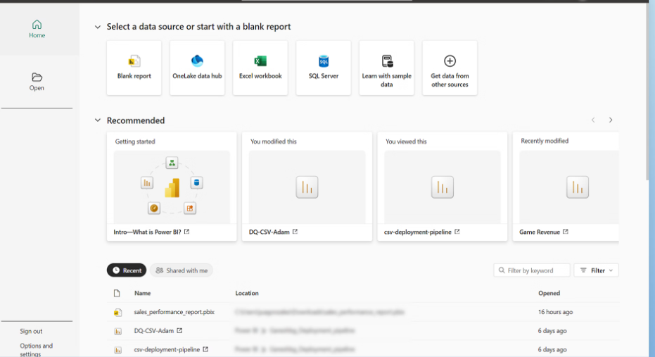
Figure 3: Power BI Dashboard
(Source: microsoft.com, 2026)
These tools further provide some interactive and real-time dashboards, which support the continuous monitoring of the clinical and operational performance. This allows for quick and evidence-based decision-making.

Explanation of Its Value for Real-Time Monitoring and Decision-Making
For Spire Healthcare, dashboards could easily integrate the data from the diagnostics, surgical procedures, and hospital operations, for delivering a unified view of performance. Some key metrics and KPIs might include patient admission rates, bed occupancy levels, surgical success rates, average length of stay, satisfaction scores of patients, and utilisation of the staff (Harode et al. 2022). Real-time visualisation of these indicators therefore helps the management to identify trends quickly, inefficiencies or risks, such as increasing demand or delays in treatment.

Metrics/KPIs Relevant to Chosen Organisation
Thus, from the above discussion, overall, it can be stated that BI dashboards could enhance the transparency, while improving the responsiveness and supporting the strategic planning by allowing the data-driven decisions throughout their multiple healthcare facilities (Jayaraman and Jain, 2024).

Conclusion
Based on the above discussion, it can be stated that BI, DW, and DM play an important role in enhancing the decision-making process within Spire Healthcare Group Plc. This study further highlights the way DW has enabled the consolidation of data efficiently, while DM techniques and predictive analytics support the improved patient outcomes and their operational efficiency.
Overall, it can be seen that BI has significantly improved the organisational performance by transforming the complex healthcare data into some actionable insights in relation to Spire Healthcare.
On the other side, their strategic importance depends on enhancing the quality of the services, optimising the resources, while maintaining the competitiveness in the context of data-driven healthcare environment.
It is further recommended that Spire Healthcare needs to continue to invest in integrated BI systems, which further strengthen the data governance practices. They should adopt the advanced analytics tools to maximise the long-term value, while ensuring some sustainable organisational growth.

Reference list
Adeshina, Y.T., 2023. Strategic implementation of predictive analytics and business intelligence for value-based healthcare performance optimization in US health sector. International Journal of Computer Applications Technology and Research, 12(12), pp.101-114.
Adewusi, A.O., Okoli, U.I., Adaga, E., Olorunsogo, T., Asuzu, O.F. and Daraojimba, D.O., 2024. Business intelligence in the era of big data: A review of analytical tools and competitive advantage. Computer Science & IT Research Journal, 5(2), pp.415-431.
Alkhwaldi, A.F., 2024. Understanding the acceptance of business intelligence from healthcare professionals’ perspective: an empirical study of healthcare organizations. International Journal of Organizational Analysis, 32(9), pp.2135-2163.
Atobatele, O.K., Ajayi, O.O., Hungbo, A.Q. and Adeyemi, C., 2022. Improving strategic health decision-making with SQL-driven dashboards and Power BI visualization models. Shodhshauryam Int Sci Refereed Res J, 5(5), pp.291-313.
Chen, K., Abtahi, F., Carrero, J.J., Fernandez-Llatas, C. and Seoane, F., 2023. Process mining and data mining applications in the domain of chronic diseases: A systematic review. Artificial Intelligence in Medicine, 144, p.102645.
Dogra, V., Verma, S., Kavita, Chatterjee, P., Shafi, J., Choi, J. and Ijaz, M.F., 2022. A complete process of text classification system using state‐of‐the‐art NLP models. Computational Intelligence and Neuroscience, 2022(1), p.1883698.
gov.uk, (2026), Data protection, Available at: https://www.gov.uk/data-protection [Accessed on 22.03.2026]
Gupta, A.D., Rafi, S.M., Rajagopal, B.R., Milton, T. and Hymlin, S.G., 2022. Comparative analysis of internet of things (IoT) in supporting the health care professionals towards smart health research using correlation analysis. Bull. Env. Pharmacol. Life Sci., Spl, 1, pp.701-708.
Harode, A., Ensafi, M. and Thabet, W., 2022. Linking BIM to power BI and Hololens 2 to support facility management: a case study approach. Buildings, 12(6), p.852.
Hungbo, A.Q., Adeyemi, C. and Ajayi, O.O., 2024. Power BI-based clinical decision support system for evidence-based nurse decision-making. International Journals of Advanced Multidisciplinary Research Studies, 4(6), pp.2653-2668.
Jayaraman, K.D. and Jain, S., 2024. Leveraging Power BI for advanced business intelligence and reporting. International Journal for Research in Management and Pharmacy, 13(11), pp.21-36.
Kannengiesser, U. and Gero, J.S., 2023. Modelling the design of models: an example using CRISP-DM. Proceedings of the Design Society, 3, pp.2705-2714.
microsoft.com, (2026), Power BI Desktop, Available at: https://www.microsoft.com/en-us/power-platform/products/power-bi/desktop [Accessed on 22.03.2026]
Mumtaz, J., Naqvi, S.A.A., Ahmad, M.H., Rehman, M. and Mumtaz, G., 2024. RapidMiner-based Clustering Techniques for Enhancing Intrusion Detection System (IDS) Performance. Journal of Computing & Biomedical Informatics, 7(02).
Nambiar, A. and Mundra, D., 2022. An overview of data warehouse and data lake in modern enterprise data management. Big data and cognitive computing, 6(4), p.132.
Oyewole, G.J. and Thopil, G.A., 2023. Data clustering: application and trends. Artificial intelligence review, 56(7), pp.6439-6475.
Prasuna, A. and Rachh, A., 2023. A study on challenges of data security and data privacy in the healthcare sector: Swot analysis. Asia Pacific Journal of Health Management, 18(1), pp.283-289.
Ramalingam, S., Subramanian, M., Reddy, A.S., Tarakaramu, N., Khan, M.I., Abdullaev, S. and Dhahbi, S., 2024. Exploring business intelligence applications in the healthcare industry: A comprehensive analysis. Egyptian Informatics Journal, 25, p.100438.
Ramancha, N.K., 2025. Evaluation of Computer Architecture and Organization Using the SPSS Method. International Journal of Cloud Computing and Supply Chain Management, 1(1).
researchgate.net, (2026), Analyzing and Processing of Supplier Database Based on the Cross-Industry Standard Process for Data Mining (CRISP-DM) Algorithm, Available at: https://www.researchgate.net/publication/338358899_Analyzing_and_Processing_of_Supplier_Database_Based_on_the_Cross-Industry_Standard_Process_for_Data_Mining_CRISP-DM_Algorithm/figures?lo=1 [Accessed on 22.03.2026]
researchgate.net, (2026), Comparative study of data warehouses modeling approaches: Inmon, Kimball and Data Vault, Available at: https://www.researchgate.net/publication/312486486_Comparative_study_of_data_warehouses_modeling_approaches_Inmon_Kimball_and_Data_Vault/figures?lo=1 [Accessed on 22.03.2026]
Savitri, N.K.W., Sandhiyasa, I.M.S., Fittryani, Y.P., Sudipa, I.G.I. and Putra, D.M.D.U., 2025. Design of Real-Time Project Monitoring Dashboard Using Kimball’s Data Warehouse Approach and Google Data Studio. Sinkron: jurnal dan penelitian teknik informatika, 9(3), pp.1050-1061.
spirehealthcare.com, (2026), Finding Answers with the Latest Technology at Spire Cheshire Hospital, Available at: https://www.spirehealthcare.com/spire-cheshire-hospital/patient-information/news-and-events/latest-technology-at-spire-cheshire-hospital-helps-diagnose-crohns-disease/ [Accessed on 22.03.2026]
spirehealthcare.com, (2026), Quality and patient safety, Available at: https://www. /patient-information/safety-overview/ [Accessed on 22.03.2026]
spirehealthcare.com, (2026), Spire Healthcare, Available at: https://www.spirehealthcare.com/ [Accessed on 22.03.2026]
spirehealthcare.com, (2026), Spire St Anthony’s Hospital expands its investment in robotic surgery with new da Vinci Xi system, Available at: https://www.spirehealthcare.com/spire-st-anthonys-hospital/patient-information/news-and-events/spire-st-anthony-s-hospital-expands-its-investment-in-robotic-surgery/ [Accessed on 22.03.2026]
Srivastava, D., Pandey, H. and Agarwal, A.K., 2023. Complex predictive analysis for health care: a comprehensive review. Bulletin of Electrical Engineering and Informatics, 12(1), pp.521-531.
theguardian.com, (2026), Spire Healthcare reports profit and revenue jump as its work for NHS increases, Available at: https://www.theguardian.com/business/2024/sep/12/spire-healthcare-profit-revenue-nhs-outsourcing [Accessed on 22.03.2026]

