

Academic Travel Journal
Submitted to Jacqui Jones
BA Events and Festival Management
M6X02120

Prepared by:
Mrs Sarah Hillam
P137987

This travel journal will be based around the 1990 riots at Glastonbury and how it has affected the future of the festival along with the local community network and surrounding areas near the festival site in pilton England, over the past 30 years glastonbury has seen its fair share of problems since the riots in 1990 and then issues with drugs and weapons being smuggled into the festival.
The festival took the name of the Glastonbury Festival for Contemporary Performing Arts for the first time, to reflect the diversity of attractions within the Festival. It was the twentieth anniversary of the first Festival but unfortunately ended with a confrontation between the security teams and travellers (The so-called Battle of Yeoman’s Bridge) who were looting the festival site. This resulted in 235 arrests and £50,000 worth of damage to property and hired plant. Glastonbury’s founder Michael Eavis has readily admitted, Pilton has changed so much since the first festival in 1970, he says it hasn’t always been like it is now. In the 1980’s and 90’s the festival started turning violent and they see more and more incidents of drug dealing and it got worse over time. some of the people arrested were caught with mass amounts of drugs, guns and knives. The riots were described as horrendous by some attendees, staff and security members which they said they can remember Molotov cocktails being thrown around the farm setting mass fires and destroying the land the festival was held on, there was also massive thefts from various houses and pubs around the area, one resident describes it saying they would steal anything not nailed down, another resident describes it saying the travellers urinated in his swimming pool by accessing private property and their dogs tore his lambs apart after he confronted them about being on his land, but they were not punished for this.
After all the trouble with the 1990 festival it led the organisers taking the 1991 festival off and to re think the festival completely, when the festival returned in 1992 it proved to be a big success as the new age travellers were initially not allowed on site or to attend the festival but when the 1993 festival returned it wasn’t a big hit as the travellers were allowed back on site free and they organisers built a more sturdier fence to keep the travellers separate from other attendees.
In 1995 the festival saw another big year of trouble and the security fences were breached and there was an eruption of violence between attendees and staff again which saw the festival called off early due to the trouble. The festival then took another year off in 1996 to allow the land to recover due to damage and restructure the modelling of the event and improve security to improve the event.
In 1998 after the restructuring of the festival and security in 1997 the festival was once again struck with severe flooding and storms and eruption occurred again leading most of the attendees to depart early.
There seems to be a re-occurring pattern of violence at the festival and drugs and crime don’t seem to have improved much, according to Rachael Lamberth even though security has improved a lot during the years of the festival there is still drugs and weapons been smuggled into the event even these days, the security staff now have metal detector wands to use to search attendees which is newly introduced to the festival in 2019.
From the secondary research that has being conducted by using accredited journals, articles and websites on the glastonbury riots in 1990, it was found that the riots erupted due to poor weather conditions and packed fields of attendees and unfortunately the event ended with major confrontations between attendees and security staff at the event which saw a vast amount of damage being caused to the festival site and neighbouring properties and village landmarks.
From the research conducted by Adam Hamilton on the 1990 riots, his newspaper article on the festival was focused on mud rain and near asphyxiation and how the event turned so violent within a short time frame and left many attendees knee deep in mud and unable to move due to the vast amount of water that had poured down on the festival, this left the attendees struggling to breath as some were up to their necks in mud and rain and near asphyxiation, unfortunately for those attendees the outlook was bleak and some say they thought they were going to die (Hamilton. A, 2013).

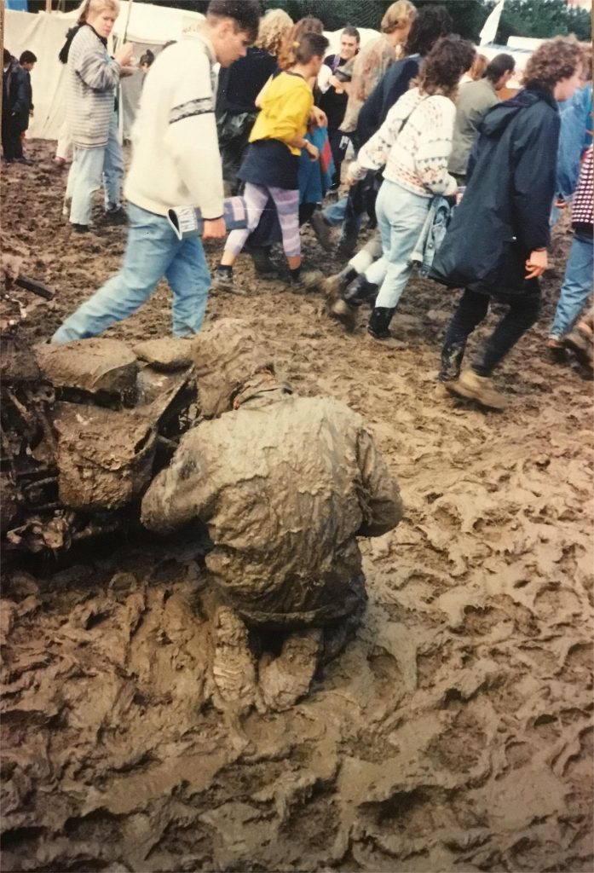(2019. Google Images)
From the research conducted by the guardian newspaper regarding the riots and talks with the owner Michael Eavis, it was determined that the riots caused chaos and over £50,000 worth of damage to the festival site and neighbouring properties and farms and cars, it was also reported to the guardian that the travellers let their dogs tear lambs and sheep apart after the farmer asked them to leave his property as they were causing chaos and one neighbour Ann Goode said it was like something from a horror movie(Topping, A., 2010).

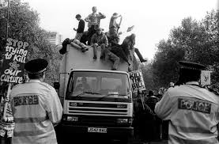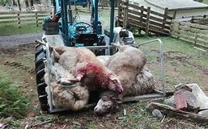(Images.Google.2012) (Edwards. S.2016)

From the research conducted by BBC News in June 2012 it was decided that glastonbury festivals and the promotors of festival republic would go their separate ways, this was a mutual agreement by Michael Eavis and festival republic leader Melvin Benn, the decision came after the festival saw a record number of years where there was trouble at each event and some years the festival was called off completely so that it could be restructured and more measures put in place to make the festival more safe for attendees and staff
Benn said: "I am committed to ensuring as smooth a handover as possible”.
"It has been a wonderful journey with Michael but Latitude, Berlin, Hove and Electric Picnic, none of which existed in 2002, are my priorities, alongside maintaining Leeds and Reading as the bastions of the festival calendar they are," said Benn. ( BBC News, 2012)
 (BBC News, 2012)
Michael Eavis said he was sorry to see Benn go and credited the promoter with helping to create a more professional set-up at Glastonbury.
When the pair officially teamed up in late 2001, they quickly introduced stricter ticketing and the £1m 'super-fence' surrounding the whole site, designed to keep gate crashers out.
The local council had made it clear that the festival could not continue without acting, after police claimed 100,000 ticketless fans managed to sneak in during 2000's three-day event.
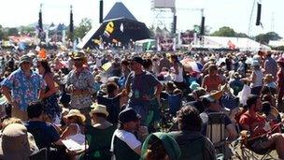
. (BBC News, 2012)
According to the Huffington Post newspaper, Notting hill carnival and Glastonbury have similar arrest statistics, Huff Post took the number of arrests at each event and divided it by the number of respective attendees. They found that there were 3.10 arrests per 10,000 people at Glastonbury and 3.76 per 10,000 at Notting Hill Carnival.
But this doesn’t account for the fact that Glastonbury lasts for five days, whereas Notting Hill Carnival lasts for two. Imagine that there were the same number of arrests and people at both festivals; you would say that the arrest rate was lower at Glastonbury than Notting Hill because it lasts over twice as long.
The same logic applies when calculating the number of arrests per 10,000 people. If, say, there are 3.1 arrests per 10,000 people at Glastonbury, then on any one of the five days of the festival you’d expect 0.6 in every 10,000 people to be arrested.
If there are 3.76 arrests per 10,000 people at Notting Hill, then on any one of the Carnival’s two days you would expect 1.88 in every 10,000 people to be arrested.
“This is a hypothetical calculation, not our estimate of the true arrest rate at either festival (for reasons we’ll get on to). But it helps to illustrate why it’s important to account for the duration of the festival in the calculation” (Yule, E., 2019).

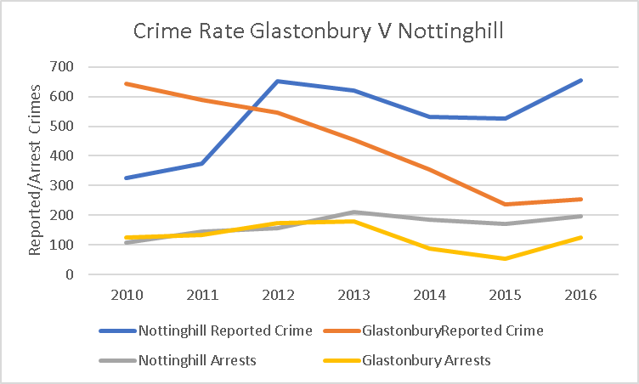
(Lamberth, R., 2019)

From the graphs above you can see there isn’t much difference in the statistics between glastonbury and Notting hill carnival and the statistics show similar crime rates.
From an interview I conducted with Rachel Lambeth from the glastonbury press office in 2019 regarding the riots in 1990, she informed me that they had many unsuccessful festival, post the riots but things are improving as they work on implementing new security measures for 2020, they are looking at bringing in sniffer dogs, mobile cctv units supplied by local police force and more security staff on entrance gates to perform personal searches on attendees, she said this was an important change and one that needs to be set up asap due to drugs and weapons still being smuggled into events (Lamberth, R., 2019).

From conducting the research on this topic, there are a lot of weaknesses that could of contributed to the riots in 1990, these weaknesses consist of poor security at evets and lack of personal searches of the travellers and other attendees also poor weather conditions that obviously caused major issues and definitely did contribute to the riots, typically the event never should of gone ahead due to the poor conditions but back in them days the event organisers probably wouldn’t have wanted to loose funds by cancelling the event, back in the 90’s the use of drugs was typically an everyday thing for most of society and carrying weapons was part of their culture, to protect themselves from harm, as they typically live in caravans where ever they can put them, sometimes these weapons were used against police, fellow travellers and anyone who dared to cause trouble for them but even now in 2020 drugs and weapons are a big issue at the festival and is still causing issues with attendees being evicted from the festival. The focus of the organisers is the safety of those who are there to respect the rules and want to take part in a fun filled festival not a riot of violence and drugs.
The problem at the festival is mainly drugs and alcohol, which when over consumed it can lead to major problems these include violence rape and sometimes fatality. It would be in the best interest of the attendees to be searched on a more proactive basis and only be allowed to take bare minimum with them. If these issues got sorted out, I think the festival would be much more enjoyable for those who want to attend. The demand is high for this project and having spoken to the press officer at Glastonbury who has provided feedback from attendees that this project is vital to the survival of Glastonbury. From writing this travel journal the organisers want to be able to achieve a safer festival for attendees so people can feel safe and not have to worry about their safety while attending the event. Some people attend every year and they said they are actually considering not attending the event anymore due to the violence at the festivals in the past, sorting these issues would make a better future for Glastonbury as it is 50 years old and its legacy should continue for as long as possible, the only way this is going to happen is to stop drugs and violence at the event.
By researching the riots of 1990 at Glastonbury festival in Pilton England, it is clear that the festival has suffered for a number of years from the early 90’s with crime and drugs, this has resulted in the festival being given a bad reputation and resulted in the festival having to close on several occasions to restructure the event and security measures they have in place to make the festival a more safer environment for festival attendees, although they have restricted the event to attendees only taking certain personal items in with them and now being searched at the event when entering this has not fully resolved the issues of crime and drugs at the event and people are still managing to smuggle them in to the event whether this is secreted in their private areas or they have them well hidden in their luggage.
From a critical point this could have severe consequences for the owners of Glastonbury if the issues surrounding the drugs and crime is not dealt within an efficient manner it could result in the police raiding the festival site and the festival will end up with a poor reputation again, although there are suggestions that the festivals crime rates are improving by looking at the freedom of information request has revealed arrests at Glastonbury Festival in 2015 were dramatically down, both in terms of drugs arrests and crime in general.
Perhaps the starkest figure revealed by The Bristol Posts’ request surrounding drug seizure figures shows that in 2015 1,639grams of cannabis bush were confiscated compared to 7,600grams in 2010. While 80 doses of LSD were confiscated by police in 2010, none were found in 2015. Ecstasy, in contrast, saw a huge rise, from 40 tablets back in 2010 to 880 in 2015.
There were 54 arrests for drug related offences in 2015, compared to 125 back in 2010. Crime levels in general were also down, with 236 crimes in total reported to police at Glastonbury, compared to a total of 453 at the 2013 event. 168 of the reports related to theft, while there were 12 reports of violence.
Jordan Hughes/NME
Glastonbury 2016 is already long since sold out, with organiser Emily Eavis having revealed late in 2015 that more than 80% of bookings were in place.
Eavis said in November: “We are about 80% of the way there already. We are so lucky now to have so many huge bands touring and wanting to play. That’s one of the reasons we are doing a festival in 2017 [according to the normal cycle, 2017 would be scheduled to be a fallow year] – we already have the headliners pencilled in for that too, which is unusual.”
All of the recommendations below are ones that will significantly improve the festival for the future and survival of Glastonbury, although the festival is now 50 years on, it needs to bear in mind the implications of crime and drugs rates at the events and still try to improve on the statistics for arrests at the event.

The implementation underpinned of a successful licence application. As part of the programme of continuous improvement.
Movement Strategies undertakes risk assessments, crowd safety and visitor experience audits at each Festival, helping to improve safety during the event and refine the site design for the following year.
Improved security at festivals so attendees feel safer and more protected from crime.
Improved bag searches at the event to prevent weapons and drugs being smuggled in.
Bigger police presence at the event which may deter troublemakers.
Bibliography
© 1997–2019 Glastonbury Festival, 2019. Glastonbury Festivals. [Online]
Available at: https://www.glastonburyfestivals.co.uk/history/history-1990/
[Accessed 17th October 2019].
Adam Hamilton, 2013. Glastonbury 1990 review: 'mud, rain and near-asphyxiation'. [Online]
Available at: https://www.telegraph.co.uk/culture/glastonbury/10141298/Glastonbury-1990-review-mud-rain-and-near-asphyxiation.html
[Accessed 17th October 2019].
Anon., 2019. Google Images. [Online]
Available at: https://www.google.com/search?q=glastonbury+statistics&rlz=1C1GCEB_enGB873GB873&source=lnms&tbm=isch&sa=X&ved=0ahUKEwid6Y3t8MjlAhVwRxUIHd2bC5kQ_AUIEygC&biw=1920&bih=969#imgrc=7FGSWUdselJCNM:
[Accessed 1ST November 2019].
BBC News, 2012. Glastonbury splits from promoters Festival Republic. [Online]
Available at: https://www.bbc.co.uk/news/entertainment-arts-18607315
[Accessed 17th October 2019].
Bell, M., 1990. Glastonbury Festivals. [Online]
Available at: https://en.wikipedia.org/wiki/Glastonbury_Festival#1990s
[Accessed 17 October 2019].
Lamberth, R., 2019. Glastonbury 1990 [Interview] (15th October 2019).
Malloy, T., 2018. Glastonbury Festival: Statistics reveal the average Glasto-goer. [Online]
Available at: https://www.somersetlive.co.uk/whats-on/music-nightlife/glastonbury-festival-statistics-reveal-average-1952547
[Accessed 1st November 2019].
Steve Bubble, 1990. Glastonbury 1990. [Online]
Available at: http://www.ukrockfestivals.com/glastonbury-festival-1990.html
[Accessed 17th October 2019].
The West This week, Drugs at Glastonbury Festival. 2012. [Film] England`: WebM8 Productions.
Topping, A., 2010. Glastonbury festivals make peace with put-upon Pilton. [Online]
Available at: https://www.theguardian.com/music/2010/apr/30/glastonbury-festival-pilton-village
[Accessed 17th October 2019].
Yule, E., 2019. Notting Hill Carnival: New Data Reveals Crime Should Not Be the Story of The Weekend. [Online]
Available at: https://www.huffingtonpost.co.uk/entry/notting-hill-carnival-arrest-rates-same-as-glastonbury_uk_5d5d1d18e4b063487e9519d5?guccounter=1&guce_referrer=aHR0cHM6Ly93d3cuZ29vZ2xlLmNvbS8&guce_referrer_sig=AQAAAJE2wbPHKmqNxLG_Yfy0VbH0SHACgtM9xFltr0SiEQUBU-PzV-dE
[Accessed 1ST November 2019].

