

Assessment 1
Module: Strategic Management & Sustainability
LCBB6004

Student name: Georgiana Loredana Nedelcu
ID: 2018584

Table of Contents
Introduction 3
Company background 4
Key Business Strategies of Volkswagen 5
Resources and Capabilities Analysis 7
Strategic Alignment and Sustainable Evolution. 9
Environmental sustainability efforts from VW 12
Conclusion 14
Reference 15

Introduction
The 2015 Volkswagen (VW) emissions scandal, often known as "Dieselgate," completely shook the automobile industry. Volkswagen has incorporated technical gadgets into its cars with the goal of falsifying emission testing and so encouraging regulatory fraud. This research looks at VW's modern business strategy and how they use sustainable practises to provide them a competitive edge. Volkswagen's misleading practises regarding emissions and their environmental effect were exposed by the scandal. Volkswagen (VW) used "defeat devices" in its cars, which caused nitrogen dioxide emissions that were higher than allowed and had a negative effect on the environment as well as people. Ninety thousand drivers in Wales and England were successful in winning a £193 million monetary settlement after a judicial battle. The goal-oriented examination of Volkswagen's five-year business plan is the main topic of this study. To identify and assess the underlying changes and their underlying reasons, established frameworks are used. Volkswagen's resources and capabilities are compared with their strategic approaches in this research. This study looks at Volkswagen's approach from the perspectives of sustainability, competitiveness, and the environment. Volkswagen's sustainability initiatives as a way to obtain a competitive edge are covered in the paper's conclusion. In light of the emissions crisis, this in-depth analysis looks at Volkswagen's competitive position, strategic approach, available resources, and long-term viability. The Volkswagen case provides an instructive example of the difficulties businesses confront in striking a balance between their pursuit of financial development and their responsibility to the environment, ethics, and regulations. (Atiyeh, 2019).

Company background
The history of Volkswagen is discussed below from few aspects:
Number of Employees: Volkswagen Group is one of the world's leading automobile manufacturers and has a large global workforce. As of recent time, the company has employed around 664,500 people worldwide.
Company's Age: Volkswagen was founded on May 28, 1937, making it over 84 years old as of my last update.
Financial Situation: Volkswagen Group is a publicly traded company, and its financial situation can vary over time based on market conditions, economic factors, and company performance. Up until recent years, Volkswagen had faced challenges due to the "Dieselgate" scandal, which involved cheating on emissions tests. The company had to pay significant fines and compensation, impacting its financials. However, Volkswagen has been taking steps to recover from this incident and transition towards electric and sustainable mobility solutions (Wagner, 2022).
Operating Markets: Volkswagen operates in various global markets. It has a strong presence in Europe, particularly in its home country Germany, as well as in China and North America. The company has a diverse range of products and brands, including Volkswagen Passenger Cars, Audi, SEAT, Skoda, Bentley, Bugatti, Lamborghini, Porsche, Ducati (motorcycles), and commercial vehicle brands such as Volkswagen Commercial Vehicles, MAN, and Scania (Wagner, 2022).

Key Business Strategies of Volkswagen
Over the span of the previous five years, Volkswagen (VW) has adopted a novel business strategy. The pollution issue and developments in the automotive industry prompted an internal evaluation of the company's strategic approach as well as external influences.
Following the crisis, Volkswagen (VW) placed the utmost emphasis on restoring consumer confidence and enhancing its corporate reputation. Upon recognising the significant undertaking, Volkswagen made the strategic choice to align with the ideals of transparency, ethics, and environmental responsibility. The intentional adoption of this strategy serves to highlight Volkswagen's commitment to environmental preservation and offers the corporation the capacity to anticipate and adapt to evolving consumer preferences and legal regulations (Schiermeier, 2015).
Porter's generic strategy analysis is able to accurately summarise VW's major business strategy discussion.
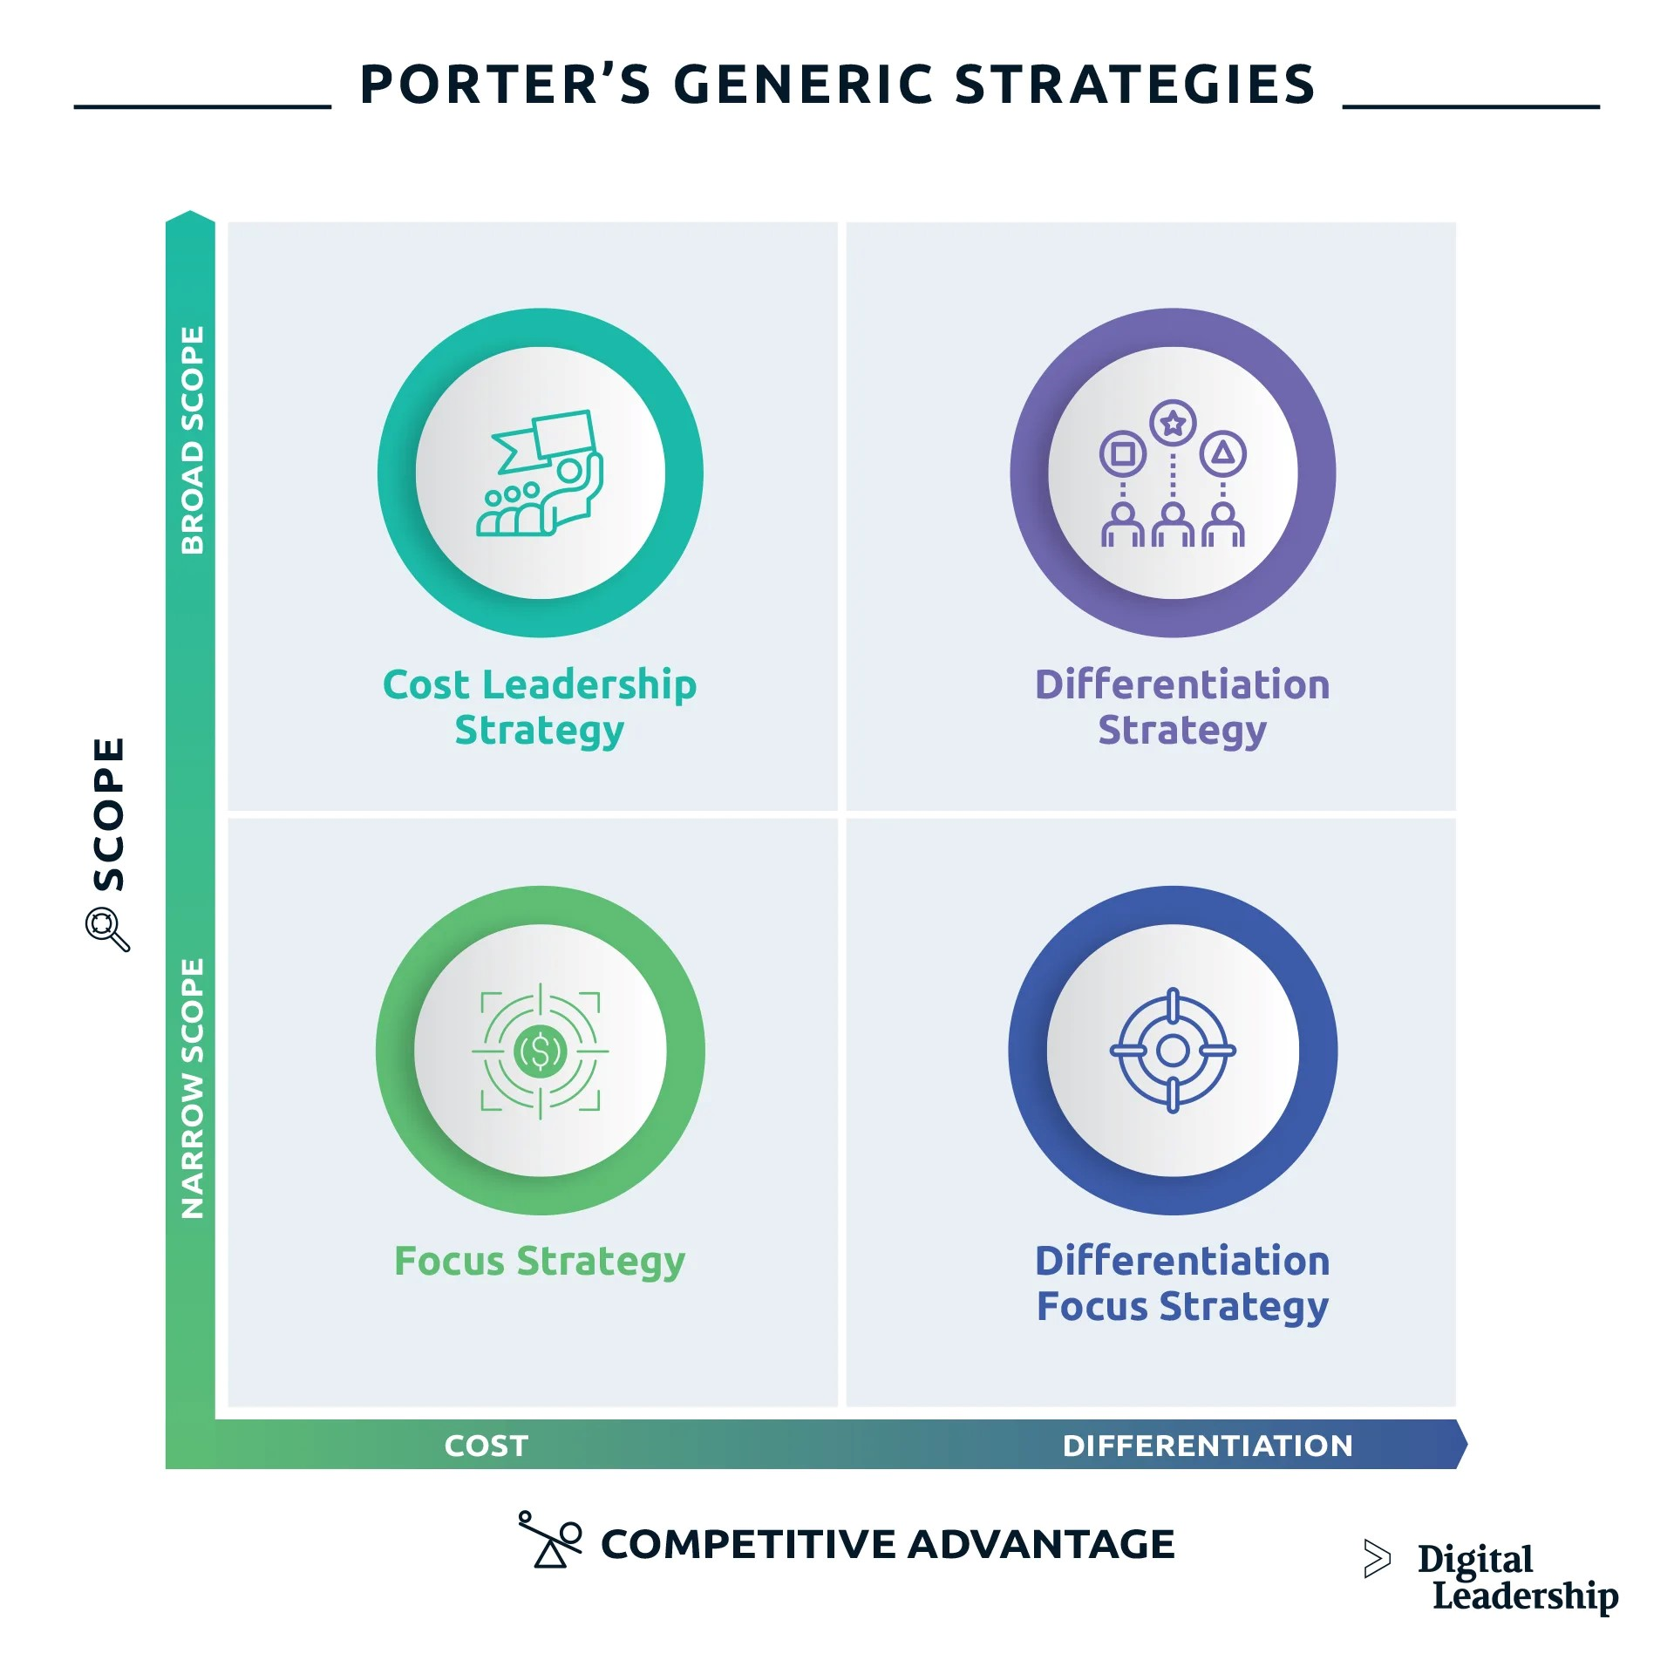
Figure: Porter’s generic strategies (Dieffenbacher, 2023).
Cost leadership strategy: Volkswagen has always prioritised cost reduction, with a strong emphasis on optimising supply chain operations and enhancing production efficiency. As a result of this, the company successfully marketed a significant volume of automobiles at reasonable prices. The financial implications and penalties arising from the "dieselgate" scandal presented a dual threat to the company's fiscal stability and strategic goals.
Differentiation strategy: In recent years, Volkswagen has used many strategies to differentiate its range of electric vehicles. The company aims to attract environmentally conscious clients by offering state-of-the-art, eco-friendly automobiles. The ID electric vehicle series and the financial commitments made to digital technology are examples of this type of cognitive process.
Focus strategy: Maintaining focus might pose challenges for Volkswagen, given its global presence. Nevertheless, in response to the increasing need for autos, the company has strategically focused its endeavours on a limited number of nations, with a primary emphasis on China. This market has witnessed substantial monetary commitments from the corporation.
Differentiation focus strategy: Volkswagen utilises a diverse range of strategies. The corporation employs a range of tactics in order to achieve both uniqueness and cost leadership. Presently, it holds a dominant position in the electric vehicle and technologically advanced technology sectors, while also striving to attain a competitive advantage in terms of cost leadership within the conventional automotive industry.

In summary, Volkswagen's strategic five-year plan was formulated in response to the issue of emissions and in consideration of advancements within the automotive sector. Volkswagen's operational strategies effectively incorporate a harmonious integration of innovation, sustainability, and adaptability. The proposed approach aims to establish linkages, bolster the adoption of electric transportation and digitization, regain confidence via ethical conduct and transparency, and foster a climate that promotes ethical behaviour and adherence to regulations. The aforementioned activities lay the foundation for an examination of Volkswagen's alignment of resources and capabilities, as well as its competitiveness and prospects for expansion, which will be expounded upon in the subsequent sections.

Resources and Capabilities Analysis
Volkswagen (VW) has incorporated its inventive endeavours into its capabilities and resources for a period of five years. In response to the emissions issue, Volkswagen (VW) undertook a strategic adaptation, necessitating an evaluation of the alignment between its resources and competencies and its organisational objectives.
The manufacturing capabilities of Volkswagen (VW) serve as a foundation for its ambitious shift towards electric transportation and its operational proficiency. After years of extensive manufacturing experience, Volkswagen has the necessary capabilities to effectively navigate the intricate procedures involved in producing electric vehicles (EVs) and their components. The global supply network of Volkswagen (VW) facilitated the procurement of electric vehicle components and materials. The collaboration between the two entities resulted in an enhancement in cost-effectiveness and dependability in the delivery of products (Pierik and Robeyns, 2021).
A SWOT analysis is able to accurately summarise VW's major resources and capabilities discussion:
Strengths:  - Strong Brand recognition and reputation  - Large scale production capabilities  - Focus on digital transformation  - Global presence  Opportunities:  - Growing demand in vehicles  - Increasing demand on sustainability and environmental concern  - Digital services in the car | Weakness:  - Dislegate scandal and related legal and financial consequence.  - Dependence on traditional  combustion engine models  - High competition in EV market.  Threats:  - Intense competition from the other  automakers in the present market.  - Stringent emissions regulations.  - Economic uncertainties and market  fluctuations

Volkswagen (VW) has made significant investments in technology innovation through its research and development (R&D) activities. The company's research and development expenditures were mostly allocated towards advanced autonomous and electric driving technologies. Volkswagen (VW) gained a competitive advantage in the rapidly evolving automotive industry through strategic collaborations with esteemed research institutes and prominent technology companies. Volkswagen had challenges upon its entry into the electric car industry. Battery technology is a significant factor in the advancement of electric vehicle technology. Volkswagen (VW) made strategic investments in battery research and established collaborative partnerships to effectively handle the resource and competence gap resulting from the rapid advancement of battery technologies. The reputation of Volkswagen (VW) was a significant intangible asset after the emissions scandal. The organisation's capacity to restore trust was facilitated by the implementation of open channels of communication, adherence to moral principles, and a steadfast dedication to sustainability. These factors were crucial in leveraging the organisation's esteemed worldwide brand and extensive historical legacy. Volkswagen (VW) has the potential to enhance consumer impressions by using this intangible asset (Barua et al., 2001).

Strategic Alignment and Sustainable Evolution.
The UK automobile industry, characterized by evolving consumer preferences, technological advancements, and stringent environmental regulations, has witnessed strategic realignments to remain competitive. Volkswagen (VW), as a major player in this industry, has demonstrated a concerted effort to align its resources and capabilities with its current business strategies, as evident through several key factors.
Electric Mobility Focus: VW clearly supports the industry's electric mobility transformation. The Modular Electric Drive Matrix (MEB) shows the company's commitment to sustainability and carbon reduction through its investments in electric vehicle platforms. VW's ID.3 and ID.4 electric vehicles meet the increased demand for eco-friendly mobility thanks to this alignment..
Technological Transformation: VW's emphasis on digital transformation highlights how in step it is with technological improvements since the founding of the vehicle. The company's alignment with the technology transition in the industry is demonstrated by its investments in software development, autonomous driving, and networking, as well as its software organisation. Through these efforts, VW's competitive position is strengthened, and its capabilities are better matched with the growing need for cutting-edge, technologically sophisticated features.
Rebuilding Trust and Ethical Practices: Post the "dieselgate" scandal, VW's alignment with ethical considerations is evident in its efforts to rebuild trust and integrity. The company's allocation of resources towards addressing legal consequences, compensation, and fines demonstrates its commitment to rectifying past missteps. This strategic alignment aligns with the need to restore consumer confidence and uphold ethical practices, contributing to long-term sustainability.
Global Expansion and Adaptation: VW's alignment with market expansion is highlighted by its endeavours in the UK, including investments in local production facilities and market-specific models. Such expansion reflects a strategic alignment with market demands and preferences, enabling the company to effectively cater to the UK audience while utilizing its global resources and capabilities.
Environmental Responsibility: VW's alignment with environmental concerns is showcased through its commitment to compliance with stringent emission regulations. By aligning its resources towards developing vehicles that adhere to emission standards, such as the Euro 6 norms, the company demonstrates an alignment with environmental obligations and consumer expectations for cleaner mobility solutions.
A PESTEL analysis may clarify VW’s position:
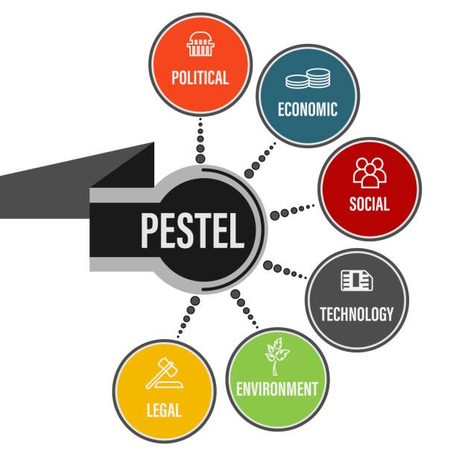
Figure: PESTEL analysis (de Bruin, 2016)
Political: VW's alignment with political factors is notable in its response to tightening emission regulations. The company's investments in electric vehicle technology and emission reduction strategies align with governmental efforts to curb pollution and promote cleaner transportation.
Economic: The Company’s alignment with economic factors is reflected in its investment in efficient supply chain management and manufacturing technologies. These efforts help VW remain competitive by optimizing production costs and maintaining affordable vehicle prices.
Social: VW's alignment with social factors is evident in its focus on rebuilding trust post the "dieselgate" scandal. This strategy resonates with socially conscious consumers who seek transparency, ethical practices, and sustainable mobility options.
Technological: VW's alignment with technological factors is exemplified by its digital transformation initiatives. These include investments in connectivity, autonomous driving technology, and software development. These efforts enhance the company's competitiveness in an era of rapid technological evolution.
Environmental: VW's alignment with environmental considerations is evident through its emphasis on electric mobility. By embracing electric vehicles and sustainable practices, the company aligns its operations with growing consumer demand for environmentally friendly products.
Legal: VW's alignment with legal factors is observed in its compliance efforts to meet stringent emission standards. The company's investments in emission reduction technologies and sustainable manufacturing align with legal requirements and contribute to minimizing legal risks.

Environmental sustainability efforts from VW
Volkswagen (VW) can strategically implement environmental sustainability science, theories, and ways of thinking to enhance its competitiveness in the automobile industry. By aligning with global sustainability trends and incorporating responsible practices, VW can drive innovation, improve brand perception, and attract environmentally conscious consumers. Here's an evaluation with evidence:
Electric Vehicle (EV) Innovation: VW can leverage environmental sustainability theories by focusing on EV innovation. The company has already made significant strides with its ID. Series of electric vehicles. By investing in EV technology, VW can tap into the growing demand for clean and efficient transportation, aligning with global efforts to reduce carbon emissions. This approach is supported by evidence of increasing EV sales globally and incentives from governments to promote electric mobility.
Circular Economy and Resource Efficiency: Embracing circular economy principles, VW can enhance its resource efficiency and reduce waste. By designing vehicles with modular components that are easily disassembled and recycled, the company can minimize the environmental impact of its products. Initiatives like using recycled materials, as demonstrated by the concept of the "Virtually Reality" car made from recycled and natural materials, showcase VW's commitment to circularity.
Life Cycle Assessment (LCA) Integration: Incorporating LCA methodologies can guide VW's decision-making process. By assessing the environmental impacts of its products throughout their lifecycle, VW can identify hotspots for improvement. The company's emphasis on LCA and transparency is evident in its efforts to provide detailed environmental information about its vehicles, helping consumers make informed choices.
Stakeholder Engagement and Reporting: Applying environmental sustainability theories, VW can engage with stakeholders and collaborate with environmental organizations. By participating in initiatives such as the Science Based Targets initiative and transparently reporting its progress, VW can showcase its commitment to reducing greenhouse gas emissions. The company's membership in industry groups like the RE100 campaign further underscores its dedication to sustainability.
Green Manufacturing Practices: VW can implement eco-friendly manufacturing practices, aligning with sustainability theories. The company's commitment to reducing its carbon footprint is exemplified by its efforts to establish carbon-neutral production, as seen in its Zwickau factory in Germany. Such initiatives resonate with consumers who prioritize environmentally responsible companies.

Conclusion
The Volkswagen (VW) emissions issue and its aftermath have shown how business goals can conflict with moral, legal, and environmental concerns. Volkswagen's five-year journey shows how strategic decision-making must adapt to opportunities and challenges. The emissions problem pushed VW to own its faults, regain customers' trust, and rebuild itself. VW used a multipronged approach to balance sustainability, competitiveness, and environmental concerns. VW was able to shift to electric mobility and digitization because its resources and skills matched its aspirations. Volkswagen's flexibility and innovation spending showed its commitment to staying relevant in a fast-changing industry, despite battery technology and profitability concerns. VW sought to incorporate environmental responsibility and sustainability into their competitive advantage as they gained popularity. Volkswagen established its commitment to a cleaner future while remaining a market participant by embracing cutting-edge battery technology, prioritising supply chain sustainability, and leveraging data to improve environmental awareness. VW's lessons are crucial in a world where corporate social responsibility and sustainability are becoming increasingly relevant. Ethics, transparency, and sustainability strategy are essential for long-term business success. VW should pursue a holistic approach that balances social duty, environmental impact, and profitability. VW can redefine its market position and contribute to a more sustainable future by leveraging sustainability as a business advantage. The Volkswagen emissions scandal underscores the need of morality and environmental protection. VW's following policies show how dynamic modern company is, where competitiveness and sustainability work together to achieve long-term success

Reference
de Bruin, L. (2016). Scanning the environment: PESTEL analysis. [online] B2U - Business-to-you.com. Available at: https://www.business-to-you.com/scanning-the-environment-pestel-analysis/.
Barua, A., Prabhudev Konana, Whinston, A.B. and Yin, F. (2001). Driving E-Business Excellence. MIT Sloan Management Review, 43(1), pp.36–44.
Cohen, W.M. and Levinthal, D.A. (2019). Innovation and Learning: The Two Faces of R & D. The Economic Journal, 99(397), p.569. doi:https://doi.org/10.2307/2233763.
Dieffenbacher, S. (2023). Porter’s Generic Strategies: Cost Leadership, Differentiation and Focus. [online] Digital Leadership. Available at: https://digitalleadership.com/blog/porters-generic-strategies/.
Atiyeh, C. (2019). Everything You Need to Know about the VW Diesel-Emissions Scandal. [online] Car and Driver. Available at:
https://www.caranddriver.com/news/a15339250/everything-you-need-to-know-about-the-vw-diesel-emissions-scandal/.
Flynn, B.B., Koufteros, X. and Lu, G. (2018). On Theory in Supply Chain Uncertainty and its Implications for Supply Chain Integration. Journal of Supply Chain Management, 52(3), pp.3–27. doi:https://doi.org/10.1111/jscm.12106.
Ghamari, J. (2018). Conceptualization of Competitive Advantage and Sustainable Competitive Advantage, the Question of Diversity. SSRN Electronic Journal.
doi:https://doi.org/10.2139/ssrn.1673322.
Hesselbein, F. (2019). The key to cultural transformation. Leader to Leader, 1999(12), pp.1–7. doi:https://doi.org/10.1002/ltl.40619991201.
Lin, L.-H., Wang, P.-L., Rumble, D., Lippmann-Pipke, J., Boice, E., Pratt, L.M., Lollar, B.S., Brodie, E.L., Hazen, T.C., Andersen, G.L., DeSantis, T.Z., Moser, D.P., Kershaw, D. and
Onstott, T.C. (2006). Long-Term Sustainability of a High-Energy, Low-Diversity Crustal
Biome. Science, [online] 314(5798), pp.479–482.
Doi:https://doi.org/10.1126/science.1127376.
Pierik, R. and Robeyns, I. (2021). Resources Versus Capabilities: Social Endowments in Egalitarian Theory. SSRN Electronic Journal. doi:https://doi.org/10.2139/ssrn.2033287.
Schiermeier, Q. (2015). The science behind the Volkswagen emissions scandal. Nature. doi:https://doi.org/10.1038/nature.2015.18426.
Si, X.-S., Wang, W., Hu, C.-H. and Zhou, D.-H. (2016). Remaining useful life estimation – A review on the statistical data driven approaches. European Journal of Operational Research, 213(1), pp.1–14. doi:https://doi.org/10.1016/j.ejor.2010.11.018.
wagner, H. (2022). Topic: Volkswagen. [online] www.statista.com. Available at:
https://www.statista.com/topics/1574/volkswagen/.

