HARDWARE AND SOFTWARE DISASTER RECOVERY CONTROL PROJECT

Assignment: Project Initiation Document

Name: Said Ahmed
ID Number: P150856
Lecturer: Sue Maw
Module: Project Management
Submission date: 18/11/2018

Contents

1 INTRODUCTION BACKGROUND 3
2 OBJECTIVE 3
3 SCOPE 4
4 DELIVERABLES 4
5 CONSTRAINTS 4
6 ASSUMPTIONS 4
7 BUSINESS PLAN 5
7.1 BENIFITS 5
8 ROLES AND RESPONSBILITIES 5
9 INITIAL PROJECT PLAN 6
9.1 SCHEDULE AND GANTT CHART 7
9.2 PROJECT RELATIONSHIPS 8
10 RESOURCES 8
11 PROJECT CONTROL 9
12 REFERENCES 9

INTRODUCTION BACKGROUND
This summary explained the Project Initiation Document for Driver and Vehicle Licencing Agency (DVLA) that keeps the registration records of the United Kingdom vehicles and drivers in a specific database.
The DVLA provide some of online helps for the United Kingdom drivers and vehicles as a part of the responsibilities to ensure good records for the driver medical conditions, vehicles registration certificate, help the police department for the crime caused by the drivers, also issuing ID card driving licences from the central office in Swansea. [1]
Nevertheless, the entire system will be broken up when the natural disaster happened, so that will make the failure of hardware, software and all network in general. Without a good backup plans nothing will function as normal.
To overcome from any natural disaster should think the best and good alternative ways for the all network system to work as usual and restore data in a good time without any interruption, so the high speed Local Area Network (LAN) and Wireless Local Area Network (WLAN) communications such as voice, video and data to run normal like nothing occur.

OBJECTIVE
The main objective for the project is
- To make sure the availability of the high speed network when the disaster happened.
- To construct a good backup database plan.
- The network in disaster period, the fault tolerance should be created.
- The specific devices required to run on entire network system must be provided.
- To protect the online services for the customers and can be access easily without interfering.

SCOPE
This is for the project goals, what the things need to achieve, such as:
- The disaster recovery plan only for the United Kingdom drivers and vehicles.
- The European drivers not involved.
- System data is the main to consider.
- For this project services through the internet is the included key.
- No printing will be involved.

DELIVERABLES
The productivity for this project is to create another network for the good backup when the disaster take place and approximately to be completed by the 27 of January 2019.

CONSTRAINTS
This involved the limitation or restriction on a project such as:
- The all planned project should completed on 27 of January 2019.
- Fewer or none of Voice IP phone knowledge.
- The limitation of the security applying.
- Dealers is belongs to cisco.
- Fewer of knowledge expert.

ASSUMPTIONS
Below is the assumptions that can be true results in the future time of this project
- Expert network workers.
- The availability of sufficient tools and assets.
- Sufficient Financial plan for the project.
- Packet tracer software tools installed for testing purpose.
- Availability for the main project team.

BUSINESS PLAN
In this project business plan is looks deep to bring the outputs and the awareness of project results.

BENIFITS
Some of the benefits gained thought disaster from this project are:
- Controlling the online system services from any interruption.
- DVLA clients will able to access the online system services.
- The DVLA database will able to access by any firm.
- Protects the records of the database.
- Security data can be implementing.

ROLES AND RESPONSBILITIES

Name | Position | Internal/external | Project Role | Contact information
Oliver Morley | CEO DVLA | External | Project manager
Sue Maw | Lecturer | Internal | Project approval | Sue.maw@uwtsd.ac.uk
Yohannes Zerzghi | Project team | Internal | Design Network | Yzerzghi.151368@student.uwtsd.ac.uk
Andom alemayo | Project team | Internal | implementing | Aalemayo.151438@student.uwtsd.ac.uk
Jasitharan Kugathasan | Project team | internal | Configuring devices | Jkugathasan.151435@student.uwtsd.ac.uk
Said Ahmed | Project team | Internal | deploying | Sahmed.150856@student.uwtsd.ac.uk

INITIAL PROJECT PLAN
Below if the project timeline:
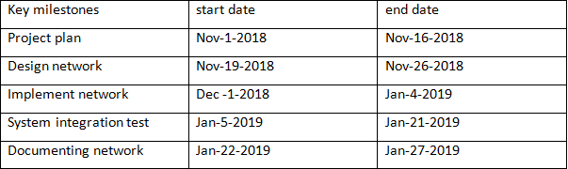

SCHEDULE AND GANTT CHART
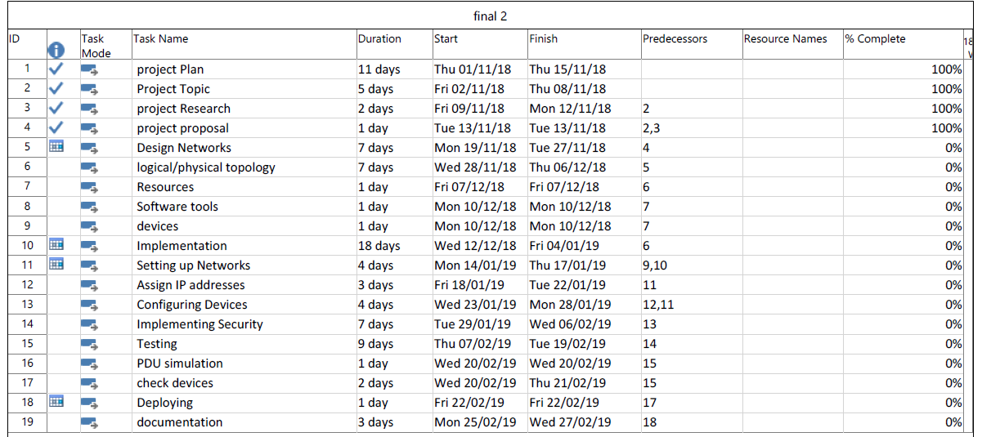
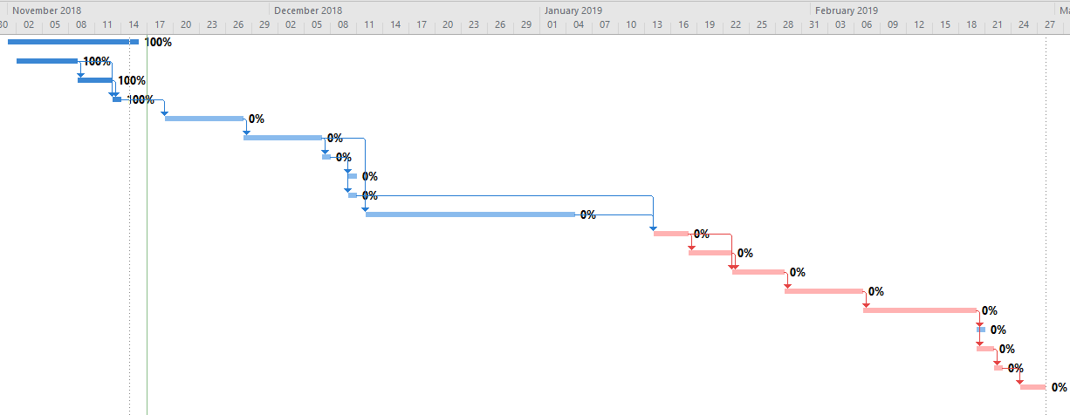

PROJECT RELATIONSHIPS
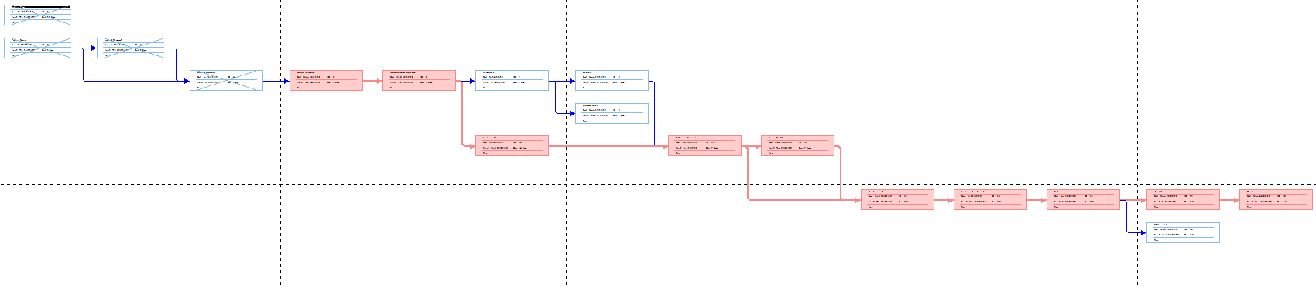

RESOURCES
In order for the project to be completed, below points are needed
- Members team for the project
- University of Wales Trinity St David IT staffs and Lecturers members.
- The accessibility of the Internet.
- Either Personal Computers or Laptops.
- Project, Ms-word, Excel and Packet tracer software.

PROJECT CONTROL
Progression for this project to be completed is shown on below diagram.

REFERENCES

[1] | “Department of Transport,” [Online]. Available: https://www.gov.uk/government/organisations/department-for-transport/about.

