Module: Developing Innovation and Creativity for Business Advantage.
Module code :BMSW6102_LON
Lecturer – Eijoro Esohwode
Student – Mantas Stonys
Student ID - 2029520

Table of Contents
1. Introduction 4
2. Innovative Product or Unique Service Proposition 4
2.1 Q-Delivery's Unique Service Proposition 4
2.1.1 Fresh and Quality Grocery Items 4
2.1.2 Competitive Pricing 4
2.2 Target Customers 4
2.3 Sales Channels 5
2.4 Venture Name 5
2.5 Sustainability of the Business Proposition 5
2.6 Competitive Landscape 6
2.6.1 Identification of Competitors 6
2.6.2 Points of Differentiation 6
2.6.3 Competitors' Strategies 6
3. eCommerce Implementation 6
3.1 Online Platform Selection 6
3.1.1 SaaS Options (e.g., Shopify) 6
3.1.2 Marketplace Considerations (e.g., Amazon, eBay) 7
3.2 Content Creation 7
3.2.1 Copywriting 7
3.2.2 Photography 7
3.3 Payment Services 8
3.3.1 Card Payments 8
3.3.2 PayPal 8
3.3.3 PCI-DSS Compliance 8
4. Marketing Strategy 9
4.1 Product/Service Promotion 9
4.1.1 Social Media (e.g., Facebook) 9
4.1.2 Paid Search Engines (e.g., Google) 9
4.2 Target Customer Identification 9
4.3 Customer Journeys 9
4.4 Email Marketing 10
4.4.1 Pre-launch Promotion 10
4.4.2 Gathering Email Addresses 10
5. Privacy and Data Protection 10
5.1 GDPR/Data Protection Act 2018 11
5.2 Privacy and Electronic Communication Regulations (PECR) 11
5.2.1 Consent Requirements 11
5.2.2 Opt-Out Mechanisms 11
5.3 Support for Rights such as "the Right to Erasure" 12
5.4 Security Measures 12
5.4.1 Secure Access to Cloud Provider 12
5.4.2 Default Access and Regular Changes 12
5.4.3 Encryption of Traffic in Transit and at Rest 13
6. Conclusion 13
7. References 14
Appendix 16
Task 2 16

1. Introduction
This business plan suggests Q-Delivery, an innovative online grocery delivery service that meets the changing needs of customers in central London, as a response to rising living expenses and economic challenges. Q-Delivery is driven by the need to offer fresh, high-quality groceries at affordable costs, as well as the constraints of conventional brick and mortar stores. In order to align the business with the needs of a market that is changing quickly, this introduction lays the groundwork for a thorough examination of Q-unique Delivery's service offering, eCommerce implementation, marketing strategy, and privacy and data protection considerations.

2. Innovative Product or Unique Service Proposition

2.1 Q-Delivery's Unique Service Proposition

2.1.1 Fresh and Quality Grocery Items
Delivering high-quality, freshly-picked groceries to homes in central London is how Q-Delivery sets itself apart. Using Ferreira et al. (2020)'s insights regarding the significance of dynamic capabilities and innovation in establishing a competitive advantage, Q-Delivery is dedicated to providing only the freshest and highest-quality products in an effort to cultivate customer satisfaction and loyalty.

2.1.2 Competitive Pricing
Q-Delivery strategically positions itself with competitive pricing in line with the economic challenges brought to light by Parliament.UK (2023). In an effort to give customers affordable options, this pricing strategy takes into account the growing expense of living. Q-Delivery's strategy of combining affordability and quality to establish a strong market position is supported by research by Azeem et al. (2021) that highlights the relationship between organizational culture, knowledge sharing, and competitive advantage.

2.2 Target Customers
Determining the intended clientele is essential to Q-Delivery's prosperity. According to Lestari et al (2020) .'s research on the causes and effects of innovation and business strategy for SMEs, urban households in central London that are looking for convenient and reasonably priced grocery options comprise Q-Delivery's main target market. The emphasis on this group is in line with the rising need for online shopping options in the present financial situation.

2.3 Sales Channels
Q-Delivery intends to use an online sales platform that will give consumers an easy-to-use interface for grocery shopping and browsing. In keeping with the observations made by Bresciani et al. (2021) regarding the influence of digital transformation on the innovation of business models, Q-Delivery acknowledges the significance of a flawless online purchasing experience. A dedicated website, the use of a SaaS platform like Shopify, and possibly taking part in well-known marketplaces like Amazon or eBay for greater exposure are among the suggested sales channels.

2.4 Venture Name
The venture will be aptly named "Q-Delivery," signifying both the quality of products delivered and the swift and efficient nature of the delivery service. This is consistent with the investigation of business strategies and competitive advantage by Farida and Setiawan (2022), which highlights the significance of a brand that embodies the company's core values and USPs.

2.5 Sustainability of the Business Proposition
In order to guarantee the longevity of Q-business Delivery's concept, the organization intends to consistently observe developments in the market and customer inclinations. Q-Delivery endeavors to cultivate an organizational culture that welcomes innovation and adjusts to shifting market conditions, drawing from research conducted by Arsawan et al. (2022) on the use of knowledge sharing and innovation culture for sustainable competitive advantage in SMEs.

2.6 Competitive Landscape

2.6.1 Identification of Competitors
Q-Delivery is up against competition in the London grocery delivery market from well-known online grocery retailers like Tesco, Sainsbury's, and Ocado as well as neighborhood supermarkets that provide their own delivery services. Comprehending the advantages and disadvantages of these rivals is crucial for Q-tactical Delivery's placement.

2.6.2 Points of Differentiation
Q-Delivery wants to set itself apart by providing a special blend of high-quality, freshly-picked goods at affordable costs. It differs from market leaders like Tesco and Sainsbury's with this approach because they may put scale before individualized care. The focus on freshness gives Q-Delivery a unique advantage in the market and is in line with the growing consumer desire for healthier and locally sourced options.

2.6.3 Competitors' Strategies
In order to obtain a competitive edge, Q-Delivery will examine the tactics used by major rivals. As recommended by Distanont and Khongmalai (2020), Q-Delivery can modify its delivery methods, product offerings, and marketing strategies by taking note of these industry leaders' experiences. By keeping abreast of rivals' innovations, Q-Delivery can improve its own business model and make sure it continues to be customers' first choice when it comes to grocery delivery that combines affordability and quality.

3. eCommerce Implementation

3.1 Online Platform Selection

3.1.1 SaaS Options (e.g., Shopify)
Choosing an appropriate web platform is essential for Q-Delivery's online presence. Making use of Software as a Service (SaaS) solutions, like Shopify, is consistent with the digital transformation suggestions made by Bresciani et al. (2021). Shopify offers an intuitive user interface that makes managing and setting up an online store easier. The scalability, customization options, and integrated payment solutions of this platform are what make it the best choice for a seamless client experience.

3.1.2 Marketplace Considerations (e.g., Amazon, eBay)
Apart from having a website of its own, Q-Delivery is thinking about incorporating well-known marketplaces such as Amazon or eBay into its eCommerce plan. This is consistent with the research on business model innovation using digital technologies conducted by Tohánean et al. (2020). By participating in these marketplaces, Q-Delivery can expand its reach and visibility while gaining access to preexisting clientele. To balance the benefits of greater exposure against any potential drawbacks and costs related to marketplace participation, however, careful thought is required.

3.2 Content Creation

3.2.1 Copywriting
Writing copy that effectively communicates Q-Delivery's unique service offering is essential. The website's content will highlight the freshness and quality of the grocery products in addition to their affordability, in line with Farida and Setiawan's (2022) insights regarding the importance of business strategies and competitive advantage. To captivate users and communicate Q-dedication Delivery's to providing an exceptional grocery shopping experience, copy will be written with clarity, persuasiveness, and the needs of the customer in mind.

3.2.2 Photography
Exquisite photography is essential to effectively presenting Q-Delivery's product line. Because product images are the primary source of decision-making for customers in the online grocery market, visual appeal is crucial. Q-Delivery intends to invest in professional product photography, motivated by research conducted by Distanont and Khongmalai (2020) regarding the contribution of innovation towards gaining a competitive advantage. This guarantees that the freshness and quality of the groceries are visually communicated on the website in a way that is consistent with the brand's USP.

3.3 Payment Services

3.3.1 Card Payments
Providing easy and safe ways to make payments is crucial to keeping customers happy. Taking credit card payments is in line with the desires of contemporary customers who want smooth transactions (Azeem et al., 2021). Customers will have a hassle-free checkout experience with Q-Delivery as they process card transactions through a secure payment gateway.

3.3.2 PayPal
Offering PayPal as a payment option in addition to card payments serves a wide range of customers. According to Ferreira et al. (2020), dynamic capabilities are critical for boosting competitive advantage. Integrating PayPal guarantees that Q-Delivery adjusts to changing customer preferences and is consistent with the dynamic nature of the digital payments market.

3.3.3 PCI-DSS Compliance
For Q-Delivery to maintain a strong cybersecurity posture, compliance with the Payment Card Industry Data Security Standard (PCI-DSS) is essential. Respecting these guidelines is essential to protecting consumer payment information (Parliament.UK, 2023). As required by industry regulations, Q-Delivery will put strong security measures in place, such as encryption of payment data, secure cloud provider access, and frequent evaluations to maintain PCI-DSS compliance.

4. Marketing Strategy

4.1 Product/Service Promotion

4.1.1 Social Media (e.g., Facebook)
Social media sites like Facebook offer effective means of advertising Q-Delivery's special offering of services. Lestari et al. (2020) have emphasized the importance of utilizing social media to promote novel products and services in order to expand one's audience. In order to engage with potential clients, Q-Delivery will create a Facebook presence and use promotions, targeted ads, and interesting content. In order to increase consumer engagement and loyalty, the idea is to build a community around the brand.

4.1.2 Paid Search Engines (e.g., Google)
Paid search engine marketing is a calculated move to raise Q-Delivery's exposure in search results, especially on Google. This is consistent with the study on the function of competitive advantage and business strategies conducted by Farida and Setiawan in 2022. In order to guarantee top placement when prospective clients look for pertinent keywords like "online grocery delivery London," Q-Delivery will invest in Google Ads. This focused strategy increases brand awareness and increases traffic to the Q-Delivery website.

4.2 Target Customer Identification
Q-Delivery's marketing strategy is based on identifying and comprehending its target customer base. Based on the ideas presented by Distanont and Khongmalai (2020), central London urban households are the main target market for Q-Delivery. This group looks for reasonably priced and easily accessible grocery options. In order to become the preferred online grocery delivery service for urban consumers, Q-Delivery will match its marketing efforts to the needs and preferences of this target market.

4.3 Customer Journeys
Providing a smooth and customized experience requires an understanding of and mapping of the customer journey. In line with the recommendations made by Bresciani et al. (2021) in their investigation of digital transformation, Q-Delivery will examine every touchpoint that clients experience from the point of initial awareness to the point of sale. Through the identification of these touchpoints, Q-Delivery is able to customize marketing messages and promotions at every turn, improving the customer journey overall and increasing conversion rates.

4.4 Email Marketing
Email marketing serves as a powerful tool for customer engagement and retention. Q-Delivery will implement a comprehensive email marketing strategy, drawing insights from various studies and regulations.

4.4.1 Pre-launch Promotion
Q-Delivery will launch an email marketing campaign during the pre-launch phase in order to build anticipation and collect email addresses for follow-up correspondence. This strategy is in line with Tohánean et al. (2020) recommendations for using digital technologies to innovate business models. Encouraging people to share their email addresses with Q-Delivery through exclusive promotions or early access gives the company a useful database for future marketing initiatives.

4.4.2 Gathering Email Addresses
It is essential to manage the collection of email addresses in accordance with privacy laws. The Data Protection Act of 2018 and the General Data Protection Regulation (GDPR) mandate that explicit consent be obtained before sending any emails (Parliament.UK, 2023). Q-Delivery will use open opt-in procedures and make clear why email addresses are being collected. By doing this, privacy laws are complied with and a permission-based email list for focused marketing campaigns is created.

5. Privacy and Data Protection
Ensuring strong privacy and data protection measures is essential for online businesses to succeed and be reputable in the digital age. Q-Delivery incorporates important components from the GDPR, Data Protection Act 2018, Privacy and Electronic Communication Regulations (PECR), and security best practices because it understands how important it is to protect customer data and privacy.

5.1 GDPR/Data Protection Act 2018
The cornerstone of Q-Delivery's commitment to data protection is compliance with the General Data Protection Regulation (GDPR) and the Data Protection Act 2018. (Parliament.UK, 2023). Q-Delivery shall comply with the regulations' guiding principles, guaranteeing that customer data is processed in a lawful, transparent manner and for the intended purposes. Putting strong data security measures in place is in line with Ferreira et al (2020) research, which highlights the value of innovation and dynamic capabilities in boosting competitive advantage.

5.2 Privacy and Electronic Communication Regulations (PECR)
In addition to GDPR, Q-Delivery acknowledges the importance of complying with the Privacy and Electronic Communication Regulations (PECR) to govern electronic communications. This includes marketing communications and the use of cookies.

5.2.1 Consent Requirements
Q-Delivery will closely follow the PECR's consent requirements for email marketing and other electronic communications. It is best practices to acquire customers' express and informed consent before sending them marketing communications (Parliament.UK, 2023). This strategy emphasizes the value of ethical data practices and is consistent with Tohánean et al. (2020) findings about business model innovation through digital technologies.

5.2.2 Opt-Out Mechanisms
Q-Delivery recognizes the need for robust opt-out mechanisms in its electronic communications. Offering users a clear and straightforward way to opt-out of marketing communications aligns with the principles of transparency and user control advocated by privacy regulations. The implementation of opt-out mechanisms also supports customer satisfaction and trust, as highlighted by Azeem et al. (2021) in their exploration of expanding competitive advantage through organizational culture and innovation.

5.3 Support for Rights such as "the Right to Erasure"
Supporting consumer rights, such as "the Right to Erasure" as outlined in the GDPR, is a priority for Q-Delivery. Clients will be able to ask for the deletion of their personal information, and Q-Delivery will make sure that these requests are handled quickly and in accordance with data protection laws. This strategy fits in with the focus on individual rights protection and customer-centric practices that Arsawan et al. (2022) covered in their study on using innovation culture and knowledge sharing to gain a sustainable competitive advantage.

5.4 Security Measures
The security of customer data is paramount for Q-Delivery's operational integrity and customer trust. The implementation of robust security measures aligns with the research of Bresciani et al. (2021) on digital transformation as a springboard for innovation.

5.4.1 Secure Access to Cloud Provider
A fundamental security measure for Q-Delivery is guaranteeing safe access to the cloud provider. Adhering to industry best practices involves putting in place stringent access controls, multi-factor authentication, and routine monitoring. This method emphasizes the need for frequent access modifications and restricted permissions in order to address the sensitive nature of default access (Bresciani et al., 2021).

5.4.2 Default Access and Regular Changes
Recognizing the importance of default access and its potential vulnerabilities, Q-Delivery will implement stringent measures to control default access. Regularly changing access credentials and permissions ensures that only authorized personnel have the necessary privileges, reducing the risk of unauthorized access (Bresciani et al., 2021).

5.4.3 Encryption of Traffic in Transit and at Rest
Q-Delivery is going to put encryption mechanisms in place to protect client data both during transmission and storage. Sensitive data is kept safe and out of the reach of unauthorized parties by encrypting communication both in transit and at rest. In their investigation of business strategies and competitive advantage, Farida and Setiawan (2022) emphasized the importance of data protection and customer trust, which is in line with this security measure.

6. Conclusion
The proposed business plan for Q-Delivery incorporates creative and inventive tactics that have been well-researched to foster creativity and innovation for commercial benefit. Q-Delivery endeavors to effectively navigate the unsteady economic landscape by placing a high priority on the delivery of fresh and high-quality groceries at competitive prices, utilizing an intuitive online platform, and putting strong privacy and security measures in place. This all-encompassing strategy prioritizes customer satisfaction and ethical business practices while keeping Q-Delivery competitive in the online grocery delivery market. It also conforms to modern business insights.

7. References
Arsawan, I. W. E., Koval, V., Rajiani, I., Rustiarini, N. W., Supartha, W. G., & Suryantini, N. P. S. (2022) Leveraging knowledge sharing and innovation culture into SMEs sustainable competitive advantage. International journal of productivity and performance management, 71(2), 405-428.
Azeem, M., Ahmed, M., Haider, S., & Sajjad, M. (2021) Expanding competitive advantage through organizational culture, knowledge sharing and organizational innovation. Technology in Society, 66, 101635.
Bresciani, S., Huarng, K. H., Malhotra, A., & Ferraris, A. (2021) Digital transformation as a springboard for product, process and business model innovation. Journal of Business Research, 128, 204-210.
Distanont, A., & Khongmalai, O. (2020) The role of innovation in creating a competitive advantage. Kasetsart Journal of Social Sciences, 41(1), 15-21.
Farida, I., & Setiawan, D. (2022) Business strategies and competitive advantage: the role of performance and innovation. Journal of Open Innovation: Technology, Market, and Complexity, 8(3), 163.
Ferreira, J., Coelho, A., & Moutinho, L. (2020) Dynamic capabilities, creativity and innovation capability and their impact on competitive advantage and firm performance: The moderating role of entrepreneurial orientation. Technovation, 92, 102061.
Lestari, S. D., Leon, F. M., Widyastuti, S., Brabo, N. A., & Putra, A. H. P. K. (2020) Antecedents and consequences of innovation and business strategy on performance and competitive advantage of SMEs. The Journal of Asian Finance, Economics and Business, 7(6), 365-378.
Parliament.UK. (2023) Rising cost of living in the UK - House of Commons Library. [ONLINE] Available at: https://commonslibrary.parliament.uk/research-briefings/cbp-9428/. [Accessed: 5 December 2023].
Tohãnean, D., Buzatu, A. I., Baba, C. A., & Georgescu, B. (2020) Business model innovation through the use of digital technologies: Managing risks and creating sustainability. Amfiteatru Economic, 22(55), 758-774.

Appendix

Task 2
Slide 1

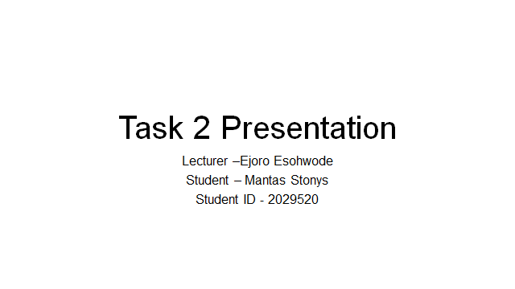

Slide 2



Slide 3
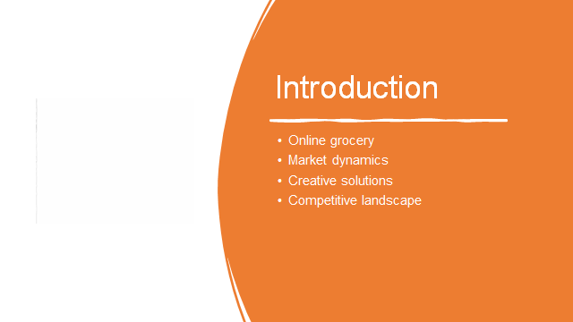

Slide 4



Slide 5

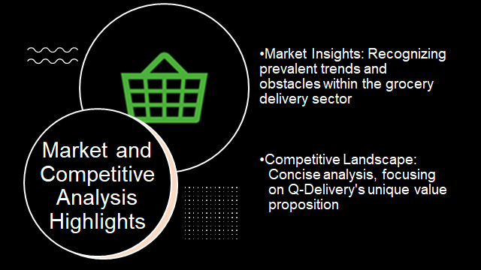

Slide 6

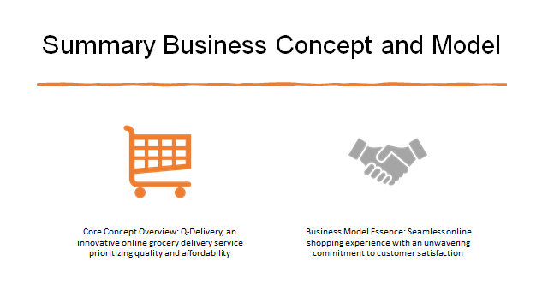

Slide 7

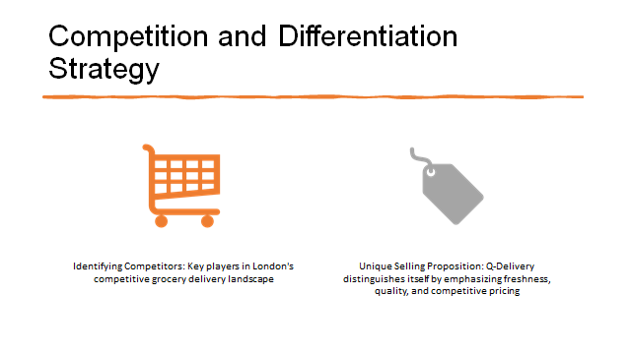

Slide 8



Slide 9



Slide 10



Slide 11



Slide 12



Slide 13

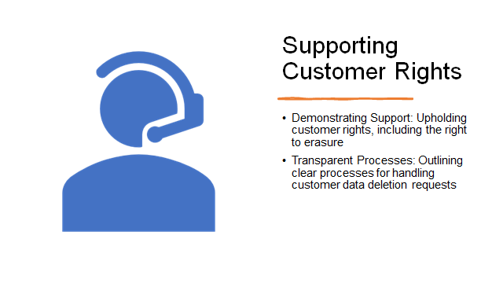

Slide 14

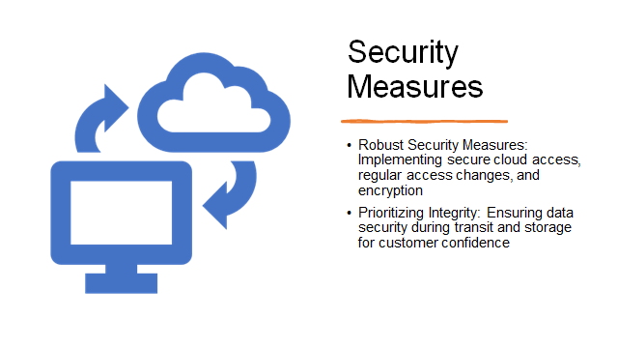

Slide 15



Slide 16



