
PROFESSIONAL CAREER DEVELOPMENT
RESIT


Florin Negurita
1913524
October 30, 2020
University of Wales Trinity Saint David

Contents

Introduction 2
SWOT Analysis 3
Learning Styles 5
SMART Goal 7
Personal Development Plan 8
Conclusion 10
References 11
Appendices 12

Introduction

This report has the purpose of sharing my experience with the Professional Career Development module, but also making a development plan for my career, using all the theories learned. I want to start by saying that the biggest challenge that I have encountered during the lectures was to be honest with myself and getting to know myself more. On the other hand, I tried my best to organize my time properly, even though this is not one of my strengths, and keep up will all the information received.
Now, that the module is finished, I can honestly say that I became more organized, and I learned how to apply the theories encountered in this module in my professional and personal life as well. Also, I consider that all the theories such as the SWOT Analysis and the learning questionnaires made me more aware of myself, while the SMART Goal and the Personal Development Plan became tools that I include in my day to day life.
In this reflective report I will analyze myself using the SWOT Analysis, to see exactly what my Strengths and Weaknesses are, but also to see what Opportunities I have, and what Threats I might face. The next step is to find what learning style is suitable for me, and for this I will use two different questionnaires, VARK and Honey & Mumford. After I will have enough information about myself, I will present my SMART Goal, and I will explain why it is smart. Lastly, based on all the facts, I will create a Personal Development Plan that will help me improve and achieve my goal.

SWOT Analysis

The SWOT Analysis is a simple, yet effective tool used to determine the Strengths, Weaknesses, Opportunities and Threats that a person might have (MindTools, 2020). This analysis is a connection between the internal factors, Strengths and Weaknesses, and external factors, Opportunities and Threats (Gürel, 2017, p. 995.) The purpose of this tool is to identify how to build and work with the strengths to identify potential opportunities, how to minimize the impact of the weaknesses and how to get rid of any threats (MindTools, 2020).

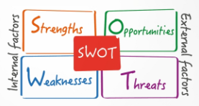

Figure 1. SWOT Analysis

My SWOT Analysis is represented by the following:
Strengths
I am confident that my biggest strength is my resilience, because I can easily adapt to new situations, and I can work in stressful conditions. I gained this strength by working in hospitality for many years, which is a fast-paced environment, where each day is different, and there are plenty of difficult situations. The hospitality industry also helped me develop other skills, such as critical thinking. I consider myself being a rational man, and I have the habit to analyze all the information that I have regarding a subject before having an opinion about it. My critical thinking developed into problem solving skill. Because I can rationally analyze the facts, I usually find the most effective solution to a problem. At the same time, I am a very patient person, and this trait is helping me to not act out of impulsive. Another strength is that I am a fast learner. Communication is also a strength for me because I am always trying to effectively communicate with the people around me. The last strength that I consider I have is digital skill because I can easily work on various applications, and being a fast learner as well helped me in various situations.
Weaknesses
I can only think of 3 weaknesses, but they are truly the biggest ones, that affected me a lot during my entire life. First of all, I admit I am unambitious. I feel good in my comfort zone, and I rarely want more from my life. I was never the person that chased dreams, perhaps I am too rational. The second fact is that I am quitter. I give up way too easy, even though I am patient. I usually tend to start things, but I never finish them, which I know it is not the best thing. The final weakness is the time management. I cannot organize at all, I always do all the things in the last moment, and I am usually late everywhere. It was hard for me to admit these weaknesses, but I hope I can work on them.
Opportunities
I think one of the biggest opportunities that I have is this course because I learn a lot of new and exciting things that can help me not only in my career, but also in my personal life. At the same time, I am obtaining the Certificate in Higher Education, that will definitely improve my CV. Another opportunity for me is that I have lots of experience in hospitality, which can help me advance at my workplace, and it also prepared me to potentially own a café in the near future. I also think that the country that I currently live in, United Kingdom, is a country full of opportunities for people, and the government is trying to help everyone with different types of funding, for studies, for living, for opening a business etc.
Threats
I think that the biggest threat that I have is myself. Being a quitter, I am afraid that If I would face difficult situations, I would think that is easier to quit than to continue what I already started. Another threat might be the loss of opportunities because I will not be ambitious enough to obtain them. Also, living in a small town like Swansea, does not offer me enough opportunities to grow in my career.

Learning Styles

Now that I have identified my Strengths, Weaknesses, Opportunities and Threats, it is time to see how I can better assimilate the information, and what learning style is suitable for me. For this, I will apply two questionnaires to myself, VARK and Honey & Mumford.
VARK
The VARK theory, which stands for Visual, Aural, Read/Write and Kinesthetic, is used to identify what type of learner a person is (Othman, Amiruddin, 2010, p. 655). According to Drago and Wagner (2004), the students that prefer the Visual type of learning are usually attracted by diagrams, charts, demonstrations, and they can be easily disturbed by movements or actions. On the other hands, according to Miller (2001), Aural students tend to better learn only by listening, and they usually remember things only by reading out loud. The Reading individuals are more attracted to text in any formal, no matter if it is digital or not (Vark, no date). Finally, the Kinesthetic people have a strong preference for senses and to practice themselves the information received (Vark, no date).
My results for the VARK questionnaire are:
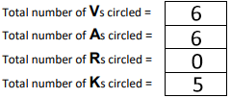
Figure 2. VARK questionnaire results

Based on the results of this questionnaire, it is clear that my learning style is a combination between Visual and Aural. That means that I can easily learn either by looking at charts, diagrams, or demonstrations, as well as by hearing someone talk about a certain topic, or by repeating or reading things out loud. I can say that this result is accurate, because through the years, I have noticed my preference for charts especially, and I also noticed that when I have for an exam, I prefer to read the information out loud, or to have someone that can explain the information to me. On the other side, I am definitely not a fan of reading, because I cannot focus on the information, especially if it is written way too formal. At the same time, I noticed that sometimes, for example when I use the computer, I tend to learn how to work in a certain program by practice.
Honey & Mumford
Another important learning theory is the one developed by Peter Honey and Alan Mumford in 1986, in which they presented 4 distinct styles of learning. The first one is the Activist, and this style is represented by people who act first, and think of the consequences later, while they are trying new things (Rosewell, 2015. p. 2). The second style is the Reflector, which is represented by the individuals who learn by observing and examining all the perspectives of the information received before making an opinion (Rosewell, 2015, p.3). The following style is the Theorist, and this is represented by the people who must understand the reason and the theory behind every action (Rosewell, 2015, p.4). The final style is the Pragmatist, and this is mostly represented by the individuals who are questioning the theory, and want to put it in practice, to make sure that is works (Rosewell, 2015, p.5).

My results for the Honey & Mumford questionnaire are:
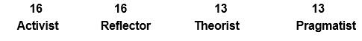
Figure 3. Honey & Mumford questionnaire results

My results indicate that my style is a combination of Activist and Reflector. These results are accurate, because I can see the characteristics of both styles in my SWOT Analysis, at the Strengths section. I am a person who likes to investigate all the facts before having an opinion, or before taking a decision, and I consider myself capable of solving problems. Also, the fact that I am patient is definitely helping me to take my time to better understand all the information that I receive, and that I must learn.

SMART Goal

Now that my self-assessment is complete, and I am aware of my Strengths, Weaknesses, Opportunities and Threats, as well as the learning styles suitable for me, I can use the information gathered to build my SMART Goal.
SMART is a tool successfully used when there is a need of planning or achieving a certain target or goal (MindTools, 2020). The acronym stands for Specific, because the goal must be simple and significant, Measurable, because the goal must be meaningful and motivating, Achievable, because the goal must be attainable, Relevant, because the goal must be reasonable and realistic, and Timely, because the goal must be time-based (MindTools, 2020).
My goal is to become a café owner in 3 years, by investing time in myself, to gain the skills needed: Time Management, Decision Making, and to train myself to not give up when it is difficult.
I consider my goal to be SMART because:
- It is Specific – I want to become a café owner in 3 years from now, and I will invest in myself to gain all the skills and attitudes that I need. This goal is significant for me, because even though it is a simple action, it requires a lot of hard work and dedication.
- It is Measurable – I know I will be a step closer to my goal when I will achieve the Time Management Skill, the Decision Making Skill and when I will be able to not quit when I will be in difficult situations. When I will possess all these, I will consider myself ready to start my own business, because I will know for sure that I will not fail.
- It is Achievable – I have all the resources needed to achieve the skill that I need to become a café owner. I study towards my Level 4, I have the financial resources, and I have the time to invest in myself.
- It is Relevant – I want to open a business in the field in which I have almost my entire work experience, because I was working as a bartender, chef, and waiter for a long period of time, and I enjoyed every second of it. This is the reason why I want to own a café, because I feel most comfortable doing all the things that I already know, and I am willing to learn new things, that can make me achieve my goal.
- It is Timely – I have given myself 3 years to learn and develop every skill and attitude that I need in order to achieve my goal. I think 3 years is very reasonable, because I can have plenty of time to practice everything that I learn at this course and face all the challenges.

Personal Development Plan
The Personal Development Plan is a tool used by people who have a SMART goal, but they need a clear vision of each step that they must make in order to achieve their goal. This plan can keep the people motivated to continue to pursue their goal, because every action is detailed, and they can keep record of the progress (Skills You Need, 2011).
My Personal Development Plan is:
Development Objective | Specific Actions | Barriers and how they will be removed | Support required | How will I know I achieved the objective
Time Management | I will try to make use of the fact that I am a Visual learner, and I will use lists and charts to organise my time. | I might not be able to keep up with the schedule that I made. | I will need support from everyone around me, to help me improve my Time Management. | When I will be able to respect the schedules that I made.
Decision Making | I will start by analysing every situation more carefully, to be able to make a decision while taking everything into consideration, without pressure. | The barriers are every new challenge or situation, and the pressure that I must make the right decision. | Support from teachers, colleagues, family, and friends to give me more opportunities to make decisions that will have a meaningful effect. | When I will constantly make decision and I will be confident that they are the right ones.
Motivate and train myself | I will push myself to finish any task that I will receive. | I will feel overwhelmed by difficult situations, or I will consider that a task is not important enough to be finished. | I need to support from friends and family, to remind me why I am working for. | When I will not feel the impulse to quit and to have unfinished tasks.

Conclusion

During each Professional Career Development lecture, I got the chance to improve myself by applying various theories on myself, with the purpose of getting to know me better, so I can figure it out how I can achieve my goals. I have to face many challenges, but I think that my biggest achievement is the fact that I am now more self-aware, and I accepted my weaknesses, and I feel motivated to make them have a lower impact in my life.
This module made me believe that if I stick with my plan, I can achieve any goal, as long as it is SMART. Also, it made me think that maybe I could not succeed in the past because my expectations were too high, unrealistic, and unreachable. I am excited to continue to practice everything that I have learned in this module, because I find everything interesting, useful, and motivating.
In conclusion, I think that this module helped me see what I want to do further in my career. By using the SMART theory, I was able to put my ideas together, to figure it out what I truly desire from my life, and it helped me to create my Personal Development Plan, that will be useful to track every little progress and remain motivated.

References

- 50minutes (2016) The SWOT Analysis. [Figure]. Available at: https://www.50minutes.com/title/the-swot-analysis/ (Accessed: 26 October 2020).
- Drago, W. A., & Wagner, R. J. (2004). VARK preferred learning styles and online education. Management Research News, 27(7), 1-13.
- Gürel, E. (2017) ‘SWOT Analysis: A Theoretical Review’. The Journal of International Social Research, 10 (51, August), p. 995. [Online]. Available at: https://www.researchgate.net/publication/319367788_SWOT_ANALYSIS_A_THEORETICAL_REVIEW (Accessed: 26 October 2020).
- Miller, P. (2001). Learning styles: the multimedia of the mind: ED 451340. [Online]. Available at: https://archive.org/stream/ERIC_ED451140/ERIC_ED451140_djvu.txt (Accessed: 26 October 2020).
- MindTools (2020) SMART GOAL. How to make your goal achievable. Available at: https://www.mindtools.com/pages/article/smart-goals.htm (Accessed: 27 October 2020).
- MindTools (2020) SWOT Analysis: How to Develop a Strategy For Success. Available at: https://www.mindtools.com/pages/article/newTMC_05.htm (Accessed: 26 October 2020).
- Othman, N., Amirrudin, M. H. (2010) Different Perspectives of Learning Styles from VARK Model. International Conference on Learner Diversity 2010.
- Rosewell, J. (2015) Learning Styles. The Open University, pp. 1-5. [Online]. Available at: https://www.open.edu/openlearn/ocw/pluginfile.php/629607/mod_resource/content/1/t175_4_3.pdf (Accessed: 27 October 2020).
- Skills You Need (2011) Personal Development Planning. Available at: https://www.skillsyouneed.com/ps/planning-personal-development.html (Accessed: 27 October 2020).
- Vark. (no date) VARK. A guide to learning preferences. Available at: https://vark-learn.com/ (Accessed: 26 October 2020).

Appendices

- VARK questionnaire:
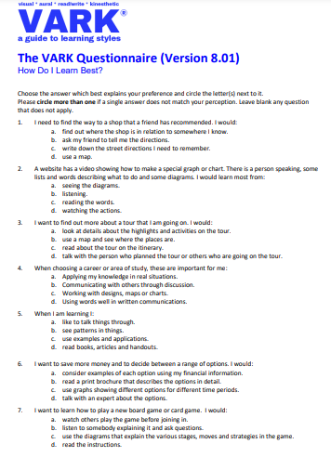

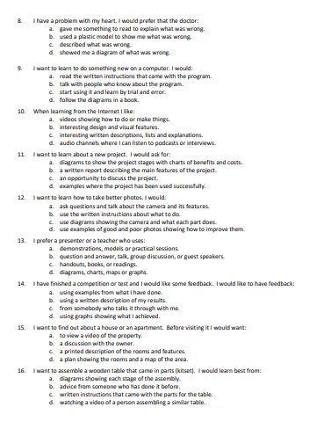

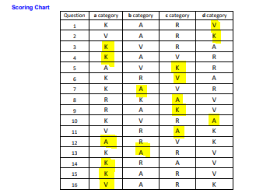

- Honey & Mumford questionnaire


