Name:_________________________________

Student Number: ________________________
__________________________________________________________

WORKSHEET 3 – TESTING (Chickens)

- Original code:
[Copy and paste your original code from Moodle into this box. Do not change it.]

Food = ["1.Normal", "2.SuperMix"]
print(Food)
FoodType = input("What type of food did you feed the Chicken")

Days = int(input("How many days has your chicken been laying eggs"))
NewDays = 0
NumberOfEggs = 0

if Days < 0:
print("Can't be less than 0")
else:
if FoodType == "2":
NewDays = int(Days * 1.5)
NumberOfEggs = int(NewDays)
print(f'You have {NumberOfEggs} Eggs!')

if FoodType == "1":
NumberOfEggs = Days
print(f'You have {NumberOfEggs} Eggs!')

NumberOfCakes = int(Days / 2)

if FoodType == "2":
NumberOfCakes = int(NewDays / 2)
print(f"You can make {NumberOfCakes} Cakes")
else:
NumberOfCakes = int(Days / 2)
print(f"You can make {NumberOfCakes} Cakes")

if NumberOfEggs > 1000:
print("That's too many eggs")

Code Testing

For each test below, run your code and enter the values provided. Provide a screenshot of what happened when the programme ran. Did the programme behave correctly or did it do something unexpected? Fill in a box for each test below. You should present 8 separate boxes, 1 for each test. (Note: the first box is provided as a template)

Normal food
i. 4 days (should be 4 eggs = 2 cakes)
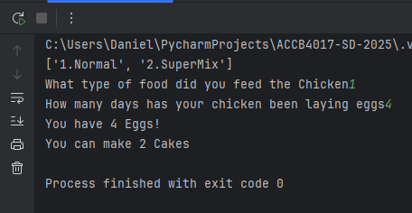
ii. 9 days (should be 9 eggs = 4 cakes)
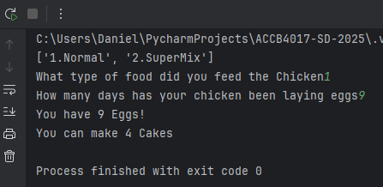
iii. -3 days (no cakes or error handled)
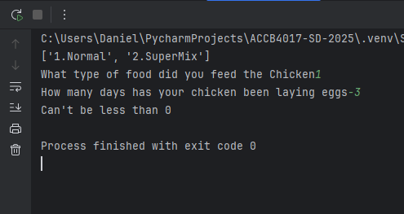
iv. 10000 days (program should catch the error – many of these eggs would be bad!)
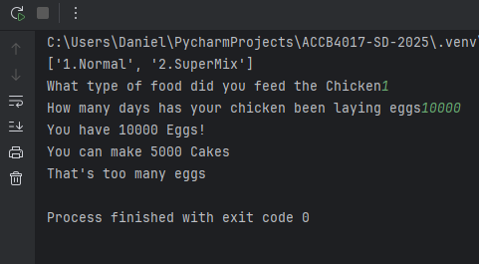

Superfood
v. 4 days (should be 6 eggs = 3 cakes)
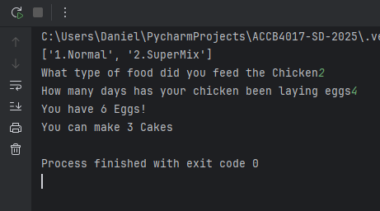
vi. 5 days (should be 7 eggs = 3 cakes)
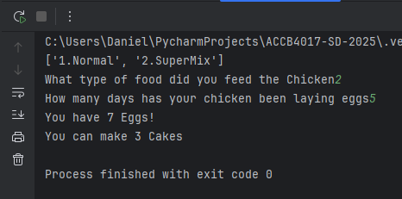
vii. 1 days (should be 1 egg = 0 cakes)
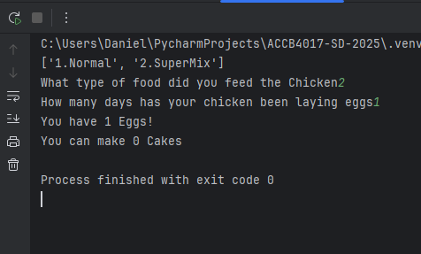

Test your menu
viii. What happens if you enter “3”?

Test:
Normal food i) 4 days

Screenshot(s) of output:
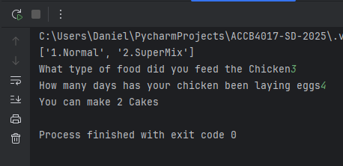
Result: Did the program behave as expected ie syntactically and logically correct?
YES
It defaulted to normal food

If NO, what problems were encountered and why? Suggest how things could be improved.

(Copy and paste box above for each of the rest of the tests)

- Consider the results of the above tests and revisit your original code in order to address the tests that failed. (Note: you may not be able to solve all of the problems that were originally encountered, but solve as many as you can.)

Paste your full revised code here :

[Copy and paste your full revised code here – note, do not use a screenshot]

