  Component One:  What are the key skills required when working in the housekeeping team? 750 words (+/- 10%)  Contribution to Overall Module Assessment: 25% | Student No: | 2207349
 | Module Title: | Operating Hotel Facilities
 | Module Code: | BMIH4006
 | Lecturer: | Lisa Knight
The contribution that placement took part on building personalised experiences had effective result in expanding knowledge regarding housekeeping department. Housekeeping is an extremely important part of a hotel and gathering insights about it, made understanding the circumstances and processes that must be fallowed much easier. Regarding the skills that a housekeeping team requires when working in this sector, based on the attributions that a housekeeper has, a mix of soft and hard skills are required. The soft skills gathered during working on hospitality industry had been extremely helpful, as a housekeeper must display interpersonal skills, being able to interact with their co-workers and customers as well. Friendliness and politeness are verry important factors who are to shape the form of a good colleague over the time. (Axelrod and Tieperman)
Another important skill that a housekeeping employee must develop and have well use of, is time management. Knowing exactly what they have to do and when, having a schedule in place and being able to fallow it, will make the job much easier and organised, not allowing to get lost into the variety of jobs that must be done in an allocated time. (UPCA)
Many soft skills contribute to a good employee and developing them leads to achieving the brand standards. Other soft skills like problem solving and self-discipline are required in order to manage to do the job properly. For example, during placement, after finishing the rooms, one of the customers was not happy regarding the way that the bathroom was cleaned and asked to speak with the person responsible for that. Being still there, happily discussed with the customer and, after apologising, the process of cleaning the bathroom was retaken, and the problem was quickly fixed. During the process of fixing the problem, being able to have a conversation with the customer regarding different subjects managed to keep him distracted from the problem while it was fixing it and at the end of the situation, the customer was happy that all was clean and had a nice conversation with me, while I was delighted that I fixed the problem and the customer was pleased.
The hard skills that a housekeeper must develop by training and learning for performing their job are specific to the various tasks they get. All the cleaning activities, as mopping, dusting, dep cleaning and many more, have a specific way to be done, depending on the organisation. (Indeed) For example, at Premier Inn, the housekeeping teams must make the beds in a specific way, as per elephant ears on the bed corners. With practice and training, these specific ways are providing standards for its company who has high demands, especially from the housekeeping team, as the standards must be meet.
A example of good practices is in place at Premier Inn regarding training and offering the best start for the employees. They have in place an online platform named Academy Online. On the website, each employee gets a login username and password, and they have to complete the trainings provided there. All the information offered are there to provide proper training and tests as well in order to make sure tat the company have informed and prepared staff, at the highest standards.
Spending time on the academy online made understanding easier, with many details offered on point, details that would be maybe forget by a person who could do training in person.
Spending time on the housekeeping area help on building a better future employee, as managing to complete all the tasks required within this department, on time, and being able to see the jobs that a housekeeper has and how the development of the skills required reach achievement, better shaped a future manager view and understanding on the importance and the difficulty that this position has.
During placement, being part of the housekeeping team, helped gathering many improvements regarding hard skills, as learning each step that the teams must comply in order to get the job done. Training regarding cleaning tools and solutions had been provided as not much information regarding this area had ben provided in the past.
After finishing placement, a strong insight regarding housekeeping will contribute to development of a much informed and prepared manager, with many activities already practiced. A better understanding of the whole subject will make the manager job easier, as after this experience, the future manager will be well prepared in regards the problems and tasks that will fallow, easing the process of managing.

Word Count | 747

Component Two:
Contribution to Overall Module Assessment: 25%
In this scenario – You have just been promoted to team leader for a floor within the hotel. A guest complains that on their arrival, their room had not been properly cleaned. Create an action plan and answer the following questions.

Problem | Why did it happen? | What are you going to do? | How will you prevent this from happening in the future? | What measures would you introduce to improve team effectiveness?
Dirty duvet cover | Rejected linen not observed | Apologise  Ask housekeeping to change the duvet | Special area designed for rejected linen better signalised | Implementing checklist
Dirt on floor | Room not hoovered | Apologise  Housekeeping will remove the dirt | Retrain the housekeeper regarding the cleaning process | Arrange team meetings monthly to make sure that al the work is done effectively
Dirty mirror | Have not been used the proper cleaning equipment | Apologise  Housekeeper will clean properly with the right products | Make sure that the cleaning products are properly labelled and clothes in the right place | One-to-one conversations regarding feedbacks received
Hair on the bathroom floor | Floor not properly checked at the end with a white tissue | Apologise  Housekeeping cleaning the hair | Pay much better attention to details and ensure final checks are done | Engage in proper planning and rapid execution
Dust on the table | Missing tool | Apologise  Clean | Ensure that trolley is fully equipped | Develop PowerPoint presentation to be displayed at team meetings

Component Three:
Contribution to Overall Module Assessment: 50%
Your task is to create and prepare a presentation following the detailed scenario provided below.

As the floor housekeeping manager and given the recent guest complaints you need to put together a basic training presentation for your colleagues within the housekeeping team to get the best out of them, ensure that brand standard is being achieved and that Health and Safety procedures are also being followed.

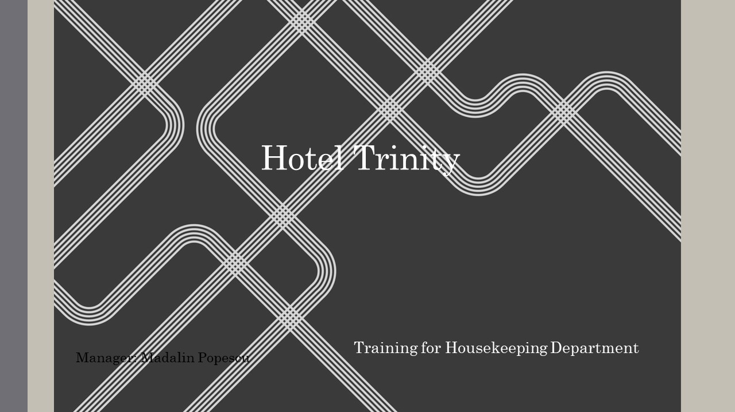

Training Notes: As Mullins and Dossor states in their book, “Level of work performance are determined not only by the ability of the staff but also by the strength of their motivation.” (Mullins and Dossor,2013).
Preparing this presentation, the Management Team of Hotel Trinity expects to provide a training refreshment because of the past events which occurred within the hotel and provided some bad feedback from our customers. With emphasise on the fact that we are a team and each member counts, will be reminded our brand standards, as well as some basic practices that must be fallowed at your place of work. Please fallow the slide ahead.
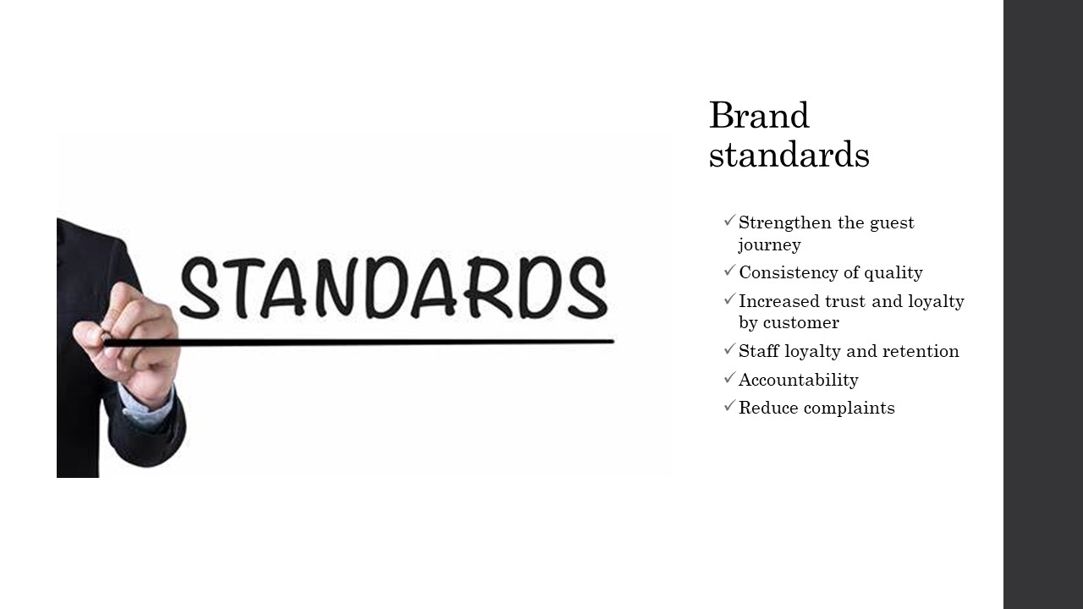

Training Notes: Hotel Trinity brand’s standards are always displayed in our meetings, reminding all our employees our references points. Brand Standards should be number one on your list of priorities to ensure a high standard of great service is offered. (Hospitality Audit Services, n.d.) We must make sure that as a housekeeping team, we do our best to reduce complaints, increase trust and loyalty of our customers and the most important factor is that we are consistent in our service quality that we offer. Housekeeping area is extremely important when it comes to services, and we must make sure that our customers are delight regarding the creaseless of our hotel.

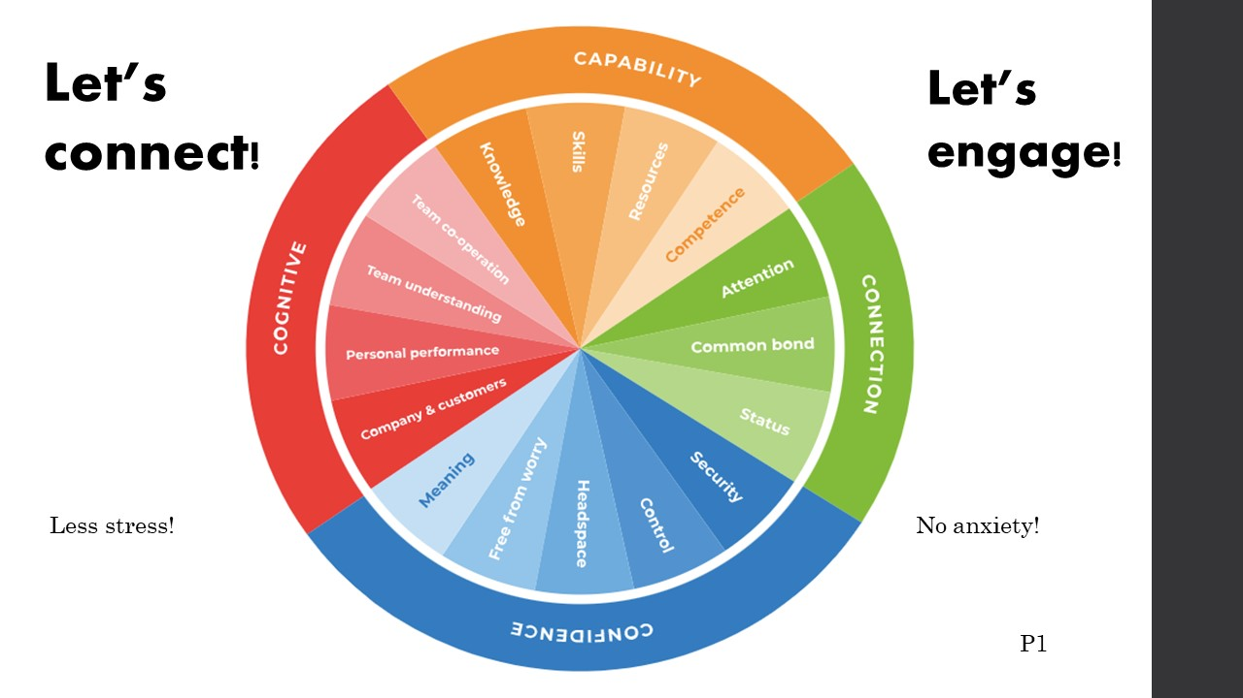

Training Notes: In order to make sure that all our employees are doing them jobs right, we must make sure that all 4 C areas shown in the slide are meet. Connection, confidence, cognitive and capability are the main areas that we must work with our employees in order to obtain the best results. We strive to offer the best experiences in all areas. The trainings provided along with the skills that employees develop over the time, makes them more competent in their jobs. When problems occur, do not hesitate to contact us, as we have a common bond, and our attention is yours. We can do this together!

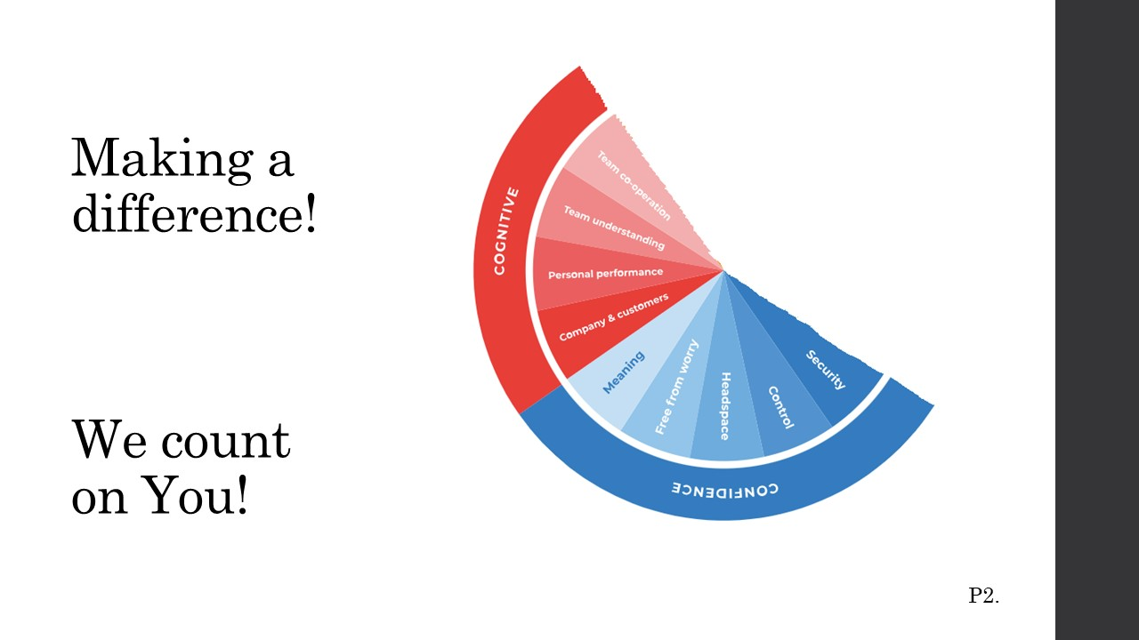

Training Notes: Making sure that our employees feels free from worries , secure and in control, we strive to work towards reassuring you that our employees are first in our lists of priorities. Your services are extremely important, and we must make sure that you feel secure, free from worries so that your performances can go high as expected. Your services create bond between customers and company. As a team, we expect understanding and cooperation, and each personal performance added together, to get the best outcome from our work.
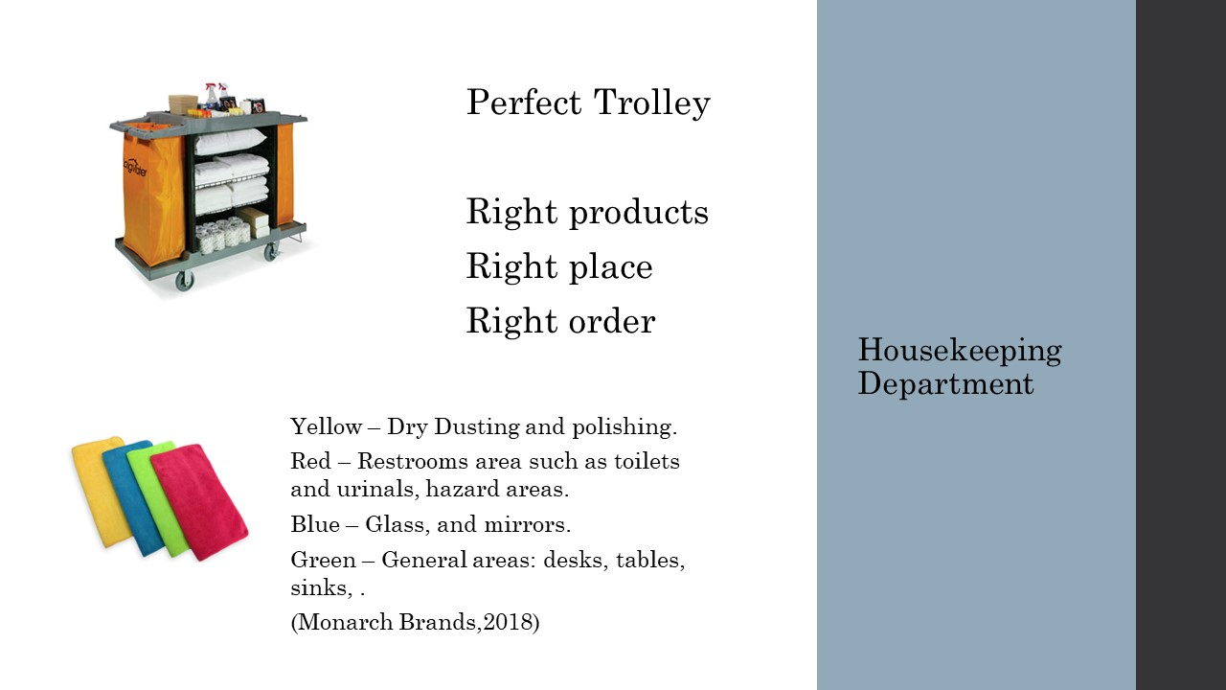

Training Notes: As a housekeeper, to make sure that the day will get the best start, and on the right tracks, the trolleys must be equipped with all the necessary products in order to make sure that the day will go smooth and without any interruptions by going up and down on the stairs from the rooms to the supply store . Make sure that before leaving work, trolleys are top-up and ready for the next day. Another problem is regarding the order that the products for cleaning are used. Make sure that the clothes are used properly, fallowing the directions on the slide. Being enthusiastic, using the right tools and finishing the job in time represents the best employee. And we count on you!

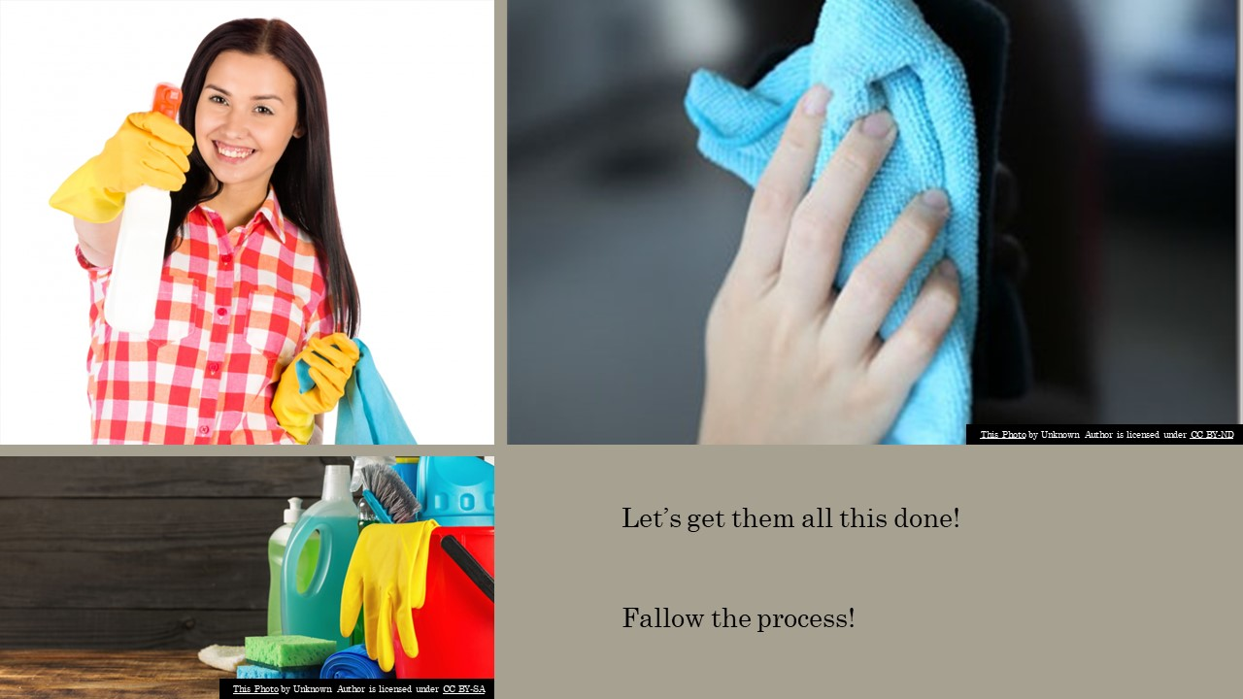

Training Notes: Please pay particular attention when cleaning, especially for the items involving direct contact with guests, including bedding, linen and towels. Baths, showers and WCs must be proper cleaned. As well make sure that all walls, ceilings, pipes, ledges, equipment and fittings, which are beyond reach from floor level, cleaned on a regular basis.
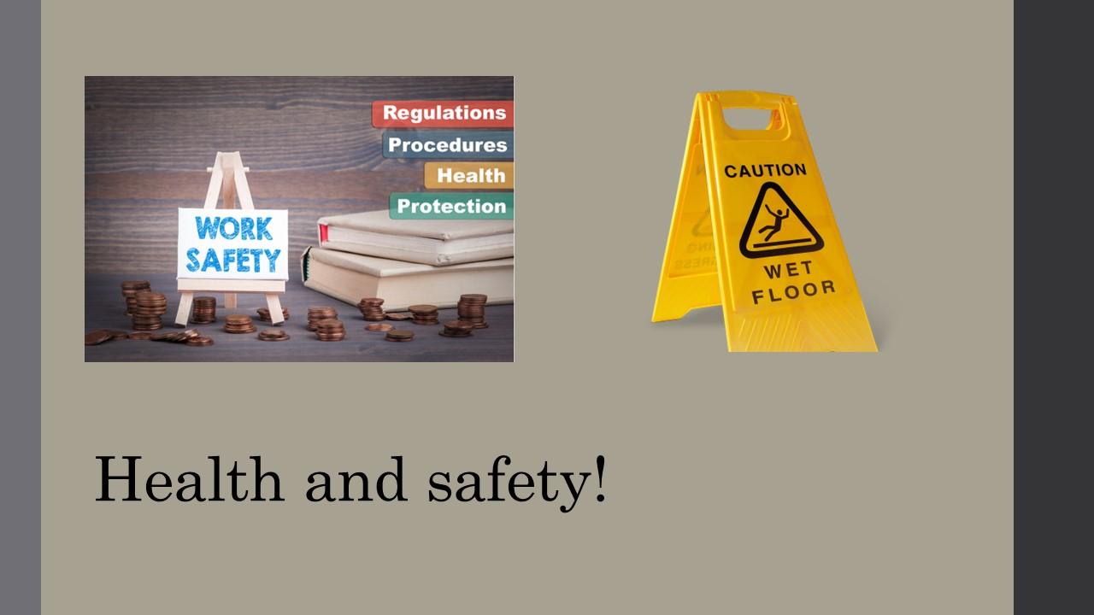

Training Notes: Regarding health and safety regulations, you must remember to always signal any hazardous areas and reported it immediately so it can be removed/repaired. Is everybody’s job to make sure that dangerous items/ areas are removed/fixed in order to be able to have a safe environment. An effective housekeeping is providing less to zero hazards.
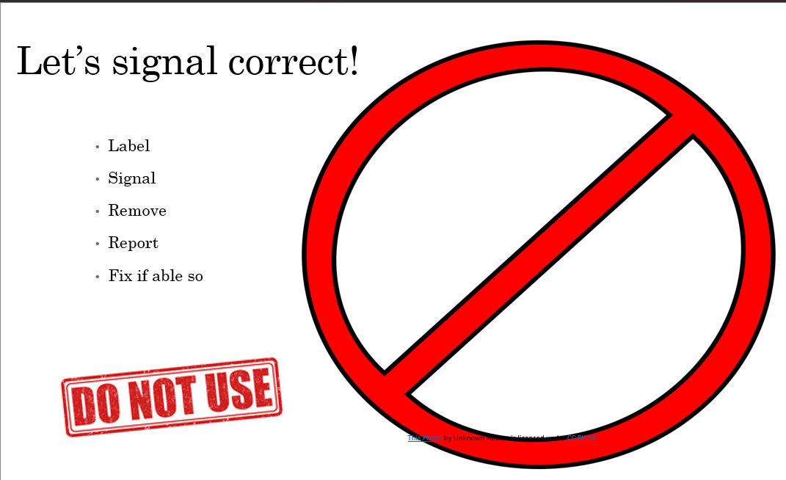

Training Notes: If any of the items used in the process of cleaning are faulty, please make sure to label them, remove them from the area and report them as soon as possible in order to be able to be fixed. If possible, fix them but please do not put you or others around you in danger. Report as soon as possible any electrical faulty products in rooms while checking them, so they can be removed, replaced or fixed by professionals. (JanitorialExpress)
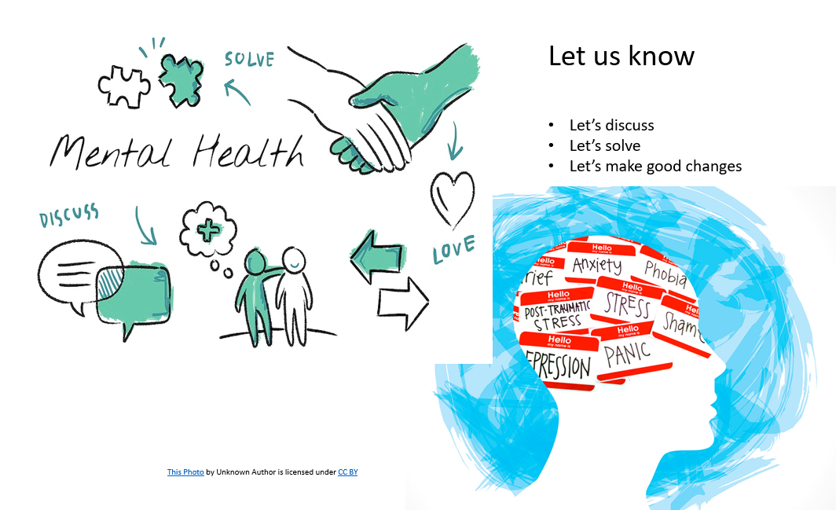

Training Notes: We strive in offering a safe and peaceful place of work for our employees and your wellbeing is extremely important. If by any case you need to speak with the management team, if any problems occur while working or even outside work, came and have a chat with us. We expect to get the best results out of your work and if any difficulties occur, make sure to communicate with us and we eill do our best in order to help you overhaul these and return to best results as before. Each employee is different and if you think that we are not able to help, please contact our professional wellbeing team so you can get professional help. (Hosco)

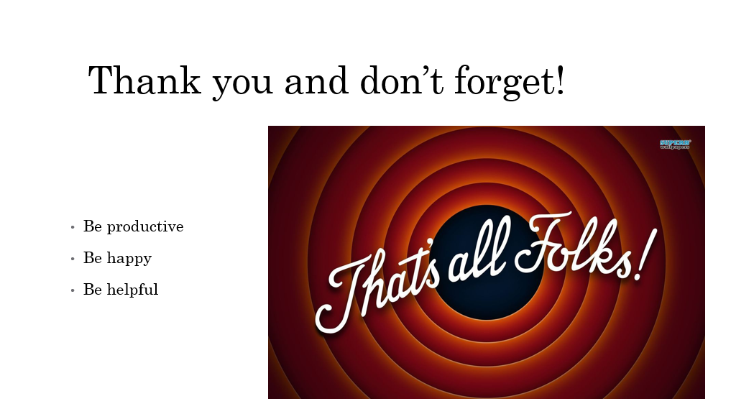

Training Notes:With this small presentation, we hope to refresh your basic information regarding health and safety and about the procedures that must be fallowed in order to get the best results from our work. Safety is extremely important and is everybody’s job to make sure that we work in a safe environment. Please fallow the processes and get the best outcome from your activities.
Remember that you are extremely important and that if any problems occur, cam and speak to us, and together we can find a solution, and if not, try to get professional help as it is available for free. Thank you and goodbye!

Reference list
AA (2018). brand standards hosptaloty industry. [online] Bing. Available at: https://www.bing.com/search?q=brand+standards+hosptaloty+industry&qs=n&form=QBRE&sp=-1&ghc=1&lq=0&pq=brand+standards+hosptaloty+industry&sc=8-35&sk=&cvid=E673BF43DE8043AAAD63FD0AEC3A7E8F&ghsh=0&ghacc=0&ghpl= [Accessed Jun. 2023].
Axelrod, S. and Tieperman, J.T. (2023). 15 Basic Skills You Need to Be a Good Housekeeper. [online] wikiHow. Available at: https://www.wikihow.com/What-Basic-Skills-Do-You-Need-to-Be-a-Good-Housekeeper.
BNG Hotel Management Institute (2023). Housekeeping Duties And Responsibilities | BNG Hotel Management Kolkata. [online] bngkolkata.com. Available at: https://bngkolkata.com/housekeeping-duties-and-responsibilities/.
Business Smart International (2017). How can you engage your employees in 2017? [online] www.business-smart.com. Available at: https://www.business-smart.com/how-can-you-engage-your-employees-in-2017?msclkid=5fceb40bad1016f2c89fd07666378ff7 [Accessed Jun. 2023].
Chloe (2020). What is Good Housekeeping? [online] Polo & Tweed. Available at: https://poloandtweed.com/blog/why-is-good-housekeeping-important.
Clare, S. (2019). 5 Housekeeping Scenarios You Can Avoid at Your Hotel. [online] Voxer Business | The Walkie Talkie App For Teams. Available at: https://www.voxer.com/blog/5-housekeeping-scenarios-you-can-avoid-at-your-hotel/.
Deputy (2019). The 20 Most Common Hotel Guest Complaints. [online] Deputy. Available at: https://www.deputy.com/blog/the-20-most-common-hotel-guest-complaints.
Emmanuel, O. (2020). 7 Benefits of good housekeeping practises in the workplace. [online] Validworth. Available at: https://www.validworth.com/benefits-of-good-housekeeping-in-the-workplace/.
Health and Safety Executive (2020). Health and safety risk assessment and management. YouTube. Available at: https://www.youtube.com/watch?v=xyANahuhGs0.
Health and Safety Executive (2023). Provide information and training - HSE. [online] www.hse.gov.uk. Available at: https://www.hse.gov.uk/simple-health-safety/training/index.htm.
hosco (2022). The Importance Of Mental Health For Hospitality Workers. [online] hosco. Available at: https://advice.hosco.com/en/the-importance-of-mental-health-for-hospitality-workers/#:~:text=As%20a%20manager%20or%20team [Accessed: Jun. 2023].
Hospitality Audit Services (n.d.). Brand Standards. [online] www.hospitalityauditservices.co.uk. Available at: http://www.hospitalityauditservices.co.uk/test-purchasing/brand-standards.php#:~:text=Brand%20Standards%201%20%20Strengthen%20the%20guest%20journey [Accessed: Jun. 2023].
Indeed (2020). Guide to Housekeeping Skills (With Tips and Examples) | Indeed.com. [online] www.indeed.com. Available at: https://www.indeed.com/career-advice/career-development/housekeeping-skills.
Indeed Premier Inn (2023). Premier Inn Mission, Benefits, and Work Culture | Indeed.com. [online] uk.indeed.com. Available at: https://uk.indeed.com/cmp/Premier-Inn/about.
JanitorialExpress (2011). HEALTH & SAFETY TRAINING VIDEO FOR THE CLEANING INDUSTRY. YouTube. Available at: https://www.youtube.com/watch?v=BOxy2nPebz0.
Kelly, L. (2021). 7 Team Engagement Tips to Boost Teamwork and Performance. [online] www.peoplegoal.com. Available at: https://www.peoplegoal.com/blog/team-engagement.
Kral, H. (2023). 12 Outside-the-Box Solutions for Common Household Problems. [online] Family Handyman. Available at: https://www.familyhandyman.com/list/solutions-common-household-problems/#:~:text=12%20Outside-the-Box%20Solutions%20for%20Common%20Household%20Problems%201.
Monarch Brands (2018). Color-Coded Microfiber Cleaning Systems. [online] Monarch Brands. Available at: https://www.monarchbrands.com/2018/11/27/color-coded-microfiber-cleaning-systems-2/#:~:text=Here%20are%20the%20colors%20I%20recommend%20designating%20for [Accessed Jun. 2023].
Mullins, L.J. and Dossor, P. (2013). Hospitality management and organisational behaviour. 5th ed. Harlow: Pearson.
People, P. (2022). 7 Powerful ways to motivate your team. [online] Precision People. Available at: https://www.precision-people.uk/news/2018/12/7-powerful-ways-to-motivate-your-team/135.
Premier Inn (2021). CleanProtect. [online] www.premierinn.com. Available at: https://www.premierinn.com/gb/en/why/cleanliness.html.
Raghubalan, G. and Raghubalan, S. (2015). Hotel Housekeeping : Operations and Management. New Delhi, India: Oxford University Press.
Rolfe, L. (2023). Engagement - The 4C areas | WeThrive Help Center. [online] intercom.help. Available at: https://intercom.help/wethrive/en/articles/2631607-engagement-the-4c-areas [Accessed Jun. 2023].
Safeti (2022). Staff Induction for Hospitality - Bars & Hotels | Health and Safety. [online] www.youtube.com. Available at: https://www.youtube.com/watch?v=U7DyCuxE5Z8 [Accessed Jun. 2023].
The Marketing Society (2015). 2015 winner: Premier Inn, Employee Engagement - case study | The Marketing Society. [online] www.marketingsociety.com. Available at: https://www.marketingsociety.com/the-library/2015-winner-premier-inn-employee-engagement-case-study.
UPCA (2018). 10 Important Professional Required Skills for Cleaning Job. [online] cleaningalliance.com. Available at: https://cleaningalliance.com/required-skills-for-cleaning-job.
Wright, K. (2013). Leadership - Engage your Team - Create a Culture of Engagement. YouTube. Available at: https://www.youtube.com/watch?v=IZA94smSkQg.

