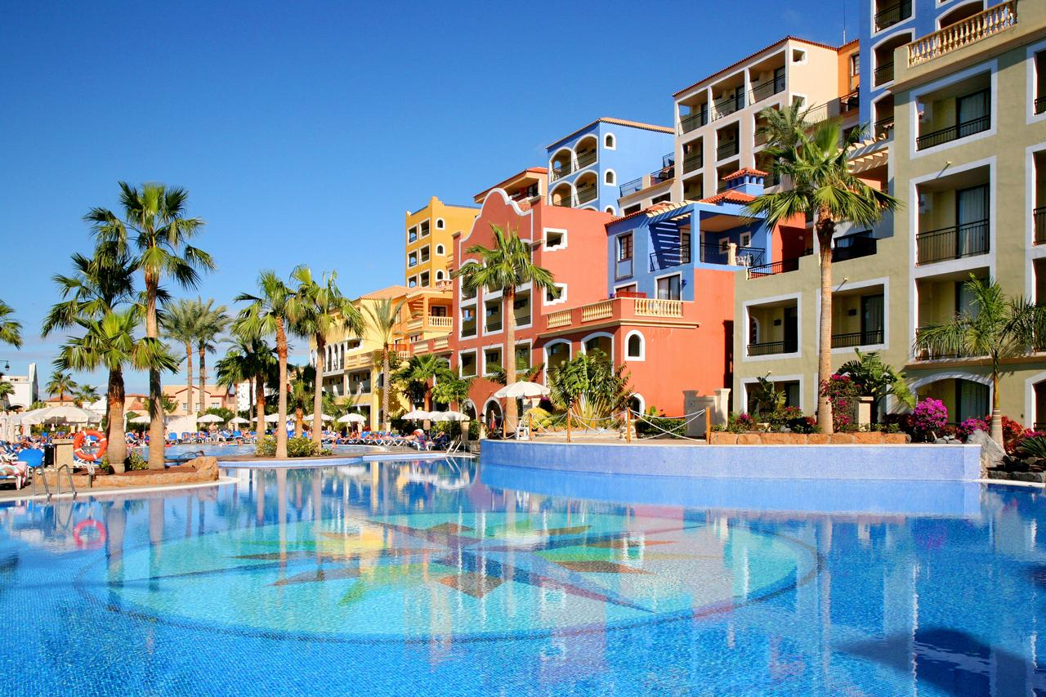
Sunlight Bahia Principle Costa Adeje Hotel
Mustata Elisei (1815341)
University of Wales Trinity Saint David
Hospitality and Guest services

Module Code: M4X01915
Lecturer: Dr Dale Clark

Table of Contents
Introduction 2
Sunlight Bahia Principe costa Adeje 2
Customer satisfaction, service quality and customers’ expectations 2
Customer relationship management (CRM) 3
Conclusion 4
Refrences 5

Introduction

This report has been designed to analyse how Sunlight Bahia Principle Costa Adeje Hotel’s guest service performance and see how the hotel is able to adapt to the fast-changing environment where customers’ needs, and expectations are changing all the time. This report will cover the most important aspects which are addressed to the e4-start rating, these are: the management decisions and the professionalism that it is shown by the staff. According to Szwarc (2005) the essential factor of guaranteeing customer loyalty and customer satisfaction is only by performance and quality. Therefore, by the end of this report we will be able to identify if this particular hotel has what it takes to survive in the market. One of the most important factors for a hotel is their reputation. This is because it created an image that allows the customers to create their own impression, which can be positive and negative. This is why it is very important that businesses in this industry show high levels of services, in order to make customers come back. If they are not able to fulfil customer’s needs and expectations it will lead to unsatisfactory services, which will create a bad image. This will affect the overall sales of the hotel as they will have less customer (Pearce & Robinson, 2011). In addition, when managing a 4-start hotel it is also important to be aware of the competitors, as if there are other hotel who offer the same services but at a lower rate, then customers will choose the most efficient for themselves. This is why it is important that the services are higher than competitors and change with the demand of the guests. (Nurminem 2017)

Sunlight Bahia Principe costa Adeje

Sunlight Bahia Principle Costa Adeje is a 4-start hotel resort in the south- western coast of Tenerife, located in the Playa Paraiso which is translated as the “Paradise Beach” area. This resort is close to the local centre of Costa Adeje. This attracts customers as it offers a relaxed, quiet vibe, but it is also allowing customers to be able have a shopping day and sightseeing in the town. The resort has a Spanish colonial architectural style with the atmosphere of a Spanish village. The Sunlight Bahia Principle Costa Adeje makes part from a division of resorts owned by Grupo Piñero, which was established in 1995 with the first hotel being open in town of Rio San Juan on the northern coast of Dominican Republic. They are currently maintaining a total of 27 hotels and resorts in 14 countries.

Customer satisfaction, service quality and customers’ expectations

Chandra and Jana (2016) is telling us that customer satisfaction is one of the most important factors of hotel industry. This is because if customer are satisfied with the services that the hotel offers , it will make them come back , but also recommended to others, which will bust the number of sales , which will increase the profitability of the business , but it will also create a good image for hotel. This resort is manly destinated to couples and families, offering them all the required facilities to satisfy their needs, such as kid’s clubs when parents can enjoy the facilities of the resort. There are 478 guest rooms in the hotel, double rooms and twin rooms. The rooms are well selected which come with facilities such as: air conditioning, satellite TV, en-suite bathrooms, telephone, fridge, balcony or terrace and wi-fi. Having this facility at a good level attracts customers as they feel satisfied with the facilities their room is offering. as this is one of the things that there are mostly interested. The hotel is also using a Spanish colonial décor. This attracts the guest as they want to feel like they get to know a bit of the culture of the country they are spending their holiday. When going on holiday people expect to have a dream holiday by having nice experiences and forgetting about the stress they might run away from. This is why the hotel is able to offer exceptional sea views from the outdoor pools. This makes customers find relaxation from the moment they arrive on their lavish rooms. Resort is also located in a popular destination which allows guest to find a high range of dining options, but also an easy access to the attractions that are located nearby. Another thing that customers expect from a good holiday is to enjoy the food and drinks. The hotel spoils their guest with a wife ranges, as there are serval buffets that are available for the guest, they can choose from Italian, Mexican, Brazilian, Spanish and Mexican fusion, ensuring that there is something for every guest. There are also several bars that are offering to serve light snacks during the day, with a range of refreshing beverages. This shows that they pay attention at taking care of the customer’s needs, which makes quest feel appreciated with their services. In addition to offering a dream holiday to their guest, the hotel offers entertainments, sports and games. The hotel has serval sun terraces and pools where guest can easily take thugs and enjoy a swim in the polls. There is a kid’s club where they can splash around all day as they have their own dedicated pools. This facility makes guest feel that they are being taken care of and that their children are safe. This will increase their satisfaction and make them happy. The hotel then offers acracies such as basketball, volleyball, tennis, football, mini golf, aerobics and water polo, while there is a fully equipped gym. There is also a spa where quest can recharge their batteries and relax. Then they have entertainment night where one day can be karaoke night, the other Spanish dancing etc. All these facilities are the important things that draws customers, and if they are offering these services with quality as it seems, then they make their customers satisfied.

Customer relationship management (CRM)

In order for organisations to have a clear picture of their relationship with their customers they use customer relationship management systems. This includes actions such as: first contract, acquisition, sales funnel, up-sells, renewals, ongoing sales, and conversions. This leads to the improvement of communication between customers and the business. In the case of the hotel resort we have been analysing, it shows that they are using a goof customer relationship management system. This is because they are showing good customer care, making customers feel welcomed and satisfied. One of the things that makes this resort have good communication with their guest is that even before the guest arrive at the property, they keep in contact with them via email, text or calls. This enables them to aware the customers of any unpredictable changes. This will make the customers confident about their accommodation and comfortability at the resort, as they build up trust. Kotler (2002) tells us that one of the benefits of CRM is that it enables the hotel to generate more information about their quest. This creates a higher advantage compared to their competitors that might not use a CRM system, as the more an organisation knows about their customers, the more they are able to adapt to their needs, making them feel special.

Conclusion

The hotel industry has to be able to adapt to the fast-changing environment, where new technology is developing every day. This hotel has developed and improved significantly since the first hotel that was open. Sunlight Bahia Principle Hotel has been able to adapt to these changes, which has led to the business performing well and having good communication with their customers. The service quality that they offer is high, and this is achieved through the well-trained staff that show good customer care and pay attention to detail. The hotel has generated high profitability during the past few years, and this is due to the customer’s needs and expectations being fulfilled. It is advisable that businesses in this industry pay attention at their customers’ needs as customers are the main factor that keeps the business running. Therefore, organisations should do their best to achieve this target and make more and more improvements to their services to ensures that they are completing this target. Sunlight Bahia Hotel has also very good and positive reviews on websites such as trivago. This is quite important as customers check the reviews to find out what other people have experienced. This shows that is is quite important to remain a good reputation and always try to make customers happy as the future of the business depends on the amount of the customers.

Refrences

Jana, A., & Chandra, B. (2016). Mediating Role of Customer Satisfaction in the Mid-Market Hotels: An Empirical Analysis. Indian Journal Of Science And Technology, p9

Kotler, P. (2002). When to use CRM and When to forget it!. Paper presented at the Academy of Marketing Science, Sanibel Harbour Resort and Spa, 30 May.

Mathews, J. (2008). Hotel management. Jaipur, Raj., India: Pointer Publishers,.p54

Morrison, A. & O‟Mahoney, G. B. (2002). Hospitality: A Liberal introduction. Journal of Hospitality and Tourism Management, Vol. 9 No. 2, pp 189-197

Nurminen, M. (2007). Guest experience design in hotel industry. Burnaby, B.C.: Simon Fraser University.

Pearce, J. A. and Robinson, R. B. (2011). Strategic Management: Formulation, Implementation, and Control.(12th Ed.).Boston Burr Ridge: McGraw-Hill/Irwin

Szwarc, P. (2005). Researching customer satisfaction & loyalty. London:Kogan p64

Tsiotsou, R., & Goldsmith, R. (2012). Strategic marketing in tourism services, Publisher: Bingley: Emerald

www.loveholidays.com. (2019). Sunlight Bahia Principe Tenerife in Costa Adeje, Tenerife | Holidays from £545pp | loveholidays. [online] Available at: https://www.loveholidays.com/holidays/tenerife/costa-adeje/sunlight-bahia-principe-tenerife.html [Accessed 7 Jul. 2019].

