University of Wales Trinity Saint David
School of Engineering

Major Project Proposal
Automated Defect Detection using Vision Guided Robotics



Major Project
M6X00417
Jordan Ross Jenkins
P149066
Due: 18/10/2019

Overview
To develop and test an automated defect detection system for Printed circuit Boards utilising vision guided robotics. Building on knowledge and experience gained through the completion of an automation project over summer.
Reasons for and relevance of the project.
With the ever increasing complexity of electronic components, as well as the automation of manufacture, it is more important than ever to ensure that defective components are eliminated or reworked during the manufacturing process. During a guest lecture by the CEO of JRT Value Stream Mapping, Dr John Rhys Thomas, the importance of the 1:10:100 rule was discussed. The rule suggests that if defects are found early in the manufacturing process it costs 1𝑥 pounds to correct, late in the manufacturing process 10𝑥 pounds, and 100𝑥 at the consumer Stage. Due to the aforementioned increased complexity of printed circuit boards as well as the sheer volume of the components produced, manual inspection if no longer viable. The market now demands that high quality, reliable products are produced at a speeds previously unseen. To this end, even modern automated defect detection techniques, such as optical defect detection, suffer the inflexibility created by the batch production methodology. It is then no surprise that developing dynamic and autonomously adaptable manufacturing and inspection techniques is one of the primary regions of interest in manufacturing research and development.
Aims of the project.
- Conduct research into and evaluate current defect detection techniques used by both small and large electronic manufacturing enterprises.
- Create a defect detection program in MATLAB using image Analysis techniques, primarily centred around the image subtraction method.
- Utilise offline programming software through a digital twin of the simulated production line to develop a robotic control program.
- Use Vision guided robotics to then remove the defective component from the simulated production line using Visual servoing.
- Analyse the developed defect detection system against the techniques used by small and large enterprises.
Background research carried out to date.
- Image acquisition and analysis techniques using MATLAB.
- Off/online programming of universal robots (ur10) through RoboDK API for MATLAB.
- Digital twin creation in RoboDK.
- Background research into the defect detection techniques currently used in industry.
- Background research on the types of defects that regularly occur in PCB Production.
Details of facilities required including computer software and laboratory support needed to complete your work

- Access to the robotics laboratory, specifically the UR10 robot and the conveyor belt.
- MATLAB (Arnaud Marotin).
- SolidWorks.
- RoboDK.
- Process simulate (potentially).

Bibliography
Hara, Y., 1983. Automatic Inspection System for Printed Circuit Boards, Lodon : Institute of Electronic and Eletrical Engineers .
Jing, L., 2014. Research on Robotic Visual Servoing System. CONTROL THEORY & APPLICATIONS, 1(1), p. 54.
stemmer-imaging, 2019. The role of machine vision in manufacturing. [Online]
Available at: https://www.stemmer-imaging.com/en-gb/news/2019-07-the-role-of-machine-vision-in-manufacturing/
[Accessed 14 10 2019].

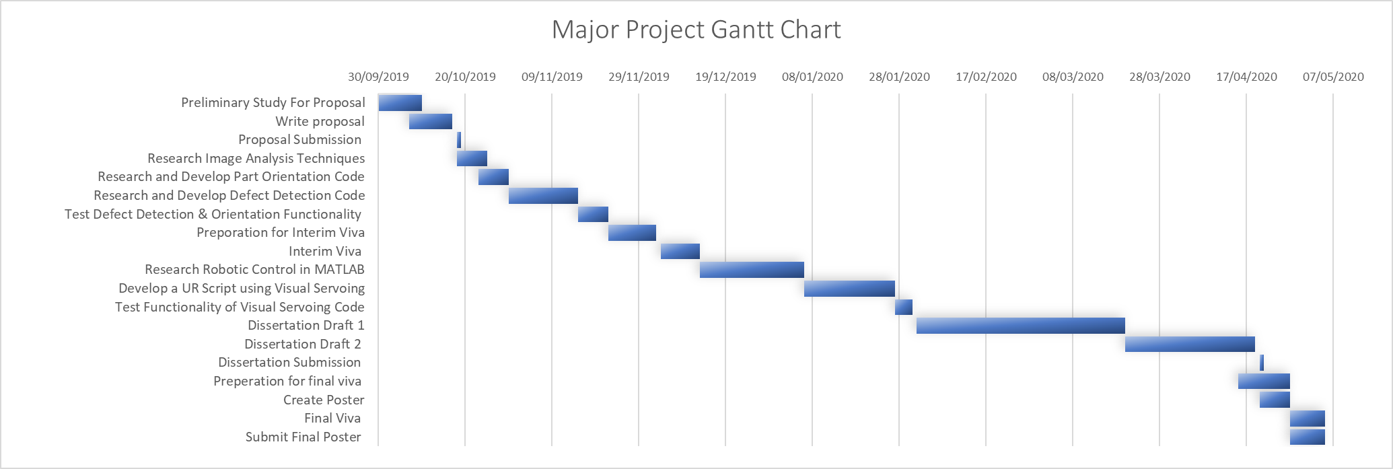
Timing Plan

