International Financial Management
Name of the student:Nicoleta Mădălina Rusu
Name of the university: University of Wales Trinity Saint David
Student ID: 2121755

Table of Contents
Introduction……………………………………………………………………………………….2
Theoretical Framework of IFM 4
Strategies for Managing Foreign Exchange Risks: 6
Hedging Techniques 6
Diversification of Currency Exposure 6
Leading and Lagging Strategies 7
Operational Strategies 7
Evaluation of Different Strategies 8
Hedging Techniques 8
Diversification of Currency Exposure 9
Leading and Lagging Strategies 10
Operational Strategies 10
Empirical Evidence Supporting Claims 11
Empirical Evidence 11
Successful Implementation Examples 12
Limitations and Challenges of Empirical Studies 12
Conclusion: 13
References 14

Introduction
International Financial Management or IFM plays a crucial role which involves high-level systems in financial dangers management like, resource management and foreign posting areas, assuming an urgent part in upgrading the financial presentation and dependability of global endeavours (Eun et al. 2021). The strategies for overseeing unfamiliar trade foreign for MNCs incorporate managing cross-line exchanges, foreign fiscal standards, advancing, carrying out spot, and choices techniques in unfamiliar trade. International financial management encases exercises like dissecting, observing, and guiding financial assets to boost business goals across borders. The financial assets, including resources like money, advances, securities and stocks, are indispensable for supporting business tasks and objectives, both locally and internationally (Grundy et al. 2022). This includes vital oversight of financial properties all around the world to examine, design, and benefit from expansion in various nations. The management of foreign trade chances is fundamental for MNCs working internationally.

Theoretical Framework of IFM
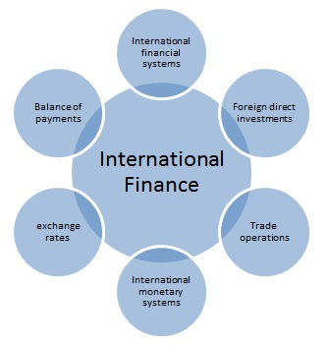
Figure 1: International Finance
(Source: International Finance, 2018)
These frameworks within the IFM give an organised way to deal with understanding and overseeing financial assets across borders, particularly concerning foreign trade chances. The dangers emerge because of variances in return rates, affecting the worth of resources, liabilities, and incomes named in foreign fiscal standards (Doszhan et al. 2020.). Managing foreign trade chances is vital in international business tasks for MNCs. the central issues to be considered for overseeing foreign trade risks include,
Exchange Rate Determination: The comprehension of the aspects concerning exchanging scale consequences is critical for expecting and handling dangers related to currency vacillations (Bakr and Napier, 2022). One vital theoretical structure in IFM is the home money approach, which includes changing the market worth of future settlements in unfamiliar fiscal standards into the home currency and limiting them utilising the expense of capital of the home cash to decide the market esteem communicated in the home currency.
Valuation Methods: The use of proper valuation techniques for cross-line exchanges is necessary to evaluate the financial importance of international assignments precisely (Ezenwoke and Tion, 2020). These models are an essential part of directing dynamic processes for worldwide organisations (MNCs) working universally.
Cost of Equity Calculation: The estimation of the expenditure of value is compulsory for deciding the essential rate of return from interests in foreign business sectors, taking into account the related dangers (Younas and Turdialiev, 2021).
Equivalence of Home and Foreign Currency Approaches: The examination of the speculation that the home cash and foreign money methods are identical aids in picking the most appropriate strategy for surveying financial execution and dangers in international settings (Bowe and Dean, 2021).

Strategies for Managing Foreign Exchange Risks:

Hedging Techniques
Forward Contracts: These agreements include consenting to trade money at a foreordained rate from now on, giving insurance against unfavourable swapping scale developments.
Futures Contracts: Besides the forward agreements, futures contracts are normalized arrangements to trade monetary forms at a predefined cost on a future date, permitting organizations to support against money risk (financeseva, 2023).
Options: The choices give the holder the right but not the commitment to trade monetary standards at a foreordained cost inside a predetermined period, offering adaptability in overseeing foreign trade dangers.
Swaps: The money trades include trading incomes in various monetary standards, permitting organizations to deal with their openness to actual conversion scale vacillations (Hedging, 2023).

Diversification of Currency Exposure
Developing the fiscal currency incorporates spreading assumptions across various financial standards to reduce the effect of unfriendly developments in withdrawn cash on the all-around portfolio estimation.

Leading and Lagging Strategies
Leading Strategy: This includes hustling up foreign cash inflows or deferring surges to exploit great conversion scale developments.
Lagging Strategy: This includes delaying unfamiliar money inflows or hurrying up outpourings to relieve casualties from troublesome swapping scale consequences.

Operational Strategies
Invoicing in Local Currency: With the invoicing of exchanges in neighbourhood monetary standards, organizations can decrease openness to conversion scale vacillations and work on financial management.
Invoicing in Local Currency: The unifying of depository capabilities takes into account better observing and management of unfamiliar trade gambles across the association, upgrading proficiency and command over cash openings.

Evaluation of Different Strategies

Hedging Techniques
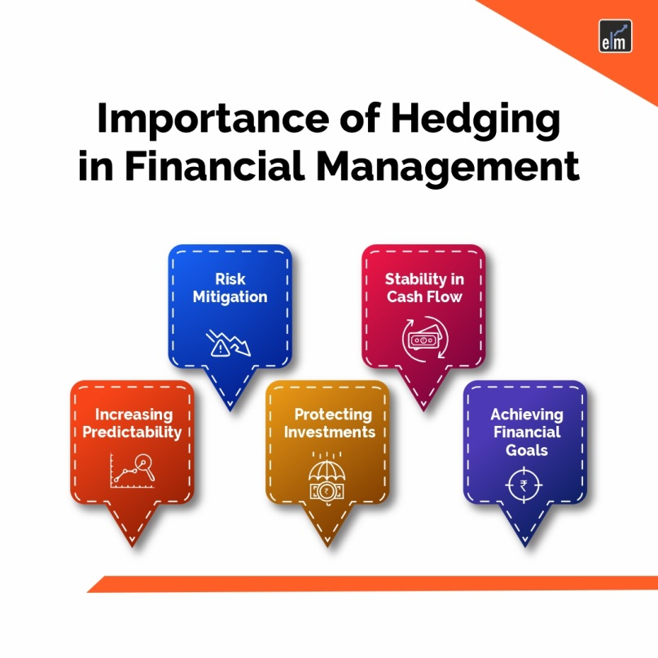
Figure 2: Hedging techniques
(Source: Hedging Strategies, 2024)
Effectiveness: They give assurance in incomes and safeguard against unfavourable cash developments (scholarlycommon, 2024). Hedging strategies like forward agreements, prospects agreements, choices, and trades are compelling in moderating conversion scale gambles by securing future trade rates.
Costs: While supporting can bring about expenses, for example, charges or expenses, the advantages of diminishing vulnerability and limiting misfortunes from horrible conversion scale vacillations frequently offset these expenses.
Suitability: They are useful for organizations with unsurprising incomes and good resilience (Energiaa, 2023). These strategies are reasonable for MNCs with critical openness to unfamiliar trade chances, particularly those working in unstable money markets.

Diversification of Currency Exposure
Advantages: It spreads risk across numerous monetary standards, upgrading flexibility to cash vacillations. Hence differentiating money disclosure lessens the effect of unfavourable developments in solitary cash on the general portfolio.
Disadvantages: It requires cautious checking and management to guarantee an ideal equilibrium of money commencements. Enhancement might restrict likely gains assuming one money appreciates altogether.
Impact on Financial Performance: It can upgrade investor esteem by limiting the effect of unfriendly conversion standard developments on income (financeseva, 2023). The differentiation can stimulate more steady financial execution by decreasing the weakness of money stakes.

Leading and Lagging Strategies
Effectiveness: They give adaptability in overseeing income and money risks. Leading and Lagging procedures can be successful in profiting from great conversion standard developments or moderating misfortunes from ominous developments.
Costs: These systems might include exchange costs or functional intricacies, particularly while changing instalment timings to line up with conversion standard assumptions.
Suitability: They are gainful for organizations with a proactive way of dealing with overseeing cash circumstances (Hedging, 2023). Leading and Lagging procedures are appropriate for MNCs with the capacity to conjecture swapping scale developments precisely.

Operational Strategies
Advantages: They upgrade functional productivity and command over cash stakes. Hence invoicing in nearby cash and unified depository management improves financial activities and decreases exposure to trading scale changes.
Disadvantages: These applicable techniques might expect acclimations to existing processes and frameworks, possibly prompting execution costs and changes within the company.
Impact on Financial Performance: They add to improving investor esteem by smoothing out financial activities and diminishing dangers related to unfamiliar trade (scholarlycommon, 2024). The operational techniques can work on financial execution by diminishing conditional intricacies and limiting the effect of money variances on incomes.

Empirical Evidence Supporting Claims

Empirical Evidence
Foreign Exchange Exposure and Firm Value: This empirical proof features the huge effect that money fluctuations can have on an organization's main concern and emphasises the significance of hazard management to defend financial security and upgrade investor esteem.
Foreign Exchange Risk Hedging and Firm Value: This proof accentuates the significance of executing suitable supporting instruments to alleviate the unfavourable impacts of conversion scale instability on financial execution (Energiaa, 2023). The discoveries from this examination, especially concerning Chinese organizations, show a reasonable connection between powerful danger management systems and firm worth.
Foreign Currency Risk Management Practices: They likewise highlight the difficulties and intricacies implied in overseeing money gambles really in a powerful worldwide monetary climate. These papers feature the advantages of key gamble management rehearses in improving the versatility of MNCs to swapping scale vacillations.

Successful Implementation Examples
GlaxoSmithKline (GSK): Supporting against money vacillations, GSK safeguards its financial exhibition and guarantees strength in incomes, eventually improving investor esteem. GSK's effective use of supporting strategies like forward agreements epitomizes how MNCs can proactively oversee unfamiliar trade gambles.
Unilever: The company worked in numerous monetary standards and areas, Unilever diminishes its weakness to unfriendly conversion scale developments, subsequently protecting its financial execution and investor esteem (scholarlycommon, 2024). Unilever's powerful enhancement of cash openness exhibits one more way to deal with overseeing unfamiliar trade hazards.

Limitations and Challenges of Empirical Studies
Data Availability: The restricted accessibility of information might upset the capacity to draw definitive bits of knowledge or sum up discoveries across various settings. The studies might experience difficulties in getting thorough and modern information on MNCs' unfamiliar trade risk management rehearses.
Generalizability: The studies have factors like administrative conditions, industry elements, and vital targets that can fundamentally impact the adequacy of chance management systems (Bakr and Napier, 2022). The findings from the studies may not necessarily be relevant to all MNCs because of varieties in industry areas, geographic areas, and plans of action.
Complexity of Factors: Elements like macroeconomic patterns, international occasions, and market thought can overcome the connection between risk management activities and financial results (Ezenwoke and Tion 2020). The complex idea of unfamiliar trade risks, combined with the unique worldwide financial situation, presents difficulties in segregating the result of explicit hazard management techniques on firm execution.

Conclusion
The breakdown of the Bretton Woods framework prompted the reception of free-drifting trade rates by most created nations, mirroring the pattern towards progressing capital and current-account exchanges. The practitioner is urged to fit systems to their particular settings, taking into account industry elements, administrative conditions, and key goals, to moderate the antagonistic impacts of money changes and improve financial flexibility in the worldwide commercial centre. The examination focussed on tending to information restrictions, upgrading the generalizability of discoveries, and investigating imaginative gamble management draws near. This report features the critical effect of unfamiliar trade gambles on global companies' financial execution and investor esteem. The empirical studies show the significance of taking on compelling danger management systems, including supporting strategies and expansion of money openness.

References
Bakr, S.A. and Napier, C.J., 2022. Adopting the international financial reporting standard for small and medium-sized entities in Saudi Arabia. Journal of Economic and Administrative Sciences, 38(1), pp.18-40.
Bowe, M. and Dean, J.W. (2021) International Financial Management and Multinational Enterprises, OUP Academic. Available at: https://academic.oup.com/book/10408/chapter/158243043 (Accessed: 19 March 2024).
Doszhan, R., Nurmaganbetova, A., Pukala, R., Yessenova, G., Omar, S. and Sabidullina, A., 2020. New challenges in the financial management under the influence of financial technology. In E3S Web of Conferences (Vol. 159, p. 04015). EDP Sciences.
Energiaa (2023) Strategies for managing Foreign Exchange Risk in global business ventures, Energiaa online newspaper. Available at: https://energiaa.vamk.fi/en/articles/future/strategies-for-managing-foreign-exchange-risk-in-global-business-ventures/ (Accessed: 19 March 2024). International Finance (2018) International Finance Assignment help Australia, Online Assignment Services. Available at: https://onlineassignmentservices.com/international-finance-assignment-help/ (Accessed: 19 March 2024).
Eun, C.S., Resnick, B.G. and Chuluun, T., 2021. International financial management. McGraw-Hill.
Ezenwoke, O. and Tion, W., 2020. International financial reporting standards (IFRSs) adoption in Africa: Abibliometric analysis. Cogent Social Sciences, 6(1), p.1801370.
financeseva (2023) Wiley Online Library | Scientific Research Articles, journals, ... Available at: https://onlinelibrary.wiley.com/ (Accessed: 19 March 2024).
Grundy, T., Johnson, G. and Scholes, K., 2022. Strategic Financial Management. Bachelor of Business Administration Programme Code: BBA Duration–3 Years Full Time, 2(1), pp.1-575.
Hedging (2023) Risk management strategies for foreign exchange hedging, Risk management strategies for foreign exchange hedging | U.S. Bank. Available at: https://www.usbank.com/financialiq/improve-your-operations/minimize-risk/risk-management-strategies-foreign-exchange-hedging.html (Accessed: 19 March 2024).
Hedging strategies (2024) Hedging strategies-A comprehensive guide, Elearnmarkets. Available at: https://blog.elearnmarkets.com/a-comprehensive-guide-to-hedging-strategies/ (Accessed: 19 March 2024).
scholarlycommon (2024) Foreign currency risk management practices in U.S. ... Available at: https://scholarlycommons.law.hofstra.edu/cgi/viewcontent.cgi?article=1125&context=jibl (Accessed: 19 March 2024).
Younas, A. and Turdialiev, M.A., 2021. Special Features Of International Financial Centres And Its Establishment In Uzbekistan. The American Journal of Political Science Law and Criminology, 3(08), pp.17-21.

