LCBB4003
Introducing the Modern Workplace
Assessment 01: Organisational Structure & Culture
Student Name: Narcis-Nicu Gavril
Student ID: 2022007
Contents
Introduction 3
Organisational Structure and Culture and its Impact on the Morrisons’ Organisational Performance 4
Organisational Structure 4
Organisational Culture 5
Relationship with Morrisons’ Overall Performance 8
Importance of Managerial Job; Leadership Role and Effective Management Variables 9
Managerial Work and its Nature 9
Role of Leadership 9
Effective Management and Leadership Variables 10
Various Behavioural Approaches and its Impact on the Individual Behaviour at Workplace 11
Conclusion 13
References 14

Introduction
Organisational structure refers to a framework that defines how particular tasks are conducted to accomplish an organisation's strategic mission. Besides, organisational culture talks about all the common interests, views, and beliefs that indicate how people should communicate, make decisions, and carry out tasks inside an organisation (Maduenyi, Oke, Fadeyi, and Ajagbe, 2021). Moreover, employee welfare and human interaction are at the center of the management behavioral approach. All these factors influence organisational performance and eventually contribute to fulfilling organisational goals. Morrisons is a UK-based retail organisation that was established by William Morrison in 1899 (Richards, Lawrence, and Burch, 2021). In this report, the relationship between the culture, structure, people, its managerial work, and different behavioural approaches that have an impact on the overall organisational performance will be addressed.

Organisational Structure and Culture and its Impact on the Morrisons’ Organisational Performance

Organisational Structure
The way activities including coordination, resource allocation, and administration are oriented towards the attainment of organisational goals is outlined by an organisational structure (Ashton, 2019). The level of productivity inside an organisation is defined by its organizational structure. It encourages individuals to collaborate on tasks within their specific roles. This way, all of them can come together to ensure maximum productivity within their ability. Organisational structure can be divided into 5 types including the Hierarchical, Flat, Flatter, Flatarchies, and Holacratic organisations (Maduenyi, Oke, Fadeyi, and Ajagbe, 2021). Each of them has its advantages and disadvantages and contributes to the organisational performance in its way.
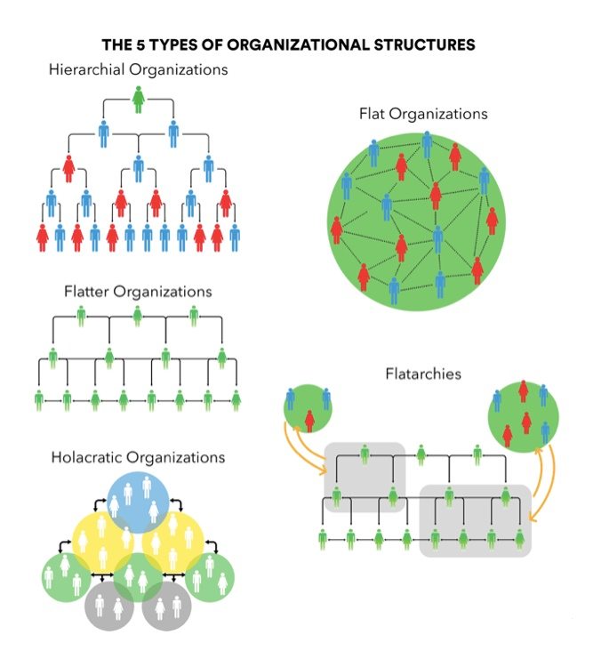
Figure 1: Different Types of Organisational Structure
Source: (Maduenyi, Oke, Fadeyi, and Ajagbe, 2021)

Morrisons, United Kingdom's fourth-biggest supermarket chain used to follow the hierarchical structure and it used to be a single-format superstore. It was operating with all the upper-level executives but later on, after acquiring Safeway, a Chairman, 5 executive, and non-executive directors were assigned by the committee (Skrainka, 2020). The committee had approved the distribution of duties between the executives and the chairman in writing. The committee was in charge of establishing and implementing the Group's strategy and important policies, as well as evaluating progress toward these goals. Later on, Morrison's organisational structure stayed nearly unchanged till now due to the conversion of Safeway stores to the Morrison model and the elimination of other formats such as Safeway's Mini Stores.
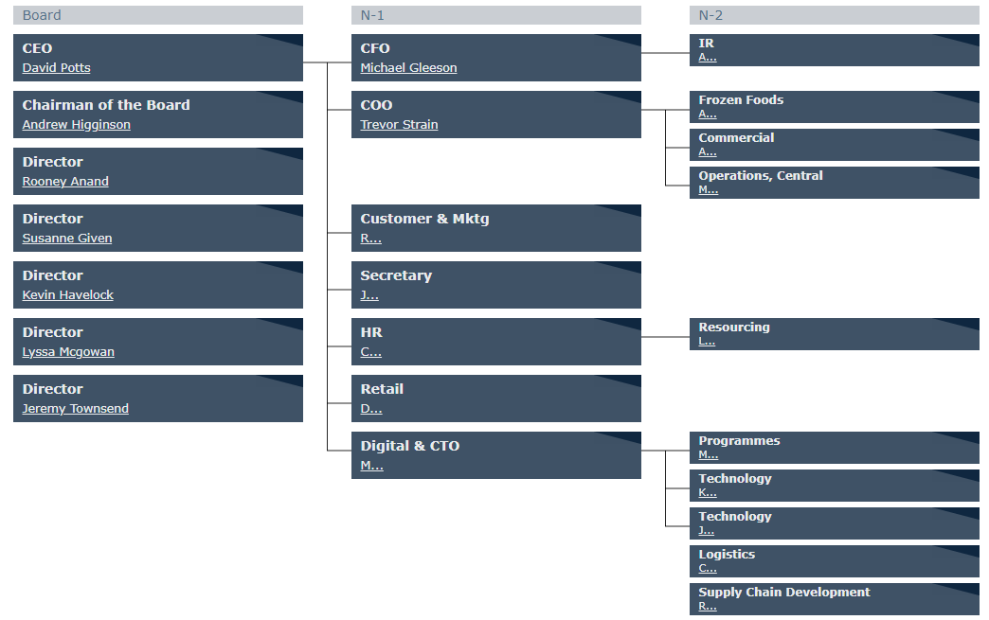
Figure 2: Morrisons' Organisational Structure
Source: (Skrainka, 2020)

Organisational Culture
The set of values, beliefs, and behaviors that influence and guide the activities of all workers is referred to as organisational culture. A company's culture influences everything from timeliness and attitude to agreement conditions and employee compensation. Employees are expected to feel at ease, encouraged, and appreciated when the workplace culture is aligned with their needs (Sinclair, 2019). A positive organisational culture can drive an average worker to work well and achieve great things, while a negative culture can demoralize an exceptional worker to outperform and achieve nothing. Hence, organisational culture plays a vital role in organisation's overall performance. There are mainly four types of organisational culture that most companies follow, and they are- Clan, Market, Adhocracy, and Hierarchy culture (Sinclair, 2019).
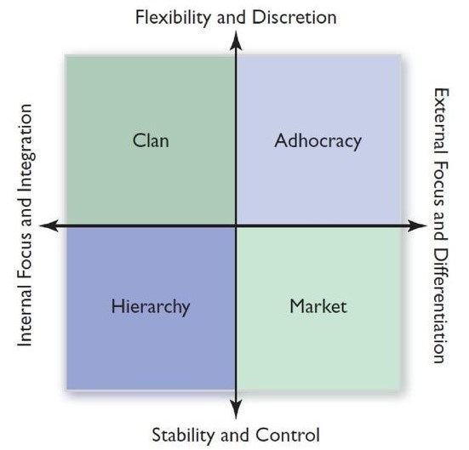
Figure 3: Different Types of Organisational Culture
Source: (Sinclair, 2019)
Morrisons has always focused on establishing a corporate culture where they could make the environment appropriate for teamwork. Although the company follows hierarchical corporate culture, they always welcome employees to share their thoughts into teamwork while getting supervised by upper-level management (Richards, Lawrence, and Burch, 2021). For example- employees working here do not need to think twice before participating in a decision-making process. Everyone is open to take suggestions. To have a detailed overview of Morrisons' organisational culture, first, their assumptions, values, and artifacts need to be evaluated and it can be done by applying Edgar Schein's organisational culture model. Edgar Schein presented an organizational culture model in which fundamental assumptions create values, and values affect procedures and attitude, which are the organisation's considerable cultural aspects. It is given below:
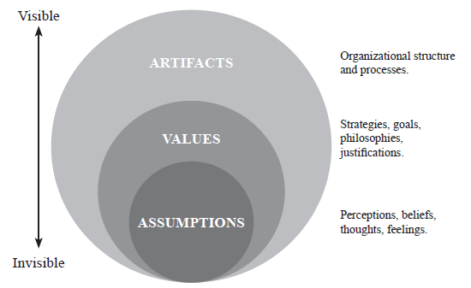
Figure 4: Three Steps of Edgar Schein's Model
Source: (Schein, 2020)
- Morrisons’s Organisational Culture Artifacts
The outermost layer of this framework talks about all the processes, qualities, and structures that are easily seen, and heard by humans (Schein, 2020). Morrisons' organisational culture is represented via tangible artifacts. For example, the dress-code that Morrisons employees are bound to follow inside their organisations, Morrisons office layout, and the open door policy. Even though Morrisons' cultural artifacts are visible but they are difficult to interpret.
- Morrisons’s Organisational Culture Values
Morrisons’ core values are difficult to be observed. The values include- their standards, shared objectives, and the principles they follow (Schein, 2020). Responsibility, diversification, innovation, leadership, collaboration, enthusiasm, and integrity are some of the Morrisons' other essential values. Morrisons management recognizes the need of expressing basic principles to employees thus they can embrace and modify their conduct as needed.
- Morrisons’s Organisational Culture Assumptions
Assumptions are the strongly ingrained attitudes and beliefs that drive Morrisons' organisational culture. Morrisons employees often remain ignorant of these basic assumptions, although they play a critical role in the development of visible actions and guiding principles (Schein, 2020). Morrisons employees should always keep all the six types of assumptions given by Schein in their mind.

Relationship with Morrisons’ Overall Performance
Until February 2021, Morrisons has successfully served almost 11m consumers/week. It would not be possible if they were not considered as an honest and trustworthy organisation with proper structure and culture.
Since Morrisons PLC follows the hierarchical structure for their organisation their employees are always bound to report about their progress to some upper management executive (Ashton, 2019). It indicated how the communication method leaves no gap between Morrisons employees. The method allows the executives to ask questions when there is any confusion and sets responsibilities in a defined way. It also offers a defined way of advancing paths. The employees get the opportunity to make improvements in their work for both the company and themself. Moreover, diverse tasks let focus on a bundle of skills that help achieve maximum efficiency and these are the reason a company should focus on improving the overall performance.
Besides, Morrisons follow the hierarchical corporate culture, which means productivity, cooperation, and organisation are all enhanced by the transparency of roles and duties (Ashton, 2019). Since this model is mostly about planning, regulations, procedures, and perfections, Morrisons does not need to worry about going the wrong way. Following this culture makes Morrisons’ goals sustainable by making incremental modifications focusing on corporate stability and efficiency. Clear direction towards promotion, the space for personal growth makes the employees motivated towards their work which eventually improves work engagement and thus Morrisons’ performance in general.

Importance of Managerial Job; Leadership Role and Effective Management Variables

Managerial Work and its Nature
Any organization's management must satisfy their employees to achieve organisational goals promptly. Rewarding employees with motivation, compensation, and proper leadership can go long way. To choose a board of directors, various companies follow various voting methods. Collecting employee votes to elect a BOM is known as the employee-voting model. As per Mintzberg, some of the characteristics are- ensuring a high quality of services and work, emphasizing verbal interaction overwritten ones, intertwining internal and external contracts, being in charge of the work, choosing work by variety, breakdown, and so on (Lau, Newman, and Broedling, 2020). Inside the organisation's managerial job, the management process entails identifying assets, setting goals, and arranging activities, and then putting those plans into action.

Role of Leadership
Effective leadership is required to meet the company's objectives. A successful organisation requires providing direction and instructions to its employees (Singh, 2018). For an efficient and effective result, the organisation's workforce should follow orders. Some of the most crucial of proper leadership is-
- Monitoring the organisation's working environment.
- Focusing on the company's ongoing operations more than its past and history to bring the desired outcome.
- Acquiring company’s every improvement strategies.
- Making each of the employees follow the instructions and strategic implementations.
- Ensuring all the methods that asses improve maximum production and productivity.
- Considering term coordination and allocation properly etc.
Finding the right tactics is tough, but not unattainable. For this, a leader needs to follow the following steps-
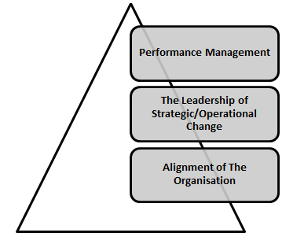
Figure 5: Stages of Strategy Execution by Leaders
Source: (Singh, 2018)
A leader's role also includes monitoring and evaluating the effect of such tactics on the organisation's performance. Adapting those tactics will provide the company with several advantages.

Effective Management and Leadership Variables
Many obstacles will stand in the path of effective leadership management. Some factors improve the efficiency of both management and leadership. The goal of leadership and management is to use influence to achieve goals where managerial influence is not important to be interpersonal, rather a leadership focuses on that. Individual motivation is used by leaders to improve the organisation's overall performance. Three of the most significant criteria that describe the efficacy of management are money, resources, and time (Singh, 2018).
- One of the most critical elements in good management and leadership is the quantity of money available and the expertise required to handle it.
- The leader has both the authority and the obligation of encouraging and mobilizing the organisation's resources.
- In leadership, setting deadlines and managing time for completing tasks is critical.

Various Behavioural Approaches and its Impact on the Individual Behaviour at Workplace
Behaviours simply refer to the way individual acts and react that he/she learns from his surroundings, and contextual processes. The behavioural approach is one of five key approaches in human nature that regulates thought processes and attitudes. It emphasizes identifying the ways of improving behavioural patterns and how external influences affect a person’s thoughts (Singh, 2018). An employee’s behavioural approach makes a huge impact on his performance both favourably and adversely. It is related to the objectives of interest, goals, competition, compensating, managing, in the organization. Many organisations use it to assess their employees' performance as it is a trustworthy and efficient way. Besides, management can better evaluate their workers' capabilities and keep track of their progress daily, allowing them to flourish.
Proper Leadership
Managers'/supervisors' styles of leadership can have an impact on employees' overall workplace behavior. Hence, leading employees in the right ways are their core responsibility. It includes setting up a training program when a new employee joins in, setting up goals for them, supervising them, checking their progress, and so on (Singh, 2018). Besides, inspiring the employees when they face failure is one of the major duties of a proper leader.
Clear Communication
The management, as well as all of the staff, must establish a trustworthy relationship. When a staff is dissatisfied with their job or gets tired, they must notify their supervisor (Sinclair, 2019). Managers should allow people to vent their emotions. Employees' abilities will be developed when they share positive interactions.
Workplace Culture
A positive and comfortable workplace environment help employees increase productivity and efficiency in the long run. Otherwise employee turnover and dissatisfaction may occur. Thus, to motivate employees, the authority should use a fair performance appraisal system. Because it will discourage the competent people if the authority provides a prize to someone who does not earn it (Singh, 2018). Morrison’s works try to observe the company's standards and ethics and try to respect the decisions. Besides, employees support each other in times of crisis since the company focuses mostly on teamwork.
Workplace Responsibility
Recruiting a new employee requires the Morrisons managers to explain all the duties the recruited employee is to obey and to guide him appropriately (Sinclair, 2019). They must inquire as to how he can work at his best, and tasks should be assigned to him accordingly. The manager should not overwork him and should inspire him to engage in difficult jobs.

Conclusion
The structure and culture of an organisation are intertwined and assist obtain a strategic advantage by increasing work performance and making it easier for workers to complete their tasks on time. When individuals perceive the whole structure of the company, performance can improve as they become more devoted to their duties and obligations (Ashton, 2019). However, the behavioral approach aids in decision-making and evaluating staff operations to achieve organizational objectives. It guarantees that employees and management have efficient interactions and collaboration. As a result, organizations become capable to operate more efficiently in the long run.

References
Ashton, D.N., 2019. The impact of organisational structure and practices on learning in the workplace. International journal of training and development, 8(1), pp.43-53.
Lau, A.W., Newman, A.R. and Broedling, L.A., 2020. The nature of managerial work in the public sector. Public Administration Review, 40(5), pp.513-520.
Maduenyi, S., Oke, A.O., Fadeyi, O. and Ajagbe, A.M., 2021. Impact of organisational structure on organisational performance.
Richards, C., Lawrence, G. and Burch, D., 2021. Supermarkets and agro-industrial foods: The strategic manufacturing of consumer trust. Food, Culture & Society, 14(1), pp.29-47.
Skrainka, B.S., 2020. The Geography of Grocery Demand in the UK: An Evaluation of the 2003 Morrisons-Safeway Merger. Available at SSRN 2061845.
Sinclair, A., 1993. Approaches to organisational culture and ethics. Journal of Business ethics, 12(1), pp.63-73.
Schein, E.H., 2020. Organizational culture and leadership (Vol. 2). John Wiley & Sons.
Singh, S.K., 2018. Role of leadership in knowledge management: a study. Journal of knowledge management.

