Reflective Account: Multi-Stakeholder Working

Empowering people to look after their own health and well-being in the community through Telehealth technology

Author: Sue Hamer
Student Number: 2112925
9 June 2022
Word Count: 1614
- Introduction
This essay reflects on the methods of multi- and inter-disciplinary working involved in the design of digital technology that is ultimately to support a policy or strategy aim. This has been achieved by reflecting on a previous paper submitted that focused on A Digital Health and Social Care Strategy for Wales (2015) “Information for you” policy aim, where using technology to support independence and promote well-being was part of the vision, as detailed in Table 1, and whether the range of stakeholders identified to engage with met the brief or could there have been improvements.
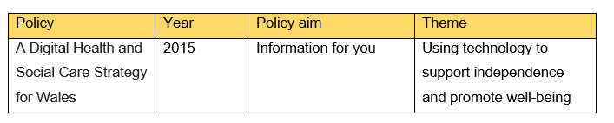

Table 1
A Digital Health and Social Care Strategy for Wales Policy Aim
Reflection techniques and practice provide a platform for learning (Jasper, 2013), and as defined by Reid (1993), provides a process of reviewing an experience of practice in order to describe, analyse, evaluate and inform learning about practice. I used the What? So What? Now What? Reflection framework developed by Driscoll (2007), as this allowed a clear method of structuring my essay with a number of prompt questions to guide the reflective process. Other models were reviewed, for example Gibbs (1988) and Kolbs (1984), which are both used extensively in a healthcare setting, however Driscoll (2007) was simpler to follow as new to reflective writing.
2.0 What - 308
I decided to reflect on the range of stakeholders that I chose to engage with and the reasons why, when looking at identifying the gaps of a Welsh Government policy aim, and what I felt was the biggest driver to get people to look after their own health and well-being in the community.
From the 7 areas identified in the gap analysis, there were 2 areas that I felt were being underutilised. A system used by GP practices called My Health Online (MHO) which was developed as a patient portal to allow patients to book and cancel their own appointments, order repeat prescriptions, and update their personal details. All which promote empowering patients to manage their own health. From previous experiences working in Primary Care, I was aware that the portal was used variably by the 16 GP practices in Powys.
The other area I decided to focus on was Telehealth. Due to time constraints, I only engaged with one department within the health board as I knew they had been using Telehealth to support patients with long term health conditions and they had recently interviewed clinicians around their experiences with the system and supporting patients manage their health and wellbeing.
From these two areas, there were three groups of stakeholders that I engaged with. These have been evidenced in Table 1 along with the methods used to engage.
Stakeholder Identified | Tools to engage
Practice Managers | Email
Digital Health & Care Wales Primary Care Facilitator | Email
Living Well Team | Email and Microsoft Teams meeting

Table 1
Stakeholder engagement

The reasons I chose to engage predominantly via email was due to restrictions still being in place from the covid pandemic and the pressures departments were under due to staff sicknesses. Powys is also very rural covering 2,000 sq. miles, so arranging face to face meetings would have been challenging.
3.0 So What
There were two areas that I felt needed strengthening with the policy aim and it was difficult selecting which one to focus on for the purpose of the paper. This first one was around getting GP practices to use My Health Online (MHO) more, as it is underutilised and has so much potential. Engaging with the Primary Care Facilitator meant I had access to data to see what elements of the system are being used by each of the 16 medical practices. I had to rely on this data as not many practice managers responded to me when I tried to find out what aspects of the system they were using. So having a contact outside of the GP practices was beneficial to build on my existing knowledge.
Because of the time constraints and not being able to develop a survey to find out why the system was not being used to its full advantage by the GP Practices, this formed the reason why I decided not to focus on this particular policy gap. Instead, I used the information already available around Telehealth and a particular system called Florence. The advantages of using Florence was that I had a good working relationship with the Living Well Service Team who were able to share a recent clinical survey with me and who I was able to ask direct questions with around the existing functionality and where the gaps were.
The disadvantage to this approach was that I was using second-hand feedback and I would have gained further insights if I had arranged face to face sessions with the clinical staff. It would have also been beneficial to work with more than one service area if Id had more time to gather information.
4.0 Now What
A component which can affect a project significantly and one of the most important tasks to reduce the impact of change, is managing communication and engagement. More is better is the general rule. The prime criticism from people who are affected by a change is that they never heard about it until it was forced upon them. (Shirley, D, 2020, p.99).
If I’d had more time, there are a few areas that I would expand on when involving stakeholders in change, which I have had previous experience with and works well. I would firstly identify all the stakeholders where the change will likely affect them, and prioritise them using the high power, low power, high impact, low impact grid as detailed in table 2.
High Power | Patients  Service leads / managers  Primary Care  Third Party Providers | Digital Transformation & Informatics Team  Information Governance  Senior Responsible Owner  Cyber security
Low Power | Staff  Other Health Boards | Community Health Council  Digital Champions
 | Low Impact | High Impact

Table 2
Stakeholder Mapping

Those that have low interest and impact would suffice from email notifications ensuring they are aware of the change and the reasons behind it. The group of stakeholders who have high power and impact would require a greater level of engagement, i.e., Team meetings, workshops and providing a questionnaire so feedback can be received to improve on what is already available in this case.
I would firstly engage with patients as I didn’t find out what they feel needs to happen for them to feel empowered and how they would like to see the system work for them. Equally what is important for them. I would do this by arranging workshops and inviting people to participate through existing forums, i.e., 3rd sector groups, older people group run by the local authority.
As noted in the Topol Review (2019), Technology offers the potential to reshape health and care, empowering people, who are willing and able, to become more actively engaged in their health. For this to be successful, patients, carers and the public must be included as partners in their own care and education. It is therefore important to engage with the relevant stakeholders.
I would also talk direct to clinicians and not take feedback from a second source. It is important to involve and enrol clinicians in the design of their workflows, to integrate their ideas and feedback into the design of the overall solution, and to rigorously resolve the issues that reportedly plague them (Milaster, 2022).
Early, effective, and sustained staff engagement at all levels, especially front-line staff, is a pre-requisite for technology enabled transformational change to be successful (Topol Review, 2019).
When looking at ways to engage participants in decision making, the Groupthink model developed by Janis (1972), describes how poor decisions are made when a group of people are forced together, where the desire for consensus leads to wrong decisions being made and when members strive for unanimity overrides their motivation to realistically appraise alternative courses of action (Janis,1972, p. 8). Janis (1972) identified eight features of groupthink. They were:
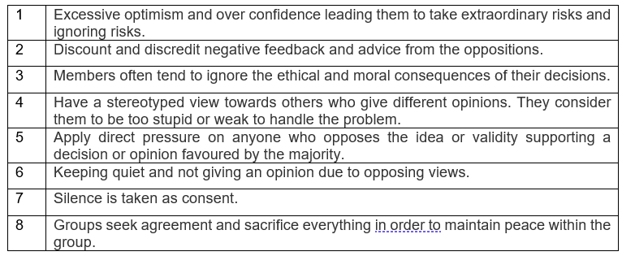

There are many defective points of group think as alternatives are not considered and not everyone participates in the discussions. As described by Smith et al (2014), there are common techniques which facilitates all participants to have a voice, and not just dominant individuals or professions which can support the process.
- Encouraging participants to critically evaluate proposals
- Encouraging the opinions of junior participants before calling on the senior participants
- Seeking the views of specialist experts
- Looking at alternative options
- Appointing a ‘devil’s advocate’ whose role is to take and defend the opposite view.
Having a facilitator can break the barriers down associated with group think and improve outcomes so decisions are thought about. The opposite of Groupthink is achieving consensus, which relies on careful and thoughtful communication between members of the group who are committed to a decision. The disadvantage of consensus is that coming to a decision can take a long time so it wouldn’t work in an emergency.
Both have advantages and disadvantages, so it is applying the right method to the situation and making sure the right people are involved with the decisions which goes back to the stakeholder mapping exercise identified in table 2.
5.0 Conclusion
With Health Boards expecting a significant increase in demand for health and care above the impact of lifestyle factors such as smoking, obesity, and alcohol use, it is crucial not to undervalue the impact on providing a sustainable and viable future for healthcare services.
Communicating and engaging with the right stakeholders plays an important role. Changing the behaviours so people feel they have co-created a product can improve useability and builds on trust that people feel their voice has been heard.
<<more>>

Referencing
- Driscoll, J. (2007). Practising clinical supervision: A reflective approach for healthcare professionals. 2nd edn. Edinburgh, UK: Bailliere Tindall Elsevier.
- Gibbs, G. (1988). Learning by Doing: A guide to teaching and learning methods. Oxford, UK: Further Education Unit, Oxford Polytechnic.
- Janis, I. (1972). Victims of Groupthink: A Psychological Study of Foreign-Policy Decisions and Fiascos. Houghton Mifflin Harcourt.
- Jasper, M. (2013). Beginning reflective practice. 2nd edn. Andover MI: Cengage Learning.
- Kolb, D.A. (1984). Experiential learning: experience as the source of learning and development. Englewood Cliffs, NJ; London, UK: Prentice-Hall.
- Milaster, C. (2022). Clinical Engagement in Telehealth. Available at: Clinician Engagement in Telehealth | Ingenium Digital Health. (Accessed: May 2022)
- Reid, B. (1993). “But we’re doing it already!” Exploring a response to the concept of reflective practice in order to improve its facilitation. Nurse Education Today, 13, 305-309.
- Shirley, D., (2020). Project Management for Healthcare. 2nd edn. Boca Raton: CRC Press.
- Smith et al (2015). The Effective Change Manager’s Handbook: Essential Guidance to the Change Management Body of Knowledge. Great Britain: Kogan Page Limited.
- Tanguay, E, Hanratty, P and Martin, B. (2020). Reflective writing for nursing, health and social work. London: Red Globe Press an imprint of Macmillan Education Limited.
- Topol, E., (2019) The Topol Review. Preparing the Healthcare Workforce to Deliver the Digital Future, pp.1-48. Available at https://topol.hee.nhs.uk/. (Accessed: 6 June 2022).
- Welsh Government (2015) Informed Health and Care - A Digital Health and Social Care Strategy for Wales. Available at: A Digital Health and Social Care Informed Heath and Care; A Digital Health and Social Care Strategy for Wales (gov.wales). (Accessed: 8 April 2022).

