

Assessment 1 – Reading Task Template
PART 1: Upload your photo of your A3 in-class notes here:
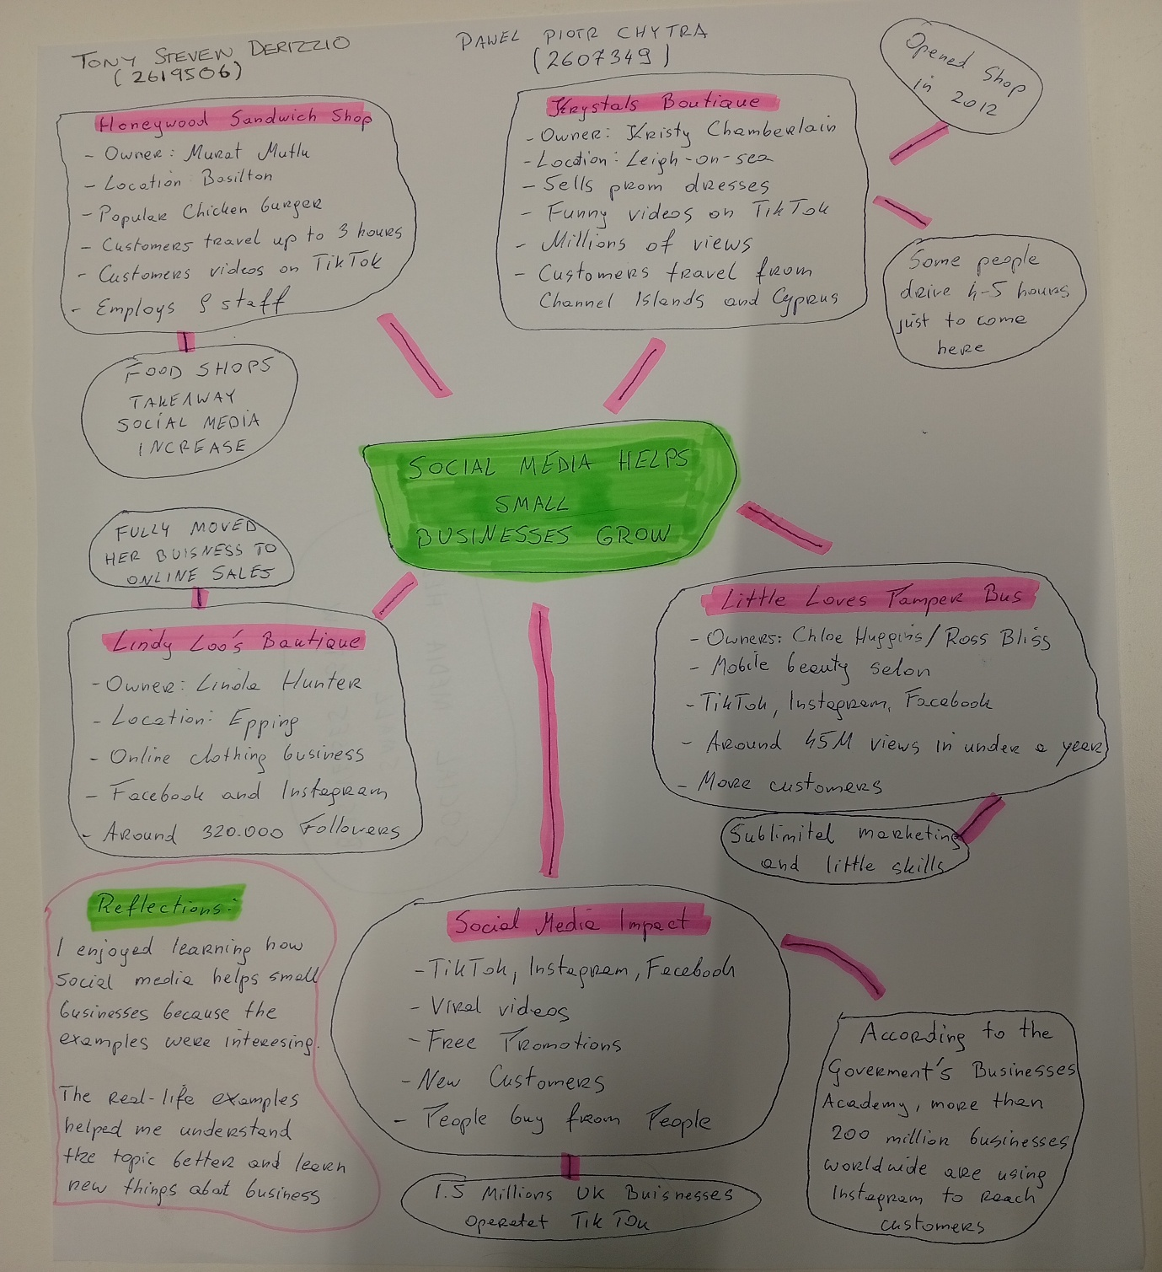

PART 2:
- Answer every question below in 1-3 full sentences.
- Use your own words. Do not use generative AI to answer these questions.
- Include a specific detail from the text when asked.

REMINDER
- The main idea is the overall message of the whole text.
- A key point helps to explain the main idea.
- A specific detail or example from the text shows that the key point is true.

- What is the main idea of the whole text?

The main idea is that social media can help mall businesses become more popular and attract more customers. Platforms such as TikTok and Instagram can help businesses grow and increase their sales. The article explains that about 1.5 million UK businesses operate on TikTok

- What is one key point that supports the main idea, and which specific example from the text shows this?

One key point is that viral videos can attract customers from far away. For example, customers travelled for three hours to try the chicken burger at Honywood Sandwich Shop after videos about the food were shared online. The owner, Murat Mutlu, employs nine staff members.

- What is a different key point that supports the main idea, and which specific example from the text shows this?

Another key point is that social media can help businesses reach a much larger audience and sell more products. For example, Krystals Boutique became popular through funny TikTok videos, and teenagers travelled from the Channel Islands and Cyprus to buy dresses from the shop. The shop opened in 2012, and its videos have received millions of views.

- Which part of the text do you think is most important, and why?

I think the most important part is the example of Honywood Sandwich Shop. Customers travelled for three hours to try chicken burger, showing how social media can help a small business attract more customers. The article explains that customer videos, rather than only the shop’s own videos, helped increase its business.

Reflection:
- What did you find difficult in this task (including in-class components), and why was it difficult?

I found it difficult to identify the main idea and choose the best examples from the text. Some information was similar, so I had to read carefully to understand the important points. The article included several different businesses, which made it harder to choose the strongest examples.

- What helped you with this difficulty, and how did it help you?

Reading the text carefully and looking for specific example helped me. It made it easier to understand the main ideas and choose the right information foe my answers. I used details such as three journeys to the sandwich shop and the number of views received by the businesses to support my answers.

