University of Wales Trinity Saint David
Wales Institute of Science and Art


Engine Performance Characteristics

Motorsport Technology
ACHA4004

Evan Arthur
2304605
30/03/25

Contents
1 Introduction 2
2 Equipment & Testing Procedure 2
3 Data Collected/Calculated 3
3.1 Data Collected: 3
3.2 Data Calculated: 4
4 Analysis of Data 5
5 Conclusion 6
6 Evaluation 6

Figure 1 – Specific Fuel Consumption vs. Engine Speed 5
Figure 2 – Torque vs. Engine Speed 5
Figure 3 – Brake Power vs. Engine Speed 6

Introduction
This report investigates the performance characteristics of an internal combustion engine across varying engine speeds, focusing on Specific Fuel Consumption (SFC), Torque and Power. The analysis is based on experimental data collected using an engine dynamometer – a high precision testing device capable of measuring engine outputs by generating resistive forces through opposing magnetic fields.
The primary objective of this report is to examine how SFC, torque and power vary with engine speeds, identifying the optimal ranges for efficiency and performance. By understanding the relationship between these characteristics, it becomes possible to evaluate the engine’s ability to convert fuel energy into useful work while minimising energy losses.
The findings presented in this report offer valuable perspectives on the characteristics of the engine while operating, highlighting the interplay between combustion efficiency, mechanical losses and thermal effects. These points can influence engine design and tuning to maximise efficiency, performance and reliability simultaneously.
The following sections detail the experimental results, with a focus on the trends observed in SFC, Torque and Power as functions of engine speed, followed by a conclusion which summarises the key findings and the implications they hold.

Equipment & Testing Procedure
The equipment used during the experiment was the Schenck W230. This is an eddy current dynamometer which produces 230kW of power and 750Nm of torque at speeds of up to 7500rpm by utilising opposing magnetic fields created by a rotor, an engine and a stator with coils – making it ideal for evaluating a wide range of engine types. As the engine drives the rotor, electrical currents (eddy) are induced in the stator coils due to the motion of the magnetic fields. As effect, these eddy currents produce a resistive force that opposes the rotor’s motion. This force is proportional to the rotor’s rotational speed, allowing the dynamometer to simulate the varying load conditions the engine might experience during operation. By precisely measuring the resistive force applied to the rotor the dynamometer can determine the torque output by the engine at test. This value can then be combined with the calibrated rotational speed of the system, giving an accurate reading for power output of the engine. Additionally, the use of a dynamometer provides a controlled environment for testing, allowing consistency and reliable data collection.

Data Collected/Calculated

Data Collected:
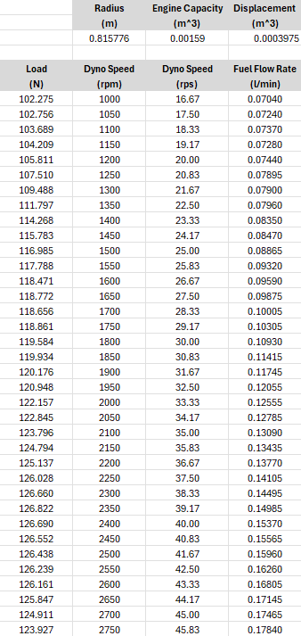
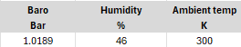
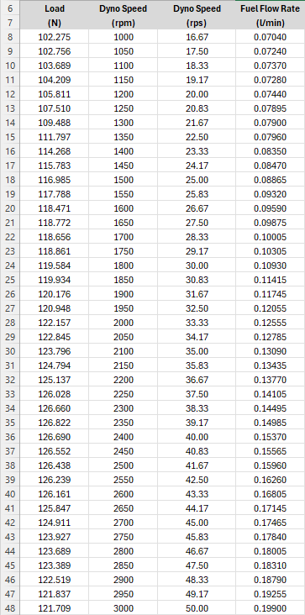
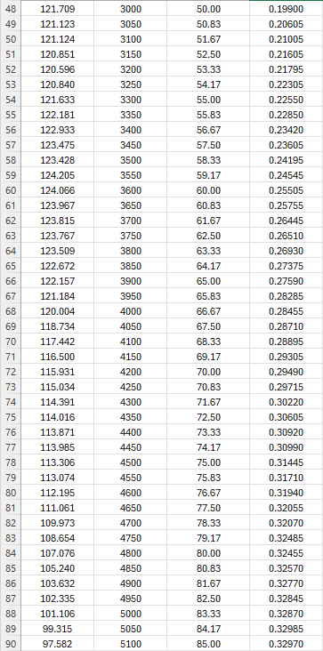
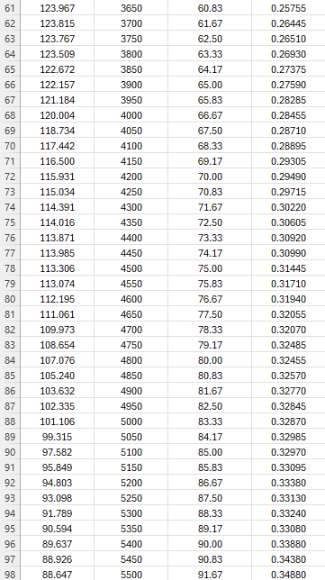

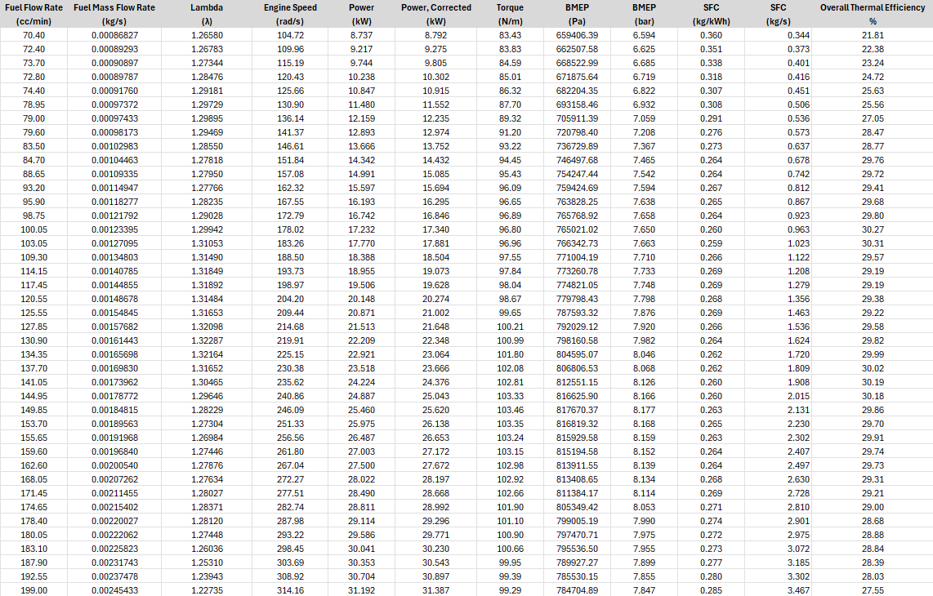
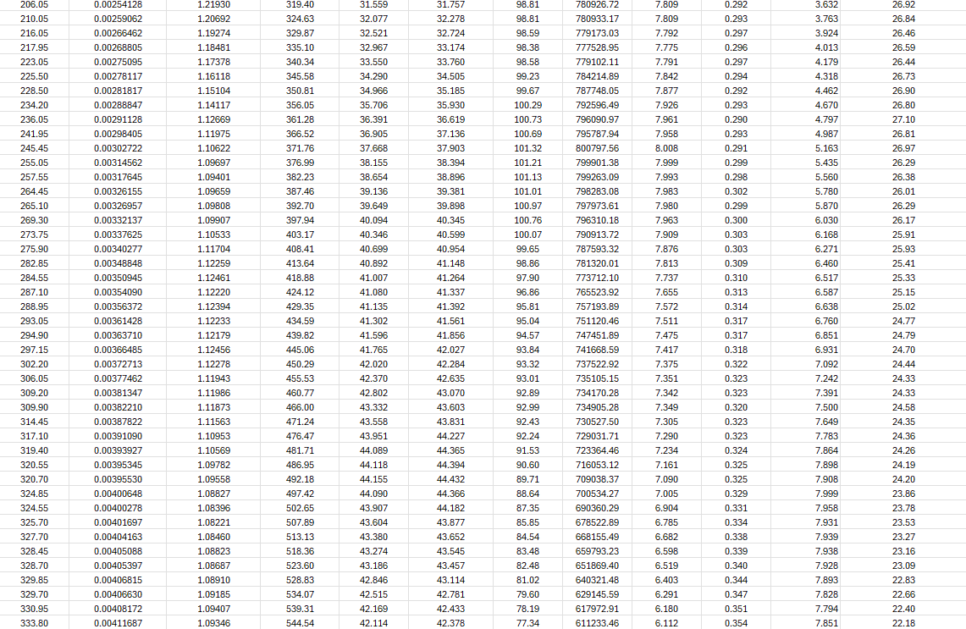
Data Calculated:

Analysis of Data
Figure 1 – Specific Fuel Consumption vs. Engine Speed
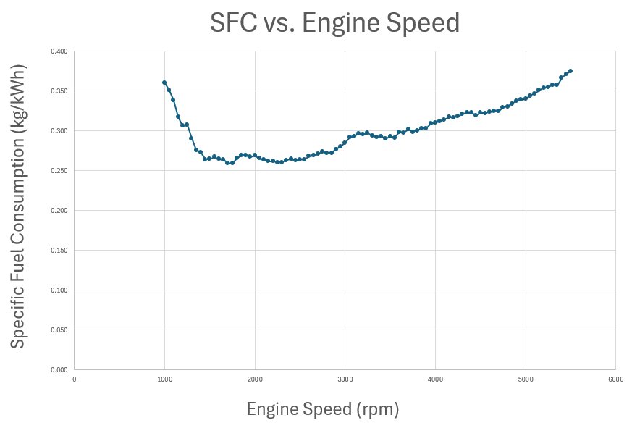
Figure 1 shows the change in Specific Fuel Consumption in relation to engine speed. Initially this shows the SFC decreasing to a minimum point while engine speed increases, highlighting the most fuel-efficient operating speed of the engine which is at 1700-1750rpm. The lower end speeds show a relatively inefficient operating speed of the engine, this can be caused by poor combustion or incomplete combustion due to the longer burn duration and likely lower cylinder pressures, this results in additional energy losses and overall higher fuel consumption for the power that is being made. Additionally, frictional losses take part in the inefficiency of the engine – such as that from the piston rings and the viscosity from the oil. At the operating speed of lowest SFC, the cylinders are at their ideal pressures, meaning the fuel is burned completely - due to this the overall energy conserved is maximised. Mechanical losses, such as the previous mentioned friction, are minimised in relation to the engine’s speed/power causing more effective energy transfer into and through the crankshaft. After this period, the SFC begins to rise therefore reducing the total time for combustion leading to incomplete combustion – this is clear from the smooth increase following the optimal rpm for SFC. As the engine speeds up, mechanical losses increase. This can be seen in the bearing, piston rings, valves and other moving components in the engine itself. As effect of more friction the internal temperature of the engine will also increase once again lowering efficiency therefore requiring a higher volume of fuel.
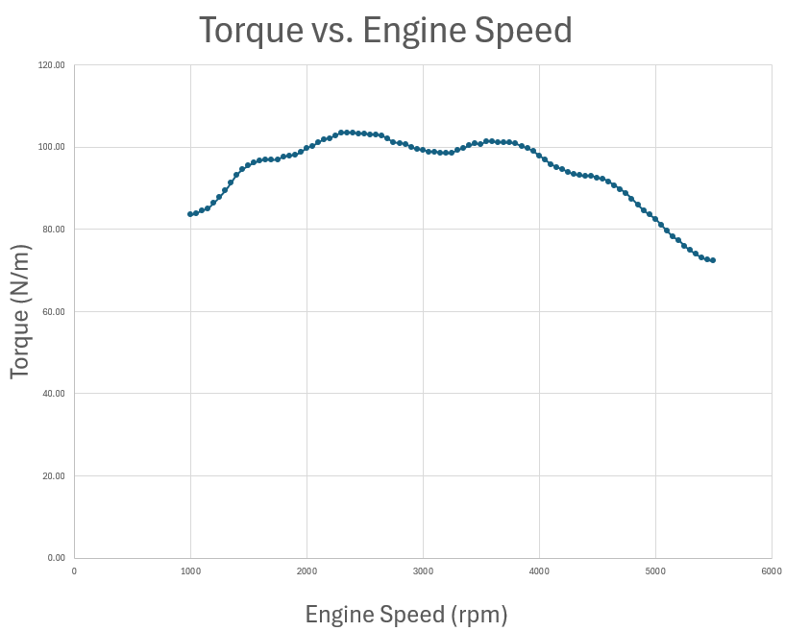
Figure 2 displays the relationship between torque produced through the operating speeds of the engine tested. The initial increase in torque (between 1000-1500rpm) suggests that the engine produces higher torque as the engine speed rises. This is because the air-fuel mix is becoming much more well mixed and the combustion is tending to the optimal rpm range. With higher engine speeds, the pressure within the cylinder also increases. This also helps to produce a closer to complete combustion. The plateau seen between 2000 and 4000rpm highlights the range of rpm at which the engine is most efficient in the generation of torque, benefitting from the previously mentioned optimal cylinder pressures and temperatures to allow minimal energy lost from the fuel. Adding to this, the cylinders achieve peak volumetric efficiency. Meaning the cylinders are to take in the closest to perfect air-fuel mixture during each intake stroke which leads to a much more consistent and stronger power stroke to follow. After the peak of the graph, the torque begins to decrease as the rpm increases further. At a higher rpm, the time for combustion becomes much more limited which leads to incomplete combustion where not all of the air-fuel mix is burned resulting in power loss therefore less torque.
Figure 2 – Torque vs. Engine Speed
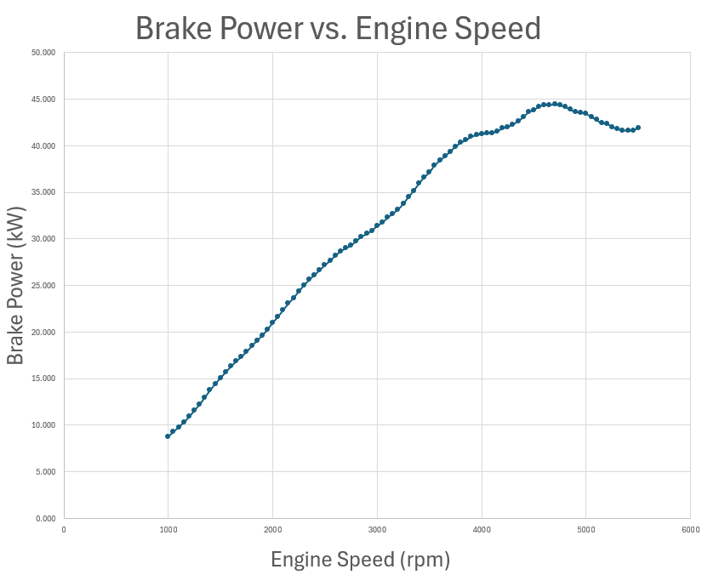
Figure 3 shows how much power the engine makes as rpm increases. The increase of power through 1000-4500rpm is relatively linear, this indicates improving engine performance as the engine is speeding up which is down to multiple factors. One of these being in the proportional relationship between power and torque. Since power is the product of torque and rotational speed, the consistent torque, seen in figure 2, across this range of rpm results in a relatively linear increase to power following rising rpm.
Figure 3 – Brake Power vs. Engine Speed
The peak of the graph (4600rpm) highlights the maximum power produced by this engine during the test – where torque and engine speed are at a balance to produce the most power. Frictional and thermal losses are not yet severe enough to result in significant a loss in the production of power, meaning the engine is running at peak capacity. As mentioned previously regarding torque, at this rev range the engine is very near the optimal air-fuel ratio alongside cylinder pressure. This contributes to the engine producing maximum power. Following this, a drop in power is seen beyond the 4700rpm point. This is the point during the test where the engine had surpassed optimal combustion conditions and factors such as friction, heat and incomplete combustion become significant enough to hinder the performance of the engine. This displays the considerations and trade-offs thought about when setting engine timings and fuel volumes.

Conclusion
This report has provided a detailed analysis of the relationship between Specific Fuel Consumption (SFC), Torque and Power against Engine Speed. Each section highlights the complexity of combustion efficiency, mechanical losses and thermodynamic attributes that make up engine performance.
From Figure 1, it is evident that the SFC decreases to a minimum at the most fuel efficient operating speed. This range is made up of complete combustion, ideal cylinder pressures and minimised mechanical losses. Both above and below this range, poor combustion and increased friction both contribute to inefficient running.
Figure 2 displays the torque characteristics, showing an initial rise due to improving combustion efficiency and cylinder pressures. A plateau is seen between 2000 & 4000rpm, this is where peak volumetric efficiency is achieved – representing the engine’s most torque effective zone. Beyond this the torque declines reasons that the same as SFC.
Finally, Figure 3 highlights the linear increase in power output with rising rpm up to a peak of 4600. This peak reflects the balance between torque and speed as well as the conditions for optimal combustion. Beyond this range, power begins to decline for reasons such as thermal inefficiency and incomplete combustion once again.
Overall, the data gathered and referred to underlines the importance of understanding optimal ranges for SFC, Torque and Power to achieve maximum performance and efficiency. Additionally, understanding the trade offs at higher engine speeds puts emphasis on the need for precision in designing engines and relevant components to ensure not only performance but also reliability.

Evaluation
While the Schneck W230 dynamometer was intended for use in this experiment, it was unfortunately not operational during the test. As a result, the data analysed during this report was provided rather than collected firsthand. This limitation affects the ability to evaluate the engine’s performance under controlled, real-time conditions as hands on operation of the equipment would have offered deeper insights into the dynamometers functionality and the testing process.
Despite these limitations, the analysis of the data provided remains valuable in highlighting key engine performance concepts and trends. However, future studies would benefit greatly from functional equipment to allow for a direct interaction with the testing process to gather a further understanding and more accurate interpretation of the results at hand.

