
Faculty of Architecture and Construction
Advance Construction Technology
Lecturer: Alun Watkins

The Senedd

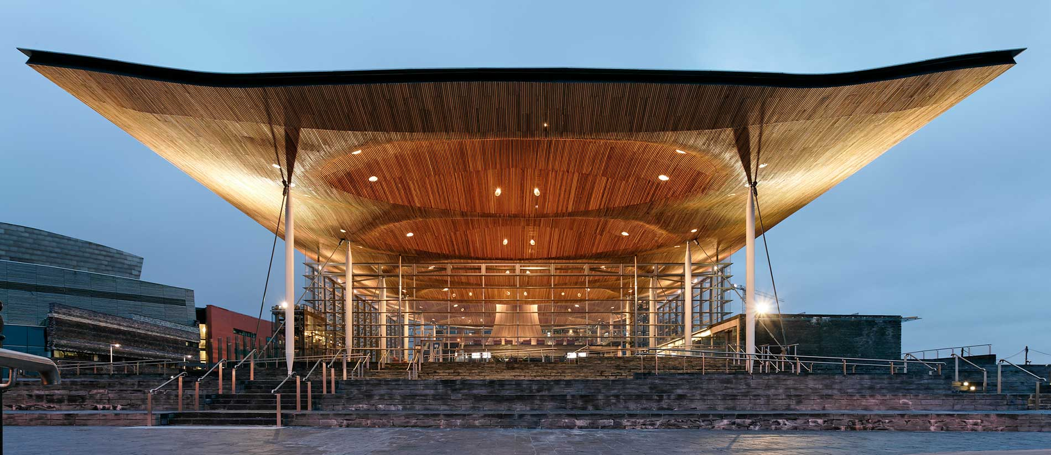

Author: Kelene Frederick

Date of submission:

Table of Contents

TABLE OF FIGURES ………………………………………………………………………3

ABSTRACT ………………………………………………………………………………….4

- INTRODUCTION ……………………………………………………………………5

  - Purpose …………………………………………………………………..……...5

  - The History…………… …………………………………………………………5

  - The Concept & Description……………………………………………………..7

    - The Concept…………………………………………………….…………….7
    - The Design……………………………………………………………….8
1.3.2a Space Occupancy……………………………………………………...12

  - The Importance of the Senedd……………………………………………….15

- The Construction…………...………………………………………………………16

  - Key Principles of Construction………………………………………………..16

- Positive Properties & Improvements of the Senedd…………………………….20

  - Positive Properties……………………………………………………………..20

  - Improvements ……………………………………………………………….…24

- The Conclusion……………………………………………………………………..26

- References………………………………………………………………………….28

TABLE OF FIGURES

Figure | Title | Page
1 | An initial concept of the Senedd | 7
2 | Shows an initial internal concept of the Senedd | 8
3 | The reception area of the Senedd | 8
4 | Shows debating chamber public viewing gallery of the Senedd | 9
5 | Shows the inside of the debating chamber in the Senedd | 10
6 | The National Assembly of Wales | 10
7 | Shows a rough estimate of the ground floor area in metres | 12
8 | Shows a rough estimate of the first-floor area in metres | 12
9 | Shows a rough estimate of the first-floor area in metres | 14
10 | Is a pie chart showing the total space occupancy percentage of both the Ground and First floor | 14
11 | Showing more awards that the Welsh Parliament building received | 15
12 | Showing the funnel at the centre of the Oriel | 17
13 | Shows a section showing natural ventilation and lighting | 18
14 | Showing the reduction of water consumption in the Senedd decreasing yearly | 212
15 | Showing the reduction of energy emission used in the Senedd decreasing yearly | 22
16 | Showing the key performance indicators of the Senedd decreasing yearly | 22
17 | Showing the key performance indicators of the Senedd decreasing yearly | 23
18 | Showing the steel beams and glass panels in the Senedd | 24
19 | Showing the operation and maintenance cost in the Senedd | 26

ABSTRACT

This report served to evaluate a non-dwelling building over the age of 10 years. The evaluation included appearance, energy input and outputs, embodied carbon, end-of-life cycle, operational cost and maintenance for the chosen building.
This information helped to acknowledge the social, environmental and economic contributions that were associated with the building. Recommendations were created to explain what could be improved within the building and what could have been done instead. Information was gathered using official government sites, case studies, newspapers, and audits.
The building that was selected is called the Senedd also known as the Welsh Parliament Building. It is located at Cardiff Bay with easy access via walking from the train station, bikes, and vehicles.
The construction of the Senedd began in 2003 and was completed in 2006, the main composition of the structure is glass, steel frames and a solid concrete foundation. An open concept was incorporated into the design, hence the extensive use of glass. It was also fitted with other innovations to reduce energy consumption.
It Is yet to meet its carbon neutral targets, nevertheless, there are improvements made every year, for example, one hundred per cent of waste is recycled. However, electric bills have not declined in the past year. This could be because of the glass, which allows for hot summers and more heat loss in cold winters.
The building itself could have been built using fewer materials such as steel and concrete that require carbon elements to be released into the atmosphere.

- Introduction
1.1 Purpose

A building was selected for a detailed case study. The building should have the characteristics of a non-residential structure, such as a school, hospital, hotel, office, or retail store. The Building ought to be at least ten years old, therefore this report aims to provide an overview of the building's use and purpose, together with details about its age, architectural style, gross interior floor area, number of rooms, and exterior façade area. The evaluation takes into account the building's social and economic worth in addition to its environmental effects.
The Senedd was chosen for this report because when the scholarship began as a Vincentian student who was not extremely knowledgeable about Wales the Welsh Parliament building was a usual topic in different modules. It was spoken about in class, compared to the Scottish Parliament building (Holyrood) and given as an assignment to identify the reasons the Senedd went over budget. Not only was it a popular topic the building had an interesting design that was enticing. This report will aid in identifying what was done correctly and what can be improved in terms of the construction of the Senedd.

  - The History
According to The Senedd Welsh Parliament, (2020), initially in April 1998, Ron Davies, as Secretary of State for Wales, decided to put the Senedd in its current location on Cardiff Bay. After much deliberation, the decision was made to construct a new structure on the land next to Crick Howell House, which was then located in front of the harbour, to house a specially designed debating chamber.
The Senedd Welsh Parliament, (2020), continues to explain that Lord Richard Rogers and Ivan Harbour were the architects of the Senedd, which was inaugurated on St David's Day in 2006. It was quickly acknowledged as a significant structure, representing the Welsh Parliament's dedication to open democracy.

Cymru | Welsh Parliament, (2020) provided the following explanation of the Senedd's building timeline:
Timeline According to the Cymru | Welsh Parliament, (2020)
- In January 2003, Taylor Woodrow was selected as the preferred bidder, and by the end of May 2003, their complete tender was anticipated. The contract had a one-time payment of GBP 40.997 million with VAT excluded. The contract was awarded to Taylor Woodrow Construction Ltd. on July 1st, 2003. In August 2003, the project's second phase got underway.

- On the job site, work was to commence in August 2003 and end in late summer 2005, with the first phase finished by early summer 2005. On August 4th 2003, Taylor Woodrow deployed on the site to begin the enabling work necessary to finish the excavation of the site. large equipment arrived on the scene on August 14th and 15th, ready to begin drilling boreholes for the earth heat exchanger system and piling the remaining foundations.

- Contractors arrived at the site on July 28, 2003, and set up temporary site offices. As of September 2003, the rigs were demobilised and the piling for the building foundations was finished. With a gradual movement away from Crickhowell House, the pile tops were being revealed and levelled. Many reinforcing cages have been prepared by prefabrication, and the pile caps and ground beams were being produced. To make room for the concrete frame, foundation work continued over the coming weeks. Formwork was now being done on the tower crane's base.

- The piling was finished in October 2003, and this included assessing the piles that were already there. Following that, the Earth Heat Exchangers were installed. Alongside the groundwork, the connection of the well heads was taking shape. On October 24, the Tower Crane was delivered and put into place.

- November 2003 saw the timely completion of the Earth Heat Exchanger installation. The labour to connect the well heads and the preparation of the ground were continuous activities. All of the piles have been removed, except for those close to the truck road and ramp. The plant room area was gradually scraped away, exposing the last few piles while maintaining access to the activities.
- The Senedd was formally inaugurated by Her Majesty The Queen on March 1, 2006, in the presence of Assembly Members (AMs), Members of Parliament, parliamentarians, and other representatives.

  - The Concept and Description

1.3.1. The Concept:

The Senedd Cymru | Welsh Parliament, (2020) explain that the architect's concept behind the Senedd was to create a distinctive structure emerging from the bay that attracts attention with an overhanging roof acting as a gathering place. The design aims to sculpt the sky (roof plane) and the working areas (ground plane) to establish a clear separation between the public space and the functional areas. The primary objective of the design is to embody an open democracy while also promoting sustainable development.
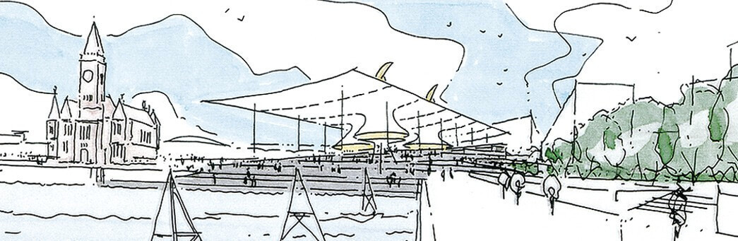
Figure 1. Shows an initial concept of the Senedd taken from, the RSHP, (2019)
The RSHP, (2019) states that the concepts of transparency and openness were incorporated as a design principle for the National Assembly for Wales in Cardiff. The building was intended to be a transparent exterior that looked outward to Cardiff Bay and beyond, rather than an isolated, closed structure. This would have allowed the public to participate in the democratic process and shown the Assembly's inner workings. Elevated on a plinth covered in slate, the public spaces rise from the water and are cut away to let daylight into the administrative offices below. This creates a visible link between the elected and the electorate.
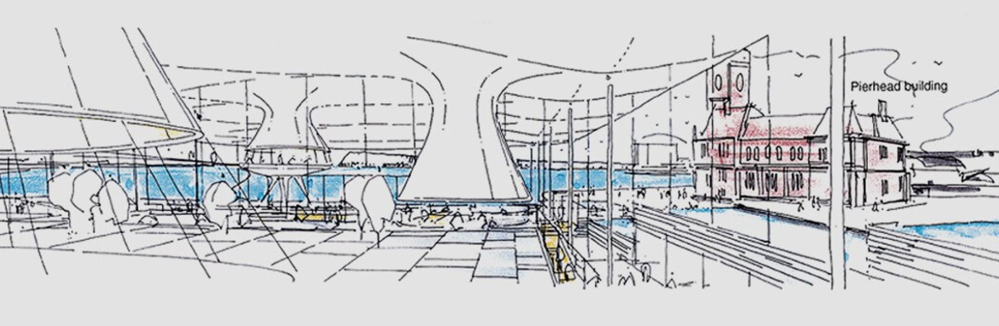
Figure 2. Shows an initial internal concept of the Senedd taken from, the RSHP, (2019)

1.3.2. The Design:
RSHP, (2019) describes the design of the Senedd as follows:

The Main Hall consists of two levels, the lower level contains the public reception and information facilities. Adjacent to the reception desk, there is a staircase that leads to the upper level. On the upper level, there is a café and exhibition area with a glass floor that provides views of the Debating Chamber below and panoramic views in every direction.
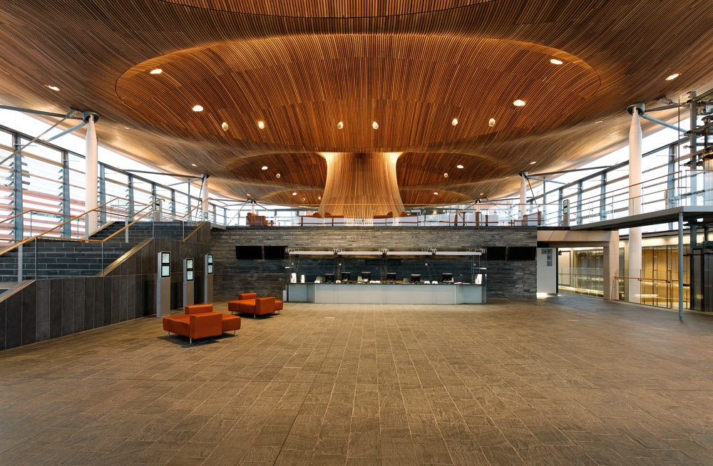
Figure 3. Shows the reception area of the Senedd taken from, the RSHP, (2019)

The main area of the building, known as the Debating Chamber, has a striking design with a circular shape. Its roof features a prominent bell-like structure, and the inside of the bell is adorned with rings made of satin-finished aluminium arranged in concentric circles. Above these rings, there is a glass lantern that lets soft natural light enter the chamber, and within the lantern, a cone-shaped mirror reflects more daylight into the space below.
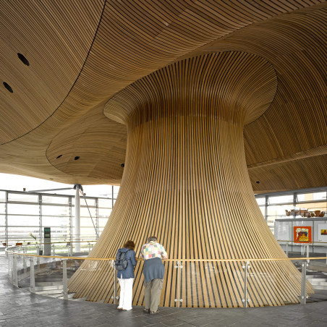
Figure 4. Shows debating chamber public viewing gallery of the Senedd taken from, the RSHP, (2019)

The Debating Chamber occupies a central position both physically and symbolically within the design, and it is encircled by public areas to maintain its openness and inclusivity. The presence of the chamber is highlighted by the striking bell-shaped structure that rises above the roof. The lower part of the bell is made of glass, allowing views of the chamber from the public viewing gallery situated above. This gallery can accommodate up to 128 individuals, with provisions for wheelchair users as well. Enhanced security measures were implemented in the chamber after the occurrence of the 9/11 terrorist attacks in New York City in 2001.
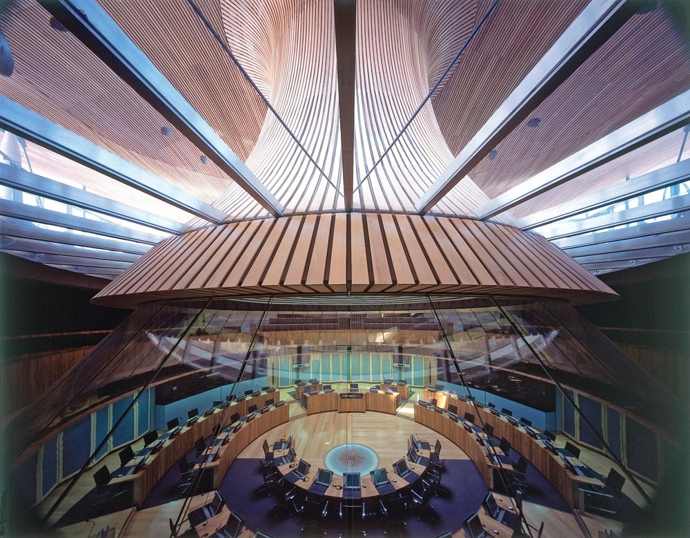
Figure 5. Shows the inside of the debating chamber in the Senedd taken from, the RSHP, (2019)

RSHP proposed enlarging the Cardiff Bay-facing site to establish a fresh public area that seamlessly blends with nearby constructions. The architectural plan incorporates terraces delineated by short walls made of slate, which cascade from the building's front onto the existing harbour wall. Through the utilization of the Old Dock, these terraces are extended towards the water, connecting with a boardwalk. This innovative design unites the new building with Cardiff Bay, resulting in a captivating public space that allows individuals to relish the waterfront and actively engage in democratic endeavours. The choice of local materials, including slate, contributes to the harmonization of the overall landscape.
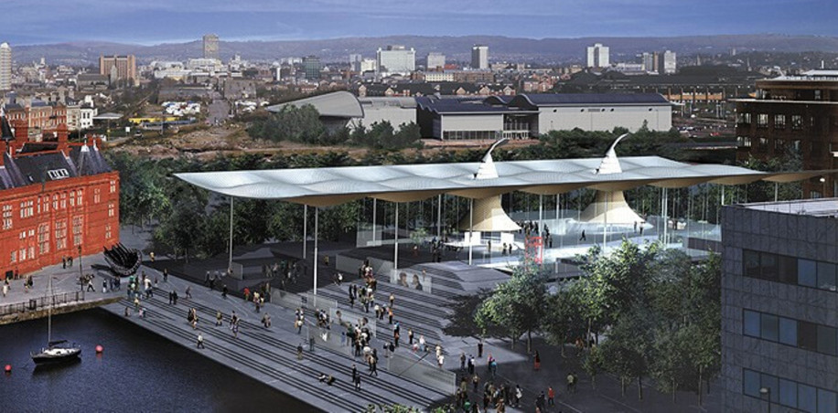
Figure 6. Shows The National Assembly of Wales, taken from, the RSHP, (2019)
Design Summary:
The Senedd is a Government building that falls under the Modern Architecture style according to Barker, (2018), he continues to say that function is given precedence over form in the modernist style, along with a clear, uncluttered structure and minimal decoration. The developments in concrete, steel, and glass were also embraced by this design. The RSHP, (2019) states that the total gross internal floor area is 5,308 m² and the site area is 14,382 m². The Senedd has slabs, beams, and columns and is supported by a concrete plinth. Senedd Cymru | Welsh Parliament, (2021) explains that this sturdy foundation is composed of more than 16,700 tonnes of concrete. There are 421 tonnes of steel, 21,900 bolts, and 2,088 connections making up the steel roof. The concrete was poured on site and has an excellent finish; it was chosen for its sturdy quality and thermal qualities.

Based on concept and design the layout of the structure serves as an appropriate example of transparency. The design completely portrays and embodies openness using both materials and physically allowing citizens to view the discussions within the building through the view gallery of the chamber. This allows persons to have their own opinions on any topics that are discussed within the chamber, nothing is withheld against the public. One of the reasons the building was designed with an open concept was to encompass a welcoming feel to grab attention and encourage individuals to visit.
This was successful because according to the Welsh Parliament, (2009) since its opening in 2006, the Senedd has welcomed 750,000 visitors, with Alison Bennett from Dartford, Kent, being the milestone 750,000th visitor. It is safe to say that from the timeline of 2009-2023, the building would have had approximately millions of visitors. The Senedd encourages tours of the building which does help to attract more people other than the unique design.

1.3.2a Space Occupancy:

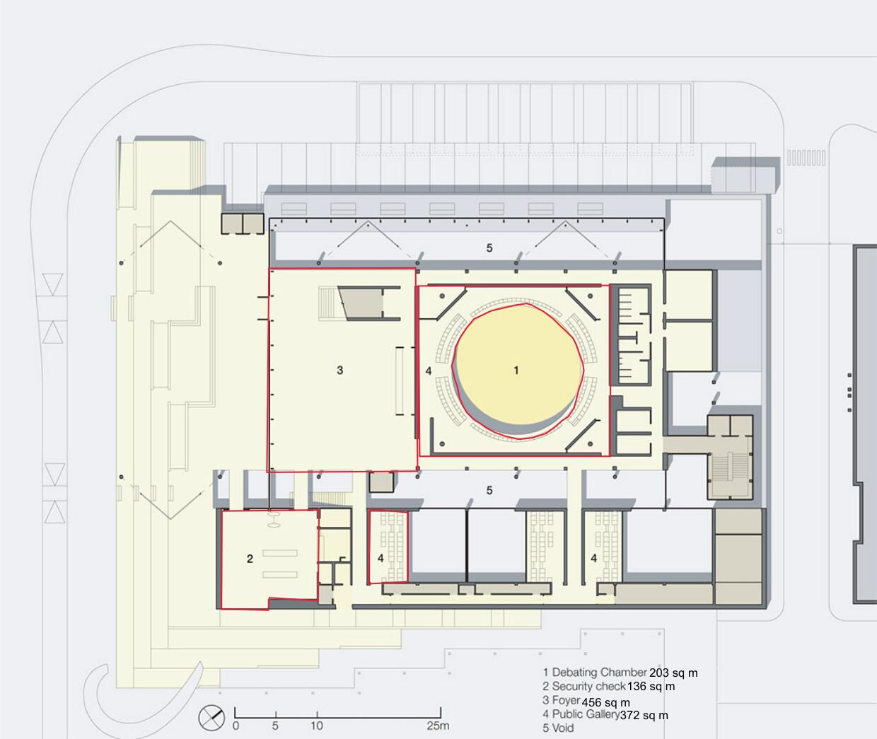
Figure 7. Shows a rough estimate of the ground floor area in metres, from Archiweb, (2015) and edited by Frederick, K. (2023)
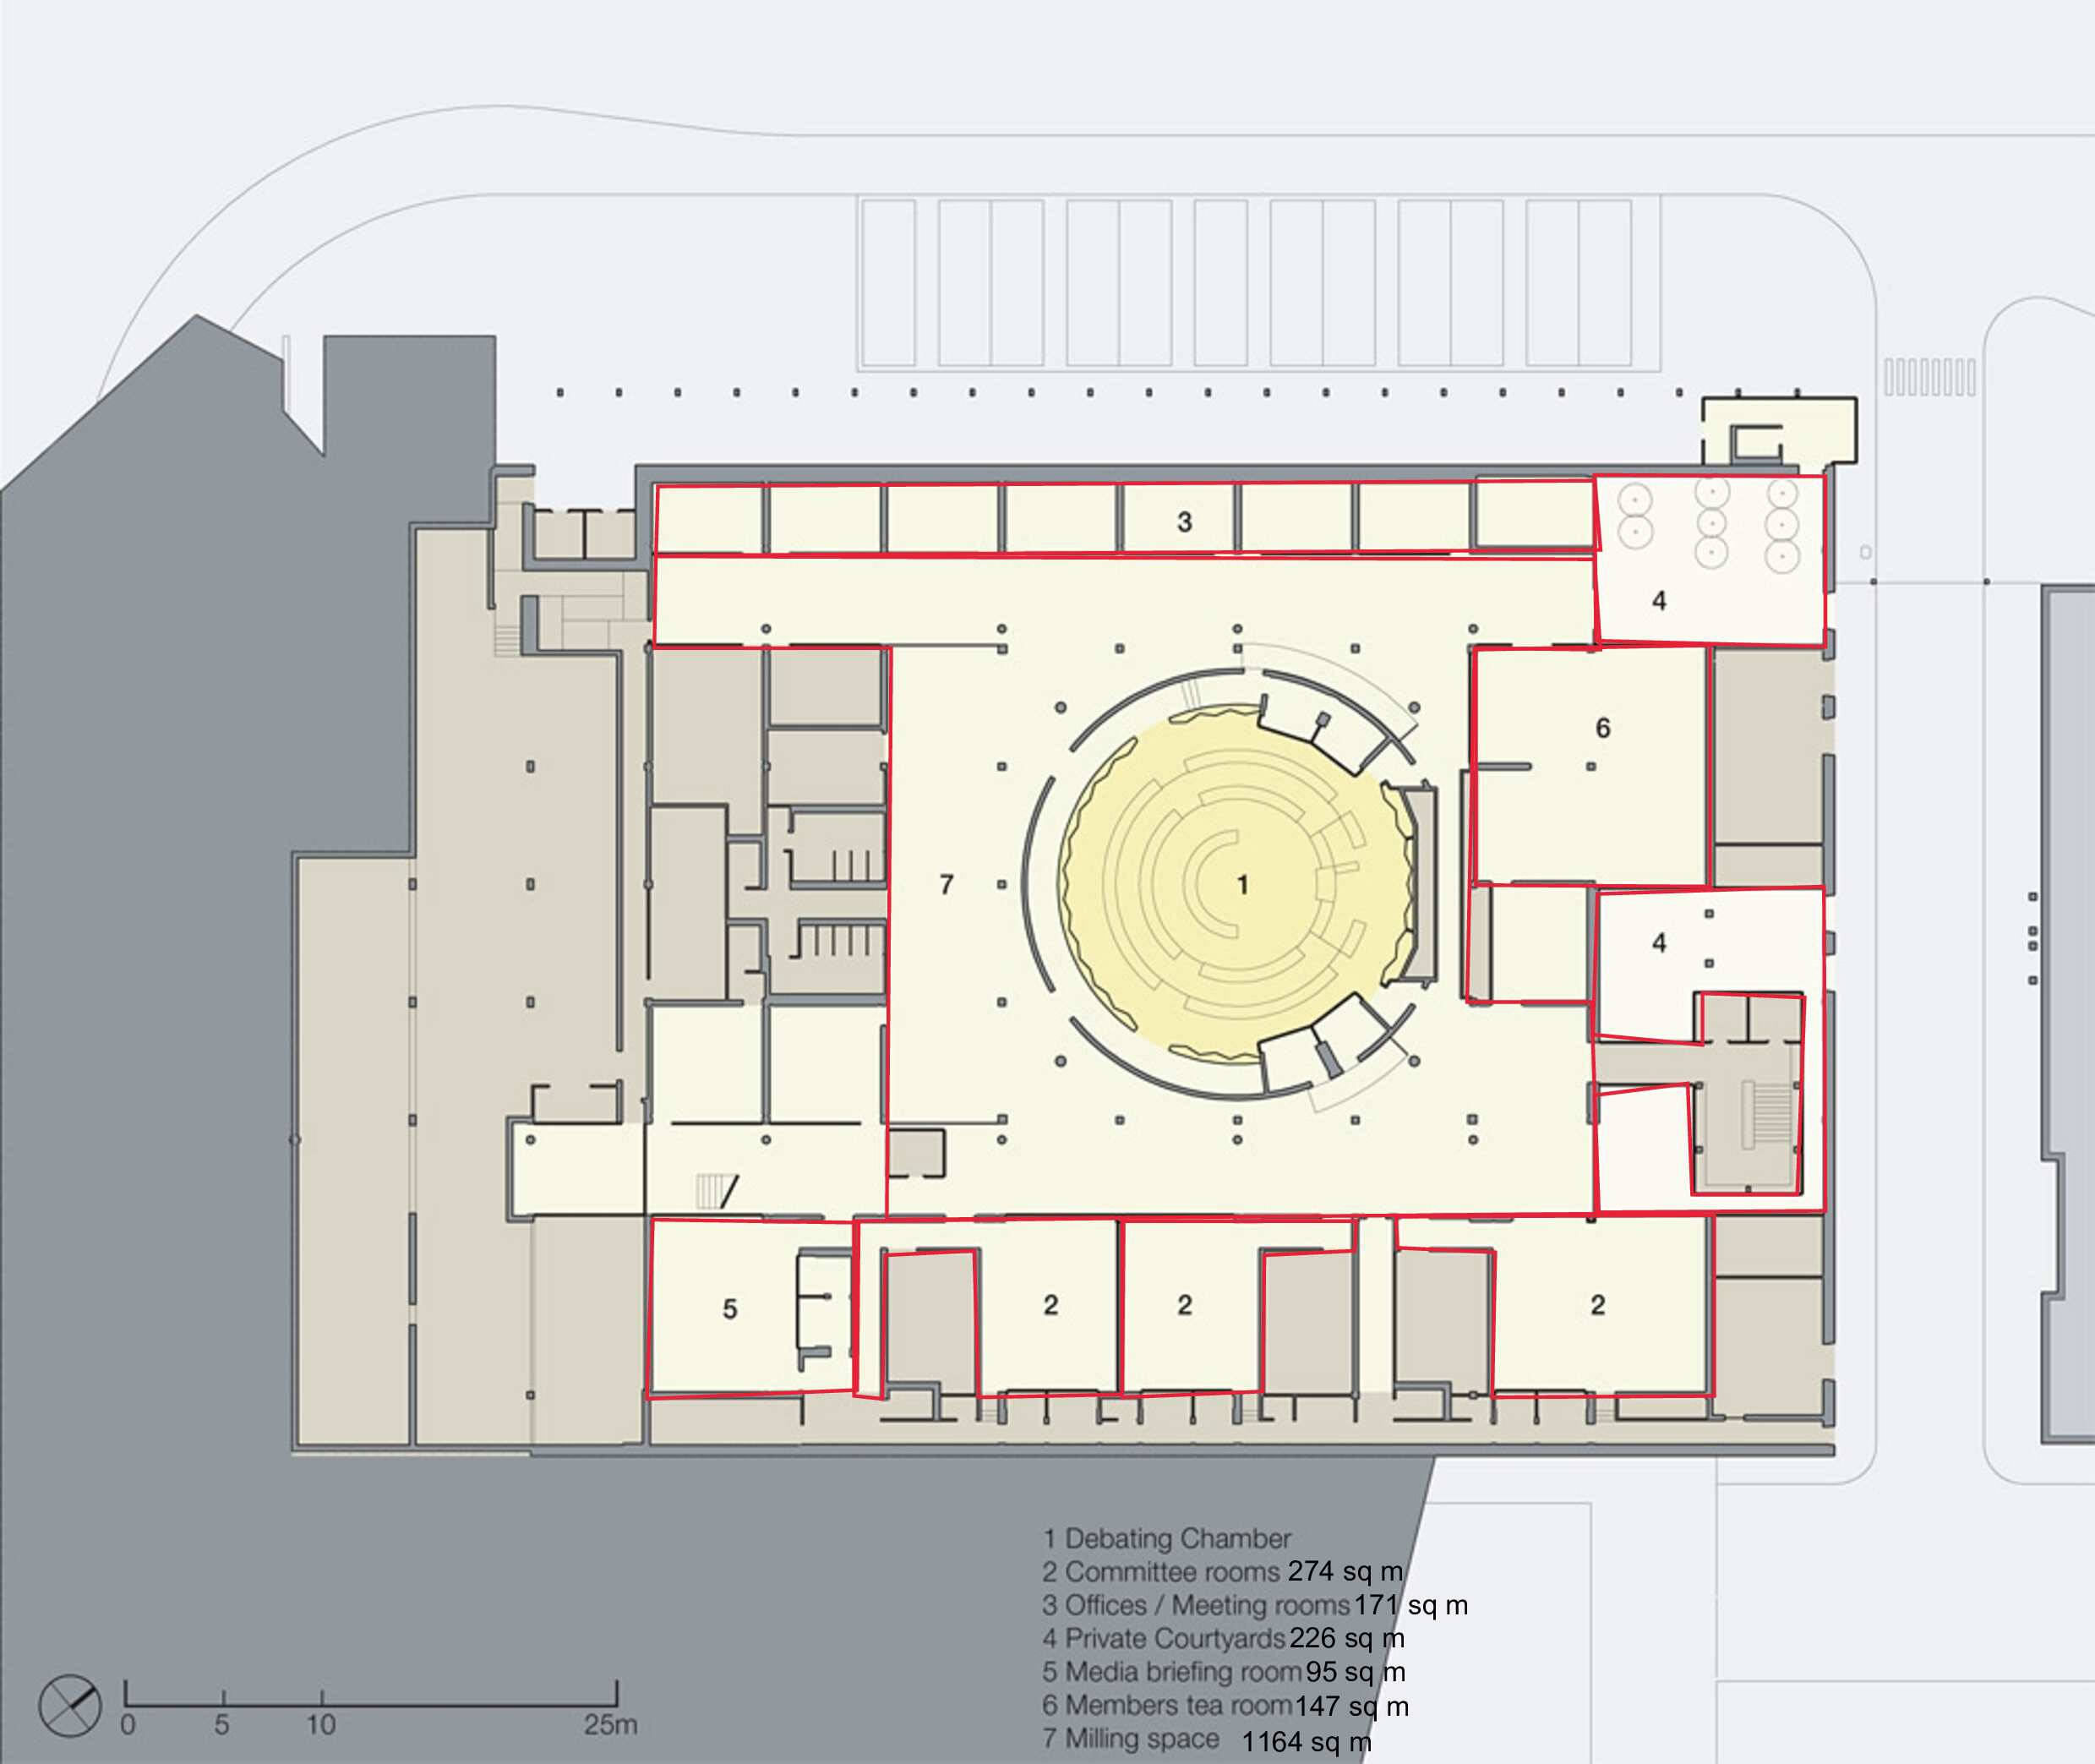
Figure 8. Shows a rough estimate of the first-floor area in metres, from Archiweb, (2015) and edited by Frederick, K. (2023)

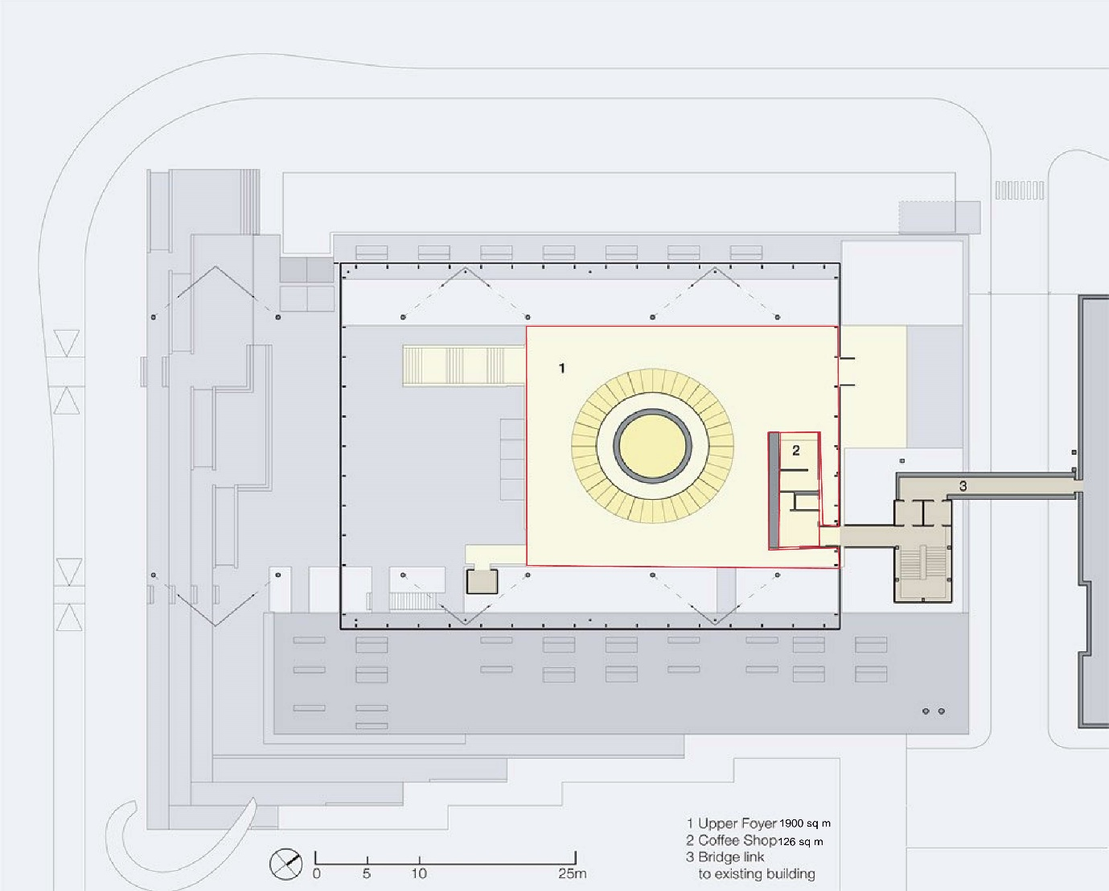
Figure 9. Shows a rough estimate of the first-floor area in metres, from Archiweb, (2015) and edited by Frederick, K. (2023)

These drawings were used to derive the floor areas for each section of the Senedd to calculate the variable occupancy spaces on both the ground and first floor. The pie chart below shows a visual representation of how the space is shared throughout.
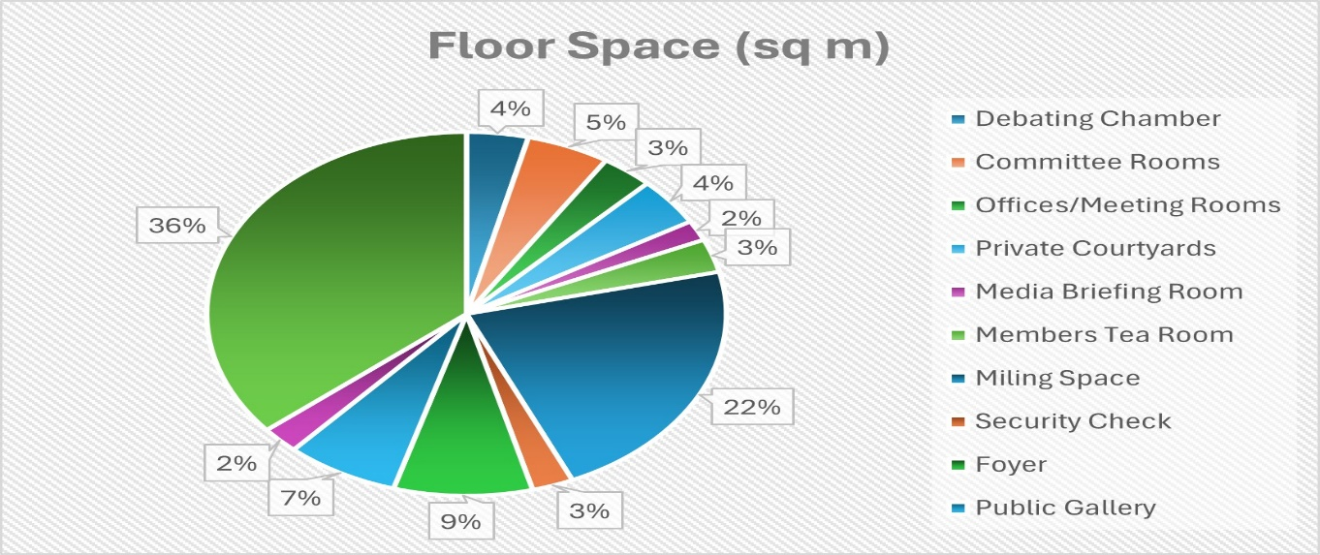
Figure 10. Is a pie chart showing the total space occupancy percentage of both the Ground and First floor, taken from Frederick, K. (2023)
1.4. Importance of The Senedd Building

Senedd Welsh Parliament, (2021) summarises the importance of the building saying that it marks a crucial chapter in Welsh history. Therefore, the construction of this building provides a setting stone and an example for the future construction of sustainable buildings.

The Senedd was able to achieve numerous awards such as according to the Senedd Welsh Parliament, (2020):
Awards
Action for Hearing Loss Cymru has recognized us with Excellent Wales awards, designating us as an exemplary organization in this regard.
Acknowledged as one of the Top 50 Employers for Women by The Times/Opportunity Now.
Attained the status of Age Employer Champion and have been acknowledged as a Disability Confident employer by the Department for Work and Pensions.
Secured a position in the Top Ten UK employers list, accredited by the organization Top Employers for Working Families. This organization is a recognized benchmark for excellence in creating a work environment that supports a positive work/life balance.
Granted the Platinum Standard by Investors in People, a global mark of international excellence.
Granted the National Autism Society Access Award.

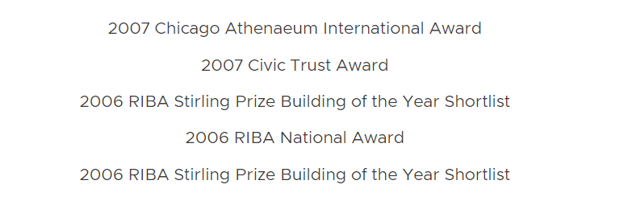
Figure 11. Showing more awards that the Welsh Parliament building received, taken from Gillespies, (2008)

The main types of awards that were received show that the Senedd took full consideration of social values. Ensuring that there was no discrimination of gender in the workplace, providing easy access to all types of disabled, training staff to provide excellent services to all visitors including those with disabilities and supplying a safe and friendly working environment for staff to feel comfortable. This acknowledgement reflects their dedication to ensuring the accessibility of their building for visitors especially persons who are hearing impaired and or have autism, along with the training of their staff to welcome them. Not only has the building been designed to welcome all but its staff carries on the legacy and concept of openness with their attitudes.

- The Construction

2.1. Key Principles of Construction
Environmental Sustainability:
According to Senedd Cymru | Welsh Parliament, (2021), ways in which the Senedd incorporated environmental sustainability include:

Natural ventilation-: The central funnel within the Oriel plays a crucial role in the building's ventilation system. The upper cowl adjusts its position according to the wind, creating a negative pressure within the funnel. This process helps extract warm air from the chamber while simultaneously introducing cooler, fresh air from the lower part.

Natural Lighting- The upper lantern of the funnel facilitates the entry of natural daylight. With the use of a conical mirror at the top of the funnel it allows more natural light with the use of refraction. The use of LED bulbs were used along with natural lighting.

Natural Materials- The exterior of the funnel and the ceiling are clad in red cedar wood. This wood is naturally endowed with self-preserving oils.

Natural Heating- The architectural plan incorporates a ground-source heat pump that harnesses the earth's temperature for both heating and cooling purposes. This system enables the introduction of warmth into the building during late summer when the earth retains heat, and it can be reversed in spring to aid cooling on sunny days. During the winter, an additional heating source involves the utilization of a biomass boiler. This boiler operates with nearly zero-carbon wood chips derived from sustainably sourced timber. The building envelope is made of glass which allows for heating through solar rays.

Rainwater catchment- The Senedd's roof is engineered to gather rainwater, which serves purposes like toilet flushing and maintenance tasks. The collected rainwater undergoes cleaning through ultraviolet light before being stored in two sizable tanks beneath the building, each with a capacity of 75 cubic meters. In conjunction with water-conserving features like waterless urinals and automatic taps.

The natural ventilation design should reduce operational energy due to there being no mechanical aspects.
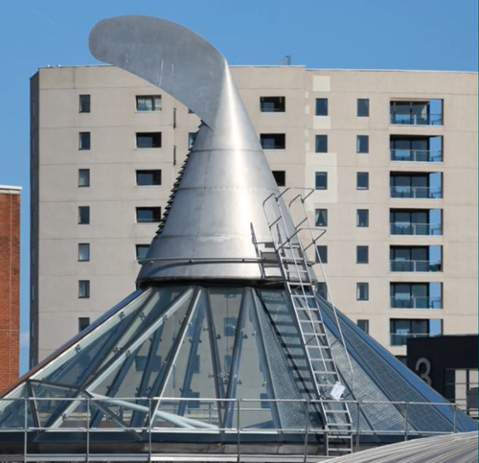
Figure 12. Showing the funnel at the centre of the Oriel, taken from Senedd Cymru | Welsh Parliament, (2021)
In terms of lighting most of the building utilizes natural light during the day until it is dark where energy-saving bulbs are used which should also reduce operational energy costs.
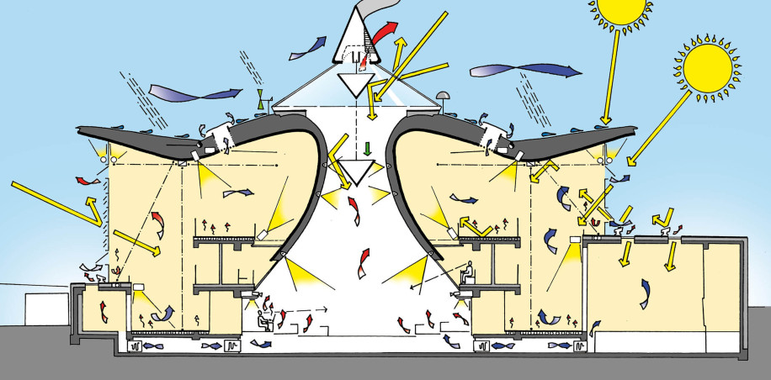
Figure 13. Shows a section showing natural ventilation and lighting, taken from RSHP, (2019)
The wood used for the funnels has preserving oils that should eliminate the need for treatment of the wood for at least 100 years according to Senedd Cymru | Welsh Parliament, (2021), therefore there should be no extra cost for treatment.

Using natural heating and low-carbon woodchips reduces the Senedd’s carbon emissions. An assumption can be made that the Senedd may be a bit hotter in the summer because of the extensive use of glass walls. The entire building is surrounded by glass, which means that the south-facing section allows more heat in during the summer if the wind speeds are too low to regulate natural ventilation. In this case, heating may not be needed as often in the summer times. Reusing rainwater significantly reduces the reliance on municipal water supply saving money.

Health and Safety:
The Senedd has its own Health, Safety and well-being policy for different individuals including, employees, contractors, visitors, directors, chief executives and heads of services.
The Senedd Health, Safety and Wellbeing policy, (2020) gives an example of what occurs as a result of an accident:
All occurrences, no matter how minor, must be documented. The person associated with the incident, or a representative acting on their behalf, must promptly complete an Incident Reporting Form, incidents include:

- Accidents: events resulting in injury or poor health.
- Near misses: events that may not cause harm but have the potential to cause injury.

The Health, Safety, and Wellbeing Team will investigate the incident, collaborating with all involved parties. This involves interviewing affected individuals, witnesses, first aiders, and line managers.

Economic Impact:
The project experienced a hiatus in 2001 due to various issues, with escalating costs being the most significant challenge. Upon resuming in 2002, the project adopted a modified project management structure and a different procurement route. The primary objective of the Welsh Assembly government was to successfully deliver a landmark meeting the desired quality standards, and staying within the allocated budget. The initial projection for the second phase of the Senedd was £37 million to £47 million, but the ultimate cost ended up being £70 million. Mr Wilson clarifies the rationale behind this cost escalation in the National Assembly of Wales (2008, p.27), attributing it to the fact that the client did not conduct a thorough market analysis for prices and costs or fully refine the design to the same extent as they had when entered into a contract with Taylor Woodrow.

The Economic impacts of the construction of the Senedd were positive. More jobs were provided for the locals. There was an increase in revenue as a result of tourism when people came to visit the landmark building. The building itself is used to hold discussions for the improvement of the economy which in turn can increase capital costs.

Aesthetic attributes:
The building is aesthetically pleasing to the eyes as the design is unique and stands out in the area it is located. The Senedd is perfectly placed at Cardiff Bay overlooking the ocean which can be categorized as a scenic view. When entering into the Senedd persons are met with an open space facing the reception to a lovely staff. The entire building utilizes an open concept that would allow a person to see most of the facilities available just by looking.

Accessibility and Security:
Planning a visit to the Welsh Parliament building is relatively simple, it is located in Cardiff Bay where the Cardiff Queen Street train station is a few minutes’ walk away.
In terms of security the Welsh Parliament, (2020) states that the design of security access arrangements, systems, and procedures aims to allow unrestricted entry to designated areas while simultaneously safeguarding the building and the well-being of all occupants.
The Welsh Parliament, (2020) continues to explain that if persons are led by authorised staff, then entry to restricted areas is guaranteed. All visitors must wear and display their visitor permits, which are provided by reception.

- Positive Properties & Improvements Of the Senedd

3.1. Positive Properties

In terms of new regulations such as Approved Documents Part L (Energy Efficiency), Part B (Building Fire Safety), Part F (Building Ventilation), and the introduction of two recently approved documents, namely (O) Overheating and (S) Infrastructure for electric vehicle charging the Senedd had already implemented a few of these regulations. Another set of regulations that the Senedd is trying to follow is the new carbon emission target. According to Uttlesford District Council, (2022), The government unveiled adjustments to The Building Regulations on December 15, 2021, intending to assist the UK in achieving net-zero emissions.

Uttlesford District Council, (2022) says that according to the updated regulations, carbon dioxide (CO2) emissions from other newly erected structures, such as offices and retail spaces, must undergo a reduction of 27%. The Senedd had already begun working on achieving net zero emissions from the completion of construction. For example, reusing 100% waste, the use of biofuel heating, reusing rainwater from catchments, the use of LED bulbs, and using natural light and ventilation all fall under good energy conservation and efficiency. The Senedd has also ensured that there are electric car outlets for workers and other citizens to charge their vehicles, which fall under document (S). This shows that staff is encouraged to travel sustainably to reduce carbon emissions. Falling under document (F) comes their natural ventilation for the entire building.
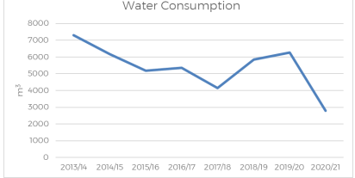
Figure 14. Showing the reduction of water consumption in the Senedd decreasing yearly, taken from Welsh Parliament Senedd Commission, (2021)
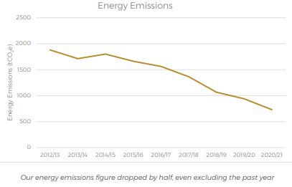
Figure 15. Showing the reduction of energy emissions used in the Senedd decreasing yearly, taken from Welsh Parliament Senedd Commission, (2021)

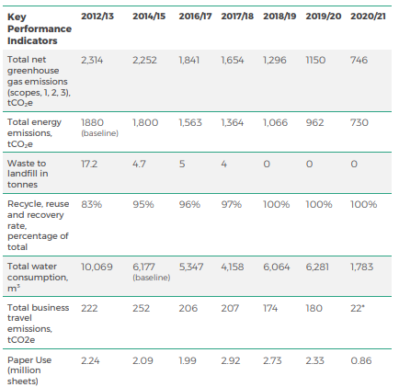
Figure 16. Showing the key performance indicators of the Senedd decreasing yearly, taken from Welsh Parliament Senedd Commission, (2021)
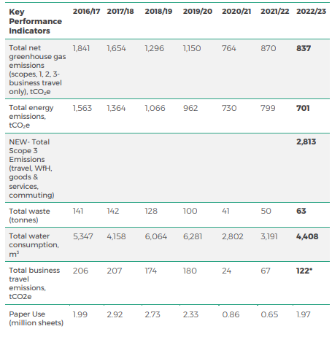
Figure 17. Showing the key performance indicators of the Senedd decreasing yearly, taken from Welsh Parliament Senedd Commission, (2023)

The graphs show evidence of a reduction in emissions, waste production, and water consumption among other key performance factors over the years, except for the recent year 2023 there have been some increases in water consumption, waste produced and travelling emissions. This shows some inconsistency that is not extremely significant but can be an implication. Nevertheless, with improvements the characteristics of the building will continue to aid in achieving the Net Zero regulations. In addition to aspects of the Senedd that are positive is the way they utilized approved document M that gives regulations for access to the building for persons who may be disabled. Based on the numerous awards that were given as a result of thoroughly following these regulations show that the Senedd stuck to the ideology of openness and welcoming everyone.

3.2. Improvements

Operation Energy Use
The current operational energy use of the building has been slowly declining over the years since it was completed. At times the uses would increase based on the demand for heat or light. If this building were to be constructed in the future it is recommended that solar panels be utilized to reduce the cost of electricity further, there are no current solar panels installed.
Installing solar panels would reduce the cost of electricity and allow for the installation of mechanical ventilation when the wind speeds are too low to allow natural ventilation. Although the Senedd is mainly naturally ventilated there are a few air condition units that are used during hot periods in the office spaces, installing solar panels would also reduce the operational cost of using these units. The building utilizes glass as its main façade which allows natural light, glass that faces the south attracts more heating which would create a hot humid environment within the building during the summer. To avoid this, adding shading to the glass panels will lessen the amount of heat that is absorbed into the building. The Senedd may also have large amounts of heat loss through the glass. A suggestion to improve this would be to install insulated external walls and utilize a façade that is reflective and gives the same effect as glass to maintain the concept. Although the building is made mainly of glass it is shaded from the surrounding building at the sides while the entrance faces the bay. From a personal source it was explained that during the summer times, it is still very comfortable within the Senedd due to the natural ventilation.

Embodied Energy/Carbon
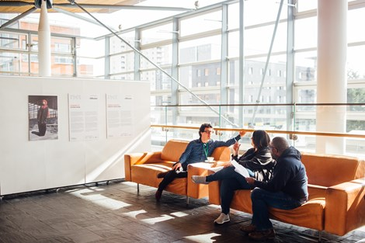
Figure 18. Showing the steel beams and glass panels in the Senedd, taken from Senedd Cymru | Welsh Parliament, (2021)

The Senedd was constructed with materials that produced large amounts of carbon emissions such as steel and concrete. If this building were to be constructed in the future it would be best to use glulam wood for the superstructure instead of steel. Glulam is fire resistant, able to form any shape and durable. The Senedd was also constructed at its location rather than prefabricated, the only thing that was prefabricated was the tower crane according to the Senedd Welsh Parliament, (2020). There are numerous prefabrication factories found in Cardiff that would have been able to construct segments of the Senedd. This would have been beneficial due to the proximity. Once the elements that contain the superstructure travel a shorter distance to the site there is a reduction in emissions through transportation.

Cost Of Construction

As established the reason the budget of this building was exceeded was because of the lack of research about what different prices the market had to offer. To avoid this in the future the client should thoroughly research the prices available for specific elements that are designed for the building. Another option is to hire a Quantity Surveyor to produce a more accurate budget for the building based on market prices.

Cost of Operation and Maintenance

The cost of operation and maintenance increases yearly, once the Senedd can save money while using renewable energy resources and conservation techniques then enough money will be available for operations and maintenance. Special staff should also be trained to maintain operated machinery instead of hiring private outside personnel to carry out the job.
A maintenance strategy should be set in place that allows for routine checks of the building to ensure that all machinery is working to standard. Routine checks allow trained staff to identify any pending problems that may shut down operations completely.
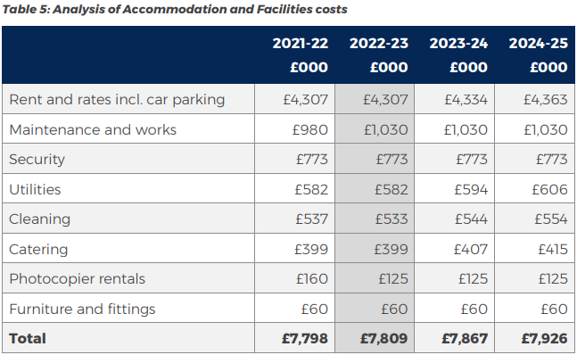
Figure 19. Showing the operation and maintenance cost in the Senedd, taken from Welsh Parliament Senedd Commission, (2021a)

Recycling and End Of Life

The entire construction of the Senedd is recyclable and or reusable. The wooden roof, concrete casted foundation, glass panels and steel beam are all recyclable materials. Although the entire building can be broken down and its materials recycled the process that some of these materials go through to be reused utilises carbon emissions. For example, steel and glass must be melted to form new moulds. If most of the building was constructed with the indigenous wood used for the roof that has its preserving chemicals that last 100 years, then there would be no need to burn or melt any elements to reuse.

- The Conclusion
The Senedd was an appropriate example for future buildings to follow in achieving the net-zero targets. It may not have perfectly executed all energy-efficient strategies, nevertheless each year there is a decline in emissions due to small improvements. Better investments should have been made initially to ensure the upkeep of the entire structure to reduce the cost of maintenance. According to Senedd’s carbon neutral strategy they hope to install solar panels between 2023-2025, this shows initiative, but the timeframe does not show urgency. Overall, the Senedd was able to receive numerous awards for the hard work placed into its constructions and continue to welcome visitors from all nations.

- References
- Archiweb (2015). Archiweb - National Assembly for Wales. [online] www.archiweb.cz. Available at: https://www.archiweb.cz/en/b/budova-velsskeho-narodniho-shromazdeni [Accessed 13 Dec. 2023].
- Barker (2018). Most Recognised Architectural Styles - Barker Associates. [online] Barker. Available at: https://www.barker-associates.co.uk/service/architecture/most-recognised-architectural-styles/ [Accessed 13 Dec. 2023].
- Gillespies (2008). Senedd Cymru - Welsh Parliament - Projects. [online] Gillespies. Available at: https://www.gillespies.co.uk/projects/national-assembly-for-wales [Accessed 24 Dec. 2023].
- Personal Source, email: d.hughes@uwtsd.ac.uk, [Accessed 12/1/24]
- RSHP (2019). Senedd Welsh Parliament – Civic – Projects – RSHP. [online] rshp.com. Available at: https://rshp.com/projects/civic/senedd-cymru-welsh-parliament/ [Accessed 8 Dec. 2023].
- Senedd Cymru | Welsh Parliament (2021). The Senedd - a Landmark Building. [online] Senedd. Wales. Available at: https://senedd.wales/visit/our-estate/the-senedd-a-landmark-building/ [Accessed 13 Dec. 2023].
- Senedd Welsh Parliament (2020). External Recognition and Rewards. [online] Senedd. Wales. Available at: https://senedd.wales/commission/work-for-the-senedd-commission/diversity-and-inclusion-at-the-commission/external-recognition-and-rewards/ [Accessed 24 Dec. 2023].
- The National Assembly of Wales (2008). The Senedd Wales: Audit Committee. [online] The Senedd, pp.27–36. Available at: https://senedd.wales/media/55gnbpbl/cr-ld7285-e-english.pdf [Accessed 25 Dec. 2023].
- The Senedd Health, Safety and Wellbeing policy (2020). Health, Safety and Wellbeing. [online] Senedd Welsh Parliament. Available at: https://senedd.wales/commission/senedd-commission-policy/health-safety-and-wellbeing/ [Accessed 25 Dec. 2023].
- The Senedd Welsh Parliament (2020). Senedd Building History 1998-2001 - Design Stage. [online] Senedd. wales. Available at: https://senedd.wales/visit/our-estate/senedd-at-15/senedd-building-history-1998-2001-design-stage/ [Accessed 25 Dec. 2022].
- The Welsh Parliament (2020). Security and Access. [online] Senedd. wales. Available at: https://senedd.wales/visit/security-and-access/ [Accessed 25 Dec. 2023].
- Uttlesford District Council (2022). New building regulations from June 2022. [online] Uttlesford District Council. Available at: https://www.uttlesford.gov.uk/article/7861/New-building-regulations-from-June-2022#:~:text=On%2015%20December%202021%20the [Accessed 30 Dec. 2023].
- Welsh Parliament (2009). 750,000th Visitor through Doors of Senedd. [online] Senedd. Wales. Available at: https://senedd.wales/senedd-now/news/750-000th-visitor-through-doors-of-senedd/ [Accessed 24 Dec. 2023].
- Welsh Parliament Senedd Commission (2021a). Budget 2022-23. [online] p.22. Available at: https://senedd.wales/media/n32fdhpm/gen-ld14663-e.pdf [Accessed 30 Dec. 2023].
- Welsh Parliament Senedd Commission (2021b). Sustainability: Annual Report 2020-21. [online] The Senedd, pp.10–24. Available at: https://senedd.wales/media/xvkktmug/sustainability-annual-report-2020-21.pdf [Accessed 30 Dec. 2023].
- Welsh Parliament Senedd Commission (2023). Sustainability: Annual report 2022-23. [online] p.30. Available at: https://business.senedd.wales/documents/s139375/Senedd%20Commission%20-%20Sustainability%20Annual%20report%202022-23%20-%20June%202023.pdf [Accessed 30 Dec. 2023].
- Senedd Cymru | Welsh Parliament (2020). Senedd Building - Design Concept. [online] Senedd. Wales. Available at: https://senedd.wales/visit/our-estate/senedd-at-15/senedd-building-design-concept/ [Accessed 8 Dec. 2023].
- Senedd Cymru | Welsh Parliament (2020). Senedd Building History - 2003. [online] Senedd. Wales. Available at: https://senedd.wales/visit/our-estate/senedd-at-15/senedd-building-history-2003/ [Accessed 8 Dec. 2023].

