Worksheet 1

Neil O’Mahoney 0351709
Part Time Cyber Security Networks

Table of Contents
Task 1 VM creation and operating system instructions 3
TASK 2 -Virtual Network Configurations 6
TASK 3 -Observational Tasks 9
References 16

Task 1 VM creation and operating system instructions

Figure 1- Servers 1+2 and Clients 1+2 created and established with sufficient storage, RAM and Processing power
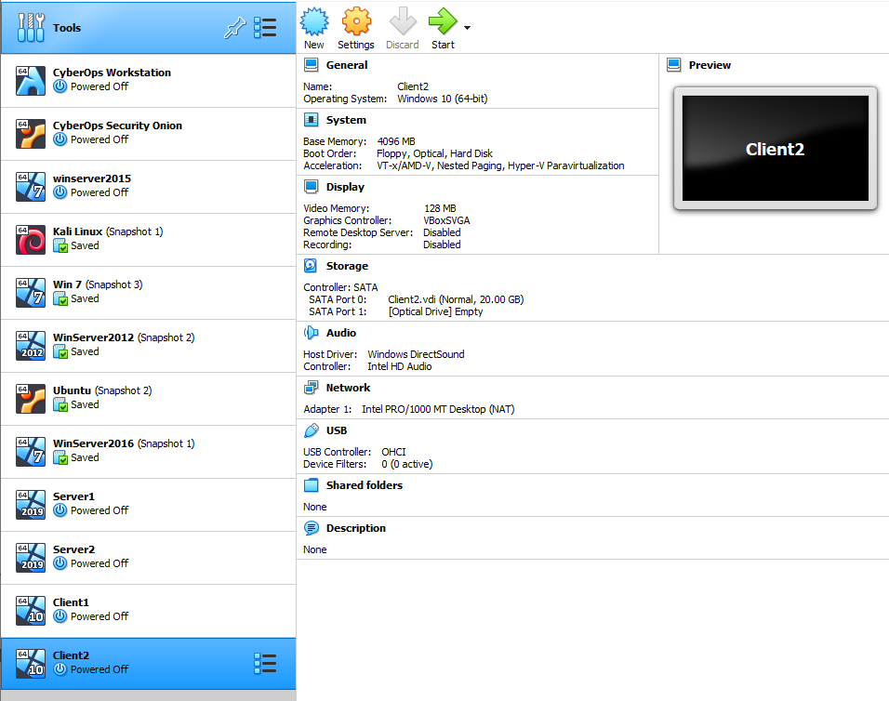

Figure 2 - Server 1 installed and now shutting down
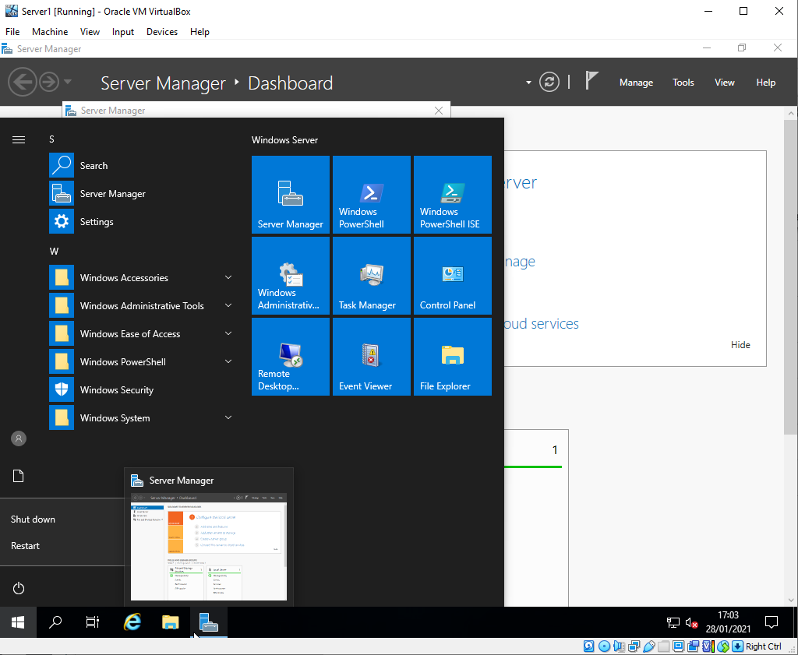

Figure 3 - Server 2 after installation, logging in shutting down again
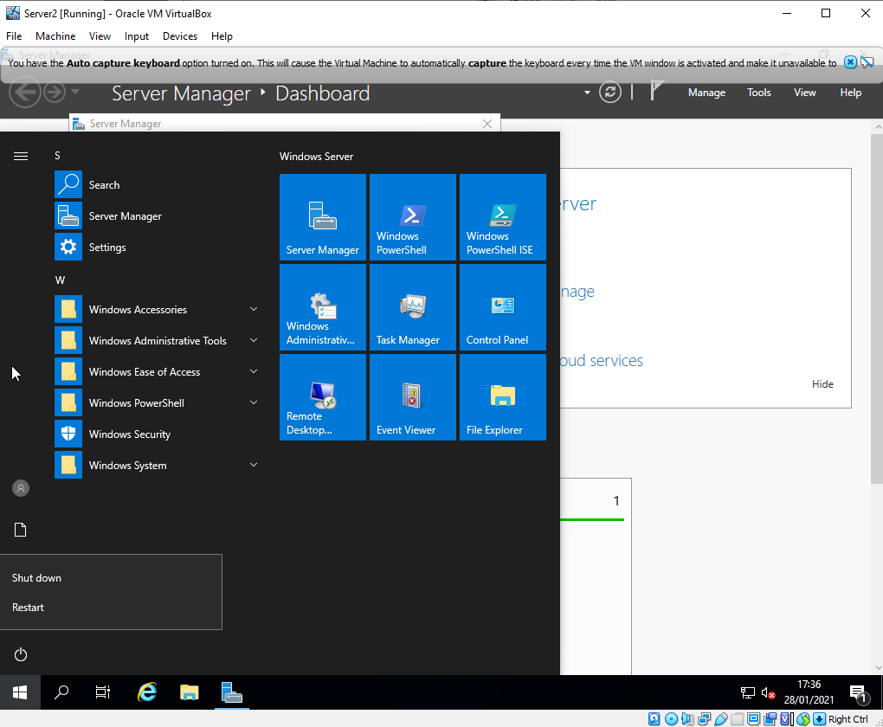

Figure 4 - Client 1 logged in for testing and then shut down again
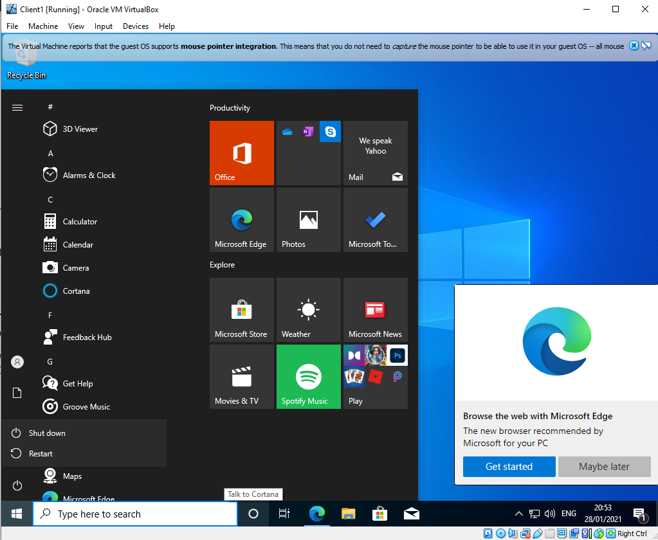

Figure 5 - Client 2 logged in for testing and then shut down again
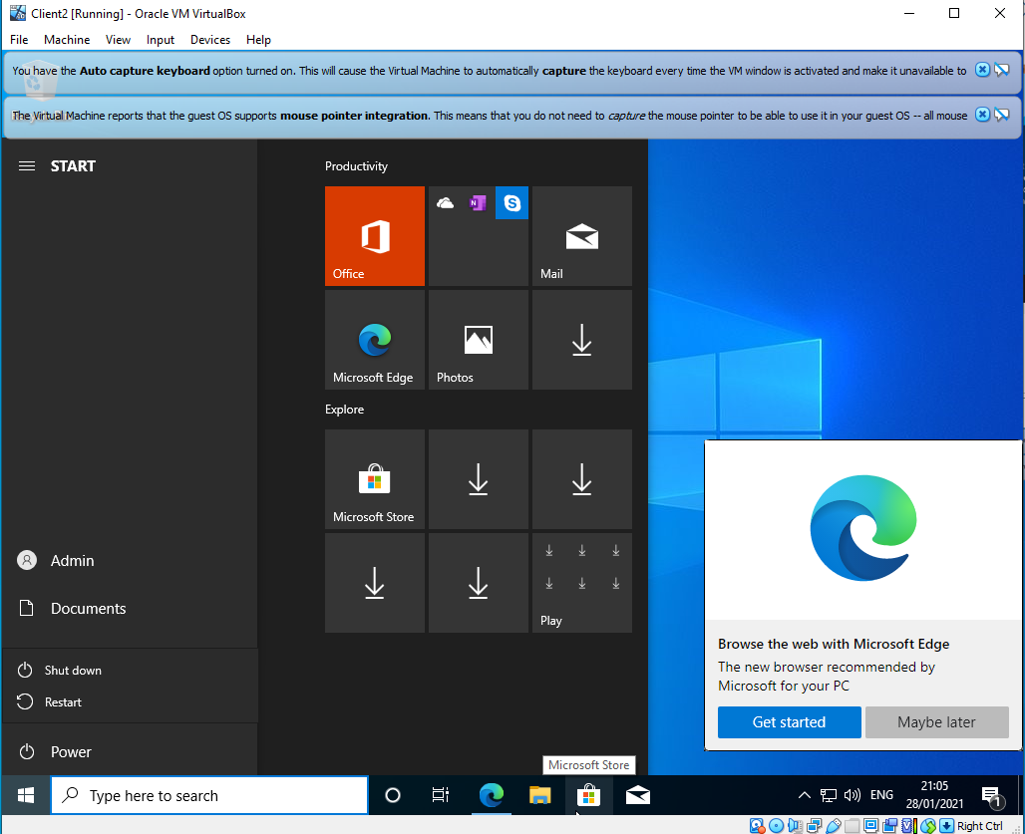
Figure 5

TASK 2 -Virtual Network Configurations

Figure 6 - Server1 Public Net LAN being configured
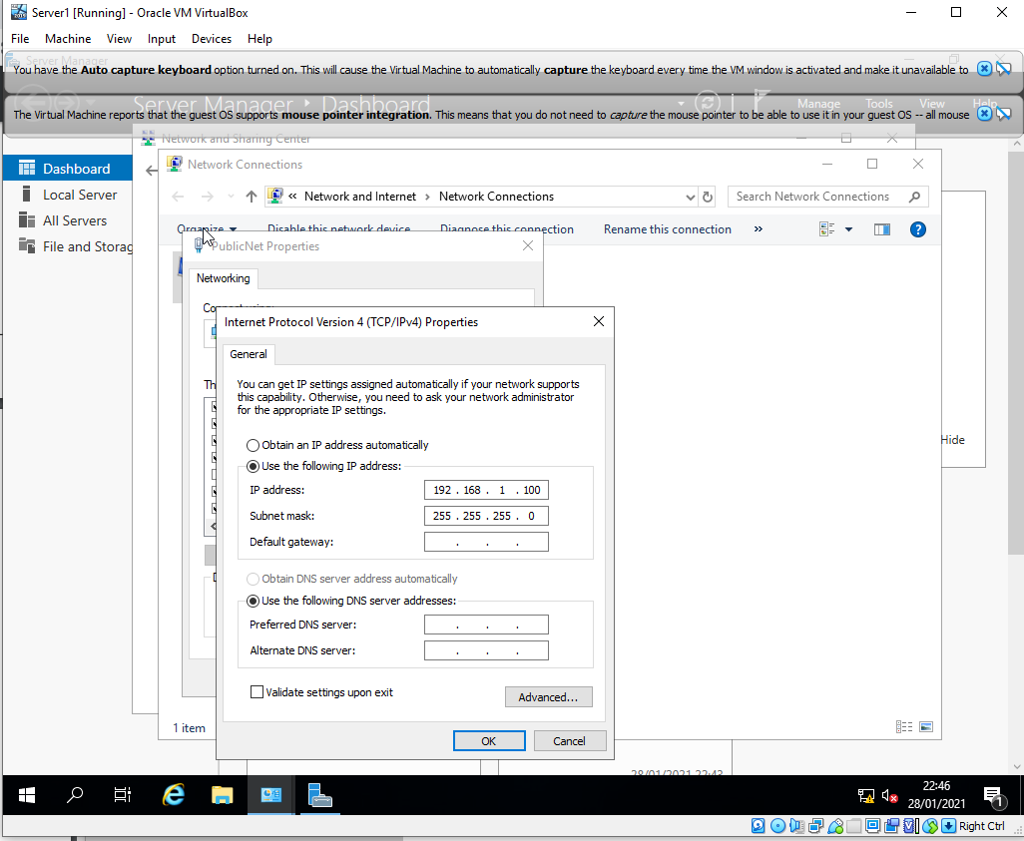

Figure 7 - Server 1 Private Net Configuration
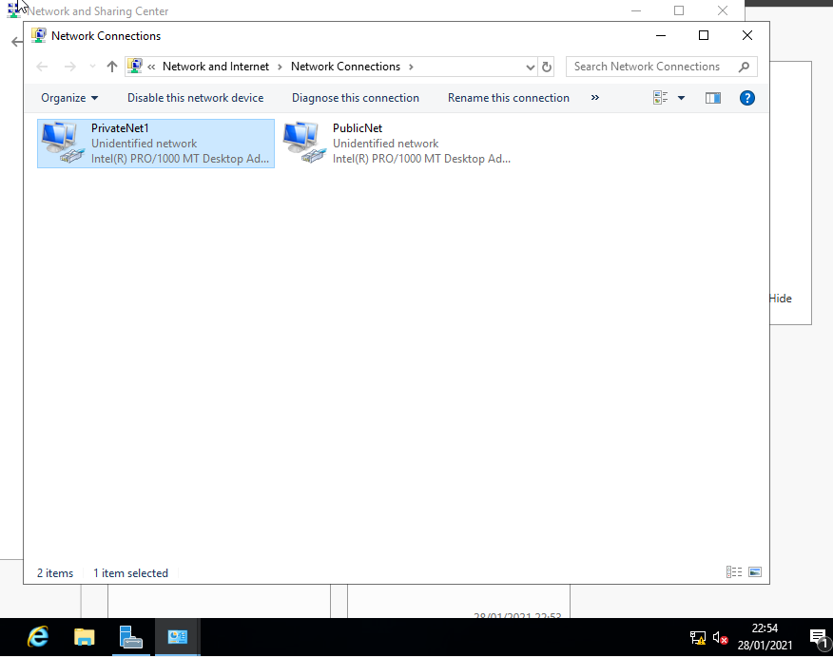

Figure 8 - Client setup of PublicNet and PrivateNet
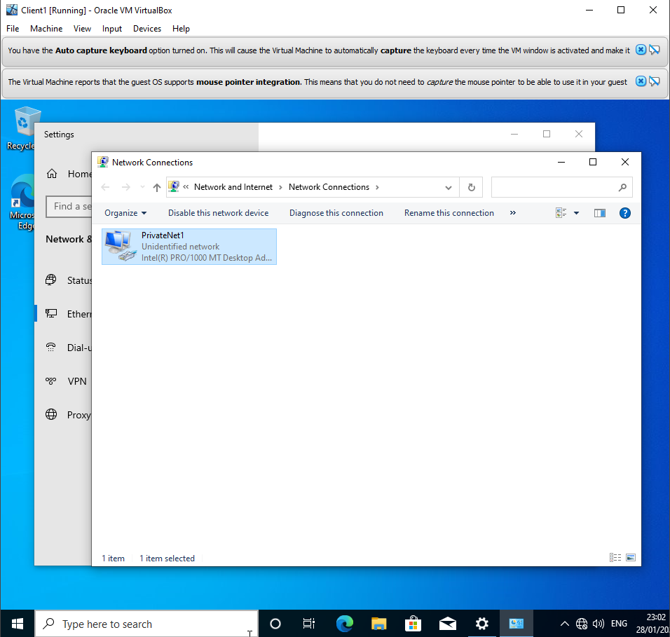

Figure 9 - Server 2 configuration of adapters to PublicNet and PrivateNet2
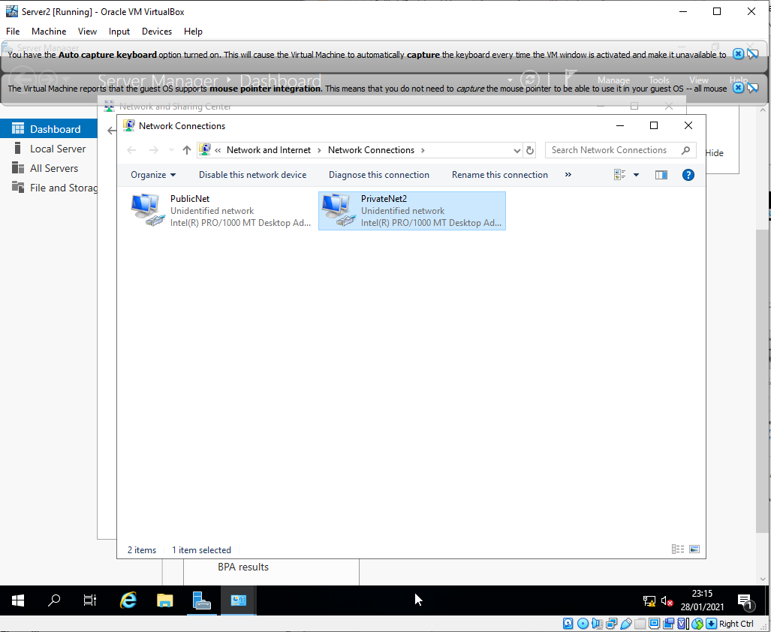

Figure 10 - Firewalls turned off between devices, Server 1 pings 192.168.100.2 – Client 1 (works)
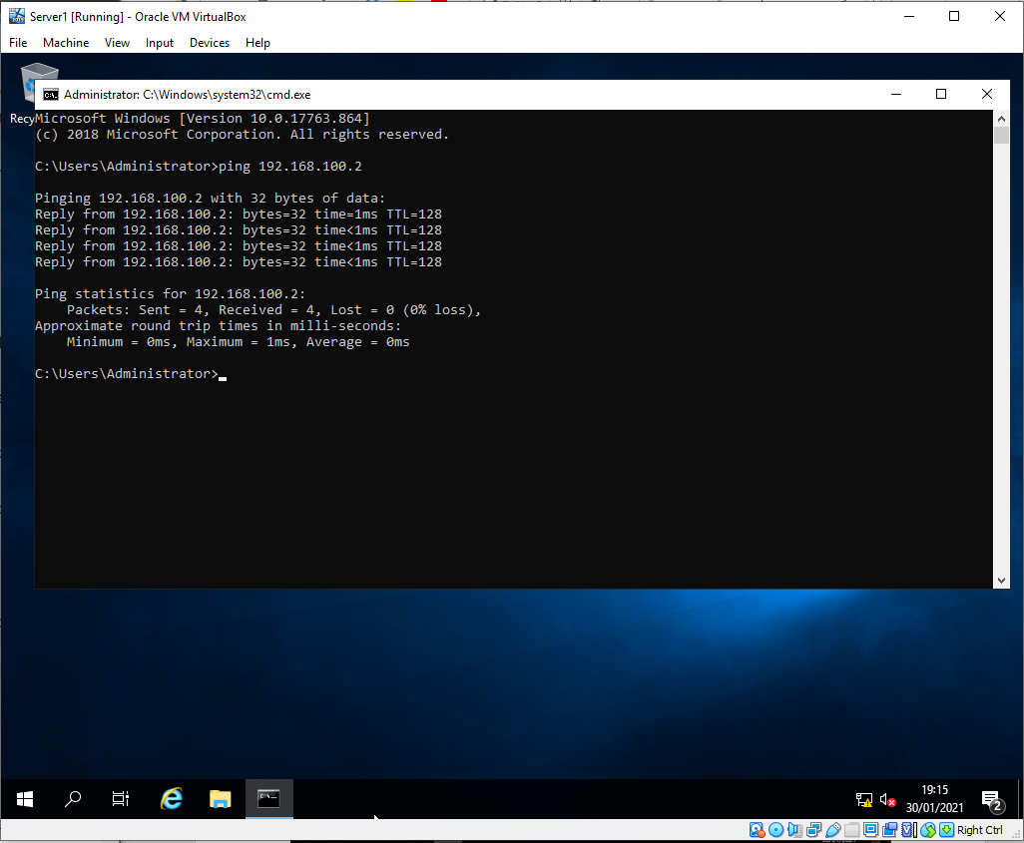

Figure 11 - Server 2 ping test works (some trouble shooting) in this case the author had typed in incorrect IP address and not that of Client 2.
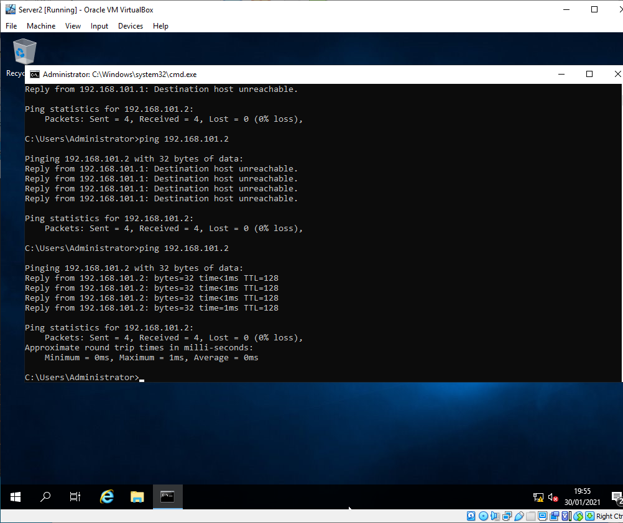

TASK 3 -Observational Tasks
3 a)
According to VMWare website a hypervisor is ‘…Known as a Virtual Machine Monitor or VMM, is software that creates and runs Virtual Machines. A Hypervisor allows one host computer to support multiple guest VMs by virtually sharing its resources, such as memory and processing. [1]
Cloud computing has indeed revolutionised the IT in the past decade however its origins were started by IBM in the 1950’s, in the past decade, has become more prominent. ‘…Large-scale mainframes were made available to schools and corporations…multiple users were able to access the mainframe via “dumb terminals”. [2]
Essentially, hypervisors are designed to separate the Operating System (OS) as well as the applications from the physical machine itself.
A Type-1 hypervisor (like Hyper-V) is designed to ‘Run off a computer’s hardware’. It directly interacts with storage, memory and central processing unit. This can sometimes also be referred to as a ‘bare-metal hypervisor.’ Type-1 hypervisors have a direct connection to the hardware of the machine they are running on it is considered to be a better performing and increase of efficiency. As see in the figure below, operating systems are isolated from one another. This benefits the security of the other devices (as well as from the host machine itself) and safe guards them against malicious hackers, malware to name but a few.
There are drawbacks to Type-1 hypervisors in that they are each a separate machine to administer which would make changes more time consuming as well as requiring hardware accelerated technology. Without the hardware acceleration technology, it would lead to a drop in the performance of the virtualisation.
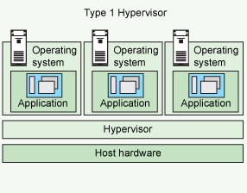
Figure 12 - Image of a Type 1 hypervisor [3]
A Type 2 Hypervisor (like Oracle VMWare) this type of hypervisor is designed to run as an application on an Operating System rather than off the computer’s hardware, like a Type 1 hypervisor. Typically suited to a user’s PC whereby multiple differing types of operating systems can be ran simultaneously. Type 2 hypervisors also use hardware accelerated technologies if available but fall back on emulation software if unavailable.
Type 2 Hypervisors are quick and easy access to differing OS’s. There is also an ability to mix and match programs across differing OS’s giving the users flexibility. There are however some drawbacks to Type 2’s; the access to resources (memory, processor etc) must be via hosted OS which can in turn introduce latency and security issues accessed and manipulation of guest Operating Systems.
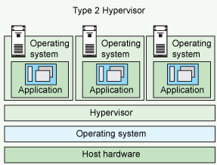
Figure 13 - Image of a type 2 hypervisor [3]

The Microsoft Hypervisor offering is called ‘Hyper-V’ which is a Type 1 (Hypervisor). Creating virtual machines on x86-64 systems which are running Windows OS. Originally released as a beta version on Windows Server 2008, Hyper-V has featured on every Windows Server since. Often used for testing purposes, Hyper-V can be used as a test to run software on differing versions of operating systems.
Oracle VirtualBox is an open-source hypervisor, this is a Type 2 Hypervisor. It is open sourced and runs host operating systems as well as guest with anything from Windows to Linux. Virtual box can also be installed on Windows, Linux or other operating systems. VirtualBox emulates hard disks in VDO, VHD and VMDK formats.
3 b)
A subnet mask is a 32-bit number which is designed to logically separate an IP address so that which side is network and which part is the host. ’The engineer assigns each subnet a subnet mask, and that mask, among other things, defines the size of that subnet.’ [4] To further explain this, the subnet mask separates the host from the network portion so communication is sent to hosts within a particular range for logic and security purposes.
An example of a Subnet this would be 192.168.1.23/24 the /24 bit describes that the first 3 octets are the network and the last part (.23) is the host.
Figure 14 – Subnetting a /24 network
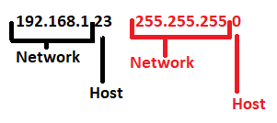
The host portion of a /24 or 255.255.255.0 network allows for a range of hosts between 192.168.1.1 and upper end of 192.168.1.254. 192.168.1.255 allows for a broadcast of the network. If the number of hosts were greater than 254 or smaller than, more or less it would require a different Subnet Mask i.e a smaller one would look like this:
Figure 15 – Subnetting 2 a /25 network
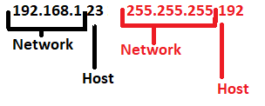
192.168.1.23/23 255.255.255.192 would allow for between 1-126 hosts. By varying the length of the Subnet Mask it is possible to have a smaller range of IP addresses. Although some calculations are more complex it does save IP’s but makes troubleshooting a little more difficult as the engineer might need to work with Variable Length Subnet Masks (VLSM).
‘Subnetting allows you to create multiple logical networks that exist within a single Class A, B, or C network. If you do not subnet, you are only able to use one network from your Class A, B, or C network, which is unrealistic.’ [5]
By subnetting it is a way of conserving IP addresses. Class A subnets (255.0.0.0) for example could allow for in excess of 4 million hosts. If you are only using a few hundred addresses within this range, then the rest are wasted if they are not split down more.
3 c)
Defined by Amazon as: ‘Cloud computing is the on-demand delivery of IT resources over the Internet with pay-as-you-go pricing. Instead of buying, owning, and maintaining physical Data Centres and servers, you can access technology services, such as computing power, storage, and databases, on an as-needed basis from a cloud provider like Amazon Web Services (AWS).’
Cloud computing can also be defined as ‘…Creating virtual isolated instances of computer hardware platforms, operating systems, storage devices, and network resources by using techniques such as timesharing, emulation and partitioning. It is the key technology to create a cloud computing platform.’ [6]
Cloud computing has indeed revolutionised the IT in the past decade however its origins were beginning by IBM in the 1950’s in the past decade has become more prominent. ‘…Large-scale mainframes were made available to schools and corporations…multiple users were able to access the mainframe via “dumb terminals”. [2]
In its earlier days, applications were designed for single computers or servers running its own CPU, HDD and memory. Hypervisors allowed for multiple applications to be spread over a single device sharing a single physical resource. Demand in IT to reduce costs while remaining scalable, and effectively virtualising them on the Internet, became the preferred option.
There are several benefits in having cloud virtualised instances: the cost savings – rather than having the outlay, maintenance costs and staff employment costs this is taken over by the cloud company who will have staff and infrastructure that you pay to use.
Scalability the ability to upscale or downsize as your requirements change. Being able to spin up VM’s geographically close to customers/ users for quicker access.
Speed commonly able to make changes in a rapid space of time using a credit card and a few clicks a customer can purchase more space or another instance of a server.
Clients and users can access services from remote locations just requiring internet access, this is an increase in mobility.
Backup, restore and reliability; the ability to take snapshots, shutdown and spin up new VM’s if they fail. The cloud also lends itself to testing in this instance also very well.
Confidentiality, security at risk, who else is accessing this data on a day-to-day basis in the data farms? Where in the world is the data being stored? Does this raise questions with GDPR for British data to be moved to America? Is the integrity of the data secure, if errors are found who is to blame? Centralised point of failure (AWS) for example. Probably robust but not completely immune to failure, if running one on a private device more likely if one instance of a virtual server is compromised that all other instances could be affected also.
‘Theoretically virtual machines are in isolation with each other, but then it is prone to attacks such as side channel attacks, Confidentiality breaches, Authentication attacks, Inter-VM commutation attacks, Malware injection and so on.’ [6]
Internet connection might not be as good, if geographically the cloud is in the wrong country then might not be the best option to migrate to the cloud just yet.
Finally Microsoft offers Azure as its cloud solution the mission statement from Microsoft is: ‘The Azure cloud platform is more than 200 products and cloud services designed to help you bring new solutions to life – to solve today’s challenges and create the future. Build, run and manage applications across multiple clouds, on-premises and at the edge, with the tools and frameworks of your choice.’ [7] In short this is a familiar platform for users with a lot of gadgets like MS SQL which have been incorporated into the suite.

3 d)
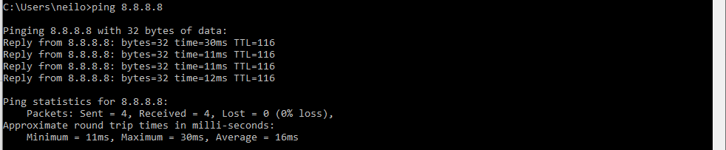
Figure 16 – image of Ping Command (IPv4)
Ping or Internet Control Message Protocol (ICMP) is a software test which sends an echo request to a subject and then gets (or doesn’t get) a response. When responding it will also give a response time that the ping took to get to the target and back. Its primary function is for error reporting and diagnostic functioning, the author named it after the sound that a sonar makes. IPv6 has its own version called ICMPv6. Ping does not use a port but utilises echo request and echo reply message.
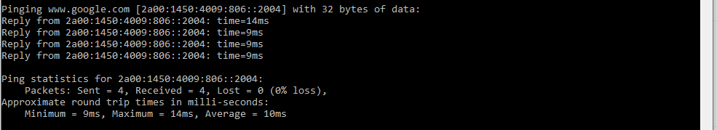
Figure 17 – IPv6 ping
Linux also utilises the ping command whether the destination is reachable and can also be used for troubleshooting. Again the ICMP echo request is used and the echo reply for each request. Just like in Windows it can be used to ping an IP address or a hostname (see hostname ping below). There are also several switches that the Linux commands has to offer such as varying the size of the packet or the time interval, or the internet Protocol. (IPv6)
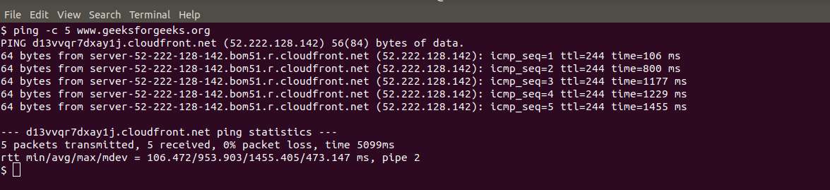
Figure 18 – Linux Ping [8]
Server Management
In a Windows product, the server management is in the form of a Graphical User Interface console which is designed to install, configure and administrate the current system as well as changing it in the future. Such functions as Active Directory to administrate the users, computers to name but a few of the network can be found here. Dynamic Host Configuration Protocol (DHCP) which is the leasing, reserving and administration side of the IP’s of the network are delegated here. Other functions or services include group policy management, File services or Hyper-V. This can also be administered through windows PowerShell for the more command driven administrators.
A Linux version of server management is called Cockpit
Windows Firewall
Windows firewall is a stateful firewall (a firewall that monitors the full state of active network connections) that by creating a setting a plethora of rules, will allow or disallow traffic ingress and egress to the network. IPSec is also supported which can be used for authenticating devices which are communicating to Windows Server. Unauthenticated devices will be denied access to the network and will be unable to communicate. IPSec is also intelligent enough that it can be used to mandate certain network traffic is encrypted.
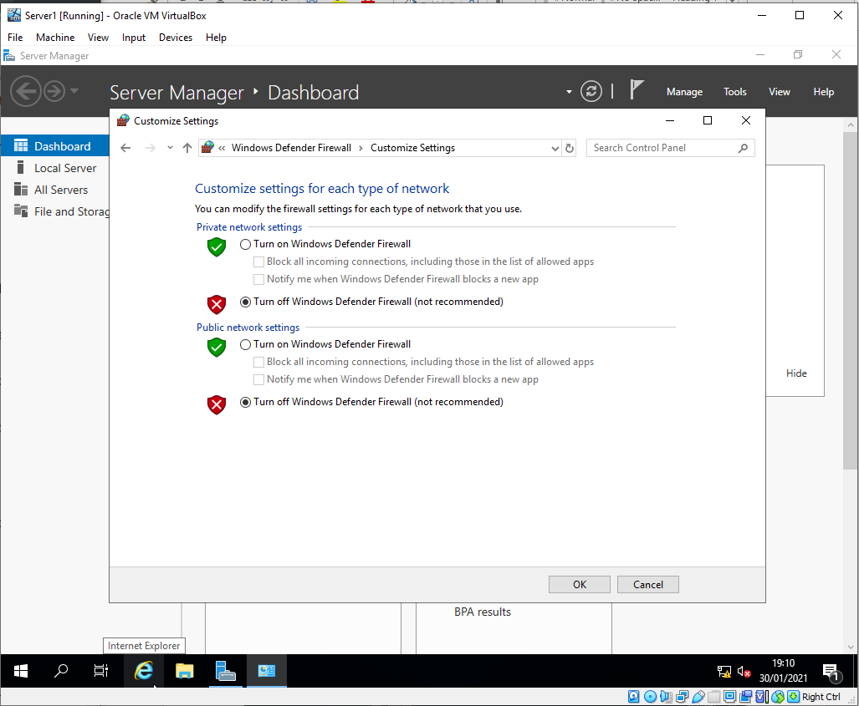
Figure 19 – Windows Firewall Screen
PAE Physical Address Extension is a memory management feature for the x86 architecture and defines whether the hosts CPU will be exposed to the virtual machine. First introduced on Pentium and later onto AMD processors it allows CPU’s to directly access a physical address space larger than 4 Gig. Some operating systems such as Ubuntu Server require it and cannot be ran within it.
NX stands for No-Execute. It is a segregated area of a processor which, for security reasons such as malicious code being written such as a buffer overflow attack.
Intel calls this the XD bit (execute disable) and ARM calls this XN (Execute Never).

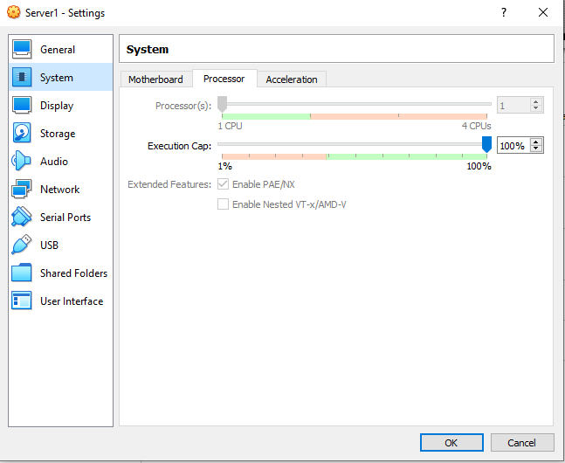
Figure 20 – VMWare System PAE enable screen

References

[1] | VMWare, [Online]. Available: https://www.vmware.com/topics/glossary/content/hypervisor. [Accessed 04 Feb 2021].
[2] | IBM Cloud Team, “https://www.ibm.com/cloud/blog/cloud-computing-history,” IBM Cloud Team, 06 Jan 2017. [Online]. Available: https://www.ibm.com/cloud/blog/cloud-computing-history. [Accessed 04 March 2021].
[3] | IBM, IBM, 2020. [Online]. Available: https://developer.ibm.com/depmodels/cloud/articles/cl-hypervisorcompare/. [Accessed 14 Jan 2021].
[4] | W. Odom, CCNA 200-301 Official Cert Guide, Hoboken NJ: Cisco Press, 2020.
[5] | Cisco, “IP Addressing and Subnetting for New Users,” Cisco.com, 10 Aug 2016. [Online]. Available: https://www.cisco.com/c/en/us/support/docs/ip/routing-information-protocol-rip/13788-3.html. [Accessed 05 Feb 2021].
[6] | R. M. Linda Joseph, “Securing and Self recovery of Virtual Machines in cloud with an Autonomic Approach using Snapshots,” Mobile Networks and Applications, vol. 24, no. 4, p. 1240, 2019.
[7] | Microsoft, “What is Azure,” Microsoft, 01 Dec 2020. [Online]. Available: https://azure.microsoft.com/en-gb/overview/what-is-azure/. [Accessed 05 Feb 2021].
[8] | Anonymous, “PIng Command In Linux with Examples,” Geeks For Geeks, 24 May 2019. [Online]. Available: https://www.geeksforgeeks.org/ping-command-in-linux-with-examples/. [Accessed 05 Feb 2021].

