Appendices
Appendix A – Ethics Form
Appendix B – Pupil Information Sheet
Appendix C – Parent Information Sheet
Appendix D – Blank Consent Slip
Appendix E – Observation Schedule and Record
Appendix F – Semi-Structured Interview Guide
Appendix G – Questionnaire

Appendix A
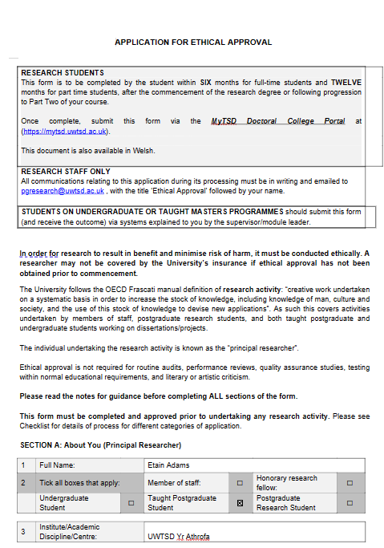
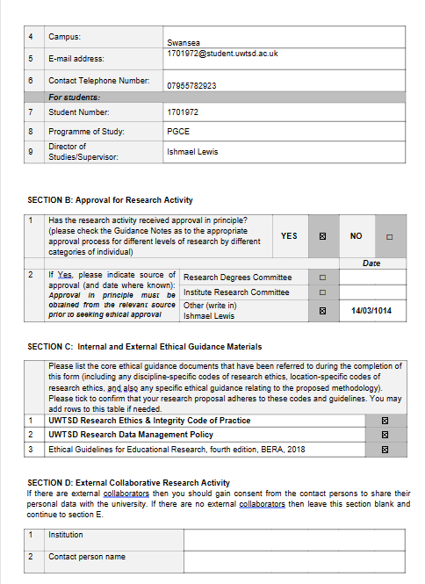
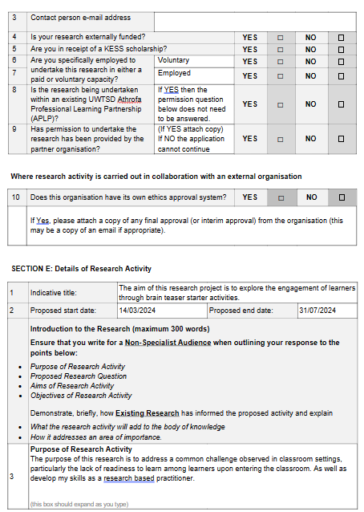
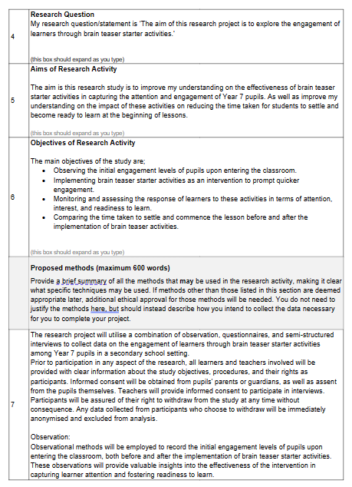
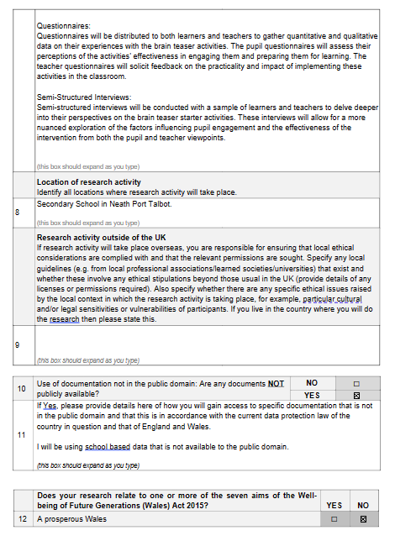
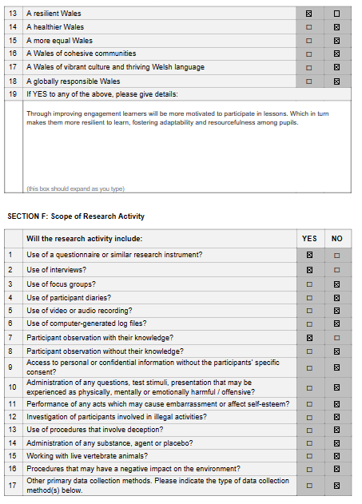
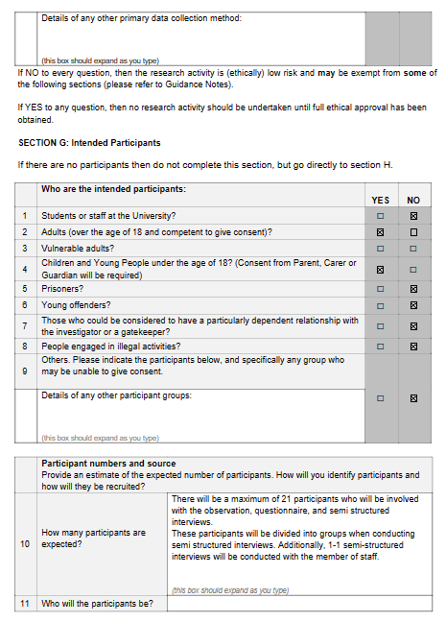
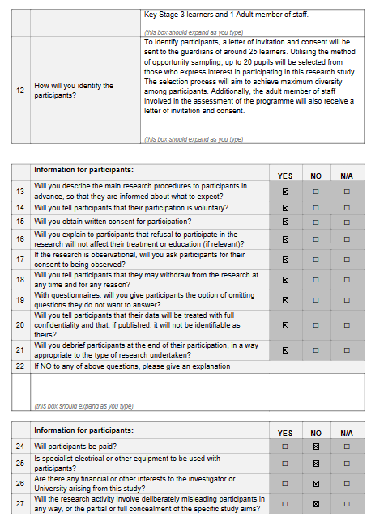
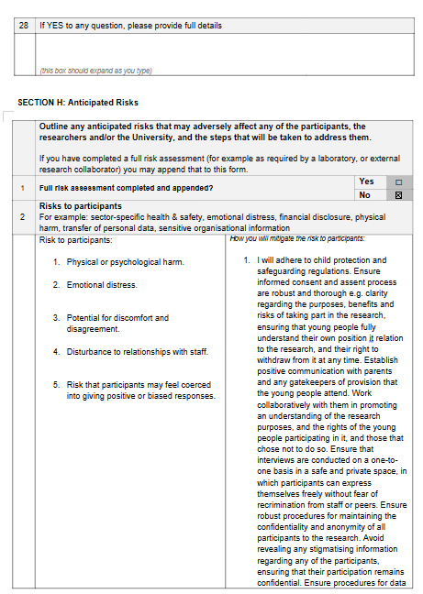
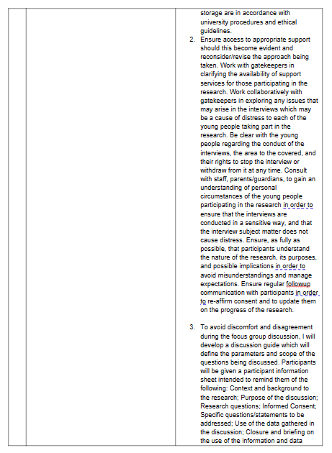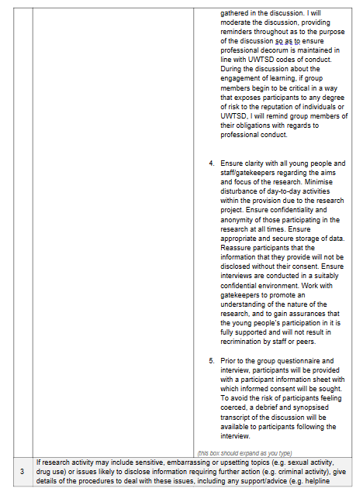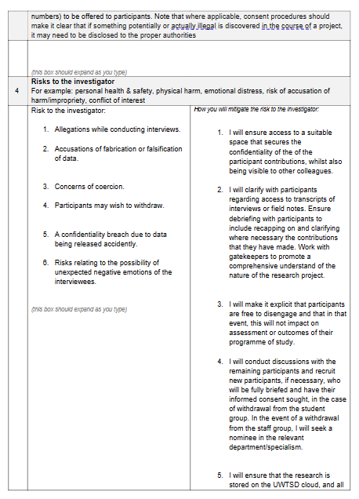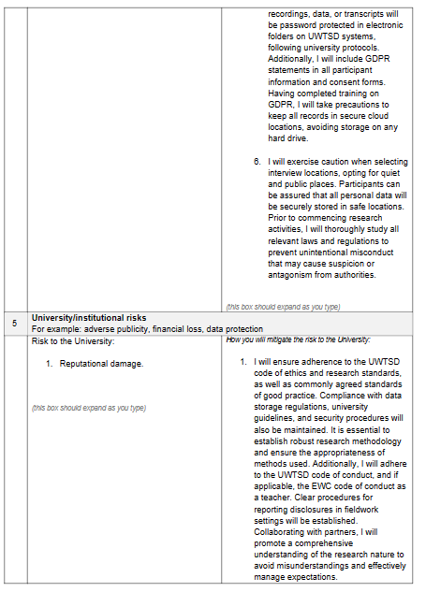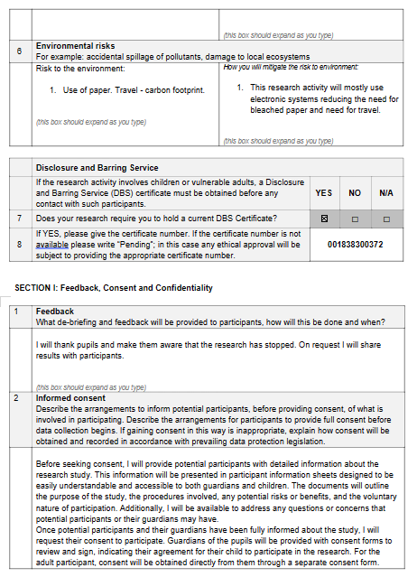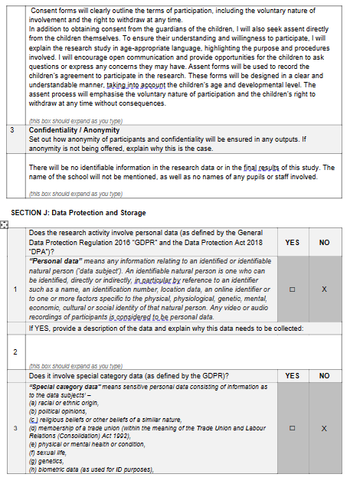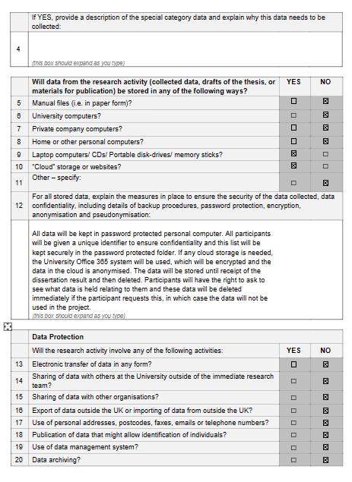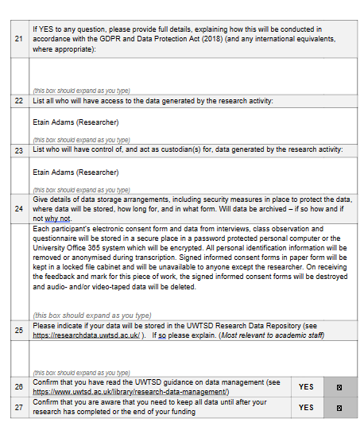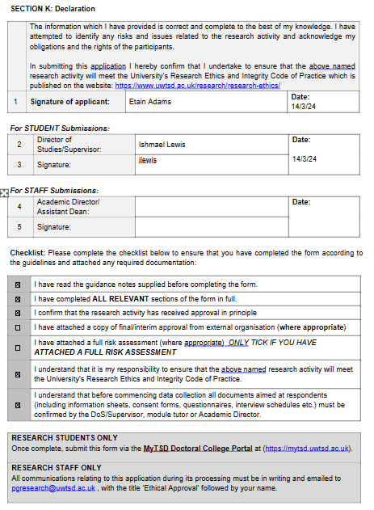
Appendix B
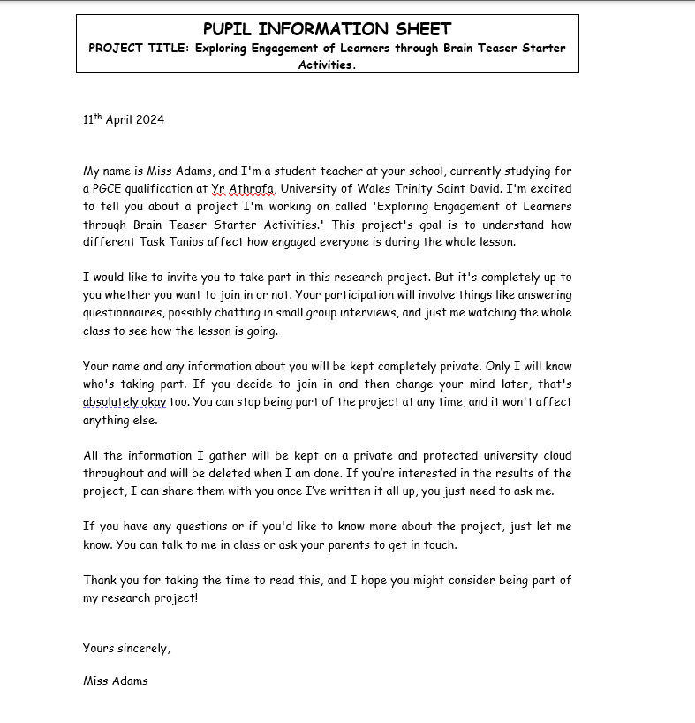

Appendix C
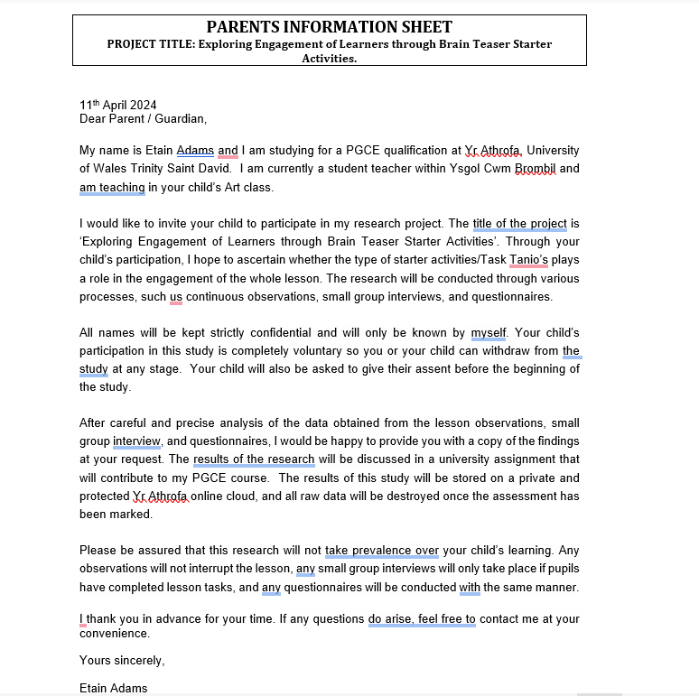

Appendix D
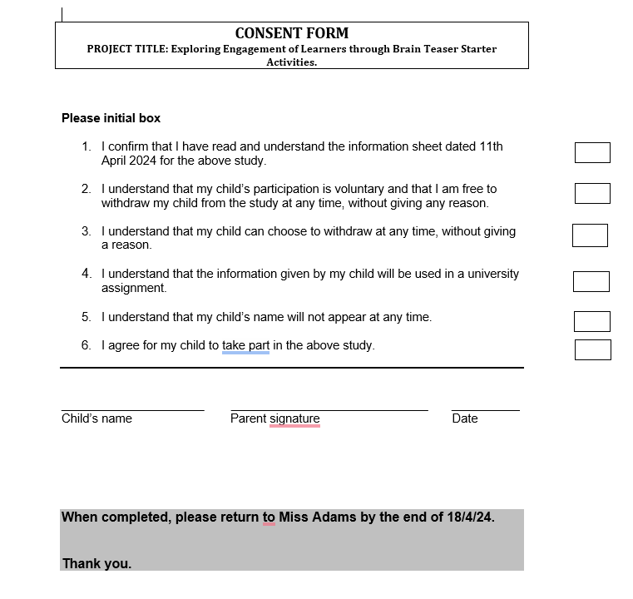

Appendix E
Lesson | Starter Activity | Observation Notes
1 | Regular Lesson | - Pupils entered the classroom with varied levels of enthusiasm. Some appeared disengaged, while others were attentive.
 |  | - The teacher delivered instructions for the lesson, but there was limited interaction with students during this time.
 |  | - No specific engagement strategy was observed to aid readiness to learn as pupils entered the classroom.
2 | Brain Teaser Starter Activity | - As pupils entered, there was a noticeable increase in energy and excitement, with many eagerly anticipating the activity.
 |  | - Clear engagement was observed as students eagerly participated in solving the brain teaser, actively discussing solutions.
 |  | - Teacher encouraged collaboration and critical thinking, fostering a positive and stimulating learning environment.
3 | Brain Teaser Starter Activity | - Similar to Lesson 2, pupils showed anticipation and curiosity towards the brain teaser, with lively discussions.
 |  | - Teacher provided scaffolding for struggling students, offering hints and guidance to keep all students engaged.
4 | Brain Teaser Starter Activity | - The majority of pupils engaged positively and actively participated in solving the brain teaser.
 |  | - However, a few students demonstrated signs of frustration and disengagement due to the complexity of the brain teaser.
 |  | - Teacher provided additional support and encouragement to help struggling students, promoting perseverance.
5 | Brain Teaser Starter Activity | - Overall, a positive response was observed, with most students eagerly participating in the brain teaser activity.
 |  | - However, a small number of students continued to struggle with the complexity of the task, leading to occasional disengagement.
 |  | - Teacher adapted the activity on the go, providing alternative challenges for struggling students to maintain engagement.

Appendix F
Introduction:
"Hey there! Thanks for joining me. Your thoughts are really important for my research on brain teasers. Before we dive in, know that your answers are confidential, and there is no right or wrong. I want to hear what you think. Do you have any questions before we get started?"

Thoughts about Brain Teasers
"What do you think about the brain teasers we do at the beginning of class?"
Follow-up: "Can you tell me more about why you feel that way?"
"What do you enjoy most about these brain teasers?"
Follow-up: "Is there a specific brain teaser that is particularly enjoyable to you?"
"Can you tell me about a time when you really liked working on a brain teaser?"
Follow-up: "What made that brain teaser memorable for you?"
"What makes a brain teaser interesting or fun for you?"
Follow-up: "Are there specific qualities of a brain teaser that you find engaging?"

Experiences with Brain Teasers
5. "How do you usually approach brain teasers when we have them in class?"

Follow-up: "Can you describe a strategy you have used to solve a brain teaser before?"
"Have you ever found a brain teaser too hard or too easy? What was that like?"
Follow-up: "How did you feel when you encountered a brain teaser that was too difficult/easy?"
"Do brain teasers help you stay focused in class? Why or why not?"
Follow-up: "Can you give me an example of a time when a brain teaser helped you stay focused?"
"How do you think brain teasers help you learn?"
Follow-up: "In what ways do brain teasers contribute to your understanding of the lesson?"

Factors that Affect Your Enjoyment of Brain Teasers
9. "Do things outside school affect how much you enjoy brain teasers?"
Follow-up: "Could you give me an example of something outside of school that affects your enjoyment?"
"How do you feel when a brain teaser is about something you really like?"
Follow-up: "Can you tell me more about a brain teaser related to something you are interested in?"
"Do your classmates' reactions to brain teasers affect how much you like them? How?"
Follow-up: "Could you give me an example of a time when your classmates' reactions influenced your enjoyment?"
"Are there any times or things in class that make it hard for you to enjoy brain teasers?"
Follow-up: "Can you describe a situation where you found engaging with a brain teaser challenging?"

Ideas for Making Brain Teasers Even Better
13. "Is there anything you would change about how we do brain teasers in class?"
- Follow-up: "What specific changes would you suggest?"
14. "Do you have any ideas for making brain teasers more fun for everyone?"
- Follow-up: "Could you give me an example of a brain teaser idea you think would be enjoyable?"
15. "How do you think brain teasers could help us learn better?"
- Follow-up: "In what ways do you think brain teasers could improve our learning experience?"

Closing:
"Thanks for sharing your thoughts with me today. Your ideas help my research. If you have anything else to add, feel free. Otherwise, we are done. Thanks again for chatting with me."
Appendix G 

