PSYCHOLOGY IN HEALTH AND SOCIAL CARE

Student name: Zainab Jalloh Student ID: 2008337
module code: BMHP4003
Executive Summary
The report ponders to identify the role of psychology of human development and behaviour in various stages of human life and the efforts of health and social care personnel in upholding its value. The assessment will proceed with an in-depth understanding of Kohlberg's theory of moral development and successively identify the biological and social parameters of human behaviour from the standpoint of health and social care. It includes information related to the factors that can help in the development of a child’s morality based on the use of the mentioned theory. Moreover, it also provides the manner that can be used through this theory as a nursery manager for an effective future career.

Table of Contents
Introduction 4
Kohlberg’s theory of moral development 4
Role of healthcare professional 5
Reflection 6
Conclusion 7
References: 9

Introduction
Theories of lifespan development refer to human development and their growth over lifecycles. Lifespan development is generally associated with the exploration of changes within human life cycles and the way humans grow from their birth cradles to death. Psychological fields are pondered by developmental psychologists and they view human development as an ever-occurring procedure that might be pondered scientifically all across three underlying developmental domains such as psychological domain, cognitive domain and cognitive domain. There are numerous theories that highlight the process of growing up babies into healthy and happy adults.
The study will primarily focus on the assessment of Kohlberg’s theory of moral development and the role of social and healthcare workers in inculcating the sense of morality and cognitive development of people.

Kohlberg’s theory of moral development
Kohlberg’s theory of moral development is a framework that primarily concerns the developmental process of children’s morality and their ability for moral reasoning. The theory proposes that moral development forms in a sequence of six phases and moral logic mainly concentrates on finding and maintaining justice. Theory of Kohlberg can be broken down into three primordial stages and in every stage there are two sub-stages.
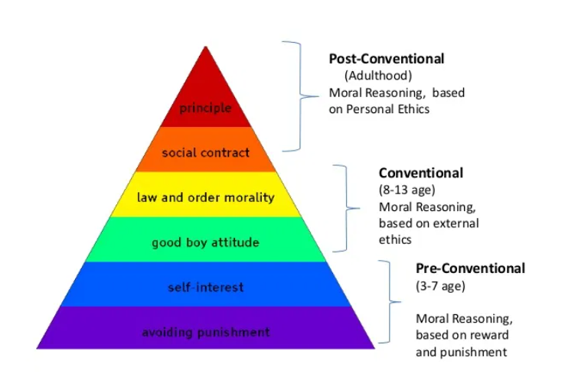
Figure 1: Kohlberg’s theory of moral development
(Source:Tahiraet al. 2020)
1st Level: Pre-conventional morality
It is the primordial stage of moral development and lasts till age 9. In this stage decisions of children are given shape through adults’ expectations and outcome of breaking rules. There are two sub-stages in this level.
- Stage 1 (punishment and obedience)- punishment and obedience common in infants and children whereas adults are also competent in showcasing the aforesaid reasoning. Obeying rules is deemed necessary to avoid punishments (Tahiraet al. 2020).
- Stage 2 (exchange and individualism)- in this phase infants account for individual standpoints and successively judge their actions depending upon their process of fulfilling their needs.
2nd Level: Conventional morality
It is the next level where moral development is associated with acceptance of social regulations depending upon their morality and good deeds. In this phase adolescence and young adults internalise their moral benchmarks learned from society and role models.
- Stage 3 (formulating proper interpersonal bonding)- in this phase moral development is associated with living as per social norms and expectations. According to (Carmichaelet al. 2019), there is an active involvement of conformity of being good and processes of making choices that influences people’s relationships.
- Stage 4 (preserving social order)- in this stage, people make sure that social order is maintained alongside people and also start to realise society as a singular unit while making prime judgments. Therefore, there is an emphasis on maintaining proper law and order by abiding rules.
3rd Level: Post-conventional morality
At this phase of moral development, individuals develop a cognitive interpreting of abstract fundamentals of morality.
- Stage 5 (individual rights and social contracts) - underlying ideas of individual rights and social contracts causes individuals to account for varied opinions, values and belief systems. Regulations for laws are relevant for preserving the society, whereas societal members must abide by the aforesaid benchmarks.
- Stage 6 (universal principles) - the final stage of Kohlberg’s moral development is based upon universal principles of abstract reasoning and ethics (Forsha, 2017). In this phase individuals are deemed to oblige internalised principles for justice even though there occurs a situation for conflict with rules and regulations.

Role of healthcare professional
In order to cultivate a strong moral development, healthcare and social care personnel are needed to start the task from a very tender age of an individual. It is the case because development of moral ethics is considered to initiate since infancy and generally occur during social/healthcare worker-child relationship. According to Lafmejani (2019), it is essential to decipher when the young individual is ready to develop moral development. It is assessed by interpreting natural traits. In this case, the theory can be used to take note of all stages in it and consider all traits of children for their development. Considering these matters a social worker can contribute in supporting moral development by:
Cultivating a strong bond with the child- concerned professional invests huge time in learning the dislikes and likes, their hopes, plans and their dreams and permits them to view that the former values them exceedingly as human beings (Ball et al. 2017). Nursery managers also closely watch the children and their way of handling conflicts in a proportionate and fair manner through exchange and individualism, and formulation of proper interpersonal bonding. Demonstrations of respect and care for children are intended to travel a long way while encouraging people to trust and listen to their guidance simultaneously.
Fostering moral identities- the identity that is deemed crucial for conducting right things is moral identity that highlights how good an individual is to others’ senses and their own selves. Professionals help their pupils in viewing them as good people and praise them and their character. According to Yung et al. (2021), complimenting children especially those around eight years of age through punishment and obedience, along with exchange and individualism can be effective.
Teaching mindfulness skill sets and SEL- it is the most crucial inner work meant for moral development and there are numerous layers within it initiating from emotional skills. Nursery managers help children to realise feelings and emotions attached to guilt and remorse and successively help in identifying these emotions and interpret their meaning. It helps them to develop empathy for other human beings. In addition, mindfulness facilitates kids to develop their somatic awareness in order to better amalgamate with the instructions of their conscience and therefore they tend to listen more carefully to their inner conscience. According to Staines et al. (2019), it helps the individual to be more sensitive mentally, physically and emotionally. Eventually, teachings about self-control are inculcated within young children and with its absence; individuals will not be able to appropriately act as per the direction of their conscience.

Reflection
According to Kohlberg’s theory of moral development, children’s development of morality is directly connected to their social development. It promotes co-existence peacefully and harmoniously within a community that are considered as society require setting some predefined regulations. The theory can help in considering the matters necessary for a future career as a nursery manager. In primary classrooms there are golden rules that assist children to enhance their level of patience and concern for others. These two factors are very much essential for developing morality. Considering Kohlberg's theory and thinking about the golden rules, nursery managers will be able to guide children through pre-conventional morality. Managers will be able to recognise children’s inner feelings and ensure methods for nurturing obedience and punishment, along with exchange and individualism. According to Ranjbar et al. (2018), in due course of time children start to view themselves as part of a group and as these people progress in life their individual social awareness starts to improve. These people start to act in a more thoughtful manner keeping in mind the benefits for other individuals are preserved simultaneously. Considering the types of communication and rules implemented within classrooms of primary level children I can think of strategies to foster moral development from homes.
It might be helpful to offer a nurturing empathetic and warm connection between children and their parents. The post-conventional morality can be utilised in this case while parents are involved with their children. Parents need to help the child by making them realise that the society is safe, benevolent. Moreover, they also need to behave and act in a morally correct manner and they must always rely upon truth in front of their children as children lack the ability to distinguish white lies from blatant lies. In this case, a nursery manager can play a huge part in helping parents to look after their children. Looking for various ways to foster patience, honesty and integrity while doing activities such as handling pets, going to the grocery store and while driving vehicles might be a kick-start to instil moral mannerism. According to Sánchez-Martínet al. (2017), authoritative parents tend to be more responsive and warm while being directive and firm. Nursery managers have to take note of this concept, understand parenting styles of children’s parents and act accordingly with them. It is the case because excessive supervision can also disable children’s ability to carry out personal decisions, which is highly essential for their personality development. On the other hand, the theory can be of much help for nursery manager career due to the abundance of processes for each group of individuals that can be applied as a guide.

Conclusion
The assessment concludes that moral development of individuals from an early age is very crucial to raise responsible and morally sound people for the future therefore it is necessary to instil a feeling a remorse, guilt and a sense of mutual respect for people all around young children and adults alike. The assessment pondered Kohlberg’s theory of moral development in a thorough manner stating its three primordial stages for moral development followed by the role of healthcare and social workers in upholding moral values and human development by considering Kohlberg’s theory of moral development. Finally the practical application of the theory for career development in the future as a nursery manager has been served. It also includes the relevance of good mentoring and parenting has been highlighted to nurture the future citizens.

References:
Ball, C.L., Smetana, J.G., Sturge-Apple, M.L., Suor, J.H. and Skibo, M.A., 2017. Moral development in context: Associations of neighborhood and maternal discipline with preschoolers’ moral judgments. Developmental psychology, 53(10), p.1881.
Carmichael, C.L., Schwartz, A.M., Coyle, M.A. and Goldberg, M.H., 2019. A Classroom Activity for Teaching Kohlberg’s Theory of Moral Development. Teaching of Psychology, 46(1), pp.80-86.
Forsha, S.K., 2017. Virtue and moral development, changing ethics instruction in business school education. College Student Journal, 51(3), pp.429-443.
Lafmejani, A.Q., 2019. LAWRENCE KOHLBERG’S THEORY OF MORAL DEVELOPMENT AND ITS COMPARISON WITH ETHICS FROM THE PERSPECTIVE OF SHIA ISLAM. European Journal of Science and Theology, 15(1), pp.97-112.
Ranjbar, H., Joolaee, S., Vedadhir, A., Abbasszadeh, A. and Bernstein, C., 2018. An evolutionary route for the moral development of nursing students: a constructivist grounded theory. Journal of Nursing Research, 26(3), pp.158-167.
Sánchez-Martín, J., Zamora-Polo, F., Moreno-Losada, J. and Parejo-Ayuso, J.P., 2017. Innovative education tools for developing ethical skills in university science lessons. The case of the moral cross dilemma. Ramon Llull Journal of Applied Ethics, (8), pp.225-245.
Staines, D., Formosa, P. and Ryan, M., 2019. Morality play: a model for developing games of moral expertise. Games and Culture, 14(4), pp.410-429.
Tahira, F., Kazmi, Q.A. and Zahid, M., 2020.Analysis of moral reasoning of teachers and the students with respect to Kohlbergs theory of moral development. International Journal of Business, 3(1), pp.11-29.
Yung, B., Yu, K.P., Leung, B.Y. and Chun, J., 2021. Efficacy of Border-Crossing Service-Learning in Empathy and Moral Development: Urban Students in the Rural Developing World. Journal of Higher Education Outreach and Engagement, 25(1).

