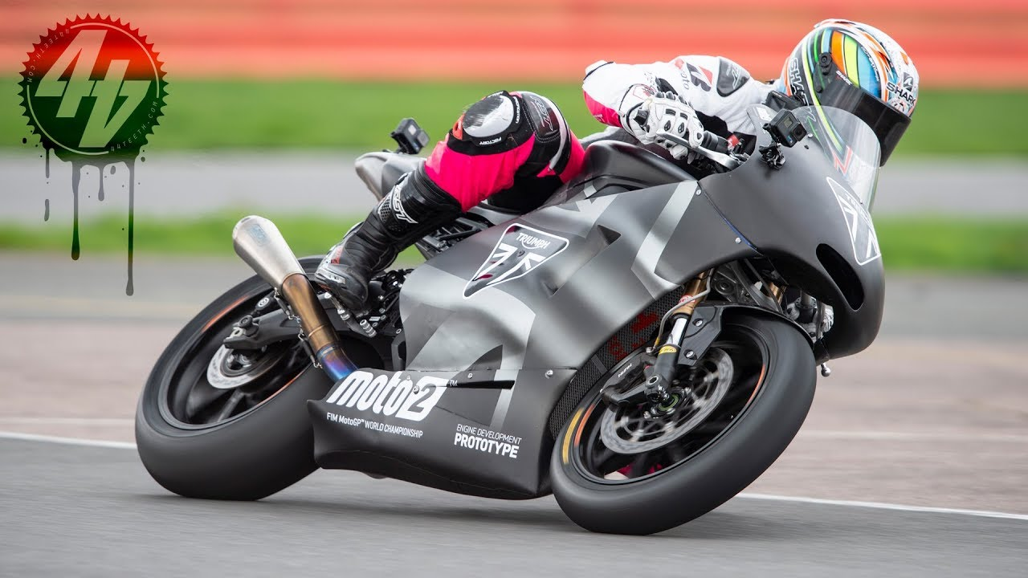  Triumph Motorcycles  Marketing Mix | Ian Newberry (1703128)
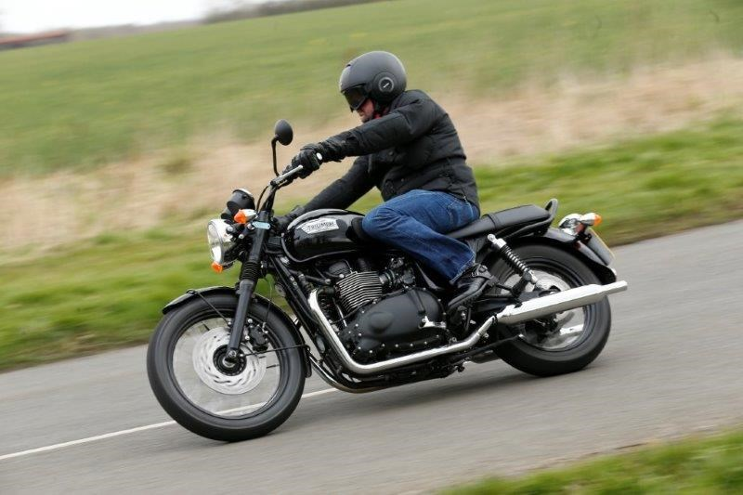

Contents
Abstract 2
Introduction 3
methodology 4
History of Triumph Motorcycles 5
Product 5
Place 6
Price 6
Promotion 7
Conclusion 7
References 8

Abstract
This report has been researched and compiled to show how Triumph Motorcycles use their Marketing Mix and if it is successful. To do this the report has looked at the history Triumph Motorcycles, their products, pricing strategy, place in the market and how they promote themselves. This will build a picture of their overall marketing mix from there a conclusion can be drawn.

Introduction
This report has been produced to look at the Marketing Mix of Triumph Motorcycles. If it is affective. The definition of the Marketing Mix is as follows:
‘‘A company's marketing mix is the combination of marketing activities it uses in order to promote a particular product or service. [business] The key focus of the marketing mix will be on price and distribution.’’ Dictionary definition, Collins English Dictionary, 2018

methodology
Most of the research material for this report is from literature review, information from The Illustrated Encyclopedia of Motorcycles by Erwin Tragatsch. There’s information from several websites and online articles that are all covered in the references section.

History of Triumph Motorcycles
Triumph Motorcycles started in 1902 when engineer Mauritz Schulte designed a motorcycle aptly dubbed the Number One. It was powered by a 2.2 horse power engine of Belgian design and make. Over the next five years, Triumph Motorcycles grew to selling over one thousand units a year. This meant that they had to move to a larger factory in Coventry. In 1907 Triumph entered the inaugural Isle of Man TT coming second. The following year, Jack Marshall won the single cylinder class on a Triumph with an average speed of 40 miles per hour. From this point Triumph grew from strength to strength, relocating again to a larger factory and supplying motorcycles to the British army during two world wars. Between 1940 and 1959 three of there most iconic models are designed and built. The Tiger, the Thunderbird and the Bonneville. Triumph Motorcycles, 2018
However, by the late 1960’s the landscape had completely changed, with Japanese motorcycle companies, Honda, Kawasaki, Suzuki and Yamaha able to mass produce motorcycles on a scale unheard of in Britain and with a level of reliability unmatched by British manufacturers, several British motorcycle makers, such BSA, Norton Villiers and Francis Barnett slowed production and eventually ceased production, some have had their rights bought and are producing motorcycles again. Tragatsch, 1977
With such a turbulent past, Triumph Motorcycles had to essentially reinvent themselves. Making their marketing mix all the more important.

Product
Triumph Motorcycles are currently a large enough company to be able to offer models in almost every class of motorcycle, from high performance roadsters to cruisers. This wasn’t always the case. In the late 1970’s and early 1980’s with the Japanese manufacturers holding such a large part of the market share, Triumph had difficulty maintaining market share and connecting with customers.
For most people, owning a motorcycle is not just a form of transport, it’s an emotional relationship and status symbol. So to create a product that would bring back their customer base Triumph Motorcycles began to carry out market research, which continues today.
This research led to Triumph Motorcycles redefining their products and re-releasing some of their classic models featuring modern technology. Using the fact that they were built in Britain, by British engineers to create an image of genuine build quality that their customer base really wanted.
Triumph Motorcycles also endeavour to create a closeness to the customers. This has benefits for both parties. It helps the customer base feel close to Triumph Motorcycles, creating an understanding of their history and heritage. The intention of this is to give the customer a feeling of belonging, being part of this heritage. They create this closeness through a series of events and experiences. These range from how the dealerships handle the purchasing experience to holding events and tours at their Hinckley factory. While creating a product and brand identity these events also create a brand loyalty, which helps promote their products in the future.
Using their redesigned classic models, along with their new customer experiences, Triumph Motorcycles have been able to grow and expand their product range from custom classics all the way through to high performance roadster models. They have expanded to the point where they are now the sole supplier of engines in the Moto2 motorcycle racing championships. Cooray & Duus, 2018

Place
Triumph Motorcycles main base of operations is their Hinckley plant in Leicestershire, this is where their experience days are held. It’s also where most of their production is based. Due to their global reach it was deemed necessary to open another plant containing three factories in Thailand. There are several reasons that company owner, John Bloor chose Thailand, specifically Chonburi, fifty miles southeast of Bangkok. The factors that influenced this location were mainly down to logistics and supply chain. Within approximately sixty miles of their Thailand plant are at least five of their major component suppliers, including Ohlins Suspension, NOK bearings and FCC Clutches.
in the year ending 30th June 2016 Triumph motorcycles produced a record high 56,253 motorcycles, with approximately 48,000 of them sold internationally. Triumph Motorcycles report that around eighty percent of these 48,000 units sold were made in their Thailand plant.
The Thailand plant was originally set up to be a components factory. A way for Triumph Motorcycles to make most of the non-specialist components in house. This was set up so that Triumph Motorcycles could guarantee high quality components at a lower price. This enabled them to compete with their larger German and Japanese competitors. Thailand is also free of import taxes, meaning that the parts that they can’t make themselves, or source locally, such as the crankshafts that are made and imported from their Hinckley plant carry no import tax. This is just another example of John Bloor’s forward thinking. He was the driving force behind the Thailand plant and pushed it through before any other motorcycle manufacturers began to move into the area. The Triumph Motorcycles plant opened in Thailand in 2002 and since that date, there has been at least another three manufacturers moved into the area, including Honda, Ducati and Harley Davidson.
By managing the logistics well and making a majority of their components in house, Triumph Motorcycles are able to keep manufacturing costs relatively low while keeping the quality high. Combined with their target customer base and lower production numbers (than the big Japanese manufacturers) they have managed to cement a place in the market as a company that delivers distinctive, high quality but low quantity motorcycles. DriveMag, 2018
Triumph motorcycles also have a significant online presence where, via their own website where members of the public are able to interact direct them, find out about the latest models, availability and pricing.

Price
Being in quite a unique market place, specialising in their modern classic range, with their reputation for reliable engineering, Triumph Motorcycles could charge a price above the market average. However, on comparison there is very difference between the Triumph Bonneville T100 at £8900 Triumph Motorcycles, 2018 and the Kawasaki Z900RS, which is a very similar specification model from a competitor priced at £9899 GT Superbikes. In fact the Triumph Bonneville is almost £2000 less. This trend is apparent across the range. The pricing structure gives Triumph Motorcycles a slight competitive edge over their rivals. They are able to keep their costs low as previously stated in this report due to a lot of their components being made in house. By keeping their production costs down they are able to keep their retail costs without making to much of an impact on their profitability.

Promotion
The report has touched briefly upon how Triumph Motorcycles promote their company through experience but that is just the start. Along with guided tours of their factory facilities they also offer an adventure training experience. Based at the foot of the Brecon Beacons, Triumph Motorcycles have a customer built multi-terrain adventure arena. Designed so that owners of Triumph adventure motorcycles, such as the Triumph Tiger are able to get trained in how to ride in off-road or poor conditions. These events have been put in place to create a brand identity that not many other motorcycle companies compete with. By creating this type of interaction with their customers the brand identity is not the only benefit to Triumph Motorcycles, it also engenders customer loyalty. This is because purchasing a motorcycle from Triumph Motorcycles is not simply a business transaction anymore. It is an event that Triumph Motorcycles try to make a positive experience for the purchaser. This also applies to the after sales service. Triumph Motorcycles only use approved dealerships who have to go through very specific Triumph Motorcycles training Triumph Motorcycles, 2018.
Triumph Motorcycles also use sponsorships to create a brand identity and community, they are the main sponsor for the Distinguished Gentleman’s Ride. An event that has been set up to raise awareness and charitable funds for two men’s charities. Gentlemans Ride, 2018.

Conclusion
So in conclusion, it would appear, based on the research of this report that Triumph Motorcycles have a very strong & successful marketing mix. Their balance of product quality, value for money due to their pricing structure and the community they have built using special events and the brand identity they have spent years creating. It was this marketing strategy that helped save the company when things weren’t going so well.

References
cooray, M. and Duus, R. (2018). The reincarnation of Triumph, the iconic British brand. [online] The Independent. Available at: https://www.independent.co.uk/news/long_reads/triumph-motorbikes-british-brand-incarnation-a8155241.html [Accessed 1 Dec. 2018].
Motorcycles, T. (2018). For the Ride. [online] Triumph Motorcycles. Available at: https://www.triumphmotorcycles.co.uk/our-story/brand-timeline [Accessed 1 Dec. 2018].
The Distinguished Gentleman's Ride. (2018). The 2018 Distinguished Gentleman's Ride. [online] Available at: https://www.gentlemansride.com/ [Accessed 3 Dec. 2018].
Tragatsch, E. and Ash, K. (1977). The Illustrated Encyclopedia of Motorcycles. Scarborough: Auantum Pub.

