

Project Outline

Establishing “Sense Mortgage & Residential” under Financial (FCA) Network

Student Name: Kaniz Chowdhury
Student Id: 2429424
Programme: MBA – Business Administration
Supervisor: Mr Valendran Kandasamy
Submission Date: 7th November 2025

Table of Contents

Executive Summary 4
Business Concept: 4
Vision and Mission 4
Vision: 4
Mission: 4
Business Objectives 4
Target Market and Customer Needs 5
Unique Selling Proposition (USP) 5
Business Model Canvas Summary 5
Methodology 6
Research Approach 6
Data Sources 7
Secondary Data: 7
Search strategy: 7
Quality appraisal: 7
Data extraction: 7
Synthesis and analysis: 7
Limitations: 7
Ethical consideration: 7
Data Analysis 7
Qualitative Data: 7
Quantitative Data: 7
Ethics and Data Management: 8
Market Research and Validation 8
Industry Overview 8
Competitor Analysis 8
Moderate Competitive Rivalry: 8
High Threat of New Entrants: 8
High Bargaining Power of Buyers: 8
Target Market Characteristics and Segmentation: 9
The target market is segmented into: 9
Market Validation: 9
Link to Academic Theories: 9
Risks 9
Business Risks 9
Market/Financial Risk: 9
Operational/Regulatory Risk: 9
Resource Risk: 9
Research Risks 10
Data Access Risk: 10
Ethical Risk: 10
Mitigation Strategies 10
For Business Risks: 10
For Research Risks: 10
Timeline (Gantt Chart) 11
Reference 13

Executive Summary

Business Concept:
Sense Mortgage & Residential, located in London, offers comprehensive financial planning and advisory services to individuals and businesses. It will be proposed mortgage intermediary firm that will operate as an Appointed Representative (AR) under the financial Network. The business will offer tailored mortgage and protection advice to clients in the UK, ensuring full compliance with Financial Conduct Authority (FCA) regulations.

Vision and Mission

Vision:
To become the most trusted and innovative mortgage advisory hub in the Southeast of England, known for delivering clear, compliant, and client-centred financial solutions.

Mission:
To empower clients to make informed property finance decisions through transparent, personalised advice, while leveraging technology for efficient operations and sustainable growth.

Business Objectives
- Identify a secure and reliable financial Network under FCA, liaise with their requirements and get connected.
- Secure formal AR authorisation from the financial Network and the FCA, launching full operations within three months of approval.
- Achieve 50 completed mortgage transactions within the first 12 months of operation.
- Implement a fully compliant Customer Relationship Management (CRM) and financial tracking system by the end of the first operational year.
- Expand the network of qualified advisers and establish a structured internal training programme within 24 months to support scaling.

Target Market and Customer Needs
The primary target market includes first-time buyers, homeowners seeking remortgages, and property investors in London and the Southeast. These segments require expert, transparent guidance to navigate complex mortgage products, interest rate fluctuations, and regulatory requirements.

Unique Selling Proposition (USP)
Sense Mortgage & Residential differentiates itself by combining deep, professional advisory expertise with a digitally driven operational framework. This includes dedicated internal support teams for paraplanning and administration, enabling advisers to focus more time on high-value client service and complex cases. We specialize in building long-term client relationships and leveraging advanced financial tools to ensure security and growth.

Business Model Canvas Summary
The business model for Sense Mortgage & Residential focuses on delivering professional, transparent, and technology-driven mortgage and protection advice to clients across London and the Southeast.
Key partners: A Financial Conduct Authority (FCA)-authorised network (to be selected), mortgage lenders, protection and insurance providers, solicitors, surveyors, and digital CRM system providers.
Key Activities: Providing expert mortgage and protection advice, conducting detailed client fact-finds, sourcing competitive mortgage products, managing compliance and record-keeping, and delivering consistent aftercare services such as renewals and portfolio reviews.
Value Proposition: Sense Mortgage & Residential offers clients clear, compliant, and tailored financial solutions supported by digital tools that enhance accuracy and convenience. We simplify the mortgage process, build trust through transparency, and help clients make confident long-term property finance decisions.
Customer relationships: We aim to build long-term, trust-based relationships through regular communication, personalised support, and reliable service delivery both digitally and in person.
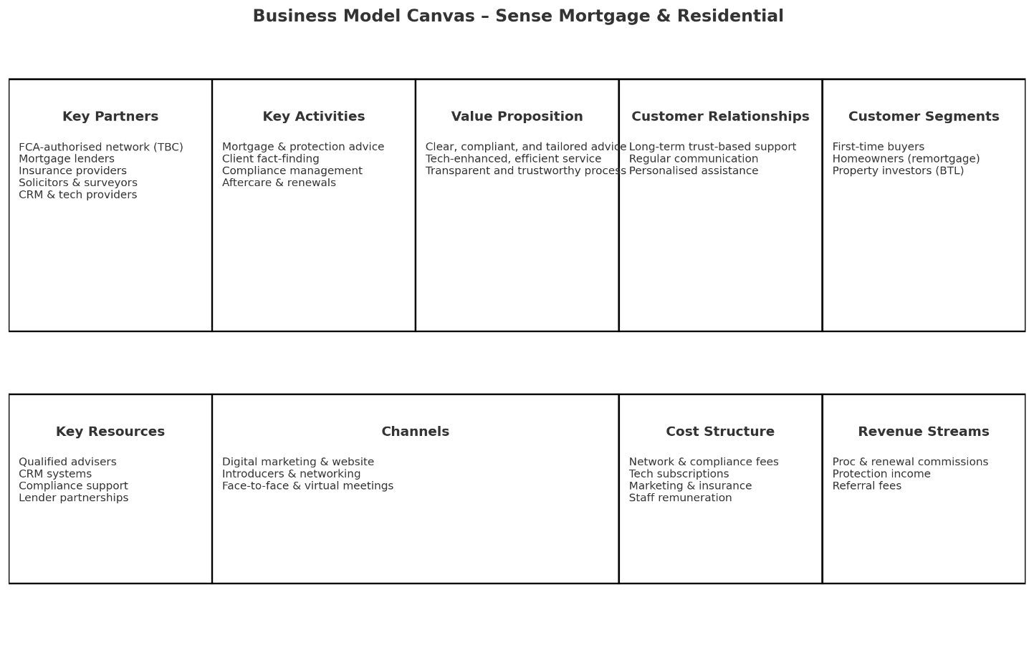

Methodology
This proposal will employ a mixed-methods research approach to ensure a comprehensive and justified business development plan, triangulating qualitative insights with quantitative data for robust validation (Creswell, 2018; Saunders, Lewis & Thornhill, 2019).

Research Approach
This proposal will employ a mixed-data analytical approach using both qualitative and quantitative information from secondary sources. Desk-Based secondary research will be implemented due to suitability of the project. Business development proposal (BDP) covers wide range of information such as financial, marketing, business strategy, human resources and so on. Therefore, it will be convenient to cover all criteria within timeline.

Data Sources
Secondary Data: Extensive use will be made of industry reports from UK Finance and the FCA, market analysis from firms like Moneyfacts, and relevant academic literature on business models and strategy. Google Scholar, ONS, Statista, IBISWorld, industry white papers, company reports, regulator publications also be in used.
The search strategy employed targeted keywords such as UK mortgage market, FCA authorisation, and mortgage intermediary networks, using Boolean operators to refine results. Sources were limited to English-language publications from 2019 to 2025 to ensure recency and relevance. Inclusion criteria prioritised FCA documentation, UK market reports, and publications from credible financial institutions, while non-UK or opinion-based sources were excluded.
Quality appraisal emphasised peer-reviewed or industry-verified data, recency within the last five years, and transparent research methodologies. Priority was given to information from reputable organisations such as the FCA, HM Treasury, UK Finance, and established mortgage networks.
The collected data were synthesised narratively to identify trends in regulation, compliance, and market growth, alongside comparative analysis of potential network partners such as Quilter, City Plus, and OSL. Thematic analysis highlighted recurring issues including compliance costs, technology adoption, and network support structures.
The research acknowledges several limitations, including restricted access to paid industry data, potential publication bias in commercial reports, and limited regional specificity in available datasets. Ethical considerations were strictly observed, with proper citation of all sources, respect for copyright and data protection requirements, and adherence to academic integrity throughout the process

Data Analysis
Qualitative Data: Interview transcripts which may published for public use will be analysed using thematic analysis to identify key patterns, challenges, and opportunities within the mortgage advisory landscape.
Quantitative Data: Secondary market data (e.g., market size, lending volumes, interest rate trends) will be analysed using descriptive statistics and trend analysis to substantiate the market opportunity.
Ethics and Data Management: This research will adhere strictly to the UWTSD Research Ethics Policy (2024). All participants will provide informed consent using a standardised form (see appendix). All data collected will be anonymised to protect participant confidentiality and stored securely on password-protected university systems. Data will be retained only for the duration required for the project.

Market Research and Validation

Industry Overview
The UK mortgage market is substantial and dynamic, with total lending exceeding £310 billion in 2024 (UK Finance, 2024). Key trends include ongoing digital transformation, increased regulatory scrutiny from the FCA (2024), and a persistent consumer demand for trusted, personalised advice amidst economic uncertainty.

Competitor Analysis
Key competitors include established advisory networks such as Quilter and Openwork. An analysis using Porter's Five Forces (Porter, 2008) reveals:
Moderate Competitive Rivalry: Many firms compete, but differentiation through service quality is possible.
High Threat of New Entrants: Regulatory barriers (e.g., FCA authorisation) are significant.
High Bargaining Power of Buyers: Clients have access to extensive information and can easily compare advisers.
A SWOT analysis of these competitors indicates that while they have strong brand recognition, they can sometimes lack the agility and personalised touch of a smaller, focused firm like Thames Mortgage & Residential.

Target Market Characteristics and Segmentation:

The target market is segmented into:
1. First-Time Buyers: Requiring education and guidance.
2. Homeowners Remortgaging: Seeking better rates and product features.
3. Property Investors: Needing complex, portfolio-based advice.
These segments are primarily located in London and the Southeast, a region with high property values and transaction volumes.
Market Validation: Preliminary secondary data from UK Finance (2024) confirms sustained demand in the target regions. Sense Mortgage & Residential will initially pursue a Market Penetration strategy (gaining share in the existing market with a core service) and later a Product Development strategy (adding new financial products).
Link to Academic Theories: The business strategy is informed by Porter's (2008) generic strategies, aiming for a focus differentiation by serving a specific geographic and client demographic with a superior, digitally enabled service model. The operational plan is structured around the value propositions and key activities outlined in the Business Model Canvas (Osterwalder and Pigneur, 2010).

Risks

Business Risks
Market/Financial Risk: Interest rate volatility could reduce mortgage demand and impact revenue forecasts.
Operational/Regulatory Risk: Delays in obtaining FCA/financial authorisation or failure to maintain ongoing compliance could halt operations.
Resource Risk: Challenges in recruiting and retaining qualified mortgage advisers could impede growth.

Research Risks
Data Access Risk: Potential difficulty in accessing sufficient primary interview participants or proprietary industry data.
Ethical Risk: Ensuring complete anonymity and confidentiality for all data collection resources.

Mitigation Strategies
For Business Risks: Implement a phased business launch plan; engage in continuous professional development and compliance training; develop a competitive remuneration package to attract talent.
For Research Risks: Utilise a diverse range of secondary data sources to compensate for any primary data shortfalls; obtain formal ethical approval and informed consent; maintain secure, anonymised records.

Timeline (Gantt Chart)
A 16-week schedule has been developed to manage the research and drafting of the full Business Development Proposal, aligning with the UWTSD BDP template and academic best practices (Saunders et al., 2019). The timeline is presented below.
Task | Linked BDP Section per week |  | 1 | 2 | 3 | 4 | 5 | 6 | 7 | 8 | 9 | 10 | 11 | 12 | 13 | 14 | 15 | 16
Topic finalisation, initial literature review, draft Company Description | 1. Company / Idea Description |  | 🟩 | 🟩
Conduct secondary research on industry, competitors, and target market | 3. Market Research & Validation |  |  |  | 🟦 | 🟦 | 🟦
Finalise Methodology. | 2. Methodology |  |  |  |  |  | 🟨 | 🟨
Secondary data collection & analysis | 3. Market Research & Validation |  |  |  |  |  |  |  | 🟧 | 🟧 | 🟧
Draft core BDP sections: Business Model, Marketing, Operations, HR, Financials | All sections |  |  |  |  |  |  |  |  |  |  | 🟥 | 🟥 | 🟥 | 🟥
Full draft revision, integration of feedback, proofreading, formatting | All sections |  |  |  |  |  |  |  |  |  |  |  |  |  | 🟪 | 🟪 | 🟪
Final submission of the BDP Outline | — |  |  |  |  |  |  |  |  |  |  |  |  |  |  |  |  | ⬛

Symbol | Meaning
🟩 | Topic & company description
🟦 | Secondary market research
🟨 | Methodology & ethics submission
🟧 | Primary data collection & analysis
🟥 | Drafting BDP core sections
🟪 | Revision & proofreading
⬛ | Final submission

Reference
Ansoff, I. (1957). Strategies for Diversification. Harvard Business Review. Creswell, J. W. (2018). Research Design: Qualitative, Quantitative, and Mixed Methods Approaches. Sage.
FCA (2024). Mortgage Market Review Report. Financial Conduct Authority.
Kotler, P. & Keller, K. (2023). Marketing Management. Pearson Education.
Moneyfacts (2025). Mortgage Trends Analysis. [Online] Available at: moneyfacts.co.uk
Osterwalder, A. & Pigneur, Y. (2010). Business Model Generation. Wiley.
Porter, M. E. (2008). Competitive Strategy: Techniques for Analyzing Industries and Competitors. Free Press.
Project Management Institute (PMI) (2021). A Guide to the Project Management Body of Knowledge (PMBOK® Guide).
Saunders, M., Lewis, P. & Thornhill, A. (2019). Research Methods for Business Students. Pearson.
UK Finance (2024). Mortgage Trends Report. London: UK Finance.
University of Wales Trinity Saint David (UWTSD) (2024). Research Ethics Policy.

