Group Software Development

Andrew Ridgeway
Steffan Davies
Richard Hankey
Fraser Sweetman

Table of Contents
1. Introduction 1
2. Overview 2
3. Key Stakeholders Identified 2
4. Team Members 2
5. Functional and Non-Function Requirements 2
6. Use Cases Derived from Scenario 3
7. Identified requirements for first iteration 6
8. Plan for requirements for 2nd iteration 6
9. Sustainability, Ethical and Legal Issues 6
Intellectual property 6
Sustainability 7
Ethical and Legal issues 7
10. Elaboration 8
Static Design 8
Class design (UML) 8
Collaboration and Responsibilities 9
Dynamic Design 9
Sequence Diagrams 9
User Interface Design Prototypes 10
11. Individual Contribution 12
Usability of phones and tablets 12
Computer Vision 13
12. Design to Requirements Matrix 13
13. Team Meeting 13
14. References 16

1. Introduction
Here is a short summary of what this brief for contain such as overview, key stakeholders identified, team members, functional and non-function requirements, use cases derived from scenario, identified requirements for first iteration, plan for requirements for 2nd iteration, sustainability, ethical and legal Issues, elaboration, individual contribution, design to requirements matrix and team meeting.

2. Overview
Is to create a digital Tour Guide application that would be used with smartphone and tablets to allow the customer to gain information while they are exploring, such as museums, historical monuments, cathedrals and more. For example, customers would gain information just by simply using a phone to scan the artefact to gain information about the artefact and the type of information the customers get on that artefact, such as is the Year the artefact was made in and what it was used for.

3. Key Stakeholders Identified
Andrew Ridgeway
The key stakeholders are the team members are Andrew Ridgeway, Steffan Davies, Richard Hankey and Fraser Sweetman that will develop the application. the museum is the next stakeholders that the application will be used to scan each artefact that is in the museum. The key stakeholders are that requested for the applications for the museum and the stakeholders are Gordon Dickers and Andrew Baker.

4. Team Members

Andrew Ridgeway: - Main Documenter/User Interface
Steffan Davies: - Main Researcher/Form manager
Richard Hankey: - Main Organiser/Code Director
Fraser Sweetman: - Tester/Developer

5. Functional and Non-Function Requirements
Andrew Ridgeway
The application will contain three buttons that will have the following: The type of function the first button will have the scan it features, and this will allow the end user to scan an artefact, it will bring information to the end-user about the artefact.
The second button will have a feature known as look at previous artefacts that already been scanned and this will give the end user the capability to look at the artefacts they have already scanned.
The third button will have a function known as tour guide mode and this will guide people through the museum while telling them which room they're in.
Another functional part of this application would be the Wi-Fi and the main reason for this it needs the Wi-Fi to allow the smartphone or tablet to connect to the internet to access the application.
The non-functional part will be the GPS and the main reason why this is for the non-functioning part, because the app can rely on the Wi-Fi within the museum to guide the tourist through and the GPS will not be needed.

6. Use Cases Derived from Scenario

Andrew Ridgeway Use-Case
USE CASE 1 | Tour Guide App
Goal in Context | Delivering a working app to the end-user which they can use to get information on any historical information for them to read up on their phones. The app will be free to download for the end-user.
Scope & Level | The tour guide app will be used on a handheld device such as iPhones Android, iPads, Windows phones and tablets. The app will be used to guide tourist or people may want to visit such as museums, historical monuments, cathedrals and any other historical places they may want to visit.
Preconditions | The end users may want to use an app to read up about the information on historical artefacts in museums, historical monuments and cathedrals.
Success End Condition | The app is successful and useful to the end-user.
Failed End Condition | The app is unsuccessful and not useful to the end-user.
Primary, Secondary Actors | Given the end-user a tour guide app what gives the end user information about ancient artefacts in historical artefacts in museums, historical monuments and cathedrals.  The app will run on device such as iPhones, Android, Windows phones, iPads and Tablets.
Trigger | Given the end user information on historical artefacts.
DESCRIPTION | Step | Action
 | 1 | The end-user downloads the app.
 | 2 | The end-user wait until the download is finished.
 | 3 | Download it finish and the end-user can open app.
 | 4 | The end-users using the app in the tour to guide through the tour.
EXTENSIONS | Step | Branching Action
 | 1a | The app may have new features in future.
SUB-VARIATIONS | Step | Branching Action
 | 1 | The end-user can scan the barcode while on tour to download the app or go to the App Store, Google Play and Windows Store to download the app.

RELATED INFORMATION | 1. Tour Guide App
Priority: | Very important.
Performance | The end-user phone and internet connection/3G/4G.
Frequency | Daily while on tour.
Channels to actors | The tour guide app will have features such as buttons that will be shown on the screen.  The first button will have a function known as scan the artefact to gain information and this feature may have a barcode on the artefact or number.  The second button will have function known as look at previous artefact and this feature will allow the end user to look at each of the artefacts what they have scanned in a certain area.  The third button will have a function known as tour guide mode and this will give the capability to guide people through the museum telling them about the artefacts.  The database will be used to store the information for each artefact that is to be used for the tour guide app.
OPEN ISSUES | <list of issues  awaiting decision  affecting this use case >
Due Date | Version Release 1.0
...any other management information... | N/A
Superordinate’s | Tour Guide App
Subordinates | N/A

Steffan Davies Use-Case
USE CASE #2 | Tour Guide App for Mobile Devices
Goal in Context | Develop a digital tour guide app for mobile devices to be used in tourist attractions such as museums, cathedrals etc.
Scope & Level | Contract given by the client. The client wants the app to replace the guides that are currently in use at the tourist attractions.  Main aim is to create a functional app that can be used with ease. E.G. use of three buttons, one for scanning an artefact, second for accessing the scan gallery to re-access the previous scanning information and the last to give audio guides (can be repeated if pressed again). Additional functions could include use of computer vision.  Main keys identified:  - Use of computer vision  - To be used in multiple locations  - Content to added/expanded by local tour guides
Preconditions | Team to work on developing the app on decided use of software
Success End Condition | App to function successfully and be used by the public with ease. The client to be satisfied with the end result.
Failed End Condition | App missing features or functions wanted by the client, leaving them dissatisfied. The app to not function as it should successfully.
Primary,  Secondary Actors | To have an app that functions as it should and allows ease of use for the public in the tourist attraction.  The app to have a feature to allow the user to have information displayed to them using the app. This would be computer vision. The app is to be available on all mobile devices.
Trigger | User starts the app.
DESCRIPTION | Step | Action
 | 1 | After user has started app, they will need to find the area they are currently in at the attraction.
 | 2 | User uses the buttons to navigate through the app with ease and find relevant information.
 | 3 | If user is interested with specific objects that are part of the attraction, they can use computer vision technology that is part of the app to have further information given on said object.
EXTENSIONS | Step | Branching Action
 | 2a | User presses one of three buttons to navigate through the app. Scan, Guide, and Gallery.
SUB-VARIATIONS |  | Branching Action
 | 2a | 2a1 – user uses the app to look at an artefact and scan the artefact for further information by using the scan button.  2a2 – user uses the app and listens to one of audio files for the area they are in by using the guide button.  2a3 – user uses the app and presses the gallery button to look at any previous scans that were done and look at the information again.

RELATED INFORMATION | 2 – Tour Guide App for Mobile Devices
Priority: | Very High Priority
Performance | 7 Months
Frequency | User expected to use it many times whilst on attraction.
Channels to actors | Tour Guide App will have 3 buttons. Scan, Guide and Gallery.  Scan will be used to scan an artefact. The app will use a camera function for the user to highlight over the artefact.  Guide will be used to provide an audio description of the area the user is in as well as specific artefacts within that area.  Gallery will be used to allow the user to access previous scans that have been done by the user to look at the information that was already given to them.
OPEN ISSUES | N/A
Due Date | May 2018
...any other  management  Information... | N/A
Superordinate’s | N/A
Subordinates | N/A

Richard Hankey Use-Case
USE CASE # | Scanning
Goal in Context | User must locate an exhibit and scan it into the app.
Scope & Level | Primary task of scan using the camera of the hardware
Preconditions | App has been downloaded and is functional. Scan program or scan button has been used.
Success End Condition | Exhibit interaction has been established and user is receiving notated or speech about exhibit
Failed End Condition | App will display an error and give advice of how use the software appropriately and try again.
Primary,  Secondary Actors | Primary actor: the user,  Secondary actors: camera and internet.
Trigger | User presses the “scan” button.
DESCRIPTION | Step | Action
 | 1 | User would aim camera at exhibit
 | 2 | Scan exhibit
 | 3 | Scan would link up a database and push relevant information to device.

RELATED INFORMATION | Loading an exhibit
Priority: | Highest priority, main function of app
Performance | From pressing scan to scanning the exhibit: 5-10seconds to scan and 5 seconds to load exhibit information.
Frequency | 1 every minute at peak, 1 every 5mins otherwise.
Channels to actors | Access to databases required.
OPEN ISSUES | Access to database from device  Exhibit to database relatability
Due Date | asap
...any other  management  information... | none
Super ordinates | <names of the other use cases >
Subordinates | none

Fraser Sweetman Use-Case
USE CASE 4 | Tour Guide Application
Goal in Context | The User can use the application to have a tour of a monument or museum exhibition and receive information relevant to the tour from the application
Scope & Level | The application will be designed and developed to function on multiple different handheld device such as Apple’s IOS system Android’s system, Windows phones and tablets. The app will be intended to be used to guide the user and provide information on historical locations, museum exhibits, castles, monuments and key landmarks etc.
Preconditions | The user will have downloaded the functioning app onto her device and is at a location where the can provide information on the area, building or the exhibits inside.
Success End Condition | The app functions as intended and meets the client’s needs and demands
Failed End Condition | The app does not function properly or does not meet the clients need and demands
Primary, Secondary Actors | The application given to the client can be downloaded, installed and function on multiple handheld platforms and provide the user with accurate information about the museum exhibits, monuments, historic buildings (castles etc) and other tourist attractions that the app will have information stored.
Trigger | User stats the app and selects the object, monument etc they want to receive information on.
DESCRIPTION | Step | Action
 | 1 | User downloads and installs app on handheld device.
 | 2 | User opens the app
 | 3 | User selects location, exhibit etc where they are e.g. British war museum
 | 4 | Ussr selects tour, object, monument etc. they wish to receive information on
EXTENSIONS | Step | Branching Action
 | 1a | The app may have new features in future.
SUB-VARIATIONS | Step | Branching Action
 | 1 | The user may scan a barcode while touring near an item, location point that the app has information on to download and install the app or they can go to their devices application store e.g. Google Play.

RELATED INFORMATION | Tour Guide application for handheld devices.
Priority: | Crucial
Performance | User has access and a connection to the internet via wi-fi, 3G/4G etc.
Frequency | Daily while on sightseeing tours.
Channels to actors | A database system will be used to store all information on the artefacts, locations etc to be used for the app. The app will have buttons visible on screen that will perform a function once pressed. The first button will have a scan function to gain information on an object, this function may work with a barcode on or next to the artefact that will provide the app with the information required for it to provide information on the correct object.  The second button will have a previous artefact function that will allow the user to browse the previous artefacts the previous they have scanned in the area. The third button will have a function referred as the tour guide mode which will have the app function as a tour guide of the are/exhibit etc for the user providing all necessary information.
OPEN ISSUES | The app requires internet connection. The more artefacts, museums etc the app holds information on the larger the database system will be eventually requiring larger data storage. Barcode scanners have always not functioned at !00% and so another method of reading the barcode may be required to get the scan function to work consistently.
Due Date | On Version Release date given by client
...any other management information... | N/A
Superordinate’s | Tour Guide Application
Subordinates | N/A

7. Identified requirements for first iteration

The requirements identified is the app must be would be guide users in and around the artefacts and app was not to be too distracting to enable the users to enjoy artefacts more than the app.
App must consist of:
- A suitable User Interface
- Scan of artefacts using an image scanner.
- Voice recorded information about the artefacts
- Cheap as possible options
- GPS Location
- Gallery of images

After deliberation the group has decided that a user saved gallery not a preset gallery so user can enjoy the artefacts without too much attention on the app.

8. Plan for requirements for 2nd iteration
The artefact will be recorded on to a database will have their own in individual gallery ID and in the database, there will be a location to where the artefact will be. There will be a file path but it's not complete as of yet and here is the lookup table showing below.
Database of images to artefacts
Artifact | Gallery ID | Location | File path
Drawbridge | 001 | Main gate | File path not yet identified
Moat | 002 | Main gate | File path not yet identified
Wall | 003 | Main gate | File path not yet identified
Ladder | 004 | Main gate | File path not yet identified
Dining table | 005 | Dining hall | File path not yet identified
Dining Chair | 006 | Dining hall | File path not yet identified
Head chair | 007 | Dining hall | File path not yet identified
Plates and cutlery | 008 | Dining hall | File path not yet identified
Cannon | 009 | Castle wall | File path not yet identified
Archer station | 010 | Castle wall | File path not yet identified
Catapult | 011 | Castle wall | File path not yet identified
Boulder pile | 012 | Castle wall | File path not yet identified
Horses stable | 013 | Stables | File path not yet identified
Horse feeding trough | 014 | Stables | File path not yet identified
Horse hide | 015 | Stables | File path not yet identified
Horse saddles | 016 | Stables | File path not yet identified
Horse shoes | 017 | Stables | File path not yet identified
Gravestone of VIP | 018 | Cemetery | File path not yet identified
Rudimentary gravestone | 019 | Cemetery | File path not yet identified
Memorial | 020 | Cemetery | File path not yet identified
Altar | 021 | Chapel | File path not yet identified
Seats | 022 | Chapel | File path not yet identified
Confession box | 023 | Chapel | File path not yet identified
Judge quarters | 024 | Courtroom | File path not yet identified
Arrow Target | 025 | Training grounds | File path not yet identified
Prison cell | 026 | Dungeon | File path not yet identified
Swords and Shields | 027 | Armory | File path not yet identified
The app will use this lookup table to find the required file path of the artefact to display the correct information and/or play the pre-recorded voice overlay. The Gallery will contain up to 12 images (taken by the client or developers in a clock type fashion around the artefacts) within each “Gallery ID” so when user scans the artefact will look through the Gallery ID using Co-ordinates found via GPS or otherwise.

9. Sustainability, Ethical and Legal Issues

Intellectual property
All information on the artefacts, locations etc must be accurate and all information acquired by a third party cited.

Sustainability

Ass more artefacts and museums and exhibits are added to the app the database will need to be edited. When the database gets to large for current storage method e.g. a database server the database will have to transferred to a larger capacity storage method.

Ethical and Legal issues
Due to other tour guide apps existing it is important that the app designed and developed by the group does not infringe on the copyright of any existing apps.

10. Elaboration

Class design (UML)
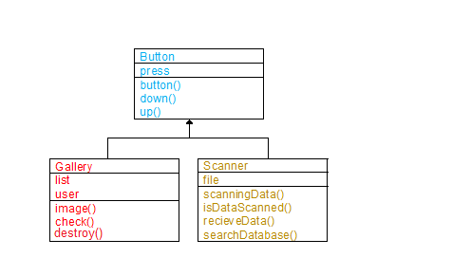

Collaboration and Responsibilities

Andrew Ridgeway
Tour Guide App
Guide Customer | Tour Guide
Scan Artefacts | Scan
Preview Gallery | Scan Gallery
Andrew Ridgeway
Tour Guide
Press Button | Back button
Press Button | Start/Stop button
Guide Customer | Audio
Steffan Davies
Scan
Start scanning process | Processing scan
Scanning process done | Scan complete
Storing scan in gallery | Scan stored in gallery
Richard Hankey
Scan Gallery
Press Button “Scan gallery” | Loads all scanned image onto screen
Press Image | Go back to related tour guide

Sequence Diagrams
Steffan Davies
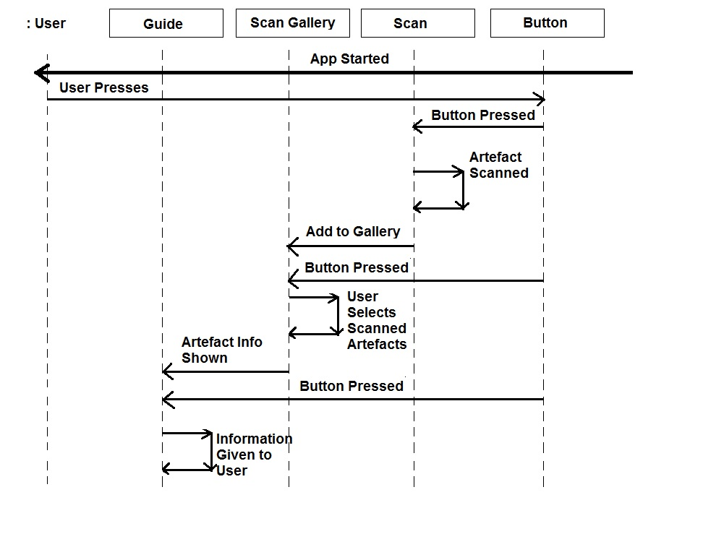

User Interface Design Prototypes
Andrew Ridgeway
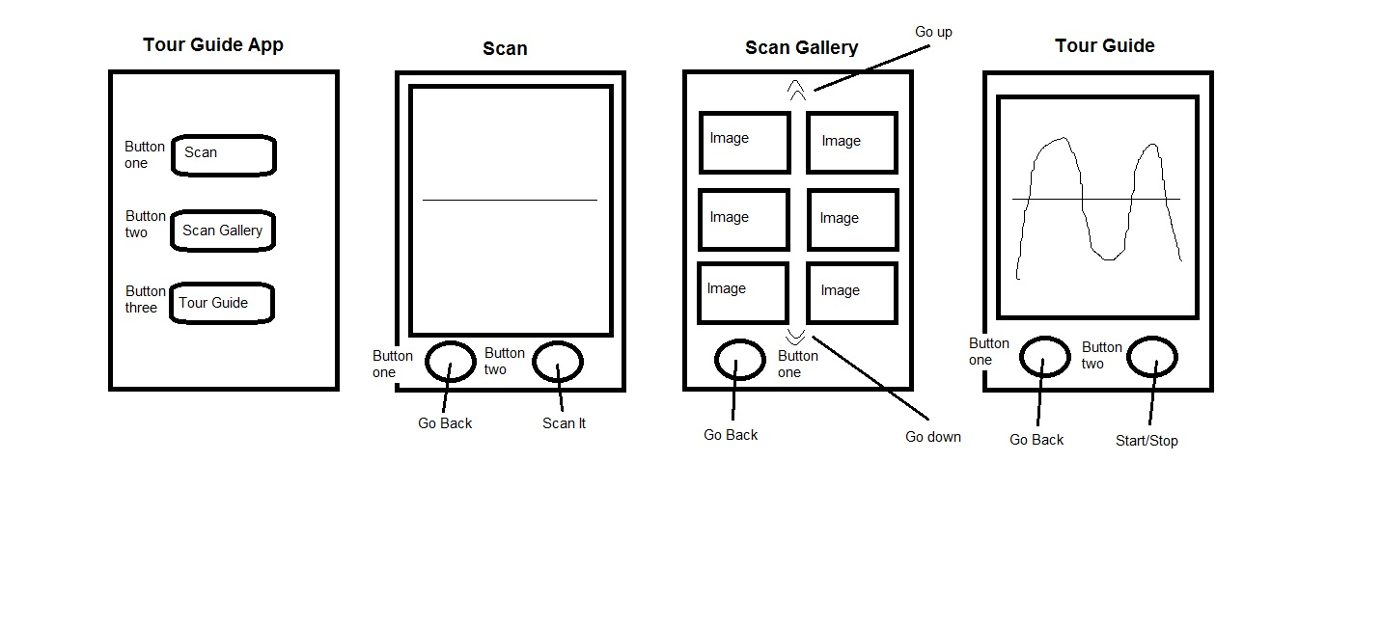

Code Implementation (1st Iteration)
Andrew Ridgeway code
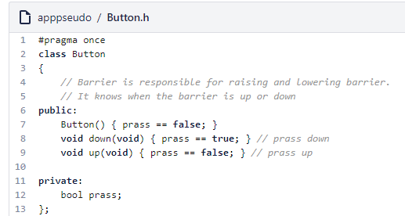
Steffan Davies code
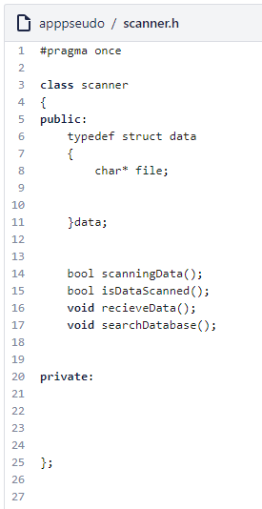
Richard Hankey code
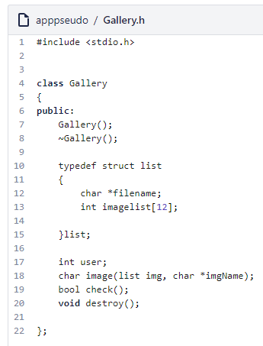
Testing
Fraser Sweetman
N/A

Version Control
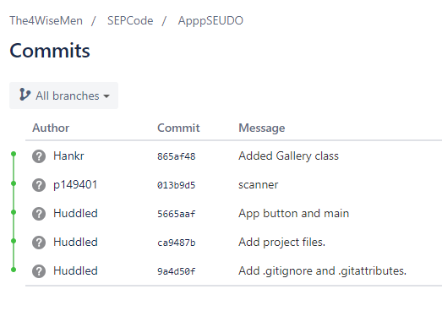
Andrew Ridgeway
Steffan Davies
Richard Hankey

11. Individual Contribution

12. Design to Requirements Matrix
Steffan Davies
 | Section
Requirement | 1 | 2 | 3 | 4 | 5 | 6 | 7 | 8 | 9 | 10 | 11 | 12 | 13 | 14
Implement a Scan Button |  |  |  |  | X | X |  |  |  | X
Implement a Guide Button |  |  |  |  | X | X |  |  |  | X
Implement a Gallery Button |  |  |  |  | X | X |  |  |  | X
Implement a Scanning Function |  |  |  |  |  |  |  |  |  | X
Implement a database Checker |  |  |  |  |  |  |  |  |  | X
Information to be read to the user (Audio) |  |  |  |  |  | X
Store scans done by the user (no Preset) |  |  |  |  |  | X
Implementing Computer Vision Technology |  |  |  |  |  | X |  |  |  |  | X

13. Team Meeting
Meeting 1 – Members present (Steffan Davies, Fraser Sweetman, and Andrew Ridgeway)
Meeting Time: 15/11/2017, 10:45 – 11:00
Topics Discussed:
• Each Member is to create their own use-case to compare with each other in the next meeting.
• Each member decided their text layout to identify their contribution to the project.
Steffan Davies: gold
Fraser Sweetman: green
Andrew Ridgeway: blue
Richard Hankey: red

Meeting 2 – Members present (Steffan Davies, Fraser Sweetman, and Andrew Ridgeway)
Meeting Time: 22/11/2017, 10:45 – 11:00
Topics Discussed:
• Continued Discussing use-cases

Meeting 3 – Members present (Everyone)
Meeting Time: 29/11/2017, 10:20 – 10:30
Topics Discussed:
• Everyone decided to use the same use-case after its completion
• Each member to continue working on their own use-case
• Decided a date and time for the next meeting

Meeting 4 – Members present (Everyone)
Meeting Time: 29/11/2017, 10:20 – 10:50
Topics Discussed:
- Use-Case continued
• Extension (think else)
• Use of Collab email to share & discuss work
• Everyone to create use-cases
• Next meeting, discuss use-cases
• Research lightly on use-cases
• Decided rich note-takes

Meeting 5
Date: 21/03/2018
Time: 9:30am
Meeting with client
Members present: Richard Hankey, Fraser Sweetman, Steffan Davies, Andrew Ridgeway
Client present: Andrew Baker
Issues discussed: Richard has done research into AR and RFID. Results are that both cost money and client would rather not buy equipment. GPS and QR codes are essentially free. Client would rather not have stickers on the artefacts.
Idea for cheapest and easiest to manage is an image scanner using and array of photos taken within certain parameters would be put into a database.
Customers would take a photo and the app would search the database for matching image.
Meeting time end: 10:17am
Next steps:
Richard Hankey: research and create database structures for images.
Andrew Ridgeway: research Game mobile app game cover recognition for how it works.
Steffan Davies: Research GPS on how accurate it and is pros and cons.
Fraser Sweetman: research similar attractions using app-based products.

Meeting 6
Meeting with client
Date: 28/03/18
Time: 10:30am
Subject: Detailed information of clients’ requirements.
• Client wants a tour guide application designed specifically for a castle.
• The application needs to have the widest audience possible.
• The client needs the app to be new and exciting
• Nothing like a boring database.
• Ideas talked about
• Peripherals
• Smart phones and tablet owned by user to download app
• Or loaned by the castle/museum
• Idea of AR (augmented reality)
• Google Glass?
• Intel’s new “vaunt”?
• Information
• Where from?
• GPS?
• QR code?
• Interactive?
• RFID?
Meeting Time End: 10:40am
Members Present
Andrew Ridgway
Richard Hankey
Steffan Davies
Apologies: Fraser Sweetman unable to attend.
Next steps:
Richard Hankey: Research AR and RFID.
Steffan Davies: Research Google, GPS and QR codes
Andrew Ridgeway: Research Phones and tablets interactively.
Meeting 7
Date: 28/04/2018
Time: 11:00am
Members present:
Richard Hankey
Steffan Davies
Andrew Ridgeway
Apologies: Fraser Sweetman
Issues discussed:
Richard has researched and created a prototype lookup table for access of the images for the database structure.
Andrew had done research on the Game mobile app game cover recognition technology and the team has had decided to build from that idea.
Steffan had researched GPS has had found out that GPS is accurate to at least 3 meter accuracy so the team can use the GPS in room locations to pinpoint location of user in accordance to the Lookup table created by Richard.
Fraser Sweetman had not been present for this meeting so no feedback has been received.
Meeting time end.
12:30pm
Next steps:
Richard Hankey: create gallery classes and UML for team to build from
Andrew Ridgeway: create classes and UML for team to build from
Steffan Davies: create classes and UML for team to build from
Whole team needs attempt to establish contact with Fraser to notify him of the next steps
Fraser Sweetman: create test harness to test the classes in the main and build prototype main.

14. References

