
UWTSD
The Significance of Global Navigation Satellite Systems (GNSS) Spoofing to OME
Samuel Parker (2023507)
12-9-2022

Contents
Abstract 2
Introduction 3
How GPS works 3
GPS Signals 4
GPS in OME 6
Jamming 6
Spoofing 7
Conclusions 7
References 8

Abstract

A Global Navigation Satellite System is a means whereby users can determine their location using the properties of electromagnetic waves – in this case microwaves. There are different ‘brand names’ this service, and the UK most commonly uses the Global Positioning System (GPS). Both civilians and the military rely heavily on GPS for a multitude of uses. This report will introduce concepts that describe how GPS works, whilst providing the reader with illustrative examples of the magnitudes that govern GPS navigation.
The significance of GPS jamming and GPS spoofing to UK Ordnance, Munitions and Explosives (OME) will then be discussed.

Introduction
Global Navigation Satellite Systems (GNSS) is the technology that is used by many countries, with the Global Positioning System (GPS) being the ‘brand name’ that is used in the United Kingdom. GPS is the term that will be discussed in this report, but information discussed really applies to the GNSS technology as a whole.
GPS was first developed by the United States (US) Department of Defence (DoD) in the early 1970s as a driver for the Trident Missile Program, which allowed for Intercontinental Ballistic Missiles to carry a nuclear payload from a submarine to a target destination [1]. The first prototype satellite was launched in 1978 and was stated to be fully operational in April 1995 [2] once the constellation of 24 operational satellites had been completed. Although GPS was originally designed for military applications, it is now widely available all over the world for civilian use – providing that they have a device capable of communicating with the satellites.
GPS consist of three main components or segments, which are:
- The Space Segment
This consists of the aforementioned 24 satellite constellation that are arranged in 6 circular orbital planes. This design tries to ensure that a receiving device (such as mobile phone) will always have at least 4 satellites in view, which is a requirement for accurately determining location [3]. A typical altitude is approximately 20,200km for a satellite [4]. Each satellite transmits a signal that is comprised of several parts. These include 2 sine waves which are often referred to as carrier frequencies, a navigation message and 2 digital codes. The sine waves and digital codes are the components that are responsible for determining distance between the receiver and satellite, whereas the navigation message contains the information regarding the satellites position in orbit.
- The Control Segment
This consists of the control stations located on Earth that track the satellites in orbit, and then provide them with corrected orbital and time information. The master control station located and controlled by Schriever Air Force Base, Colorado collates and processes the information it receives from the monitor stations located all around the globe, and then transmits this data back to the satellites.
- The User Segment
This consists of all military personnel and civilians who receive GPS signals. Typically, this segment can be sub categorised into two components: a receiver and a translator. A receiver does as the name suggests and receives the electromagnetic waves from the satellites, whereas a translator shifts the frequency of the GPS signal to a different band. [5]

How GPS works
GPS works by a process called trilateration that uses distances to deduce a location (not to be confused with triangulation, which uses the size of angles to determine the length of the side). As the satellites emit the microwaves in a sphere, with the satellite itself at the centre. then 4 satellites are required for a user to accurately know their location, as demonstrated in figures 1 and 2 below. A basic outline of how GPS works is that the GPS receiver knows the exact location of the satellites in space – but does not know the distance between itself and the satellites. To get this information, the receiver can calculate the distance from the satellite by multiplying the speed of the wave (approx. 3 × 10⁸ m/s = the speed of light) by the time taken for the signal to reach the receiver. This time portion of the formula is generated by the receiver matching the transmitted code from the satellite with its own, and then delaying this code such that it matches up with that from the satellite.
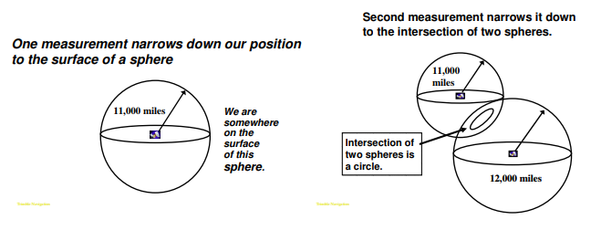
Figure 1 - Representation of 1 and 2 Satellites [6]
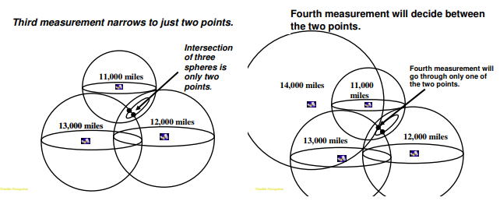
Figure 2- Representation of 3 and 4 Satellites [6]

GPS Signals
As previously mentioned, a GPS satellite emits microwaves with 2 carrier frequencies. The first frequency known as the L1 Carrier transmits at 1,575.42 MHz and the second, known as the L2 carrier is at 1,227.60 MHz. The L1 and L2 carrier frequencies are generated by multiplying the fundamental clock frequency (10.23 MHz) by 154 (L1) and 120 (L2). Using the equation v = f λ (where v is velocity – of light in this case, f is the frequency and λ is the wavelength) and rearranging to make λ the subject, it can be deduced that the wavelengths of the L1 and L2 band are approximately 19 cm and 24 cm respectively [7].
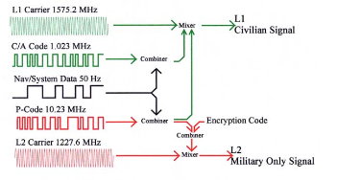
Figure 3 - L1, L2 - C/A-code, P-code [8]
The 2 digital GPS codes are known as the C/A-code (course acquisition code) and P-code (precision code). The binary codes are generated with a mathematical algorithm which are then labelled as Pseudo Random Numbers (PRNs). The C/A-code is then superimposed on top of the L1 carrier sine wave, whereas the P-code is superimposed on both the L1 and L2 carriers. The C/A-code is made up of 1023 binary digits that repeat every millisecond – equating to a data transfer rate of 1.023 Mbps, and a chip length (which is the physical distance between each binary digit) of 293m. Each satellite has its own C/A-code so that the receiver can identify where the signal is originating from [9]. The P-code is also made of binary digits, but is far more complex and repeats itself after 266 days [7], and has a chip length of 29.3m. The long code is cut into segments which are then distributed the satellite constellation and can transmit at 10.23 Mbps. Clearly, as the chip length is far shorter in the P-code, this allows for better positioning accuracy. As the P-code is generally for military uses, it is encrypted with an unknown W encryption. The encrypted P-code is then referred to as a Y-Code/ P(Y)-code, which acts as the first method of anti-spoofing.
The Pseudorange is another important concept in understanding how GPS signals operate, and brings together points that have previously been discussed. As the satellite transmits its signal, there will be a time delay (given by the distance between the satellite and receiver, and the speed the transmitted data is travelling). There is a time stamp on the signal sent by the satellite, known as the Time Of Transmission (TOT) which has to be decoded by the receiver. When the receiver decodes the signal, it also generates a Time Of Reception (TOR). Therefore, the difference between the TOT and TOR is the time taken for the signal from the satellite to reach the receiver. Clearly, this mathematical process only works if the satellite and receiver clocks are perfectly synchronised, which they are not; a satellite uses an atomic clock, which is far more accurate than those on any receiver. This discrepancy between the internal clocks is why the distance between a satellite and receiver is known as a pseudo range [10]. This is one of the limitations of GPS that has drastically improved over the years as receiver technology has improved, allowing for much more precise location knowledge. The atomic clocks on satellites are not perfect however. Typically, there is an error of 8.64 – 17.28 ns per day, which corresponds to range errors of 2.95 – 5.18m [9]. This error is monitored by the ground ‘control segment’ and is then transmitted as part of the navigation message.
Another limitation of GPS is due to signal reflection. As the emitted waves are part of the electromagnetic spectrum, the same laws that govern all other frequencies bind them. Reflection is the process whereby a wave is not absorbed by a surface that is strikes, and bounces off instead. This is an issue for GPS as it creates a problem known as ‘Multipathing’. An example of this would by a microwave bouncing off the surface of a body of water, and then being detected by the receiver. This receiver is also detecting the signal that has not reflected, and is coming straight from the satellite, hence creating a multipath. A potential solution to this is to use receivers that are tuned to the polarisation of the wave. When a wave reflects, it changes its polarisation – therefore, using an antenna receiver that only responds to the original polarisation can overcome this problem [9].
One final limitation of GPS is that is suffers from ionospheric delay. The ionosphere is a layer in the atmosphere, which consist of several sub-regions. These different regions cause dispersion of electromagnetic radiation, and so ‘bend’ the GPS signal. This bending will affect the time it takes for the signal to reach the receiver, and so hinders GPS accuracy. As the GPS signal is made of different components of different wavelengths, the ionosphere will disperse these frequencies by different amounts (i.e visible light through a prism). This factor also needs to be taken into account when processing a GPS signal [9].

GPS in OME
Clearly, as mentioned previously - GPS was first invented by the US DoD for military application, and so it has a significant role to play in OME. The primary tool for GPS in a military context is still for navigation. As military GPS has access to the encrypted Y-Code in the L2 band, navigation can be more precise, as it allows for smaller margins of error when determining precise location. Military GPS receivers were originally also of a higher specification than those in civilian devices. Military receivers contain oven-controlled crystal oscillators (OCXO’s), whereas commercial civilian devices contained worse temperature-compensated crystal oscillators (TCXO’s) [11]. With recent advances in receiver technology however, GPS for civilian use has become much more accurate than it was in 1999.

GPS also plays a crucial part in missile guidance. Modern-day missiles have incorporated GPS into their targeting mechanisms, making them far more accurate than early seekers utilising technology such as the ‘Rising Sun Reticle Seeker’, shown in figure 4 below.

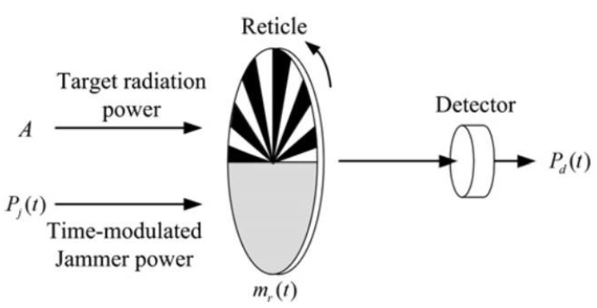
Figure 4 - Rising Sun Reticle Seeker [12]

Modern day missiles are beginning to rely on GPS to provide locational data to the onboard navigation system of the missile. An example of this is for precision guided munitions to be more accurate in finding the target area, and so allowing them to deliver their payload in a small area – thus increasing the effectiveness of the munition. GPS is also used in missile defence systems, as it works in conjunction with the defence systems other navigation tools to provide smoother handover between the phases of engagement. For example as the missile is reaching the midpoint of its trajectory, the GPS will then help guide the terminal phase, increasing the chances of a successful interception. It does this by reducing course errors and alignment errors in the other navigation systems [13].

Jamming
As this paper has explained, GPS receivers rely on signals from satellites orbiting the planet. Jamming is the process of disrupting or overwhelming the receivers ability to receive and process the signals from the satellite. Hui Hu states that there are 2 different types of GPS jamming – blanket jamming and deception jamming. Blanket jamming works via a ‘trial of strength’ mechanism on the L1 band whereby the person trying to jam the receiver sends signals that are stronger than those of the satellite – also known as interference. This means that the desired signal is drowned out by the stronger signal, which can result in the GPS receiver being completely unable to function [14]. Seeing as the signal from the satellite at most 25.6W [15], the jammer does not have to be particularly powerful to be effective.
A countermeasure to a trial of strength jamming attack is to have a ‘smart’ receiver that is able to tell if the signal it is receiving is far too strong. The high power signal is then filtered out, allowing the real signal from the satellite to be processed.

Spoofing
GPS spoofing attempts to manipulate the GPS receiver into thinking that there are legitimate satellite signals, when in fact it is a spoofing device. This causes the GPS receiver to display incorrect information. Jon Warner has shown that it is very easy, with readily available equipment to spoof the L1 band, and so civilian infrastructure [8]. However, as the focus of this assignment is on the significance of spoofing to UK OME, I have formed the opinion based on the literature that GPS spoofing is not likely to a threat. This is due to the encryption of the P(Y)-Code, which acts as mitigation for GPS spoofing. John Fischer, Chief Technical Officer for Spectracom in Rochester has stated “Doing this requires some very complex signal-generation equipment to track the vehicle first to exactly match its trajectory before you can start spoofing. So, if you’re engaging an enemy vehicle and have acquired it and are tracking it, there are simpler ways of engaging – like shooting it down – than spoofing” [16]. That being said, Russia has reportedly used spoofing in the black sea to misguide civilian GPS signals [17].

Conclusions
Overall, I believe that if spoofing military GPS signals was possible then it would provide a serious threat to UK OME. However, as it is going to be very challenging for adversaries to crack the US DoD encryption on the P(Y)-code the likelihood of such an attack occurring a very low. Jamming, on the other hand is a less acute, but more common threat. This is because you know when you are being jammed and so can plan accordingly around the fact (unlike spoofing), and utilise a systems other means of navigation. Additionally, jamming has occurred in military confrontation around the world already, but US and UK forces estimate that jamming was largely ineffective [18].

References

[1] | L. Winternitz, "Introduction to GPS and other Global Navigation Satellite Systems," in 42nd Annual Time and Frequency Metrology Seminar, Greenbelt, 2017.
[2] | United States Government, "SCHRIEVER SPACE FORCE BASE (ARCHIVED)," Official Air Force Website, October 2020. [Online]. Available: https://www.schriever.spaceforce.mil/GPS/. [Accessed 24 Novemeber 2022].
[3] | G. Blewitt, "Basics of the GPS Technique: Observation Equations," Department of Geomatics, University of Newcastle, Newcastle, 1997.
[4] | R. Langley, "The Orbits of GPS Satellites," GPS World, vol. 2, no. 3, pp. 50-53, March 1991.
[5] | J. Dougherty, H. El-Sherief, D. Simon and W. Gary, "A Design Appriach for a GPS User Segment for Aerospace Vehicles," in American Control Conference, San Francisco, 1983.
[6] | New Hampshire Government, "Introduction to Global Positioning System," New Hampshire Government, [Online]. Available: https://www.nh.gov/nhdfl/documents/introduction-to-global-positioning-system.pdf. [Accessed 29 November 2022].
[7] | B. Hoffmann-Wellenhof, H. Lichtenegger and J. Collins, Global Positioning System; Theory and Practice, New York: Springer-Verlah, 1997.
[8] | J. Warner, "A simple demonstration that the global positioning system (GPS) is vulnerable to spoofing," Journal of Security Administration, 2002.
[9] | A. El-Rabbany, Introduction to GPS: The Global Positioning System, Norwood: Artech House, 2002.
[10] | M. Braasch, "GPS Receiver Architectures and Measurements," IEEE, vol. 87, no. 1, pp. 48-64, 1999.
[11] | J. R, "Military Applications of High Accuracy Frequnecy Standards and Clocks," IEEE TRANSACTIONS ON ULTRASONICS, FERROELECI'RICS, AND FREQUENCY CONTROL, vol. 40, no. 5, pp. 522-527, 1993.
[12] | C. Silvestre and L. Faria, "Analysis of Open-Loop DIRCM Jamming Effects on First Generation Infrared Seekers," in Infrared Missiles Susceptibility to Countermeasures, São José, 2018.
[13] | E. Ohlmeyer and e. al, "GPS-Aided Navigation System Requirements For Smart Munitions and Guided Missiles," in Guidance, Navigation, and Control Conference, New Orleans, 1997.
[14] | H. Hu and N. Wei, "A Study of GPS Jamming an Anti-jamming," in Power Electronics and Intelligent Transportation System, Nanchang, 2009.
[15] | U. Hunkeler, "Effectiveness of GPS-jamming and Counter-measures," in International Conference on Localization and GNSS, Lausanne, 2012.
[16] | J. Fischer, Interviewee, Securing military GPS from spoofing and jamming vulnerabilities. [Interview]. 30 November 2015.
[17] | D. Hambling, "Ships fooled in GPS spoofing attack suggest Russian cyberweapon," NewScientist, 10 August 2017.
[18] | T. Westbrook, "The Global Positioning System and Military Jamming: The geographies of electronic warfare," Journal of Strategic Security, vol. 12, no. 2, pp. 1-16, 2019.

