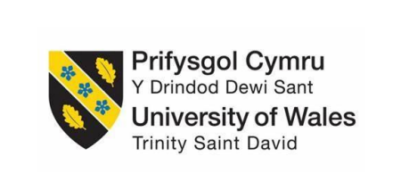

Assessment Component 1
Case study - Supporting Paper

Student name: Nataliya Virych
Student ID: 1909127
Module name: Children, Young People and Families
Module code: (BMHP5004_LON)
Lecturer name: Bianca Sanfilippo
Submission Date: 21/04/2022
Word count: 1091

Introduction
This supporting paper explains the general definition of vulnerable children and young people. It introduces a case study of the Troubled family: Wandsworth, facing adversities. The family presents vulnerability factors, and the main element of vulnerability is parental mental health. The paper discusses the impact of this factor on the child's wellbeing. It also includes the intervention process of the relevant health and welfare authorities.
Finally, the work provides current assessed policy and the roles of multi-professional services within this case study and the results of their activity on the child and family.

Case study Trouble family – Wandsworth
The case concerns a troubled family which lived in Wandsworth (London) and consisted of a single mother and one child.
This family faced adversity because the mother had mental health problems. She experienced domestic violence for a long time. It harmed her mental health. She did not perform daily care of her son. The boy did not attend school regularly. Mom constantly skipped medical and dental examinations for her son and was not made in the time for vaccinations. She did not work anywhere and did nothing. Social services have identified signs of abandonment. One time, a boy was left at home alone for 6 hours due to domestic violence (gov.uk, 2014).

Family facing adversity – The risk factors of vulnerability
This paper evaluates a case of a family facing adversity. Families facing hardships comprise families with specific problems, such as substances misuse, domestic violence, and involvement with the criminal justice system. These factors make the child vulnerable.
The literal meaning of the term “vulnerability” is the state or condition of being weak or poorly defended (Shilpa Khanna Arora, 2015).
A more detailed explanation of vulnerability has been given by Skinner. He defined vulnerable children as” the ones not having certain of their basic rights fulfilled” (Skinner, 2006). Consequently, it has three main aspects of dependency:
Material - funds, nutriment, clothing, home, wellness program and education.
Emotional - safekeeping, love, encouragement.
Social - absence of caring friends, models to follow and risks in the immediate environment.
In my case study, the mother was subjected to domestic violence for a long time. It affected her mental health, and she failed to be a good mother. The family worker put the boy with his grandparents while social services assessed the family's situation.
The main fact of vulnerability in this case is moms mental health.
The annual statistics in England shows that 1 in 100 parents has an emotional disstress. It is more common in women than men (gov.uk, 2021).
The term ‘parental mental health problems’ to mean that a parent has a mental health problem and she/he need help to care their children (nspcc, 2021).

The impact of vulnerability factors on the children's health and wellbeing
According to the NSPCC, parental substance misuses can lead to other risks for the child/children, such as neglect.
Neglect is the continuing inability to meet a child's basic needs and is the most common form of child abuse (NSPCC, n.d.). A child or young person left without food, or unwashed and with dirty clothes, without anyone looking at him, without medical assistance, can endanger.
There are four different types of neglect:
- Physical neglect.(Case study: mom does not provide basic care)
- Educational neglect.(Case study: not attending school regularly)
- Emotional neglect.
- Medical neglect.(Case study: missing health and dental appointments, vaccinations not done at the scheduled time)

The procedure of intervention by relevant health and social care organizations
The intervention of the social services starts with the warning by police, doctor, teacher, neighbours, and anyone who work with children. One working day after referral, a Local Authority social worker decides on the next steps.
The referral actions are based on Assessment framework.
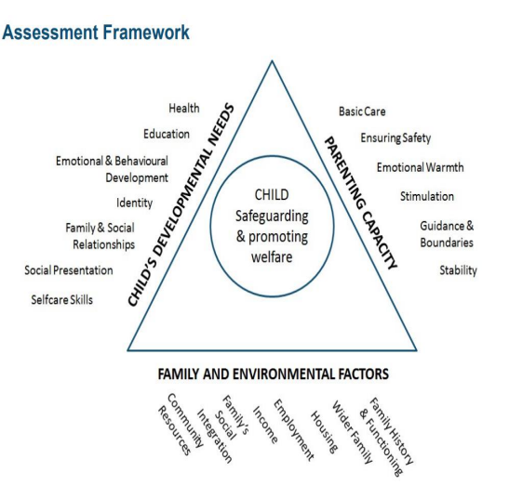
The Assessment Framework include into the Policy Working Together to Safeguard children A Guide to inter-agency working to safeguard and promote the welfare of children.
That consider a social service to assess a child in Need (Workingtogetheronline.co.uk, 2018). It means that the children were not removed. First, the family should be together. Any action should be informed by three elements:
- Parenting capacity
- Family and Environmental factors
- Child environmental needs

The legislation related to the case study and the work of the agencies involved
In this case, based on the assessment framework, the practitioner starts the plan to support the child and family. According to the Children Act 1989, the local authority put the child under the section Children in Need and the family was kept together. The child must stay with the mom.
“Child in Need” means that “is a child who needs additional support from the local authority to meet their potential.” (scie, 2012)
In this case, interevent the social services are necessary. According to the Act 2004, they have to work in multy-agency, in order to provide realistic support. Working together with different professionals. For example, in the case study: the mom has a mental problem because she was under domestic abuse.
The family worker sends her to the NHS to provide support and she is now on anti-depressives.
The family worker collaborates with the Council (housing) to organise an accommodation transfer for the mother to take her away from an unsafe place.
The social worker referred the mom to an employment centre to help her find a job
This is coming from the Law Children Act 2004 working together in multy-agency.
Equality Act 2010 was applied in the case study as a family compost with single mom and son. The social services worked and providing care to the family without discrimination. All children should receive same care and protection.

Conclusion
In conclusion, the services provided support to children and families facing adversity must be of high quality and improved. The children should receive real protection and support.
This can be linked to Bronfenbrenner's theory of ecological systems. According to Bronfenbrenner, social environment, and family effect on the development of human beings. The concept of social environment includes health care, social services, and welfare systems (Bronfenbrenner, 2005).

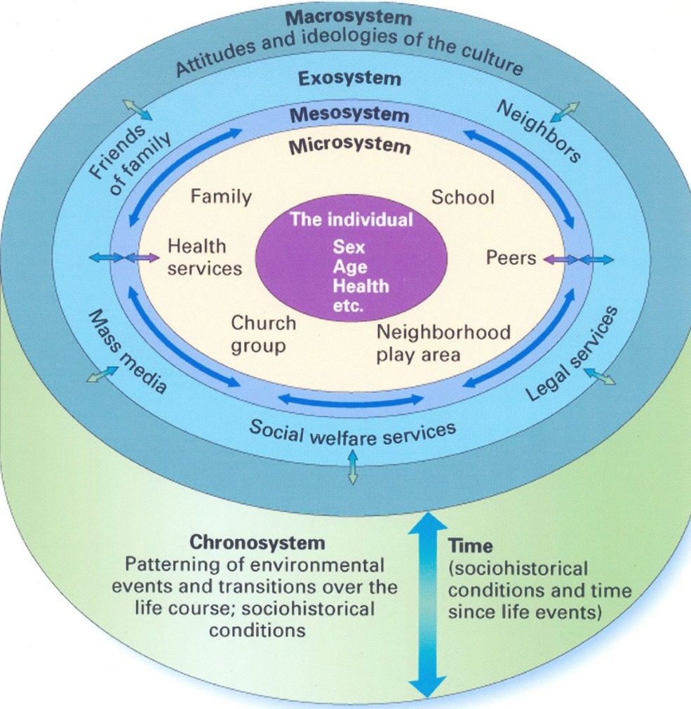

Ecosystems can be beneficial (for example, case study: include mom on mental health support program that benefits the whole family, especially for her child: the house now is clean and tidy, the mental state of the mother is balanced, she volunteers and is looking for a job, the son goes to school regularly.

References:

Bronfenbrenner, U. (2005) Making human beings human: Bioecological perspectives on human development. Thousand Oaks, CA: Sage
Children Act 2004, c. 31. (Online). Available at: http://www.legislation.gov.uk/ukpga/2004/31/contents (date accessed: 28 March 2022).
Children Act 1989, (Online). Available at: Children Act 1989 (legislation.gov.uk) (date accessed: 28 March 2022).
gov.uk, 2014. Troubled families: Wandsworth. [Online]
Available at: https://www.gov.uk/government/case-studies/troubled-families-wandsworth
[Accessed 10 april 2022].
HM Government (2018) Working Together to Safeguard Children A guide to inter-agency working to safeguard and promote the welfare of children (Online). Available at: https://assets.publishing.service.gov.uk/government/uploads/system/uploads/attachment_data/file/942454/Working_together_to_safeguard_children_inter_agency_guidance.pdf (date accessed: 21 March 2022).
Shilpa Khanna Arora, D. S. S. C., 2015. Defining and Measuring Vulnerability in Young People. ncbi, pp. 193-197.
Skinner, D., 2006. Towards a definition of orphaned and vulnerable children. PubMed.gov.
gov.uk, 2021. Methodology and supporting information: children living with parents in emotional distress. [Online]
Available at: https://www.gov.uk/government/statistics/children-living-with-parents-in-emotional-distress-march-2021-update/methodology-and-supporting-information-children-living-with-parents-in-emotional-distress-2021-update
[Accessed 10 April 2022].
NSPCC (2019) Children living in families facing adversity. (online) Available at: https://learning.nspcc.org.uk/media/1432/nspcc-families-facing-adversity-helplines-report.pdf (Date accessed: 21 March 2022)
nspcc, 2021. Parental mental health problems. [Online]
Available at: https://learning.nspcc.org.uk/children-and-families-at-risk/parental-mental-health-problems
[Accessed 10 april 2022].
NSPCC, n.d. Neglect. [Online]
Available at: https://www.nspcc.org.uk/what-is-child-abuse/types-of-abuse/neglect/
[Accessed 10 April 2022].
United Nations (1989)The United Nations Convention on the Rights of the Child (Online). Available at: Layout 1 (unicef.org.uk) (date accessed: 21 March 2022).

Workingtogetheronline.co.uk, 2018. A guide to inter-agency working to safeguard children. [Online]
Available at: https://www.workingtogetheronline.co.uk/chapters/chapter_one.html
[Accessed 10 April 2022].
scie, 2012. Introduction to children's social care. [Online]
Available at: https://www.scie.org.uk/publications/introductionto/childrenssocialcare/legalandpolicycontexts.asp
[Accessed 10 April 2022].

Appendix: Power Point Presentation for debate WEEK 9

