

Assessment 1 – Reading Task Template
PART 1: Upload your photo of your A3 in-class notes here:
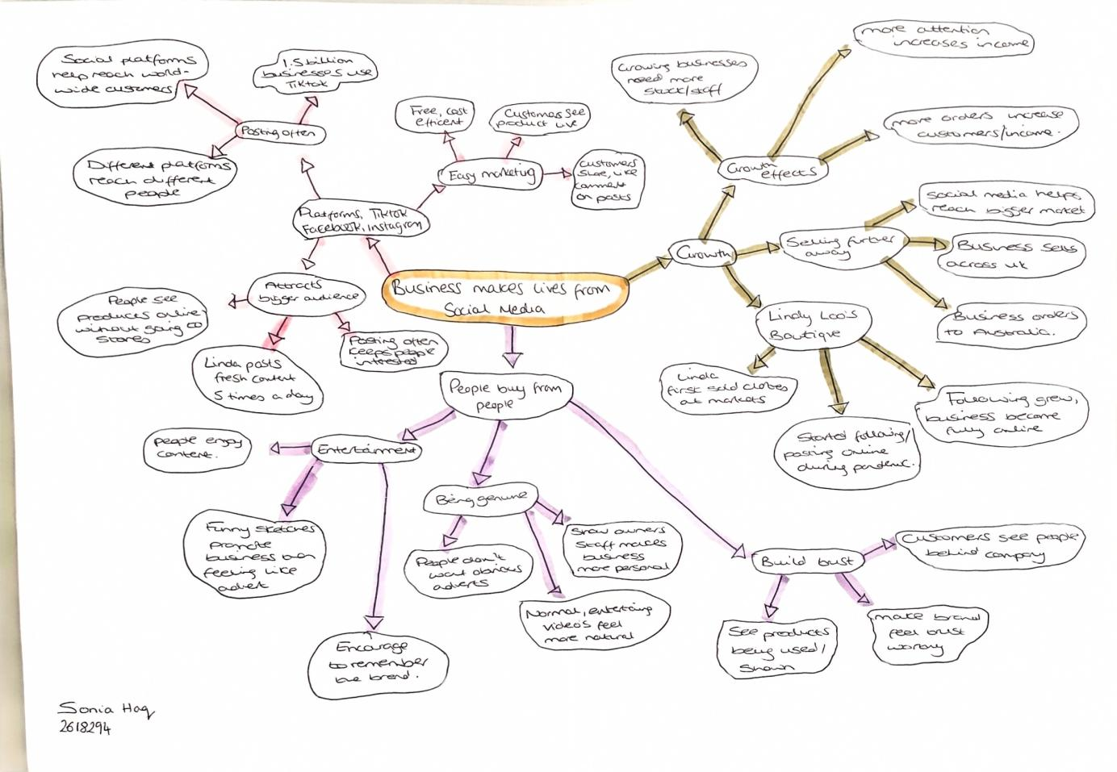

PART 2:
- Answer every question below in 1-3 full sentences.
- Use your own words. Do not use generative AI to answer these questions.
- Include a specific detail from the text when asked.
REMINDER
- The main idea is the overall message of the whole text.
- A key point helps to explain the main idea.
- A specific detail or example from the text shows that the key point is true.

- What is the main idea of the whole text?

The main idea of the whole text is how social media has helped businesses start, improve, expand and become popular. Social media is helping many businesses reach more people and attract new customer's from around the world. For example, Linda Hunter, who is known online as Lindy Loo, runs an online clothing business based in Epping and now ships outfits across the UK and even to Australia. ​

​
- What is one key point that supports the main idea, and which specific example from the text shows this?

The one key point that supports the main idea is that social media can help small businesses attract customers from further away than their local area. An example of this is the Honywood Sandwich Shop in Basildon, where customer's posting content on social media has helped boost the business. Some customers have even travelled three hours to try their chicken burger.​

​

- ​What is a different key point that supports the main idea, and which specific example from the text shows this?

A different key point that supports the main idea is that social media can help businesses become well known very quickly when their posts or video's go viral. An example of this is Chloe Higgins and Ross Bliss, who st up their mobile party business in December and started posting video's of their children's pamper parties on social media. According to Ross, their business gained up to 45 million views in under a year. ​

- Which part of the text do you think is most important, and why?

I think the most important part of the text is 'people buy from people's. Faye Martin, who is a marketing expert in Laindon, believes social media has made it easier for businesses to reach new customers, as many customers can recognise when something is just an advert. Customers prefer more subtle marketing because it can make a brand feel more authentic and relatable. ​

Reflection:
- What did you find difficult in this task (including in-class components), and why was it difficult?

I found it difficult to identify the main idea because the text contained a lot of information and examples from different businesses. I also found it challenging at first to understand the difference between the main idea and the key points, as they were all related to the same topic. Once I understood that the main idea
referred to the overall message of the text and that the key points were individual ideas that supported it, I found the task much easier. ​

- What helped you with this difficulty, and how did it help you?
​

The mind map helped me because it allowed me to break down the text and better understand its meaning. It helped me organise the information and separate it into different sections. It also enabled me to distinguish the examples from the key points. Having the information clearly organised improved my
understanding of the text and helped me complete Part 2 using my own interpretation of the information.​

