Name – Soham Bhaveshbhai Kachhadiya
Student ID – 2328821
Title – Dissertation Proposal

RESEARCH PROPOSAL
THE EFFECTIVENESS OF SOCIAL MEDIA MARKETING IN DRIVING BRAND ENGAGEMENT

Table of Contents
Introduction 3
Background of the research 3
Research problem 4
Research rationale 4
Significance of research 4
Aims, objectives, and research questions 5
Aim 5
Research Objectives 5
Research questions 5
Methodology 6
Research philosophy 6
Research approach 6
Research design 7
Data collection 7
Sampling 7
Data analysis 8
Literature Review 8
Theoretical framework 9
Research gap 10
Limitations 10
Ethical considerations 11
Timeframe 11
Conclusion 12
References 13

Introduction

Background of the research
Social Media has progressed immensely in the establishment of successful consumer engagement both in brand building and sustainable consumption. Social media marketing helps in driving the brand engagement by providing a platform for the establishment of relationships, fostering of a two-way conversation and enhancing the brand visibility (Bryła et al., 2022). This leads to strong customer connections and loyalty by directly interacting with consumers, content creation, storytelling. For example, M&S have launched their digital-first campaign to showcase their products to the audience. They are mainly focusing on digital channels such as VOD, Google Advertising and Instagram to facilitate engagement of customers and drive of sales of the company (corporate.marksandspencer, 2025).
In the UK, the social media market holds the prime position in the market, and YouTube ranked as the first in terms of being the most well-known social network, followed by Facebook and Instagram (statista, 2025).
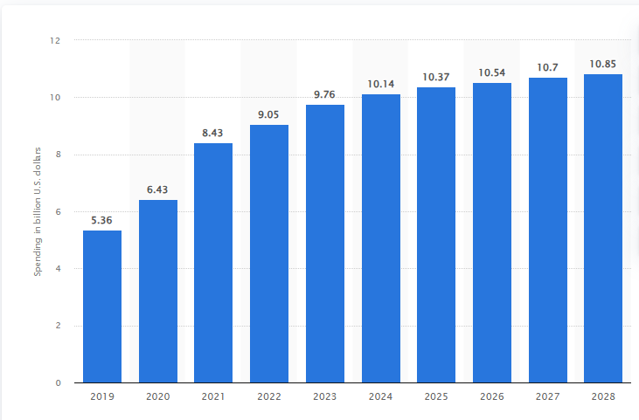
Figure 1: Revenue of social media marketing in the UK market
(Source: statista, 2025)
Ad spending through the measures of social media marketing in the UK market was forecast to increase by 1.1 billion U.S dollars by 2023 and 2028 (statista, 2025). Therefore, these measures have allowed different brands to facilitate the aspect of social media marketing in driving the brand engagement and ensure success in the market.

Research problem
The rise of digitalisation has allowed brands to rely on the approaches of social media marketing, such as advertising regarding products on social media platforms, and content marketing. The selection of the right platforms for the engagement of customers, the creation of engaging content, and measuring results (Shahbaznezhadet al., 2021). Moreover, social media marketing raises critical data privacy and security issues, which impact on facilitating the engagement of customers. Social media platforms are targets for cyber criminals for stealing the user data. It develops concern among consumers due to the social media phishing scams, which reveal personal information. Therefore, failure in developing appropriate content, an inconsistent posting schedule has drawn negative attributes in driving the brand engagement through social media marketing.

Research rationale
Brands are investing in the social media marketing approach to enhance the brand visibility, enabling real-time interaction with audiences to lead the way for customer interactions and conversions. Creation of engaging content and distribution of it to Facebook, Instagram and TikTok has helped to build on a strong foundation of consumers for brands. Social media platforms hold a wider base of audience and it is easy to attract the attention of customers to showcase their products (Aydin et al., 2021). Social media platforms facilitate real-time interaction with consumers and help brands to respond to inquiries, address concerns and build a community. Through data analytics, companies easily track the performance of the campaigns facilitated by them and understand the demands of the consumers. Positive customer experience on social media fosters brand loyalty and helps in expanding the brand awareness through word-of-mouth marketing.

Significance of research
The research will focus on the effectiveness of social media marketing to drive the brand engagement. This research will highlight the measures of different approaches of social media marketing, such as content marketing, influencer marketing, to acknowledge its impact on consumers. Brands are adopting the measures of social media initiatives like developing an integrated targeted marketing campaign to facilitate the engagement of consumers.
The context of social media usage surge, the customer engagement has been proposed as a concept that allows in developing beneficial relationships between consumers and brands (Vinerean and Opreana, 2021). Additionally, it will highlight the challenges faced by brands to facilitate social media marketing for driving brand engagement. This as a result will help brands to optimise their strategies by addressing the raised concerns. It will lead to an improvement of the brand loyalty and ultimately an increase of sales and business growth by leveraging the power of social media platforms.

Aims, objectives, and research questions

Aim
The main aim of the research is to evaluate the effectiveness of social media marketing to drive the brand engagement.

Research Objectives
- To assess the impact of social media marketing strategies on customer engagement
- To examine the role of different social media marketing tactics to enhance brand engagement among customers
- To analyse the challenges faced by brands while using the social media marketing strategies in driving brand engagement
- To recommend possible strategies to mitigate the issues regarding social media marketing to drive brand engagement

Research questions
- How do different social media marketing tactics facilitated by brands help in enhancing brand engagement among customers?
- Why do brands invest in the measures of social media marketing to drive the brand engagement?
- What are the challenges faced by brands to acknowledge social media marketing strategies to drive the brand engagement?
- What strategies are suitable to mitigate the challenges regarding social media marketing to enhance brand engagement?

Methodology

Research philosophy
The research will focus on positivism research philosophy to support the effectiveness of social media marketing in driving brand engagement. It will use measurements and reasons to discover real strategies offered by social media marketing. It is based on the idea that knowledge comes from observation and covers a wide range of contexts to enhance the integrity of the research (Maksimovic and Evtimov, 2023). The utilisation of the observable and measurable data, the research will effectively help in understanding the attributes of social media marketing tactics and their impact on consumers. It reflects on the cause and effects of relationships, by highlighting the specific social media content, strategies and platforms to acknowledge the impact on the engagement levels of customers.
On the other hand, interpretivism research philosophy will not be an appropriate choice to understand the topic of the research. Interpretivism prioritises the subjective experiences and nuanced interpretations, leading to challenges in generalisability, replicability and objectivity (Junjie and Yingxin, 2022). The focus on the reliable data, in the context of social media, emphasises measuring metrics such as likes, shares, comments featured within the posts developed by brands to quantify the engagement and effectiveness of different social media campaigns.

Research approach
Deductive research approach will help to understand the efficacy of social media marketing in driving the brand engagement. Deductive research approach focuses on verifying pre-existing knowledge and theories to develop a structured approach through research (Casula et al., 2021). It will help in addressing the factors influencing the engagement of customers to incorporate different measures to attract the attention of customers. The identification of causation has allowed for the comparison of the engagement levels associated with different circumstances. This has assisted in an understanding of the interconnection between social media actions and brand engagement. Additionally, it relies on the empirical data to undermine the effectiveness of social media marketing tactics such as content marketing, paying for ads in social media platforms. Therefore, the structured approach will be effective in ensuring a systematic and objective investigation for the research topic (Fife and Gossner, 2024).
On the other hand, the inductive research approach lacks the precision of the deductive research, leading to enhanced bias for the research objectives. The generalised results focusing on the wide range of the social media content will offer complexities in establishing the causal relationship between the variables.

Research design
Exploratory research design will be used to recognise the effectiveness of the social media marketing tactics to enhance the engagement of brands. It will help in understanding the challenges incorporated by the attributes of marketing in a thorough manner. It helps in discovery of unexplored issues and variables by addressing the research objectives (Olawale et al., 2023). The flexibility offered through this research design aids in acknowledging the efficacy of social media marketing to engage customers. Exploration of the unclear concepts and discovery of the emerging trends associated in the market will be beneficial to enhance the credibility of the research by incorporating updated information. Therefore, it will help in discovering the hidden opportunities and patterns related to social media engagement to undermine the impact of social media marketing on customers facilitated by the brand. Explanatory research design narrows down the topic of the research and offers hindrance on exploring a broader area, neglecting the updates on the topic.

Data collection
Primary quantitative data collection process will be appropriate to undermine the effectiveness of social media marketing to enhance brand engagement opportunities for brands. The research will have a greater control over the data collection process and helps in ensuring that the objectives of the research (Karunarathna et al., 2024). It will conduct a survey, and the data collected through the survey will help to have a more specific focus on the research objectives to yield more detailed data. It will help to understand the effectiveness of the social media marketing by acknowledging the tangible measuring metrics. It will be helpful in recognising the interrelatedness of the campaign strategies and the development of the content, allowing for data-driven optimisation.
It is suitable to acknowledge the challenges facilitated through social media marketing approaches to develop appropriate results to bring effectiveness in the operations of brands. On the other hand, qualitative data collection method heavily relies on interpretation that can be subjective and prone to the research bias, offering complications to deliver the outcomes of research.

Sampling
The research will conduct a survey to justify the research objectives, and the survey is designed to target different demographics, providing a broader perspective on the research topic. It will use random sampling to enhance precision and validity, and make reliable inferences, generalisation regarding the topic. It will develop a set of 10 closed-ended questions and focus on 52 participants to acknowledge their perspectives regarding social media marketing approaches and their impact on brand engagement.

Data analysis
The research will adhere to the principles of mono quantitative data analysis, relying solely on the numerical data to investigate the relationships between the tactics of social media marketing and their impact on the consumers. The structured approach allows for the precise measurement of variables and relationships, which has allowed in providing a detailed understanding of the research topic. Moreover, this data analysis method will help to understand the way social media efforts are impacting on the brand engagement to ensure success in the market. The applicability of the research can be enhanced through this process, through generalisability for a large population.

Literature Review
Impact of social media marketing approaches on brand engagement
According to Joshi et al (2023), increasing use and effectiveness of social media influencers in marketing are in demand. This measure has been accounted for by different brands to enhance the engagement of consumers and drive revenue for them. Posts by influencers play an essential role from the marketing perspective to increase the purchase intention of consumers. It is an effective approach to boost the brand engagement by leveraging the followers of influencers. This helps in promoting products and services by fostering the interactions.
On the contrary, Al-Azzam and Al-Mizeed (2021) have stated that online advertising is considered as a form of promoting the products or services of brands. It helps in providing information to consumers at ease and helps in influencing the decision of consumers. The targeted campaigns, paying social media platforms to promote products, allow in reaching a large audience base to drive engagement and conversions for brands.
The influence of content type used by social media platforms on consumer engagement
As opined by Eslami et al. (2022), Social media platforms enable users to build their virtual communities by sharing ideas. The creation of effective content relating to a product and posting it on effective platforms helps in engaging the consumers. The majority of populations are quite friendly with the use of the social media platforms, which have allowed brands to take it as an opportunity to drive engagement of the brand. The measures of paying for ads on social media platforms have allowed us to reach the targeted audience.
On the other hand, Mtjilibe et al. (2024), stated that the rapid proliferation of social media has transformed the way organisations operate their functionalities to ensure engagement of consumers. Moreover, social media platforms continuously change their algorithms that affect the content and hence brands, need to continuously update themselves regarding the trends and preferences of consumers to boost consumer engagement.
Challenges faced by brands to incorporate social media marketing to drive brand engagement
Jeswani (2023) has stated that Facebook, Twitter and Instagram are dynamic spaces for brand engagement and effective social marketing strategies of the brand can enhance the brand engagement. Approach of staying consistent regarding posting, delivering original content and balancing multiple platforms has been acknowledged as a challenge. The failure in assessing all these measures, brands face complications to drive brand engagement.
On the contrary, Bakri (2023), the awareness of data privacy raises concerns among consumers, which as a result impacts their willingness to engage with brands. It is the responsibility of brands to respect the user consent and must adhere to the authentic data measures to protect the privacy of personal information of users.

Theoretical framework
Technology Acceptance Model (TAM)
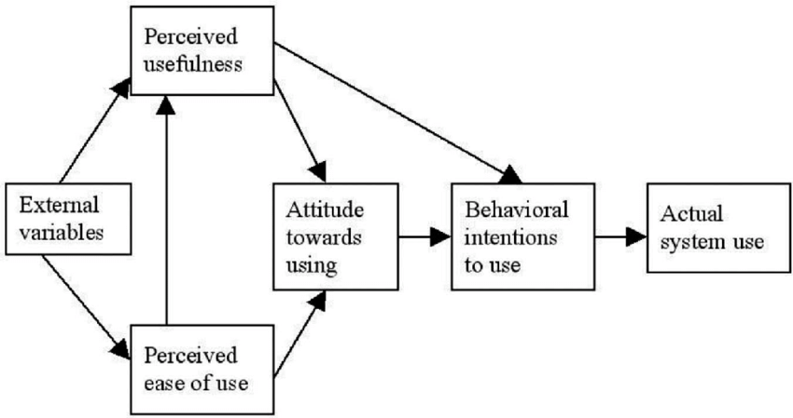
Figure 2: Technology Acceptance Model (TAM)
(Source: Goh and Wen, 2021)
TAM model reflects on the way individuals accept and use the new technologies, focusing on perceived usefulness and ease of use of technology (Al-Rahmi et al., 2021).
This theory will help to understand the effectiveness of social media marketing in driving brand engagement by acknowledging the perceived usefulness and perceived use of the social media tools by influencing users’ behavioural intentions and actual usage. Brands can apply the principles of the TAM model to optimise the social media strategies, development of effective content and maintaining consistency to ensure brand engagement positively.
Social Exchange theory

Figure 3:Social Exchange theory
(Source: Jayakumar et al., 2024)
This theory reflects those social interactions and relationships are shaped by individuals by acknowledging the rewards and aims in maximising the cost (Ahmad et al., 2023). This theory helps in understanding the effectiveness of social media marketing to boost brand engagement by highlighting that brand can incentivise discounts, benefits through loyalty programs, to ensure engagement of customers. Therefore, facilitating engaging content and advertisements of the discount programs helps in ensuring brand engagement.

Research gap
The articles taken for the research focus on the roles of different social media marketing approaches and their impact on consumer sentiment. However, the article fails in recognising the different factors taken by brands to facilitate social media marketing approaches to ensure success for brands.

Limitations
The research focuses on the measures of effectiveness of social media marketing to acknowledge the impact of brand engagement through customers. The research covers a broader aspect of the approaches of social media marketing, and limited time offers a bit of complication in reflecting on the research topic. The research can detail and elaborate on important factors to the initiative of social media marketing and its potential to drive brand engagement by providing more time.

Ethical considerations
The research will use the survey to ensure the effectiveness of the tactics of social media marketing to drive brand engagement. Hence, it will focus on obtaining informed consent, ensuring confidentiality and anonymity while securing the data. It will follow on the rules and regulations facilitated by the Data Protection Act 2018 to ensure fair and transparent processing of personal data of participants taking part in a survey (legislation.gov.uk, 2025).

Timeframe
Activities | 1 month | 2 months | 3 months | 4 months | 5 months | 6 months | 7 months | 8 months | 9 months
Selection of research topic
Proposal
Introduction
Literature review
Research Methodology
Data analysis
Discussion
Conclusion
Table 1: Gantt Chart
(Source: Self-developed)

Conclusion
The research focuses on the social media functionalities to enhance the brand engagements for brands. It highlights the key components of the research and developed research objectives to portray a clear understanding of the research topic. I have addressed limitations on identifying the factors of the social media marketing approaches while exploring different studies relating to research. Using primary quantitative data collection through a focus on a survey to evaluate the efficacy of social media marketing to enhance the brand engagement will be helpful for my research work. It emphasises on methods such as primary quantitative data collection methods and identifies theories to justify the objectives of the research.

References
Ahmad, R., Nawaz, M.R., Ishaq, M.I., Khan, M.M. and Ashraf, H.A., 2023. Social exchange theory: Systematic review and future directions. Frontiers in Psychology, 13, p.1015921.
Al-Azzam, A.F. and Al-Mizeed, K., 2021. The effect of digital marketing on purchasing decisions: A case study in Jordan. The Journal of Asian Finance, Economics and Business, 8(5), pp.455-463.
Al-Rahmi, A.M., Shamsuddin, A., Alturki, U., Aldraiweesh, A., Yusof, F.M., Al-Rahmi, W.M. and Aljeraiwi, A.A., 2021. The influence of information system success and technology acceptance model on social media factors in education. Sustainability, 13(14), p.7770.
Aydin, G., Uray, N. and Silahtaroglu, G., 2021. How to engage consumers through effective social media use—Guidelines for consumer goods companies from an emerging market. Journal of theoretical and applied electronic commerce research, 16(4), pp.768-790.
Bakri, Z.F., 2023. Analyzing the influence of digital marketing strategies on business performance in the beauty industry: a comprehensive analysis of social media engagement and influencer collaborations. Journal on Economics, Management and Business Technology, 2(1), pp.37-48.
Bryła, P., Chatterjee, S. and Ciabiada-Bryła, B., 2022. The impact of social media marketing on consumer engagement in sustainable consumption: A systematic literature review. International Journal of Environmental Research and Public Health, 19(24), p.16637.
Casula, M., Rangarajan, N. and Shields, P., 2021. The potential of working hypotheses for deductive exploratory research. Quality & Quantity, 55(5), pp.1703-1725.
corporate.marksandspencer, 2025. Spencer, M.& and Spencer, M.& (2022) 'M&S LAUNCHES MOST DIGITAL MARKETING CAMPAIGN TO DATE: “MUST-HAVES”,' Marks & Spencer, 28June.https://corporate.marksandspencer.com/media/press-releases/ms-launches-most-digital-marketing-campaign-date-must-haves.
Eslami, S.P., Ghasemaghaei, M. and Hassanein, K., 2022. Understanding consumer engagement in social media: The role of product lifecycle. Decision Support Systems, 162, p.113707.
Fife, S.T. and Gossner, J.D., 2024. Deductive qualitative analysis: Evaluating, expanding, and refining theory. International Journal of Qualitative Methods, 23, p.16094069241244856.
Goh, E. and Wen, J., 2021. Applying the technology acceptance model to understand hospitality management students’ intentions to use electronic discussion boards as a learning tool. Journal of Teaching in Travel & Tourism, 21(2), pp.142-154.
Jayakumar, R.R., Saad, N. and Marimuthu, M., 2024. Are Psychological Empowerment and Tax Transparency Related with Tax Compliance Behaviour of SMEs in Malaysia? An Empirical Approach. PaperASIA, 40(4b), pp.59-70.
Jeswani, R., 2023. The role and importance of social media marketing in brand building. Irish Interdisciplinary Journal of Science & Research, 7(04), pp.01-09.
Junjie, M. and Yingxin, M., 2022. The Discussions of Positivism and Interpretivism. Online Submission, 4(1), pp.10-14.
Karunarathna, I., Gunasena, P., Hapuarachchi, T. and Gunathilake, S., 2024. The crucial role of data collection in research: Techniques, challenges, and best practices. Uva Clinical Research, pp.1-24.
legislation.gov.uk, 2025. Data Protection Act 2018. https://www.legislation.gov.uk/ukpga/2018/12/contents
Maksimovic, J. and Evtimov, J., 2023. Positivism and post-positivism as the basis of quantitative research in pedagogy. Research in Pedagogy, 13(1), pp.208-218.
Mtjilibe, T., Rameetse, E., Mgwenya, N. and Thango, B., 2024. Exploring the Challenges and Opportunities of Social Media for Organizational Engagement in SMEs: A Comprehensive Systematic Review. Available at SSRN 4998542.
Olawale, S.R., Chinagozi, O.G. and Joe, O.N., 2023. Exploratory research design in management science: A review of literature on conduct and application. International Journal of Research and Innovation in Social Science, 7(4), pp.1384-1395.
Shahbaznezhad, H., Dolan, R. and Rashidirad, M., 2021. The role of social media content format and platform in users’ engagement behavior. Journal of Interactive Marketing, 53(1), pp.47-65.
statista, 2025. Revenue of the social media advertising industry in the UK 2019-2028. https://www.statista.com/forecasts/461858/social-media-advertising-revenue-digital-market-outlook-uk#:~:text=Revenue%20of%20the%20social%20media%20advertising%20industry%20in%20the%20UK%202019%2D2028&text=The%20ad%20spending%20in%20the,U.S.%20dollars%20(%2B11.27%20percent).
statista, 2025. Topic: Social media usage in the UK (2024). https://www.statista.com/topics/3236/social-media-usage-in-the-uk/#topicOverview.
Vinerean, S. and Opreana, A., 2021. Measuring customer engagement in social media marketing: A higher-order model. Journal of Theoretical and Applied Electronic Commerce Research, 16(7), pp.2633-2654.

