  - Construction Materials
  - ACBA4006

Prepared for Allan Nantel

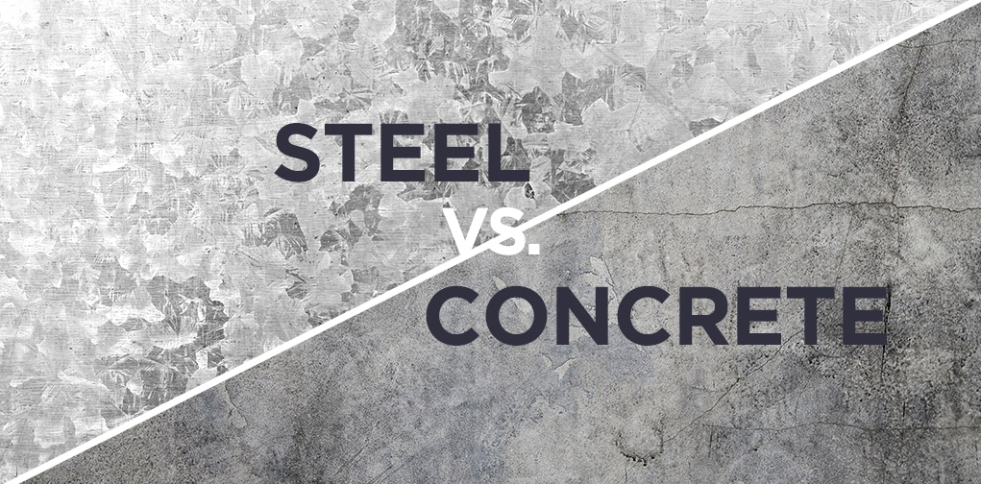


Created by Jonathan Langstone
Date Completed:
02 March 2021

Contents
1.0 Executive Summary 2
2.0 Terms of Reference 2
3.0 Procedure 2
4.0 Findings 2
4.1 Concrete Frame 3
4.1.1 Brief History of Concrete 7
4.2 Steel Frame 8
4.2.2 Brief History of Steel 11
4.3 Concrete Frame Case-study 12
4.3.1 The Burj Khalifa 12
4.3.2 Construction Method 13
4.4 Steel Frame Case-study 14
4.4.1 The Willis Tower (aka Sears Tower) 14
5.0 Conclusion 16
6.0 References 17

Figures
Figure 1 Cement production (Rodgers, 2018) 3
Figure 2 Global Cement Production (Shivaram, 2014) 6
Figure 3 Pantheon, Rome (Ranogajec, n.d.) 7
Figure 4 Steel flowlines (Institute, 2020) 8
Figure 5 desired life cycle of the construction materials (A.Puskas, 2015) 10
Figure 6 Randy McNalley Building (Randy McNally Buildings, 2020) 12
Figure 7 The Burj Khalifa (Skyscraper.org, 2010) 13
Figure 8 Burj Khalifa Concrete Frame (Nasvik, 2008) 14
Figure 9 Willis Tower (Brooke, 2013) 15
Figure 10 Willis Tower 'tube concept' (Major Works, n.d.) 16

Executive Summary
This report aims to examine Steel and Concrete. There are two different buildings with a concrete and steel frame used as case studies, which are analyzed to compare the strengths and weaknesses of the framing material. The report will also look at the climactic resistance, potential impact, environmental sustainability, methods of construction and production process of both materials.

Terms of Reference

  - The Principle Focus.

2.1.1 To compare the construction frame materials shown.
2.1.2 To Examine how they differ in strengths and weaknesses.
2.1.3 To evaluate why and where these materials would be best used for chosen construction framing materials.

  - The Report was constrained by the information given and researched and the need to complete it by the 2nd of March 2021.

3.0 Procedure
This section identifies the research sources used.

3.1 The research included secondary sources about Steel and concrete and their use as a framing material in constructing buildings from websites, Textbooks, magazines set out in the references and bibliography.

  - University notes also provided background to the research.

4.0 Findings

4.1 Concrete Frame
Concrete is the most used man-made product on the planet and is mainly used for construction.
Concrete is a composite material made up of four raw materials:
Water
“A chemical reaction is initiated when cement encounters water. This is known as hydration, and is responsible for the setting and hardening of cement.”
(Virdi, 2017)
Aggregates (Typically crushed Limestone)
In a concrete mix, the aggregate acts as the rigid skeletal structure to reduce any space that might be occupied by cement. Essentially to ‘bulk up’ the mix. Typically, thicker aggregates are made of crushed limestone or shale.
Cement (predominantly Old Portland Cement)
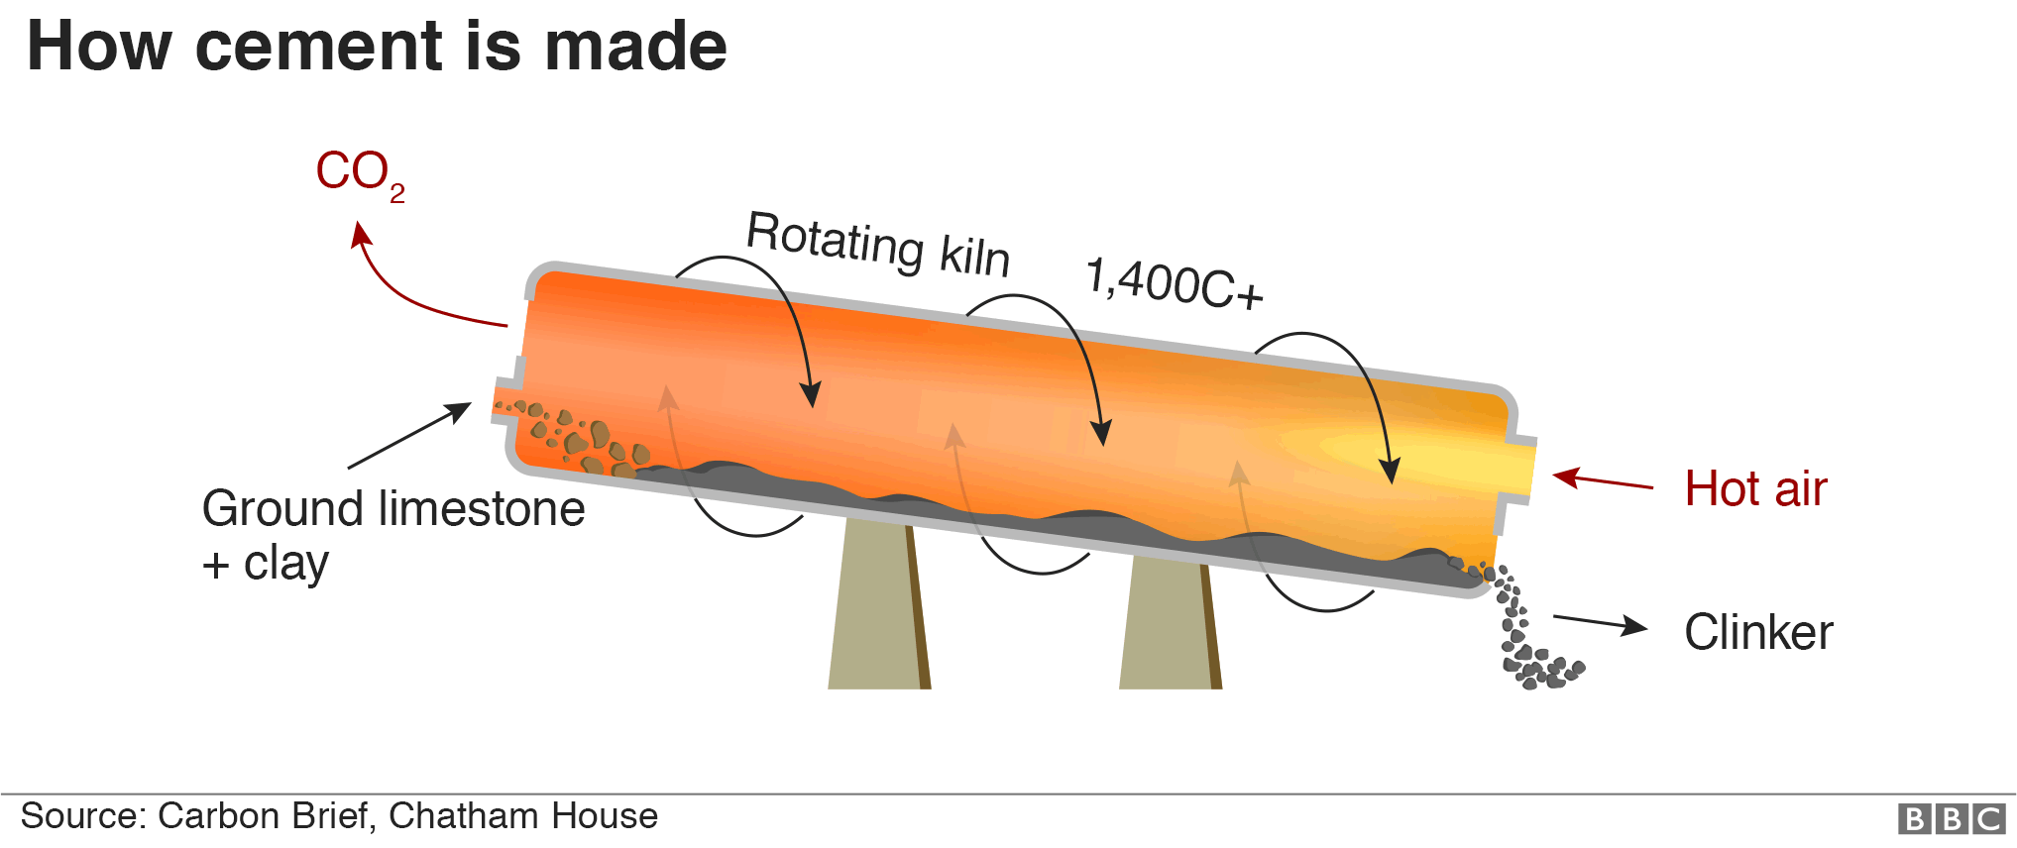
Cement is the binding material. It allows concrete to cure and solidify. The cement process begins with the mining of limestone and clay in quarries. These huge blocks are crushed, ground, and mixed with other minerals. The mix is conveyed into a kiln at temperatures approaching 2000 degrees Celsius. This is transformed into small granules known as clinker. Clinker is mixed with gypsum to become cement. The figure below shows the cycle of production:
Figure 1 Cement production (Rodgers, 2018)
Sand (fine Aggregate)
Sand is an aggregate that is finer to fill in smaller gaps of the skeleton of the concrete mix that the larger aggregate cannot. This will make the mix denser.
Types of concrete
- Structural
- Reinforced (steel Rebar)
- Pre-stressed
- High Density
- Plain-mass
Durability
Concrete’s durability is ideal for large structures. concrete buildings can last up to 100 years or more when built properly and are sufficiently maintained.
“concrete may be subjected to external agencies that cause deterioration or in certain circumstances, such as alkali-silica reaction it may be subject to internal degradation.”
(Lyons, 2020)
Versatility
Other materials such as steel, insulation and admixtures can be added to the structure of concrete for added strength, insulation, and aesthetic attractiveness.
Fire Safety
Concrete does not burn. It has a high degree of resistance to fire and offers increased protection to buildings.
“In fire, concrete performs well – both as an engineered structure and as a material in its own right. It has the highest fire resistance classification (class AI) under EN 13501-1:2007- A1:2009.”
(Fire Resistance, n.d.)
Workability
The workability of concrete is generally determined by how fluid the mix is. This is commonly referred to as "slump". It will be tested on its water to cement ratio which is key to getting right for correct working concrete mix.
Concrete workability can be tested. Generally, the test is referred to as a ‘slump test’ and can be carried out on-site before work commences, and before the concrete cures.

The workability of a mix can also be determined by the shape and size of the chosen aggregate.

Advantages:
- Strong and Durable
- Energy efficient
- Resistant to climatic conditions
- Can be poured in situ. (form any shape)
- The low expansion rate in high temperatures.
- Good acoustic values

Disadvantages:
- Low tensile strength
- Generally High-density material
- Susceptibility to frost and chemical deterioration
- The extra cost for skilled labour.
- Less space for internal services.

Environmental impact
The process of making cement does impact the environment. The process of making cement produces a huge amount of Carbon Dioxide. Also, the extraction of limestone by blasting produces dust, gas, noise and damage to the landscape (Virdi, 2017).
The production of Cement globally has a huge impact on the environment it contributes to nearly 40% of the worlds C02 emissions.

Below is a graph showing the projected global amount of Carbon dioxide that will be produced by the production of cement until 2050:
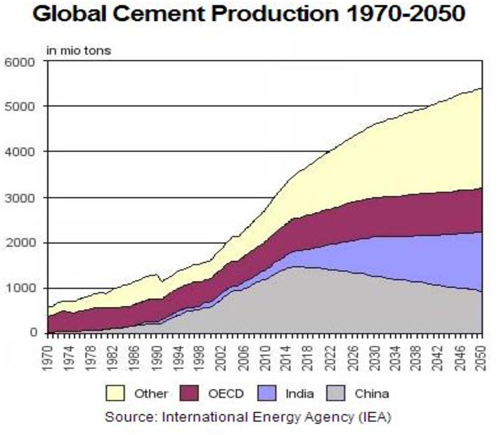
Figure 2 Global Cement Production (Shivaram, 2014)

These results show that the global production of cement is rising. This will inevitably mean that C02 levels will rise unless new forms of technology can bring pollution levels down.

4.1.1 Brief History of Concrete
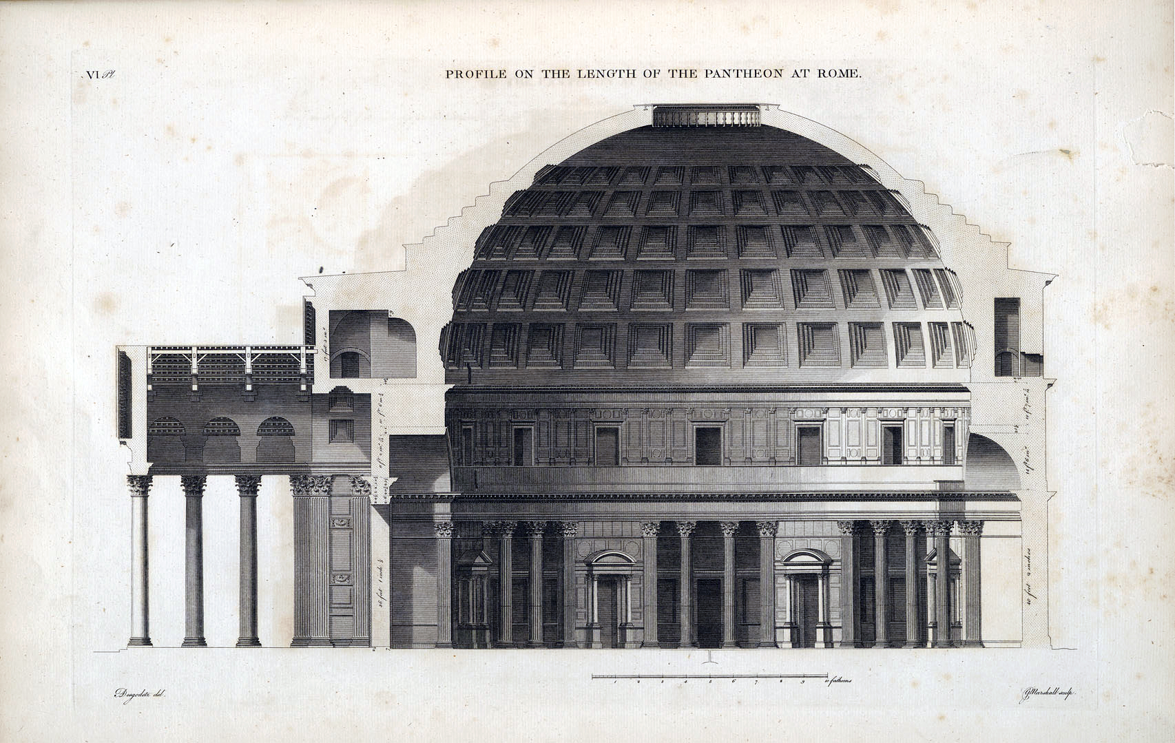
Concrete comes from the Latin word ‘Concretus’. Concrete has been used to build structures for an estimated three thousand years. The Romans vastly developed the material, starting from 300BC to 476AD. In this time, they managed to enhance its potential by using different types of physical properties, which would later allow them to construct buildings such as the Pantheon (un-reinforced concrete), situated in Rome, Italy. Which still stands today.

Figure 3 Pantheon, Rome (Ranogajec, n.d.)
Below is a quote that describes how the Romans used volcanic ash in a concrete mixture. This made it incredibly strong, even for modern-day standards:
“The Vesuvian components make Roman cement a superior cement that rivals modern standards. The ancient Romans, perhaps, stumbled upon the use of the Vesuvian component to the cement while quarrying for its components, clay, gypsum, and lime.”
(DceodedScience.org, 2021)

4.2 Steel Frame
“steel, the most important ferrous metal in building construction, is an alloy of iron and carbon” (G.D.Taylor, 2000). Steel is an alloy of iron and carbon containing less than 1%manganese and 2% Carbon and small amounts of silicon, phosphorus, sulphur and oxygen. Steel contains an iron concentration of 98 to 99% or more. Steel is one of the world's most important construction materials. A large portion of the world's steel is used to help reinforce concrete structures. figure 4 shows the process of modern-day steel:
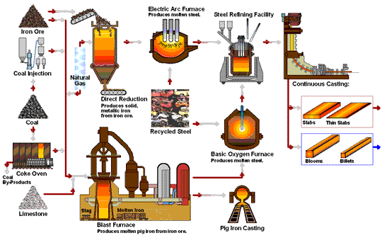
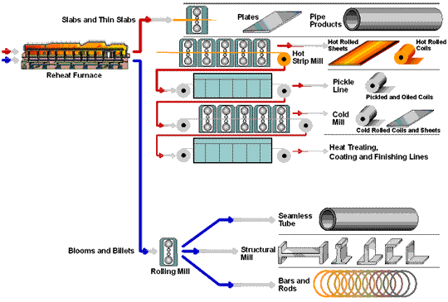
Figure 4 Steel flowlines (Institute, 2020)
Steel frame construction is mainly used to build a high-rise, industrial, warehouse, and residential buildings.
Advantages:
- Very strong properties.
- Span large distances.
- Ease and speed of installation.
- Can be prefabricated and built off-site.
- resistant to wind and earthquakes.
- Can adapt to virtually any shape.
- Can have additional cladding with a wide variety of materials.
- Weighs less than concrete.
- Mass-produced.
- No sudden failure structure.
- Space for internal services
Disadvantages:
- Can corrode if exposed to the elements and rust over time.
- Steel is susceptible to fire and high temperatures.
- Expensive to transport
- High maintenance costs
- High expansion rate
- Lesser acoustic values
Cost
“concrete allows for more flexibility in design, but for more complicated shapes and sizes formwork costs can rise dramatically” (Cotgrave, 2014).
Skill capabilities
Off-site prefabricated steel construction reduces the need for on-site labour, compared to the forming of concrete. Less skilled labour reduces on-site risk and noise disruption to the surrounding community. But Steel requires highly skilled workers as the tolerances for precise measurements can be small.
Sustainability
Steel frames reduce excess waste removal, and most structural steel can be reused and recycled. As steel is 100% recyclable.

Efficiency
Steel frames are usually built very close to a building’s specification, using 3D modelling and various new design technology. This will reduce the risk of mistakes made. This technology also ensures fast product construction and completion times.
Internal Space
Steel offers more room inside the building space for services to be installed efficiently and safely. As steel offers more volume inside a built structure, compared to concrete.
Environmental Impact
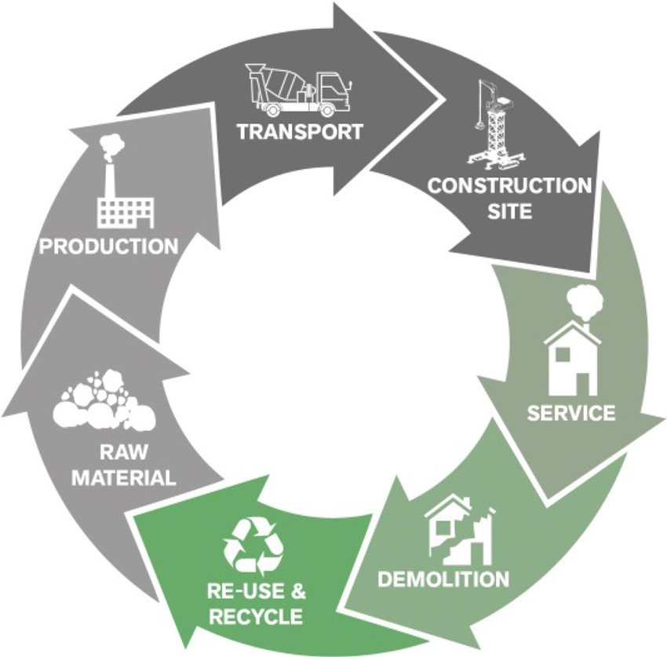
100% of steel can be recycled. This is a massive advantage over the use of concrete, as it has a very small percentage of recyclability. The figure below shows the desired route for the life cycle of most construction materials for environmental sustainability.
Figure 5 desired life cycle of the construction materials (A.Puskas, 2015)

By product of steel
- Slags 90%
- Dust 10%
- Sludges 10%
These by-products are completely recyclable with recent new technology. Making steel more environmentally friendly and more cost-effective.

4.2.2 Brief History of Steel
As early as 6,000 years ago, early civilizations have used iron ore found in meteorites to construct tools and weapons. In 1854 Henry Bessemer the British inventor is universally credited with the invention of the very first technique to mass-produce steel. Iron and cast iron, the close relative of steel had been around for thousands of years, but steel came long after.
In 1890 the first steel-framed building was the Rand McNally, built in Chicago, Illinois, USA.
Rand, McNalley & Co built the first steel frame building in 1889, which had 10 stories. This sparked a new era for steel frame building and the emergence of skyscrapers.

Figure 6 Randy McNalley Building (Randy McNally Buildings, 2020)
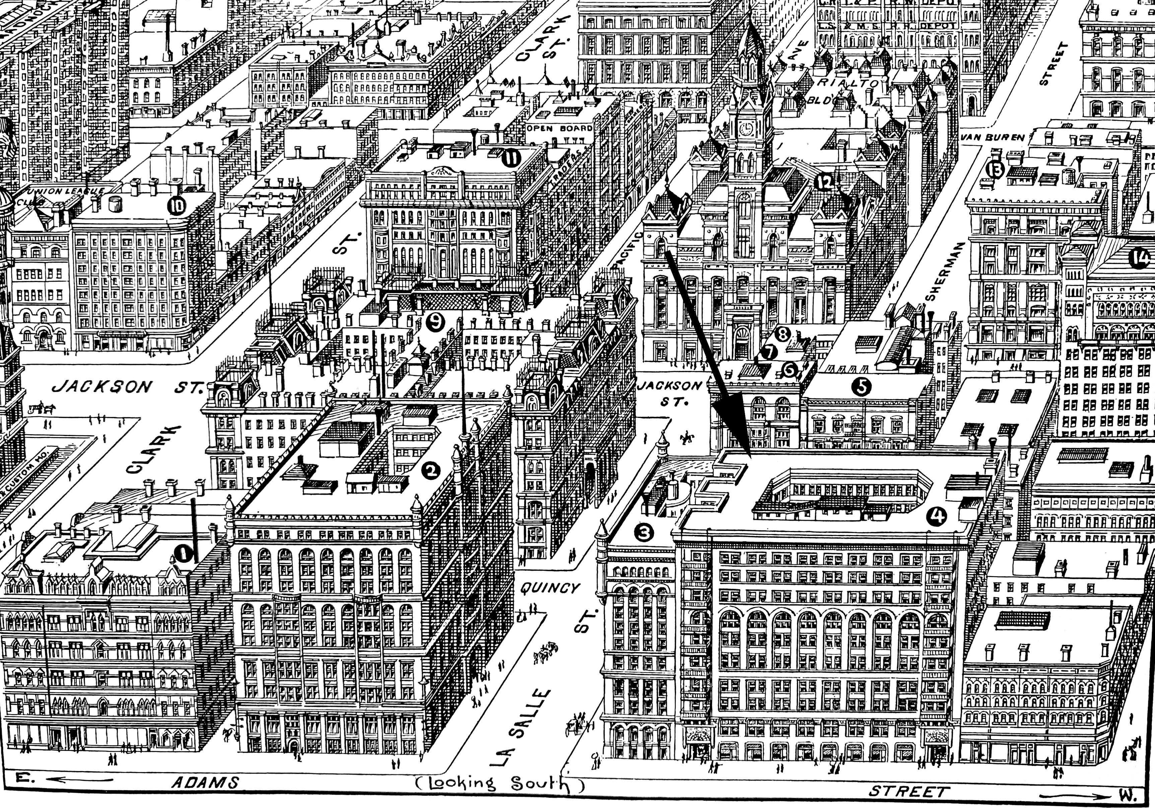

4.3 Concrete Frame Case-study

4.3.1 The Burj Khalifa
Figure 7 The Burj Khalifa (Skyscraper.org, 2010)
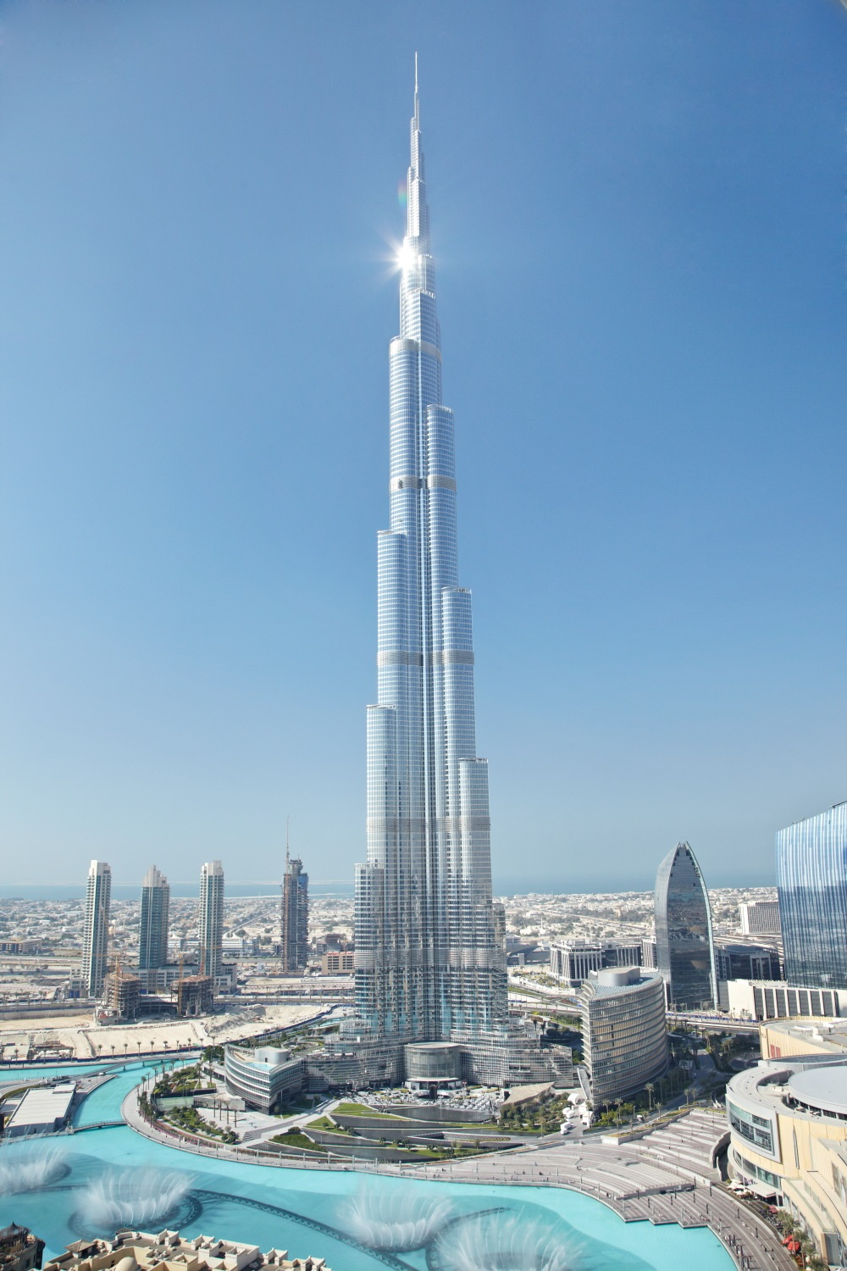
The Burj Khalifa is currently the tallest building in the world since its completed construction on 4th January 2010. The name is translated into “The Tower of Dubai” from Arabic.
Building facts
Location: Dubai, United Arab Emirates
Building Frame: Concrete
Cost: $1.5 Billion USD
Time to build: 4 years.
Principle designer: (SOM) Skidmore, Owings & Merrill.
Construction manager: David Bradford
Height: 828 Meters
No. of Floors: 160
Floor area: 460,000M squared.
Building Cladding: Triple glazed curtain walling system
Weight: 500,000 Tons in total, steel rebar used: 39,000 tons

4.3.2 Construction Method
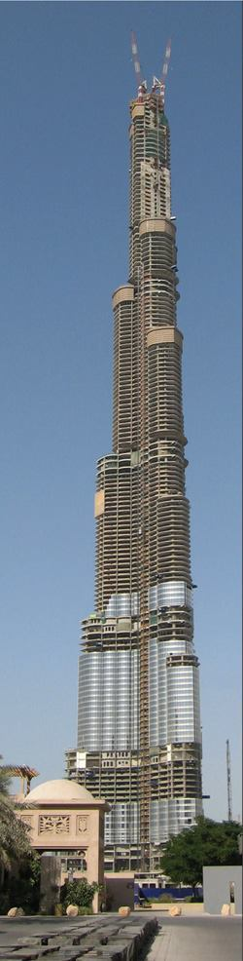
Figure 8 Burj Khalifa Concrete Frame (Nasvik, 2008)
The engineers and designers at SOM produced an expensive design that would allow cutting-edge technology to achieve high performance in an extreme desert macroclimate. Here is a quote is taken from Concrete Construction magazine outlining the key structure of the building:
“Structurally reinforced concrete and self-consolidating concrete will give this super-tall building the strength it needs to withstand wind forces and the site's corrosive soil.”
(The Burj Dubai, 2007)

Reinforced Concrete Frame
The Concrete frame was designed to counteract the high-velocity winds that are found at high altitude. These winds can compromise the structural integrity of the building over time.
The building was built in the shape of a ‘Y’. The structure decreased in size and shape as it ascended to its top.
Here is a quote from SOM describing how the shape of the building helped adapt to the climate: “Wind vortexes can never sufficiently coalesce because the wind encounters a different building shape at each tier” (SOM, Burj Khalifa - Structural Engineering, n.d.).
The Concrete frame can be described as having a buttressed core. It was built very quickly and efficiently for its size compared to other projects around the world.

4.4 Steel Frame Case-study
Figure 9 Willis Tower (Brooke, 2013)

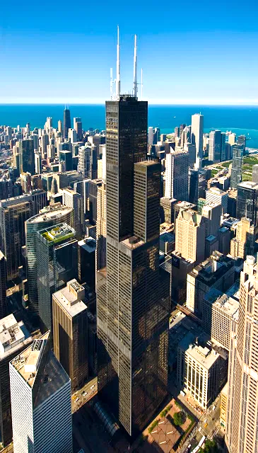
4.4.1 The Willis Tower (aka Sears Tower)

The Willis Tower is currently the 12th tallest building in the world. It originally held the top spot in the world rankings since its completion in 1973 to 1998. The highest skyscraper that uses only steel structure. Others use composite construction material (concrete and steel).
But currently the 2nd tallest building in the USA
Building facts
Location: Chicago, Illinois, USA
Building Frame: Steel
Cost: Estimated at $150 Million – $800million equivalent to today
Duration of build: 3 years
Principle designer: (SOM) Skidmore, Owings & Merrill.
Construction manager: Richard C. Halpern
Height: 442metres
No. of floors: 110-storeys
Floor area: M squared
Building Cladding: Black aluminium structure and bronze-tinted vision glass panels
Weight: Total weight: 222,500 tons, 76,000 tons of steel
4.4.2 Construction Method
Steel frame
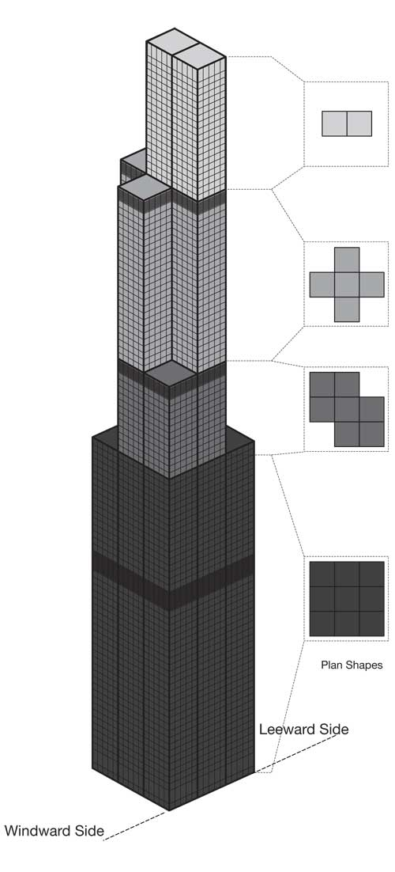
Chicago is well known for being called ‘the windy city’. The climate of the region endures hot summers and harsh winters which bring very strong winds. This led the engineer Fazlur Khan to invent a new system to allow this building to be built to a great height. That new idea was a ‘tube concept’. The tube concept system was different from the traditional form of steel frame because it brings the external columns closer together so that the columns would act as a wall on the perimeter of the building.
Figure 10 Willis Tower 'tube concept' (Major Works, n.d.)
At the base of the building, there is a series of 9 steel tubes for the frame, as you can see in the figure to the right. Due to the structure’s height-to-width ratio, a single framed tube (traditional method) is not adequate. But bundling the tubes does increase the strength as the building rises in height. This staggered effect is also used on the Burj Khalifa. But the Willis tower was the first of its kind to use this system. The staggered and step system helped withstand high winds at tall heights, which would normally cause a lot of harm to a traditionally built steel frame over a period. Here is a quote from SOM, briefly describing the tube concept:
“The tubes are bundled together as a closed square below the first 50 stories. Above the first 50 stories, the tubes terminate at varying heights and create a multi-tiered form.”
(SOM, The Willis Tower, n.d.)
Prefabricated steel
The construction site was very small as it is in the centre of busy downtown Chicago. This meant it was very difficult to store the steel on the site, ready for use. The solution was to have daily, continuous deliveries of prefabricated steel. This put a lot of pressure on the workforce. But the columns and half of the girders were welded offsite in the factory to help speed up the construction times, which in turn helped ease the pressure. The use of a concrete frame on this project would be challenging, as it would take much longer than the steel installation.
As the project went on and the height of the building grew, the operation became more and more difficult as the temperatures and wind speeds rose. This then made construction speeds decrease.

5.0 Conclusion
Looking carefully at both case studies. There are many advantages and disadvantages that differ to both types of materials for building frames. Steel looks to be the more of a cost efficient, quicker form of construction and a more easily built frame. In terms of the environment impact, it seems again that steel would be the preferred choice as it is 100% recyclable. But in the case of the Burj Khalifa, a steel frame would have struggled to hold the weight of the building at such a height. Concrete was the perfect option as its heavy loads made it strong for its life cycle in the hot desert. It is clearly shown that both the buildings shown in the case studies, were the right choice for their own environments for the right reasons, in accordance to their surroundings.

6.0 References
A.Puskas. (2015, April). Desired life cycle of the construction materials. . Retrieved from researchgate.net: https://www.researchgate.net/figure/Desired-life-cycle-of-the-construction-materials_fig1_276846142
Brooke. (2013). Willis Tower Chicago. Retrieved from brooklynberrydesigns.com: https://brooklynberrydesigns.com/willis-tower-chicago-skydeck/
Cotgrave, M. R. (2014). Industrial & Commercial Building. Palgrave Macmillan.
DceodedScience.org. (2021). Decoded Science. Retrieved from Dceoded science.org: https://decodedscience.org/roman-cement-genius-from-roman-artisans-and-engineers/#:~:text=The%20fly%20ash%20of%20Mount,%2C%20in%20truth%2C%20a%20science.
Fire Resistance. (n.d.). Retrieved from concretecentre.com: https://www.concretecentre.com/Performance-Sustainability/Fire-Resistance.aspx#:~:text=Concrete%20does%20not%20burn%20%E2%80%93%20it,fumes%20when%20affected%20by%20fire.&text=It%20is%20this%20slow%20rate,protect%20itself%20from%20fire%20damage.
G.D.Taylor. (2000). Materials in Construction: an Introduction. Longman.
Institute, 2. A. (2020). Steel Production. Retrieved from www.steel.org: https://www.steel.org/steel-technology/steel-production/
Lyons, A. (2020). Materials for Architest and Builders. Routledge.
Major Works. (n.d.). Retrieved from khan.princeton.edu: http://khan.princeton.edu/khanSears.html
Nasvik, J. (2008). the Burj Khalifa. Retrieved from concreteconstruction.net: https://www.concreteconstruction.net/projects/commercial-industrial/the-burj-dubai_o
Randy McNally Buildings. (2020). Retrieved from chicagology.com: https://chicagology.com/goldenage/goldenage006/
Ranogajec, D. P. (n.d.). The Pantheon. Retrieved from khanacademy.org: https://www.khanacademy.org/humanities/ancient-art-civilizations/roman/middle-empire/a/the-pantheon
Rodgers, L. (2018). Climate change: The massive CO2 emitter you may not know about. Retrieved from bbc.co.uk: https://www.bbc.co.uk/news/science-environment-46455844
Shivaram, S. (2014). Measures to Contain Pollution Caused Due to Cement Productions. Retrieved from www.semanticscholar.org: https://www.semanticscholar.org/paper/Measures-to-Contain-Pollution-Caused-Due-to-Cement-Shivaram/2ff61fa7d517ef6200195907340ecd7a94df10de/figure/0
Skyscraper.org. (2010). Sky Scraper Museum. Retrieved from skyscraper.org: https://skyscraper.org/exhibitions/worlds-tallest-building-burj-dubai/#construction
SOM. (n.d.). Burj Khalifa - Structural Engineering. Retrieved from www.som.com: https://www.som.com/projects/burj_khalifa__structural_engineering
SOM. (n.d.). The Willis Tower. Retrieved from https://www.som.com/projects/willis_tower_formerly_sears_tower: https://www.som.com/projects/willis_tower_formerly_sears_tower
The Burj Dubai. (2007). Retrieved from concreteconstruction.net: https://www.concreteconstruction.net/projects/the-burj-dubai_o
Virdi, S. s. (2017). construction science and materials. Wiley Blackwell.

