An undergraduate research proposal for the study of the relationship between employee engagement and organisational performance



Name: Jordan Hitchcock
Student Number: 1808395
Programme of Study: BA Business and Management
Module: Business Inquiry and Research
Tutor: Dr Alex Bell

Introduction
“The notion of employee engagement is a relatively new one, one that is heavily marketed by human resource consulting firms” (Macey, W. & Schneider, B. 2008) Initial observations carried out by field experts suggest that employee engagement administers bottom line results. Leading global professional services firm Aon, state that engaged employees deliver greater productivity, better customer service and superior quality products and services (AON, 2014). Considering that the relationship between employee engagement and organisational performance is relatively newly established, the aim of the research is to assess the relationship between employee engagement and organisational performance.
Business author and senior contributor at Forbes, Steve Denning states that “The ultimate goal of any corporation is to make money” (Denning, S. 2011) Suppose that this statement is true, any corporation would aim to increase their profitability and would examine every possible pathway in doing so. In recent years, employee engagement has been a pivotal interest in research with regards to the success of an organisation and therefore the aim of the research conducted is to gather first hand feedback from individuals across a wide variety of professions and operations.
After studying business at GCSE level, A-Level and Degree level, an extensive interest in management styles and the motivations and behaviours of employees and customers has been developed and is something that is very intriguing to research. The relevance that these topics have within the business environment is enormous. Similarly, profitability is a driving factor of many organisations, therefore companies are willing to invest and improve upon their profitability. Thus, having an increased knowledge on this matter is a convenient skill to have as a business owner, manager or employee.
The overall aim of the investigation is to identify a relationship between employee engagement within the workplace and organisational performance. However, there will be many other questions which will also need to be answered. Employee engagement is not a yes or no answer and therefore, it is important to be able to quantify the level of employee engagement and the success of a company. Do the extra expenses to provide the employees with satisfaction outweigh the additional profits gained as a result of the customer experience? Furthermore, what does truly motivate employees and are they aware that they perform to a better standard when they feel valued by the company?
Background Literature
Why does one business succeed whereas another might fail? They might sell almost identical products/ services so what differentiates one from another? In a study conducted by Bryan J. Poulin et. al(2007) of 15 companies, 8 considered successful and 7 considered not, two patterns emerged which were “leadership and management principles to serve the needs of others and personalised leadership relationships achieved more success”. The conclusion of the investigation was that socialized leadership relations matter critically and therefore did employee engagement. Similarly, Lynn Cowart, senior consultant for Career Systems International claims that “Employee disengagement is the single most important factor in declining productivity” (Cowart, L. 2014) Interpreting Cowarts’ words, we can assume that the inverse of the statement is true, meaning high employee engagement is the most important factor in increasing productivity and in turn increasing output and decreasing costs.

Methodological Approach
The research methodology is the approach in which a scientific and systematic search for pertinent information on a specific topic is carried out (Kothari, C. 2004). The approach taken varies dependent upon the ideal outcome of the investigation, it is of great importance to choose the most suited approach to every investigation. Two of the most commonly used types of research are qualitative and quantitative collection methods. Quantitative data research can be described as “data that normally begin in words, are transformed into numbers, are subjected to different levels of statistical manipulation and are reported in both numbers and words” (Blaikie, N. 2003) Qualitative data on the other hand is data which gives more contextual feedback that can be applied, rather than solely using figures. “A qualitative approach to research is concerned with subjective assessment of attitudes, opinions and behaviour” (Kothari, C. 2004).
For this particular investigation, a quantitative approach will be taken as the method is best for measuring, ranking, categorizing, identifying patterns and making generalisations (McCombes, S. 2019). The survey which will be created will measure and quantify the regularity of feedback, the sincerity of feedback, their motivation levels, their general mood, productivity etc. Gathering a large amount of quantitative data will allow to identify relationships and trends due to the analytical approach which will be used. Furthermore, “interpreting data and presenting those findings is straightforward and less open to error and subjectivity” (Devault, G. 2019) By reducing error and allowing for consistent, set feedback from respondents it will allow for a more accurate and honest set of results which qualitative data collection does not always provide.
The survey will be created using google forms. There is no limit to the amount of questions that can be asked, the software is completely free to use and the survey can easily be sent via a link to anyone who intends to give their feedback. Social media will be a key medium in which the respondents will answer the survey. I will promote the survey on social media sites such as Facebook and Twitter so that individuals can easily access the survey by opening the link which is provided. The use of survey being the primary method of data collection means that it is capable of collecting data from a large number of respondents (DeFranzo, S. 2012) and can be administered at no cost. The larger a sample size of a questionnaire, the more of the population that is accounted for which will allow again for more accurate results. Survey software has been used as a method of data collection as its easy to administer to a large audience, cost-effective, can be conducted remotely and a large amount of questions can be answered in a relatively short time whereas with interviews as a data collection method, they are a lot more time consuming as it is only possible to carry out one interview at a time which limits the capability to reach a mass audience. Also, time taken transcribing interviews could be used carrying out further research instead.
From past experience, the amount of respondents which were sent the survey was not large enough to fully develop a relationship despite showing some trends. This investigation will require a much larger data set and therefore it will be encourage that individuals share the survey to their friends and colleagues. The surveys will also be administered via email where they will be sent to company bosses and management who could then pass the survey on to their employees.
Along with the primary data which will be collected via the survey, secondary data will also be used to further assess the relationship between the employee engagement and organisational success. In recent years, the link between the two has played a central role in theory and research therefore there will be many credible sources which would have carried out similar investigations. An advantage to the use of quantitative data is that data from other investigations can be transferred and interpreted as the results are quantified and not subject to change. “Secondary data sets tend to be far less costly and take far less time to organize relative to primary data sets” (Vartanian, T. 2010)

Planned Data Analysis and Presentation
“Data is useless without the skills to analyse it” (Harris, J. 2012). Without the ability to analyse and interpret a set of data, the data is relatively useless as it would just be numbers on a screen. However, depending upon how data is analysed and which methods are used, the data sets can become very useful and trends can become apparent. SPSS software will be used in order to analyse the data set of results. Respondents’ answers can be transferred into SPSS very easily and then utilising the numerous tools of the software, the data can be analysed and presented. The cross tabulation tool on the software will primarily be used as the analytic method. The feature allows the user to easily identify trends between different sets of data. This is a very useful tool which presents data in an easily visible format so that trends can be easily identified.
One example which could be used within the investigation to identify a possible trend would be comparing questions that asked “Do you feel valued by the company that you work for?” and “On a scale of 1-10 how motivated are you within the workplace?”. These questions are just examples however the concept is the same. If the 2 example questions were to be cross-tabulated, possible trends could be identified such as if an employee feels valued within the workplace, they are more motivated to work.

Research Planning and Ethics
The resources required for the research are minimal and the budget is £0. No expensive equipment, software or services are required to thoroughly carry out the investigation. A method of data collection will be surveys and the software which will be used is Google Forms. This allows the surveys to be completed to a professionally, to a good standard for no cost as the software is free and there will be no additional printing costs as the surveys are completed online. Furthermore, when interviewing the subjects there will be no need for expensive recording equipment as a mobile phone can be utilised to record the whole interview. Again, this will come at no cost as there will be no further purchases required. Similarly, being a student there is access to thousands if not millions of education resources completely for free, therefore gathering secondary data to be analysed will also come at no extra cost due to the extra privileges of being a student.
Time will be the largest cost of carrying out the investigation. It will be critical when designing the surveys and interviews that open and closed questions are provided and all questions included are relevant to the research topic. Time will be invested in the creation of the survey in order to allow the respondent to open up as much as possible and provide the most honest and accurate feedback that they can. In turn, this will allow for a more credible set of results and allowing a stronger conclusion to be made on the relationship between employee engagement and organisational performance.
It is recognised that contacting external parties and seeking their opinions and feedback regarding a topic will have ethical concerns and respondents might not be completely honest if they feel that their identity or responses will be used for additional purposes than the research project. To avert this, no sensitive or personal data will be gathered from participants and at the beginning of the survey there will be a statement on the anonymity of the respondents and how their data will be handled. Names are not important for this investigation however the experience of employers and their employees is. An ethics form will also be completed before beginning the investigation.
In order to meet the objectives of the research, a Gantt Chart has been created to use as a timeline for the project. Planning makes objectives more clear and specific (Juneja, P. 2015) Planning will allow attention to be focused on the most important tasks at any given time. A Gantt Chart has been created (below) to illustrate each of the tasks and their time scales for completion. A Gantt Chart is used as it shows clarity of the entirety of the project and every task which needs to be completed from beginning to end (Nordqvist, J. 2019)
Below is an image of the Gantt Chart created for the allocation of time required to complete tasks. This can be subject to change.

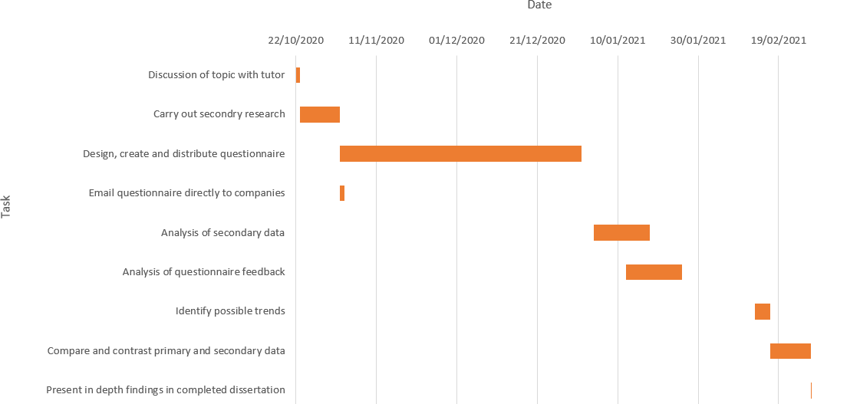

References
AON (Apr, 2014) Employee Engagement Online article accessed on 19/05/20 retrieved from https://www.aon.com/unitedkingdom/employee-engagement-old.jsp
Blaikie, N. (Oct 2003) Analyzing Quantitative Data: From Description to Explanation Social Research and Data Analysis, pp21-23 Published by Sage Publications
Cowart, Lynn. (2014) Why Employee Morale Matters- Especially Now pp.45 Accessed from https://talent-dimensions.com/wp-content/uploads/2018/04/Why-Employee-Morale-Matters.pdf
DeFranzo, S. (Nov, 2012) Advantages and Disadvantages of Surveys Online article accessed on 20/05/20 retrieved from https://www.snapsurveys.com/blog/advantages-disadvantages-surveys/
Denning, S. (Sep, 2011) Is The Goal Of A Corporation To Make Money? Forbes online article accessed on 19/05/20 retrieved from https://www.forbes.com/sites/stevedenning/2011/09/26/is-the-goal-of-a-corporation-to-make-money/#7fb1dd4754ed

Devault, G. (Jun, 2019) How to create a research design Online article accessed on 20/05/20 retrieved from https://www.scribbr.com/research-process/research-design/
Harris, J. (Sept, 2012) Data Is Useless Without the Skills to Analyze it Online article accessed on 20/05/20 retrieved from https://hbr.org/2012/09/data-is-useless-without-the-skills
Juneja, P. (Mar 2015) Advantages of Planning Management Study Guide Online article accessed on 20/05/20 retrieved from https://www.managementstudyguide.com/planning_advantages.htm
Kothari, C. (2004) Research Methodology: Methods and techniques. New Age International. Pp.14
Macey, W.H., & Schneider, B. (2008) The meaning of employee engagement. Industrial and organizational Psychology, 1(1), 3-30.
McCombes, S. (Feb, 2019) How to write research methodology Online article accessed on 20/05/20 retrieved from https://www.scribbr.com/research-process/research-design/
Nordqvist, J. (May, 2019) Benefits of using Gantt Charts in Project Management Online article accessed on 20/05/20 retrieved from https://marketbusinessnews.com/benefits-gantt-charts-project-management/203653/
Poulin, B. J., Hackman, M. Z., & Barbarasa-Mihai, C. (2007) Leadership and succession: The challenge to succeed and the vortex of failure. Leadership, 3(3). 301-324
Vartanian, T.P. (2010) Secondary data analysis Oxford University press (3)13

