

BA Business Management
Management Economics.
LCBB5003
Assessment 1

Name: Larisa Claudia Hodor
Student ID: 1917710

Table of Contents
Introduction 4
Study of The Company’s History 5
Identifying Demand And Market Equilibrium Of HP 7
Factors That Influence Demand 8
HP’s Price Elasticity Of Demand 14
Substitution Effects For HP Laptop 15
Income Effects for HP Laptops 16
Analysis for Pricing Policy 17
Conclusion 18
References 19

Table of Figures
Figure 1: Company profile of HP (Reliableplant, 2021). 6
Figure 2: Market share of prevalent companies in the IT industry (OxfordEconomics, 2019). 7
Figure 3: Relation between substitution product and quantity demand (EconomicsOnline, 2020). 8
Figure 4: Price of complementary goods effect on demand curve (Economicsnetwork, 2021). 9
Figure 5: Change in customer's income influence the demand for a product (Mandal, 2017). 10
Figure 6: Consumer expectations for a normal product and its influence on the demand curve (EconomicsUK, 2021). 12
Figure 7: Demographic effect on demand (Gelders, 2012). 13
Figure 8: Price elasticity and its relation with demand (Statista, 2021). 14
Figure 9: Substitution effect between two products (UniversalClass, 2020). 15
Figure 10: Income effect on products (Woodfield, 2012). 16

Introduction
This report aims to address and evaluate economic data. For this purpose, Hewlett-Packard Company’s product laptop is chosen for this report to analyse its nature and business data. To be successful and develop a place in the world market, a company has to comply with all economic terms in the business and must maintain the demand and supply process (Mullins, 2016). Therefore, the report is organized to cover all information relevant to HP as well as will show the market equilibrium for the company and last but not least, all factors that will influence price elasticity of demand will also be discussed in the report.

Study of The Company’s History
As mentioned before that Hewlett-Packard Company’s laptop product is chosen for this study. In 1939, Hewlett-Packard was established by Bill Hewlett and Dave Packard. They began selling an audio oscillator as their first product. The first personal computer designed and produced by HP was the HP 2116A, which was released in 1966. The main purpose of this device was to manage HP's expansive product range of measuring and test equipment (Reliableplant, 2021). The HP-35 hand-held calculator was part of a timesharing computer system that HP also sold in the 1970s. The company also launched a number of other products during this time period, including several HP-35 calculators and the HP4430 minicomputer. Below a company profile of Hewlett-Packard Company is given.
Table 1: Data of HP company in 2020.
Employee Numbers | Costs | Profit Margin | Sales | Market Share in the Industry
53000 | $53,177 million | 5.02% | $56.64 billion | 21.2%

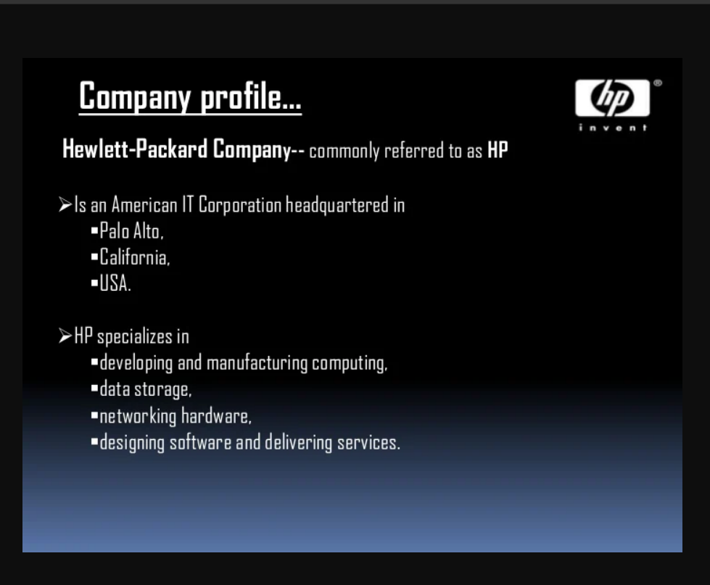
Figure 1: Company profile of HP (Reliableplant, 2021).
It belongs to the Computer hardware Computer software IT services IT consulting industry where it produces multiple IT-related products, the laptop is one of them. For example, personal computer devices, corporate and industry-standard servers, associated storage devices, networking equipment, software, and a variety of printers and other image products were among the company's major product lines.
The reason for this product is because HP laptops are a worldwide popular and accepted laptop that has a great sale and demand to the customers. Moreover, HP laptops, particularly those in the luxury and premium categories, are equipped with cutting-edge features and characteristics that set the industry standard. The company has built a reputation for producing dependable laptops and providing very excellent customer support along this process. And also, it updates all business and company’s economic data on its website periodically which may help the author to find all relevant information for this report. Hence, the product and the company are chosen for this study.

Identifying Demand And Market Equilibrium Of HP
Achieving equilibrium price and quantity is achieved by bringing the supply and demand curves together (Merkert, 2012). HP laptops have huge demand in the world because of the quality characteristics of the product. But yet the demand of the product is influenced by some other factors that can affect the demand and market equilibrium for HP laptops effectively. As laptops product is chosen for this report, it also faces huge competition because of the strong rivals in the market. Despite this, it has been successful to capture the market for these years.
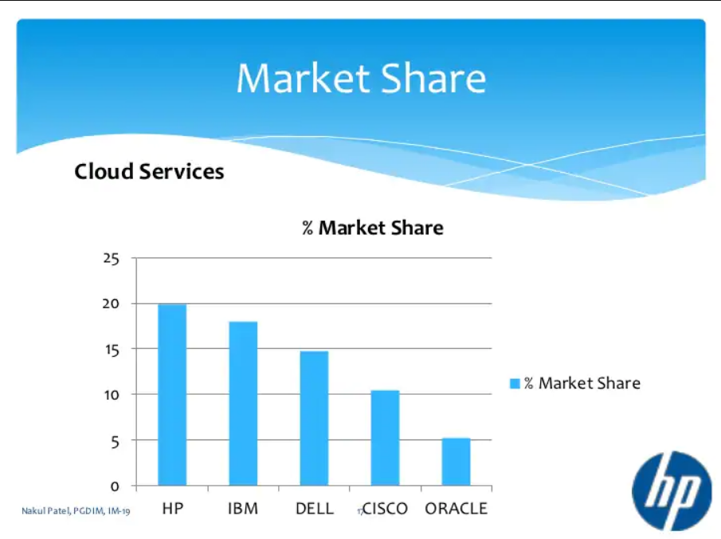
Figure 2: Market share of prevalent companies in the IT industry (OxfordEconomics, 2019).
The above figure 2 implies how HP was able to capture the market over its rivals IBM, Dell, etc. Besides this, it shows that it stands at top of them in the market which clearly indicates its success.

Factors That Influence Demand
Price of Substitutes Products
HP has great competition in the laptop business because in the market there are lots of different brands are offering laptops with distinct features. So, it is sure that many substitutes’ products exist in the market which prices can impact the demand for HP laptops profoundly. It is considered that Dell, Asus, and Apple laptops are substitutes products for HP (Peter, 2021). Though the price of Apple MacBook laptops prices is somewhat higher than the HP laptop’s prices the Dell almost offers similar products at about the same price. On the other hand, Asus provides the same features laptops with slightly lower prices than HP laptops which may influence the total demand for HP laptops.
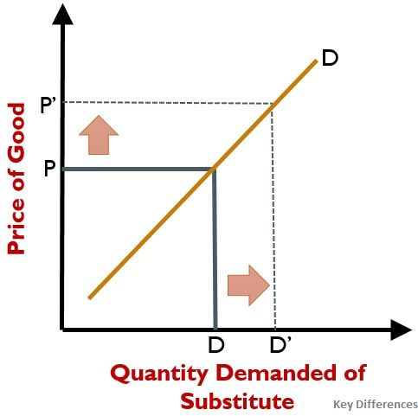
Figure 3: Relation between substitution product and quantity demand (EconomicsOnline, 2020).
The following diagram shows a positive cross demand curve for HP laptop substitutes, which implies that it is moving higher, suggesting that there is an increase in commodity quantities in the rise in substitute prices such as the hike of Dell or Asus laptops. Furthermore, the substitute product price is considered to be constant. Thus, if the price of HP laptops increases, the demand for its substitute will grow.

Price of Complements
Complementary commodities are described as items utilized or consumed simultaneously so that a certain need may be satisfied (Joshua, 2018). Complementary products of laptops can be its battery, charger, DVD and so on. These things prices also can affect the demand for HP laptops. The price of the HP complementary product also changes the curve of demand. For instance, if the price of complimentary HP laptop batteries drops, the required amount of HP laptops may rise and the demand for laptops can rise as well. Nowadays it is not seen to be increasing the price of HP laptop’s complementary product much which can be a positive symbol for increasing the demand for HP laptops.
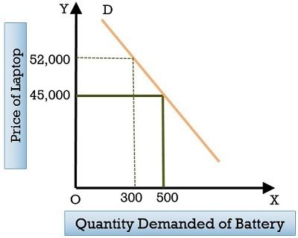
Figure 4: Price of complementary goods effect on demand curve (Economicsnetwork, 2021).
The effect of an increase of complementary products on HP laptops can be perceived from the above chart. The above chart shows that there are two laptop and battery products complementing each other. The pricing and quantity changes required are shown below:
Table 2: Demand changes if the price of complementary goods changes.
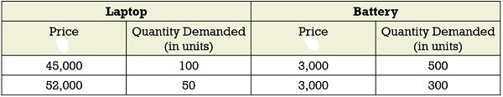
In the above scenario, the demand for laptop batteries is decreasing as the price of computers rises. So, this clearly shows the effect of price fluctuation of complementary products of HP laptops demand.
Consumer Income
As the HP laptop product is a normal product and not a necessary product, consumer income has a great impact on the demand for HP laptops. Consumer income does also increase days after days and after the moment, there may arise a new need for a laptop which can increase the demand (Weaver, 2013). For example, as actual consumer income increases, customers are demanding a luxury good to buy after they meet fundamental requirements.
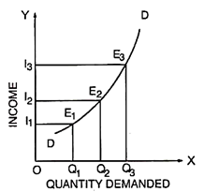
Figure 5: Change in customer's income influence the demand for a product (Mandal, 2017).
The graph above shows a clear connection between consumer income and product demand. As can be seen in the picture, the demand for the goods rises from OI1 to OI2 from OQ1 to OQ2 as the consumers' income increases. The demand for the product also rises from OI2 to OI3, ranging from OQ2 to OQ3.
So, it can be concluded that the income changes of consumers have an effective impact on the demand. The demand for the HP laptop increases or decreases by the customer's income fluctuation.
Consumer Tastes & Preferences
In purchasing a new laptop, the consumer’s tastes and preferences play a vital role. As HP laptop is a luxurious product, a consumer does a lot of research before buying it since there are many substitute products of HP are available. So, there may arise a preference for laptops brand and they buy their preferred products eventually.
Customer's preferences change over laptops when they find out laptops with advanced technology and with high-quality features at an affordable price (Larson, 2016). Moreover, price lowering also attracts customers towards a product and may switch their preferences after using it. And again, customers switch to other products when a celebrity endorses a product. Last but not the least, people also jump on the trends and buys things too.
Tastes and preferences affect the demand profoundly. When consumer's tastes and preferences change, the demand curve for a product changes (Philip, 2019). A rise in the price of a product leads to an increase in the demand for substitutes and a reduction in the demand for complements of the product. Consumer expectations lead to consumers demanding more or fewer goods. Similarly, if HP promotes its laptops with a celebrity and maintains the price under affordable it may increase the demand by attracting and switching the customers towards it.
Consumer Expectations of Price
Customers always expect to get products under their limits and at an affordable price (JonesJones, 2013). Since the HP laptop is a luxurious product, customers don’t buy usually this product always. So, they always expect to lessen the product so that they can buy it. So, it can be hypothesized that customers always want to decrease the price. And the demand for the overall HP laptops may increase if the price is lowered because that’s what customers want and they buy the product.
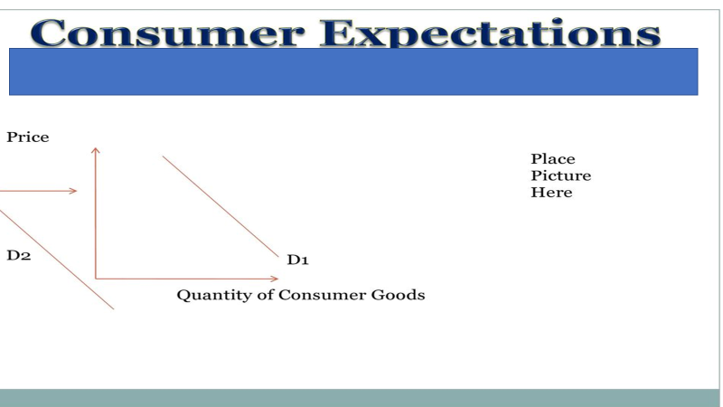
Figure 6: Consumer expectations for a normal product and its influence on the demand curve (EconomicsUK, 2021).
Figure 6 depicts the fact that how customer’s price expectation affects the demand curve. For example, the expectations of consumers about a product's future price, which are believed to be consistent when a demand curve is built. If consumers anticipate a cheaper price, demand will grow. If consumers anticipate a higher price, demand will decline. Thus, the demand curve is influenced by customers’ expectations.

Demographics
Products are made intending for specific people which come under demographic factors (Henry, 2015). The number of customers is huge as HP produce several types of a laptop with different characteristics. Moreover, the number of new customers is increasing day after day as it brings newness to its products periodically. Demographic factor has a significant impact on demand. For example, HP also produces gaming laptop which is targeted to sell to the youth and young people who love to play the game on laptops.
It is claimed that a smaller elasticity of a product has a larger effect on the consumption of a product by the size of the population (Russell, 2013). Current population sizes will influence future market demand via pricing and elasticity of supply. If population change is sluggish and therefore changes in consumption will be slow.
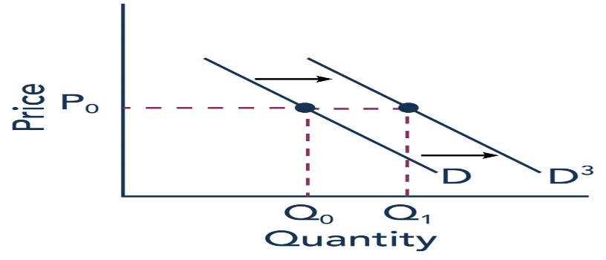
Figure 7: Demographic effect on demand (Gelders, 2012).
The chart shows the effect that if the price remains consistent and the customers of the product could be increased then there will be more increase in quantity demand and so the demand curve will shift rightward. From this, it is understood that demographic and demand have positive relationships. An increase in target customers can increase total quantity demand.

HP’s Price Elasticity Of Demand
HP’s laptops demand is very elastic to price, substitution and income effects. Any changes of these can result in a change in the overall demand for HP’s laptops. Price demand elasticity is a result of a change in product usage in proportion to its price change. From the above analysis, it has been aforementioned that how factors can influence the demand effectively.
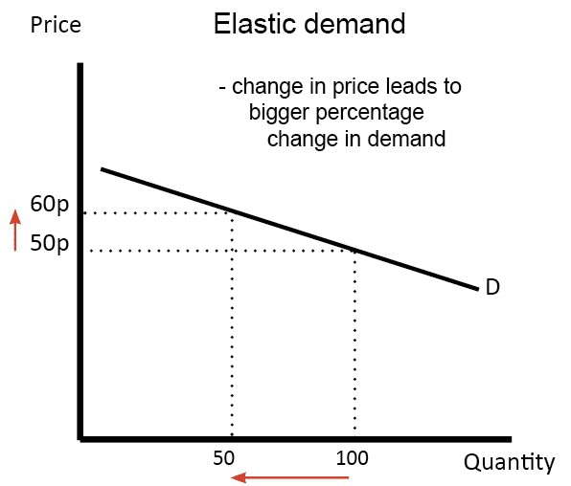
Figure 8: Price elasticity and its relation with demand (Statista, 2021).
The chart shows the high elasticity concerning the price and demand. As it can be seen that a slightly 10p change in price brought the decrease in 100 demand to 50 which is higher elasticity to the demand and price.
This is also relatable to HP’s laptops. Laptops demand is also elastic to the price. For instance, as laptops are electronic products, the price of the laptop seems to decrease day after day and this is why it is seen that the demand for a newly invented laptop may face lower demand but when days pass the demand is appearing to rise as the price is also reducing. Hereat, it is pointed out that the demand for HP laptops is elastic to the price.

Substitution Effects for HP Laptop
From a previous study, it is found that 51% of a sample of people said laptops and computers to be a necessity product. One need not have a computer to die, yet one needs a computer almost to pay taxes in 2016, or to carry out academic or official duties easily. So, it's not a luxury need. It is difficult to classify anything into need, comfort, or luxury. It's extremely subjective from the customer's point of view.
The substitution effect is a reduction in sales for a product attributable to customers moving to cheaper options as their prices rise. For numerous reasons a product may lose its market share, but the substitution effect reflects just frugality (Dockalikova, 2014).
HP faces this effect on its demand as there are many brand’s laptops already exist in the market. So, if any brand of laptop if brings a change in price or in the laptop's features customers may switch to that brand from HP’s.
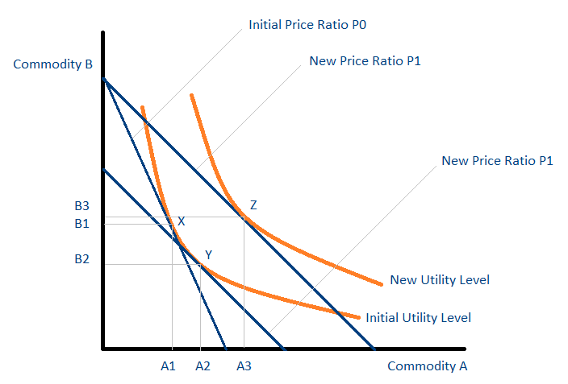
Figure 9: Substitution effect between two products (UniversalClass, 2020).
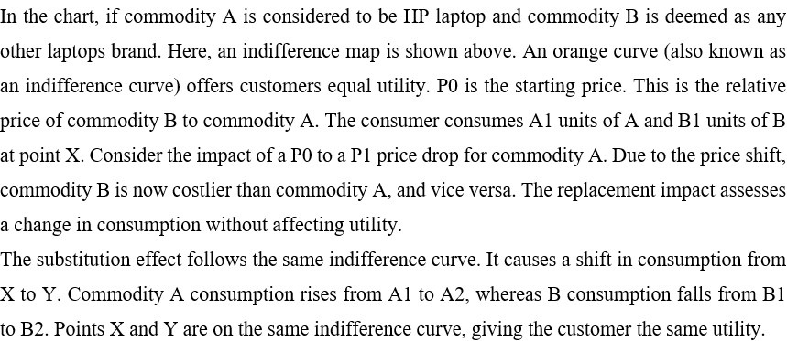
Put simply, the more substitutes are available for an item, the more elastic it is. Consequently, the demand for HP laptops is becoming more elastic because of the substitution effect.

Income Effects for HP Laptops
The income effect is the changing of the demand for a product or service coming from a change in the buying power of the customer as a consequence of a change in real income (Boddy, 2017).
Maximum HP laptops are in a price range that may need a higher percentage of income to buy them. For example, if a middle-class man wants to buy a standard HP laptop which will incur £300 to £500 which may be considered 60% to 80% of a middle-class man. Therefore, usually one may take time to buy a new HP laptop because of the income effect. If the deflation is somehow increasing one day or a recession if comes in the UK the HP company may face a higher reduction in the demand which is clearly due to the lower income of customers and a higher portion of income percentages.
Income demand elasticity illustrates the sensitivity of consumer income fluctuations to the volume of products demanded by customers. Laptops are normal products that show a positive demand elasticity of income. With a rise in consumer income, the purchase of normal products is increasing and declines with a drop-in income.
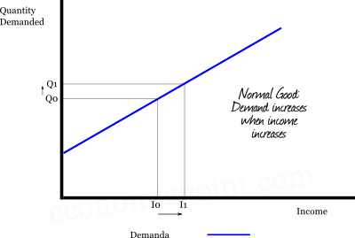
Figure 10: Income effect on products (Woodfield, 2012).
In this figure, it is shown that how an increase in income can increase the quantity demand for the normal products. As the laptop is a normal product, the demand for it will increase if customers see an income increase which implies a positive elasticity of demand.

Analysis for Pricing Policy
Pricing policy refers to how a business determines the prices of its goods and services based on factors such as costs, value, demand, and competitive pressures (Birkinshaw, 2013).
For HP laptops, the value-based pricing strategy will be suitable to apply. Value-based pricing accepts that the optimum sales price reflects a customer's perceived product or service value, not simply the cost of the business to manufacture or deliver a product or service. The value of a product or service is based on consumer requirements, preferences, expectations, financial resources, and offers of rivals (Gibson, 2019). As a result, this method requires managers to ask consumers and investigate the market to evaluate the value of a product or service.
As HP has numerous competitive brands out there in the market. If it starts producing products that increase the overall value and complying with customers' preferences, it may be able to capture the market effectively and many other brands' laptop users also probably switch their taste towards it. So, the value-based pricing policy will be the best pricing policy for HP laptops to conquer the market.

Conclusion
The report is structured in a way to cover the economic data of HP company. Therefore, here in this report, the company profile of HP company has been covered and a product was also chosen for this report. Then, factors that can influence the demand are explained in the report in terms of HP laptops and also identify the market equilibrium for the product. In today’s world, demand can be affected easily by factors that change. In addition, a change in the price of a product may result in a change in the overall demand for that product as well (Adam, 2021). Eventually, the substitution effect and income effect in relation to the chosen product are also discussed in the report.

References
Adam., 2021. A significant study on demand and its factors. Journal of Financial Economy, 76(6), p.15.
Birkinshaw, J., 2013. Ways to determine an effective pricing policy. Northampton, MA: Edward Elgar Pub.
Boddy, D., 2017. Effects of the income changes on the demand for an established product. Harlow: Pearson. British Journal of Economics, Vol 16, No.3. pp.175-194.
Dockalikova, I., 2014. Product substitution can bring huge influence over a demand, Economy & Business Governance (p. 418). Academic Conferences International Limited.
Economics Online., 2020. The way the substitution effect can increase the demand for a product. [online] Available at: https://www.economicsonline.co.uk/substitution-effect-demandeconomics>.html (Accessed: 23 August 2021).
Economicsnetwork., 2021. Impacts of changing complementary goods price can influence the demand curve effectively. [online] Available at: &lt; https://www. https://www.economicsnetwork.ac.uk//2/mccall5.asp&gt; [Accessed 23 August 2021].
EconomicsUK., 2021. Consumer expectation’s influence on a products quantity demand. [online] Available at: &lt; https://www.economicsuk.com/5386-consumer-expectation.html&gt; [Accessed 6 June 2021].
Gelders, L., 2012. Segmenting customers demographically can increase the overall demand for the specific product. European Journal of Economic News, 62(2), p.258.
Gibson, J., 2019. The best and effective pricing policy for a distinct company to capture the market. Journal of Applied Business Research, 44(7), p.150.
Henry., 2015. Target marketing applies to demographic factors. London, GA: Robin Collingwood & Brothers Publications.
JonesJones., 2013. Effective evaluation of consumer's behavior toward a product. Nollamara, W.A.: HRVET.
Joshua, A., 2018. Effect of price hike in complementary products to its total demand. Oxford University Press, 34(9), p.190.
Larson, H., 2016. Customers behavior differences from Europe to America- A findings of the study to apply new business policy. Bulletin of the Economy of Western Society, 24(3), p.120.
Mandal, P., 2017. Income change effect on demand for a particular product. International Journal of Economy and Management, Vol 11, No.6. pp.18-19.
Merkert, R., 2012. Analysis for getting equilibrium price for a product. Macroeconomics, 4, pp.1-2.
Mullins, L. J., 2016. Strategies to follow in modern world business to be successful. Harlow: Pearson, 6, pp.143-157.
OxfordEconomics., 2021. Market share of HP in the IT industry. [online] Available at: <https://oxfordeconomics.com/market-share.html> [Accessed 23 August 2021].
Peter, J., 2021. Emerging and existing competitors of the laptop market in the world- An analysis about their ability. Harlow: Pearson. The Review of Business World, Vol 11, No.6. pp.185-199.
Philip, L., 2019. The role of customers' tastes and preferences to a product and its impact on the future demand. Journal of Political Economy, 62(2), p.258.
Reliableplant., 2020. History of HP company and company profile of 2021. [online] Available at: <https://www.reliableplant.com/Read/130/HP-history-profile> [Accessed 23 August 2021].
Russell., 2013. Research on the elasticity of demand and its elements. Hoboken, NJ: John Wiley & Sons Ltd.
Statista., 2021. A study on the price elasticity of demand. [online] Available at: https://www.statista.com/270384/price-elasticity/ (Accessed: 23 August 2021).
UniversalClass., 2020. The effect of substitute products on each other. [online] Available at: <https://www.universalclass.com/articles/business/substitution-effect.htm> [Accessed 23 August 2021].
Weaver, J., 2013. Consumer income and the relation of demand with it. New York: McGraw-Hill Publication.
Woodfield, S. 2012. Income effect on a product which can influence the demand effectively. The Application of Macroeconomic Policy and Economic Review, 30(2), pp.235-238.

