University of Wales Trinity Saint David
School of Engineering

Six Sigma Green Belt
ACMA5005
Joseph Tobin
2317637
Word count – 4,343

Abstract
This project applies the Lean Six Sigma DMAIC (Define, Measure, Analyse, Improve, Control) methodology to investigate and reduce unnecessary metallurgical rework on Tata Steel’s Automotive Finishing Line (AFL). Initial data identified 'Outside Metallurgical Limits' as the leading cause of coil diversions in 2024, with repeat reprocessing of certain specifications—particularly S450GD+Z—driving excessive cost and inefficiency.
Through SQL-based data collection and analysis, the project revealed that S450GD+Z, an MA-grade coil requiring only single-end testing, was being routed through AFL multiple times, despite a 92% failure rate on retest and £36,000+ in rework costs. Root cause analysis attributed this to a lack of product-specific referral logic and inconsistent decision-making.
Improvement proposals include implementing a referral database flag, updating the AFL control plan, and deploying a new Standard Operating Procedure (SOP) to prevent unnecessary rework of S450GD+Z. A 3-month pilot and long-term monitoring plan have been developed to assess the impact and sustainability of these changes. The project demonstrates a clear “quick win” aligned with Six Sigma principles, offering an opportunity to reduce waste, standardise operations, and enhance cost efficiency.

Contents
1 Abstract ii
3 Table of Figures v
4 Table of Appendices vi
5 Introduction 1
5.1 Background Information 1
6 Literature review 1
6.1 Six Sigma Methodology 1
6.2 Product Type 1
7 Define 2
7.1 Problem Statement 2
7.2 Process Map 3
7.2.1 Key Issues Identified in Process Mapping 5
7.3 Ishikawa Diagram 5
7.3.1 Key Findings from the Ishikawa Analysis 5
7.4 Voice of Customer 7
7.5 Critical to Quality 7
7.6 Scope 8
7.7 Project Charter / Selection Form 9
8 Measure 10
8.1 Identify Measurement Variation 11
8.2 Determine Data Type 11
8.3 Develop Data Collection Plan 11
8.4 Perform Measurement System Analysis (MSA) 12
8.5 Data Collection and Assess Process Capability 12
9 Analyse 13
9.1 Introduction to Analyse Phase 13
9.2 5 why analysis 13
9.3 Exploratory Data Analysis 15
9.3.1 Pass/Fail Percentage by Caption 15
9.3.2 Total Cost vs. Tonnage Loss by Caption 16
9.3.3 Product Type Analysis (MA, FF, GP) 16
9.3.4 MA Specification Deep Dive 18
9.4 Refined Problem Statement 19
9.5 Root Cause Hypothesis 19
9.6 Summary of Key Findings & Critical Next Steps 20
10 Improve 20
10.1 Generate Improvement Alternatives 21
10.2 Improvement FMEA 21
10.3 Control Plan 22
10.4 Standard Operating Procedure (SOP) 23
10.5 Cost/Benefit Analysis 24
10.6 Future State Process Map 25
10.7 Implementation Plan 26
10.8 Validate Improvements 26
11 Control 28
11.1 Monitoring Plan 28
11.2 Embedding Improvements 28
11.3 Training and Standardisation 29
11.4 Escalation and Review 29
12 Conclusion 29
13 References 29
14 Appendices 30

Table of Figures
Figure 1 - AFL top 10 Divert Reasons 2024 (Steel, 2025) 2
Figure 2 - Problem Summary Table – Key Issues, Impacts, and Objectives of AFL Metallurgical Rework 3
Figure 3 – Simplified Process Flow 4
Figure 4 - Ishikawa analysis Diagram 5
Figure 5 - Ishikawa Key Issues and details 6
Figure 6 - CTQ diagram…………………………………………………….. 8
Figure 7 - Initial Project Selection Form for AFL Metallurgical Rework Reduction 10
Figure 8 - Data collection plan 12
Figure 9 - Initial 5 Why Analysis (Broad Focus) 14
Figure 10 - Refined 5 Why Analysis 14
Figure 11 - Pass/Fail Percentage by Caption 15
Figure 12 - Total Cost Loss vs tonnage loss per Caption 16
Figure 13 - Product Type Analysis (MA, FF, GP) 16
Figure 14 - Product Cost of 2x AFL 17
Figure 15 - Product type vs. Yield - Weight Lost 17
Figure 16 - MA spec cost & weight 18
Figure 17 - MA spec pass/fail percentage 18
Figure 18 - Improvement Alternatives Evaluated Based on Feasibility and Impact 21
Figure 19 - FMEA Row Added to Reflect S450GD+Z Misrouting Risk 22
Figure 20 - Updated AFL Control Plan Entry for S450GD+Z 23
Figure 21 - S450GD+Z SOP Document 24
Figure 22 - Future State Process Map 25
Figure 23 - A3 Tracker Overview of Improvement Implementation Plan 27
Figure 24 - Gantt Timeline for Implementation 28

Table of Appendices
Appendix 1 - Full Process flow 30
Appendix 2 - Project Selection Form for AFL Metallurgical Rework Reduction 31
Appendix 3 - B Shift Process flow 32
Appendix 4 - B shift Ishikawa 33
Appendix 5 - D Shift Process flow 34
Appendix 6 - D Shift Ishikawa 35
Appendix 7 - A Shift Process Flow 36
Appendix 8 - A Shift Ishikawa 37

Introduction

Background Information

Literature review

Six Sigma Methodology
This report adopts the Lean Six Sigma DMAIC framework (Define, Measure, Analyse, Improve, Control) as its core methodology for driving process improvement. Lean Six Sigma is widely used across industries to minimise variation, eliminate waste, and enhance process efficiency. Pioneered by companies such as Motorola, IBM, and General Electric, it integrates data-driven analysis with structured problem-solving to improve quality and performance (von Rosing, 2015)
Tata Steel has implemented Lean Six Sigma across its UK sites, including Llanwern, where structured belts—Yellow, Green, and Black—are responsible for delivering improvement projects. This project aligns with that framework, employing the DMAIC cycle to investigate metallurgical rework inefficiencies on the Coil Inspection Line.
Each stage of DMAIC supports a logical, systematic approach (Smętkowska, 2018)
- Define - Identifies the problem, maps the process, and outlines stakeholder needs.
- Measure - Establishes baseline data and evaluates process capability.
- Analyse - Investigates root causes using statistical tools and failure analysis.
- Improve - Develops and tests solutions aimed at reducing rework.
- Control - Implements controls to sustain improvements and prevent regression.
By applying this methodology, the project seeks to reduce unnecessary retesting, cut costs, and optimise decision-making processes within the AFL metallurgical route.

Product Type
FF (Full Finish) products are extremely high value and primarily used for automotive outer body panels, with customers including Nissan, JLR, BMW, and Renault. These coils are often run speculatively in anticipation of orders and require both front and back testing, making AFL processing essential. GP (General Purpose) coils follow similar requirements due to dual-end testing and automotive applications. In contrast, MA (Mechanical Application) products only require single-end testing and, therefore, do not typically need to go through the AFL.

Define
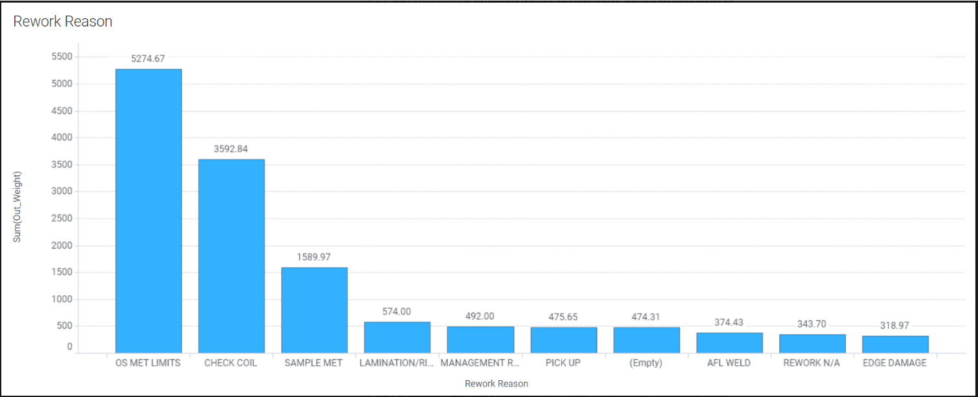Figure 1 - AFL top 10 Divert Reasons 2024 (Steel, 2025)

Problem Statement
"In 2024, the top divert reason on the Coil Inspection Line was 'Outside Metallurgical Limits'."
Each time a coil is reprocessed through the AFL, it incurs a cost of £75 per tonne, meaning a second test results in a total cost of £150/t. This cycle of retesting and reprocessing contributes to significant operational and financial losses, raising concerns about whether continued testing adds value or if alternative approaches — such as earlier classification decisions — should be considered.
Figure 2 - Problem Summary Table – Key Issues, Impacts, and Objectives of AFL Metallurgical Rework

Process Map
The process map visually represents the AFL metallurgical rework process, outlining the flow of coils through testing, referral, reprocessing, and final disposition. It highlights key decision points where material is either accepted, reprocessed, or rejected, helping to identify inefficiencies and areas for improvement. A simplified version is shown in Figure 3, with the full process map included in Appendix A for reference.
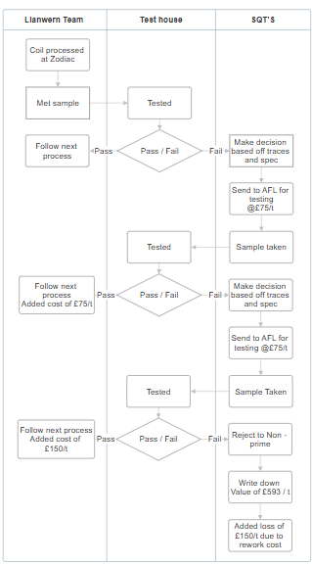
Figure 3 – Simplified Process Flow

Key Issues Identified in Process Mapping
Process mapping highlighted several inefficiencies contributing to unnecessary rework. These include delays due to data errors and QR system faults, limited value in retesting after two failures, and a £75/t cost per retest. Variability in SQT decision-making and the overall impact of rework on production flow and delivery timelines were also identified as key concerns.

Ishikawa Diagram
To investigate the causes of repeated metallurgical rework, an Ishikawa Diagram was created, categorising potential issues across six key areas: Man, Method, Material, Machine, Measurement, and Environment. This structured approach helped identify root causes on the AFL (Botezatu, 2019).
Figure 4 - Ishikawa analysis Diagram

Key Findings from the Ishikawa Analysis
From the Ishikawa Diagram, five primary areas of concern were identified
Figure 5 - Ishikawa Key Issues and details
The Ishikawa analysis has highlighted several process weaknesses contributing to repeated rework on the Coil Inspection Line. The primary concerns include misclassified referrals, decision-making inconsistencies, product-specific variations, specification constraints, and tracking failures in sample collection. These findings will inform the next phase of the project, focusing on root cause investigation and structured process improvements.

Voice of Customer
Metallurgical failures and repeated rework on the AFL affect several areas of the business—causing delays and added costs in Further Processing, risking late deliveries and customer dissatisfaction on the Commercial side, and disrupting scheduling and stock control within the Supply Chain. Ultimately, these issues impact customers the most, particularly those relying on just-in-time operations.

Critical to Quality
Critical to Quality (CTQ) is a Six Sigma tool used to translate customer requirements into measurable outcomes. It breaks down into needs (customer expectations), drivers (how quality is judged), and requirements (measurable standards) to ensure quality is defined and delivered from the customer’s perspective (Moosa, 2010).
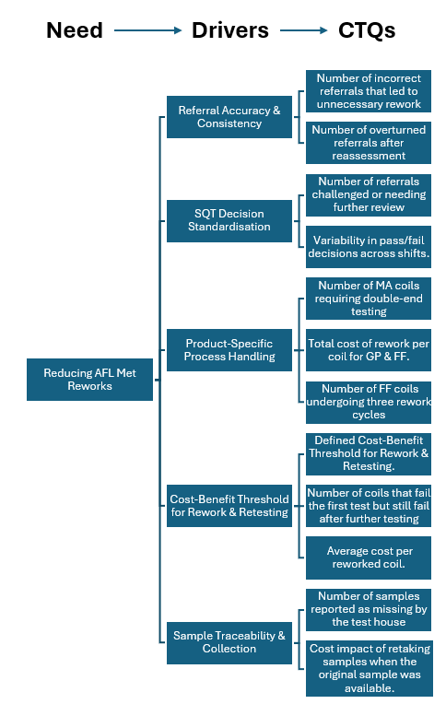 Figure 6 - CTQ diagram
This project aims to reduce AFL metallurgical reworks while maintaining quality and efficiency. Key drivers include referral accuracy, inconsistent SQT decisions, differing rework requirements for MA, GP, and FF products, and sample traceability issues. These factors lead to unnecessary costs and delays, informing CTQs such as rework frequency, cost per coil, failure rates by spec, and sample retest counts. Defining these metrics supports focused improvements in later DMAIC phases.

Scope
This project focuses on reducing unnecessary AFL metallurgical rework by analysing product specifications, selected for their clear data trends and strong alignment with Six Sigma methodology. While other CTQ areas like referral accuracy and SQT decision-making are important, they are excluded due to data limitations or coverage by other initiatives. The project also excludes fundamental metallurgy, which falls under separate process reviews. Deliverables include failure trend analysis, rework cost evaluation, and recommendations to minimise redundant AFL cycles, aiming to improve efficiency and reduce costs without compromising quality.

Project Charter / Selection Form
At Tata Steel, project charters begin with a structured Project Selection Form outlining the scope, objectives, financial impact, and responsibilities. This project was originally scoped as the AFL Metallurgical Rework Reduction Project, aiming to reduce unnecessary rework across various specifications by identifying inefficiencies, quantifying costs, and improving decision-making.
However, following further data collection and analysis in the Measure and Analyse phases, the project’s scope was refined to focus specifically on the S450GD+Z specification, where the greatest cost-saving opportunity and process inconsistency were identified.
Figure 7 - Initial Project Selection Form for AFL Metallurgical Rework Reduction

Measure
The Measure phase establishes a baseline understanding of process performance by validating the measurement system, collecting relevant data, and assessing capability. In this project, Structured Query Language (SQL) was used to extract targeted data across multiple tables to quantify the frequency and impact of metallurgical rework, particularly for coils flagged as "Outside Met Limits” (Hollingshed, 2022).

Identify Measurement Variation
To ensure accuracy, the project focused solely on coils routed to the AFL under the “Outside Met Limits” code, isolating genuine metallurgical rework cases and excluding unrelated rework. Data was extracted via SQL from multiple tables, capturing coil specification, product type, AFL rework count, test outcomes, input/output IDs, weights, and processing time.
A custom counter was developed to track how often coils were routed to AFL specifically for “Outside Met Limits,” ensuring precise, consistent measurement of metallurgical rework while excluding unrelated processing. Variability from manual inputs remains outside this project’s scope.

Determine Data Type
This project uses quantitative data, including discrete variables (e.g., rework count, pass/fail outcomes) and continuous variables (e.g., tonnage, processing time, cost per tonne). No qualitative data was used, as analysis focused solely on measurable metrics aligned with Six Sigma methodology (institute, n.d.).

Develop Data Collection Plan
A structured data collection plan was developed, detailing each measure’s type, definition, stratification, sampling notes, and responsible party. This aligns with Tata’s standard approach to ensure consistency and reliable data for analysing AFL metallurgical rework (Kunz, n.d.).
Figure 8 - Data collection plan
At Llanwern, analysts use SQL to extract targeted data and Spotfire to visualise trends. Both attribute e.g., pass/fail and variable data e.g. tonnage, process time are collected, with variable data providing deeper insights for performance improvement.

Perform Measurement System Analysis (MSA)
Traditional gauge R&R studies were not applicable as the project relied on historical data from SQL queries. Instead, system-generated and time-stamped data—such as coil routing, tonnage, and processing time—was assessed for consistency and reliability. SQL queries returned repeatable results, and all calculations (e.g., cost, yield loss) were tested for accuracy. The measurement system was deemed reliable and appropriate for the project’s scope.

Data Collection and Assess Process Capability
The dataset includes coils routed through the AFL under the “Outside Metallurgical Limits” (M31) code and reprocessed at least twice. For each coil, it captures specification, product type (MA, GP, or FF), input/output weights, final test result, and process duration. This data was used to calculate rework counts and retests by specification.
From this, key performance metrics were established;
- Total AFL rework cost, based on £75/t per reprocess cycle.
- Yield loss, measured as the difference between input and output weight across AFL cycles.
- A write-down value of £598.28/t, based on FY24 averages, represents the commercial loss when coils fail all rework cycles and are downgraded to non-prime.
Pivot tables and dashboards were used to assess process capability by comparing rework costs, yield losses, and failure rates across specifications. Specs with high failure rates and little improvement were identified as key targets for cost-saving improvements in the Analyse and Improve phases.

Analyse

Introduction to Analyse Phase
To ensure insights are relevant and actionable, the analysis phase remains closely aligned with the original problem statement. A range of Six Sigma tools—including Pareto charts, failure rate analysis, cost calculations, and yield loss evaluations—were applied to uncover inefficiencies. A Five Whys analysis was also used to explore root causes of repeated metallurgical rework, helping to move beyond surface-level symptoms (Sunny, n.d.).

5 why analysis
An initial Five Why analysis was carried out to explore broad causes of excessive metallurgical rework on the AFL, identifying key issues such as referral errors, inconsistent SQT decision-making, sample traceability, and product variability. However, following the data review during the Measure phase, the project scope was refined to focus specifically on product specification trends, which showed the highest quantifiable impact and strongest alignment with Six Sigma methodology.
Figure 9 - Initial 5 Why Analysis (Broad Focus)
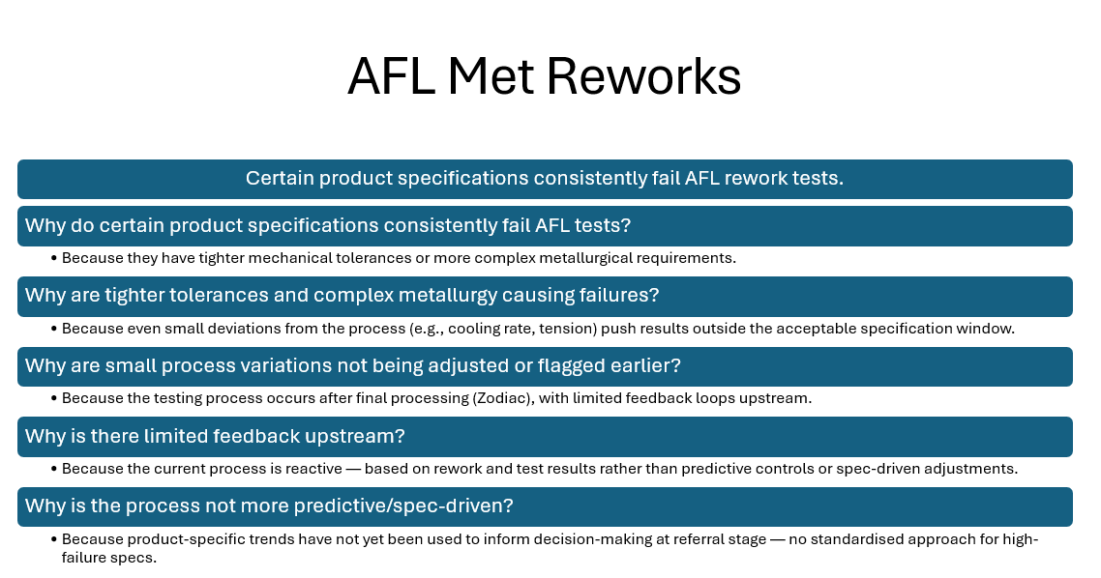Figure 10 - Refined 5 Why Analysis
Following this refinement, a revised Five Why analysis was conducted with a narrowed focus on product specifications. This updated analysis identified that certain coil specifications repeatedly fail AFL rework due to tighter mechanical tolerances and more complex metallurgical requirements. Small process variations — such as cooling rate or tension — can easily push results outside of acceptable specification windows. Because testing only occurs post-processing at Zodiac, there is limited opportunity to intervene or adjust earlier in the process. This lack of upstream feedback means decisions are made reactively, rather than proactively. Ultimately, the root cause identified is that current processes do not use product-specific trends to inform referral decisions — highlighting the need for a more predictive, data-driven approach for managing high-risk specifications.

Exploratory Data Analysis
The Exploratory Data Analysis (EDA) phase focused on identifying trends and concerns related to AFL metallurgical reworks by organising and filtering data from the Measure phase. Irrelevant passes, duplicates, and incomplete records were removed, leaving only coils routed through the AFL multiple times for “Outside Met Limits.” Pivot tables and visual tools were then used to explore this refined dataset.

Pass/Fail Percentage by Caption
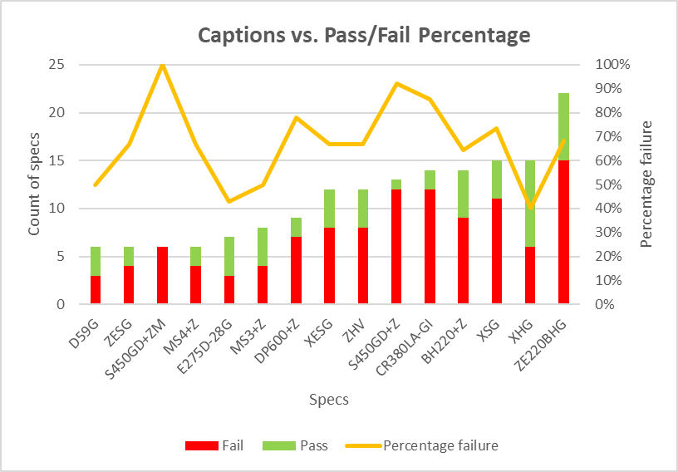Figure 11 - Pass/Fail Percentage by Caption
This chart showed significant variation in failure rates across specifications. Some specs, such as S450GD+ZM (100%), S450GD+Z (92%), and CR380LA-GI (86%), consistently failed AFL retesting despite going through twice. These high failure percentages suggest that for certain specs, continued retesting offers little value and contributes to unnecessary cost.

Total Cost vs. Tonnage Loss by Caption
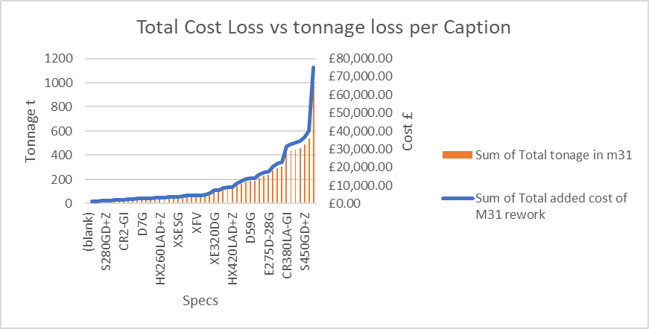Figure 12 - Total Cost Loss vs tonnage loss per Caption
This Pareto-style graph highlights that a small number of specifications contribute to the majority of rework cost and tonnage loss. Captions like ZE220BHG, XSG, ZHV, CR380LA-GI and others are responsible for substantial financial losses — exceeding £30,000+ per caption. This supports focusing on a subset of recurring high-loss specs for improvement efforts.

Product Type Analysis (MA, FF, GP)
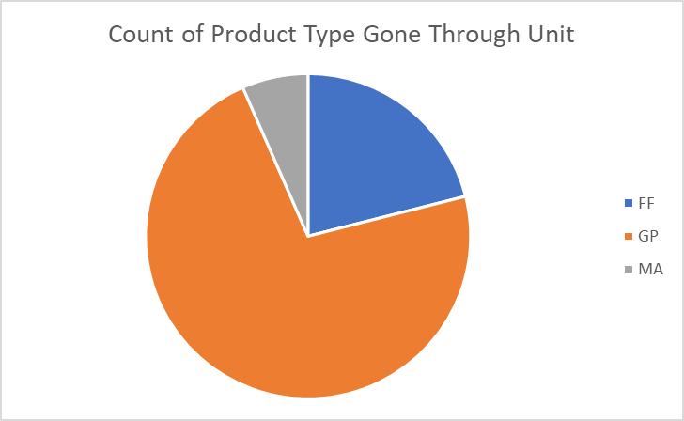Figure 13 - Product Type Analysis (MA, FF, GP)
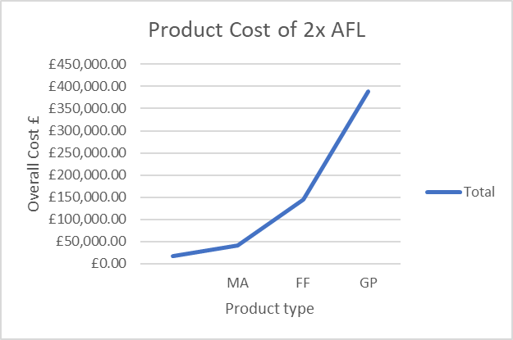Figure 14 - Product Cost of 2x AFL
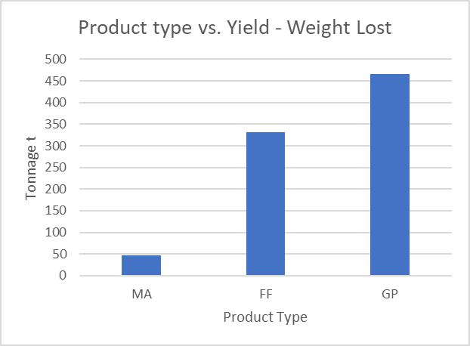Figure 15 - Product type vs. Yield - Weight Lost
GP and FF coils drive most rework activity, with GP products alone incurring over £389k in costs and FF showing the highest yield loss by tonnage; however, both require front and back testing, justifying their AFL presence. In contrast, MA products, which only require single-end testing, show disproportionately high failure rates and rework costs despite lower volumes. This highlights MA coils—particularly S450GD+Z—as a clear “quick win” for reducing unnecessary AFL rework in line with Six Sigma principles..

MA Specification Deep Dive
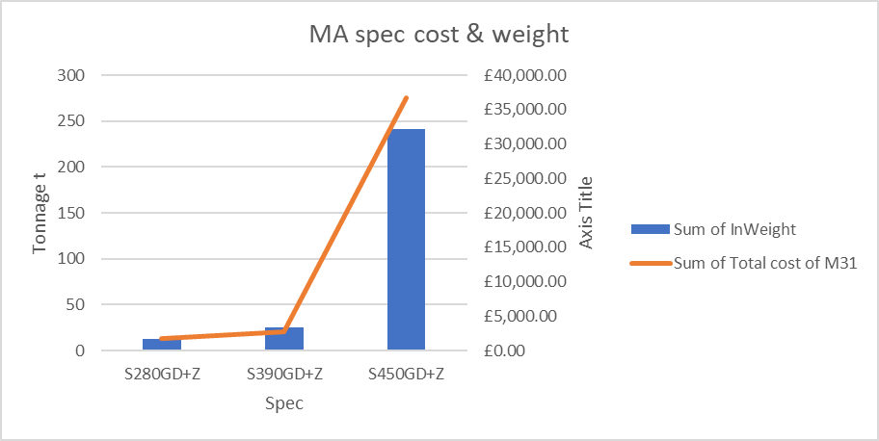Figure 16 - MA spec cost & weight
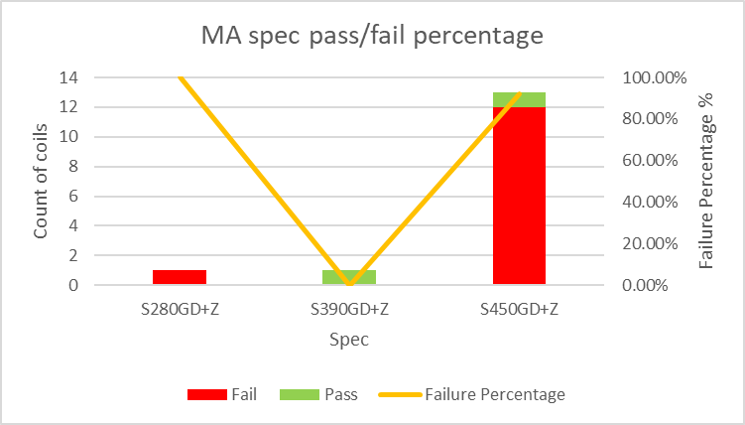Figure 17 - MA spec pass/fail percentage
A focused drilldown into MA specifications confirmed that although MA products make up a smaller proportion of total rework cases, the rework cost per coil is disproportionately high. For example, S450GD+Z, an MA product, had a failure rate exceeding 90%, contributing over £36,000 in rework costs alone. While FF and GP products inherently require front and back testing, MA coils should not typically be routed through AFL, as single-end testing is sufficient for their qualification. The fact that these coils are being reprocessed — and frequently failing — highlights a critical inefficiency in the system. Targeting MA products for process control and test-routing improvements offers a data-backed opportunity to reduce unnecessary costs and cycle time, with minimal operational disruption.

Refined Problem Statement
Based on the findings from the Exploratory Data Analysis and the MA product deep dive, the original problem statement has been refined to reflect the most impactful and addressable issue. While FF and GP coils account for the majority of rework by volume and cost, their AFL routing is typically justified due to front and back testing requirements. In contrast, MA products — which are only intended for single-end testing — are being unnecessarily routed through the AFL, incurring avoidable costs and exhibiting disproportionately high failure rates.
Particularly, the MA specification S450GD+Z stands out, contributing over £36,000 in rework costs with a failure rate exceeding 90%. This indicates a critical inefficiency where the current process does not distinguish between product types during referrals, resulting in repeated rework with minimal likelihood of recovery.
The refined problem statement is:
"The S450GD+Z MA specification is being unnecessarily routed through the AFL despite requiring only single-end testing. This misrouting leads to repeated failures, inflated rework costs, and unnecessary strain on resources — representing a key opportunity for immediate process improvement and cost savings."

Root Cause Hypothesis
Root cause analysis has revealed that the continued rework of MA specifications, particularly S450GD+Z, stems from a lack of product-specific routing and control at the point of referral. While MA products require only single-end metallurgical testing, the current process does not differentiate adequately between product types when assigning rework through the AFL. As a result, coils such as S450GD+Z are routed through full rework cycles designed for GP and FF products, which include front and back testing — processes that are unnecessary and misaligned with the intended testing regime for MA products.
This misclassification introduces multiple inefficiencies:
- Unjustified AFL costs at £75/t per rework cycle.
- High failure rates, with limited likelihood of improvement after first failure.
- Resource drain, as AFL time is allocated to coils that should not be present in the first place.
- Disruption to operational flow, increasing delays and reducing throughput.
The hypothesis is that if MA coils are identified and excluded from standard AFL rework routing, particularly in the case of repeat failures, significant cost savings can be achieved with no adverse impact on quality or customer satisfaction. Specifically, by implementing a product-specification-informed decision-making process, the unnecessary rework of coils like S450GD+Z can be eliminated, aligning rework activity with the actual testing requirements of each product type.

Summary of Key Findings & Critical Next Steps
The Analyse phase confirmed that while FF and GP products dominate overall rework volumes and cost, their AFL routing is operationally justified due to front and back testing requirements. In contrast, MA products — particularly S450GD+Z — demonstrated disproportionately high failure rates and rework costs, despite only requiring single-end testing. This highlights a mismatch between product testing requirements and current AFL referral practices.
The absence of product-specific logic at the point of referral is leading to unnecessary retesting, inflated processing costs, and inefficient resource use. As such, S450GD+Z has been identified as a clear opportunity for targeted process improvement — offering a high-impact, low-complexity “quick win” aligned with Six Sigma methodology.
The next phase will focus on developing data-driven improvements to address this gap, ensuring that coils are routed based on product-specific needs. This will reduce unnecessary AFL usage and improve both cost efficiency and operational flow.

Improve
This phase builds on the data-driven insights gathered earlier and aims to reduce process inefficiencies, eliminate unnecessary rework, and improve decision-making.
To support this, several Six Sigma tools are utilised — including Failure Mode and Effects Analysis (FMEA) to assess risk and prioritise actions, and process mapping to visualise future-state improvements. Particular attention is given to the critical next steps identified during the root cause analysis, with a focus on preventing the unnecessary reprocessing of MA products such as S450GD+Z. The improvements proposed in this section aim to deliver measurable cost savings, reduce resource strain, and align AFL routing with actual product testing requirements (Hessing, n.d.)

Generate Improvement Alternatives
Based on the root cause hypothesis and critical next steps identified in the Analyse phase, several improvement alternatives were considered to address unnecessary AFL rework of MA specifications, particularly S450GD+Z. These ideas were evaluated based on feasibility, potential impact, and alignment with Six Sigma methodology. The following are the selected improvement options for implementation:
Figure 18 - Improvement Alternatives Evaluated Based on Feasibility and Impact

Improvement FMEA
To ensure the proposed improvements are robust and risks are effectively managed, the AFL Finishing Line FMEA was reviewed and updated to reflect the new findings from this project. Specifically, a new entry was added to highlight the unnecessary reprocessing of S450GD+Z coils through AFL despite their single-end testing requirement. This misrouting was identified as a root cause of excessive rework, cost, and resource strain.
The FMEA entry captures the potential failure mode, its effects (e.g., unnecessary rework and wasted capacity), and the lack of product-specific referral logic as the root cause. The updated FMEA recommends implementing a referral flag and an SOP to prevent S450GD+Z from being reprocessed after failure. The resulting Risk Priority Number (RPN) was significantly reduced from 294 to 42, demonstrating the effectiveness of the proposed mitigation actions.Figure 19 - FMEA Row Added to Reflect S450GD+Z Misrouting Risk

Control Plan
To embed the proposed improvements into standard operations, the existing AFL control plan was updated to include a new entry specific to S450GD+Z. This control step ensures that any coil with this MA specification is flagged as single-end testing only and excluded from AFL rework after initial failure. It also instructs SQTs to follow a new SOP, with escalation to the Area Technologist if the process is not followed. This change strengthens compliance, prevents future misrouting, and supports sustainable process control.
Figure 20 - Updated AFL Control Plan Entry for S450GD+Z

Standard Operating Procedure (SOP)
To support standardisation and minimise variation in how S450GD+Z coils are handled across shifts, a dedicated Standard Operating Procedure (SOP) has been created. This SOP will be formally stored in Tata Steel’s Document Management System (DMS) to ensure it is accessible to all relevant stakeholders and included in the controlled documentation set for the Automotive Finishing Line (AFL).
The SOP outlines the actions required by Shift Quality Technicians (SQTs) when dealing with referrals involving the S450GD+Z specification. This aligns with the revised AFL control plan and aims to prevent unnecessary rework, reduce cost, and support faster decision-making.
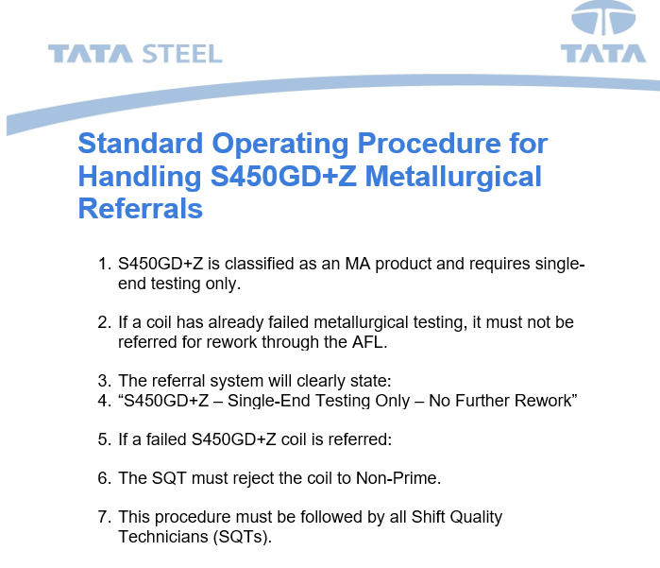Figure 21 - S450GD+Z SOP Document

Cost/Benefit Analysis
The total rework cost of S450GD+Z coils over the period analysed was £36,678, covering 13 coils that were routed through the AFL twice. Of these, 12 coils failed retesting, while only one passed — despite the cost and effort of reprocessing.

If that single passing coil (weighing 11.78 tonnes) had instead been immediately rejected to non-prime without AFL rework, the cost would have been a £6,985.54 write-down (based on £593/t). This would have avoided the full rework cost of processing it twice through the AFL.
By taking this approach, the total rework cost would have dropped from £36,678 to £6,985.54 — representing a potential cost saving of £29,692.46.
This highlights that continued AFL rework of S450GD+Z offers diminishing returns, even in rare "pass" scenarios, and supports the decision to immediately reject after first failure as the most cost-effective and value-aligned action.

Future State Process Map
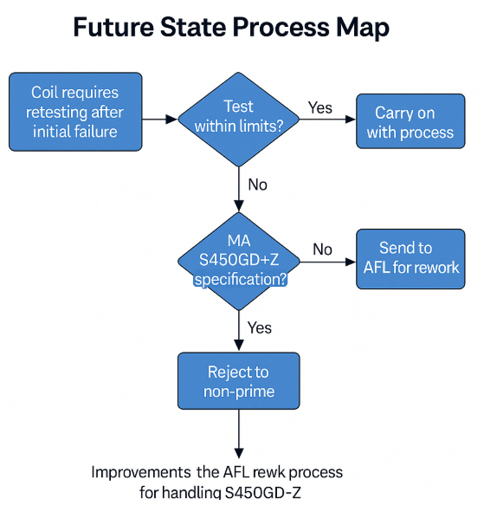Figure 22 - Future State Process Map
The future state process map outlines a revised decision pathway for coils failing initial metallurgical tests. If the failed coil is a GP or FF product, it proceeds to AFL rework due to dual-end testing requirements. However, if the coil is an MA product—specifically S450GD+Z—it will be flagged in the referral system and should be rejected to non-prime without further rework. This change ensures Shift Quality Technicians (SQTs) are guided to take the correct action, reducing unnecessary rework, cost, and misalignment with product testing requirements.

Implementation Plan
To test the proposed improvements, a controlled 3-month pilot will be run focusing specifically on the S450GD+Z specification. The implementation will begin with the addition of a product-specification flag in the referral database to identify MA products, followed by roll-out of a Standard Operating Procedure (SOP) for SQTs outlining that S450GD+Z must not be reworked after a first metallurgical failure. This SOP will be stored in Tata Steel’s Document Management System (DMS) to ensure visibility and standardisation across shifts.
The pilot will be supported by the Met Team and Data Team, who will ensure the referral system accurately highlights relevant products and monitor compliance with the updated SOP. Weekly data tracking in Spotfire will measure how many S450GD+Z coils are referred to AFL post-failure. Success criteria will include a measurable reduction in S450GD+Z reworks, improved yield from less unnecessary processing, and a projected cost saving based on avoided AFL cycles. Following pilot evaluation, recommendations will be made for permanent implementation or adjustment.

Validate Improvements
To ensure successful delivery of the proposed improvements, a structured implementation plan has been developed using an A3 Tracker format. This visual management tool outlines short-term tasks, longer-term actions, and ongoing responsibilities over a 34-week period.
Key milestones include drafting and uploading the SOP for S450GD+Z, updating the control plan, implementing a referral flag in the database, and conducting a three-month pilot trial. Responsibilities are distributed across production, technical, and IT stakeholders, with clear accountability.
The plan balances practical deployment with sustainability. Tasks such as cost-saving tracking and SOP refresher training have been embedded as ongoing items to support long-term adoption. Status indicators show that the project is currently at “Amber” due to pending system changes but is on track for delivery.
Figure 23 - A3 Tracker Overview of Improvement Implementation Plan

Figure 24 - Gantt Timeline for Implementation

Control
The Control phase ensures that improvements identified during the project are sustained over time through standardised processes, clear documentation, and ongoing monitoring. In this project, control mechanisms have been developed theoretically to demonstrate how unnecessary AFL rework for MA specifications, particularly S450GD+Z, could be prevented. Though not yet live, these controls are designed to embed consistency, reduce variation, and protect long-term gains.

Monitoring Plan
Ongoing performance will be tracked using Spotfire dashboards, focusing on the frequency of S450GD+Z referrals and their routing outcomes. Monthly audits will verify whether these coils are being handled in line with the updated guidance.

Embedding Improvements
A revised Control Plan and a dedicated Standard Operating Procedure (SOP) have been created and uploaded to Tata Steel’s Document Management System (DMS). These documents formalise the correct handling of MA specifications, ensuring consistent decision-making across shifts.

Training and Standardisation
The SOP will be incorporated into training materials and used in refresher sessions for Shift Quality Technicians (SQTs). This ensures that new and existing staff are aware of the correct referral protocol for MA products like S450GD+Z.

Escalation and Review
Should future data indicate that S450GD+Z or other MA specifications are still being referred unnecessarily, the issue will be escalated for review. The Control Plan will be updated as required, and further training or process interventions will be introduced.

Conclusion
This project successfully applied the Lean Six Sigma DMAIC methodology to investigate and address inefficiencies in metallurgical rework on Tata Steel’s Coil Inspection Line. Through comprehensive data analysis and stakeholder input, the S450GD+Z MA specification was identified as a key contributor to unnecessary AFL rework, with high failure rates and significant cost implications despite its single-end testing requirement.
The project’s data-driven approach led to the development of targeted improvement measures, including updated control plans, a new SOP, and proposed referral system logic. These improvements, though currently theoretical, demonstrate clear potential to reduce rework, cut costs, and improve operational efficiency. A 3-month pilot plan has been proposed to test and validate these changes, supported by a detailed implementation timeline and control framework.
Overall, the findings provide strong justification for excluding MA products like S450GD+Z from standard AFL rework processes. This refined strategy aligns with Six Sigma principles and offers a practical path toward sustainable quality improvement, better resource use, and enhanced decision-making across shifts. With effective execution, this project could deliver measurable benefits to Tata Steel’s operations and set a precedent for future product-specific process optimisation.

References
Botezatu, C. a. C. I. a. O. B. a. H. A. a. E. M. a. S. L., 2019. Use of the Ishikawa diagram in the investigation of some industrial processes. 1 ed. s.l.:IOP Publishing.
Hessing, T., n.d. Analyze Phase (DMAIC). [Online]
Available at: https://sixsigmastudyguide.com/analyze-phase-dmaic/
[Accessed 18 04 2025].
Hessing, T., n.d. Improve Phase (DMAIC). [Online]
Available at: https://sixsigmastudyguide.com/improve-phase-dmaic/
[Accessed 04 18 2025].
Hollingshed, M., 2022. Standardizing Six Sigma Green Belt training: identification of the most frequently used measure phase DMAIC tools. International Journal of Lean Six Sigma, 13(2), pp. 276--294.
institute, S., n.d. Data Types in Six Sigma: A Comprehensive Guide for Analysis and Examples. [Online]
Available at: https://www.sixsigma-institute.org/Six_Sigma_DMAIC_Process_Measure_Phase_Types_Of_Data.php
[Accessed 16 04 2025].
Kunz, K., n.d. How to Write a Data Collection Plan (Templates and Examples Included). [Online]
Available at: https://www.formsonfire.com/blog/data-collection-plan
[Accessed 17 04 2025].
Moosa, K. ,. S. ,., 2010. Critical analysis of Six Sigma implementation. Total Quality Management & Business Excellence, 21(1478-3363), pp. 745 - 759.
Smętkowska, M. a. M. B., 2018. Using Six Sigma DMAIC to improve the quality of the production process: a case study. Procedia-Social and Behavioral Sciences, Volume 238, pp. 590--596.
Steel, T., 2025. Screenshot of AFL Top 10 Divert Reasons 2024 From spotfire. s.l.:s.n.
Sunny, S., n.d. 5 Whys. [Online]
Available at: https://sixsigmastudyguide.com/5-whys/
[Accessed 18 04 2025].
Tobin, 2025. Screenshot of Ishikawa analysis Diagram. s.l.:s.n.
Tobin, J., 2025. Screenshot of CTQ diagram. s.l.:s.n.
von Rosing, M. a. S. A.-W. a. Z. J. A. a. J. D. T. a. W. J. P. a. v. S. H., 2015. Phase 3: Process Concept Evolution.. s.l.:s.n.

Appendices
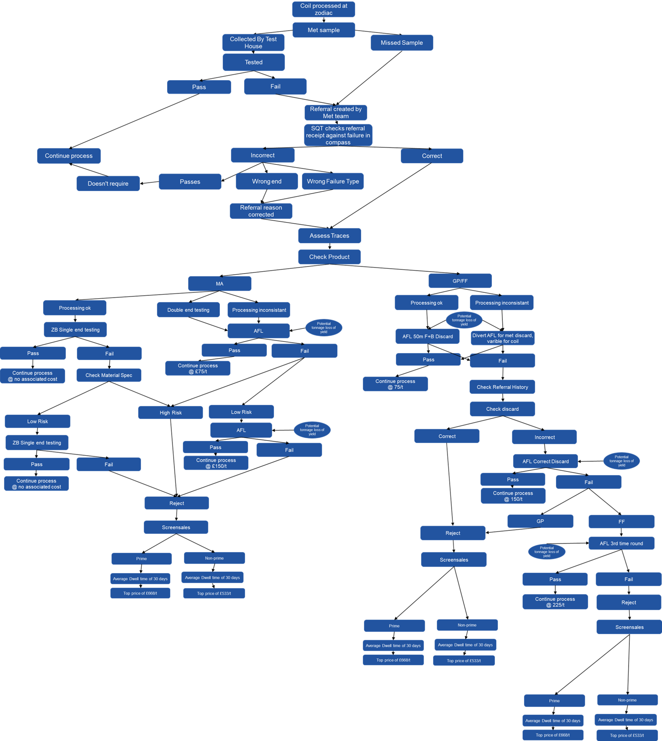Appendix 1 - Full Process flow
Appendix 2 - Project Selection Form for AFL Metallurgical Rework Reduction
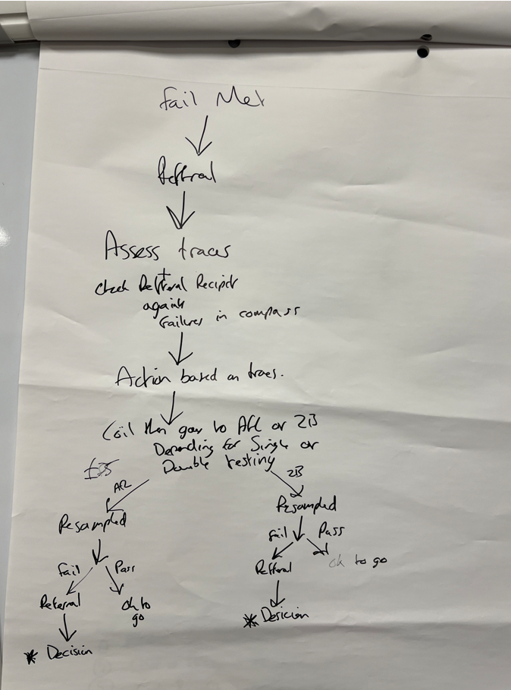 Appendix 3 - B Shift Process flow
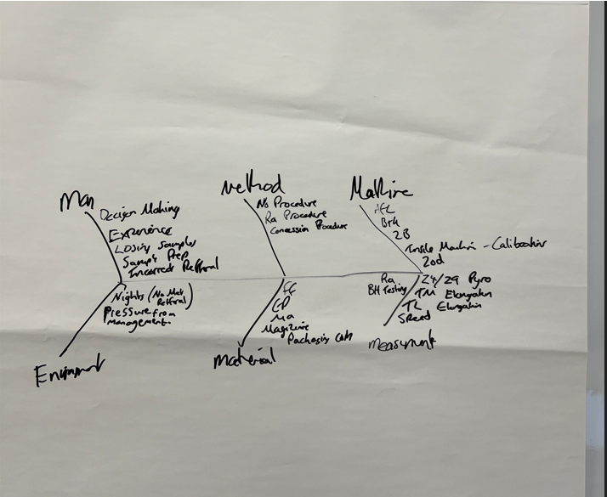Appendix 4 - B shift Ishikawa
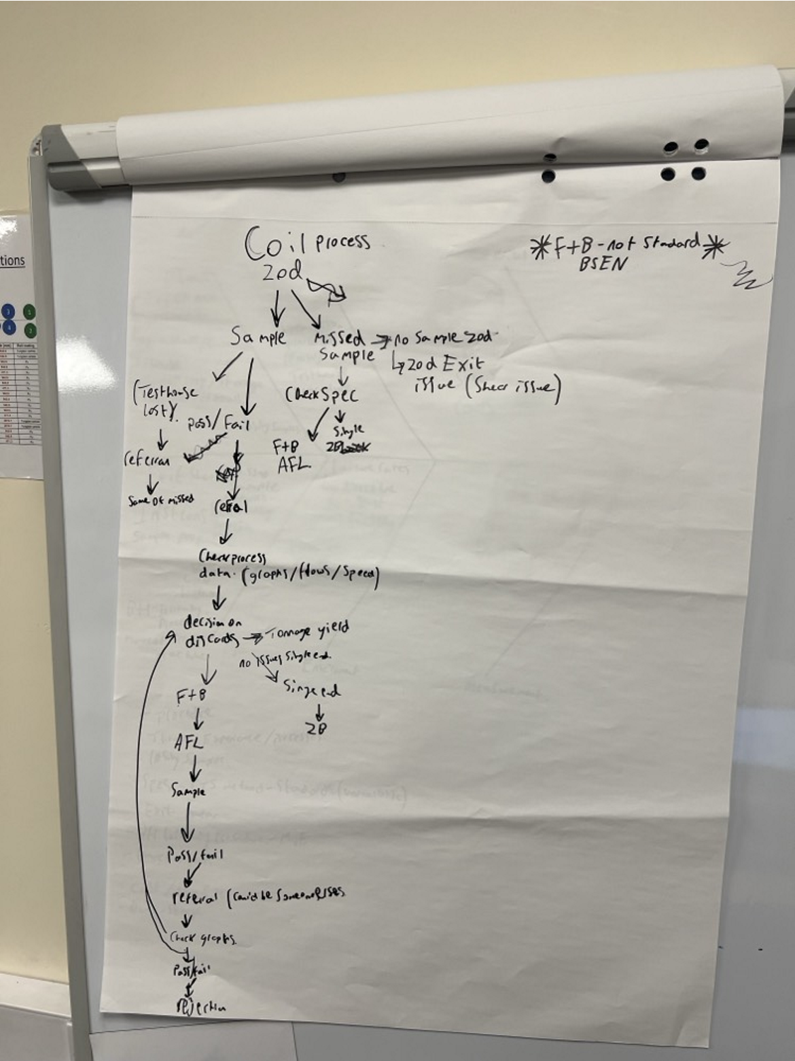Appendix 5 - D Shift Process flow
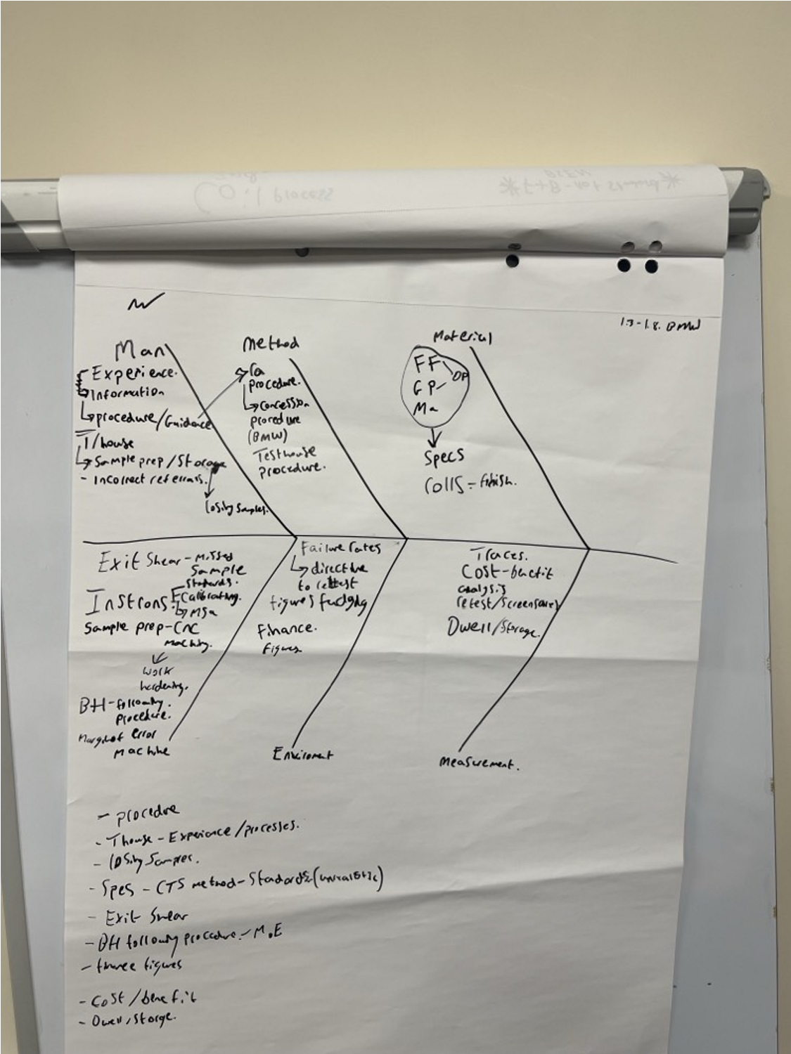
Appendix 6 - D Shift Ishikawa
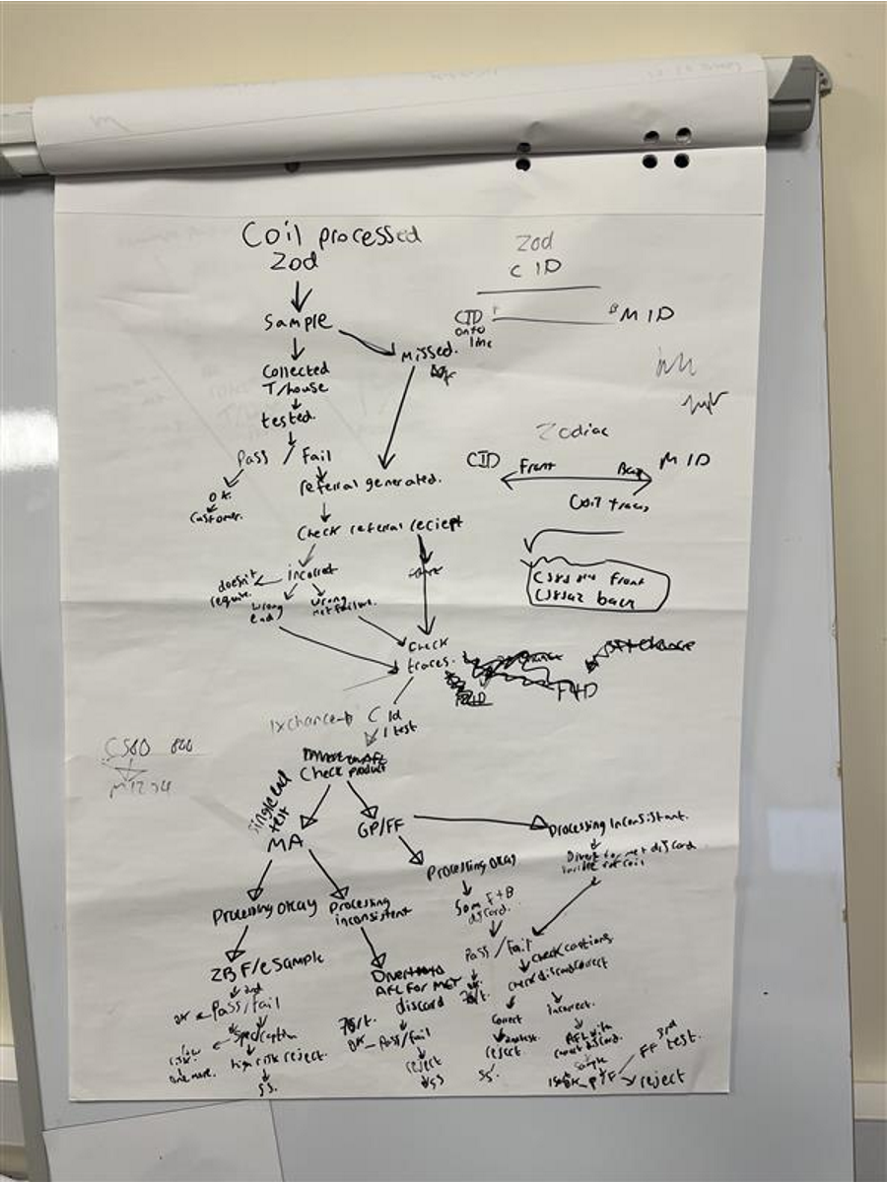Appendix 7 - A Shift Process Flow
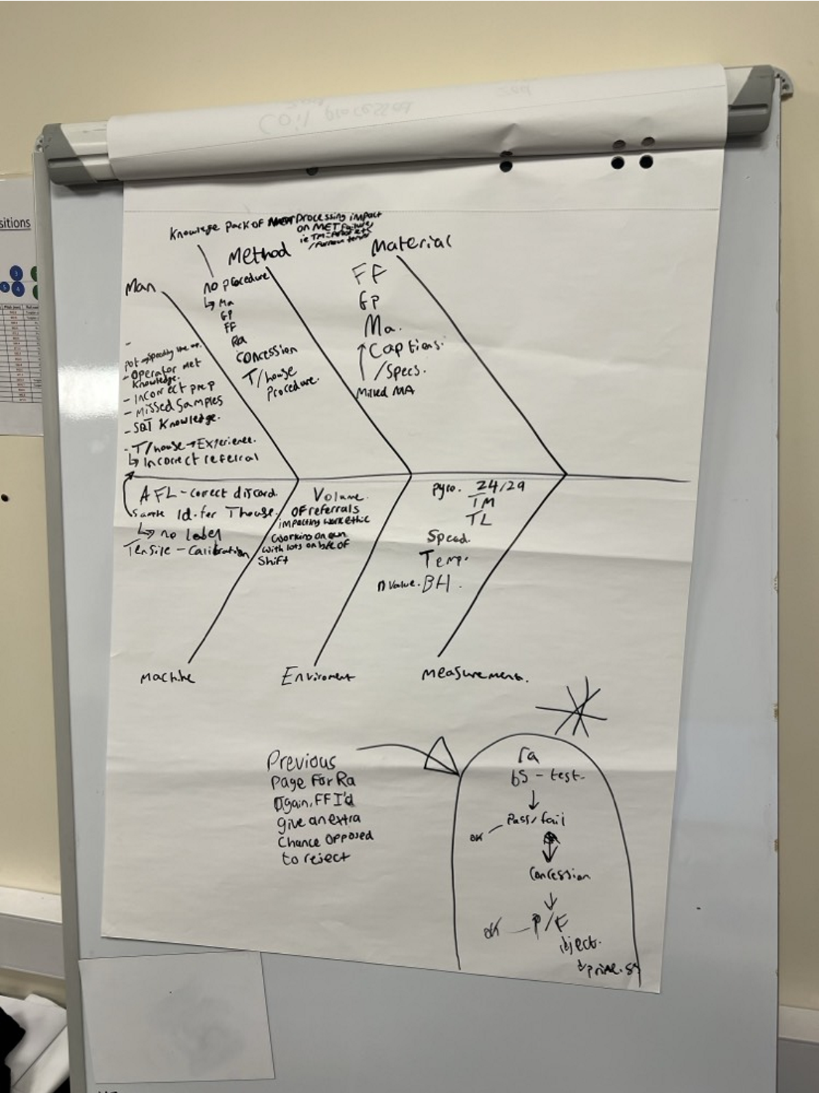Appendix 8 - A Shift Ishikawa

