

Well-being, chronic illness, and disability. An exploration into how chronic illness and disabilities affect well-being in primary school pupils and how the schools help their pupils overcome the challenges that come with having a chronic illness and disability.

Name: Shannon Cox
Student Number: 1703980
Module code: ECGE7002P
Supervisor: Nanna Ryder
Due date: 12th April 2023

Declaration Form


Name of the Programme of Study:

Name of Student (Capital Letters):

DECLARATION

I certify that the whole of this work is the result of my individual effort, and that all sources have been acknowledged.

Signed ............................................................... (Student)

Date ...............................................................

DECLARATION

I am satisfied that this work is the result of the Student’s effort.

Signed .............................................................. (Lecturer)

Date ..............................................................

Contents
Table of Contents
Declaration Form 2
Contents 3
Acknowledgements 5
Abstract 5
Acronyms 5
Chapter 1: Introduction 6
1.1 Aims and objectives. 8
Chapter 2: Defining terminology 9
Introduction 9
Definitions 9
Chapter 3: Literature review 9
3.1 Introduction 9
3.2 The historical context: how the curriculum, policy and legislation through the years has encouraged and promoted well-being and inclusion. 10
3.3 Different types of chronic illnesses and disabilities: physical and mental 21
3.4 Support available for pupils in primary education 28
3.5 Conclusion 33
Chapter 4: Methodology and methods 34
4.1 Introduction 34
4.2 Rationale 34
4.3 Qualitative design 34
4.4 Research paradigm 34
4.5 Research design 35
4.6 Ethical considerations 39
4.7 Reliability, validity, and generalisability 41
4.8Analysis of data 41
Chapter 5: Discussion 42
5.1 Introduction 42
5.2 analysis of historical context 42
5.3 analysis of the different types of chronic illnesses and disabilities: physical and mental 47
5.4 analysis of support available for pupils in primary education 49
5.5 Conclusion 50
Chapter 6: Conclusion 50
Chapter 7: Recommendation 51
Chapter 8: References 52
Chapter 9: Appendices 62
9.1 Appendices 1: Ethics Form 62
9.2 Appendices 2 : Codes 62
9.2.1 History of education codes 62
9.2.2 Different disabilities and chronic illnesses: physical and mental codes 62
9.2.3 support available for pupils in primary education codes 63
9.3 Article 2 and 23 of UNCRC 64
9.4 Well-being goals 64

Acknowledgements

Abstract
Well-being is an essential part of children’s education, there are many benefits such as increased educational attainment and being happier. This project has looked at how chronic illnesses and disabilities affect children in primary schools through the use of a systematic literature review. There is a potential for an empirical study however, due to the researcher’s own limitations of a chronic illness, a systematic literature review, with an autoethnographical and narrative approach was adopted. To find the information, several governmental sites, library searches, and google/ google scholar were used. The information obtained through articles, blogs, websites, legislation, policy and books allowed the question to be answered. Throughout the process it became clear that inclusion has room for improvement, of course, the new Curriculum for Wales has the potential to be the best curriculum Wales has faced with regards to inclusion as there is still an unknown as to where the curriculum is heading due to it being new. Furthermore, throughout this project, it became clear that education is uniquely affected by each chronic illness and disability.

Acronyms
SEND: Special Educational Needs and Disability
ALN: Additional learning needs
UNCRC: United Nations Convention on the Rights of the Child
JA: Juvenile Arthritis
CF: Cystic Fibrosis
EDS: Ehles-Danlos Syndrome
hEDS: Hypermobile EDS
CP: Cerebral Palsy
T1D: Type 1 diabetes
LEA: Local Education Authority
FP: Foundation Phase
IDP: Individual Development Plan
IEP: Individual Education Plan
SENCo: Special Education Needs Co-ordinator
ALNCo: Additional Learning Needs Co-ordinator
PISA: Programme for International Student Assessment
LSA: Learning Support Assistants.
ACE: Adverse Childhood Experiences
ADHD: Attention Deficit Hyperactivity Disorder
ADD: Attention Deficit Disorder
BG: Blood Glucose
IHP: Individual Healthcare Plans
UNCRPD: United Nations Convention on the Rights of Persons with Disabilities
AoLE: Area of learning

Chapter 1: Introduction
The main research question in this dissertation is:
“Well-being, chronic illness, and disability: An exploration into how chronic illness and disabilities affect well-being in primary school pupils and how the schools help their pupils overcome the challenges that come with having a chronic illness and disability.”
This research question is based on the need to examine the inclusion within the curriculum and how primary schools promote the well-being of children. The question promotes a qualitative research design due to the opportunity to take an autoethnogaphy approach.
This research project is going to be looking at well-being, chronic illness and disability, specifically, how students with chronic illness and/or a disability, well-being is affected, throughout their education and how they are supported by their school and/or they educational institution.
The purpose behind the research project is to bring forward personal experiences and found experiences to enable a thorough conclusion, without producing a bias piece of research.
Furthermore, this project will be completed via a literature review, bringing together a variety of current research and experience. Throughout the project, there will be a number of different areas, these being: chronic illness, disability and wellbeing, what the research project is going to be about, how it is going to be carried out, how the will results be found, where information will come from: internet, books, personal experience, the geographical area: Wales, what themes will be investigated, background information on the project, why the project is being conducted and the results found from the research.
Furthermore, this project will be conducted through an extensive literature review, using an autoethnographical approach. The literature review will be conducted using themes that will answer the overall questions. These being: The historical context- how the curriculum, policy and legislation through the years has encouraged and promoted well-being and inclusion. This theme will be looking at inclusive education pre-1900, the legislations and policies that have been created over the years, along with the different curricula through the years, these bring together a broad historical view of the education system in Wales and how inclusion within the education system has changed. Another theme being used throughout is the different types of chronic illnesses and disabilities: physical and mental. These conditions are stated above. Each condition will be discussed and defined before moving onto how well-being is affected by long-term conditions such as the ones mentioned. Furthermore, the next theme will be the support available for children in primary school, including but not limited to independent development plan (IDP), diabetic nurse and cystic fibrosis team.
Moreover, this study is important now due to the new Curriculum for Wales. The research being conducted looks at the new curriculum and how inclusion has been adopted within.
Personal experience of having lack of support within education as a person with a chronic illness has influenced this piece of research, the research in question takes a positionality approach due to personal experiences being used throughout. Positionality is considered to be when an author uses numerous personal influences such as culture, race and experiences within a piece of research (Massoud, 2022).
Furthermore, while the project has its limitations due to being done fully through a literature review, there is still benefits, these being if it is published in the future, specifically on stakeholders within the educational industry due to the emphasis on inclusion and well-being. The history of inclusive education shows how education has changed throughout the years and how it has improved, while also looking at how there is still room for improvement. There is also the benefit of understanding the education system better for the researcher’s future in the system.
The research question was developed broadly, this is due to the need to understand how children within a primary school setting are supported and their needs are met. The question encompasses the research aims which include exploring chronic illnesses and disabilities. However, it does not provide an insight into the types of chronic illnesses and disabilities that will be discussed. The different types were discussed in the literature review, however, there were key terms that arose when discussing them, this meant that groups were developed where there were similarities. These being: Asthma and cystic fibrosis (CF) due to their similarities in lung conditions. Elhers-Danlos syndrome (EDS), juvenile arthritis (JA) and cerebral palsy (CP) being a second group as they have more physical similarities. Then there are conditions that could not be categorised with others, these being, type 1 diabetes (T1D), neurodivergence and long covid. These conditions all come under chronic illness and disability and therefore help to answer the question. Furthermore, the aspect of well-being will be a prominent theme throughout due to the conditions affecting how they feel.
This research topic was decided upon due to the researcher’s own limitations in access. The researcher has a chronic illness similar to Elhers-Danlos syndrome, this means that the opportunity to conduct an empirical study was limited and the literature review was the best option for them. Furthermore, the project is relevant to the researcher’s academic discipline and therefore, makes it a relevant piece of work. The well-being aspect is one that comes up in the academic discipline which provides a background in the study. Moreover, the researcher’s own experiences in the primary school setting gives the study a more direct focus.
This topic is aimed at the educational field, providing insight into the policy and legislation that support children with chronic illnesses and disabilities. This means that if one day this research was published, the research would be aimed mainly at teachers and educational providers or local authorities, to show where the gaps are in research and care provisions.
Furthermore, the research being conducted is due to the researcher’s own experiences in school settings, the research will help fill in any gaps that the researcher has found within their findings and how they can support children in the future. This is also relevant to their future in the academic setting as a teacher, where the research will help them provide a cohesive and inclusive community within a classroom.

1.1 Aims and objectives.
This research project is an examination of well-being, chronic illness, and disability, with a focus on how students’ well-being is affected by the support that is or is not available within their educational establishment. The research will investigate the support that is available and how it can be improved if needed, based on the literature that is already available and used throughout.

This research project has four aims, these being:
- Explore chronic illnesses and disabilities amongst primary school pupils.
- Understand the challenges of access that pupils face.
- Find out how primary schools support their students with disabilities and chronic illnesses.
- Identify the potential for improvement.
These aims will be accomplished by an extensive literature review, as mentioned above, using an auto ethnographical approach, involving a variety of secondary sources and publications, such as: Peer reviewed journals, websites, books, government sites, legislations, policies, inclusion theorists and ALN codes.

Chapter 2: Defining terminology.

Introduction
Contained within this chapter, are definitions of terminology used within the dissertation to enable ease of understanding. However, simple definitions of some terminology are challenging due to different institutions, for example, the education system and the NHS, having their own particular definitions of the same term. Choice of definition will be identified and explained where appropriate.

Definitions
Chronic illness is the term given to a long-term health condition that involves ongoing medical care and/or support for a long period of time. These conditions are not curable and often cause pain which requires pain management techniques, such as medication and physiotherapy (NHS, 2022a). Furthermore, a disability is defined as a significant and long term physical and/or a mental illness, that affects one’s ability to do daily activities (Gov.uk, 2022).
Chronic illness and disability can have an effect on well-being, which is defined as the quality of a person’s life. These factors include, how the person would live their life, their employment or education, and their relationships. These factors must be positive for a person to be considered as having “good” well-being. While this is just one definition given by the Centers of Disease Control (CDC) (2018), there is no single definition due to everyone’s experience being different (CDC, 2018).

Chapter 3: Literature review

3.1 Introduction
To complete this literature review, a variety of search engines were used, including, Google, Google scholar, and UWTSD library. To complete the research, it was important to look at specific terminology and key terms, these being: well-being, support, disability, chronic illness, education, challenges, mainstream schools, school, support, and many more. The ones mentioned were the focus within the research and provided a broad picture of disability and chronic illness, which was then further defined throughout. Furthermore, policy and legislation formed a large part of the research, with the Education Act 1870 to the current Education Act, the Equality Act 2010, and the Well-being of Future Generations Act 2015. This coverage of a prolonged period was due to looking at the historical side of equality within the many different curricula in Wales, starting pre 1900 up to the new Curriculum for Wales 2022.
Here three themes will be discussed. These being the historical context. The different types of disabilities and chronic illnesses: physical and mental, these include asthma, juvenile arthritis (JA), cystic fibrosis (CF), cerebral palsy (CP), type 1 diabetes (T1D), Ehlers-Danlos syndrome (EDS), neurodivergence, long covid, anxiety and depression. Furthermore, the third theme is the support available within primary schools. Each theme will be evaluated as to how chronic illness and disabilities affect well-being in primary school pupils and how schools help them. Throughout this dissertation, a major theoretical approach will be discussed.

3.2 The historical context: how the curriculum, policy and legislation through the years has encouraged and promoted well-being and inclusion.

Over time support for children with disabilities and chronic illnesses has changed. This change includes how these children have been perceived by others over time in both a positive and negative way.
On one hand the negative attitudes make it so that children feel less motivated to engage with their peers, often being socially excluded and isolating themselves from others (Babik and Gardner, 2021). While on the other hand, there are positive attitudes, with children feeling more motivated and have a better relationship with their peers and feel more included within their school environment. Furthermore, the attitudes toward children with disabilities depends on the disability itself: it has been found that children with emotional or behavioural problems, and children with multiple disabilities are perceived more negatively that their non-disabled peers. Looking at the positive aspects, children who have positive feelings towards ‘disabled’ children are more willing to interact with their peers (Babik and Gardner, 2021).
Furthermore, having a disability automatically has an effect on the way in which children live their life, however, this does not mean that it necessarily controls their lives. In addition, individuals without a disability and/or chronic illness are likely to automatically categorise children and adults with disabilities as ‘different’ (Dunn, 2022).
Moreover, prior to the national curriculum in Wales, and prior to schools for deaf children, communities for ‘disabled people’ existed, isolating them from non-disabled individuals. These ‘disabled people’ would live in villas that slept up to 60 at a time, as these communities were for “the mentally deficient”. Children with disabilities were sent to schools specifically for them (Historic England, 2023).
Education for children with ALN began in the 1760s, starting with ‘schools for the deaf’ and ‘schools for the blind’, then in 1847 the first provisions for children with a mental disability were put in place and then again in 1865 for the physically disabled. These provisions were set up with boundaries in place, using more of a training approach rather than educational approach (Evans and Varma, 1990, Pp. 18-20). Furthermore, the Education Act 1870 was later put into place which brought about change within the educational system, the act ensured that ‘special classes’ were provided for children with physical and sensory disabilities. The Education Act 1870 was later backed up by the Royal Commission on the Blind and Deaf in 1886, where they recommended that education be accessible and compulsory for all. Moreover, the Education Act 1870 was updated, and the Education Act 1944 was developed for a post war education system. This act brought about the need to provide education to everyone regardless of ability (Evans and Varma, 1990, Pp. 18-20). As discussed, the Education Act 1944 gave educational establishments the requirement to attend to the needs of children with disabilities, the act in question referred to disabilities as “disabilities of body or mind” (Evans and Varma, 1990, Pp. 18-20) and ensured that it was known that a disability was a ‘problem’ in the child. In order to acquire support from schools, children with a disability had to meet specific criteria of ‘handicap’ while others were considered too ‘handicapped’ to attend and benefit from education, they were therefore, turned over to the health services and deemed ‘ineducable’. It was only after the second world war that research into disabilities took place which provided an insight into how children who were considered ‘too handicapped’ had abilities that were masked by their inability to respond to questions, the research then brought about change in the children’s education (Evans and Varma, 1990, Pp. 18-20).
Subsequently, as discussed above, children with disabilities started to be accepted into mainstream schools with the creation of the Education Act 1944, which brought about change. However, it was to be another 40 years before the Education Reform Act 1988 brought about another change in the form of introducing the national curriculum. In 1988 the national curriculum deemed it necessary for all children, regardless of ability, to attend mainstream school if they were of compulsory school age. This did not mean that children were all expected to achieve the same levels, for example, a child with sight loss or blindness, would not be expected to partake in handwriting lessons. Shortly before the introduction of the national curriculum, a major change was brought about regarding children with disabilities, with terminology being adapted in 1981 (Adams, 1990, Pp. 1-19). This particular change declared that children with disabilities would no longer be called ‘handicapped’ but were instead classed as having special educational needs (SEN). This change meant that instead of judging a child based on their mental and physical capabilities, they were only considered to be a ‘special needs’ pupil if their needs required specialised provisions. These provisions were to be put in place by the Local Education Authority (LEA). With the provisions in place, it became necessary to ensure that all important information be passed to all stakeholders so that the child could be supported in the best possible way. This changed perception of SEN pupils and is regarded to have made some improvements to provision (Adams, 1990, Pp. 1-19).
In 1978, the Warnock Report “Special Educational Needs” (SEN), delivered the first full review on SEN, primarily in England but also within the UK and internationally, the report provided the basis for legislation. There was a paradigm shift in regard to terminology, changing from ‘handicap’ to SEN, this change influenced the Education Act 1970, which made LEAs essential, in the integration of education of all in the area. LEAs were required to include education professionals in the decision making for pupils (Lindsay, Wendell and Dockrell, 2019). After the Warnock Report, there was the Salamanca statement and framework which states that inclusion is essential to children’s dignity and education. The statement proposed strategies to achieve education for all (UNESCO, 1994).
With regards to the impact of the national curriculum in Wales, the new policy set out that all children must have access to the system, which did raise questions at the time about children with disabilities being given access to the same curriculum and school as children without disabilities. Furthermore, the curriculum set out what children and young people needed to learn, along with how and when (Hughes, 2010, Pp. 82-83).
The national curriculum divided school age pupils into key stages. For example, ages 5-7 were key stage 1, ages 7-11 were key stage 2, with secondary school pupils being divided into key stages 3 ,4 and 5 (Gov.uk, 2023). In Wales, the curriculum was designed to deliver a secure foundation for children and young people from 5 to 16 years of age with a balanced curriculum. The curriculum provided 12 subject areas including, mathematics, English, science, Welsh, and music. Furthermore, with the national curriculum, gave headteachers the right to remove their students with ‘special needs’ both temporarily and permanently (Welsh Government, 2007). The National curriculum is exemplified in story 1 below.

Story 1: As a child who partook in the national curriculum for my primary education, I found that while inclusion was considered, there was lack of training which gave the inclusion lack of attention. There was no attempt at ensuring that the educational building was suitable for disabilities or lessons being catered to children with different needs. This brought down my desired attainment levels and being held in the lower ability groups for all lessons.

Within the last few decades, inclusive education has become a key aim for all education, policy and practice all around the world. The National curriculum had the possibility of being a fully inclusive education system (Knight and Crick, 2021).
Inclusion is vital to the well-being of children, with well-being having benefits of being promoted within schools, some of these being: improved behaviour, higher self-esteem, improved staff morale, higher engagement in lessons which leads to improved academic achievement and better attendance. Promoting well-being comes with policy that is based upon the United Nations Convention on the Rights of the Child (UNCRC) (Welsh Assembly Government, 2010).
The well-being of children is vital and therefore, the UNCRC was created to ensure that children have rights that will help them throughout their life. Specifically, article 2, and article 23, which are stated below (UNICEF, 2019). The UNCRC has 54 articles that set out the rights of a child. Number 1-41 are set to ensure that children stay happy, while the rest are specifically based around muti-working agencies that work together to ensure the first 41 articles can be met (Welsh Government, 2015a).
Health and well-being are reliant on a number of things, including, nutritious food, shelter, access to play and exercise. Primary aged children require support for their well-being, this includes providing a safe, loving and engaging environment (Childhood Education International, N.D). Well-being is vital in schools because it supports children’s engagement in learning, and their attainment levels (Bounce Together, N.D).
With well-being so important and the creation of the UNCRC, articles 2 and 23 specifically support the well-being of children and supporting children with disabilities and chronic illnesses (UNICEF, 2019). These articles can be seen in Appendix 3.
The above quotes state that no child should be discriminated against, it also ensures that all parties involved in a child’s life, takes suitable actions to ensure that the child’s needs are paramount, and that they are protected against all discrimination. Furthermore, alongside article 2, there is also article 23, which ensures that all stakeholders must recognise mental and physical disabilities and help children to enjoy their life with dignity. The article also ensures that children with disabilities receive education with financial burdens taken away from the family (UNICEF, 2016)
The national curriculum continued to be adapted, particularly in Wales where after the referendum on devolution took place in 1997, education in Wales become a devolved matter so that the Welsh Government could devise its own plans for education in Wales. For example, in 2010 the curriculum was changed for early years and lower primary school children. These changes included the introduction of the Foundation Phase (FP) for children aged 3-7 and replaced key stage 1 in Wales which set out to develop creative and imaginative children through the seven aims which stated that children must “have a safe home and a community that supports physical and emotional well-being” (Welsh Government, 2015b). It did this by ensuring that the children’s learning was fun and enjoyable. Moreover, the curriculum was based on the Education Act 2002 which was an updated version of the ones which came before as mentioned above, with the act reinforcing the premise that all children should be safeguarded (Welsh Government, 2015b). In addition, following the Equality Act 2010 the introduction of the concept of protected characteristic was developed to protect the rights of various groups in society; disability was one of these characteristics and protects all against discrimination if it happened post the first of October 2010 (Gov.uk, 2015).
Due to the curriculum having more emphasis on support and providing children with what they need to become successful members of the community, some measures were put in place that ensured that children with disabilities had appropriate levels of education. These measures included enhancing access to the curriculum and improving participation through introducing physical changes and providing information in the correct format, for example the use of braille. Furthermore, to meet the needs for all children well-being was made an integral part of FP curriculum (Welsh Government, 2015b).
To highlight well-being, the FP has this concept at the heart of the curriculum to help pupils learn about themselves and it is a fundamental aspect of providing the steppingstones of an effective learner. The FP places an emphasis on well-being but also on self-awareness,
helping the children become successful individuals and a successful member of society. Furthermore, by emphasising well-being, the FP increases confidence, allows children to express themselves and their feelings, learn to relate to others, and teaches them to work as part of a team. As with the experiential learning side of the FP, activities are integral in the success of promoting well-being, one of these activities is circle time, where children are able to introduce themselves, encourage one another, feel valued, and learn to respect themselves and others, while also teaching them the importance of being with others. Teaching and emphasising well-being also allows children to feel safe, explore their environment and also promotes independence (Welsh Government, 2008). Activities such as circle time, support the well-being of children. In the current educational climate, post covid-19, children’s well-being is as important, if not more important now than before. Circle time has been proven to help build relationships, support social, emotional, and mental well-being as well as empowering the pupils (Therese Hoyle Consultants, 2023).
Along with providing support through the FP, the Welsh Government further developed SEN provision and resourcing in schools through the introduction of the ALN concept to replace what was seen as inadequate SEN measures. This change was legislated for through the Additional Learning Needs and Education Tribunal (Wales) Act 2018, putting into place the new statutory system for all children and young people from birth to 25 years of age. Furthermore, the act ensured that all children with additional needs were provided with a support plan which was known as an individual development plan (IDP), to support them within the school environment, which replaced the pre-existing individual education plans (IEP). This change has made it so that children with an ALN regardless of the severity will have the right to have support within the school environment. With the shift from SEN to ALN, there also came a change in title, status, and role of the co-ordinators. In place of the Special Education Needs Co-ordinator (SENCo), there was now to be an Additional Learning Needs Co-ordinator (ALNCo), with this new position being a compulsory role within all schools and education settings (Welsh Government, 2022).
The ALN reform act came into being to replace SEN due to the Welsh Government wanting a fully inclusive system where identification of ALN is faster and support is implemented with efficiency. According to the Welsh Government, 23% of children in mainstream schools have both diagnosed and undiagnosed ALN and their academic achievement is lower than children without ALN. The new act comes with aims to increase support in participation for ALN pupils, simplifying IEPs into IDPs, and providing clear instructions for multi-agency work (Welsh Government, 2018). Story 2 demonstrates how support is different for each child and how education can be affected and how inclusion has room for improvement.
Story 2: When volunteering at a primary school, I observed the ALN inclusion within the school. Two children with neurodivergence. Child A has a diagnosis while child B was going through a diagnosis. Child A had a 1:1 support worker who was observed by me to provide with opportunities for the child to succeed. They were not excluded or treated with disrespect. Furthermore, child B had a part time 1:1, however, they were not provided with the support that child A had. This was mainly due to behaviour issues, during my time at the school, I saw how inclusion and support were missing, eventually, the school took steps to have the child educated elsewhere. This gave me a negative view on inclusion and provided me with knowledge on how inclusion should not be performed and how it can be improved.

Inclusion is fundamental in the education for children. Lack of inclusion and support influence the well-being of children in school. According to Pearson (2020), isolation and loneliness have an influence on mental health issues such as depression and anxiety.

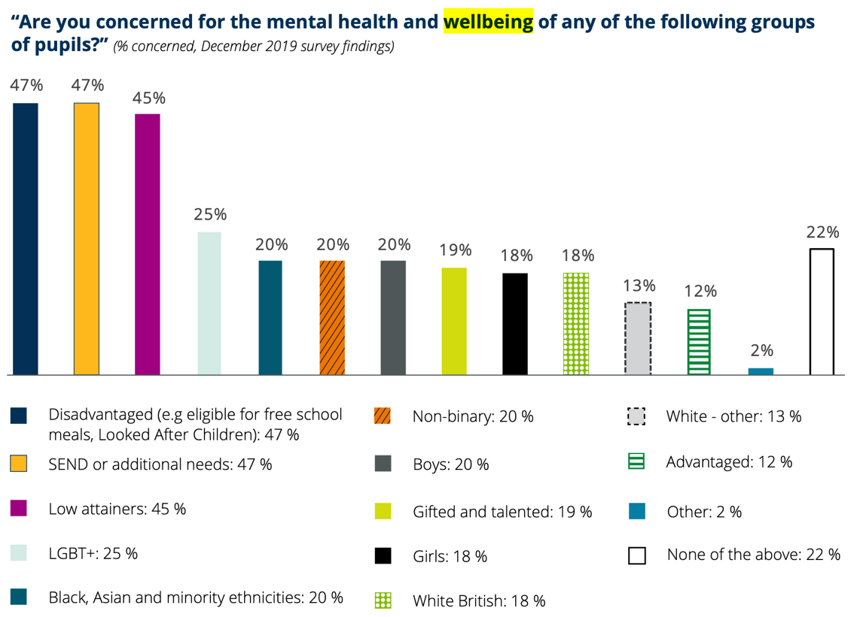
Mental health and well-being in pupils

Figure 1 (Pearson, 2020)

From figure 1 it is clear that the mental health and well-being of pupils with ALN is concerning according to a survey conducted in 2019. Lack of inclusion proved a barrier to children’s education, which concerns teachers. It has also been found that children from advantaged backgrounds have better achievement than those from a less advantaged backgrounds (Pearson, 2020).
In response to the FP, which was considered successful, in 2015 Professor Graham Donaldson was tasked with carrying out a review of the current curriculum, not just the FP, but up to key stage 4. The Welsh Government requested this review as they understood that the educational needs of children and young people would best be met through an improved curriculum with a sharper focus upon their individual needs. Throughout the review Professor Donaldson found there to be many shortcomings in the existing curriculum and coupled with the unsatisfactory Programme for International Student Assessment (PISA) survey results according to Donaldson (2015) it was felt that change was needed. Furthermore, the Donaldson report set out the basis of the new Curriculum for Wales, showing what schools need to meet all children’s needs within their care. The new curriculum was designed to use already existing strengths that were acknowledged during the review and build upon them for a more consistent teaching and learning approach. Additionally, the new curriculum would also help support children with ALN, through the designing of pedagogical approaches that would meet the needs of children, while also having a multi-agency support system (Donaldson, 2015).
The Curriculum for Wales has five progression steps per area of learning. Health and well-being the area of learning (AoLE) to be discussed. Progression within this AoLE enables pupils to deepen their understanding across a wide range of topics related to health and well-being. ‘Increasing effectiveness’ is one step within the AoLE, this is the step that allows learners to progress in their independence and responsibility towards their own health with support from responsible adults such as parents and teachers, this step includes working towards being more independent, understanding and recognising one’s feelings, the ability to make decisions, having the knowledge and understanding to ask more complex questions, and using language effectively in learning and social contexts (Welsh Government, 2021a). Furthermore, this step starts at the age of three, where a child normally has around 200 words in their vocabulary and development has already been mostly achieved (Pickles, 2021a).
Furthermore, the new curriculum for Wales has an emphasis on supporting well-being and inclusion, with learners being at the centre. Children and young people have the right to the best possible health and to be protected from harm, which means that a child’s well-being is vital to the progress in school. In order to create an inclusive school, the curriculum has ensured that unique needs or challenges are responded to and supported to enable the pupils to thrive in the school environment (Welsh Government, 2021b)
A legislation that came into place is The Well-being of Future Generations (Wales) Act 2015, which came into place to make Wales more competent with regards to well-being and to ensure that persistent inequalities such as health and poverty are driven out and children and individuals are supported. The act is unique to Wales, with lifelong impacts arising from the implementation. Moreover, the act has seven well-being goals, with a more equal Wales and a healthier Wales being the ones discussed throughout (Future Generations Commissioner for Wales, 2023). Seen below is all seven goals within figure 2

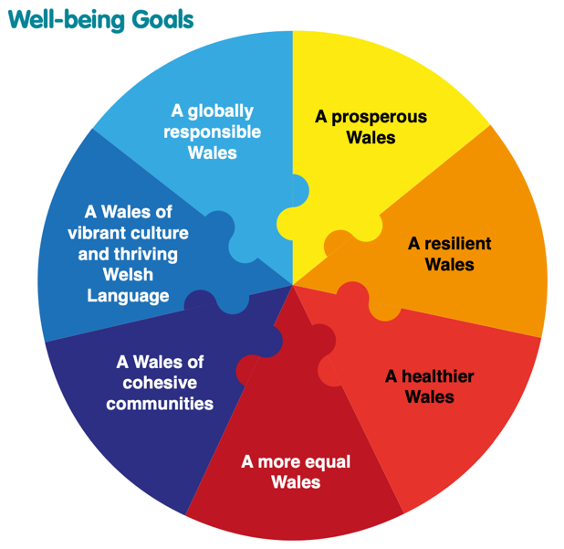
Well-being Goals

Figure 2: (Welsh Government, 2015)
A healthier Wales looks at how well-being and health can be maximised through healthy choices (Welsh Government, 2015) and a more equal Wales builds a society of enabling others and oneself to fulfil their potential (Future Generations Commissioner for Wales, 2023). The two goals being discussed, show how they were first identified in 2015 when the act was first introduced and are still an essential feature in 2023. These goals help children and schools mitigate the risk of adverse childhood experiences (ACE) by ensuring that there is early intervention in place (Future Generations Commissioner for Wales, 2018).
A more equal Wales entails a ‘journey’ that help to achieve the goal. Equality is an issue everyone should be concerned about, which is why this goal is backed by the Equality Act 2010, to protect from discrimination. Furthermore, to achieve this goal, people need to understand equality and schools need to empower equality. Education is a human right and therefore, all people in Wales have the right to access education and reach their full potential. Part of the journey to a more equal Wales is participation, which is important to be able to impact on their own care (Future Generations Commissioner for Wales, 2023). The second goal discussed in this document is a healthier Wales, this is needed to support well-being and allowing children and young people to have the best possible life. Schools and local governments need to provide environments that support the goal (Future Generations Commissioner for Wales, 2020).
Along with the number of curricula and legislation changes, there are also the models of disability that have previously been used to inform stakeholders as to how to interact with a child or an individual with a disability. The social model was created by individuals with a disability to express the barriers to them and how they affect their day-to-day life. The model was designed to show that the disability is not the issue, the problem is with the social barriers that surround them (Disability Wales, N.D). Furthermore, there is also the medical model of disability, which focuses mainly upon the ‘problem’, rather than the social barriers. This model suggests that individuals with disabilities are not participating in society due to their disability, and rather than helping them to participate, the model instead supports the idea of financially compensating the individuals, through benefits and special services (Disability Wales, N.D.). The Welsh Government have adopted the social model in a way that has provided a way for non-disabled peers to address common barriers and stereotypes. They have linked this with the Equality Act 2010 (Welsh Government, 2021c).

Similar to the UNCRC, there is also a United Nations Convention on the Rights of Persons with Disabilities (UNCRPD), which came into force in 2008, it took away the stigma of viewing individuals with disabilities as ‘charity’ objects, the UNCRPD provided individuals with disabilities with rights, ensuring that their care is informed and they have the right to be members of society (United Nations, N.D).

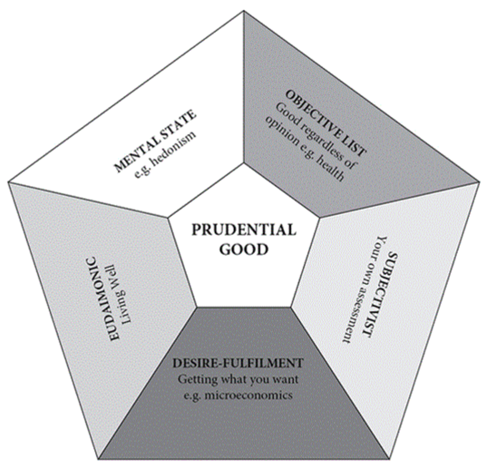
A taxonomy of wellbeing theories

Figure 3 (Fabian, 2022)

Well-being can be measured using philosophical theories, this started with the ancient Greeks, they were interested in finding out what makes a ‘good life’ (Ryff et al, 2021). Figure 3 shows five different approaches to well-being, also known as well-being theories. For the purpose of this study, only mental state, also known as hedonism, will be discussed. It is defined as the goal of life and how maximum happiness is experienced. There are different aspects to hedonism that make up the whole. The first aspect is identified as life satisfaction, that is how satisfied one is with one’s life, for example regarding health, relationships, and other areas of one’s life. Positive affect is the second aspect of hedonism, whereby data is used to evaluate how often someone felt happy, cheerful, calm, and other positive emotions. Finally, there is the negative affect, similarly this also uses data but this time to evaluate how often someone feels unhappy, sad, nervous and other negative emotions (Ryff et al, 2021).
Similarly, figure 3 demonstrates the well-being theories which includes objective well-being. This is measured through societal factors such as health and education.

3.3 Different types of chronic illnesses and disabilities: physical and mental
There are different types of chronic illnesses and disabilities some obvious some hidden, that affect children which include, but are not limited to: asthma, juvenile arthritis, cystic fibrosis, type 1 diabetes, Ehlers-Danlos syndrome, cerebral palsy, neurodivergence, long covid, anxiety and depression. For the purpose of this dissertation, these are the specific conditions that will be explored. These conditions affect individuals differently and can have a variety of symptoms which can limit the child’s experience of education and life in general.
The first condition to be explored is asthma which presents as wheezing when breathing, coughing and severe breathlessness (NHS, 2022b). According to WHO (2022), asthma affected over 262 million people in 2019, causing around 455000 deaths, and is a long-term condition that affects both children and adults (World Health Organization, 2022). Story 3 shows how asthma can affect school children and how it affects their play and emotions.

Story 3: During my time as a volunteer in a primary school, I had first-hand experience with children and asthma. During yard duty I had a child present with shortness of breath and slight wheezing when breathing. This made me realise that the child needed their inhaler, thankfully, I had been provided with the knowledge needed to find the inhalers, I was also given the necessary information on how to administer the medicine. This obviously cut into the child’s play time and affected their mood. throughout my time with the child, I found that they were very withdrawn from the other children and would play less than the other children within their class.

Children require play for their social and academic life to be successful. Children with asthma have a higher chance of not participating in play within school. There are benefits to play in school, these being, healthy and successful brain development, successful social skills and a positive outlook on learning. Without play, children have lower educational attainment and less social skills (Bhagat et al, 2019).
Juvenile arthritis (JA) is an illness which affects fewer children but still impacts over 300,000 children and young people in the world. It is considered an umbrella term that covers all inflammatory diseases that affect children under the age of 16, with most of its symptoms involving swollen and stiff joints, fatigue, and fever (Arthritis Foundation, 2022).
According to a study conducted by Fair et al (2019) in the National Library of Medicine journal, mental health conditions such as depression and anxiety are extremely rampant within children that have JA.
Another condition affecting children is cystic fibrosis (CF) which is a hereditary disorder that affects the lungs, digestive system, and other organs. It is caused by a defective gene within the DNA that causes a build-up of mucus within the lungs. Children with CF often have a wheezing, persistent cough, an intolerance to exercise, continuous chest infections and poor weight gain and slow growth (Mayo Clinic, 2023).
Cystic fibrosis (CP) is a hereditary disorder that should not prevent a child from attending school, however, attendance at school presents risks that can be dangerous to a child with CP, and due to this there is a need to put minor adjustments in place. With CP affecting more than just a child’s lungs, there is an infection risk in all areas of primary education. For example, lower primary school pupils often partake in activities involving water, sand, leaves and mud, for the purposes of experiential play. However, children with CP can become seriously unwell when involved with these activities due to exposure to harmful bacteria. That does not mean, however, that the children must be prevented from participating, instead reasonable adjustments can be made. For example, the class teachers and learning support assistant (LSA) would need to take precautions with anything involving water, such as water trays, which should be thoroughly cleaned and refilled with sterilised water to ensure that the risk of contamination by bacteria is minimised. Sand trays also have the same issues as water, as bacteria may build up within wet sand, so it needs to be sieved to help keep it dry. Furthermore, another environmental risk is rotting vegetation in the playground as any bacteria present in it is dangerous for children with CF (Cystic Fibrosis Trust, 2016).
CF causes difficulty with breathing, due to this, children with CF often find it difficult to exercise, and they tire easily. This can be supported by discussions with the pupil and parents, and others to support the child on their educational journey. Moreover, children with CF have a higher chance of becoming dehydrated during exercise, this is due to them losing more salt when sweating, therefore, they need to drink more throughout the day than other pupils. Due to all the challenges that come with CF, IEPs are put in place to support children with CF throughout their time at school, to ensure that they are able to access education on an equal level with their peers (Cystic Fibrosis Foundation, N.D).
Another ALN is Type 1 diabetes which is sometimes mistakenly thought to be caused by poor diet or being generally unhealthy. However, it is thought to be caused by the immune system attacking the insulin producing cells within the pancreas (Kawasaki, 2014). Without insulin the body becomes starved of energy due to glucose being unable to exit the bloodstream, causing blood sugars to rise and cause the body to not function the way it should. In the UK alone, over 400,000 people live with this condition, 29,000 of whom are children (JDRF, 2022). Story 4 examines how T1D affects the education and well-being of children.

Story 4: while volunteering, I had the pleasure of working with two young children with type 1 diabetes. Child A has had T1D since they were a baby while child B was diagnosed during their primary school experience. These children taught me a lot about perseverance and bravery. I was shown how the disease can affect education daily, I also saw how diabetes was perceived by other children. During low blood sugars, child A and B would be treated with coca cola or sweets, they would also prevent low blood sugars with the occasional snack throughout the day, during this time I heard “I wish I was diabetic so I could eat in class” “Child A is diabetic, they can not eat that” “They can only have diet coke because they are diabetic” “why does (Name) have that on their arm”-both children wore continuous glucose monitors- and so much more. This made child A and B very uncomfortable and allowed me to see the prejudice around T1D first hand. Furthermore, during my time at the school, I witnessed how play was affected due to low and high blood sugars. Child A experienced a stubborn low blood sugar that took three treatments to rise, this took around 45 minutes to an hour which meant they were excluded from their lesson. During this time, they experienced an abundance of emotions, including sadness, fear and stress. They tried to hold their emotions in but after being told that it was ok to feel sad and that it is normal in their circumstance, they then allowed themselves to let their emotions free. After nearly an hour, their blood sugars came back up, but they had symptoms from the low blood sugar that caused them to feel unwell, specifically a headache, child A was sent home to rest and recover for another day of learning.

T1D in children and young people has the potential to increase the risk of mental health. There are common emotions that children feel, these being, stress, sadness and anger which evidently lead to depression (American Diabetes Association, 2023). Emotions are a key factor in a child’s education, therefore, the effect that they have on a child with T1D can affect their education, with low blood sugars, there can be overwhelming feelings of sadness due to lack of glucose in the brain, the lack of glucose in the brain causes it to not function correctly, excessive sadness is a rational response and children should be comforted appropriately (Medtronic, 2017).
Stressful situations can impair memory by making the brain metaphorically freeze which disrupts learning (Davies, 2023). Furthermore, along with stress, sadness is a natural emotion for children to feel, it can however, slow a person down but also helps an individual understand a situation (Betterhealth channel, 2021).
Furthermore, Ehlers-Danlos syndrome (EDS) is a hereditary connective tissue disorder that is caused by a genetic problem that affects the connective tissue in individuals (The Ehlers-Danlos Society, 2023). There are many different types of EDS, including but not limited to joint hypermobility and tissue fragility. For the purpose of this dissertation, EDS will be described as joint hypermobility. Also known as hypermobile EDS (hEDS) this causes an abnormality affecting the range of motion within the joints, meaning that there is more movement than normal. Some people with this condition are not affected at all, while others also have joint instability, meaning that the joints are not securely held in place. The problem with joint instability is that it causes subluxations, dislocations, and other issues for the individual and causes acute and chronic pain. Furthermore, there is no specific treatment for EDS, however, as there is no generic way in which individuals respond to the diagnosis an individual development plan will be put in place to support the child once diagnosed (The Ehlers-Danlos Society, 2023). Furthermore, story 5 shows how education can be affected by EDS.

Story 5: Growing up with a condition similar to EDS, I have first-hand experience with the effects of the condition. My early education was affected by continuous dislocations and subluxations, as well as pain and fatigue.

Chronic pain changes how the life of individuals progresses. Specifically sleep, chronic pain interrupts sleep (Cherry, 2022). Everything that is leant is stored briefly in the hippocampus,
which is a part of the brain, however, that part of the brain has a limited amount of ‘storage’ and sleep is required to replenish the brain and the ability to learn (Cappello, 2020).
Another condition considered as an ALN within this project is neurodiversity. This is an umbrella term for any condition that causes a neurological difference or change in the brain chemistry that causes the brain to function ‘normally’ and process information. The conditions under this umbrella term include Attention Deficit Hyperactivity Disorder (ADHD), Attention Deficit Disorder (ADD), dyslexia, and autism. Children who have a condition under the ‘umbrella’ often have a unique way of thinking and interacting. It also provides them with a unique set of challenges that only they can fully understand. Therefore, a child with neurodiversity has an alternative way of thinking through challenges and information (The University of Edinburgh, 2023). Children with a condition under the umbrella of neurodivergence often find it challenging to fully participate in educational activities, they also face stigma due to lack of knowledge on these conditions (The University of Edinburgh, 2023).
Furthermore, an ALN that affects the capability to move, balance and control their posture is known as cerebral palsy (CP). CP is the common reason for many motor disabilities within childhood, with the symptoms differing for everyone, depending on the severity of the condition. There may be a need for special equipment to be able to walk and or move around. As the child gets older their symptoms may change, and they may need help with speech, learning, and physical mental tasks. Ideally, treatment plans need to be in place as early as possible so that the child can be supported appropriately (Centres for disease control and prevention, 2022).
Moreover, another condition that has recently been found to affect children is long covid, symptoms last around only two weeks in some, while in others, there are long term effects in children, these include fatigue, mood problems, breathing issues, headaches, and lack of concentration, these effects this has on education can be debilitating and isolating (John Hopkins Medicine, 2022). Long Covid can affect a child’s education due to the symptoms that the child experiences, and this could mean that schools will need to put changes in place, including the child’s environment. There may also be a need for an IDP, and risk assessment to support the child. (The University of Manchester, 2023).
The conditions above are likely to cause the child anxiety. Anxiety is a broad term for feeling worried and scared (NHS, 2023). It causes irregular heartrate, unsteady breathing, and can cause general feelings of distress. The condition can cause panic attacks which will cause the child to feel under threat or danger when they are not (Barnardo’s, 2020). Like adults, children will feel anxious at times and need support from the adults around them. This may start as simple separation anxiety but escalate until it becomes a significant problem in their everyday life. There are many ways in which it affects children in school, some being, lack of concentration, anger outburst, and avoiding activities such as socialising, or even attending school (NHS, 2023). The effects of anxiety on education can be seen in story 6.

Story 6: I have first-hand experience of working with a child suffering from anxiety. This mainly affected their social skills; the child would cry often and complain of stomach aches when something involving group activity was mentioned.

Anxiety affects the way children live their life, they often go to lengths to avoid any and all social interaction (Bridges to Recovery Beverly Hills, 2023).
Long term health conditions and/or disabilities such as the ones discussed above, influence the well-being and mental health of the individuals with the specific conditions. These conditions cannot be cured and are often managed through the use of medication and therapies. The effects that the conditions have upon the individuals include social isolation, low self-esteem, fatigue, worry and stress. Furthermore, children with these conditions often experience stigma and discrimination which in turn causes the feelings mentioned above, along with depression and anxiety (mental health foundation, 2022).
Furthermore, along with the effects it could have on children and their education, there is also the problem with accessibility, improvement is needed with accessibility to school buildings, school grounds and activities (Welsh Government, 2018). Highlighting the barriers children with specific chronic illnesses and/or disabilities experience, draws attention to possible exclusion from activities, thus preventing them from accessing parts of the curriculum that they may benefit from, meaning their education may be inferior compared to those without chronic illnesses and/or disabilities (Ravassard, 2022). Story 7 sheds light on how inaccessibility can affect a school.

Story 7: During my time volunteering at a primary school, I witnessed an Estyn inspection that the school received an ‘unsatisfactory’ in many areas of teaching and support, Estyn placed the school on the special measures list, which was followed up with termly, and eventually removed from the list in 2021 (Estyn, 2018). The school was old so there was only one ramp into the school, and it was only in one building, the other buildings had steps which meant they were not accessible to all.

Schools are not always provided with the funding required to renovate the school and make it accessible to all pupils. Without safe and appropriate access to all buildings, children with disabilities and/or chronic illnesses are often unable to attend school due to the lack of accessibility (UNESCO, 2020). According to the Equality Act 2010, non-inclusive factors include the inability or difficulty in moving around and/or accessing buildings, this could be because of steps, not being able to open doors and being unable to follow orders (Gov.uk, 2013).

3.4 Support available for pupils in primary education
Children with long term health problems and disabilities will often feel different to the other children, especially if they are prevented from taking part in the activities that other children can enjoy. The limitations on their education and play affects the ability to understand why they are ‘different’. (Devis.Wales, 2023). Furthermore, parents and guardians have an important role in the completion of an individual education plan (IEP), they have the most knowledge of the child, and they understand the whole child and their history (Logsdon, 2022).
Some activities that children in primary schools partake in include sand play, water play, play dough, dress up, role play, drawing, painting, Lego, dancing, imaginative play, running, jumping, nature play, sensory play, and cooking (sitter.co.uk, N.D).
Support for children with chronic illnesses and/or disabilities, is vital in schools. One way of supporting children is through a parental partnership with the school. This concept has been in place prior to 1996, with the introduction of the Plowden Report, which emphasised the importance of parental involvement in the treatment and care of children in an educational setting. Moreover, since this implementation of parental support in schools, parents have played a greater role within schools in the support of children, for example, taking part in school trips (Mills, 1996, Pp. 2-3).
Parental partnership also has other benefits, not only in participating in school trips but also in the development of the IEP for the child which is a legal requirement. As a parent, they understand their child’s development, history, and strengths and weaknesses: this information is essential in the implementation of an IEP, as this means that they can be provided with the exact information needed to help continue the child’s learning at home which will enhance the child’s learning at school. This also supports the role of advocacy, as parents are a child’s greatest advocate, and they have the greatest motivation to see their child thrive. This provides the IEP team with the best, up to date information and requirements for the child. This is achieved through the keeping of detailed records throughout the child’s life, which then become part of the child’s IEP. Parents are the people most likely to have the child’s best interest at heart, as they want their child to be given the best chance for an education and therefore, become their advocate (Logsdon, 2022).
All conditions mentioned within this project should include parental involvement with their care, including as advocates and arguably the most important person involved in the care and education of their child.
As previously mentioned, parents are a child’s biggest advocate. However, due to the new ALN code, children also have the right to an additional advocate who will help speak up for the child in situations where they are unable to speak for themselves. This could range from appealing a decision to the Education Tribunal Wales committee, to helping them understand what they need and providing the school with information on what they can do to support the child (Welsh Government, 2022).
Prior to 2018, the IEP was the document used in Wales to specify what a child with SEN would be taught, how they would be taught, and the strategies and resources that would be put in place to support the education of specific children with SEN. Furthermore, IEPs had a record section where the child’s progress would be recorded. During the time when IEPs were used, most schools used the SMART acronym, to ensure that goals or targets were specific, measurable, achievable, relevant and time limited (SENAC, 2023).
However, post 2018, Wales moved to the new system of IDP, which also abandoned the term SEN and replaced it with the term ALN which supports children and young people from birth up to 25 years of age. Each IDP document was to contain basic information on the child, such as their name, date of birth, and parent/carers contact details. Moreover, the development of an IDP was to be a collaborative process, including parents, the child, and local authorities in a multi-agency approach. (Welsh Government, 2021d). The new documents proved effective largely due to the need to engage the family in planning and decision making. However, there were some similarities to the old IEP documents, for example they also included a monitoring section, to evaluate the targets it contained and monitored the progress of the child (Newport City Council, 2023). All disabilities and chronic illnesses discussed throughout, require IDPs so that all necessary information can be compiled in one document which is easily accessed by all stakeholders.
As well as IEPs and IDPs, schools often have individual healthcare plans (IHP) in place for children with more complex medical needs, and these are required to be easily accessible to all who need it, while remaining confidential. Moreover, they include the needs of the child, such as the support they need, and should also include any requirement the child might have, for example medication dosage, or in the case of a T1D child, the carb to insulin ratio. The plans will also include side effects or symptoms, emergency contact details and protocols, and finally the role of the staff of the individuals involved in the child’s care (Swansea Council, 2022). This is a detailed document which is needed for children who have complex medical needs, specifically children with T1D, CP and CF, and highlights the development and progress made in record keeping for children with complex medical needs.
IDP’s and IHP’s require a team effort to create, this involves the class teacher, the designated ALNCo, the school’s heads teacher, GP or health visitor and a social worker (Dewis Cymru, 2023).
Furthermore, some complex medical needs require input from a healthcare professional. For example, a diabetic nurse is an essential role in the care of T1D children, they often work as part of a team, which includes the school, local authority, parents, and health services, for example, a diabetic nurse. According to Diabetes UK (2018), Wales has in the past been identified as being behind in the care and support of children with diabetes. This was discovered when families of children with diabetes were questioned regarding how often their child’s education was affected by the condition, in this survey 30% of respondents stated that their child were affected every day. Furthermore, 51% claimed to have problems with care, and 36% stated that their child had to be removed from school during the school day.
Moreover, T1D affects participation in sport, clubs and even school trips. This is where the diabetic nurse or paediatric diabetic educator comes in: they attend the school to enhance the knowledge of two or more educators so that the child or children with T1D in the school are provided with the necessary support they require (Diabetes UK, 2018). Moreover, the diabetic team supply training at different points of the year, for example on diagnosis, at the start of every school year and on any change in treatment plan. Each child with T1D will have a record keeping sheet or book to document their treatment throughout the day, blood glucose (BG) checks and number, for example, 5.0mmol/l , insulin injections, amount of insulin in units for example, 3u to emphasis three units of insulin given to cover meals and how many carbs were covered in the meal (Cardiff and Vale University Health Board, 2021). As seen by the name, a diabetic nurse is specifically for children with diabetes.
Similar to the diabetic team, the CF team play an integral part in the education of children with CF. The team are able to communicate with the school to provide support and training. CF is life threatening and can be more dangerous if there is more than one child with CF in the school. This risk of passing on infections to the child is a threat to their well-being and therefore, the CF team can provide support and training on how to care for all children with CF in the school without compromising the health of any of the children. Furthermore, children with CF require numerous medications and therapy, so the CF team can provide training and support in the provision of treatment. Education is essential in the well-being of children and the CF team can help ensure that the child’s education is not affected (Harrison et al, 2021). This support is in place for children with CF due to the needs that they have.
Another local service available to support children in schools is physiotherapy, these specialists understand the complexity of children’s needs, and are able to meet their needs in an environment in which the children are comfortable. Some of the conditions that they support include CP, JA, respiratory conditions and hEDS. They bring the equipment necessary for the treatment of the child and/or children. The physiotherapists can help the schools and family understand how the child copes throughout the day, help them to reach their potential and overcome the challenges that their condition causes (Physio.co.uk, 2023). Furthermore, children with specific needs require physiotherapy, for example, children with CP, CF, EDS, JA and occasionally long covid, depending on the symptoms the child suffers.
Another support service that the local authority provide is social services. which strengthens support for children, working as a multi-agency team, with safety officers, school nurse, and mental health practitioners for example, counsellors (Neal, 2021). Social services also liaise with other support that may be in place such as counsellors as mentioned above. They do this to support children more effectively, including in the areas of mental health and well-being of pupils, as well as disability and/or chronic illness. They also play a key role in child protection, and are known by a variety of titles, two of these being school social worker and education welfare officer (UNICEF 2022). Social services are part of the local agencies that schools employ, there is also counsellors, which would be in place for all children but specifically the children with anxiety and depression. The social workers will support children with neurodivergence specifically.
The final support system to be discussed is speech and language therapy. It is expected that a child understands basic speech and language when starting school, and that they will have the ability to express themselves and understand others. However, this is not the case for all, which can cause withdrawal and can severely impact a child’s learning (I Can, 2008). Furthermore, speech and language therapists work alongside the school to help the child understand verbal and nonverbal cues. In order to do this, they are required to work as part of a team, often with people other than just teachers, are they are also required to work in direct contact with the children, sometime 1 on 1 and at other times in a group, creating a supportive and educational environment for the child (Wittington Health, 2023). Speech and language therapists work with children who require them. This could include neurodivergence and CP.
Bronfenbrenner’s ecological systems theory theorises that the environment one lives in shapes and influences their life. There are five systems that make up the theory. The first being the microsystem which is made of the groups that the individuals are in direct contact with. Next is the mesosystem which is the relationships of those in the microsystem. Exosystem is next and is made up of the factors that affect the individual’s life but do not have direct contact with them. Furthermore, there is the macrosystem, containing the cultural elements that impact a person’s life. And finally, the chronosystem, which is the stage of life that the individual is in (Office for Multicultural Learning, 2023). These can be seen in figure 4.

Bronfenbrenner’s ecological theory
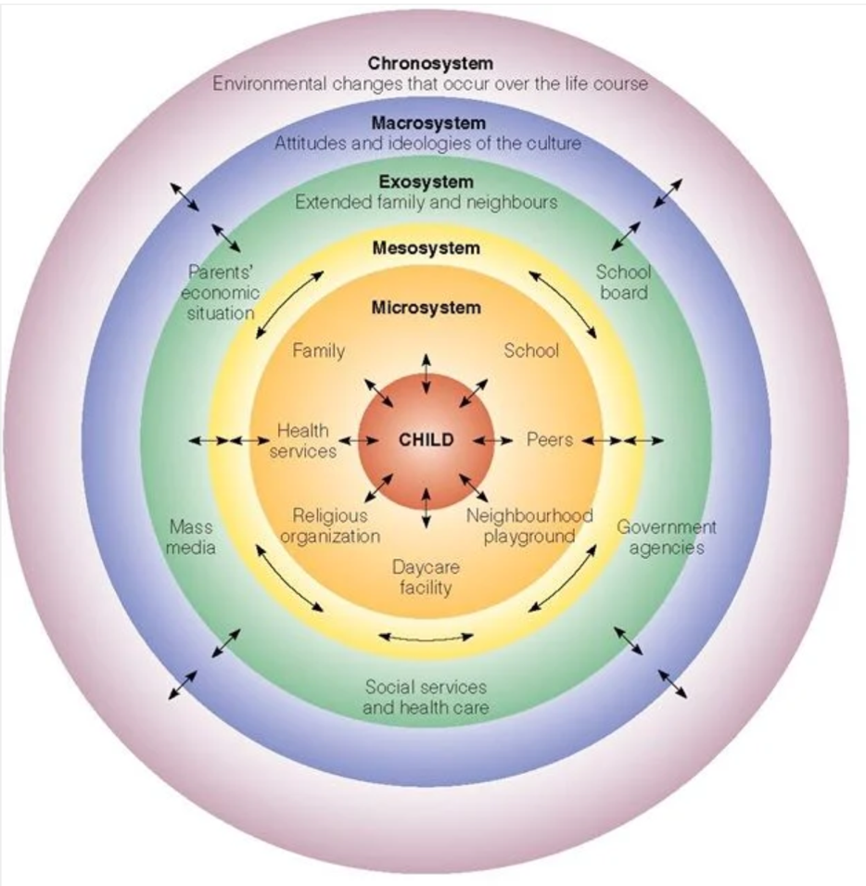

Figure 4 (Mcleod, 2023)

This project has adopted and adapted this theory. With the child with ALN in the middle, the microsystem being their immediate support system such as parents, siblings, friends, teachers and clubs. The mesosystem linking relationships between microsystem and exosystem. The exosystem being local authorities, diabetic nurse, CF team, physiotherapy, social services and speech and language. Next is the macrosystem which is the legislation and policy that support children with ALN and finally the chronosystem being the environment that surrounds the child.
As seen in figure 4 Explains how Bronfenbrenner’s ecological theory places the child in the middle and is surrounded by the child’s community, however the community is all interlinked to improve the holistic well-being of the child. The theory views development as a system of relationships that are affected by multiple factors such as the environment that surrounds the centre, in the case of this project, it is the child with an ALN (Mcleod, 2023). Ever since the introduction of the ecological systems theory, the word has advanced, making way for technological advancements, meaning that the exosystem could include the influence of social media, games, and online communities (Mcleod, 2023).

3.5 Conclusion
To conclude this chapter, the first part of this chapter was variety of curricula, legislation, policies and theories discussed, which brought attention to inclusion and how there is room for improvement. This chapter also explored the terminology change from SEN to ALN which prompted the role change from SENCo to ALNCo. Furthermore, well-being has been emphasised in the FP and was drawn up in the well-being goals from the Well-being of Future Generations Act 2015. Which only discussed ‘a more equal Wales’ and ‘a healthier Wales’ due to their appropriateness within this project. Moving forward with well-being this chapter highlights the models of disability and how the Welsh Government has adopted the social model, along with linking the UNCRC and UNCRPD to supporting disabilities in Wales. The second part explored the chronic illnesses and disabilities that this project focused upon, which are asthma, juvenile arthritis, Ehlers-Danlos syndrome, cystic fibrosis, type 1 diabetes, cerebral palsy, neurodivergence, long covid, anxiety and depression. It was concluded that each of these conditions affected everyone differently and affected children’s well-being profoundly. The final part of this chapter explored the support that is in place to help children in schools, some of these being an IDP, physiotherapy and counselling, there were a variety of other support systems discussed throughout. this section also adopted Bronfenbrenner’s ecological systems theory, placing the child with ALN in the centre and the systems surrounding it being the support and legislation. Throughout this chapter, there is a variety of personal stories that bring together the information and help understand how specific conditions affect education.

Chapter 4: Methodology and methods

4.1 Introduction
This chapter will discuss the methodology implemented in this research project and the methods used throughout to create a quality research project.

4.2 Rationale
This research project analyses well-being, chronic illness, and disability, specifically, how children in primary school are affected by chronic illnesses and disabilities and how schools help their pupils overcome the challenges they face. The aims of the research are to understand the challenges that the pupils face and to investigate whether there is any further support needed in the schools. In order to fulfil the aims, an extensive literature review will be conducted, using a qualitative methodology and autoethnographical approach.

4.3 Qualitative design
Qualitative research has the ability to answer questions that are unable to be answered by other methods such as a quantitative method and is somewhat underrepresented (Tenny et al, 2022). However, the method is flexible and allows a number of study options, such as document study, observations, and interviews. For the purpose of this study, document study will be discussed (Busseto at al, 2020). Furthermore, a qualitative study design provides the opportunity to explore and develop information on the day-to-day problems or challenges and allow for questions such as ‘how and why’ (Tenny et al, 2022).

4.4 Research paradigm
This research is conducted through an epistemology, constructivist/interpretive paradigm. Epistemology is the philosophical side of research and examines what and how others think, including how a person interprets and evaluates information (Hofer and Bendixen, 2012). Moreover, the constructivism/interpretive paradigm depends upon the individual due to the meaning varying from person to person. Simply put, it is how a person perceives, explains, and interprets information (Ültanir, 2012).
An interpretive paradigm is useful to this research due to the researcher interpreting the data in their own way, meaning that there is no two ways of repeating the analysis of information.

4.5 Research design

This research project is an extended literature review, using a qualitative methodology and an autoethnography approach. “Autoethnography is an autobiographical genre of academic writing that draws on and analyses or interprets the lived experience of the author” (Poulos, 2021). The quote emphasises what an autoethnographical approach is and how it is used. Autoethnography is a way of constructing personal experiences into academically appropriate writing, which uses a variety of ‘data collection’ methods including, but not limited to, observations, interviews, and storytelling, using narratives to capture experiences lived by the author (Poulos, 2021). Furthermore, autoethnography is a unique form of qualitative methodology. As mentioned above, it can be used to incorporate narratives into the research as essentially, the researcher uses the approach to construct stories from prior experience and uses the approach to conduct a thorough research project (Cooper and Lilyea, 2022).
Furthermore, this research takes a positionality approach which means that an author knowingly blurs the barriers between personal life and professional life and projects their views within academic work. By creating a piece of research with positionality in mind, the author or researcher can be exposed to emotional distress depending on the information (Massoud, 2022). Due to the emotional distress that this research can cause, there was a strict ethical procedure that needed to be conducted which will be pursued during discussion on ethical matters.
Autoethnography, the research method being used, comes from the Greek term meaning literally ‘self-writing’. It evolved from ethnography, as a way of including the lived experiences of the author in a cultural context to support a hypothesis or study (Poulos, 2021). Due to the limitations and timescale of the project, only a storytelling method will be used.
As mentioned, this piece of research is going to be completed through a qualitative literature review, this is because the research in question is very close to the researcher’s heart, with the researcher having a chronic illness, this meaning that going out in the field and procuring information for an empirical study is not possible. Pain and accessibility were a factor in the decision process, this meaning that a literature review project was in the best interests of the researcher. Furthermore, the literature review will include personal stories within the themes it contains.
Moreover, literature reviews are an important aspect within any form of research as they bring together a whole new perspective and an entirely new piece of work through the evaluation and analysing of current research (Burton, 2010). Therefore, the inclusion of a literature review is vital, however, the process of creating one is different for everyone, due to the methodology used in the search and how the information is evaluated (Snyder, 2019).
Furthermore, focusing on the qualitative methodology, uses a holistic approach to research. There is also the aspect of describing events and or information, evaluating them and then interpreting the information to best fit the research. This methodology can help in the creation of new theories, through five areas of study, these being: case studies, ethnography, phenomenological study, grounded theory, and content analysis (Williams, 2007). For the purpose of this research, ethnography or autoethnography will be discussed. Ethnography refers to the cultural aspect, and for this study, this will be the school setting (Williams, 2007). Regardless of the possibility of creating new theories, the time limit and scope of the project does not make it possible to create any theories.
Denscombe (2014) points out that qualitative data collection can be achieved through the use of words, both written and spoken and can be produced through a variety of methods such as narrative and ethnography. Drawing on the work of Poulos (2021) this dissertation is taking a narrative approach: a narrative is a story, which can be expressed in different ways and for the purpose of this dissertation, it will be expressed through the media of text. Narratives often have three expectations, these being: having a specific purpose, containing a plot, and involving people and their emotions (Denscombe, 2014, Pp. 276-291). Furthermore, the research will be written through a systematic literature review which is set out above.
While literature reviews are a fundamental part of research, it is important to design them correctly, taking into consideration the target audience, the methods being used and how it will be analysed. These are all important because each aspect could create a different outcome, so to prevent this, it is important to carry out research first and then analyse the information prior to conducting the literature review to ensure that there are no gaps in the research (Raju and Phung, 2021).
As stated within the literature review, a number of search engines were used, specifically Google, Google scholar and UWTSD library. These search engines provided a variety of academic articles and government information sites that provided details on inclusion of children with disabilities within the education sector. To access these details, key words mentioned within the literature review were entered, for example, chronic illnesses, disability, well-being and school.
Furthermore, the process of writing a literature review is undertaken in steps that create a whole (Efron and Ravid, 2019). Creating a research question or hypothesis comes first. Figure 5 shows that there are four steps in the development of the question or hypothesis. Task 1 involves finding a research topic; this task is the most important, as without an acceptable question/hypothesis, it would not be possible to complete the subsequent tasks. There are different resources that help to pinpoint a research study, academic journals and academic theory, being two of the many resources available. Furthermore, task 2 identifies the reason for the subject. With task 2 identifying the why, task 3 focuses more on the how, undertaking the research and defining terminology. Finally, there is task 4, taking all previous tasks and combining them in preparation for writing up the project (Machi and McEvoy, 2022).

The process of creating a research topic statement
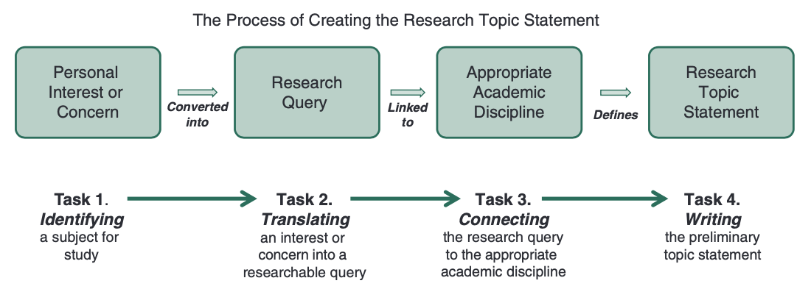

Figure 5 (Machi and McEvoy, 2022)
This figure helped to create the research question for this project, this was done by working through each task individually, starting with task 1, the researcher identified a task through the exploration into research and social media sites to find the most appropriate topic. Which then led onto task 2, the research from task 1 translated into a researchable query. This task proved more challenging than the first and resulted in three possible research questions being analysed and evaluated. Question 1: ‘Wellbeing, chronic illness, and disability. An exploration into how chronic illness and disabilities affects wellbeing in students throughout their education and how schools/educational institutions work to help their students overcome the struggles that come with a chronic illness and disability’ This question was analysed for suitability of range of students. The decision was made to have a sharper focus on school age children and so question two was devised. The second question ‘well-being, chronic illness, and disability. An exploration into how chronic illness and disabilities affect well-being in pupils within primary school education and how the schools work to help their pupils overcome the struggles that come with a chronic illness and disability’ this question was also evaluated, and the terminology used was not deemed suitable for the study. Therefore, the question was finally refined for a third time, ‘Well-being, chronic illness, and disability. An exploration into how chronic illness and disabilities affect well-being in primary school pupils and how the schools help their pupils overcome the challenges that come with having a chronic illness and disability’, it was determined that this question fit the scope and researchable query for this project. Furthermore, after finding a researchable query, the researcher then moved onto task 3. This task required the connection with appropriate academic discipline, this was done through the completion of an ethics form and analysis of the most appropriate methodology and terminology to be used throughout the project. Finally, working through task 4, this involved bringing together everything from the previous three tasks, and helped the researcher commence the written aspect of the project. To complete these tasks, it was challenging to create a researchable question with the timeline of the research. Five and a half months does not provide a wide range of options for a good research project, therefore, question 3, which is stated above became the most logical research query, however, in order to complete it, it had to be done through a literature review due to the extent of complexity that the question holds.

The above shows how the question was created, however, there are further steps undertaken in the creation of the project as a whole. Locating relevant information, was arguably the lengthiest step. The next step involved filtering the information to narrow down the search field. Which was followed by the validating the research. This ensured that the information was taken from credible and academic sites, including when using personal accounts. This meant that a more personal aspect included, while also providing a valuable insight into the subject area. Furthermore, the next step involved the application of the research: this section was mainly set in the literature review. However, the research is also integrated throughout the entire project. After applying the research, it is important to discuss the results it contains, and this is included in Chapter 4, which covers the discussion of the finding, bringing all the information together and providing an overview of what was discovered, how it can be applied, and how useful it will be in the future. Finally, Chapter 5 will conclude the project with recommendations for future possible projects which could be undertaken by the researcher or others.

4.6 Ethical considerations
Ethics are considered to be what control one’s behaviour: similarly, ethics and research have the same moral philosophy underpinning them. As part of any academic process, ethics are a vital part of the research procedure, highlighting the need for a code of research to determine if something is acceptable (Parveen and Shoowkat, 2017). To highlight the importance of ethics, the Economic and Social Research Council (2023) have outlined exactly what good practice is and why it is important, starting with ensuring their readers know that failing to maintain the ethical guidelines is unacceptable. Considering ethics is a critical step in undertaking any form of research, and there is frequently a code of conduct that includes, but is not limited to: honesty, confidentiality, and dignity. Using the code of conduct, researchers must understand that they need to interpret data in a way that ensures that all codes of research are followed (Babikir et al, 2012). Furthermore, ethics are the guidelines followed to differentiate between right and wrong. There are many reasons as to why ethical considerations should be taken to into account when completing research, these come down to one thing: promoting a morally correct piece of research (Vinayagam, n.d.).
This research project is conducted in accordance with the UWTSD ethical guidelines, data protection, and data collection all being approved through the ethics committee. According the UWTSD ethical guidelines, research should be honest, and its guidelines ensure that all researchers within their institution complete an Ethics Form to ensure the integrity and quality of the research being conducted, while also protecting everyone involved (University of Wales Trinity Saint David, 2022). Ethical considerations are important to all research projects. This being said, although the research being conducted is low risk, the university could be vulnerable to the risk of plagiarism. This, however, can be easily mitigated by ensuring all referencing is undertaken in accordance with university guidelines. Furthermore, there are also risks to the researcher, as mentioned above, the research being conducted is based on chronic illness and disability, which is personally relevant to the researcher due to them having a chronic illness. As the researcher has attached personal narratives to the literature review from their own experience, this means that there is the risk of causing upset and mental distress. However, the university would provide support to students in cases where distress has been caused. Moreover, ethical considerations are vital when undertaking research, and all universities will have ethical frameworks in place to ensure honest and respectful research, and these frameworks must be followed to prevent unfair and untruthful work (UWE Bristol, 2023).
Furthermore, there is no specific confidential data being used throughout, all information is from easy to access, government sites, books, websites and blogs. However, the personal stories used throughout require an aspect of confidentiality, schools will not be named, and neither will children, providing a confidential story that the researcher has personally experienced.
Appendix 1 shows an example of the ethics form that was completed prior to the start of this project.

4.7 Reliability, validity, and generalisability
All research is required to be reliable and valid in the area of study. This research looks at a variety of data and follows the research paradigm in its collection. Furthermore, the reliability of this research lies in the consistency of inclusion throughout and the possibility to recreate the study in more depth.
Qualitative research has positive and negative aspects. When it comes to reliability and validity, a qualitative research project is not sufficient when checking the quality by repeating the research, and the ability to verify results as there is no way to prove that the data and information collected is correct. However, one of the main benefits of qualitative design is that it provides grounded data, which builds upon comprehensive text. As well as this, generatability is also important in any qualitative research, as it looks at the probability of the research being completed elsewhere with the same or similar result (Denscombe, 2014).
With all research, the role of the researcher is fundamental to the process of data collection and will affect the reliability of the research. This is because it raises questions such as: can the research be completed by someone else with the same results? (Denscombe, 2014).
The answer to that question would be no, and due to the interpretivist paradigm, the research will be interpreted differently by others, therefore, this research would not be possible to replicate in the exact same way. Similarly, this is also connected to generatability, as depending on the paradigm, the results from this study may be transferred as basic data, however, the interpretation will differ from one person to another.

4.8Analysis of data
One way of analysing this research is through a thematic analysis, which identifies common themes throughout that help to identify information about a topic. This technique of analysis comes with two different approaches. Firstly, there is inductive, which allows data and information to establish themes, then secondly there is deductive, which is the opposite and uses pre-existing knowledge and understanding of a topic to create the themes (Caulfield, 2022). Thematic analysis is a practical analytic approach for qualitative research, an approach which is suitable for all levels of researcher. Furthermore, themes can be identified in two ways, the first being semantic which is the surface meaning of a topic, and the second being latent, which means that there is a deeper and underlaying meaning (Kiger and Varpio, 2020).
According to Braun and Clarke (2013), thematic analysis is a widely known and utilised method for qualitative research that aims to recognise themes and patterns throughout the research but is not shaped by current theories (Braun and Clarke, 2013).
In order to successfully use thematic analysis, there are steps to follow. The first being familiarising the data, the second being coding, which involves highlighting relevant sections of the text. This is followed by generating themes which come from recognising the patterns that emerge, which are reviewed in the fourth step. This step ensures that the themes identified are beneficial and information is not omitted. Defining and naming the themes follows this which entails understanding what the themes mean. The final step is writing up which brings the data together and analyses the literature (Caufield, 2022).

Chapter 5: Discussion

5.1 Introduction
Throughout this chapter, data collected in chapter 2 will be discussed and analysed through thematic analysis which has provided a thorough view on the data within the literature review. The literature review is set out within specific ‘themes’ that are not based on a thematic analysis, they are simply used to identify the sections of the literature review and separate the information appropriately. To complete the analysis, this chapter will be separated into subsections that will analyse each literature review ‘theme’ individually before concluding all in the final subsection.
To use a thematic analysis, there are six steps that need to be followed in order to complete the analysis, these steps being, familiarising the data, coding, generating themes, reviewing themes, defining and naming themes, followed by the final step of bringing data together to analyse literature (Caufield, 2022).
Thematic analysis can be used to help with the struggle of combining a narrative method with an academic stance (Lainson, Braun and Clarke, 2019).
With this research being conducted through a qualitative methodology, there is always going to be something new to learn, regardless of how much is covered within, one key aspect that draws researchers into a thematic analysis approach to analyse their qualitative data is the ability to articulate the information they find into themes to help with their analysis (Braun and Clarke, 2019).

5.2 analysis of historical context

The numerous curricula and inclusive policies and legislation surrounding the education of children with disabilities and chronic illnesses, meant that challenges were encountered. Inclusive education started prior to the national curriculum, there were schools for deaf children, along with specific communities created for “disabled people”, this is not the most inclusive as they were isolated from non-disabled individuals (Historic England, 2023). Schools for the deaf and opened in the 1760’s, with mental disability education starting in 1847, followed by education for the physically disabled in 1865. This was followed by the Education Act 1870, which changed education for the better. This act ensured that ‘special classes’. The act was then updated in 1944 in order to create a post war education system (Evans and Varma, 1990, Pp. 18-20). After years of the post war education system, the national curriculum came into force in 1988 through the form of the Education Reform Act 1988. However, prior to the implementation of the national curriculum, there was a change in terminology regarding children with disabilities, children with disabilities were considered to have special educational needs (SEN), instead of ‘handicapped’. This changed how children with disabilities were seen and helped with the improving of provisions for children with disabilities (Adams, 1990, Pp. 1-19).
Furthermore, the UNCRC came into force to support the well-being of everyone, there are specific articles throughout that specifically target the well-being of children (Welsh Government, 2015a). With the UNCRC in place, the national curriculum continued to develop until the Foundation Phase (FP) was rolled out in 2010, this curriculum focused on the well-being of the pupils, through experiential learning, meaning that children will enjoy their education (Welsh Government, 2015b). A great step forward for inclusion came in the form of terminology change, moving forward from SEN to ALN, which also changed compulsory roles within schools, in place of the Special Education Needs Co-ordinator (SENCo), there was now to be an Additional Learning Needs Co-ordinator (ALNCo) (Welsh Government, 2019). After five years of the FP, Professor Graham Donaldson was asked to review the curriculum from the FP to key stage 4. The outcome of the review showed the need for change, the results were strengthened by the national PISA results. The results developed into a new curriculum, called Curriculum for Wales. ALN becoming a key factor to focus on (Donaldson, 2015).
However, historically inclusive education has not been as prevalent therefore, research into inclusive education in the past proved problematic at times.
Finding information on inclusion throughout history became difficult due to the numerous curricula and legislations available within Wales. Disabilities have been seen in negative and positive views (Babik and Gardner, 2021). These views made it difficult to find the information necessary.
While analysing the data, various codes were developed: eight became apparent which were highlighted in different colours, these being, yellow, pink, blue, green, red, teal, gold and grey. Originally, the codes were all developed into themes, these being, support, attitudes, relationships, inclusion, exclusion, terminology, possibility, and well-being. However, when re-evaluating them, it was found that some codes were either absorbed into existing codes and others were eliminated completely. During the process of absorbing and eliminating, the eight themes were narrowed down to six, which can be seen below.
The target of thematic analysis is identifying themes or patterns within the information, these themes are then addressed and analysed. Essentially, successfully using thematic analysis is finding a way to make sense of and interpret the data in a way that others understand (Maguire and Delahunt, 2017). Below is an example of how thematic analysis was applied and how themes emerged.

Themes | Example
Support throughout history  Code: Yellow | “Support for children” (Mills, 1998, Pp. 2-3).  “Acquire support from schools” (Evans and Varma, 1990, Pp. 18-2-).  “Supported in the best possible way” (Adams, 1990, Pp. 1-19).  “Children must have access to the system” (Hughes, 2010, Pp, 82-83).  “Protected against discrimination” (UNICEF, 2016).
Attitudes towards disabilities  Code: Pink | “Attitudes toward children with disabilities depends on the disability itself” (Babik and Gardner, 2021).  “Negative attitudes” (Babik and Gardner, 2021).
Inclusion within the curricula  Code: Green | “Included within their school environment” (Babik and Gardner, 2021).  “ALN began in the 1760s” (Evans and Varma, 1990, Pp. 18-20).  “Accepted into mainstream education” (Adams, 1990, Pp. 1-19).  “Create an inclusive school” (Welsh Government, 2021b).
Exclusion within the curricula  Code: Red | “Isolating them from non-disabled individuals” (Historic England, 2023).  “too ‘Handicapped’” (Evans and Varma, 1990, Pp. 18-20).  “Remove their students both temporary and permanently” (Welsh Government, 2007).  “Brought down attainment levels” (Story 1).  “Not accessible and possible for all children” (Welsh Government, 2021b).
Possibility for inclusion  Code: Gold | “Possibility of being a fully inclusive curriculum” (Knight and Crick, 2021).  “Own plans for education” (Welsh Government, 2015b).  “How it can be improved” (Story 2).
Well-being in the curricula  Code: Teal | “Activities are integral to the success of promoting well-being” (Welsh Government, 2008).  “Children to feel safe” (Welsh Government, 2008).  “Isolation and loneliness” (Pearson, 2020).  “Depression and anxiety” (Pearson, 2020).

The table above illustrates a sample of the themes seen throughout the historical context section of the literature review. Commencing with “support throughout history” this theme started with highlighting sections of the text in yellow. In order to identify the theme, there was first a need to refamiliarize with the data, through rereading what was already written. Then a clear pattern emerged, leading to the identification of a theme, initially called ‘support’, which was then further developed into its current wording. From the samples provided within the table above, it is clear that support is prevalent within the section: below is a small extract of the literature review which shows the coding process. The yellow highlighted sections are examples of support throughout history, these sections have a standard level of support behind them, regardless of how they are worded, for example, “learning being fun and enjoyable”. Support is a primary requirement for this, due to the necessity for a certain level of support for children to enjoy their learning.
The FP ensured that children’s learning was fun and enjoyable through the seven aims, one of which states “have a safe home and a community that supports physical and emotional well-being” (Welsh Government, 2015b). Furthermore, a child’s well-being is vital to their progression in school, the new Curriculum for Wales, places an emphasis on supporting the well-being and inclusion of children (Welsh Government, 2021b).
The second theme to be discussed is ‘attitudes towards children’. Throughout the coding step, it became apparent that throughout history, attitudes have changed. Starting with “depending on the disability”, throughout history, children with specific disabilities have been treated differently to others which affected their participation within education. From research, it was found that children with disabilities were seen in a more negative light than their non-disabled peers. This was found by Dunn (2022) who says that children are automatically categorised as ‘different’.
This theme was originally coded in pink, which throughout the process came up thirteen times, making it a very important aspect to discuss.
This project specifically looked at the challenges that children with disabilities and chronic illnesses face, therefore, another theme that became prevalent throughout 2.2 was ‘inclusion throughout the curricula’. This theme is one of the most important within this dissertation due to the focus of the question: ‘Well-being, chronic illness, and disability. An exploration into how chronic illness and disabilities affect well-being in primary school pupils and how the schools help their pupils overcome the challenges that come with having a chronic illness and disability’. With inclusion being extremely important and schools supporting children through barriers to their education, this theme became apparent, through the coding process. The sections were highlighted in green and only appeared eleven times which suggests that inclusion needs to be addressed more frequently. While researching the numerous curricula, the new curriculum for Wales was one discussed, however, with it being a new curriculum, there was an assumption that there would be more focus on inclusion, however, while coding, only two sections became apparent relating to this theme.
Similar to the UNCRC, there is also a United Nations Convention on the Rights of Persons with Disabilities (UNCRPD), the UNCRPD provided individuals with disabilities with rights, ensuring that their care is informed, and they have the right to be members of society (United Nations, N.D).
While researching the numerous curricula, legislation, and policy, the UNCRPD and social model of disability arose within the literature. The social model which compensates the individual for their disability (Disability Wales, N.D) and the UNCRPD which moves away from how individuals are treated and provides them with the rights to autonomy (United Nations, N.D).
While there is a clear need for improvement when it comes to inclusion, there was a further theme which appeared even less frequently, “exclusion within the curricula” arose nine times throughout the section, which is still a high number considering the different curricula focusing on inclusion. The table above demonstrates some of the samples that were highlighted throughout the historical context section of the literature review, during the coding step.
According to Knight and Crick (2021) within the last few decades, inclusion has become a key term within education. It was also found that the curricula had a ‘possibility for inclusion’, which was highlighted in gold, this appeared only seven times in total, supporting the view that inclusion has room for improvement within the numerous curricula, legislations and policies.
The final theme to emerge within the text was ‘well-being in the curricula’: this is a very important theme due to well-being influencing how children learn. The main curriculum that well-being was found to be centred around was the Foundation Phase as well as the change in legislation changing terminology from SEN to ALN.

5.3 analysis of the different types of chronic illnesses and disabilities: physical and mental
Similar to above, the process of developing themes started with highlighting sections of the text with numerous colours. Seven codes became apparent. This section of the literature review focused on the numerous disabilities and chronic illnesses that this dissertation was focused on, throughout the process of coding, the affects they have on education became a prime theme. The theme emerged fifteen times which is higher than any other theme. Moreover, as seen below, along with in the literature review, each condition poses challenges to educational attainment, for example, Type 1 diabetes (T1D) can stop participation in class for almost an hour, this affects not only the child’s education but also their well-being.
The well-being of children is vital, those with disabilities and chronic illnesses, have a higher chance of their well-being being affected. Children with medical conditions are often victims of stigma and discrimination, which can cause feelings of depression and anxiety (Mental Health Foundation, 2022).

Theme | Example
Education affected.  Code = Blue | “Lower educational attainment” (Bhagat et al, 2019).  “Disease can affect education daily” (Story 4).  “45 minutes to an hour which meant they were excluded from their lesson” (Story 4).
Play affected.  Code = Green | “Play less than the other children” (Story 3).  “Become seriously unwell when involved with these activities due to exposure to harmful bacteria” (Cystic Fibrosis Trust, 2016).  “Avoid any and all social interactions” (Bridges to Recovery Beverly Hills, 2023).
Emotion.  Code = Pink | “Stress, sadness, anger” (American Diabetes Association, 2023).  “Ok to feel sad” (Story 4).  “Overwhelming feelings” (Medtronic, 2017).
Long term challenges  Code = Yellow | “Fatigue, mood swings, lack of concentration” (John Hopkins Medicine, 2022).  “Long-term conditions” (World Health Organization, 2022).
Accessibility.  Code = Grey | “Preventing them from accessing parts of the curriculum” (Ravassard, 2022).  “Only one ramp at the school” (Story 7).

This section developed five themes, the first being ‘education affected’ which is discussed above. The second being ‘play affected’. Play is important for children’s development which can be seen within the FP discussion in the literature review, that aspect of education is taken away and/or limited for many children in primary schools, this is due to their medical condition. Many conditions discussed will not affect attendance in school, however, that does not mean that it is possible for the child to participate in all activities within the school. Life altering conditions such as the ones discussed within this project affect how children play. Cystic fibrosis (CF) for example, affects a child’s play due to the infection risk in some of the activities within the lower primary school such as, water and sand (Cystic Fibrosis Trust, 2016). Play affecting education became a very strong theme throughout, specifically social skills, this was found with children having anxiety, they were and are less likely to interact with others in social settings. As seen within story 6 “I have first-hand experience of working with a child suffering from anxiety. This mainly affected their social skills; the child would cry often and complain of stomach aches when something involving group activity was mentioned”, children with anxiety are less likely to interact with other, this is also confirmed by Bridges to Recovery Beverly Hills (2023), who says that anxiety influences how one lives their life, this could be through avoiding social interaction.
Furthermore, another theme that developed throughout is ‘emotion’. One thing that continued to show was the big emotions that children feel. According to American Diabetes Association (2023), children with Type 1 diabetes often feel stress, sadness and anger which evidently affects their well-being. This theme was originally coded in pink, which appeared eight times throughout.
The last two themes that developed throughout the section, appeared less frequently and became ‘sub-themes’ for the three that came before, for example, ‘accessibility’ is a sub-theme of ‘play affected’ and ‘education affected’ this is due to many aspects of inclusion not being relatively effective throughout history, which was shown throughout the historical context section of the literature review, as well as the current section under analysis. Finally, ‘long-term’ is a sub-theme of all other themes throughout this section, these conditions all have long-term effects on a child’s wellbeing, which is seen within the literature review and the table above. Many of the conditions cause mood problems, headaches, fatigue, and lack of concentration (John Hopkins Medicine, 2022)
The overall outcome of this section was that the education of children with disabilities and chronic illnesses is impacted, regardless of their attendance, this affects their play which inevitably affects their emotions or well-being.

5.4 analysis of support available for pupils in primary education

Theme | Example
Supports education.  Code = Pink | “IEP” (SENAC, 2023).  “Parental partnership” (Mills, 1996, Pp. 2-3).  “Advocacy” (Logsdon, 2022).

This section was the easiest to code, this was due to the main theme that arose was ‘Supports education’ which is the pink highlighted sections of text.
Due to this subsection within chapter 2 focusing on the support available to children within primary school, this is an obvious theme to arise. The need to support children in school is one of the most important parts of childhood education, therefore, the support that has been discussed within the literature review is only a small number compared to the different services that provide support in schools. Children with long-term medical conditions such as the ones discussed within, each require individualised care, this can make them feel ‘different’ to other children, which will impact their education and play (Devis.Wales, 2023). Support can come in a variety of forms, the main one being IDPs, this was introduced after the terminology change of SEN to ALN, replacing the older system IEPs, this document is in place to express the child’s needs and provide a basis for the child’s care (Newport City Council, 2023).

5.5 Conclusion
This chapter has been split into subchapters, this is to break the literature review into each individual ‘theme’, starting with the historical context, this theme was the hardest to code due to the vast amount of information and detail that it contains. This ‘theme’ also developed the most themes from the codes. Furthermore, it was found that six themes established out of eight codes, the two that did not develop into themes were either absorbed into others or they were eliminated. This provided a clear insight into the history of education and showed where there is room for improvement. Next was different disabilities and chronic illnesses in the literature review which delves into the conditions that were discussed within, this subchapter developed five themes. It was clear that each condition affected education in different ways, while simultaneously affecting play, which is vital to a child’s education as mentioned when discussing the numerous curricula. These also showed how they affect a child’s emotions, which was the third theme to show as important. Finally, while analysing the final subtheme of the literature review, a number of codes became clear, however, only one was important which was ‘supports education’, the title makes this an obvious outcome, however, it showed just how important the services that support children are.
Appendix 2 will show an example of the codes throughout the literature review.

Chapter 6: Conclusion
This project has been completed through a systematic literature review, which involved exploring how well-being is affected by a variety of chronic illnesses and disabilities. An autoethnographical/narrative approach was taken to achieve the best results. Furthermore, the literature review was completed using themes, each theme linked to each other and supported the research question. This project used a qualitative methodology and thematic analysis, these ensured the project was conducted in an academic way and achieved results.
While analysing the literature, it became clear that each literature review theme could be split into smaller themes in relation to thematic analysis. the historical context was split into six smaller themes which ultimately revealed that the curricula, legislation, and policy have room for improvement. Furthermore, the second theme split into five smaller themes and concluded that each condition explored within have a unique effect on children’s education and play but can be supported through the variety of support available within the third theme, which revealed an obvious theme which is ‘supports education’. This showed that the variety of support options discussed overall support the education and well-being of children within primary school. Moreover, during this project, Bronfenbrenner’s ecological system was adopted and adapted to support the question. With the child with ALN in the centre and each system supporting them. This project revealed how education for children with ALN started and how it adapted over the years, starting pre 1900 to current, terminology change also developed throughout history which is brought up within the literature.
Overall, this project revealed how well-being is affected by numerous chronic illnesses and disabilities and how schools put specific support in place to help their pupils, however, it was clear that inclusion has room for improvement, even within the new Curriculum for Wales.

Chapter 7: Recommendation
Future projects can build upon this research by completing an empirical study on how the Curriculum for Wales improves throughout the next few years and how inclusion and well-being is supported. Furthermore, using this project as a basis, there is room to magnify the research for the entire UK, looking at how each country support the well-being of their pupils and how they support inclusion.

Chapter 8: References
Abbas, F. A. Babikir. M. O. Mirghani, M. E. S. and Kabbashi, N. A. (2012) ‘Why Ethics In Research Are Crutial?’, Advances in Natural and Applied Sciences. 6(5). Pp. 660-663. Available at: https://www.researchgate.net/publication/289623850_Why_ethics_in_research_are_crucial (Accessed: 30 January 2023)
American Diabete Association. (2023) Mental Health: Living with Type 1. Available at: https://diabetes.org/diabetes/type-1/mental-health (Accessed: 20 March 2023).
Arthritis Foundation. (2022) Juvenile Arthritis (JA). Available at: https://www.arthritis.org/diseases/juvenile-arthritis Accessed: 16 January 2023).
Autism Speaks. (2023) What is Autism?. Available at: https://www.autismspeaks.org/what-autism (Accessed: 25 January 2023).
Babik, I. and Gardner, E. S. (2021) ‘Factors affecting the perception of disability: A developmental perspective’, Frontiers in psychology. 12(702166). Pp. 1-26. https://doi.org/10.3389/fpsyg.2021.702166 (Accessed: 24 February 2023)
Believe in children Barnardo’s. (2020) What is anxiety?. Available at? https://www.barnardos.org.uk/blog/what-anxiety?gclid=Cj0KCQiAw8OeBhCeARIsAGxWtUzErZxo6HI94auoKQcCocpLpGaUP8XwLYMHoOdV2BRgm8pHsscGaFsaAr9bEALw_wcB (Accessed: 25 January 2023).
Better Health Channel. (2021) It’s okay to feel sad. Available at: https://www.betterhealth.vic.gov.au/health/healthyliving/its-okay-to-feel-sad (Accessed: 20 March 2023).
Bhagat, D., Fagnano, M., Halterman, J. S., and Reznik, M. (2019) ‘Asthma symptoms, interactive physical play, and socio-emotional and academic outcomes in urban children with persistent asthma’, National Library of Medicine. 56(7). Pp. 711-718. doi: 10.1080/02770903.2018.1488978 (Accessed: 19 March 2023).
Bounce Together. (N.D) Mental health and wellbeing in schools. Available at: https://www.bouncetogether.co.uk/education/wellbeing-in-schools (Accessed: 5 April 2023).

Braun, V., and Clarke, V. (2014) ‘What can ‘‘thematic analysis’’ offer health and wellbeing researchers?’, International Journal of Qualitative Studies on Health and Well-being. 9(26152). Pp. 1-2. http://dx.doi.org/10.3402/qhw.v9.26152 (Accessed: 4 April 2023).
Braun, V., and Clarke, V. (2019) ‘Reflecting on reflexive thematic analysis’, Qualitative research in sport, exercise and health. 11(4). Pp. 589-597. https://doi.org/10.1080/2159676X.2019.1628806 (Accessed: 4 April 2023).

Bridges to Recovery. (2023) High-Functioning Social Anxiety. Available at: https://www.bridgestorecovery.com/social-anxiety/high-functioning-social-anxiety/ (Accessed: 20 March 2023).

Bussetto, L., Wick, W., and Gumbinger, C. (2020) ‘How to use and assess qualitative research methods’, Neurological Research and Practice. 14(2). Pp. 1-10. https://doi.org/10.1186/s42466-020-00059-z (Accessed: 5 March 2023).

Cappello, K. (2020) ‘The impact of sleep on learning and memory’, Perelman School of Medicine. Available at: https://www.med.upenn.edu/csi/the-impact-of-sleep-on-learning-and-memory.html (Accessed: 20 March 2023).

Cardiff and Vale University Health Board. (2021) Schools Information. Available at: https://cavuhb.nhs.wales/our-services/diabetes/paediatric-diabetes/schools-information/ (Accessed: 27 February 2023).

Caulfield, J. (2022) How to do thematic analysis: Guide & Examples. Available at: https://www.scribbr.co.uk/research-methods/thematic-analysis-explained/ (Accessed: 10 March 2023).

CDC. (2022) What is CP?. Available at: https://www.cdc.gov/ncbddd/cp/facts.html (Accessed: 24 January 2023)

Cherry, K. (2022) The mental health effects of chronic pain. Available at: https://www.verywellmind.com/mental-health-effects-of-chronic-pain-5324233 (Accessed: 20 March 2023).

Childhood education International. (N.D) Well-being. Available at: https://ceinternational1892.org/well-being/ (Accessed: 5 April 2023).

Cooper, R. and Lilyea, B. V. (2022) ‘I’m interested in Autoethnography, but How Do I Do It?’, The Qualitative Report. 27(1). Pp. 197-208. https://doi.org/10.46743/2160-3715/2022.5288 (Accessed: 17 January 2023).

Cystic Fibrosis Foundation. (N.D) A teacher’s guide to Cystic Fibrosis. Available at: https://www.cff.org/intro-cf/teachers-guide-cystic-fibrosis (Accessed: 15 February 2023).

Cystic Fibrosis Trust. (2016) Cystic Fibrosis: here for families. Available at: https://www.cysticfibrosis.org.uk/sites/default/files/2020-12/Schools%20Pack%202016.pdf (Accessed: 15 February 2023).
Davies, B. (2023) How Emotions Affect Learning. Available at: https://nwacrisiscenter.org/how-emotions-affect-learning/ (Accessed: 20 March 2023).
Denscombe, M. (2014) The Good Research Guide. 5th Edn. Glasgow: Bell and Bain
Dewis.Wales. (2023) Additional Learning Needs (ALN). Available at: https://www.dewis.wales/additional-learning-needs-cyp (Accessed: 7 April 2023).

Dewis.Wales. (2023) Long-term and chronic diseases. Available at: https://www.dewis.wales/long-term-and-chronic-diseases-cyp (Accessed: 12 February 2023).
Diabetes UK. (2016) Type 1 diabetes in schools in Wales- “An Excellent chance”. Available at: https://www.diabetes.org.uk/resources-s3/2017-09/Type%201%20diabetes%20in%20schools%20in%20Wales%20-%20An%20Excellent%20Chance%20public.pdf (Accessed: 27 February 2023).
Disability Wales. (N.D). Available at: https://www.disabilitywales.org/social-model/ (Accessed: 25 February 2023).
Donaldson, G. (2015) Successful Futures. Available at: https://www.nasuwt.org.uk/static/uploaded/ad5b4d73-76eb-462a-8ba00412eb6e572a.pdf (Accessed: 9 February 2023).
Dunn, D. S. (2022) ‘Changing attitudes towards disability’, American psychological association. Available at: https://www.apa.org/ed/precollege/psychology-teacher-network/introductory-psychology/changing-attitudes-towards-disability (Accessed: 24 February 2023).
Efron. S. A. and Ravid. R. (2019) Writing the Literature Review: A practical Guide. New York: Guilford Press.
Estyn. (2018) A report on Plasnewydd Primary School. Available at: https://www.estyn.gov.wales/system/files?file=2020-08/Plasnewydd%2520Primary%2520School.pdf (Accessed: 3 April 2023).
Estyn. (2020) Pupils with special educational needs in mainstream schools. Available at: https://www.estyn.gov.wales/system/files/2022-01/Pupils%20with%20special%20educational%20needs%20in%20mainstream%20schools.pdf (Accessed: 20 March 2023).
Evans, P. and Varma, V. (1990) Special education: Past, present and future. Falmer.
Fabian, M. (2022) ‘Hedonia’, A Theory of subjective wellbeing. https://doi.org/10.1093/oso/9780197635261.003.0007 (Accessed: 10 January 2023).

Fabian, M. (2022) ‘Subjective Well-being’, A Theory of subjective wellbieng. https://doi.org/10.1093/oso/9780197635261.003.0002 (Accessed: 10 January 2023).

Fair, D. C., Rodriguez, M., Knight, A. M., and Rubinstein, T. B. (2019) ‘Depression and Anxiety In Patients With Juvenile Idiopathic Arthritis: Current Insights And Impact On Quality Of Life, A Systematic Review’, National Library of Medicine. Vol 11. Pp. 237-252. doi: 10.2147/OARRR.S174408 (Accessed: 20 March 2023).
Figgou, L., and Pavlopoulos, V. (2015) ‘Social Psychology: Research Methods’, International Encyclopedia of the Social & Behavioural Sciences. Available at: https://www.sciencedirect.com/science/article/pii/B9780080970868240282 (Accessed: 12 March 2023).
Future Generations Commissioner for Wales. (2018) Well-being in Wales: the journey so far. Available at: https://www.futuregenerations.wales/wp-content/uploads/2018/11/FGCW-1-year-Report-_English.pdf (Accessed: 25 February 2023).
Future Generations Commissioner for Wales. (2020) A healthier Wales. Available at: https://futuregenerations2020.wales/english?category=healthier (Accessed: 6 April 2023).
Future Generations Commissioner for Wales. (2023) A more equal Wales. Available at: https://www.futuregenerations.wales/a-more-equal-wales/ (Accessed: 23 February 2023).
Future Generations Commissioner for Wales. (2023) A more equal Wales. Available at: https://www.futuregenerations.wales/wp-content/uploads/2019/11/FINAL-Equality-Wales-Topic-2.pdf (Accessed: 6 April 2023).

Future Generations Commissioner for Wales. (2023) A more equal Wales. Available at: https://www.futuregenerations.wales/wp-content/uploads/2019/11/FINAL-Equality-Wales-Topic-3.pdf (Accessed: 6 April 2023).
Future Generations Commissioner for Wales. (2023) Well-being of Future Generations (Wales) Act 2015. Available at: https://www.futuregenerations.wales/about-us/future-generations-act/ (Accessed: 23 February 2023).
Gov.uk. (2013) Disability: Equality Act 2010 - Guidance on matters to be taken into account in determining questions relating to the definition of disability (HTML). Available at: https://www.gov.uk/government/publications/equality-act-guidance/disability-equality-act-2010-guidance-on-matters-to-be-taken-into-account-in-determining-questions-relating-to-the-definition-of-disability-html (Accessed: 6 April 2023).
Gov.uk. (2015) Equality Act 2010: guidance. Available at: https://www.gov.uk/guidance/equality-act-2010-guidance (Accessed: 24 February 2023).
Gov.uk. (2023) The National Curriculum. Available at: https://www.gov.uk/national-curriculum (Accessed: 8 February 2023).
Historic England. (2023) Disability in the early 20th century 1914-1945. Available at: https://historicengland.org.uk/research/inclusive-heritage/disability-history/1914-1945/ (Accessed: 24 February 2023).
Hofer, B. K., and Bendixen, L. (2012) ‘Personal epistemology: Theory, research and future directions’, American Psychological Associations. Vol 1. Pp. 227-256. DOI: 10.1037/13273-009 (Accessed: 5 March 2023).
Hughes, P. (2010) Breaking barriers to learning in primary schools: An integrated children’s services approach. London: David Fulton.
I Can. (2008) Speech, Language and Communication Needs and Primary School-aged Children. Available at: https://speechandlanguage.org.uk/media/1932/6_speech_language_and_communication_needs_and_primary_school_aged_children.pdf (Accessed:27 February 2023).
JDRF. (2022) About type 1 diabetes. Available at: https://jdrf.org.uk/information-support/about-type-1-diabetes/ (Accessed: 16 January 2023).
John Hopkins Medicine. (2022) Long covid: Long term effects of covid-19. Available at: https://www.hopkinsmedicine.org/health/conditions-and-diseases/coronavirus/covid-long-haulers-long-term-effects-of-covid19 (Accessed: 6 February 2023).
Kawasaki, E. (2014) ‘Type 1 diabetes and autoimmunity’, Clin Pediatr Endocrinol. 23(4). Pp. 99-105. doi: 10.1297/cpe.23.99 (Accessed: 5 April 2023).
Kiger, M. E., and Varpio, L. (2020) ‘Thematic analysis of qualitative data: AMEE Guide No. 131’, Medical Teacher. Available at: https://www.plymouth.ac.uk/uploads/production/document/path/18/18247/Kiger_and_Varpio__2020__Thematic_analysis_of_qualitative_data_AMEE_Guide_No_131.pdf (Accessed: 12 March 2023).
Knight, C., and Crick, T. (2021) ‘Inclusive Education in Wales: Interpreting Discourses of Values and Practice Using Critical Policy Analysis’, Sage Journals. 5(2). Pp. 258-283. https://doi.org/10.1177/20965311211039858 (Accessed: 12 March 2023).
Lainson, K., Braun, V., and Clarke, V. (2019) ‘Being both narrative practitioner and academic researcher: A reflection on what thematic analysis has to offer narratively informed research’, The international journal of narrative therapy and community work. No. 4. Pp. 86-98. Available at: https://dulwichcentre.com.au/product/being-both-narrative-practitioner-and-academic-researcher-a-reflection-on-what-thematic-analysis-has-to-offer-narratively-informed-research-kristina-lainson-virginia-braun-and-victoria-cla/ (Accessed: 4 April 2023).
Leung, L. (2015) ‘Validity, reliability, and generalizability in qualitative research’, J Family Med Prim Care. 4(3). Pp. 324-327. doi: 10.4103/2249-4863.161306 (Accessed: 20 March 2023).
Lindsay, G., Wedell, K., and Dockrell, J. (2020) ‘Warnock 40 Years on: The Development of Special Educational Needs Since the Warnock Report and Implications for the Future’, Frontiers in Education. vol 4. Available at: https://www.frontiersin.org/articles/10.3389/feduc.2019.00164/full (Accessed: 4 April 2023).
Logsdon, A. (2022) The important role of parents in special education. Available at: https://www.verywellfamily.com/parental-importance-special-education-2162701 (Accessed: 20 February 2023).
Machi, L. A. and McEvoy, B. T. (2022) The literature review: six steps to success. 4th Edn. California: Corwin
Maguire, M., and Delahunt, B. (2017) ‘Doing a Thematic Analysis: A Practical, Step-by-Step Guide for Learning and Teaching Scholars’, All Ireland Journal of Teaching and Learning in Higher Education. 8(3). Pp. 3351-33514. http://ojs.aishe.org/index.php/aishe-j/article/view/335 (Accessed: 4 April 2023).
Massoud, M. F. (2022) ‘The price of positionality: assessing the benefits and burdens of self-identification in research methods’, Journal of Law and Society. 49(S1). Pp. S64-s84. https://doi.org/10.1111/jols.12372 (Accessed: 2 March 2023).
Mayo Clinic. (2023) Cystic Fibrosis. Available at: https://www.mayoclinic.org/diseases-conditions/cystic-fibrosis/symptoms-causes/syc-20353700 (Accessed: 16 January 2023).

Mcleod, S. (2023) Bronfenbrenner’s Ecological Systems Theory. Available at: https://simplypsychology.org/bronfenbrenner.html (Accessed: 7 April 2023).
Medtronic. (2017) How blood sugar levels impact everyday emotions. Available at: https://www.medtronicdiabetes.com/loop-blog/how-blood-sugar-levels-impact-everyday-emotions/ (Accessed: 20 March 2023).
Mental Health Foundation. (2022) Long-term physical conditions and mental health. Available at: https://www.mentalhealth.org.uk/explore-mental-health/a-z-topics/long-term-physical-conditions-and-mental-health (Accessed: 25 February 2023).
Mills, J. (1996) Partnership in the primary school: working in collaboration. London: Routledge.
National education union. (2018) Asthma in Schools. Available at: https://neu.org.uk/advice/asthma-schools (Accessed: 27 February 2023).
Neal. C. (2021) Social workers in schools: bringing our expertise into educational settings. Available at: https://childrenssocialcare.blog.gov.uk/2021/05/13/social-workers-in-schools-bringing-our-expertise-into-educational-settings/ (Accessed: 27 February 2023).
Newport City Council. (2023) Individual Development Plan (IDP). Available at: https://www.newport.gov.uk/en/Schools-Education/Additional-Learning-Needs/Individual-Development-Plan-IDP.aspx (Accessed: 25 February 2023).
NHS. (2021) Information on Cystic Fibrosis for schools. Available at: https://www.worcsacute.nhs.uk/patient-information-and-leaflets/documents/patient-information-leaflets-a-z/2959-information-on-cystic-fibrosis-for-schools/file (Accessed: 27 February 2023).
NHS. (2022b) Asthma. Available at: https://www.nhs.uk/conditions/asthma/ (Accessed: 16 January 2023).
NHS. (2023) Anxiety in children. Available at: https://www.nhs.uk/mental-health/children-and-young-adults/advice-for-parents/anxiety-in-children/ (Accessed: 25 January 2023)
NHS. (2023) Speech and language therapy in special schools. Available at: https://www.whittington.nhs.uk/default.asp?c=27002 (Accessed: 27 February 2023).
Office for Multicultural Learning. (2023) Theoretical Framework. Available at: https://www.scu.edu/oml/about-us/theoretical-framework/ (Accessed: 6 April 2023).
Parveen, H. and Showkat, N. (2017) Research Ethics. Available at: https://www.researchgate.net/publication/318912804_Research_Ethics (Accessed: 10 January 2023).
Pearson. (2020) Diversity and inclusion in schools. Available at: https://www.pearson.com/content/dam/one-dot-com/one-dot-com/uk/documents/educator/schools/issues/inclusion/diversity-and-inclusion-in-schools-report.pdf (Accessed: 18 March 2023).
Physio.co.uk. (2023) School visits. Available at: https://www.physio.co.uk/treatments/paediatric-physiotherapy/school-visits.php (Accessed: 27 February 2023).
Pickles, D. (2021) Introduction to our new Curriculum for Wales assessment frameworks. Available at: https://www.bsquared.co.uk/2021/02/05/introduction-to-our-new-curriculum-for-wales-assessment-frameworks/ (Accessed: 22 February 2023).
Poulos, C. N. (2021) ‘Essentials of Autoethnography’, American Psychological Association. https://doi.org/10.1037/0000222-001 (Accessed: 9 January 2023).
Raisingchildren.net.au. (2023) Depression in children: 5-8 years. Available at: https://raisingchildren.net.au/school-age/health-daily-care/school-age-mental-health-concerns/depression-5-8-years (Accessed: 26 February 2023).
Raju, v. and Phung, S. P. (2021) ‘Resilient motive for reviewing literature in business research: Exploring process of research design’, Annals of R.S.C.B. 25(4). Pp. 6307-6328. ISSN:1583-6258 (Accessed: 1 March 2023).
Ravassard, M. (2022) Persons with disabilities. Available at: https://www.right-to-education.org/issue-page/marginalised-groups/persons-disabilities (Accessed: 25 February 2023).
Schell, C. (1992) ‘The Value of the Case Study as a Research Strategy’, Manchester Business School. Available at: https://apprendre.auf.org/wp-content/opera/13-BF-References-et-biblio-RPT-2014/The%20Value%20of%20the%20Case%20Study%20as%20a%20Research%20Strategy.pdf (Accessed: 9 January 2023).
Senac. (2023) What is an IEP? Individual Education Plan. Available at: https://senac.co.uk/advice/what-is-an-iep-individual-education-plan/ (Accessed: 25 February 2023).
Sitter.co.uk. (N.D) The 15 best activities for children to help them learn through play. Available at: https://www.sitters.co.uk/blog/the-15-best-activities-for-children-to-help-them-learn-through-play.aspx (Accessed: 22 February 2023).
Snyder, H. (2019) ‘Literature review as a research methodology: An overview and guidelines’, Journal of Business Research. 104, pp. 333-339. https://doi.org/10.1016/j.jbusres.2019.07.039 (Accessed: 6 November 2022).
Swansea Council. (2023) Supporting learning with healthcare needs policy. Available at: https://www.swansea.gov.uk/supportinglearnerswithhealthcareneedspolicy#individual%20healthcare%20plans%20(ihps) (Accessed: 27 February 2023).
Tenny, S., Brannan, J. M., and Brannan, G. D. (2022) ‘Qualitative study’, National Library of Medicine. Available at: https://www.ncbi.nlm.nih.gov/books/NBK470395/ (Accessed: 5 March 2023).
The Ehlers-Danlos Society. (2023). What is EDS?. Available at: https://www.ehlers-danlos.com/what-is-eds/ (Accessed: 24 January 2023).
The University of Edinburgh. (2023) Kids awaiting neurodivergent diagnosis need more help. Available at: https://www.ed.ac.uk/impact/opinion/kids-awaiting-neurodivergent-diagnoses-need-help (Accessed: 6 April 2023).
The University of Manchester. (2023) Supporting a child with ling covid- tips from parents of children living with the condition. Available at: https://www.manchester.ac.uk/discover/news/supporting-a-child-with-long-covid--tips-from-parents-of-children-living-with-the-condition/ (Accessed: 25 February 2023).
Therese Hoyle Consultants. (2023) How circle time supports positive playtimes and mental health and wellbeing. Available at: https://theresehoyle.com/how-circle-time-supports-positive-playtimes-and-mental-health-and-wellbeing/ (Accessed: 5 April 2023).
UK Research and Innovation. (2023) Our policy and guidelines for good research conduct. Available at: https://www.ukri.org/councils/esrc/guidance-for-applicants/research-ethics-guidance/our-policy-and-guidelines-for-good-research-conduct/ (Accessed: 10 January 2023).
Ültanir, E. (2012) ‘An epistemological glance at the constructivist approach: Constructivist learning in Dewey, Piaget, and Montessori’, International Journal of Instruction. 5(2). Pp. 195-212. Available at: https://files.eric.ed.gov/fulltext/ED533786.pdf (Accessed: 5 March 2023).
Unesco. (1994) World conference on special needs education: Access and quality. Available at: https://www.european-agency.org/sites/default/files/salamanca-statement-and-framework.pdf (Accessed: 4 April 2023).

UNESCO. (2020) School accessibility and universal design in school infrastructure. Available at: https://unesdoc.unesco.org/in/documentViewer.xhtml?v=2.1.196&id=p::usmarcdef_0000373656&file=/in/rest/annotationSVC/DownloadWatermarkedAttachment/attach_import_6dbf6f2a-0b89-43b6-aa0e-dfa43cfdce17%3F_%3D373656eng.pdf&locale=en&multi=true&ark=/ark:/48223/pf0000373656/PDF/373656eng.pdf#%5B%7B%22num%22%3A17%2C%22gen%22%3A0%7D%2C%7B%22name%22%3A%22XYZ%22%7D%2C54%2C771%2C0%5D (Accessed: 21 March 2023).
Unicef. (2016) The United Nations Convention on the Rights of the Child. Available at: https://www.unicef.org.uk/wp-content/uploads/2016/08/unicef-convention-rights-child-uncrc.pdf (Accessed: 16 January 2023).
Unicef. (2019) A summary of the UN Convention on the rights of the child. Available at: https://www.unicef.org.uk/wp-content/uploads/2019/10/UNCRC_summary-1_1.pdf (Accessed: 9 January 2023).
Unicef. (2022) How we protect children’s rights. Available at: https://www.unicef.org.uk/what-we-do/un-convention-child-rights/ (Accessed: 9 January 2023).
Unicef. (2022) Social service workers in schools: Their role in addressing violence against children and other child protection concerns. Available at: https://www.unicef.org/media/117456/file/SSW%20in%20Schools%20Technical%20Note.pdf (Accessed: 27 February 2023).
United Nations. (N.D) Convention on the rights of persons with Disabilities (CRPD). Available at: https://social.desa.un.org/issues/disability/crpd/convention-on-the-rights-of-persons-with-disabilities-crpd (Accessed: 4 April 2023).
UWE Bristol. (2023) Why you need ethical approval. Available at: https://www.uwe.ac.uk/research/policies-and-standards/research-ethics/why-you-need-ethical-approval (Accessed: 1 March 2023).
UWTSD. (2022) Research Ethics & Integrity Code of Practice. Available at: https://www.uwtsd.ac.uk/media/uwtsd-website/content-assets/documents/research/REICoP-July-2022.pdf (Accessed: 5 March 2023).
Vinayagam, M. M. (N.D) Ethics in Research and it’s Important, Available at: https://www.academia.edu/30574865/Ethics_in_Research_and_its_Important?auto=download (Accessed: 30 January 2023).
Welsh Assembly Government. (2007) How is your child doing at primary school?. Available at: https://www.caerphilly.gov.uk/caerphillydocs/schools/how-is-your-child-doing-at-primary-school.aspx (Accessed: 24 February 2023).
Welsh Assembly Government. (2008) Personal and Social Development, Well-being and Cultural Diversity. Available at: https://hwb.gov.wales/api/storage/6b693169-0407-4a33-bbd9-8c5e452dae9d/personal-and-social-development-wellbeing-and-cultural-diversity.pdf (Accessed: 24 February 2023).

Welsh Assembly Government. (2010) Thinking positively. Available at: https://www.gov.wales/sites/default/files/publications/2018-12/thinking-positively-emotional-health-and-well-being-in-schools-and-early-years-settings.pdf (Accessed: 13 March 2023).
Welsh Government. (2015) Well-being of Future Generations (Wales) Act 2015. Available at: https://www.merthyr.gov.uk/media/2695/guide-to-the-wfgact-en.pdf (Accessed: 23 February 2023).
Welsh Government. (2015a) UNCRC: An introduction to the United Nations Convention on the Rights of the Child. Available at: https://www.gov.wales/sites/default/files/inline-documents/2019-03/1_UNCRC%20Rights_En%20(1).pdf (Accessed: 9 January 2023).
Welsh Government. (2015b). Foundation Phase Framework. Available at: https://hwb.gov.wales/storage/d5d8e39c-b534-40cb-a3f5-7e2e126d8077/foundation-phase-framework.pdf (Accessed: 9 February 2023).
Welsh Government. (2017) Supporting learners with healthcare needs. Available at: https://www.gov.wales/sites/default/files/publications/2018-12/supporting-learners-with-healthcare-needs.pdf (Accessed: 5 April 2023).
Welsh Government. (2018) Additional learning needs (ALN) transformation programme. Available at: https://www.gov.wales/sites/default/files/publications/2018-09/additional-learning-needs-aln-transformation-programme-v2.pdf (Accessed: 25 February 2023).
Welsh Government. (2018) Planning to increase access to schools for disabled pupils. Available at: https://www.gov.wales/sites/default/files/publications/2018-04/planning-to-increase-access-to-schools-for-disabled-pupils.pdf (Accessed: 7 April 2023).
Welsh Government. (2021a) The Curriculum for Wales-Progression Code. Available at: https://www.gov.wales/sites/default/files/publications/2021-11/curriculum-for-wales-progression-code.pdf (Accessed: 22 February 2023).
Welsh Government. (2021b) Well-being, equity and inclusion. Available at: https://hwb.gov.wales/evaluation-improvement-and-accountability/the-national-resource-evaluation-and-improvement/what-is-the-national-resource/well-being-equity-and-inclusion (Accessed: 22 February 2023).
Welsh Government. (2021c) EU Structural Funds 2014 to 2020: social model of disability. Available at: https://www.gov.wales/eu-structural-funds-2014-2020-social-model-disability (Accessed: 6 April 2023).

Welsh Government. (2021d) The additional learning needs code for Wales 2021. Available at: https://www.gov.wales/sites/default/files/publications/2022-06/220622-the-additional-learning-needs-code-for-wales-2021.pdf (Accessed: 7 April 2023).
Welsh Government. (2022) A guide for parents about rights under the additional learning needs (ALN) system. Available at: https://www.gov.wales/guide-parents-about-rights-under-additional-learning-needs-aln-system-html (Accessed: 25 February 2023).
Welsh Government. (2022) Implementing the Additional Learning Needs and Education Tribunal (Wales) Act 2018: practitioner guide. Available at: https://www.gov.wales/implementing-additional-learning-needs-and-education-tribunal-wales-act-2018-practitioner-guide-0 (Accessed: 3 March 2023).
Williams, C. (2007) ‘Research Methods’, Journal of Business & Economic Research. 5(3). Pp. 65-72. https://doi.org/10.19030/jber.v5i3.2532 (Accessed: 1 March 2023).
World Health Organization. (2022) Asthma. Available at: https://www.who.int/news-room/fact-sheets/detail/asthma (Accessed: 16 January 2023).

Chapter 9: Appendices

9.1 Appendices 1: Ethics Form

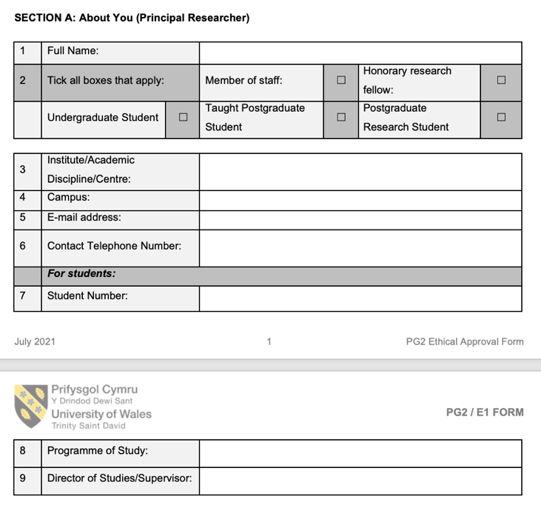

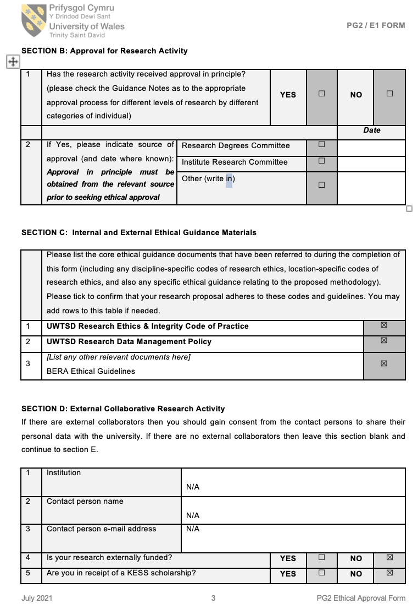

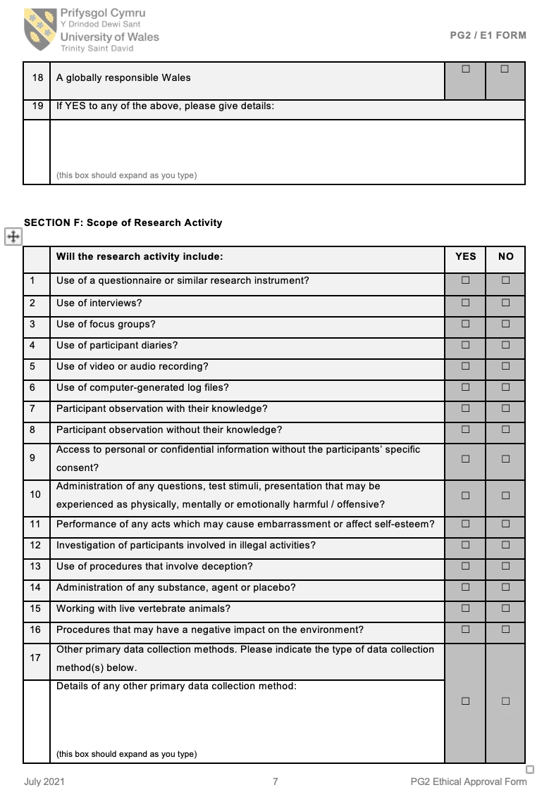
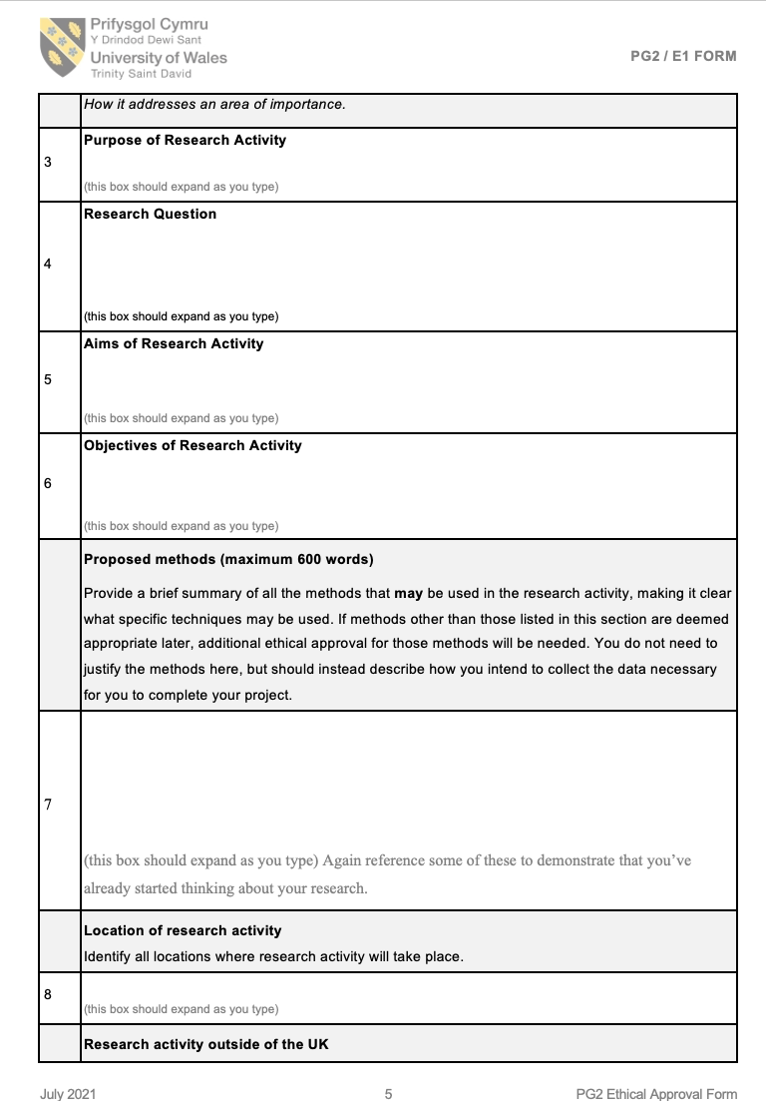
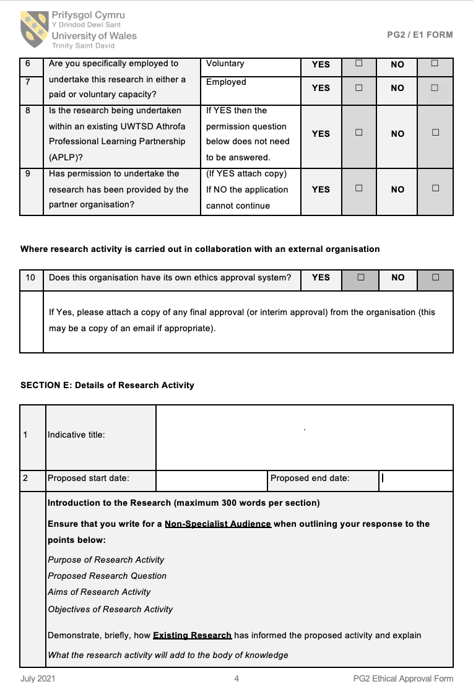
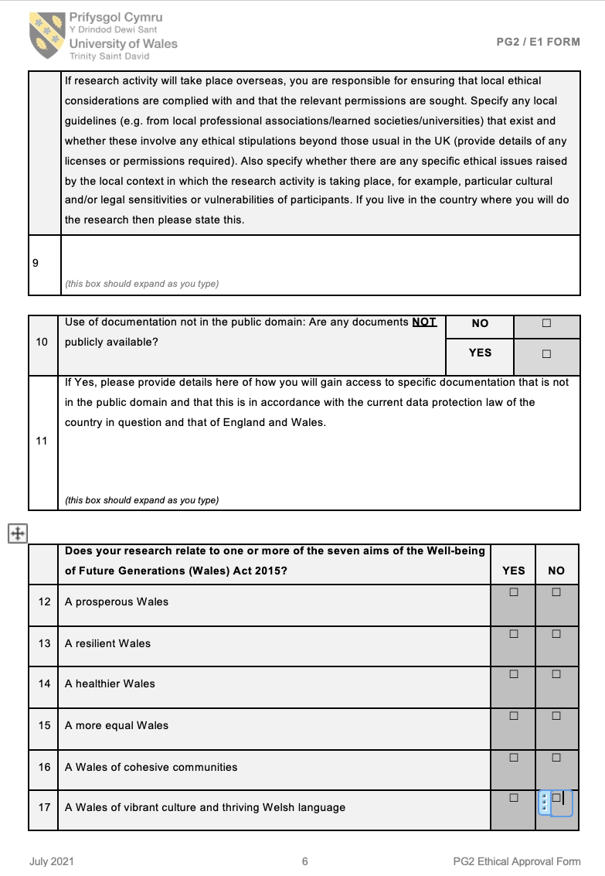

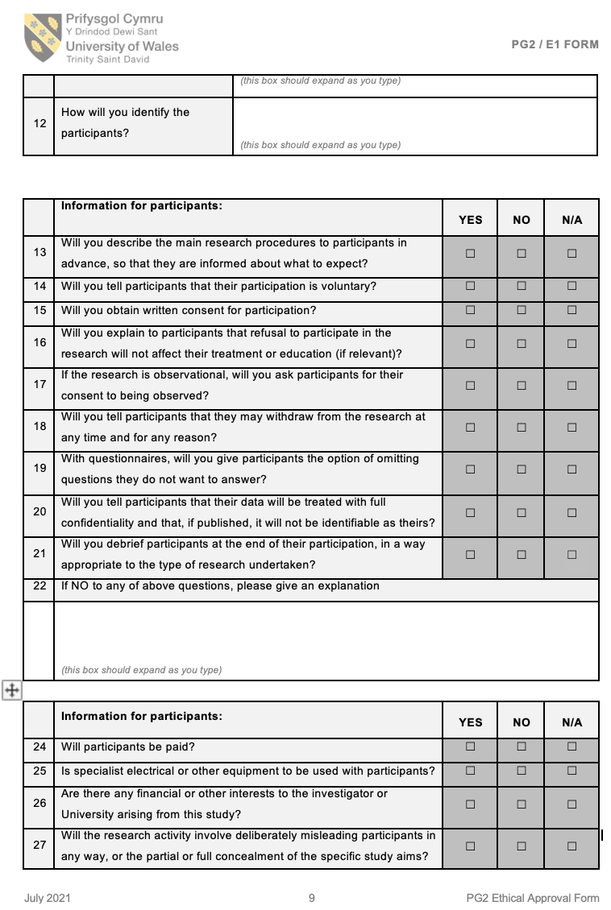
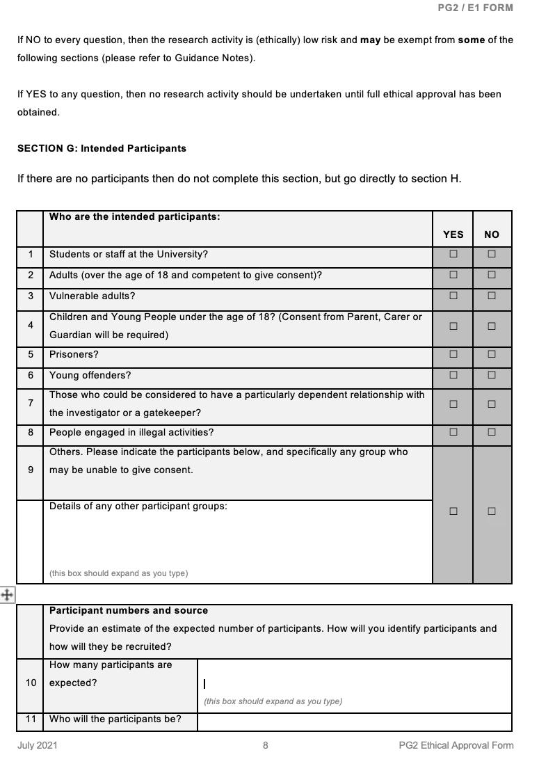

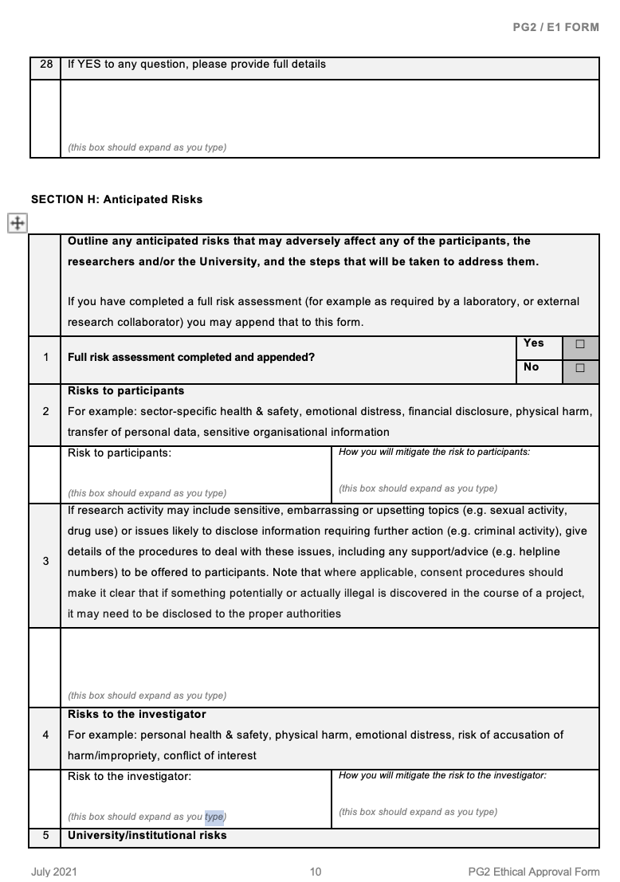

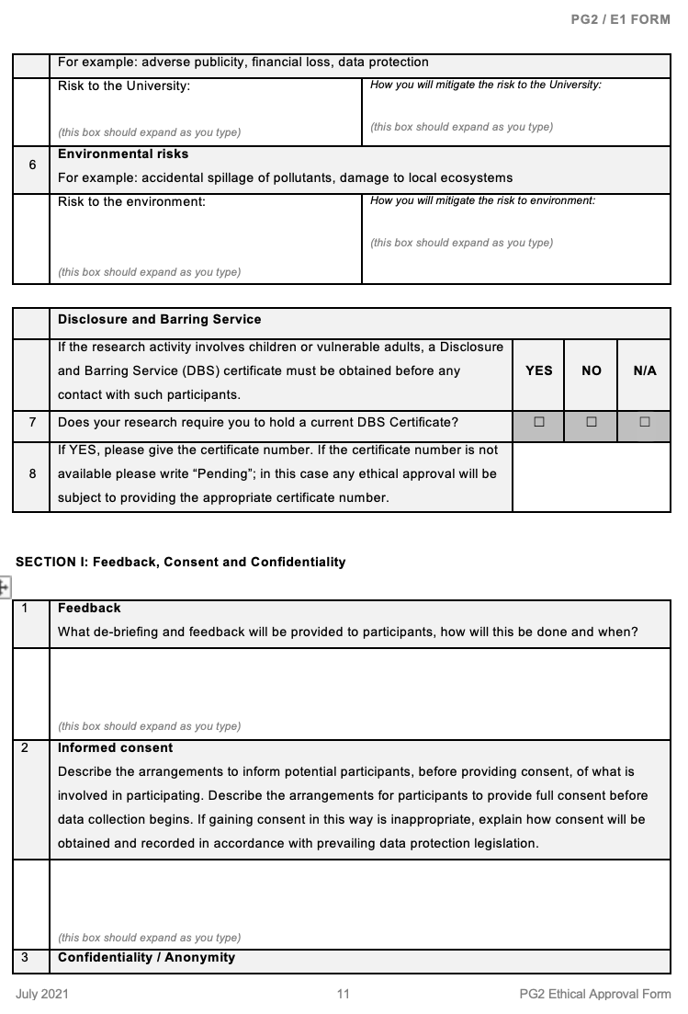

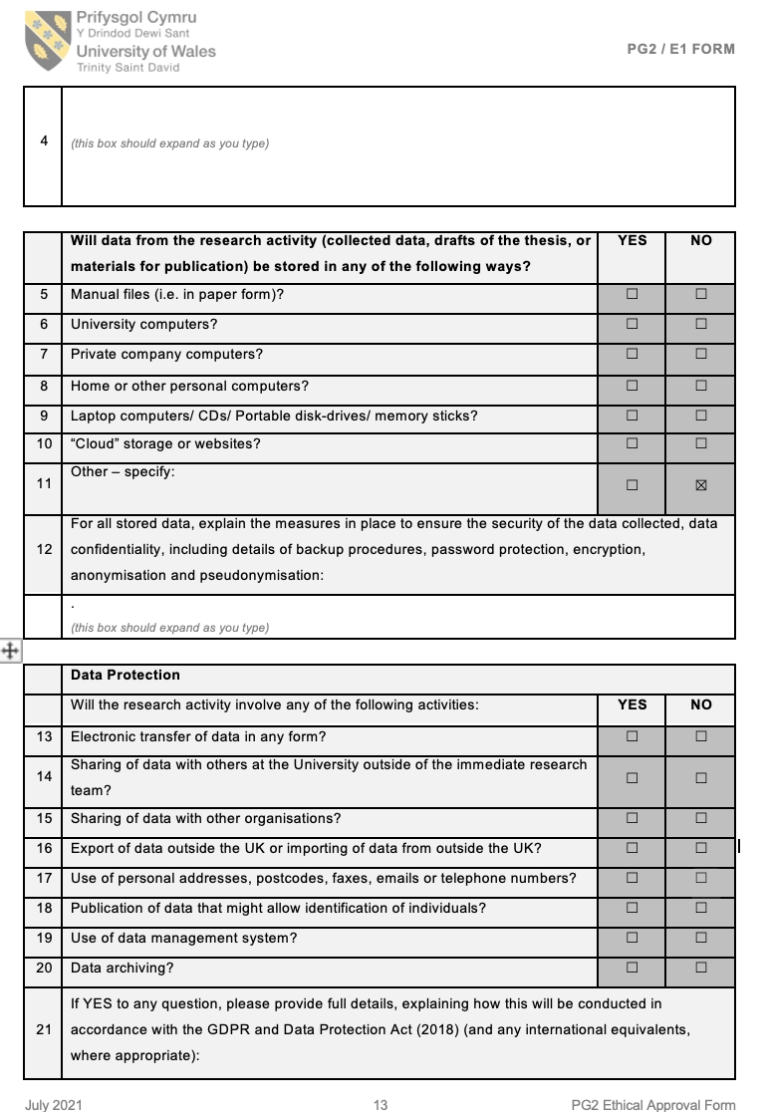
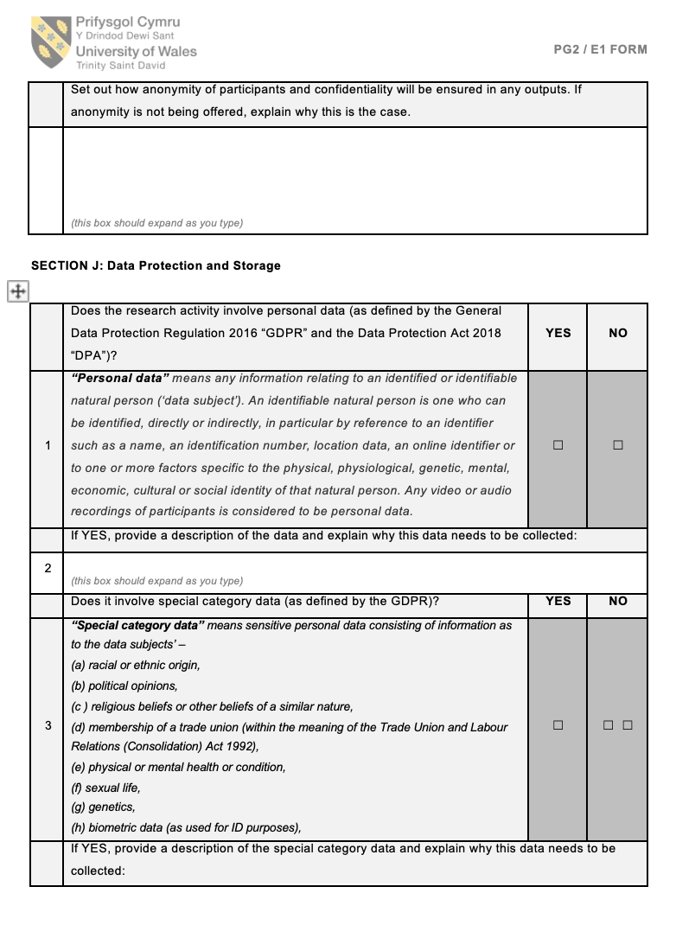

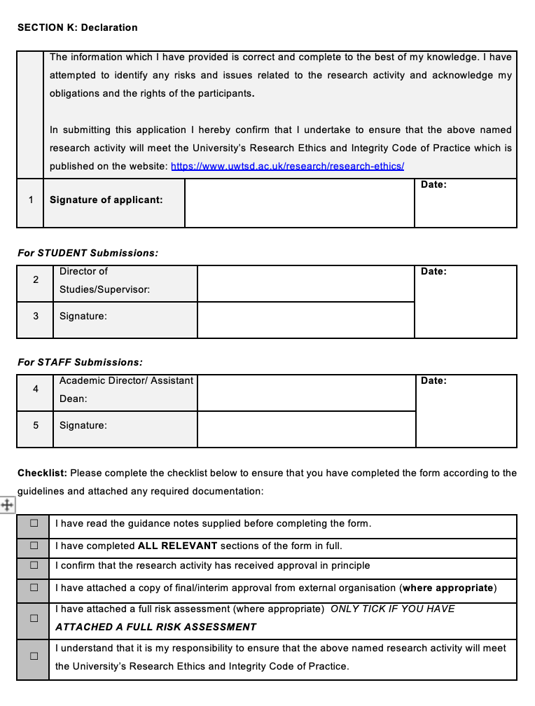
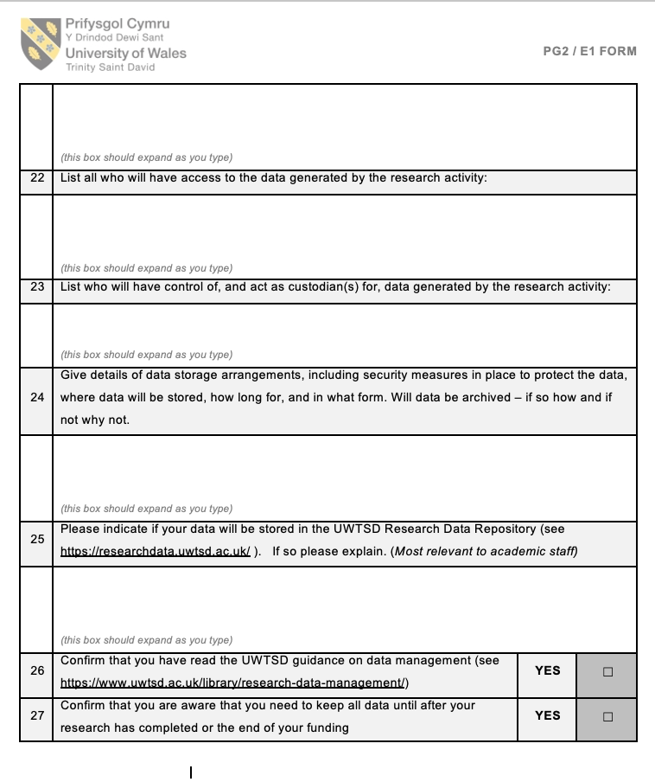

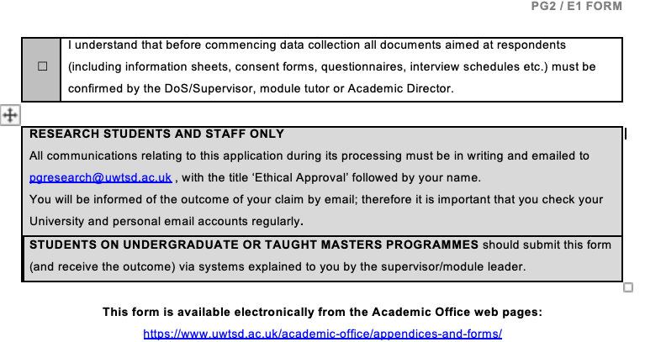

9.2 Appendices 2 : Codes

9.2.1 History of education codes
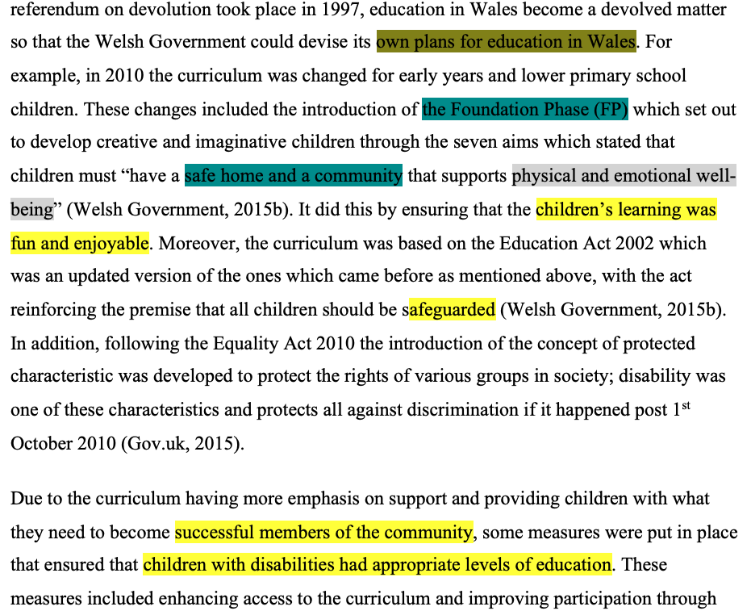

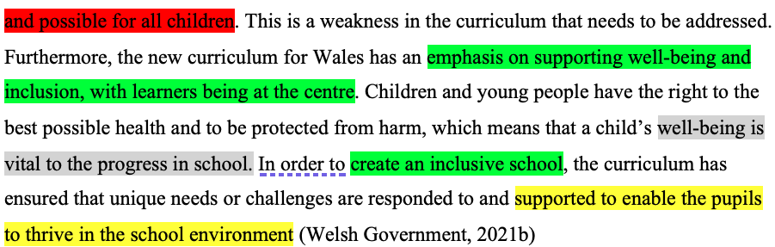

9.2.2 Different disabilities and chronic illnesses: physical and mental codes

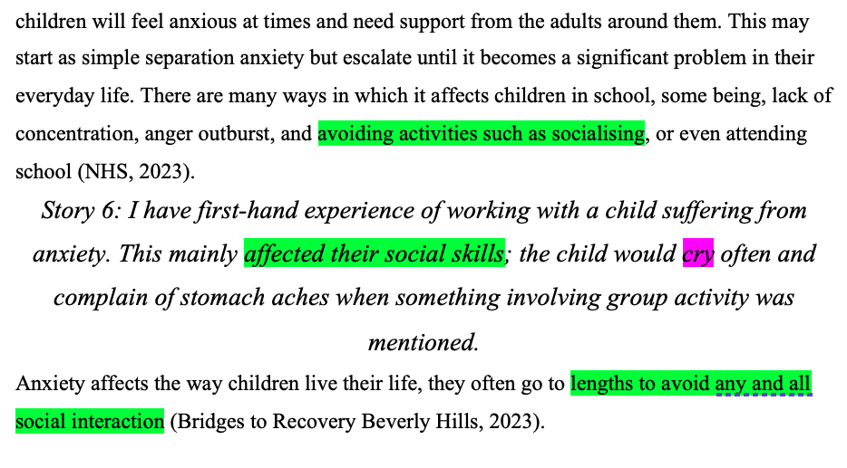

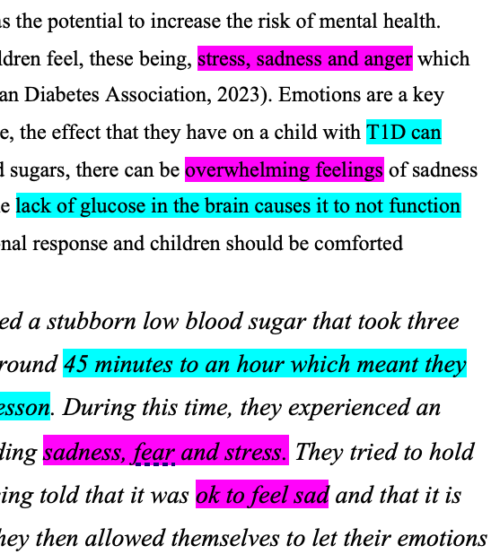

9.2.3 support available for pupils in primary education codes

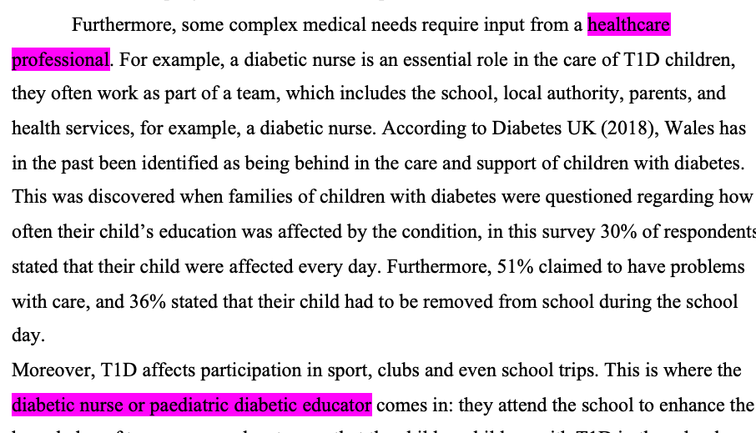

9.3 Article 2 and 23 of UNCRC
“Article 2 (non-discrimination) The Convention applies to every child without discrimination, whatever their ethnicity, sex, religion, language, abilities or any other status, whatever they think or say, whatever their family background” (UNICEF, 2019).
“Article 23 (children with a disability) A child with a disability has the right to live a full and decent life with dignity and, as far as possible, independence and to play an active part in the community. Governments must do all they can to support disabled children and their families” (UNICEF, 2019).

9.4 Well-being goals
“A society in which people’s physical and mental well-being is maximised and in which choices and behaviours that benefit future health are understood” (Welsh Government, 2015).
“A more equal Wales: A society that enables people to fulfil their potential no matter what their background or circumstances (including their socio-economic circumstances” (Future Generations Commissioner for Wales, 2023).

