Pontyates SHT Mixer
Joseph Parkhouse

Individual Project
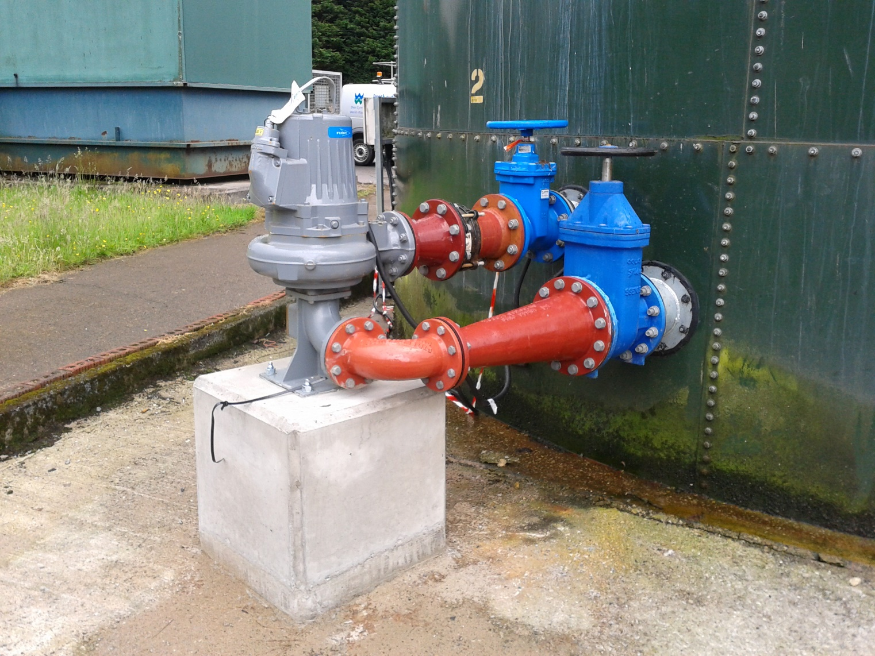


1.0 Summary

This is the final report analysing the project at Pontyates WWTW. Pontyates WWTW is a rural waste water treatment works situated in Pontyates, Carmarthen. The main issue identified on site was the inconsistency of the sludge being removed from site. The issue was always present but had recently come under scrutiny by the bio solids team due to the inefficiencies and cost associated with transporting sludge that was high in water content and low in solids.
Three possible solutions were identified to try and rectify the issue and out of the three; one was chosen. The three possible solutions were;
- De-cant more water from the existing system. An upgrade to the existing de-cant valves would be required.
- Install a new mixer system to ensure even distribution of water and solids, creating a more consistent sludge thickness.
- Upgrade the site by installing a sludge thickener system to remove excess water and leaving a higher solids content.
The solution which was chosen was the second option; to install a new mixer system. This was chosen because similar systems had been used at other sites with great success.
Quotations were gained from Pump Supplies Ltd. for the supply of the pumps and associated valves. Civil construction was completed by Whitland Engineering and they supplied a quotation for the modifications to the existing tank and the installation of a concrete plinth to support the pump. Welsh Waters own ME&I team were responsible for the installation of the mixer system.
The duration of the project was initially calculated to take 60 working days, this was extended to 90 working days due to delays in receiving quotations and lead times on pump and valve delivery.
The installation of the new mixer pump and pipework was completed on the 9th of January 2020 and has been deemed successful based on the subsequent results. The previous sludge thickness varied between <1% solids, up to 8% whereas the new system is now consistently able to achieve averages above the set target average of 4% as shown in this report.
There are several recommendations regarding how this project could have been done differently. Firstly, with a higher budget, solution three would have been yielded better results, however this would have required extensive modifications to the site including construction of a new building to house the thickener system. This solution would have allowed for expansion to the site in the future and would have allowed the works to be able to cope with any increase to incoming flows and the resulting increase in sludge produced from any future developments in the area due to population growth. However, at the time of the project, the size of the treatment works currently would not justify the extra capital expenditure.
The final recommendation would have been to contact pump manufacturers for quotations directly as opposed to going through Pump Supplies Ltd. While the Flygt pump supplied is capable of doing the job, it struggled with solids greater than 4%. Further research would have identified other pump manufacturers with greater solids handling capabilities.
A full timing plan is included within this report.

2.0 Contents

1.0 Summary i
3.0 List of Figures vi
4.0 Nomenclature viii
5.0 Acknowledgements ix
6.0 Introduction 1
7.0 Literature Review and Background Research 3
7.1 Wastewater treatment Process 3
7.2 Advanced Anaerobic Digestion (AAD) 7
8.0 Project Specification and Testing Plan 8
8.1 Product Design Specification 8
8.1.1 Performance 8
8.1.2 Environment 8
8.1.3 Life Span 8
8.1.4 Life in Service 8
8.1.5 Target Costs 8
8.1.6 Maintenance 8
8.1.7 Packaging 9
8.1.8 Size and Weight Restrictions 9
8.1.9 Shipping 9
8.1.10 Manufacturing Process 9
8.1.11 Aesthetics 9
8.1.12 Ergonomics 9
8.1.13 Quality and Reliability 9
8.1.14 Standards and Specifications 10
8.1.15 Company Constraints 10
8.1.16 Safety 10
8.1.17 Testing 10
8.1.18 Legal 10
8.1.19 Installation 10
8.1.20 Disposal 10
8.2 Testing Plan 11
9.0 Project Solutions 12
9.1 Solution 1 - Increase de-canting of water from the existing system 12
9.2 Solution 2 – Install a new mixer system 13
9.3 Solution 3 – Upgrade the site by installing a sludge thickener system 15
9.4 Chosen solution 17
10.0 Project Planning 19
10.1 Proposed Timing plan 19
10.2 Actual Timing Plan 20
10.3 Actual Gantt Chart 21
10.4 Contingency Planning 23
11.0 Design and Implementation 24
12.0 Analysis, Results and Evaluation 31
13.0 Conclusion 38
14.0 Recommendations 40
15.0 Bibliography 41
17.0 Appendices 43
17.1 Appendix 1 – Project Proposal 43
17.2 Appendix 2 – Proposed Timing Plan 45
17.3 Appendix 3 - Actual Timing Plan 46
17.4 Appendix 4 – Sludge Thickness Data 47
17.5 Appendix 5 – Sludge Data Graphs 49
17.6 Appendix 6 - Whitland Engineering Quotation (SHT modifications and Civil Work) 51
17.7 Appendix 7 - Pump Supplies Quotation (Pump, Pipework and Valves) 52
17.8 Appendix 8 – Site drawings of new mixer system 53

3.0 List of Figures

Figure 1 – Wastewater treatment process………………………………………………………………………. 3
Figure 2 – A typical primary settlement tank…………………………………………………………………… 4
Figure 3 – A typical bio-filter design………………………………………………………………………………… 5
Figure 4 – The activated sludge process…………………………………………………………………………… 5
Figure 5 – The working principles of a centrifuge…………………………………………………………….. 6
Figure 6 – A typical sludge holding tank design with decant valves…………………………………. 12
Figure 7 – A basic mixer system design……………………………………………………………………………. 13
Figure 8 – A gravity belt thickener…………………………………………………………………………………… 15
Figure 9 – Criteria analysis results……………………………………………………………………………………. 17
Figure 10 - Proposed timing plan task list………………………………………………………………………… 19
Figure 11 - Proposed timing plan…………………………………………………………………………………….. 19
Figure 12 - Actual timing plan task list……………………………………………………………………………… 20
Figure 13 - Actual timing plan………………………………………………………………………………………….. 20
Figure 14 - Actual Gantt Chart Task List…………………………………………………………………………… 21
Figure 15 - Actual Gantt Chart Timeline…………………………………………………………………………… 22
Figure 16 - Drawing of proposed new layout created by Whitland Engineering………………. 25
Figure 17 - Completed modifications to SHT……………………………………………………………………. 26
Figure 18 - The parts laid out in relation to the engineering drawing allowing the best approach to be taken assembling the pipework………………………………………………………………………………. 27
Figure 19 - It was vital that the parts were supported during assembly so not to put excessive stress/strain on the tank………………………………………………………………………………………………….. 28
Figure 20 - The preparation work for the construction of the concrete plinth. The pipe work is suitably supported by the breeze blocks and acro arms…………………………………………………… 29
Figure 21 - The completed mixer system including SHT modifications and civil work………. 30
Figure 22 – Details of sludge removed from Pontyates throughout June 2019………………… 32
Figure 23 – Details of sludge removed from Pontyates throughout July 2019…………………. 33
Figure 24 – Details of sludge removed from Pontyates throughout January 2020…………… 34
Figure 25 – Details of sludge removed from Pontyates throughout February 2020…………. 35
Figure 26 – Details of sludge removed from Pontyates throughout March 2020……………… 36

4.0 Nomenclature

DCWW Dwr Cymru Welsh Water
ME&I Mechanical, Electrical & Instrumentation
NRW Natural Resources Wales
WWTW Waste Water Treatment Works
PDS Product Design Specification
Cake Produced from dewatered sludge using a centrifuge
Sludge The solids left at the end of the wastewater treatment process
AAD Advanced Anaerobic Digestion
EX Rated Extrinsically Safe
VJ Viking Johnson

5.0 Acknowledgements

Firstly, Gratitude should be extended to Llanelli WWTW supervisor, Dylan Davies; without his cooperation and support this project would not have been possible. He was instrumental in obtaining funding for the project
Bio-Solids supervisor, Alfausto Ribieri and Bio-Solids logistics co-ordinator Caralyn Hosler also deserve thanks. They were understanding of the disruptions to the tanker scheduling and were accommodating with all requests put to them. Without his help, the installation process would have proved a more difficult and time-consuming task and they understood that the short-term disruption would eventually result in longer-term gains for the business.
Finally, assistance given by Pump Supplies Ltd owner, Andrew John and Whitland Engineering workers Dai and Matthew; over the selection of pumps and design of pipework was greatly appreciated. Gratitude must also be extended to the ME&I team of Llanelli WWTW whose assistance and expertise during the installation of the mixer system was invaluable and without their help the task would have been much more difficult to achieve.

6.0 Introduction

Dwr Cymru Welsh Water is a supplier of clean water and provides waste water treatment, it covers the majority of Wales and some parts of Hereford, England.
The waste water treatment part of the business is responsible for removing waste water from customers and transporting it to a local sewage works where it is treated before being discharged back into the environment. Natural Resources Wales sets the parameters to which the discharged effluent must comply and these are specific to each treatment works.
Pontyates WWTW is a rural waste water treatment works in rural Carmarthenshire. Solid matter (sludge) that is separated during the treatment process is stored in a holding tank until it can be removed via tanker to a reception centre for further processing. There has been a recent drive to increase the efficiency of how the company operates its bio-solids department and sludge thicknesses have come under the spotlight for improvement. Pontyates WWTW is one site where inconsistent sludge thickness is resulting in inefficiencies for the bio-solids team.
The main issue with inconsistent sludge thickness is the associated transportation costs removing it from site. Reception centres take sludge imports from smaller satellite treatment works and process it using a centrifuge to remove excess water and make a denser substance with a higher solids content. This substance is called ‘cake’ within the business. The average transport costs for a tanker is £130 per collection, the higher the solids content in the sludge the more efficient and cost effective the process. For example, one tanker load of 4% sludge is cheaper to transport and easier to process at a reception centre than two loads of 1 or 2%.
The main cause of these issues is settlement within the sludge holding tank. Heavier solids settle at the bottom while water rises to the top, because water is less dense when the tanker tries to remove the sludge using its on-board pump it is more likely to pull the water through the sludge, leaving higher density solids in the tank and transporting mainly water instead. To rectify this issue the water is decanted back into the treatment process through a series of valves on the side of the tank set at different heights. However, due to the compliance parameters of the treated effluent, if the site is close to its limit then decanting cannot be carried out as there is a risk of the sample quality worsening or failing. A mixer that can keep solids and water in suspension would allow the tanker to pull a more consistent thickness of sludge when water cannot be decanted from the tank.
The main objective of this project is to get a more consistent sludge thickness in order to reduce the overall spending on the site by the biosolids team on tankers and transportation. The installation must be fully accessible and easy to maintain and work on.
In order to deliver the project on time and within budget the following people will be worked with closely:
From Welsh Water, Area supervisor Dylan Davies, Bio-Solids supervisor, Alfausto Ribieri and Bio-Solids logistics co-ordinator Caralyn Hosler.
External contractors, Pump Supplies Ltd and Whitland Engineering.
Where required the above persons will be contacted for quotations and advice with regards to to the design and layout for the required new pipework and pump. Dylan, the area supervisor and the bio-solids team will assist with gaining budget approval for the project.
Dylan’s responsibility to co-ordinate the project has been delegated to allow the Author to assume responsibility as if it were his own project.
Any quotes will need to be approved by Dylan Davies before they are authorised due to his position within the business. All hard correspondence made for example, quotations etc. will be included in the appendix of this report. The majority of correspondence will be made via telephone.
A timing plan will be used to track the progress of the project monitor if it is staying on schedule. All timing plans and Gantt charts will be included within this report.

7.0 Literature Review and Background Research

7.1 Wastewater treatment Process
The wastewater treatment process is used to remove solids and contaminants from sewage and produce final effluent that can be returned to the water cycle. Wastewater consists of sewage, pollutants, storm/rain water and debris that find its way into the sewage networks and it all needs to be treated before it can be returned to a water course. In addition to the final treated effluent by products are created during the process that need to be disposed of including screenings, grit and sludge. The sludge aspect of the treatment process is the main focus of this report.
There are 5 main phases to the treatment process:
- Screening
- Primary Settlement
- Biological Treatment
- Final Settlement
- Sludge Treatment
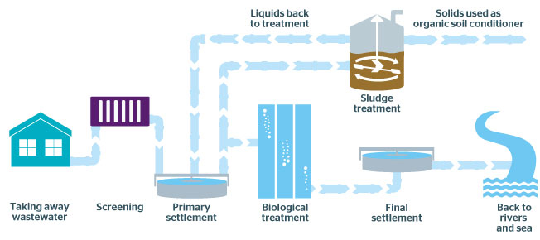
Figure 1 – Wastewater treatment process. Southern Water (2020).
The screening phase removes large debris from the incoming wastewater. This is carried out by using various designs of screens dependant on the size and flows being received at the works. They work by removing non-biological debris, such as wet wipes, sanitary products, litter etc. from the process. This is a vital phase, as any debris that passes on further can have a negative impact on the effectiveness of the treatment process by blocking or damaging pumps and equipment. Screenings are removed from site for further treatment disposal.
The next stage is primary treatment where heavy solids settle at the bottom of the tank and is removed for further treatment. The remaining water weirs over at the top of the tank and passes to the next stage of the process.
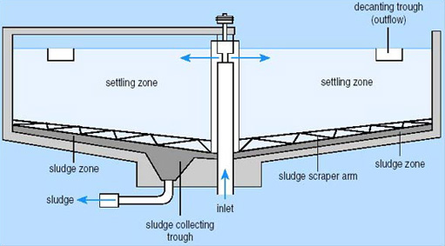
Figure 2 – A typical primary settlement tank. Porteous (2000).

The biological treatment phase uses bacteria to break down any waste left in the water. In order to effectively carry out this job the bacteria require two things; food and oxygen. To provide this the treatment is carried out in one of two ways, either through an activated sludge process, where air is pumped into the passing liquid to provide oxygen for the bacteria to break down the sewage. This is commonly used in urban treatment plants with higher incoming flows. The second method of treatment used involves stone filter beds on which the bacteria live. Oxygen is provided by the air and the sewage is trickled over the stones where it is broken down as it flows to the bottom of the filter. Bio-filter are commonly used in smaller, rural treatment works due to their low running costs when compared to activated sludge.
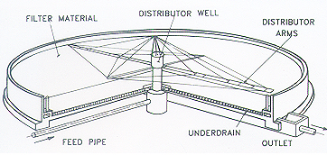
Figure 3 – A typical bio-filter design. Shiv Pad Engineers (2008).
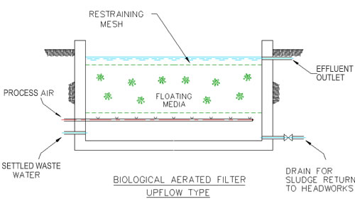
Figure 4 – The activated sludge process. Water Maxim (2007)
The final stage of treatment is final settlement. Here a tank similar to that used in the primary settlement stage is used to allow any remaining solids to collect at the bottom. In the activated sludge process these solids are returned to the aeration lanes to provide food to keep the bacteria alive. In bio-filter arrangements the solids are returned to the inlet to undergo full treatment again. If the watercourse being discharged into is particularly sensitive to algae growth further tertiary treatment may be required, such as using UV to sterilise bacteria and viruses.
The sludge that has been removed from the process requires its own treatment process so that it can be disposed of correctly. Sludge from smaller sites, like Pontyates, is transported by tanker to a central reception centre, in this case Llanelli WWTW. Here the sludge is screened and stored in large tanks ready for dewatering. Dewatering removes excess liquid from the sludge, producing a dense solid called ‘cake’. This process is carried out using a centrifuge, which uses centrifugal forces to separate liquids and solids. During the process liquid is sent to back into the treatment works while the cake is pumped into skips to be collected and taken to an advanced, anaerobic digestion site.
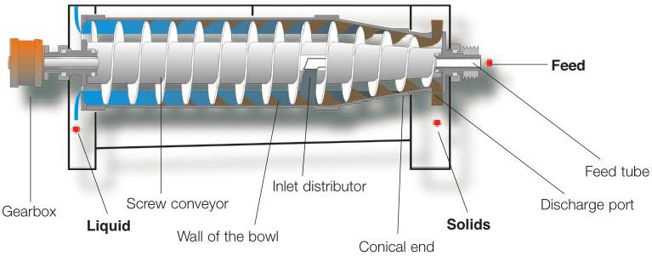
Figure 5 – The working principles of a centrifuge. Medium (2019).

7.2 Advanced Anaerobic Digestion (AAD)
AAD has recently been utilised by water companies to recover energy from the sludge treatment process. AAD uses oxygen-free (anaerobic) decomposition to break down the organic materials and produce bio-gas. The Bio gas used has a typical composition of 65% methane and 35% carbon dioxide. Another advantage is the solid material produced at the end of the process will have reduced in size, and is more stable, allowing it to be safely used as fertiliser.
The energy produced from this process is classified as renewable energy as it is produced from biomass, this can be used onsite to power the treatment works with any excess being sold back to the grid. Welsh Water has ambitious aims to be a carbon neutral organisation by 2050 and AAD, along with other renewable energy sources within the company (hydro, solar, wind, etc.), will be major contributor.
In addition to the environmental advantages, AAD also provides economic benefits. The treatment of water and waste is a very energy intensive process, making Welsh Water one of the biggest energy consumers in Wales. AAD is contributing to Welsh Water’s ambitions to become self-sufficient, reducing costs and protecting itself from unpredictable energy prices. Companywide improvements and efficiencies to sludge management also present operational cost savings. The report will look at this aspect of the process in an attempt to reduce the wasteful transportation of large amounts of water due to sludge failing to meet thickness targets. G. Neave (2009).

8.0 Project Specification and Testing Plan

8.1 Product Design Specification

8.1.1 Performance
Must be able to pump solids up to 4%
Must be able to run for up to 12h per day, 365 days a year

8.1.2 Environment
Must use IE3 energy efficient motors
Must be operate within environmental temperature range from -10 ⁰C to +50 ⁰C
Must be corrosion resistant as will be exposed to the elements

8.1.3 Life Span
6 months of service before impeller requires replacing
7-year service life before requiring replacement

8.1.4 Life in Service
Must be able to run for up to 12h per day, 365 days a year

8.1.5 Target Costs
Maximum budget is £10,000
Target to offset running costs by reducing sludge transportation costs

8.1.6 Maintenance
Basic maintenance checks to be carried out every 6 months.
Basic maintenance - check oil and impeller clearance for wear.
Full maintenance service carried out every 12 months or as required if issues detected in basic maintenance checks.
Full maintenance, such as impeller replacement, must be carried out by a qualified Welsh Water mechanical fitter or approved service provider.

8.1.7 Packaging
N/A

8.1.8 Size and Weight Restrictions
Must be able to fit to existing sludge holding tank.
Pump must weigh less than 200kg.

8.1.9 Shipping
N/A

8.1.10 Manufacturing Process
Pump manufactured by Flygt.
Pipework to be delivered to site for installation.
Tank alterations and civil work to be carried out prior to pump and parts delivery.

8.1.11 Aesthetics
Pump and pipework must be installed allowing room for installation and future maintenance.

8.1.12 Ergonomics
The pump must be connected to an existing panel and be able to be operated either manually or automatically via a timer.
New emergency stop buttons must be installed for safety reasons.
The equipment should be operated by a single man (site operator, tanker driver etc.)

8.1.13 Quality and Reliability
Pump supplied with manufacturer guarantee.
Pump specifications must be correct to produce the desired flow/mix.

8.1.14 Standards and Specifications
Pipework must be manufactured to the following standards:
• BS EN 1124 1999 C: Pipes and Fittings of Longitudinally Welded Stainless Steel Pipes with Spigot and Socket for Waste Water Systems
• BS EN 10283 2010 C: Corrosion Resistant Steel Castings
• BS EN 61439-4:2013: Low-voltage switchgear and control-gear assemblies

8.1.15 Company Constraints
Utilise existing SHT.
Work to budget provided.
Comply with company Health and Safety policies.

8.1.16 Safety
Provide means to electrically and mechanically isolated equipment safely.
Install new emergency stops and make them visible and easily identifiable.
Provide adequate space for maintenance tasks to be carried out.

8.1.17 Testing
Test installation for suitability and for leaks upon completion of work.
Test results of sludge thickness being removed from site to determine long term success of install.

8.1.18 Legal
Must comply with company, regional and national legislation.

8.1.19 Installation
Installation to be carried out by Welsh Water fitters and electricians.

8.1.20 Disposal
All waste must be disposed of and recycled where possible.

8.2 Testing Plan

The only accurate way to measure the success of the project is by analysing data for the site and this can only be done once the work has been completed.
Historical data for the sludge being removed from the site is available from the data logger that records the thickness of the sludge being received at the reception centre and the site origin. Data will be broken down to look at sludge thickness before the implementation of the project and a period of at least three months following the completion of all work. This will help to give an indication of how the equipment is performing and if any changes may be required. The data could also be used as evidence to see if the design is viable to be implemented at other treatment works that are having similar issues with sludge thickness.
Data can also be looked into finer detail, with the thickness of individual loads backdating 10+ years. For the purpose of this project the average sludge thicknesses will be used for the 12 months previous to the implementation date. This will even out any seasonal discrepancies that may be caused by weather fluctuations. For example, higher flows in the wetter/winter months. Individual loads will also be broken down and the thickness percentages tallied in a table ranging from <1% to 5% and greater. From this table approximate costs can be calculated based on tanker size and distance travelled.
A good comparison would be to compare the difference over a 12 month period after the work has been completed, however due to deadlines relating to the submission of this report, a minimum 3 month observation will be used to monitor site data and these will be costed as per the method above.

9.0 Project Solutions

9.1 Solution 1 - Increase de-canting of water from the existing system

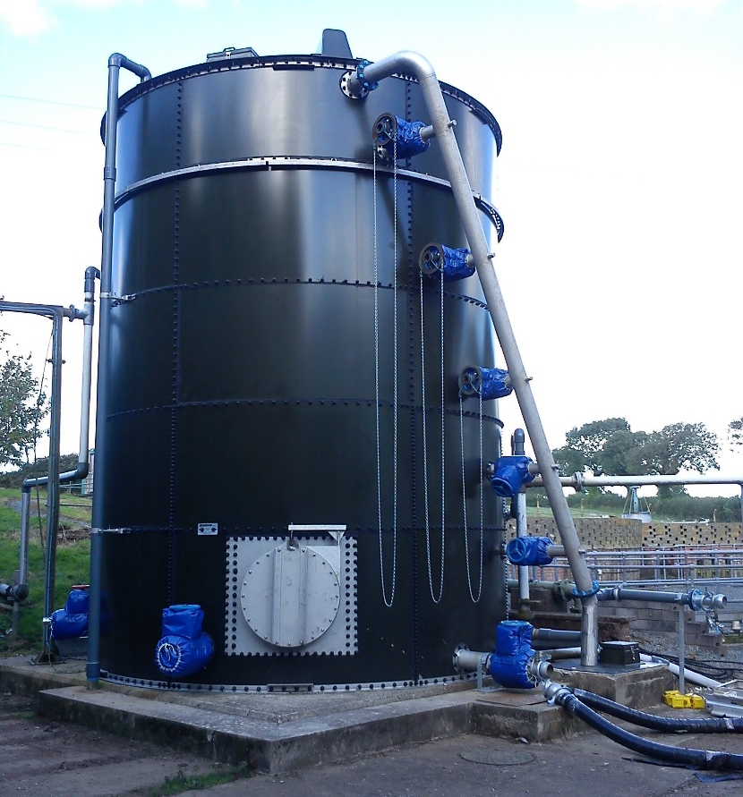
The first and most straight forward solution would be to increase decanting using the existing system. De-canting is a method commonly used to reduce the water content of sludge held in a sludge holding tank. When the SHT is filled it is left to settle out in the tank so heavy solids settle at the bottom and water rises to the top. The tank is designed to have valves at various heights and these are used to locate and drain the water, a typical SHT can be seen below. The liquid decanted is then returned to the start of the treatment process. This is the major disadvantage regarding this solution, de-canted liquid can be quite strong and if it is returned to the process when the works is already struggling it could cause a compliance failure. In addition, if the sample prevents decanting from taking place and the SHT is full then the primary tanks cannot be de-sludged. Leaving sludge within the tanks will affect the treatment and if left for too long could turn septic. The advantage of this system is cost – this is by far the most cost-effective solution.
In order to make this a viable option the existing SHT would require an overhaul to increase the number of valves and allow the operator to locate water within the tank.
Figure 6 – A typical sludge holding tank design with decant valves. Goodwin Tanks (2020).

9.2 Solution 2 – Install a new mixer system

A second solution would be to upgrade the SHT so that it incorporates a mixer system. Using a mixer will prevent settlement from occurring and keep solids in suspension with the liquid. The aim is to provide more consistent sludge thicknesses for the tankers as currently the thick sludge settles to the bottom can be over 8%, this is difficult for the tankers to offload using the onboard pumps. Once the thick sludge is removed by the first tanker the next one is left with the water often with a thickness of <1%, this is a waste of resources as the liquid is too thin to contain any useful solids and will just require removing at the reception centre. An example system that would aim to be replicated can be seen below.
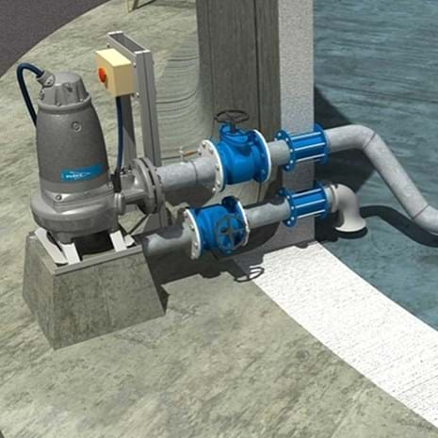
Figure 7 – A basic mixer system design. Xylem (2020).
In order to implement this system extensive modifications would be required to the SHT. Suction and delivery valves would need to be cut into the tank and civil works carried out to provide support to the pump and pipework. The advantage of this solution is that liquid does not need to be decanted from the SHT and therefore does not affect the treatment process. This will allow the primary tanks to be de-sludged when the sample is poor. The disadvantage is costs. In addition to the pump and pipework required to complete the project, modifications to the tank and civil works are needed. This will increase the overall costs of the project.

9.3 Solution 3 – Upgrade the site by installing a sludge thickener system

The final solution to be considered would be to install a gravity belt thickener. This system is used already within Welsh Water and is proven to effectively reduce sludge volumes. It works by feeding sludge onto a continually revolving filter belt. The belt is porous and as it travels gravity causes water to pass through it, producing a thicker sludge that has reduced in overall volume. The thickened sludge is stored in a holding tank for removal from site, the liquid removed from the sludge is returned to the treatment process. An example of a gravity belt thickener is shown below.

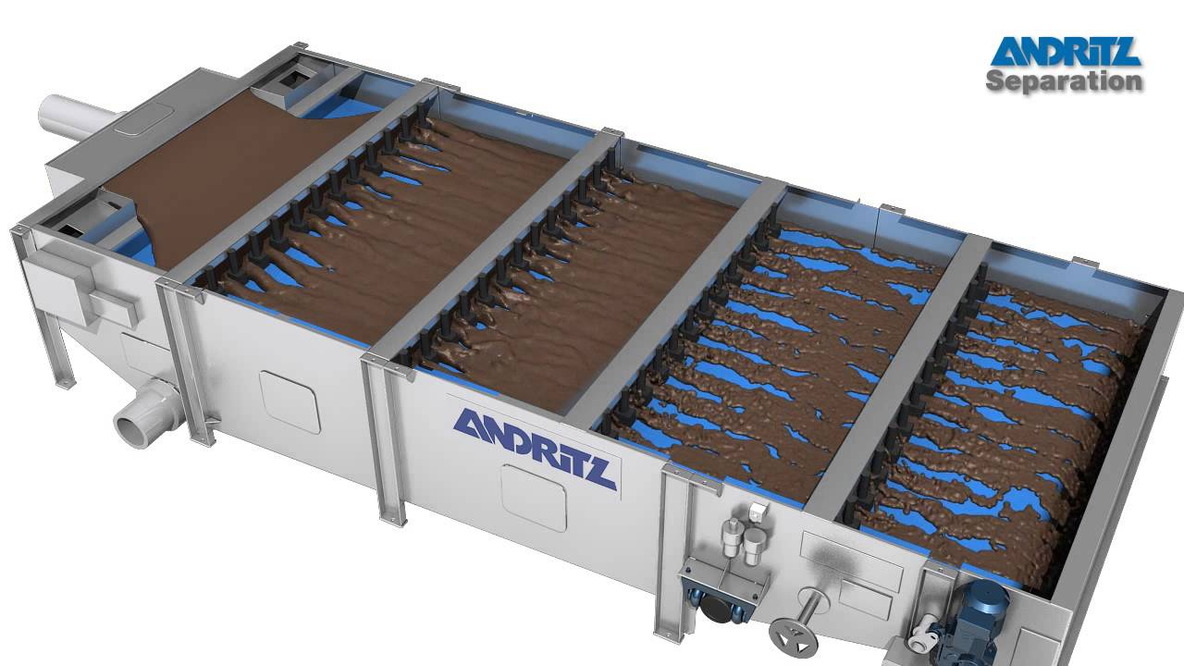
Figure 8 – A gravity belt thickener. Andritz (2016).

The advantage of a gravity belt thickener is efficiency. It is a proven method of sludge thickening that will meet and exceed the sludge thickness targets set by the biosolids team. The major disadvantage is costs. Gravity belt thickeners are expensive and are currently in use on other treatment works, these sites however are larger and treat incoming flows greater than that at Pontyates WWTW. The amount of sludge produced at Pontyates is not enough to make this solution cost effective. The running costs would be greater than the other solutions and modifications would be required to the existing sludge lines to divert the flows from the existing SHT to the thickener. This pipework is buried underground, and major civil works would be required to overcome this. In addition, a new building would be needed to house the thickener as it cannot be exposed to the elements. As well as the costs implications, the water removed from the sludge would need to be treated. This would present the same issues as the first solution that would prevent the thickener from operating when the sample is poor.

9.4 Chosen solution

After discussing all three possible solutions with operations, the bio-solids team and team supervisor it was decided that the second option would be the best solution based on a criteria analysis.
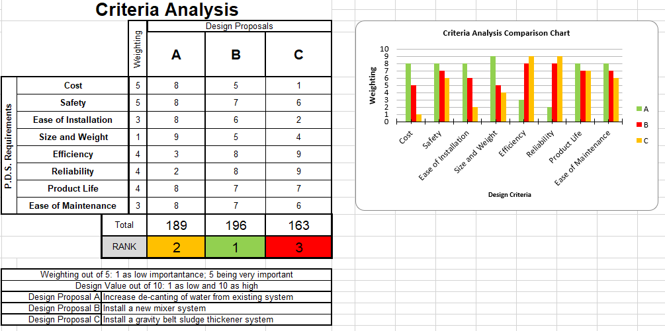
Figure 9 – Criteria analysis results
This solution minimises the impact on the works which was of great importance during the discussions. While modifications would be required to the existing SHT, contingencies would be put in place during this work. Once new delivery and suction valves are fitted, the site would be able to be operated as usual whilst the mixer system is installed in situ.
Whilst the chosen solution would increase energy consumption at the site, as a new pump would be running, using an IE3 energy efficient motor would reduce this. Savings made by more consistent sludge thickness would outweigh this extra cost.
Solution 1 would meet the project specification, however, there would need to be too many modifications, with numerous new de-cant valves fitted to the SHT. This would place the tank off line completely until work is carried out risking site compliance. Solution 3 in theory is the best solution to the problem with regard to improving sludge thickness and consistency. It was ruled out though due to its significant costs, impractical modification requirements and effect on the treatment process that would risk compliance and result in site failure.
With the solution chosen, the next stage in the process is to get a quotation for a price of the mixer system, modifications to the SHT and the required civil works.

10.0 Project Planning

10.1 Proposed Timing plan
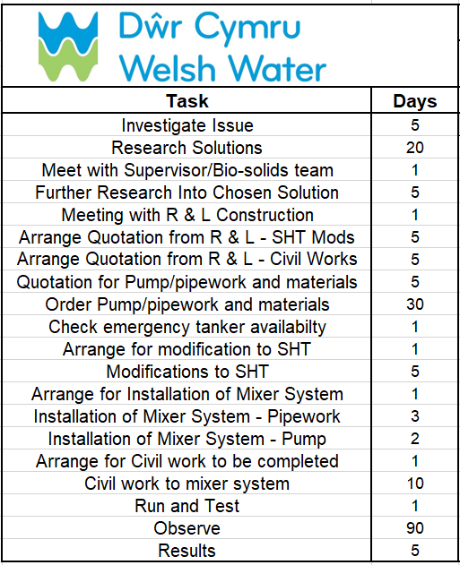
Figure 10 - Proposed timing plan task list.
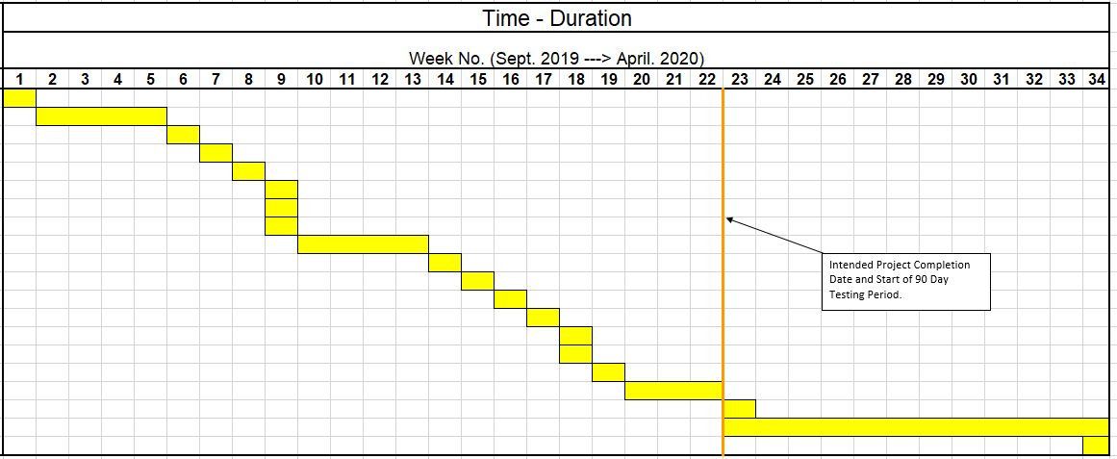
Figure 11 - Proposed timing plan.

10.2 Actual Timing Plan
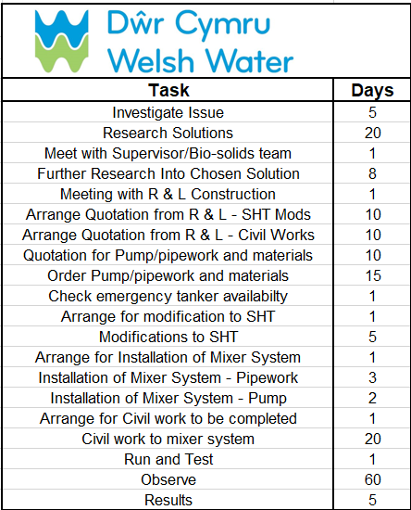
Figure 12 - Actual timing plan task list.

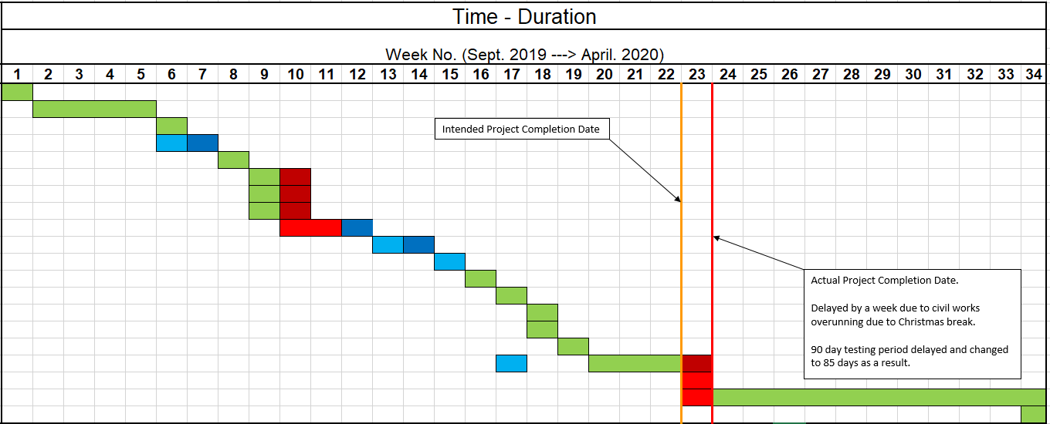
Figure 13 - Actual timing plan.

10.3 Actual Gantt Chart

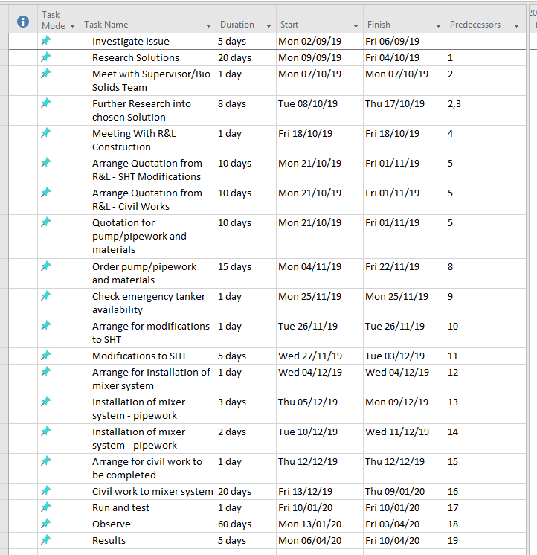
Figure 14 - Actual Gantt Chart Task List.

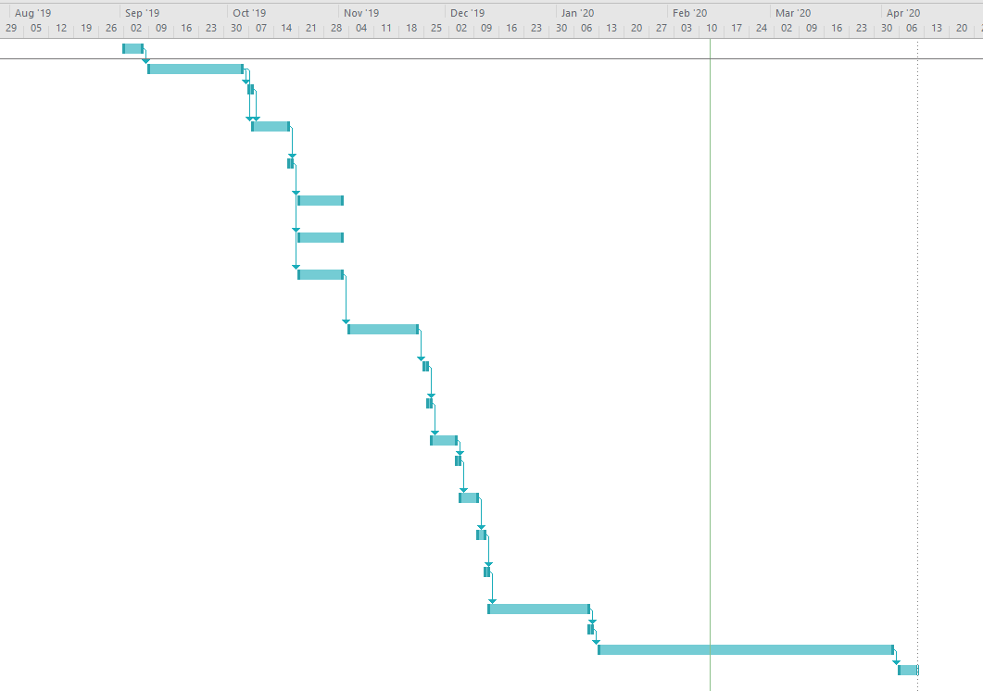
Figure 15 - Actual Gantt Chart Timeline

10.4 Contingency Planning

Contingency planning will be used to protect the works from failure, ensure it remains compliant and will be implemented in two stages. Firstly, work will be carried out only when the operator gives approval to go ahead based on the compliance of the site and the samples of effluent being discharged. The work will also be completed in stages, with the tank alterations being carried out first. After this the installation of the pump and pipework will be completed followed by the civil works. The second part of the contingency plan is to divert sludge to an old concrete sludge pit that was used before the sludge holding tank being worked on was commissioned. This will be done during the alterations to the tank and there will be a DCWW emergency tanker on standby whilst the work is being undertaken to remove sludge from site if the pit becomes too full. During the period of the work to alter the SHT there is no scope for decanting water from the concrete pit. The biosolids team will be notified accordingly to expect poor or erratic sludge thickness during the work so they can adjust their tanker fleet accordingly. There is enough room onsite for both the contractors to work onsite and a tanker will be able to fit and remove a load. Sludge removed will be discharged at Llanelli WWTW which is approximately 25 minutes away from Pontyates WWTW for a tanker.
Once the initial tank alterations have been completed and the suction and delivery valves installed the tanker will be stood down as the installation of the mixer and pipework can be carried out in situ while the SHT is in service.

11.0 Design and Implementation

With the final solution chosen the next stage was to source quotes for the work to being carried out and for the pump, pipework and valves. The first company to be contacted was Whitland Engineering who would be carrying out two stages of the work. One quotation was for the tank modifications and the second for the civil work required to support the pump and pipework. The second company providing a quotation were Pump Supplies Ltd and they would be quoting for the supply of the pump, pipework and valves. The install of the pipework would be carried out by Welsh Water ME&I so a quotation for this work was not required. Copies of the quotations received can be found in the appendices.
Modifications to the SHT would cost £5,570 and includes the work carried out and the pipework within the tank (suction pipework and delivery nozzle). Civil works would cost £1,349 and the supply of pump, pipework and valves would cost £3,370. This totalled £10,289 which was over budget by £289. This required approval from the biosolids team and as a result caused a week’s delay to the quotations being accepted by management. This can be seen in the timing plan where the delay affected work in week 9 and into week 10.
Once it had been decided that Whitland would be modifying the tank, they were required to visit site to take measurements and create the drawings for the pipework and valves to be ordered. See below images of scanned copies of the drawings made by Whitland Engineering. Larger copies of the scanned images can be found in the appendices.
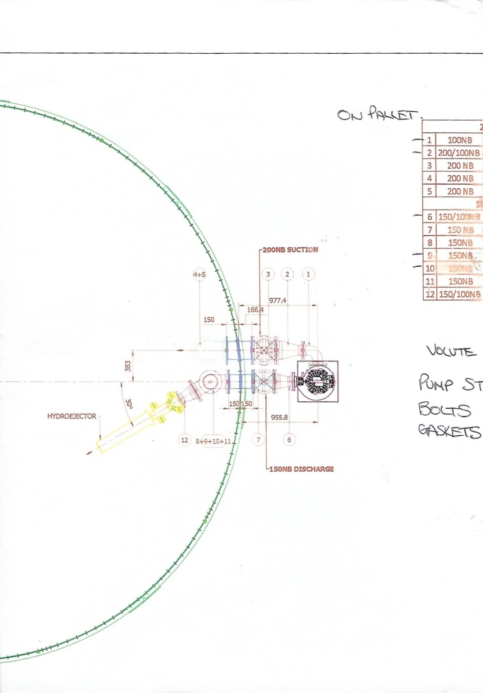
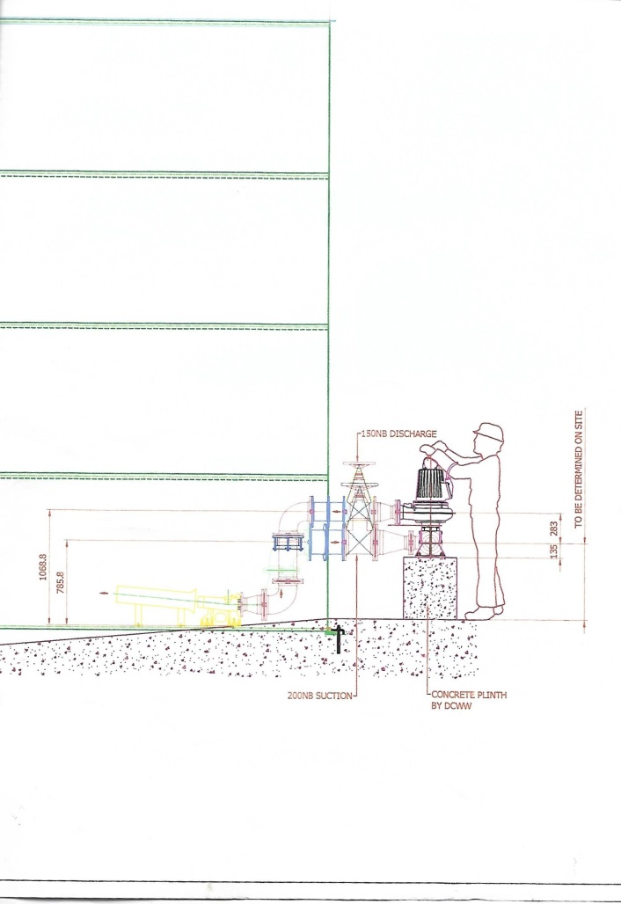
Figure 16 - Drawing of proposed new layout created by Whitland Engineering

Once all of the drawings had been completed and all measurements were taken, an order was raised with Pump Supplies to supply the pump, pipework and valves. Although initially it was raised late due to a delay in the quotation approval process the delivery was actually ahead of schedule allowing inquires into tanker schedule and SHT modification to be made early and brought the project back on schedule, this can be seen in the timing plan.
Modifications to the SHT were made and were completed within the week allocated in the timing plan. Entering the SHT was strictly controlled due to it being a confined space and restrictions on electrical equipment being EX rated meant photos could not be taken of the work inside, however, a photo of the suction and delivery valves upon completion of the work can be seen below.

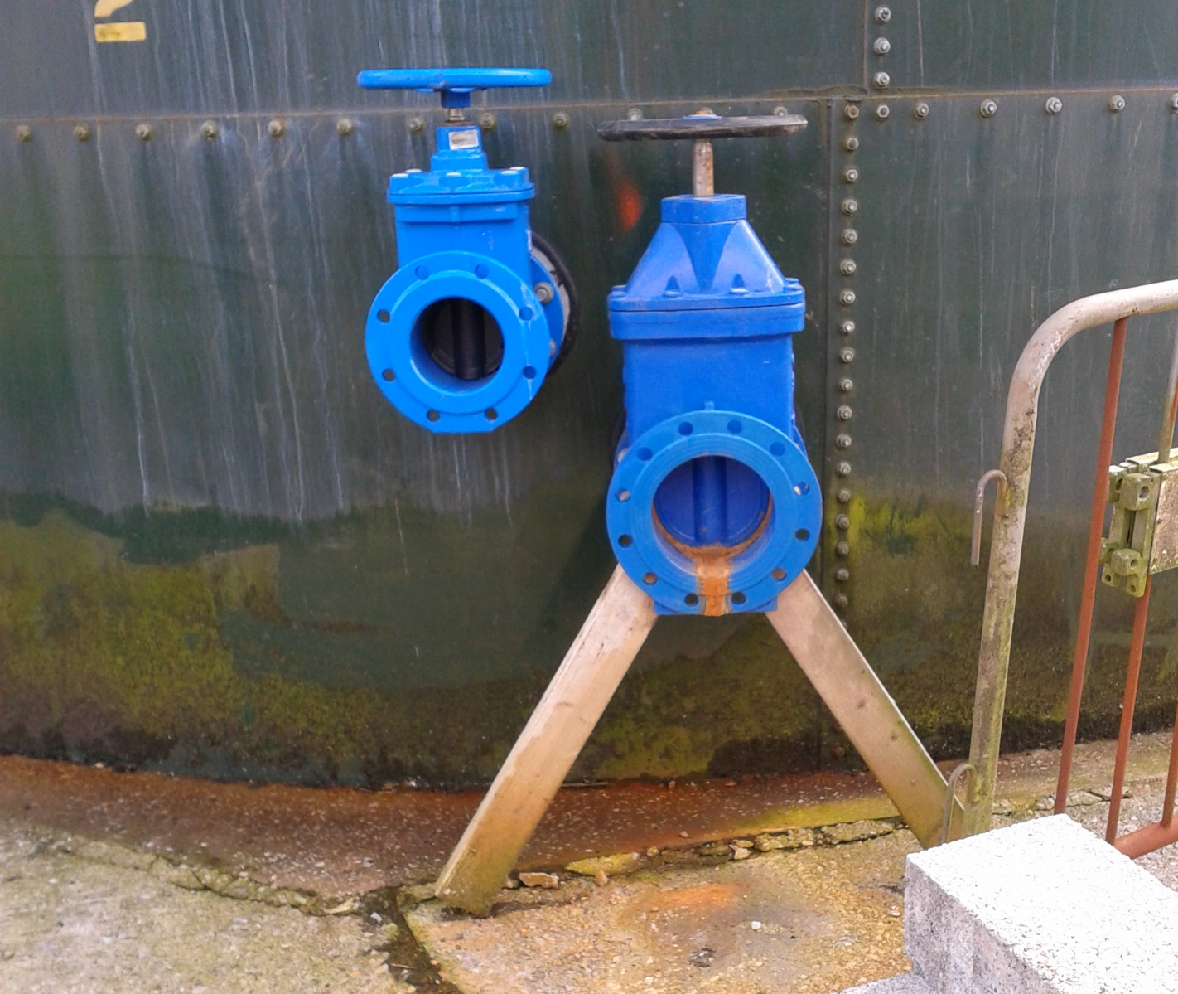
Figure 17 - Completed modifications to SHT.
With the SHT modifications complete arrangements were made to install the mixer system, 3 days were allocated to installing the pipework and 2 days allocated for installing the pump. This included all the electrical work that was also required.
The engineering drawings specified that a concrete plinth was required to support the pump, until construction could be arranged breeze blocks were positioned where a plinth was required to be constructed to act as a temporary replacement. Breeze blocks were also used as a temporary measure so that the weight of the pipework could be supported and would not place any stress on the valves attached to the side of the tank. In order to make the installation easier it was decided that the volute would be split from the pump motor so that it was easier to lift and could be placed in position without the need for any mechanical lifting equipment. Also, by using only the volute it would reduce the stress on the pipework until a permanent concrete base was constructed, it would also be safer as the breeze blocks being used were only intended as a temporary measure.
The following images were captured during the installation work.
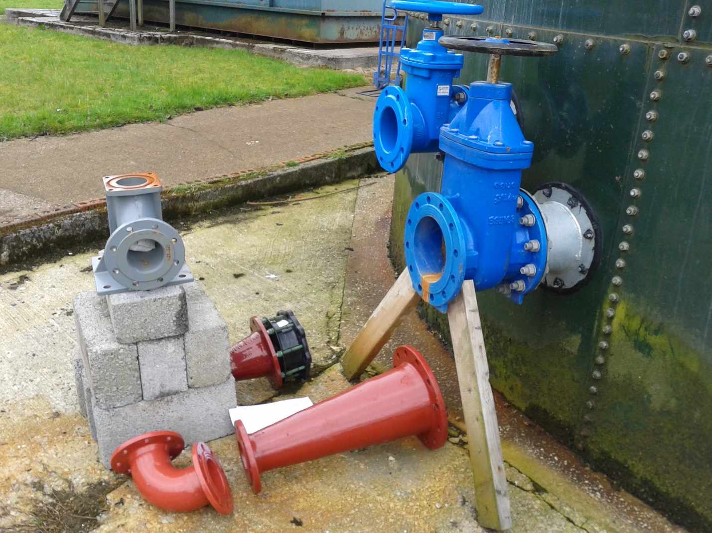
Figure 18 - The parts laid out in relation to the engineering drawing allowing the best approach to be taken assembling the pipework.

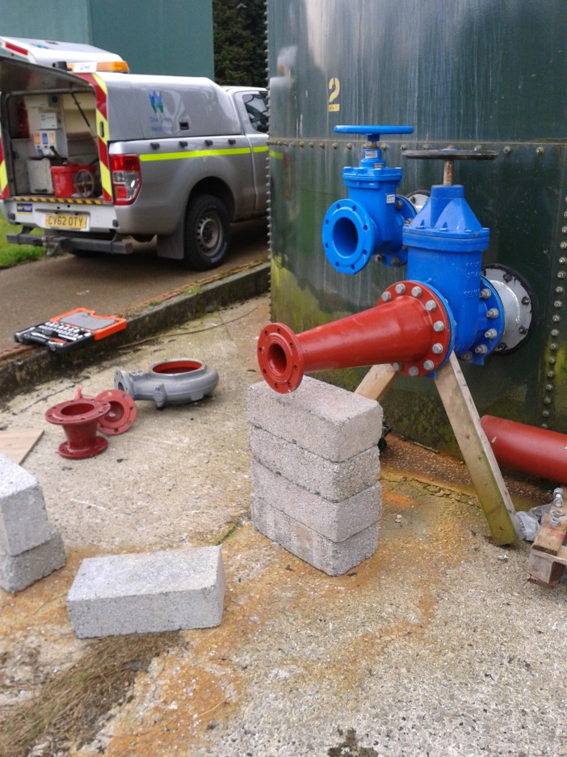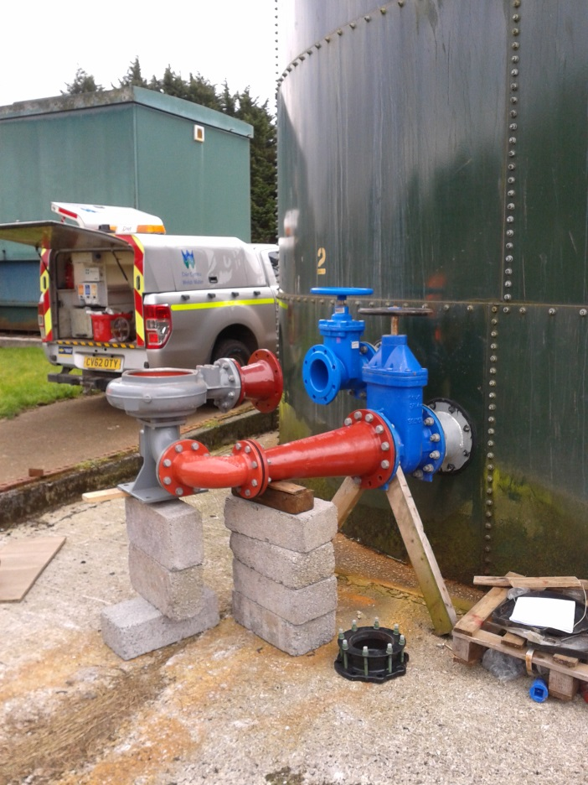
Figure 19 - It was vital that the parts were supported during assembly so not to put excessive stress/strain on the tank.
Due to the cylindrical design of the tank, aligning the pipework exactly proved to be a challenging task, in addition the convex wall of the tank to which the valves were attached caused the pipework to ‘pull’ unevenly as the bolts are tightened, this placed stress on the tank/components and could have potentially caused damage. In order to prevent this, it was decided that the delivery pipework would be attached to the valve using a plain pipe with a flange on one end and then use a flange adaptor or ‘VJ’ on the other. The principle behind the idea was that the rubber in the adaptor would provide greater flexibility where it grips the plain end of the pipe. This would minimise the amount of stress placed on the pipework as it is tightened into position and would take up the slight curvature in the tank.
Once all the pipework had been attached it was arranged for Whitland Engineering to attend so that they could begin the first stage of civil work. This was earlier than the planned schedule and is evidenced on the timing plan. The task included laying a concrete slab and preparing the rebar that would be used in the concrete plinth construction. A photo of this work can be seen below.
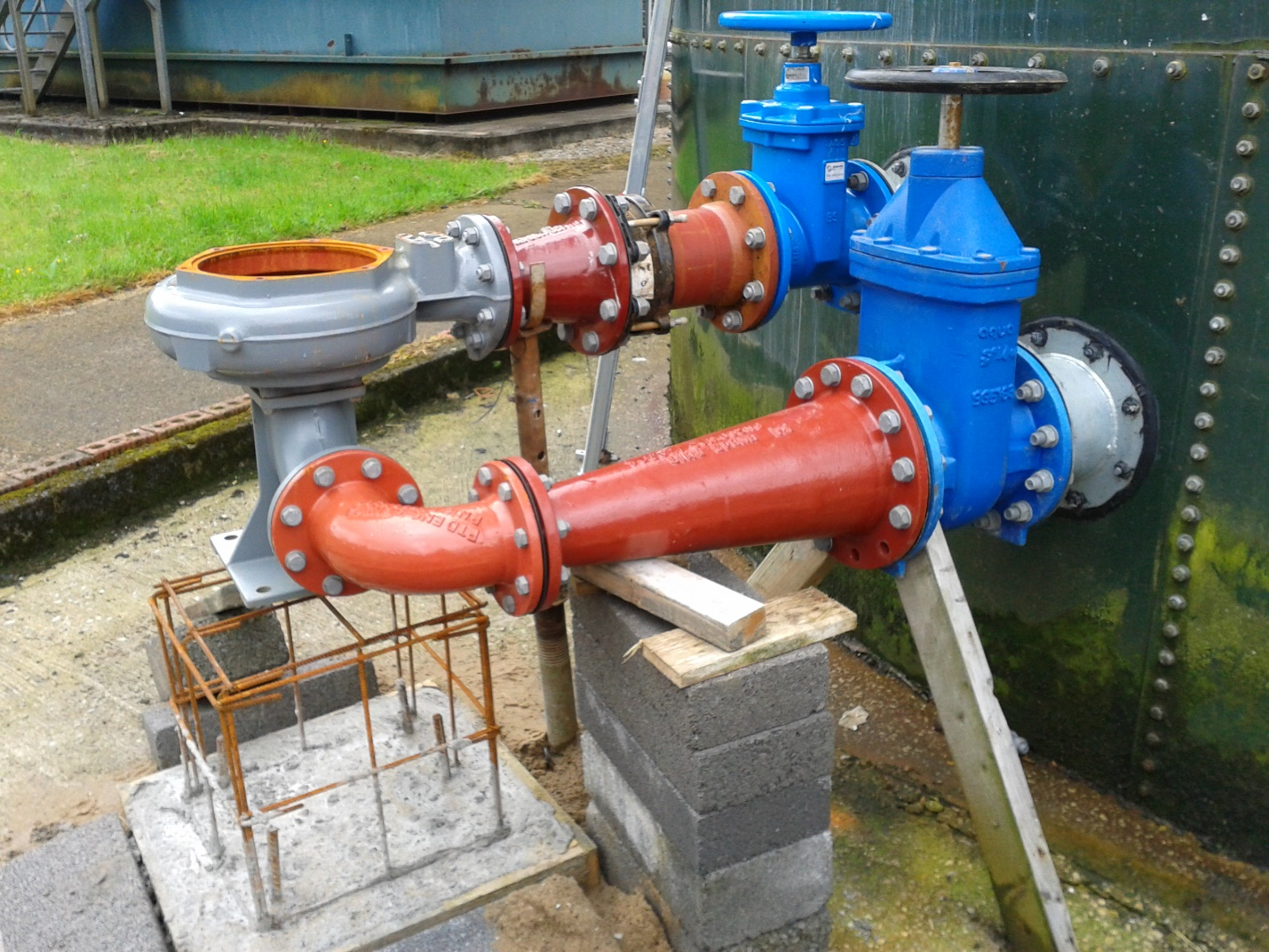
Figure 20 - The preparation work for the construction of the concrete plinth. The pipe work is suitably supported by the breeze blocks and acro arms.
Although the civil work was started early its completion overran the intended timescale due to the Christmas break where Whitland Engineering take a break between Christmas and New Year. This time was used to carry out the electrical work required to get the pump running, including the installation of a new emergency stop, as per the PDS requirements. This delay pushed the project completion back a week and as a result meant that the observation period and data collection would have to be carried out over 60 days as opposed to the intended 90. This 30-day difference would not have affected the accuracy of the gathered data as it would be looked at for consistency of sludge thickness as well as average percentage of solids.
The completed project can be seen in the photo below.
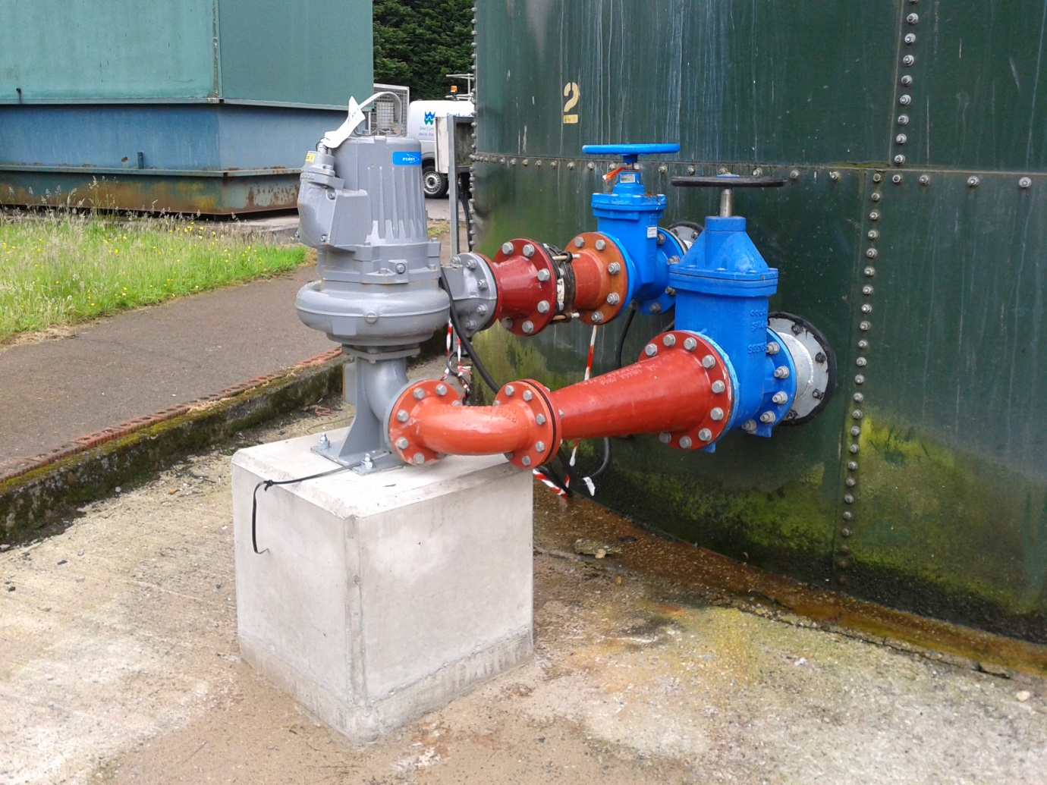
Figure 21 - The completed mixer system including SHT modifications and civil work.
From the photo it is clear that there is enough room around the pump to be able to safely carry out maintenance tasks, meeting the PDS specification.

12.0 Analysis, Results and Evaluation

It must be highlighted before evaluating the project that project overran its planned duration. As a result, the observation period had to be scaled back from 90 days to 60 in order for the project to hit its completion date of week 34 and allow time for this report to be compiled.
The areas that took the longest amount of time and had the greatest affect was the time to gather the required quotations. A mixture of annual leave on behalf of the contractors compiling the quotation, quotations being slightly over budget and the fact all quotations had to be submitted together meant it took 10 days to complete instead of the projected 5 days. The knock-on effect for each subsequent task could have been worse had it not been for the fact that the pump, pipework and materials were delivered in 15 days instead of the quoted 30 days. This pulled the project back on time until the civil works were due to be completed, which pushed the project back again. This civil work took 20 days and as opposed to the intended 10 days due to Whitland Engineering closing down for the winter break.
Upon completion of the project there was an intended 90-day observation period to assess the installation and that the equipment was running as it should. Due to the late finish of civil work and the need to complete the report before the specified deadline the 90-day observation period was unable to be completed. However, prior to the project, the sludge thickness figures were inconsistent, producing figures ranging from <1% average solids to almost 9%. After commissioning the new mixer system, although only able to gather data over 60 days the sludge leaving the site was more consistent with loads closer together and with average solids of between 4 and 5%. Data from two months before the mixer system compared to three months after can be seen below. Full data gathered from a year prior to the project and 60 days after commissioning the system can be found in the appendices of this report.
Screenshots from the system used to collected data for sludge removed from Welsh Water sites are seen below. A graph was created from the results of sludge removed from Pontyates to make comparisons easier.
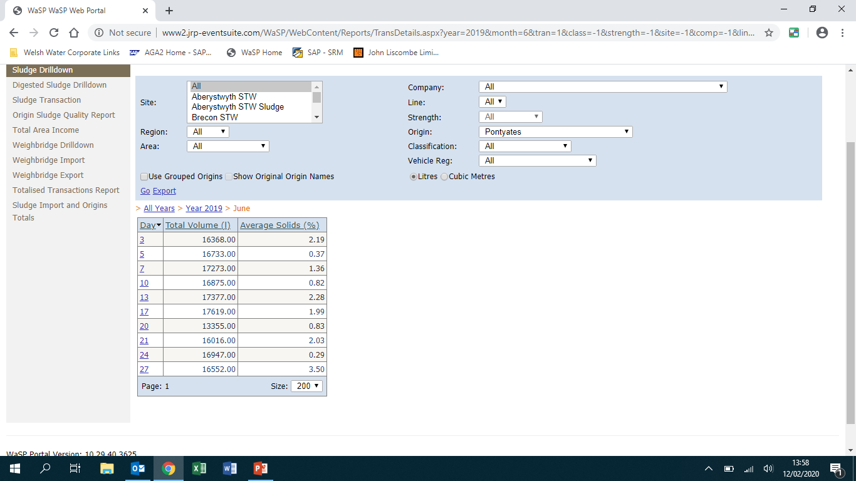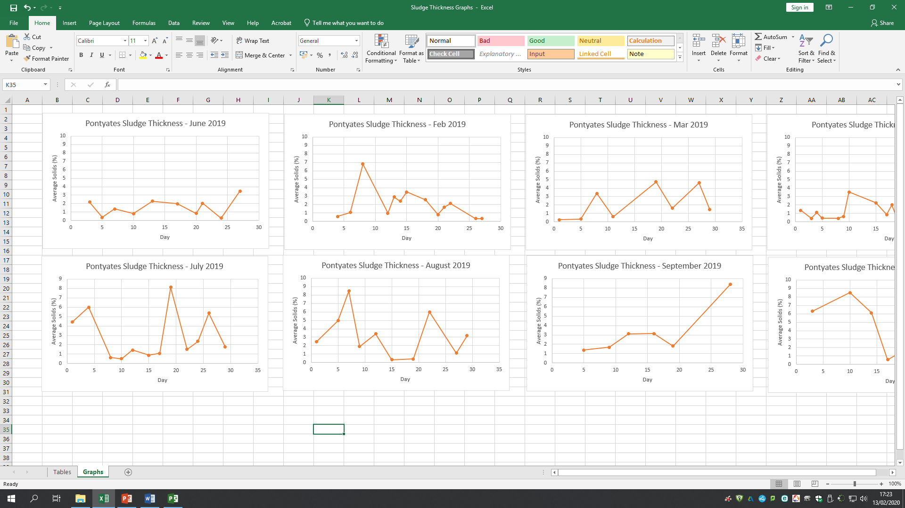
Figure 22 – Details of sludge removed from Pontyates throughout June 2019.
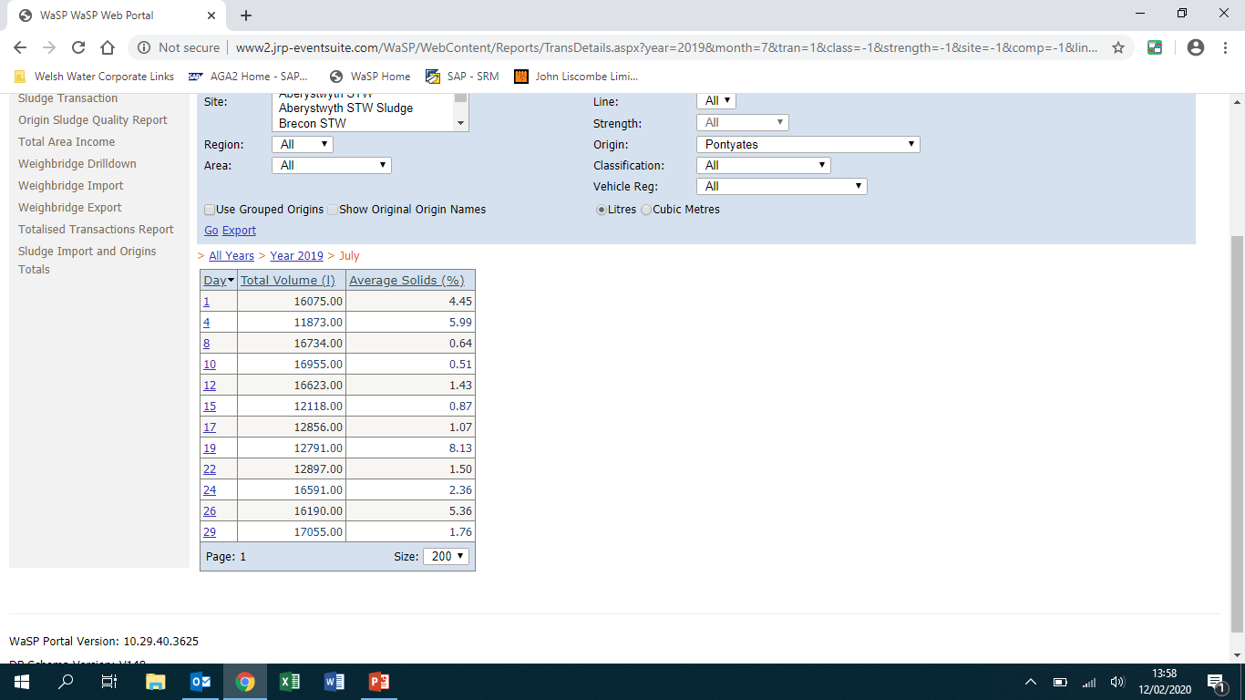
Figure 23 – Details of sludge removed from Pontyates throughout July 2019.
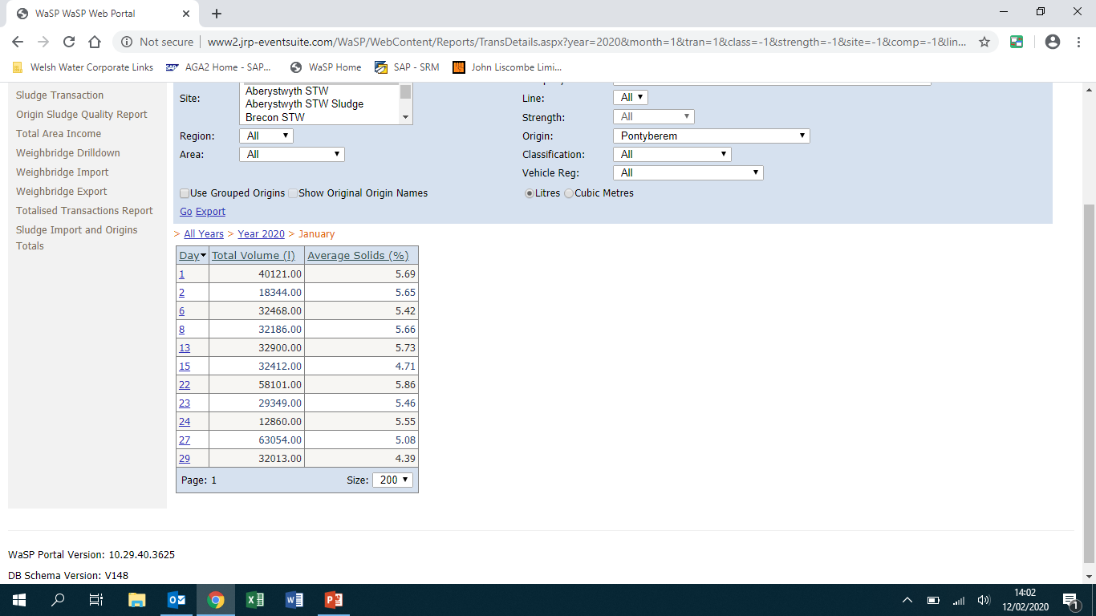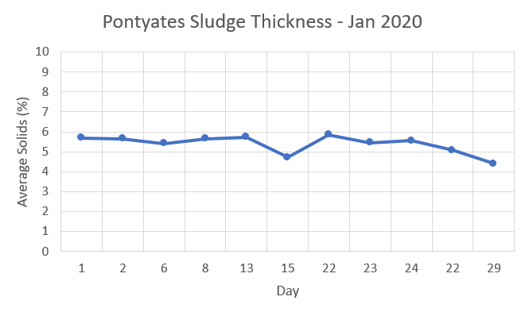
Figure 24 – Details of sludge removed from Pontyates throughout January 2020.
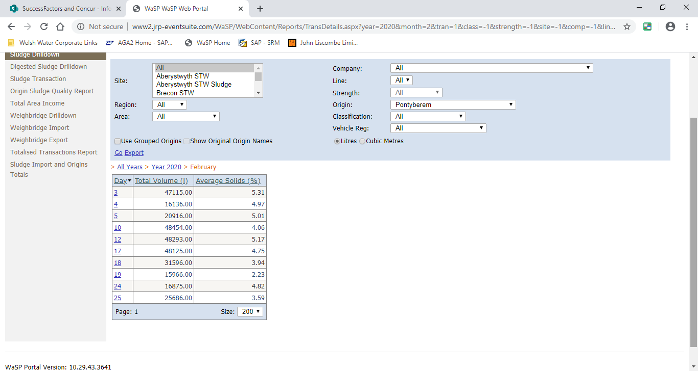
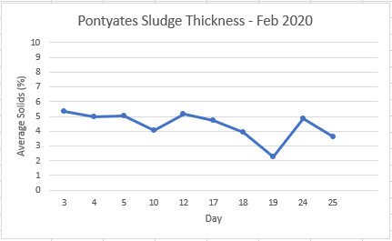
Figure 25 – Details of sludge removed from Pontyates throughout February 2020.
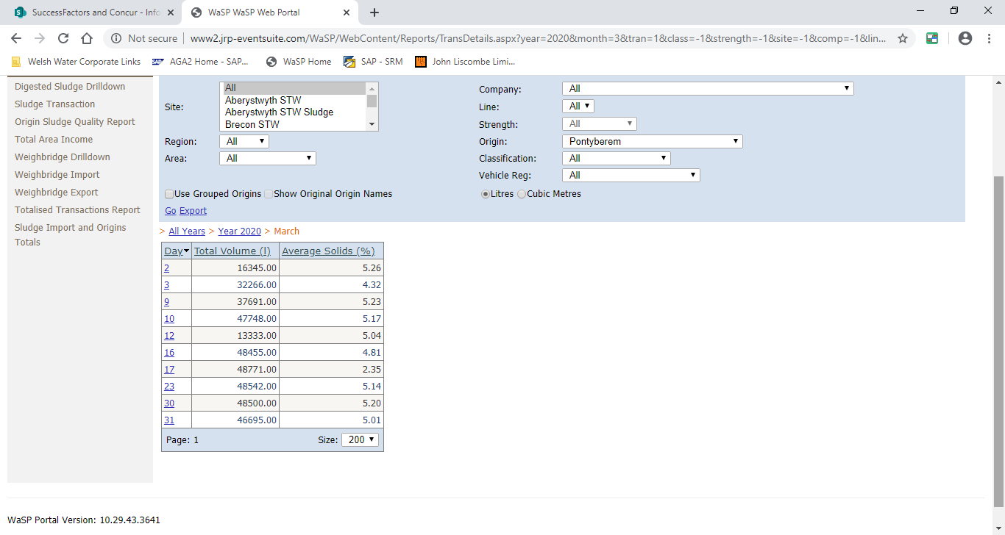
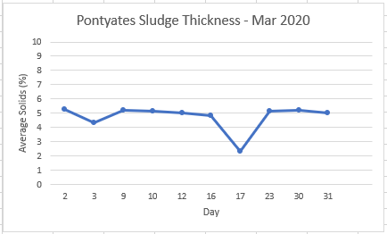
Figure 26 – Details of sludge removed from Pontyates throughout March 2020.

Looking at the results the installation was successful and all parties involved are happy with the result. Having spoken with the bio solids team since the installation, it is clear that the site is operating more consistently since completion with sludge being removed regularly achieving the 4% thickness target. This can be seen above where the data from the tables have been plotted on a graph and a red dotted line indicating the 4% target has been laid over it. This proves that the mixer has been a success as the line is more horizontal, indicating more consistent data. All loads removed are also above the target of 4% which when compared to June 2019 where there were no examples of sludge being removed that went above 4%. All the data gathered for the purpose of this report can be found in the appendices of this report.
The cost for the whole project came in at £10,289. This is slightly above the £10,000 given in the PDS and as a result the extra £289 had to be approved by the bio-solids team as it was coming out of their budget. Although technically over budget the project can be deemed as a success as it was only slightly out and the results of the installation would have paid this back in savings from thin loads.
Analysing the mixer install it is not intrusive and provides plenty of room for maintenance work to be carried out, this is important because it was a safety concern detailed in the PDS. Having plenty of space to work reduces the risk of injury when removing the pump and the new pump can be disconnected from the existing pipework thanks to new isolation valves fitted on the suction and discharge pipework. In addition, a new emergency stop was fitted to fulfil the PDS requirements.
The new pump also fulfils the PDS as it is an IE3 rated motor. This will save on power usage but because it is a new piece of equipment the running costs would have to be reviewed after 12 months to determine if the energy expenditure running the mixer are outweighed by the benefits regarding sludge thickness.

13.0 Conclusion

The results of the project will be compared to the PDS to see if they have met the proposals set out at the start. Section 8.1.1, ‘Performance’, of the PDS relates to the performance of the system and states that the pumps must be able to pump solids up to 4%. This can be proved by looking at the results of the sludge thickness being removed from site in Jan 2020. Solids were consistently above 4% and the majority of loads taken were just under 6%, proving the pump could handle pumping solids in excess of the 4% target. Also stated in section 8.1.1 the pumps were required to run on a timer for up to 12h per day 365 days a year. At present, the pump has run to specification without any issues or breakdowns to report.
Section 8.1.5 of the PDS relates to the overall target cost of the project with the budget set at £10,000. The whole project cost in total £10,289 which is slightly over budget. In this aspect the project failed to meet the PDS requirement, however, extra funding was secured to complete the project.
Section 8.1.6 relates to the maintenance of equipment. Basic maintenance is to be carried out every 6 months and a full inspection after 12. Section 8.1.11 relates to aesthetics and states that the pipework should be installed in such a way to allow ease of maintenance. The equipment has not been in service long enough to trigger a maintenance card the new pipework has been designed to allow the tank to remain online while maintenance is carried out or should the pump need to be removed for a complete overhaul in the future.
Section 8.1.15 of the PDS relates to the company constraints applied to the project and states that the project should utilise the existing SHT, comply with the company health and safety policies when undertaking the work and remain on budget. The project was completed with minor modifications carried out on the existing SHT and all health and safety policies were followed during installation. These included certificates to work, management of contractors and safe isolations.
Section 8.1 16 of the PDS relates to the safety of the installation and states that the new pump must be able to be electrically isolated and that new emergency stops be installed. The pipework has been designed so that the pump can be removed without the need to remove any of the pipework. This, as previously mentioned and will make working on the pump safer.
In conclusion, the project is deemed to be a success based on the results produced. However, these only show the short-term effects. Monitoring of the equipment will be ongoing for the next 12 months.

14.0 Recommendations

Upon completion of the project, it has been looked back upon to determine recommendations should a similar project be required in the future.
Out of the three possible solutions proposed by the Author, the third solution was selected and implemented. This solution is adequate and meets to brief set in the PDS, however, with a higher budget, solution three would have been yielded better results. This would have required extensive modifications to the site including construction of a new building to house the thickener system. This solution would have allowed for expansion to the site in the future and would have allowed the works to be able to cope with any increase to incoming flows and the resulting increase in sludge produced from any future developments in the area due to population growth. However, at the time of the project, the size of the treatment works currently would not justify the extra capital expenditure.
The final recommendation would have been to contact pump manufacturers for quotations directly as opposed to going through Pump Supplies Ltd. While the Flygt pump supplied is capable of doing the job, it struggled with solids greater than 4%. Further research would have identified other pump manufacturers with greater solids handling capabilities.

15.0 Bibliography

17.0 Appendices

17.1 Appendix 1 – Project Proposal


Project Proposal
Title: Installation of sludge holding tank mixer at Pontyates WWTW
Description:
Pontyates WWTW is a rural waste water treatment works owned and operated by Dwr Cymru Welsh Water. Solid matter (sludge) that is separated during the treatment process is stored in a holding tank until it can be removed via tanker to a reception centre for further processing. There has been a recent drive to increase the efficiency of how the company operates its bio-solids department and sludge thicknesses have come under the spotlight for improvement. Pontyates WWTW is one site where inconsistent sludge thickness is resulting in inefficiencies for the bio-solids team.
Aim:
The aim is to install a mixer system to the existing sludge holding tank in order to improve sludge thickness and make it more consistent. When sludge is taken to a reception centre it is offloaded through a sludge thickness monitor that measures the thickness in a percentage. The bio-solids team have set a target for Pontyates WWTW to achieve 4% thickness or above. Currently sludge settles in the holding tank causing thicker solids to settle in the bottom while water rises to the surface. As a result, sludge leaving site can measure anywhere between <1% and 8% depending on the state of settlement. The aim of the mixer is to keep the water and solids in suspension so that when collected it meets the set target consistently.

Start date: Week 1 (19th September 2019)
Completion date: Week 27 (30th April 2020)
Approval / Acceptance:
Student: Employer: Lecturer:

_ _ _ _ _ _ _ _ _ _ _ _ _ _ _ _ _ _ _ _ _ _ _ _ _
J.Parkhouse DCWW J. Williams

Confidentiality:
This document together with all other documentation relating to the above project is confidential, and is the sole property of Sir Gar Ltd. The documentation and / or associated information may not be used, copied or disclosed to any third party without prior written authority of Sir Gar Ltd.

17.2 Appendix 2 – Proposed Timing Plan

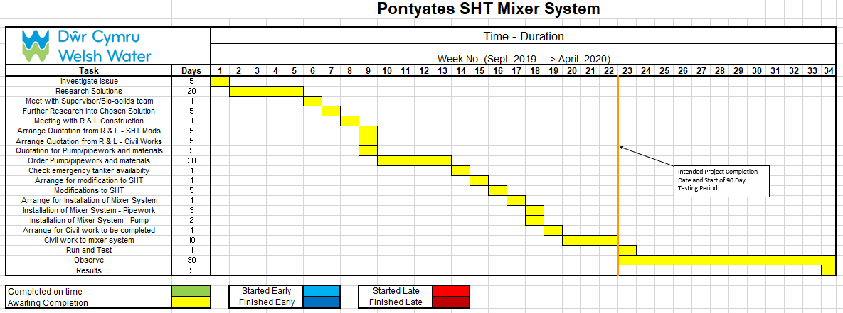

17.3 Appendix 3 - Actual Timing Plan

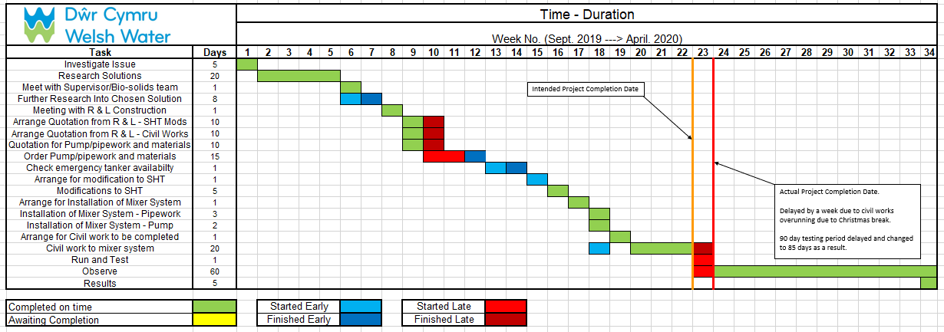

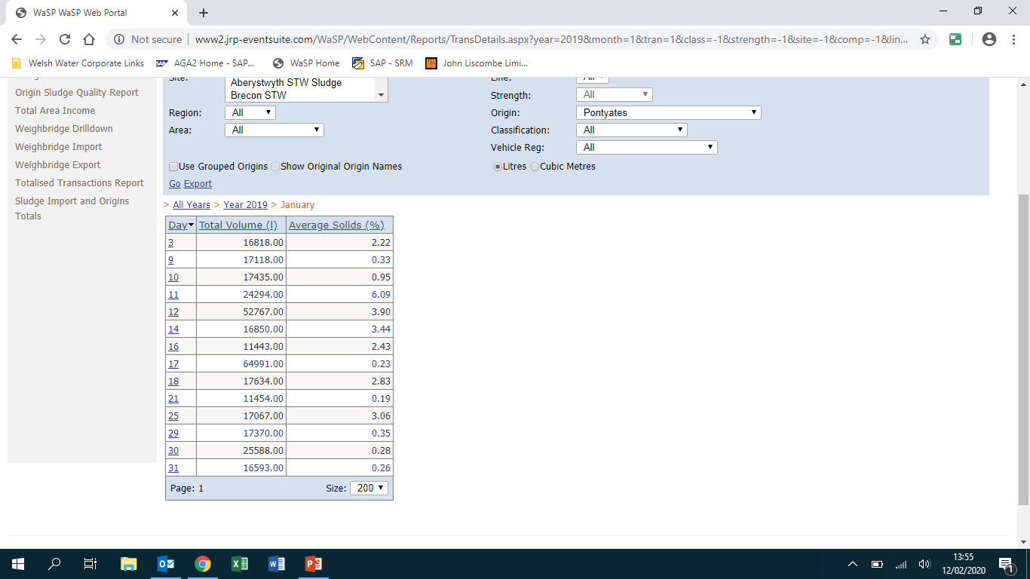
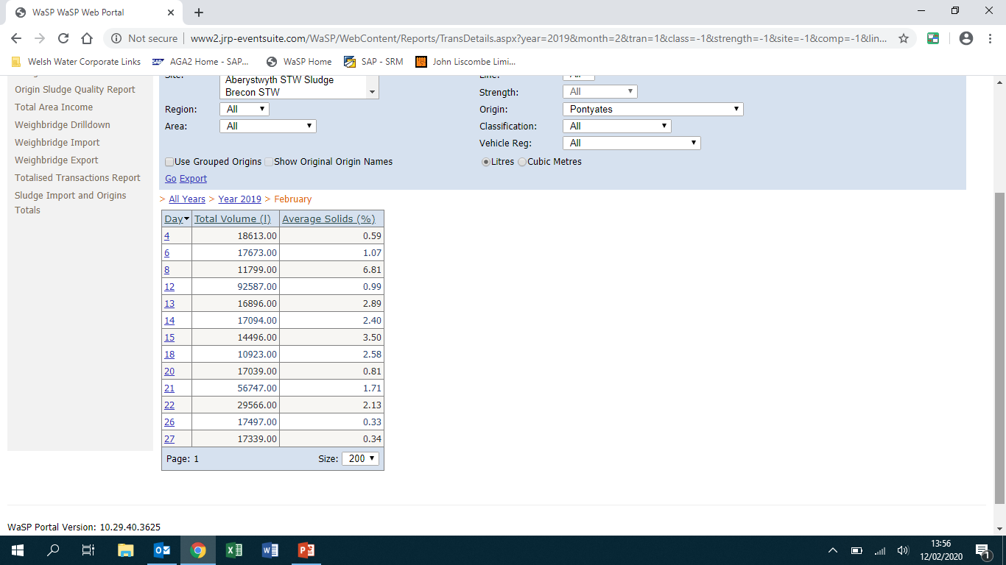
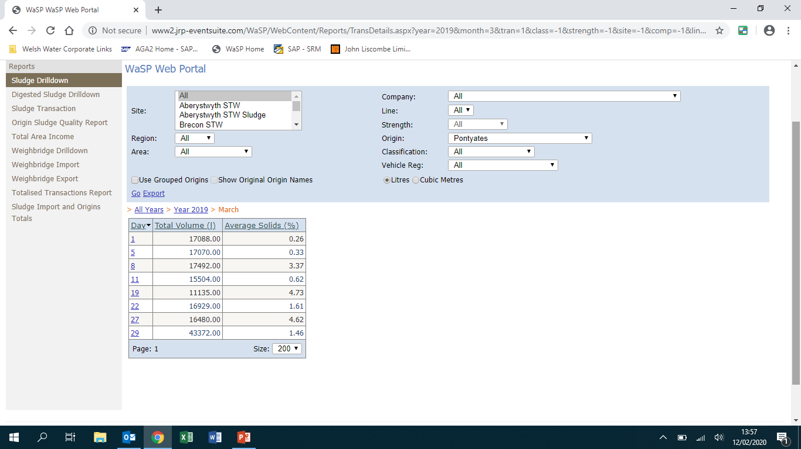
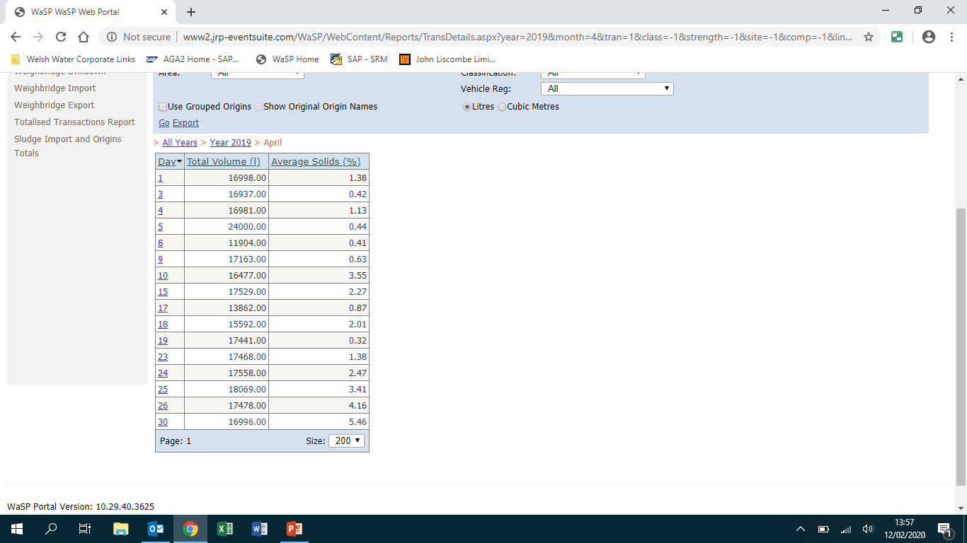
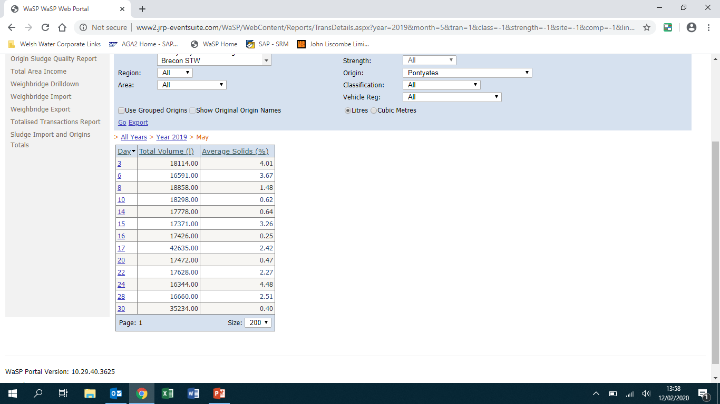
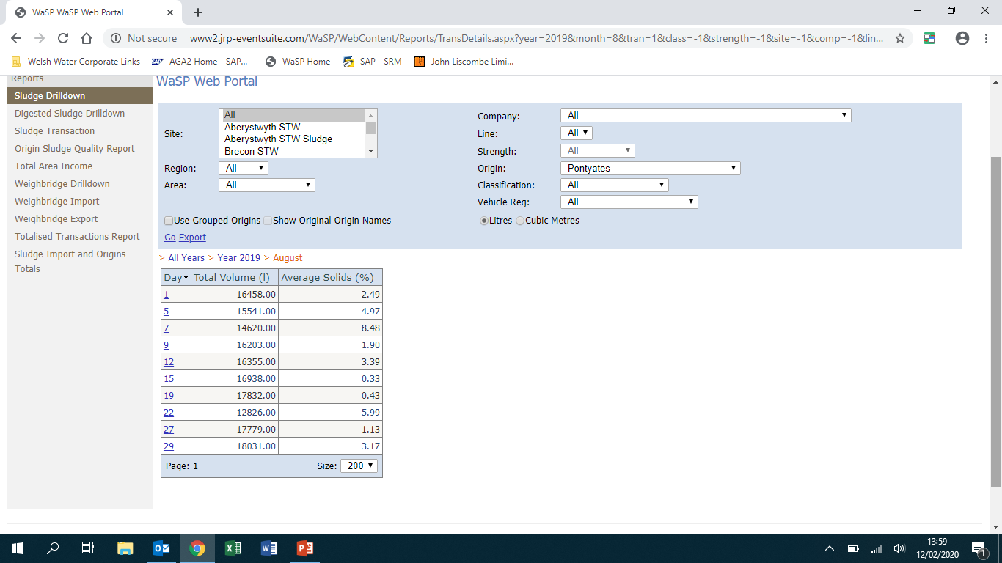
17.4 Appendix 4 – Sludge Thickness Data

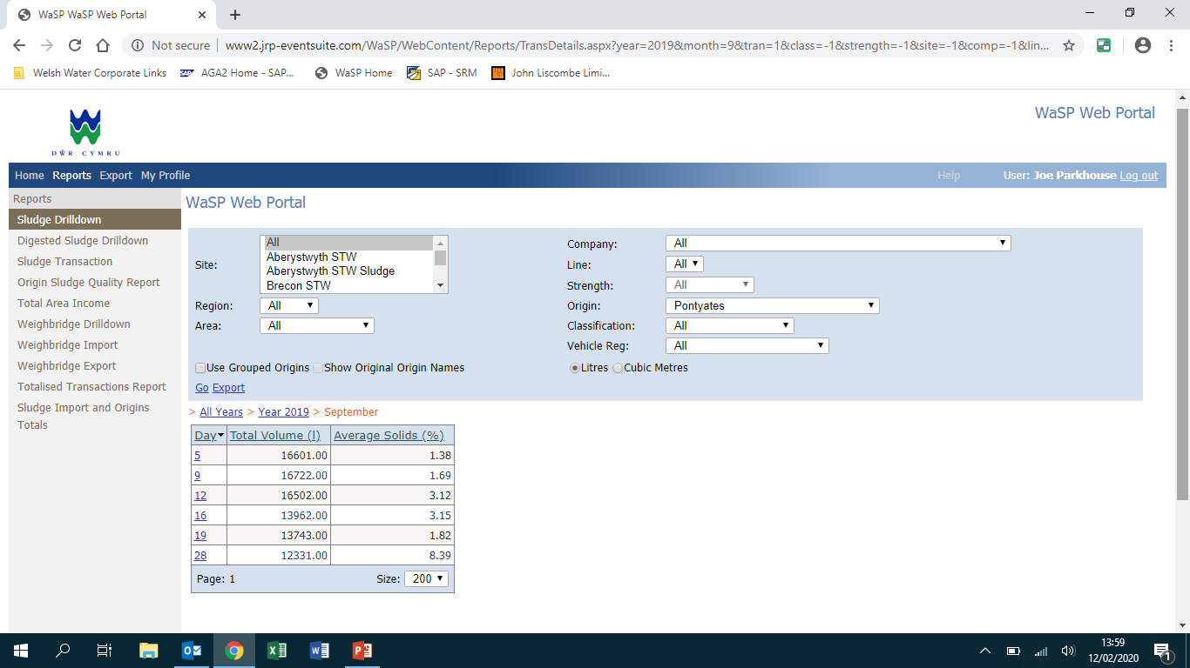
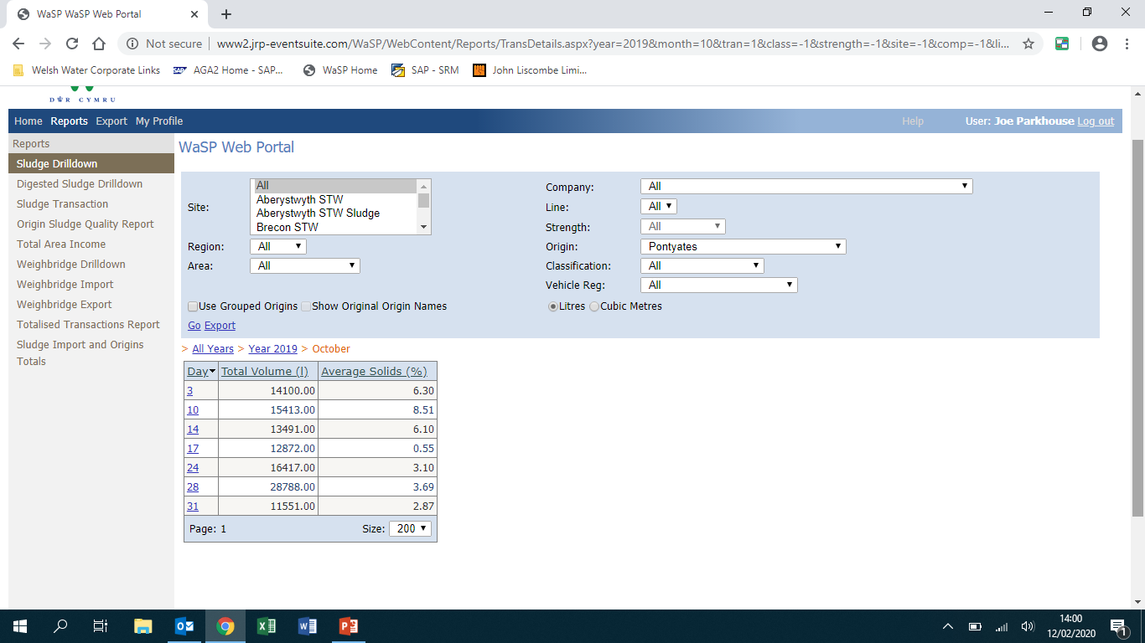
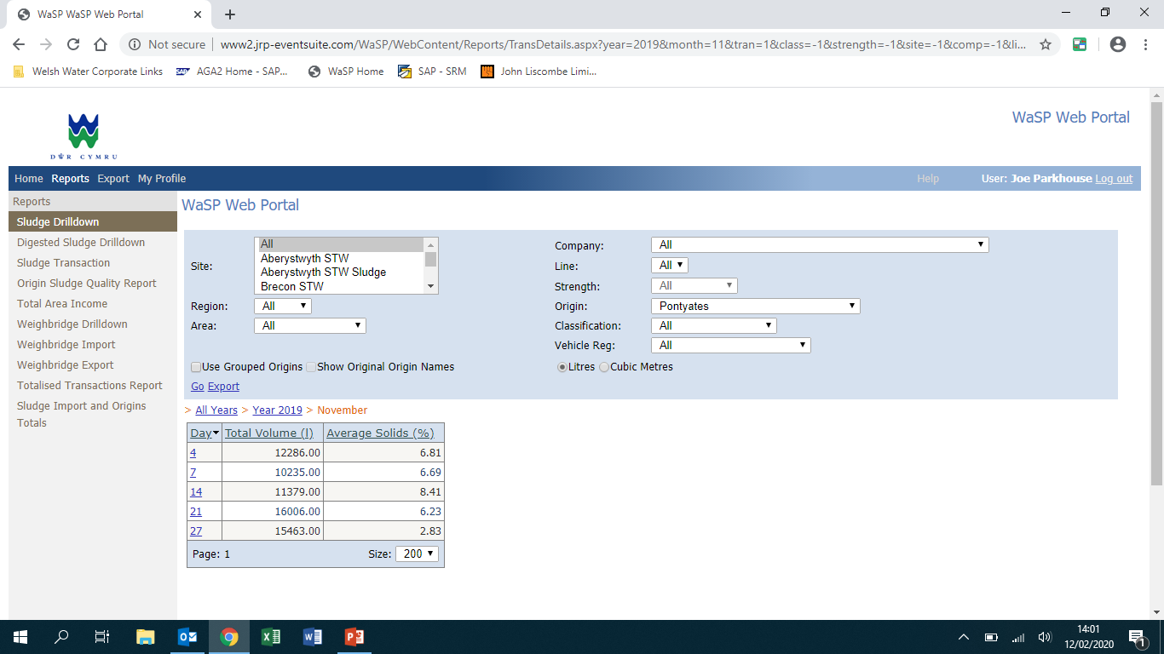
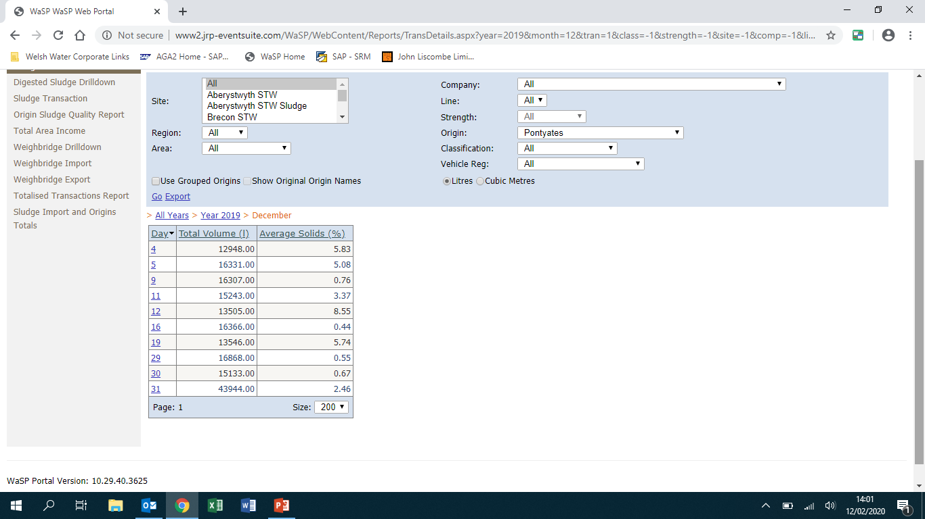
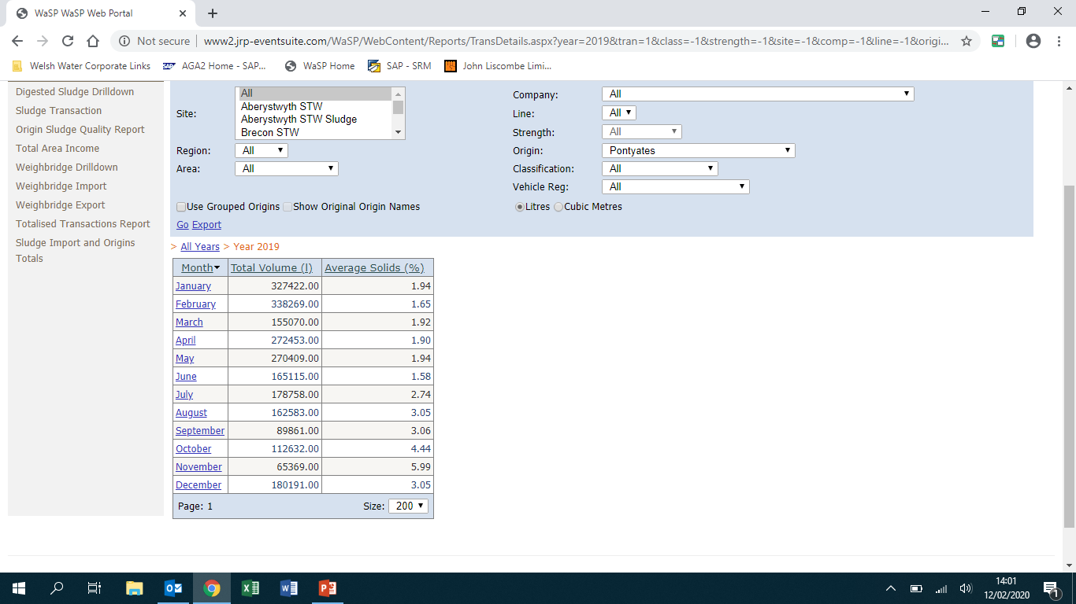

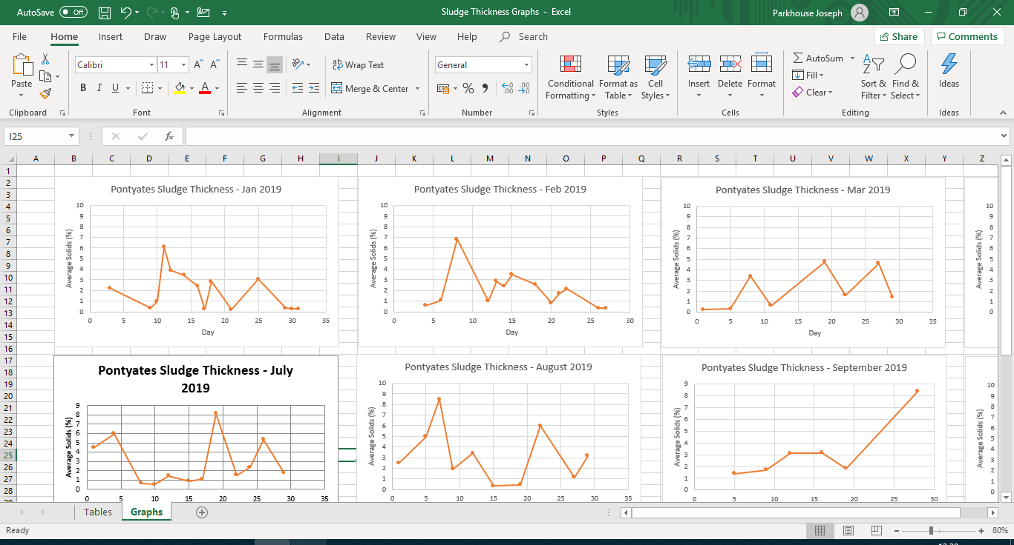
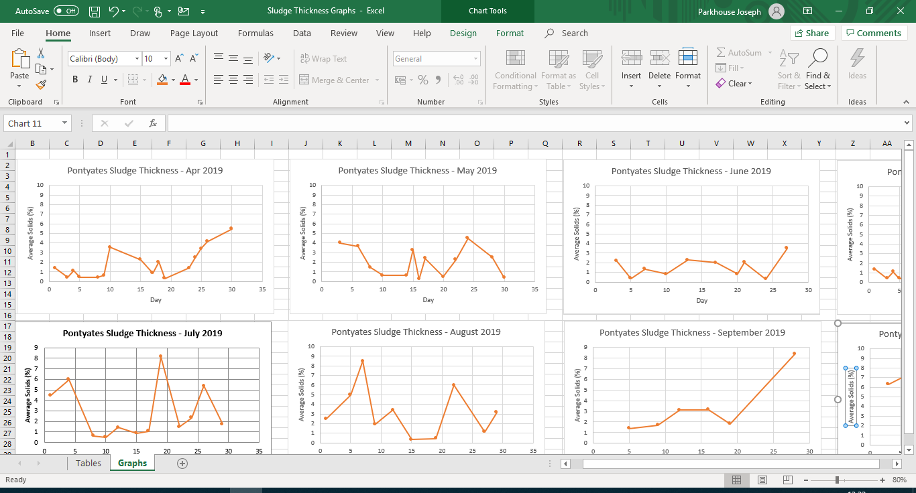
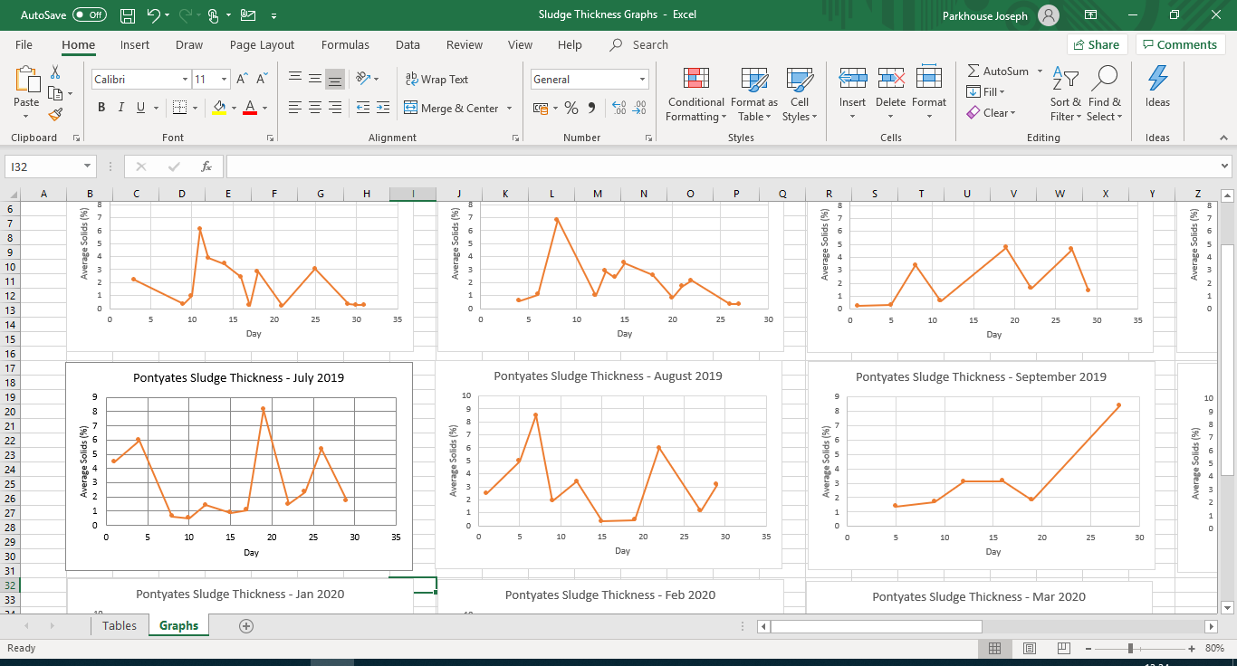
17.5 Appendix 5 – Sludge Data Graphs

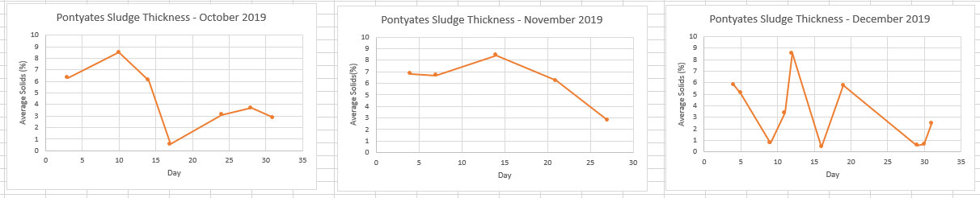

17.6 Appendix 6 - Whitland Engineering Quotation (SHT modifications and Civil Work)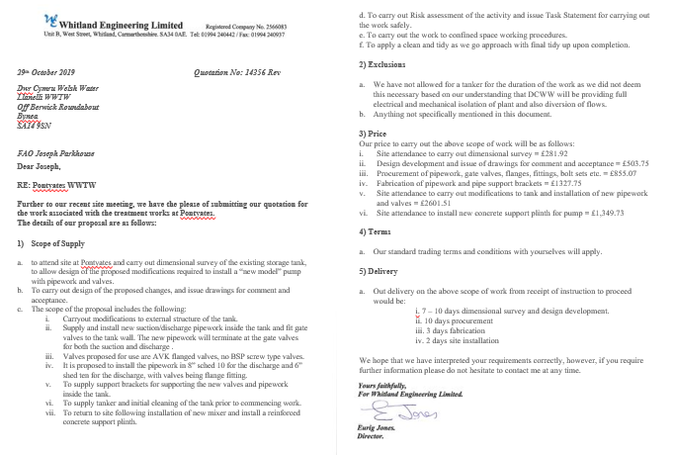

17.7 Appendix 7 - Pump Supplies Quotation (Pump, Pipework and Valves)

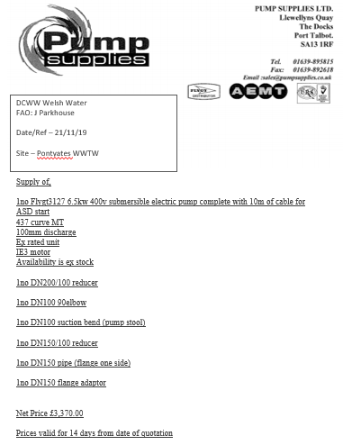

17.8 Appendix 8 – Site drawings of new mixer system

