Marks and Spencer Report
Student Number of Author: 1709292
Name of Author: Khayrun Nessa
Host Organisation: University of Wales Trinity Saint David
Date of Publication: 20th July 2018

Executive Summary
This report is designed to discuss the ideas surrounding the hypothesis of ‘Will Marks and Spencer survive and can it thrive?’ In order to discuss this, different analytical methods will be used to see the cause of the problems within the organisation and to draw a conclusion to see if Marks and Spencer will be able to ‘survive’. A brief conclusion drawn is that Marks and Spencer faces issues such as not being able to target the correct audience and competition from rivals

Contents Page

Introduction 4

Main Body 5
  - 1: Overview of the Organisation 5
  - 2: Previous Problems 5
  - 3: Current Problems 6
  - 4: Analysis of Problems 7

Conclusion 9

Recommendations 9

Appendices 10

Reference List 11

Introduction
Marks and Spencer is a staple of fashion in the UK as well as a multinational retailer and has become a well-established business since its establishment in 1884. It is well known for its excellent service, products and employees. However, as with many other large department stores in the retail sector for example British Home Stores, Marks and Spencer is facing a decline. High street stores have been more heavily impacted. The current CEO, Steve Rowe, has introduced measures to try and ensure the long term survival of the organisation. This poses the question from different types of people for example customers and employees of whether Marks and Spencer will survive and will it thrive?

Main Body
  - 1: Overview of the Organisation
One of Marks and Spencer’s main philosophies is to provide great quality products for a good value for money. ‘Although primarily based in the UK, we sell into 57 countries, from 1463 stores and 20 websites around the world. We employ 81,000 colleagues serving about 32 million customers.’ This provides an insight into the company’s customer base and employee numbers and also proving that the company operates internationally.’ In 2018, food has had a 61% contribution to the company’s UK revenue with revenue of £5.9billion. Compared to clothing and homeware which contributes 39% to the UK revenue with revenue of £3.7billion.
Corporate M&S,2018. Strategic Report. [Online] Available at: https://corporate.marksandspencer.com/annual-report-2018/mands_annualreport_2018.pdf [Accessed 16 Jul. 18]
‘The Company operates through two segments: UK and International. The UK segment consists of the United Kingdom retail business and the United Kingdom franchise operations. The International segment consists of Marks & Spencer owned businesses in the Republic of Ireland, Europe and Asia, together with international franchise operations.’ The company’s product portfolio includes food, clothes and homeware being sold in the stores as well as financial services provided in other segments of the company.
Reuters, 2018. Marks and Spencer Group PLC. [Online] Available at: https://www.reuters.com/finance/stocks/company-profile/MKS.L [Accessed 16 Jul. 18]
Marks and Spencer originated from a stall put up by Michael Marks in Leeds with his famous slogan of ‘’don’t ask the price, it’s a penny.” He went into partnership with Thomas Spencer in 1894 and opened their first shop in 1904. The year 1926 was when Marks and Spencer became a public company. The food department was opened in 1931, ‘selling produce and canned goods.’ Online shopping was introduced in 1999.
Marks and Spencer Company Archive, 2016. A Short History of Marks & Spencer. [Online] Available at: https://marksintime.marksandspencer.com/download?id=996 [Accessed 16 Jul. 18]
  - 2: Marks and Spencer’s planning, communication, monitoring and review of attempts to resolve previous problems
Problems were prevalent within the organisation in 2004 and the CEO at the time, Stuart Rose, aimed to find solutions to these problems. One problem that he was faced with at the time was the argument that ‘the business has become too complicated.’ The solution to this was to sell the financial services to HSBC for £762million and reducing the number of Simply Food stores. The idea around this was to perhaps gain assistance with the Marks and Spencer bank from HSBC, who are experts in the field. The food stores may be somewhat hard to run along with the various other sectors the organisation was involved so this will ease the pressure slightly. Another problem was that rivals, for example Primark and New Look, were taking Marks and Spencer’s core business. This was resolved by focusing on 30 to 55 year old shoppers, which are the company’s main audience, by providing style and quality and swaying shoppers away from discount stores and supermarkets.
The Guardian, 2004. It’s back to being simply the best. [Online] Available at: https://www.theguardian.com/business/2004/jul/13/marksspencer2 [Accessed 16 Jul. 18]
Problems also occurred in 2012. One problem was that the website was ‘clunky’, meaning it was difficult to use for consumers and very old-fashioned. It was based on an ‘old off the shelf Amazon model not built for the modern world of retail online.’ This problem was solved by the CEO at the time, Marc Bolland, by re-launching the site. Although, this caused a bit of a hindrance as customers had to ‘re-join’ the site.
BBC News, 2014. Fixing Marks and Spencer. [Online] Available at: https://www.bbc.co.uk/news/business-29896708 [Accessed 16 Jul. 18]
  - 3: Nature, Scope and Impact of Current Problems Facing Marks and Spencer
A more general problem facing many high street chain stores is the increase in the use of online shopping and ‘escalating’ business rates. Less people are visiting shops and business rates increase further due to the city centre locations of most Marks and Spencer stores. Compare this to larger spaces found in retail parks and lower business rates.
The Times, 2018. High street must change- or shut up shop. [Online] Available at: https://www.thetimes.co.uk/article/high-street-must-change-or-shut-up-shop-3zzgk65p6 [Accessed 17 Jul. 18]
The Financial Times Stock Exchange (FTSE) index is an index used to measure the performance of shares in the 100 largest companies in the London Stock Exchange. Marks and Spencer is risking the ‘demotion’ from this index and being placed into the FTSE 250 index due to its recent lower performance. This would affect M&S as investors tracking the FTSE 100 index would not find the company there and potential investments will not be made.
Financial Times, 2018. Definition of FTSE 100. [Online] Available at: http://lexicon.ft.com/Term?term=FTSE-100 [Accessed 17 Jul. 18]
The Times, 2018. M&S at risk of symbolic relegation. [Online] Available at: https://www.thetimes.co.uk/article/marks-spencer-at-risk-of-symbolic-relegation-from-ftse100-08b5tqkx9 [Accessed 17 Jul. 18]
Another problem is that M&S has too many stores. This costs a lot of money and therefore the company are closing ‘a third of its 300 high street stores.’ However, it is debated whether this is a far enough step to take considering we live in a digital age. Also, smaller stores are also being neglected meanwhile many stores are too big to maintain.
The Guardian, 2018. Seven reasons why Marks & Spencer is in trouble. [Online] Available at: https://www.theguardian.com/business/2018/may/23/seven-reasons-why-marks-spencer-is-in-trouble [Accessed 17 Jul. 18]

  - 4: Analysis of the causes of the problems at M&S
  - SWOT Analysis
A strength is the fact that M&S provide a wide a range of products due to their usual clothing store but additionally homeware and more importantly, food. This outcompetes other stores such as Primark and New Look who only provide clothes for the most part. Marks and Spencer has more than ‘1200 suppliers with over 400 different varieties’, just for strawberries.
Business Teacher, 2017. Marks and Spencer SWOT Analysis. [Online]. Available at: https://businessteacher.org.uk/swot/marks-and-spencer.php [Accessed 18 Jul. 18]
A weakness that the company is facing is ‘bad publicity as a non-trendy store.’ While Marks and Spencer is able to appeal to older generations (many of whom are existing customers) and keep them loyal to the store, they are failing to attract younger audiences and therefore new customers. Competition comes from stores like Zara and River Island who appeal to younger generations.
The Guardian, 2017. Not just for over-55s! M&S chairman says chain needs younger clothing. [Online] Available at: https://www.theguardian.com/business/2017/nov/05/not-just-for-over-55s-ms-chairman-says-chain-needs-younger-clothing [Accessed 18 Jul. 18]
An opportunity for Marks and Spencer is to focus on globalisation. It may be a good idea to set up websites specifically for host countries for example China or India. Representatives from these countries may also be appointed in order to know how to appeal to international audiences. There must also be research into where to place M&S stores in order to effectively appeal to the correct audiences.
UKEssays, 2013. Internationalization Strategy Of Marks And Spencer. [Online]. Available at: https://www.ukessays.com/essays/marketing/the-internationalization-strategy-of-marks-and-spencer-marketing-essay.php?vref=1 [Accessed 18 Jul. 18]
A threat is competition from many other retailers who are expanding using different methods. This includes Tesco having Tesco Express stores or Sainsbury’s having local stores while M&S still relies on large stores, increasing costs and lowering convenience to consumers.
  - PESTLE Analysis
Political factors include Brexit (pre referendum and pro referendum), hold some accountability to the decrease in sales. Due to ‘geopolitical instability, decreased demand and local currency fluctuation’ in these countries, the Middle East, Russia and Ukraine have also faced decline.
Some social factors include the emphasis on green initiatives and customers having concerns about ethics within large retailers. M&S has aimed to meet sustainability through various campaigns for example, the ‘Spark something good’ campaign.
Technological factors include M&S’s ‘good strategic position’ in the rising use of social networks and mobile phone use. The fashion business is moving faster than ever due to the enhanced use of technology as well as enhanced transport methods.
Ivory Research, 2016. Strategic Analysis of Marks & Spencer Plc. [Online] Available at: https://www.ivoryresearch.com/wp-content/uploads/2016/09/MS-Strategic-Analysis.pdf [Accessed 19 Jul. 18]
  - Stakeholder Analysis
Stakeholders in Marks and Spencer include customers, employees, investors, suppliers, the media and wider society for example non-governmental organisations or community groups.
Customers may have had an impact on Marks and Spencer by them not shopping in these stores and affecting the company’s revenue. The media may have given M&S a bad reputation due to the company’s recent performance. Employees are generally happy with the opportunities that the company has given them. ‘We provide a number of benefits that cover various stages of people’s lives, from starting their career, taking time out to study or having children, right through to taking a pension. In addition, we strive to create good working conditions, as well as providing a high standard of employee support.’
M&S, 2017. People Principles. [Online] Available at: https://corporate.marksandspencer.com/documents/policy-documents/people-principles-.pdf [Accessed 19 Jul. 18]
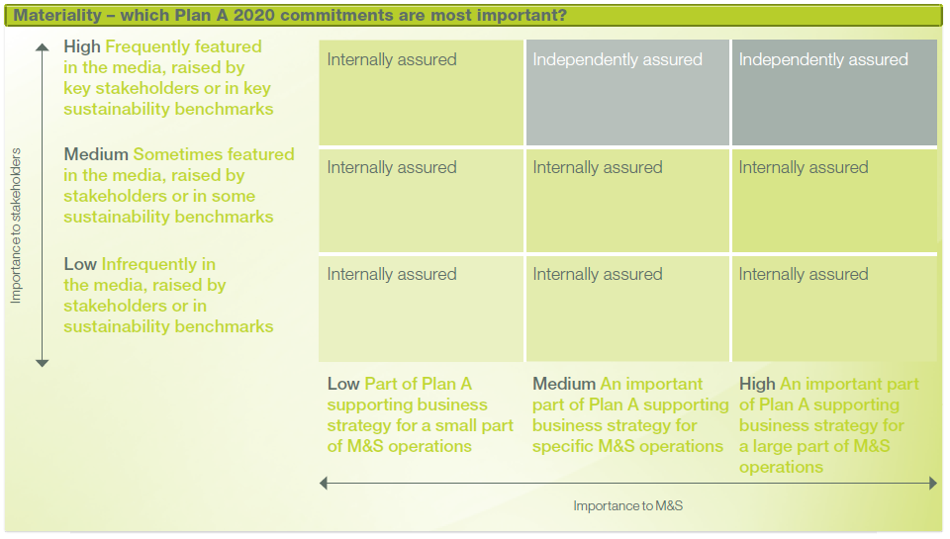
Investors must have a high influence on the company as they are they are the ones providing them with money. Lower investor confidence could have an impact on the company being able to run.
Figure 1: M&S Mendelow Model
Plan A is an M&S initiative for stakeholder involvement to contribute to the company’s sustainable development. This will help resolve some of its problems as they aim to change customer needs and expectations.
M&S, 2018. Plan A 2025 Commitments. [Online] Available at: https://corporate.marksandspencer.com/documents/plan-a/plan-a-2025-commitments.pdf {Accessed 19 Jul. 18]

Conclusion
In conclusion, the strengths of Marks and Spencer include the company’s ability to branch out more through the use of internet and the popularity of its food department while its weaknesses include its inability to provide clothing products for younger generations. Previous past decisions have not really contributed to these current problems.
Through SWOT analysis, its main issue is not appealing to younger audiences and the other competing retailers using different methods to branch out their business. Through PESTLE analysis, the main ussies faced are to do with Brexit as well as political instability in other countries affecting their international business. Furthermore, the concerns from society regarding the environment.
The main stakeholders who Marks and Spencer are concerned with are the customers and the community, who through community campaigns will improve Marks and Spencer’s development into the future.

Recommendations
M&S need to prepare for a more online-based future as there’s a target for the company to have 30% of its sales online. The company also needs to modernise the supply chain to appeal to younger generations. Some stores may be closed or down-sized in order to save on floor space and compete with other retailers. Although, the food department is successful, the company’s planned rapid expansion may need to be slowed down in order to focus on prices and improving product ranges.
The Guardian, 2017. New M&S chair promises new radical shake-up to fix ‘drifting’ business. [Online] Available at: https://www.theguardian.com/business/2017/nov/08/marks-and-spencer-speeds-up-shut-down-of-clothing-scales-back-simply-food [Accessed 19 Jul. 18]

Appendices

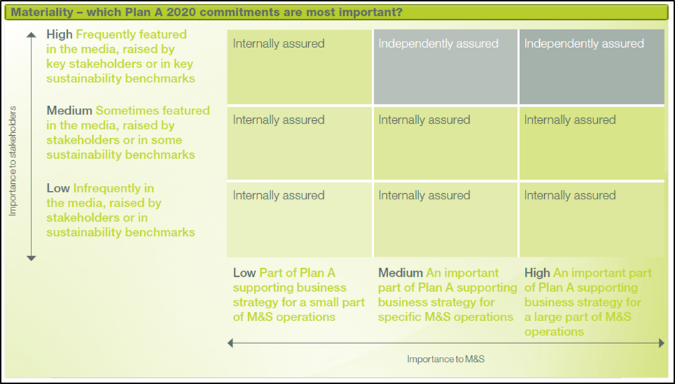
M&S Mendelow Stakeholder Model. Available at: https://corporate.marksandspencer.com/plan-a/delivering-plan-a/listening-and-taking-action

Reference List
Corporate M&S,2018. Strategic Report. [Online] Available at: https://corporate.marksandspencer.com/annual-report-2018/mands_annualreport_2018.pdf [Accessed 16 Jul. 18]
Reuters, 2018. Marks and Spencer Group PLC. [Online] Available at: https://www.reuters.com/finance/stocks/company-profile/MKS.L [Accessed 16 Jul. 18]
Marks and Spencer Company Archive, 2016. A Short History of Marks & Spencer. [Online] Available at: https://marksintime.marksandspencer.com/download?id=996 [Accessed 16 Jul. 18]
The Guardian, 2004. It’s back to being simply the best. [Online] Available at: https://www.theguardian.com/business/2004/jul/13/marksspencer2 [Accessed 16 Jul. 18]
BBC News, 2014. Fixing Marks and Spencer. [Online] Available at: https://www.bbc.co.uk/news/business-29896708 [Accessed 16 Jul. 18]
The Times, 2018. High street must change- or shut up shop. [Online] Available at: https://www.thetimes.co.uk/article/high-street-must-change-or-shut-up-shop-3zzgk65p6 [Accessed 17 Jul. 18]
Financial Times, 2018. Definition of FTSE 100. [Online] Available at: http://lexicon.ft.com/Term?term=FTSE-100 [Accessed 17 Jul. 18]
The Guardian, 2018. Seven reasons why Marks & Spencer is in trouble. [Online] Available at: https://www.theguardian.com/business/2018/may/23/seven-reasons-why-marks-spencer-is-in-trouble [Accessed 17 Jul. 18]
Business Teacher, 2017. Marks and Spencer SWOT Analysis. [Online]. Available at: https://businessteacher.org.uk/swot/marks-and-spencer.php [Accessed 18 Jul. 18]
The Guardian, 2017. Not just for over-55s! M&S chairman says chain needs younger clothing. [Online] Available at: https://www.theguardian.com/business/2017/nov/05/not-just-for-over-55s-ms-chairman-says-chain-needs-younger-clothing [Accessed 18 Jul. 18]
UKEssays, 2013. Internationalization Strategy Of Marks And Spencer. [Online]. Available at: https://www.ukessays.com/essays/marketing/the-internationalization-strategy-of-marks-and-spencer-marketing-essay.php?vref=1
Ivory Research, 2016. Strategic Analysis of Marks & Spencer Plc. [Online] Available at: https://www.ivoryresearch.com/wp-content/uploads/2016/09/MS-Strategic-Analysis.pdf [Accessed 19 Jul. 18]
M&S, 2017. People Principles. [Online] Available at: https://corporate.marksandspencer.com/documents/policy-documents/people-principles-.pdf [Accessed 19 Jul. 18]
M&S, 2018. Plan A 2025 Commitments. [Online] Available at: https://corporate.marksandspencer.com/documents/plan-a/plan-a-2025-commitments.pdf {Accessed 19 Jul. 18]
The Guardian, 2017. New M&S chair promises new radical shake-up to fix ‘drifting’ business. [Online] Available at: https://www.theguardian.com/business/2017/nov/08/marks-and-spencer-speeds-up-shut-down-of-clothing-scales-back-simply-food [Accessed 19 Jul. 18]

