Candidate Number – 2307635

The Professionalisation of Independent Advocacy within the context of the Care Act 2014 (CA2014) in England.

Introduction.
The role of independent advocates in supporting individuals has developed over more than twenty years (Henderson and Pochin, 2001, p.17; Walmsley and Buchanan, 2006, p,133). Advocacy seeks to ensure that the voices of those most at risk are heard. This empowerment can be both statutory and non-statutory (Garner and Sandow, 2018). In the United Kingdom (UK), advocates work within advocacy charters and codes of practice and, for statutory independent advocates, within a set of standards and principles in England and Wales (Dalrymple, 2004, p.182-183). Statutory advocates must also work within legislation, including the Care Act 2014 (CA2014), Equality Act 2010, Mental Capacity Act 2005 (MCA), Mental Health Act 1983/2007, Health and Social Care Act 2012, and Safeguarding and Care Act 2014, all of which contribute to the professionalisation of advocacy services (Newbigging, 2015, p.13-14; Dixon, et al, 2021, p226-228; NICE, 2022, p.8; SCIE, 2022, p.3, 16). Advocates must obtain qualifications and certification in line with national standards so that local authority commissioners can appoint them appropriately (Newbigging et al, 2017).
This contemporary framework developed from earlier roots. Advocacy in the UK was recognised in 1981 with the establishment of the Advocacy Alliance (Sang and O’Brien, 1984, cited in Pulman et al, 2025, p.42), and the People First London Boroughs (Walmsley and Buchanan, 2006. p,134). However, speaking up for people who need a voice has a much longer history, for learning disabilities (Walmsley and Buchanan, 2006, p.134; Steele et al, 2026, p.818). From 2005 to 2014, independent advocacy became increasingly embedded in legislation in England, establishing statutory advocacy and giving the field a stronger professional foundation (Care Act, 2014; Department of Health and Social Care, 2014; SCIE, 2022, p.23; Pulman et al, 2025, p.42).
As advocacy became more firmly embedded in law, professionalisation also came to include the advocacy charter and an ethical code of practice (Bateman, 2000, p.25). These set out how advocacy should operate, how advocates should behave, and the principles of client empowerment that should guide practice (Ping Kwong, 2020, p.333-334). Under the CA2014, statutory provisions require advocates to be trained and to remain independent of regulatory bodies such as commissioning services (Newbigging et al, 2015, p.275-277; Newbigging et al, 2017; McHale and Noszlopy, 2025, p.101; Alcock, 2025, p.4, 15). However, services are still commissioned and funded by local authorities (Care Act 2014, c.23, part 1; Pulman et al, 2025, p.43).
These formal requirements have important practical consequences for advocacy managers. They are responsible for maintaining high service standards, including recognised requirements such as the Quality Performance Mark for advocacy (NDTi, 2026a; NDTi, 2026b). Standards should be equitable, consistent, and fair across England so that all users receive a high-quality service. A major challenge for local authorities is meeting growing demand while ensuring that advocacy services have sufficient capacity (Cairns et al, 2010, p.199). These implications of professionalisation are discussed later in this paper.
Against this background, this article critically analyses the implications of professionalisation for advocacy managers within independent advocacy in the context of the Care Act 2014, with particular focus on Care Act Advocates (CAA) in England. It argues that professionalisation has increased legitimacy, accountability, and consistency, but has also created tensions around independence, eligibility, commissioning, and the risk that advocacy becomes constrained by the very systems it is intended to challenge (Jutte et al, 2011).

This tension becomes clearer when considering the role of statutory independent advocates in practice. Independent advocates support disabled people, people with mental illness, and others who may be unable to speak up for themselves (Cairns et al, 2010, p.194). They may help disabled and vulnerable individuals to navigate complex local authority care-planning processes. Over time, independent advocacy became embedded in legislation, giving it a stronger statutory basis in the United Kingdom (Morgan, 2017; SCIE, 2022, p7-8). Under the Care Act 2014 (CA2014), access to independent advocacy became a legal entitlement for some individuals, although eligibility depends on meeting one of two criteria and local authorities remain responsible for providing and funding the service (Newbigging, et al, 2021, p.423-424; Pullman, et al, 2025, p.43).
Under the Care Act, the two criteria are that an individual would otherwise have ‘substantial difficulty’ being involved in care and support processes, and that suitable informal support from a relative or friend is unavailable (CA2014, ss.67,68).
Once this statutory entitlement is established, advocacy services are divided into four forms of independent advocacy: Independent Mental Capacity Advocacy (IMCA), Independent Mental Health Advocacy (IMHA), Independent Care Act Advocacy (ICAA), and Independent Health Complaints Advocacy. This framework helps define roles and responsibilities but also reflects the wider professionalisation of advocacy through standardisation, commissioning, and regulation. It therefore raises an important question: does formal classification strengthen advocacy by improving consistency and accountability or narrow a practice that has historically depended on flexibility, challenge, and independence (Pulman et al, 2025, p.43).
Goble (2002) distinguishes between two forms of advocacy.
‘Advocacy with a small “a” operates within service systems, whereas advocacy with a capital “A” is social and political, linking struggles for empowerment and self-determination with challenges to those systems’ (Goble, 2002, p.73).

Advocacy, what? For me?
To understand that tension more fully, it is useful to consider how advocacy developed historically. In the UK, advocacy developed through a national user conference, the establishment of the United Kingdom Advocacy Network (UKAN) in 1990 (Henderson and Pochin, 2001, p.14), and a code of practice in 1994 (Newbigging et al, 2015, p.67). Its roots can also be traced to a 1966 conference on cerebral palsy in the United States (Sim and Mackay, 1997, p.5).
Advocacy in the UK was formally established in 1981 with the creation of the Advocacy Alliance, although speaking for those without a voice has a much longer history (Sang and O’Brien, 1984 cited in Pulman et al, 2025). These developments provide the context for continuing debate about the meaning and purpose of advocacy.
This historical development leads directly to the question of what advocacy is and how it supports individuals (Sim and Mackay, 1997, p.5-6). Definitions remain inconsistent in the literature (Warmsley, 2002, p.34-35), partly because advocacy may refer either to general advocacy or to statutory advocacy governed by law (Grace, 2001, p.2; Osgood, 2017, p.195). The definitions below highlight shared principles but provide differing emphases.
Renshaw and Metcalf (1987) emphasise representation and independence:
‘An ordinary person who acts on behalf of a vulnerable individual, representing their interests and their rights independent of any service-providing agencies’ (Renshaw and Metcalf, 1987, p.2, cited in Sim and Mackay,1997).
By contrast, Osgood (2017) emphasises voice and participation:
‘Advocates can help the voices of the powerless, be heard by the powerful’ (Osgood, 2017, p.194).
and ‘Advocates can support people to find their own voice and a sense of having the right to speak; advocates can speak to people or the individual with autism who themselves may not feel the need to speak’ (Osgood, 2017, p.194).
Taken together, these definitions present advocacy as both representation and empowerment. This dual emphasis is reflected in two UK research reports published by the Office for Disability Issues in 2009, Access to Independent Advocacy (Townsley et al, 2009) and Research on Costs and Benefits of Independent Advocacy (Davies et al, 2009), which describe independent advocacy as follows:
‘Independent advocacy involves a partnership between a concerned member of the community (advocate) and a person who may be feeling vulnerable, isolated, or disempowered. The advocate provides support, information, and representation, with the aim of empowering their advocacy partner and enabling them to express their needs and choices’ (Davies et al, 2009, p.5; Townsley et al, 2009, p.6).

Allyship
One way of extending this discussion is to consider allyship as another form of advocacy, in respect of supporting, representing or amplification of voices (Henderson and Pochin, 2001, p.1; Morgan, 2011, p. 210-213). Those supporting individuals may include friends, family members, carers, peers, or voluntary community groups (Bishop, 2002). However, the contrast between voluntary and paid advocacy exposes a central tension in professionalisation. Paid advocates may be seen as more credible or accountable, yet their role is shaped by organisational expectations, funding arrangements, and professional boundaries. This can create conflicts of interest between funders’ priorities, the advocate partner’s values, and the individual’s wishes (Bishop, 2002; Goble, 2002, p.73-76). Professionalisation may therefore enhance status and structure while also risking the independence on which advocacy depends.
This tension also returns the discussion to the wider question of how advocacy should be defined. Trusty and Brown (2005) describe advocacy as removing barriers, creating opportunities, ensuring access, collaborating with others, and promoting systemic change (Trusty and Brown, 2005, p.259). Grace (2001), however, argues that advocacy resists formal definition. This lack of consensus is analytically important. Flexibility allows advocacy to respond to diverse needs and contexts, but ambiguity makes it harder to establish clear professional boundaries, standards, and measures of effectiveness (Grace, 2001, p.152-154). Grace (2001) suggests that claims of superior advocacy may become counterproductive when they privilege confidence or status over moral judgement, understanding, and meaningful change. This debate is central to professionalisation because it highlights the difficulty of formalising a practice whose purpose is often to challenge established systems and power relations.
‘The simple reason that those who are the most powerful or vociferous debaters, do not necessarily possess the most morally defensible arguments, the best understanding of the issues, or the strongest impetus to tackle the problems at the fundamental level’ (Grace, 2001, p.154).
Taken together, these arguments show that, within advocacy, professionalisation involves representing another individual by arguing or persuading on their behalf, often within legal or statutory contexts, and is therefore intricately connected to the law (Grace, 2001, p.154).

Professionalisation.
This connection to law and formal roles helps explain why the language of professionalism becomes so significant. Gewirtz and Cribb (2015) argue that the language of professionalism has become so widespread that it risks losing analytical precision, often functioning as little more than a synonym for what is considered good (Gewirtz and Cribb, 2015, p.19). This is especially relevant to advocacy, where professionalisation is often assumed to be inherently beneficial. Yet becoming more professional does not automatically strengthen advocacy. Although it may increase credibility, consistency, and recognition, it can also introduce managerial control, standardisation, and distance from the grassroots values that historically shaped advocacy. For advocacy managers, the challenge is therefore not simply to promote professionalism, but to ensure that professional standards do not undermine independence, relational practice, or the capacity to challenge statutory systems.
‘How then are we to make sense of the ideas of being professional in a world where these ideas seem applicable to almost anything and everything?’ (Gewirtz and Cribb, 2015, p.19).
Gewirtz and Cribb (2015) conclude that professionalism remains a broad concept with significant social value, especially for new and emerging occupational roles grounded in a value-set (Gewirtz and Cribb, 2015, p.19).
This conceptual debate is reflected in the legal framework. The Care and Support (Independent Advocacy Support) (No 2) Regulations 2014, alongside section 67(2) of the Care Act, set out the requirements for independent advocates.
‘A local authority must not appoint an independent advocate under section 67(2) unless satisfied that the person has appropriate experience and training, is competent to represent and support the individual, has integrity and good character, can receive appropriate supervision, can act independently, is not otherwise employed by the local authority, and can obtain an enhanced Disclosure and Barring Service certificate’ (The Care and Support (Independent Advocacy Support) (No 2) Regulations 2014).
Even so, the regulations leave important questions unresolved. Under the Care Act, independent advocates must have appropriate training. However, what counts as appropriate training remains open to interpretation, creating ambiguity around standards, accreditation, and registration for local authority requirements (Pulman et al, 2025, p.45-46; QPM, 2025). Unclear expectations can lead to variation in practice, inconsistent commissioning decisions, and uncertainty about professional competence. For advocacy managers, the issue is not simply whether staff meet minimum requirements, but whether training frameworks equip advocates to balance legal duties, ethical independence, and person-centred representation.
These uncertainties also shape how advocacy is understood in practice. Awareness of independent advocacy among health staff and practitioners has increased, and for some individuals its benefits have been life-changing (Newbigging, 2015). Yet greater visibility does not resolve questions about advocates’ legitimacy, effectiveness, or authority within multidisciplinary systems. Although advocacy may improve access, strengthen service users’ voices, and uphold human rights and Equality and Human Rights Commission (EHRC), its impact depends on whether other professionals understand and respect the advocate’s role (Human Rights Act, 1988; Newbigging, 2015). This highlights a central paradox of professionalisation: advocacy gains recognition by becoming embedded in statutory systems, yet its value often lies in remaining sufficiently independent to challenge them (Newbigging, 2015; Pulman et al, 2025, p.52-53,).

Clinical Commissioning Group and Integrated Health Boards.
This paradox becomes clearer when placed in its wider policy context. The introduction of Care in the Community during the Margaret Thatcher era from 1979 emphasised individual choice, involvement, and participation in care (Newbigging, 2015, p.70). As the welfare state reduced its role, the independent and voluntary sectors became increasingly important in providing support (Newbigging, 2015, pp.70–71). New Labour later reinforced the principle that the voices of individuals and carers should be heard at all levels (Newbigging, 2015, p.71). However, austerity and local authority spending cuts had significant effects on social care and, in turn, on advocacy services, with uneven geographical consequences across England (Rhodes, 2000, p.183; Harrison, 2021; Heederik, 2025, p.12-16).
Within this wider system, entitlement to advocacy has also developed unevenly. If an individual is admitted to hospital under the Mental Health Act 1983/2007 as an informal patient, they are not entitled to independent advocacy, even if they may appear to meet the criteria for such support. This raises questions about the distinction between formal and informal entitlement to advocacy (IMHA quoted in Newbigging et al, 2012, p.134). Independent Mental Health Advocate services were introduced under the Mental Health Act, making Primary Care Trusts responsible for this form of independent advocacy (University of Lancashire, The Right to be Heard Project, 2012, SCIE, 2022, p.3) (See Fig 1).
Fig 1. Mental Health Act 1983, Section 5, 130A (accessed 22 May 2026, Mental Health Act 1983).
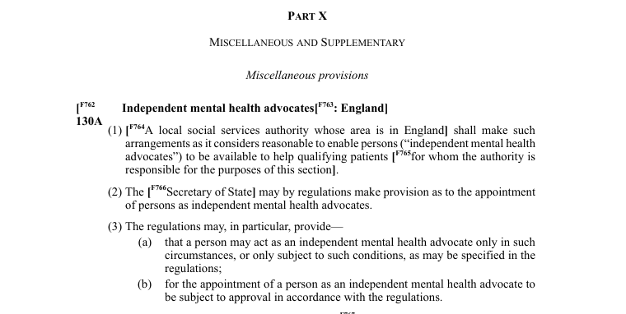
These questions of entitlement lead directly to the issue of how advocacy services are commissioned. The commissioning of advocacy services is underpinned by the Care Act 2014, which makes local authorities responsible for promoting individual wellbeing through effective care and support. Newbigging (2015) argues that commissioning is a transactional process, despite its influence on outcomes for service users and the wider community, and that it remains vulnerable to ideological shifts in welfare policy and local authority budget cuts since 2010 (Newbigging, 2015, p.263). Although co-production and co-design form part of commissioning, responsibility for these functions moved to local authorities in 2013 (Loeffler and Bovaird, 2019, p.241). (Fig. 2)
Loeffler and Boviard (2019), explained
‘This public value model provides a conceptual framework for commissioning and co-production, highlighting that public outcomes are not only achieved through commissioned public services but also directly through co-production with service users and local communities and through behaviour change on the part of citizens.’

Fig 2. An example of Co- Commissioning cycle (Loeffler and Bovaird, 2019, p.246).
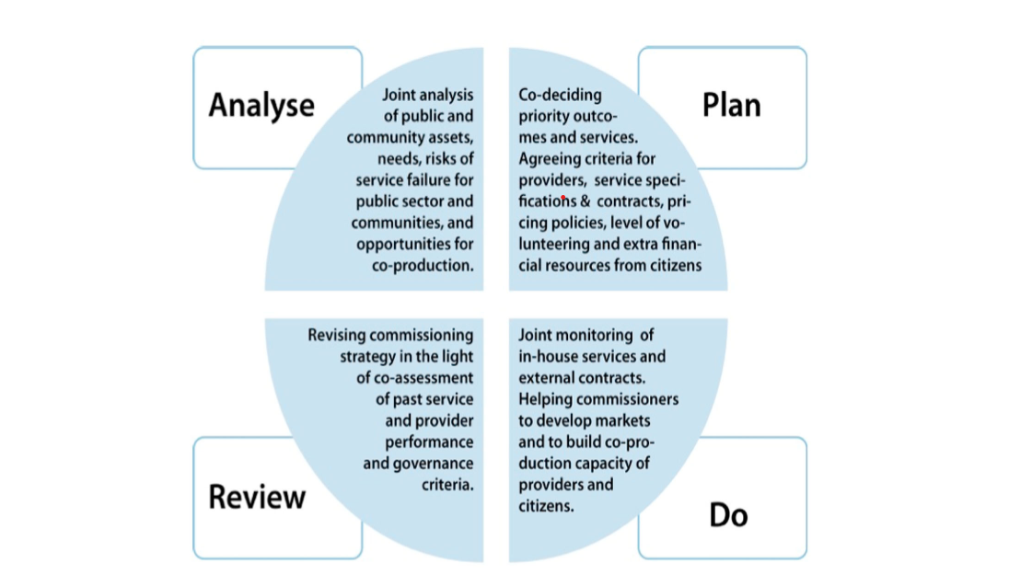

Bovaird et al (2012) also note the history of compulsory competitive tendering. For advocacy managers, this creates tension: commissioning systems may prioritise cost, compliance, and measurable outputs, while effective advocacy depends on independence, trust, and responsiveness to individual need (See Fig.3) Professionalisation may therefore strengthen accountability but also expose advocacy services to market and policy pressures that limit autonomy (El Ansari et al, 2009, p.641-643; Walmsley and Buchanan, 2006, p.137).
These tensions are reflected in the findings of Newbigging et al (2017), who note that
‘viewing all advocacy as covered by the Care Act was identified as one way of protecting wider forms of advocacy from budget restrictions’ (Newbigging et al, 2017, p.8).
They also suggest a risk that
‘The Care Act may become overly focused on process, rather than effectively advocating for the needs of the person, thereby delaying access to a Relevant Person’s Representative (RPR)’ (Newbigging et al, 2017, pp.11–12).
Positively, one outcomes-focused approach, the ‘hub model’, may improve access through a range of advocacy services and support longer-term relationships between the advocate and the individual (Newbigging et al, 2017, p.12).
Fig 3. An Example of the commissioning model (Department of Health, cited in Bovaird, et al 2012, p.29).
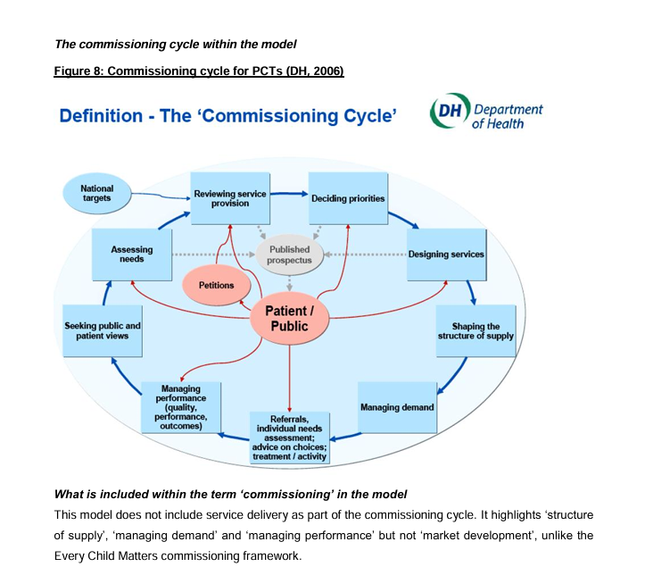

The Impact of Professoionalisation on Advocacy: Considerations & Implications, Barriers, and Remedies.
Commissioning pressures help explain why the impact of advocacy services in the UK, and their participation in healthcare settings, has often been limited (Pulman et al, 2025). Rising social worker vacancy rates, reaching 11.4% in 2012/13 (Skills for Care, 2023, cited in Pulman et al, 2025, p.43), affect service delivery and can negatively impact advocacy through pressures on contract length, funding stability, and local authority funding routes rather than a more national approach to sustaining independent advocates (Pulman et al, 2025, p.49). Practitioners nevertheless recognise that advocates provide value, assistance, cultural competence (El Ansari, et al, 2009, p.640), and understanding of the advocate partner’s circumstances,(Pulman et al, 2025, p.47) helping their views to be heard in decisions involving clinical staff, safeguarding boards, and integrated health boards (Pulman et al, 2025, p.47; NICE, 2022, p.14).
In response to these limitations, independent advocates and practitioners have documented issues requiring a different approach to strengthen both the advocacy and health and social care workforces, including recognition of qualifications (NICE, 2022, p.28, 32-34), awareness and training about advocates’ roles (Newbigging, 2012, p.12, p.19), lack of community knowledge (Alcock, 2025, p.16, 20), advocacy for human and legal rights under the EHRC (Human Rights Act, 1988; Gray and Jackson, 2002, p.99), and reminders to other professionals of the centrality of the individual’s voice (Townsley et al, 2009; Davies et al, 2009, Harrison and Davies, 2009, p.57).

Impact of Advocacy.
Taken together, these barriers and proposed remedies return attention to the broader impact of advocacy itself. A central principle of independent advocacy is that it should remain separate from local authority bodies, and legislators have consistently reinforced this through law and policy (Harrison and Davies, 2009, p.57; Bateman, 2000, p.10-11; The Care Act 2014; The Care and Support (Independent Advocacy Support) (No 2) Regulations 2014, p.3-5; Newbigging, 2015, p.287-289; Alcock, 2025). Yet this principle is difficult to sustain in practice when services are commissioned and funded by the same statutory structures from which advocates are expected to remain independent (Henderson and Pochin, 2001, p.15). Pulman et al (2025) highlight problems of visibility, noting that advocates can feel hidden, undervalued as professionals, and treated as an add-on until a crisis arises (Pulman et al, 2025, p.46.). They further argue that other professionals often have only a limited understanding of the independent advocate’s role (SCIE, 2022, p.6; Pulman et al, 2025, p.50). The impact of advocacy therefore depends not only on legal entitlement, but also on professional recognition, organisational culture, and the extent to which advocacy is treated as integral rather than peripheral to care and support systems (Grace, 2001, p.160-161; Dalrymple, 2006, p.192).
This point is captured succinctly by Newbigging et al (2017):
‘Having an advocate to support and represent individuals’ views, can increase self determination and inclusion’ (Newbigging et al, 2017, p.4).
Building on that point, in Commissioning Care Act Advocacy: A Work in Progress, Newbigging et al (2017) identify key themes for Commissioners, Primary Care Trusts, Clinical Commissioning Groups, Local Authorities, Integrated Health Boards, and service providers in relation to Care Act advocacy and the statutory advocacy local authorities should provide. Dixon et al, highlight differing approaches and models for reviewing advocacy services and frameworks to secure adequate assistance, support, and safeguarding (Dixon et al, 2020, p.6). Interviewing commissioners, advocacy managers, and providers, researchers describe approaches including a single-provider model to meet local authority advocacy duties, a more outcomes-focused model, and the hub model, alongside a human rights approach to advocacy (Newbigging et al, 2017, p.6,14).

Conclusion.
In conclusion, the professionalisation of independent advocacy within the context of the Care Act 2014 in England has undoubtedly increased the visibility, status, and formal legitimacy of advocacy, but the evidence considered in this article suggests that these developments should be treated with caution rather than as straightforward progress. The movement from voluntary and grassroots traditions towards a more regulated and statutory model has given advocacy a clearer place within health and social care, especially for those who would otherwise face substantial difficulty in participating in care and support processes. The Care Act 2014 has been central to this transformation through its eligibility criteria, legal duties, and expectations regarding training, competence, supervision, and independence. In this respect, professionalisation has strengthened consistency and accountability and has enabled advocacy managers and commissioners to frame services in ways that are more visible, measurable, and defensible. However, these advantages are also limited. Greater statutory recognition does not necessarily mean that advocacy is better protected in practice, nor does a more formal structure automatically preserve the values of empowerment, challenge, and self-determination on which advocacy depends. Indeed, the article has shown that advocacy remains conceptually unstable, because it involves both representation and empowerment and may work either within statutory systems or against them. This matters because professionalisation depends upon clearer boundaries, standards, and judgements of competence, while effective advocacy often depends upon flexibility, moral judgement, and responsiveness to individual circumstances. As a result, attempts to formalise advocacy may produce a tension that cannot be fully resolved: the more advocacy is standardised, the greater the risk that it becomes procedurally compliant but less critically effective. This concern is sharpened by the fact that services are funded and commissioned by local authorities even though advocates are expected to remain independent of those same structures. Such arrangements create an inherent contradiction at the centre of statutory advocacy, calling into question how far independence can be sustained when contractual survival may depend upon satisfying commissioners’ priorities, performance measures, and budget constraints. For advocacy managers, this is not simply a matter of operational balance but of ethical and strategic judgement. They are required to uphold standards, workforce competence, and quality assurance while also resisting forms of managerialism that may reduce advocacy to process, outputs, or procedural compliance. Ambiguity around what counts as appropriate training and how competence should be assessed further weakens the claim that professionalisation necessarily produces uniform quality across England. Ultimately, professionalisation should therefore be understood as a contested and uneven process. It has strengthened advocacy’s statutory position, but it has also exposed advocacy to forms of control that may undermine its independent and critical function. Its value must therefore be judged not by its formal recognition alone, but by whether it continues to protect voice, rights, autonomy, participation, and inclusion in practice.

Bibliography.

Alcock, R. (2025) In-between the person and the process: the liminal role of independent advocates under England’s Care Act 2014. doctoral. Manchester Metropolitan University. Available at: https://e-space.mmu.ac.uk/638686/ (Accessed: 2 May 2026).
Bateman, N. (2000) Advocacy skills for health and social care professionals. Jessica Kingsley Publishers. Available at: https://books.google.co.uk/books?hl=en&lr=&id=sdknBQAAQBAJ&oi=fnd&pg=PP1&dq=Within+professionalisation+of+the+advocacy+services,+there+is+the+advocacy+charter+a+code+of+practice,+which+sets+out+how+advocacy,+works,+how+to+behave,+and+the+empowerment+of+the+client+to+which+they+serve.+&ots=NOpx4xdbaH&sig=MonnXyuLGoc4qCWZDcF6H1-y63I (Accessed: 10 May 2026).
Bishop, A. (2023) Becoming an ally: Breaking the cycle of oppression. London: Routledge. Available at: https://api.taylorfrancis.com/content/books/mono/download?identifierName=doi&identifierValue=10.4324/9781003416487&type=googlepdf (Accessed: 14 May 2026).
Bovaird, T., Dickinson, H. and Allen, K. (2012) ‘Commissioning across government: review of evidence’, Third Sector Research Centre Research Report (86), Project for the National Audit Office, [Preprint].
Buchanan, I. and Walmsley, J. (2006) ‘Self-advocacy in historical perspective.’, British Journal of Learning Disabilities, 34(3), pp. 133–138. Available at: https://doi.org/10.1111/j.1468-3156.2006.00410.x.
Cairns, B., Hutchison, R. and Aiken, M. (2010) ‘“It’s not what we do, it’s how we do it”: managing the tension between service delivery and advocacy’, Voluntary Sector Review, 1(2), pp. 193–207. Available at: https://doi.org/10.1332/204080510X511247.
Chambers, A.W. (2024) ‘Empowering Voices: An Overview of Self-Advocacy’, in G. Bennett and E. Goodall (eds) The Palgrave Encyclopedia of Disability. Cham: Springer Nature Switzerland, pp. 1–9. Available at: https://doi.org/10.1007/978-3-031-40858-8_27-1.
Dalton, S. and Carlin, P. (2002) ‘Independent advocacy-A brief look at its past and present-is its future under threat’, February 2002 J. Mental Health L., p. 21. Available at: https://heinonline.org/hol-cgi-bin/get_pdf.cgi?handle=hein.journals/jmhl6&section=6 (Accessed: 5 May 2026).
Davies, L. et al. (2009) A framework for research on costs and benefits of independent advocacy. Research Costs on Independent Advocacy. Bristol, United Kingdom: HM Government/ University of Bristol, pp. 1–92.
Department for Health and Social Care (2026) Care and support statutory guidance- Care Act 2014, GOV.UK. London, United Kingdom: H.M. Government. Available at: https://www.gov.uk/government/publications/care-act-statutory-guidance/care-and-support-statutory-guidance (Accessed: 4 May 2026).
Dixon, J., Laing, J. and Valentine, C. (2020) ‘A human rights approach to advocacy for people with dementia: A review of current provision in England and Wales’, Dementia, 19, pp. 221–236. Available at: https://doi.org/10.1177/1471301218770478.
El Ansari, W. et al. (2009) ‘The role of advocacy and interpretation services in the delivery of quality healthcare to diverse minority communities in London, United Kingdom’, Health & Social Care in the Community, 17(6), pp. 636–646. Available at: https://doi.org/10.1111/j.1365-2524.2009.00867.x.
Equality and Human Rights Commission (2023) Challenging and monitoring adult social care decisions in England and Wales. Available at: https://view.officeapps.live.com/op/view.aspx?src=https%3A%2F%2Fwww.equalityhumanrights.com%2Fsites%2Fdefault%2Ffiles%2F2023%2Fresearch-challenging-and-monitoring-adult-social-care-decisions-england-wales.docx&wdOrigin=BROWSELINK (Accessed: 11 May 2026).
Gewirtz Sharon and Cribb Alan (2015) Professionalism. Cambridge, England ; Polity (Key Themes in Health and Social Care).
Glass, J. (2017) ‘“Advocates Change the World; Evaluation Can Help”: A Literature Review and Key Insights from the Practice of Advocacy Evaluation’, Canadian Journal of Program Evaluation, 32(1), pp. 46–64. Available at: https://doi.org/10.3138/cjpe.31039.
Goble, C. (2002) ‘Professional consciousness and conflict in advocacy’, Advocacy and learning disability, pp. 72–88. Available at: https://books.google.co.uk/books?hl=en&lr=&id=0js9DwAAQBAJ&oi=fnd&pg=PA72&dq=Goble,+C+(2002)+Professional+Consciousness+and+Conflict+in+Advocacy&ots=cxnhNDNy82&sig=Inxqv40Jq37mqGg_-OVLIVHU3ds (Accessed: 6 May 2026).
Goble, C. and Donson, J. (2013) ‘Skills for empowerment, participation and advocacy’, Skills for Social Work Practice, 2nd ed., Sage, London, pp. 71–86. Available at: https://www.torrossa.com/gs/resourceProxy?an=5017605&publisher=FZP550#page=88 (Accessed: 10 May 2026).
Grace, P.J. (2001) ‘Professional advocacy: widening the scope of accountability’, Nursing Philosophy, 2(2), pp. 151–162. Available at: https://doi.org/10.1046/j.1466-769X.2001.00048.x.
Gray, B. and Jackson, R. (2001) Advocacy and Learning Disability. Jessica Kingsley Publishers.
Harrison, K. (2021) The impact of austerity on political participation in the UK. PhD Thesis. University of Southampton. Available at: https://eprints.soton.ac.uk/467518/ (Accessed: 23 May 2026).
Harrison, T. and Davis, R. (2009) ‘Advocacy: time to communicate’, Advances in Psychiatric Treatment, 15(1), pp. 57–64. Available at: https://doi.org/10.1192/apt.bp.107.004309.
Heederik, J.R. (2025) Caring, trusting, hoping: Welfare advice in times of British austerity. PhD Thesis. Radboud Universiteit Nijmegen. Available at: https://repository.ubn.ru.nl/bitstream/handle/2066/323863/323863.pdf?sequence=1 (Accessed: 23 May 2026).
Henderson, R. and Pochin, M. (2001) A right result?: Advocacy, justice and empowerment. Policy Press. Available at: https://books.google.co.uk/books?hl=en&lr=&id=BHVoDwAAQBAJ&oi=fnd&pg=PR3&ots=AKAY2N2por&sig=BbOe8xDEkNbfXR_x_nsxipfMyQw (Accessed: 14 May 2026).
H.M Government (1988) Human Rights Act 1998. Available at: https://www.legislation.gov.uk/ukpga/1998/42/contents (Accessed: 22 May 2026).
H.M Government (2005) Mental Capacity Act 2005. Available at: https://www.legislation.gov.uk/ukpga/2005/9/contents (Accessed: 22 May 2026).
H.M. Government (2014a) Care Act 2014. Available at: https://www.legislation.gov.uk/ukpga/2014/23/contents (Accessed: 17 May 2026).
H.M. Government (2014b) The Care and Support (Independent Advocacy Support) (No. 2) Regulations 2014. Available at: https://www.legislation.gov.uk/uksi/2014/2889/contents (Accessed: 17 May 2026).
H.M Government, E. (no date) Mental Health Act 1983. Available at: https://www.legislation.gov.uk/ukpga/1983/20/contents (Accessed: 22 May 2026).
Hoefer, R. (2019) Advocacy practice for social justice. Oxford University Press. Available at: https://books.google.co.uk/books?hl=en&lr=&id=KviFDwAAQBAJ&oi=fnd&pg=PP1&dq=Within+professionalisation+of+the+advocacy+services,+there+is+the+advocacy+charter+a+code+of+practice,+which+sets+out+how+advocacy,+works,+how+to+behave,+and+the+empowerment+of+the+client+to+which+they+serve.+&ots=UKiwnwYgG0&sig=0SJEzlxltCuMzEfty3ZXyr31L6o (Accessed: 10 May 2026).
Jütte, W., Nicoll, K. and Olesen, H.S. (2011) ‘Editorial: Professionalisation – the struggle within’, European Journal for Research on the Education and Learning of Adults, 2(1), pp. 7–20. Available at: https://doi.org/10.3384/rela.2000-7426.relae2.
Loeffler, E. and Bovaird, T. (2019) ‘Co-commissioning of public services and outcomes in the UK: Bringing co-production into the strategic commissioning cycle’, Public Money & Management, 39(4), pp. 241–252. Available at: https://doi.org/10.1080/09540962.2019.1592905.
Lonbay, S.P. and Brandon, T. (2017) ‘Renegotiating power in adult safeguarding: the role of advocacy’, The Journal of Adult Protection, 19(2), pp. 78–91. Available at: https://doi.org/10.1108/JAP-09-2016-0023.
McHale, J.V. and Noszlopy, L. (2025) ‘Legal Regulation of Adult Social Care Provision in England’, Adult Social Care Law and Policy. Bristol University Press, pp. 62–115. Available at: https://bristoluniversitypressdigital.com/monochap-oa/book/9781529229882/ch003.xml (Accessed: 10 May 2026).
Morgan, G. (2010) ‘Independent advocacy and the “rise of spirituality”: views from advocates, service users and chaplains’, Mental Health, Religion & Culture, 13(6), pp. 625–636. Available at: https://doi.org/10.1080/13674676.2010.488435.
Morgan, G. (2017) ‘A History of Advocacy’, in G. Morgan (ed.) Independent Advocacy and Spiritual Care: Insights from Service Users, Advocates, Health Care Professionals and Chaplains. London: Palgrave Macmillan UK, pp. 61–92. Available at: https://doi.org/10.1057/978-1-137-53125-4_3.
National Development Team for Inclusion (2021) QPM-Assessment-Workbook, Assessment Workbook for advocacy. Bath: National Development Team. Available at: https://view.officeapps.live.com/op/view.aspx?src=https%3A%2F%2Fqualityadvocacy.org.uk%2Fwp-content%2Fuploads%2F2025%2F03%2FQPM-Assessment-Workbook_V4_V1.3_Dec-2021.docx&wdOrigin=BROWSELINK (Accessed: 2 May 2026).
National Development Team for Inclusion (2026a) ‘Advocacy : The problem with not having any national data’, NDTi. Available at: https://www.ndti.org.uk/resource/advocacy-the-problem-with-not-having-any-national-data/ (Accessed: 5 May 2026).
National Development Team for Inclusion (2026b) Introducing the Advocacy Quality Performance Mark, QPM | National Development Team for Inclusion. Available at: https://qualityadvocacy.org.uk/ (Accessed: 12 May 2026).
National Institute for Health and Care Excellence (2022) ‘Advocacy services for adults with health and social care needs - NICE Guidelines’. Available at: www.nice.org.uk/guidance/ng227 (Accessed: 13 May 2026).
Newbigging, K. (2012) The Right to Be Heard: Review of the quality of Independent Mental Health Advocate Services.
Newbigging, K., Ridley, J. and Sadd, J. (2017) Commissioning Care Act Advocacy: A working Progress Report. British Association of Social Workers. Research. University of Birmingham, pp. 1–20. Available at: https://www. basw. co. uk/system/files/resources/basw_81232-6_0. pdf (Accessed: 8 May 2026).
Newbigging, K., Ridley, J. and Sadd, J. (2021) ‘Realising the right to equal recognition for disabled people: commissioning statutory advocacy in England’, Disability & Society, 36(3), pp. 420–442. Available at: https://doi.org/10.1080/09687599.2020.1745759.
Newbigging Karen (2015) Independent mental health advocacy: the right to be heard: context, values and good practice. London: Jessica Kingsley.
Osgood, T. (2017) ‘Advocating for advocacy’, Tizard Learning Disability Review, 22(4), pp. 193–197. Available at: https://doi.org/10.1108/TLDR-03-2017-0013.
Ping Kwong, K. (2020) ‘Skills for empowerment, participation and advocacy’, Journal of Social Work, 21(3), pp. 329–352. Available at: https://doi.org/10.1177/14680173209111348.
Policy & Strategy Directorate, Department of Health (2006) ‘Health reform in England: update and commissioning framework’, H.M. Government, pp. 1–84. Available at: https://bulger.co.uk/dacorumhealth/daccom/PDF%20Documents/Health%20Reform%20in%20England%20Commissioning%20Annexe.pdf (Accessed: 23 May 2026).
Pulman, A., Sloan, H. and Fenge, L.-A. (2025) ‘Advocacy in Practice: Who Advocates for the Advocates?’, Practice, 37(1), pp. 41–57. Available at: https://doi.org/10.1080/09503153.2024.2410851.
Renshaw, J. (1987) A Friend in Need: Citizen Advocacy in Britain. University of Kent Personal Social Services Research Unit.
Rhodes, M. (2000) ‘Desperately seeking a solution: Social democracy, thatcherism and the “third way” in British welfare’, West European Politics, 23(2), pp. 161–186. Available at: https://doi.org/10.1080/01402380008425371.
Roberts, H. et al. (2012) ‘Advocacy by and for adults with learning disabilities in England’, Improving health and lives: Learning Disabilities Observatory [Preprint]. Available at: https://www.choiceforum.org/docs/ihalad.pdf (Accessed: 14 May 2026).
Sang, B. and O’Brien, J. (1984) Advocacy: the UK and American experiences. King Edwards Hospital Fund. Available at: https://scholar.google.com/scholar_lookup?&title=Advocacy%3A%20The%20UK%20and%20American%20experiences&publication_year=1984&author=Sang%2CB&author=O%E2%80%99Brien%2CJ (Accessed: 17 May 2026).
Sim, A.J. and Mackay, R. (1997) ‘Advocacy in the UK’, Practice, 9(2), pp. 5–12. Available at: https://doi.org/10.1080/09503159708411642.
Social Care and Institute for Excellence (2022) Commissioning independent advocacy under the Care Act. Available at: https://www.scie.org.uk/advocacy/commissioning/ (Accessed: 3 May 2026).
Steele, L. et al. (2026) ‘Voices of change: bridging past and present in disability self-advocacy’, Disability & Society, 41(3), pp. 816–841. Available at: https://doi.org/10.1080/09687599.2025.2564963.
The Advocacy Alliance (2020) The Advocacy Alliance - Home. Available at: https://www.theadvocacyalliance.org/ (Accessed: 17 May 2026).
Townsley, R., Marriott, A. and Ward, L. (2009) Access to independent advocacy: an evidence reviews. Office of Disability Issues. Bristol, United Kingdom: HM Government/ University of Bristol, p. 170.
Trusty, J. and Brown, D. (2005) ‘Advocacy Competencies for Professional School Counselors’, Professional School Counseling, 8(3), pp. 259–265. Available at: https://www.jstor.org/stable/42732467 (Accessed: 14 May 2026).
University of Lancashire (no date) The Right to Be Heard, University of Lancashire. Available at: https://www.lancashire.ac.uk/research/institutes/life/mental-health-and-wellbeing/right-to-be-heard-project (Accessed: 21 May 2026).
Walmsley, J. (2002) ‘Principles and types of advocacy’, Advocacy and learning disability, pp. 24–37. Available at: https://books.google.co.uk/books?hl=en&lr=&id=0js9DwAAQBAJ&oi=fnd&pg=PA24&dq=Definitions+of+advocacy+vary+in+literature,+many+differences+in+advocacy+interpretations+remain&ots=cxnhUBHB34&sig=hMhOWt0E720xycuf1zV-u3ceJd4 (Accessed: 14 May 2026).

The following is adapted from www.ageconcerncheshire.org.uk

