
Programme: Master of Business Administration
Module: International Marketing: Principles and Practices
Module code: LCMB7026
Assignment Title: International Marketing: Principles and Practices

Student Name: Neelam Rani

Student ID: 2434627

Word count: 5,000
Submission Deadline: 14-11-2025

Table of Contents
Introduction 4
Brand Overview 4
Home vs. Host Nations 5
Reason for internationalisation 5
Reasons behind entering the U.S. and India: 5
Internationalisation approach 5
Competitors 6
Description of Starbucks, its activities in India, and the US 7
Macroenvironment (PESTLE) of the US and India 7
Comparison of Starbucks' STP approaches in the US and India 12
Comparison of Marketing mix (7Ps) strategies in the USA and India 17
Starbucks' Product Strategy: USA vs. India 18
Brand Strategy 18
Product Dimensions 18
Product Lines 18
Standardisation vs. Adaptation 19
Starbucks' Pricing Strategy: USA vs. India 20
Pricing Objective 20
Pricing Method 20
Adaptation vs. Standardisation 20
Starbucks' Promotion Strategy: USA vs. India 20
Promotion Objective 20
Media Advertising 21
Type of Appeal in Advertising 21
Adaptation vs. Standardisation 22
Starbucks' Place Strategy 23
Starbucks' Process Strategy: USA vs. India 23
Evaluation of the performance of marketing strategies 24
Evaluation of marketing ethics practice 25
Recommendations 26
Conclusion 29
References 30

List of Figures

Figure 1 Inflation rate between 1987 and 2030. 9
Figure 2 Preference for regular beverage. 10
Figure 3 Mumbai flavoured, two iconic flavours launched by Starbucks 19
Figure 4 ''Hello Again' campaign launched by Starbucks 21
Figure 5 A ten-year celebration campaign was launched by Starbucks. 22

Introduction
Starbucks Corporation is a US based global leader that works mainly in the coffee industry, provides an intriguing case study for recognising the international marketing initiatives due to its opposite activities into India (host market), and United States (home marketplace). The presence of the brand, dominating the U.S. coffee market is in the mature stage. Its capability to maintain its growth by introducing innovation, digitalisation, and lifestyle-driven positioning, even though its venture into India shows the challenges and opportunities of changing according to a new, aspirational customer base. These differences make Starbucks is a significant topic to be explored to comprehend how global. brands strike the balance between standardisation and localisation. This report is aimed at critically comment Starbucks marketing in the two markets, with a focus on. its STP practices, marketing mix 7p, and ethics. The report is organized in a way that gives back the contextual analysis, effectiveness and concludes with. suggestions on how to improve the performance of Starbucks in the international arena.

Brand Overview
It was originated in 1971 in Seattle, Washington, Starbucks Company is the largest roaster, marketer and retailer of specialty coffee in the globe and has about 40000 stores operating across the world by FY 2024. (Starbucks Coffee Company, 2025b). Originally a single coffee bean outlet, the brand emerged under Howard Schultz in an international café concept. It popularised the 'third place' philosophy, a social place between work and home. The brand offers a range of products, including tea, food, coffee, and merchandise, distinguishing itself through innovation, quality, and exceptional customer experiences. Within the U.S., Starbucks is a household name, with approximately 18,000 store outlets accounting for 75% of its international revenue. Its main rivals in the U.S. involve McDonald's McCafe, Dunkin', and Peet's Café. Starbucks was not born ‘international’; however, it was a traditional organisation that became global slowly after consolidating its US dominance (Starbucks Coffee Company, 2025b).

Home vs. Host Nations
The United States is the home country of Starbucks and is one of the most profitable and mature markets. India constitutes one of its host nations and a high-growth marketplace. Starbucks entered India in 2012 through a joint venture with Tata Consumer Products (Tata Starbucks Pvt. Ltd.) (Musonera, 2021). This entry mode allowed Starbucks to leverage Tata's supply chain expertise and local market knowledge, consistent with the Uppsala model of internationalisation – starting with a partnership before committing deeper resources.

Reason for internationalisation
The global expansion of ‘Starbucks’ is stimulated by the requirement to expand revenue above its saturated U.S. market, and recognising the increasing middle-class segment in the evolving economies (Hui-Jung, 2019). The U.S. coffee market is mature thus Starbucks stimulates in the underpenetrated areas where café culture is still growing, including India. The organisation's approach involves targeting urban and affluent markets where the consumption of premium coffee is aspirational.

Reasons behind entering the U.S. and India:
The goal of the coffee brand is to manage category leadership, expansion of the digital engagement, and driving innovation within plant-based offerings, and cold beverages. Within India, the brand intends to capitalise on the young segment, rising disposable income, and rising exposure to Western lifestyles. Its Indian menu features regionally customised offerings, such as Paneer tikka sandwiches and Masala chai, to cater to local palates.

Internationalisation approach
The brand uses the Uppsala model mainly, beginning with joint ventures, and licensing into abroad markets, slowly raising regulations as the market becomes mature. In India, the joint venture ensures compliance with local regulations and cultural adaptation while mitigating risks (Igwe, Rugara, and Rahman, 2021). This staged approach aligns with Starbucks' cautious yet disciplined global growth strategy.

Competitors
Within the US, Starbucks competes mainly with McCafé and Dunkin' on price and convenience; however, the company has an advantage in differentiation through its premium experience. Within India, the main rivals involve Barista, Café Coffee Day, newer boutique cafes, and Costa Coffee. The premium pricing of Starbucks positions it as a lifestyle brand instead of a mass-market chain.

Description of Starbucks, its activities in India, and the US

Macroenvironment (PESTLE) of the US and India
PESTLE of the US
Political: The US has a low political risk, with a very low chance of government expropriation of assets. However, the political polarisation among and across the leading parties can restrict the government's capability to pass legislation or apply long-term structural reforms.
Economic: US inflation remained stable in July 2025 at around 2.7% yearly, a similar rate to that in June. Such steadiness was due to the low energy costs, which balanced out the price increases in products such as tomatoes, coffee, and tools. However, the core inflation (excluding energy prices and food products) increased by 3.1%, being the fastest pace in six months. Also, coffee costs increased by around 2.3% between June and July (BBC News, 2025a). This may potentially impact the company's profit percentages.
Social: US is the biggest coffee customer on an international scale. In FY 2022, America became the hub of coffee consumption. However, the culture of coffee consumption now expands beyond social meetups. The popularity of American coffee culture revolves around the coffee outlets. Starbucks plays a main role in motivating millennials and Gen Z to consume more coffee. Around 45% of coffee is consumed by young adults in America (The Culture Factor, 2025). As per a high indulgence score of 68, coffee consumption in the US is not merely functional; however, it is also a lifestyle and leisure choice (Cold brew, Starbucks culture, and Café ambiance). Increased indulgence contributes to the popularity of flavoured, premium, and specialty coffees.
Technological: In the US, coffee industry is one of the industries that have a great reliance on new technologies to enhance quality, manufacturing and sustainability. Precision agriculture applications, including drones and sensors, are used to monitor the soil health, irrigation, and crops, and data analytics also help in making the right decisions on farm management. Automated roasting machines and AI-driven quality control systems ensure consistency in flavor profiles. Supply chain technologies, including blockchain, are used to improve traceability and transparency from farm to cup. Additionally, mobile apps and digital platforms connect roasters, suppliers, and consumers, promoting direct trade and customer engagement. These innovations collectively strengthen efficiency, sustainability, and competitiveness in the U.S. coffee sector.
Legal: Starbucks should adhere with a diverse range of legal rules including food security, labour, and business practices. Main domains involve employment legislation, including the Fair Labour Standards Act (FLSA), regulating overtime, wages, and working hours, together with anti-discrimination laws under the Civil Rights Act and Americans with Disabilities Act (ADA). It must also meet Occupational Safety and Health Administration (OSHA) regulations to ensure workplace safety. Food safety standards set by the Food and Drug Administration (FDA) and local health codes must be followed. Additionally, Starbucks must comply with tax laws, environmental regulations, and consumer protection rules.
Environmental: Starbucks has accomplished the targets by setting up its Greener Stores program, which led in 3500+ stores fulfilling strict environmental norms by FY 2022. The company has also incurred an expenditure in climate-resilient coffee farming and assisted the ‘Greener Store' program, decreasing energy and water use in stores (Starbucks Coffee Company, 2025a). Additionally, during FY 2024, the company became the first and only national coffeehouse in the U.S. to permit consumers to use their own cups at organisation-owned outlets, including those for mobile orders and drive-thrus.
PESTLE of India
Political: India's political environment offers both risks and opportunities for Starbucks. Modi’s government advocates growth-based reforms, infrastructural investment, and digitalisation, which can strengthen retail diversification (EKN, 2024). Liberalising FDI (Foreign Direct Investment) appeals to the international companies, providing Starbucks with a good market entry potential. However, a dependence on coalition partners could slow down the reforms, while bureaucratic challenges and unknown rules escalate the compliance expenses. Protectionist procedures, such as tariffs and local standards, may complicate the efficiency of supply chains and imports of coffee or equipment (EKN, 2024). Corruption and varied business environments across states also pose operational challenges, requiring Starbucks to adapt strategies regionally to sustain growth.
Economic: Geopolitical risks, and trade distress could affect the country’s development route during 2025, and 2026 (Kumar, 2025). The country’s growth prediction was axed down by around 0.3% for the FY 2025. Additionally, inflation in India is estimated to be around 4.24% for FY 2025, a slight decrease from 4.67% in FY 2024, and is predicted to remain around 4% for future years (Statista, 2025a).
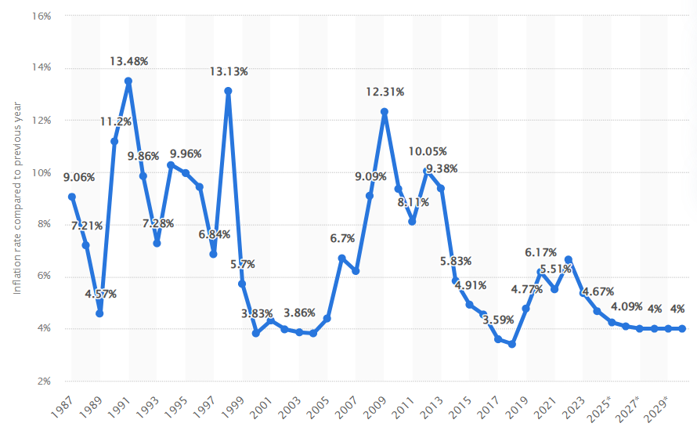
Figure 1 Inflation rate between 1987 and 2030.
(Source: Statista, 2025a)
Social: Approximately, 84 percent of the customers have a regular drinking habit of coffee or tea which means there is a high tendency towards these drinks. (Coffee Board of India, 2024; Behera, 2023). Besides coffee and tea, milk-based products, such as buttermilk, raw milk, and lassi wine are the second popular drinks, and 9% of customers are regularly purchasing milk-based drinks. Approximately 41% of Indian coffee customers prefer the traditional powder for brewing coffee, making it the most popular option (Coffee Board of India, 2024).
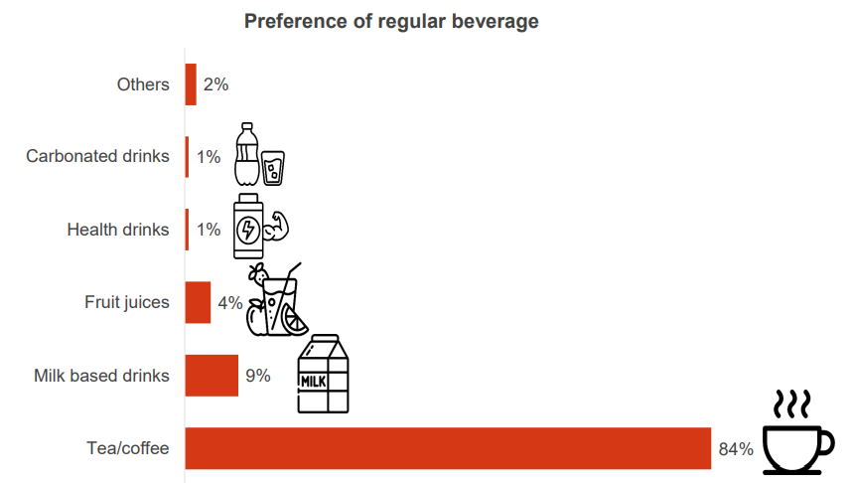
Figure 2 Preference for regular beverage.
(Source: Coffee Board of India, 2024).
Technological: Technology is being used in the Indian coffee industry to transform the production processes especially in the western Ghats. Artificial Intelligence (AI) is applied to analyse the soil by sensor-oriented methods of measuring the volumes of nutrients, soil composition and moisture. (Poonacha Machaiah, 2024). Such a data-based approach permits farmers to optimise planting, irrigation, and fertilisation, resulting in enhanced sustainability and crop health. AI-powered disease detection also plays a crucial role. Computer vision systems can identify early signs of plant diseases such as coffee leaf rust, enabling timely intervention before significant losses occur. Similarly, yield prediction models, such as Extreme Learning Machines, help forecast coffee output based on soil and environmental conditions. This helps farmers plan their harvests and make informed market decisions.
Legal: A coffee company within India should adhere to rules about Food Safety (FSSAI), general business practices (GST, Company Registration, Shop, and Establishment License), health and security (Fire Safety Certificate, and Health Trade License), Intellectual Property (Trademark Registration), as well as potential liquor and music licenses. The FSSAI has blacklisted around 32 ingredients from Starbucks and has also deemed them unapproved (BT Online Bureau, 2015).
Environmental: The company's carbon footprint increased by 8% during FY 2023, compared to the 2019 baseline, according to the organisation's latest ESG report. The company also reported a 13% rise in landfill waste. The overall energy used through the direct operations of Starbucks increased to 2,695,583 MW-hours during 2023, up from 2,590,598 in 2022 (Mirza, 2024). Scope 2 location-based emissions also rose to 835,477 metric tons of CO2, up from 789,425 in 2022. However, the organisation's Scope 1 emissions reduced by 0.6%.

Comparison of Starbucks' STP approaches in the US and India
STP approaches in the US
Segmentation element | Description
Demographics | Age: Mainly between 18 and 40; however, it is widely consumed within generations. Millennials and Gen Z comprise the largest customer base due to their increased coffee consumption and lifestyle preferences.  Income: Middle to upper income groups. Starbucks items are premium-priced, attract customers with increased disposable income.  Education: Highly educated segmentation (professionals and college students) who value experience and quality.  Ethnicity: Wide, Starbucks targets all ethnicities and promotes inclusion through initiatives that reflect multicultural America.
Psychographics | Lifestyle-based segment driving convenience, supreme quality, and brand image. Attracts the socially conscious customers who value sustainability, ethical sourcing, and corporate liability. The brand rewards loyalty through its Starbucks Rewards program, which has around 30 million active members (Starbucks Coffee Company, 2025a).
Geographic area | National coverage with around 17000 stores, specifically in California, Texas, and Florida. High concentration in suburban, and urban regions where foot traffic, and disposable income are more. Robust presence near offices, transit hubs, and universities.
Geodemographic segmentation | Targets college students, urban professionals, and families residing in suburban and metropolitan areas. Locations optimised for convenience (mobile order pickup, drive-through).
Customer type | Mix of occasional users, coffee drinkers, and treat seekers. Increased frequency among commuters and mobile-order users (80% of transactions are to-go).
Benefit segmentation | Use of customisation as per the customer’s needs helps to improve customer satisfaction and seasonal offers and cold beverage could help in the company in improving customer attraction and retention.
Usage segmentation | Heavy users constitute the Starbucks rewards base and stimulate repeated purchases. Peak use amid morning commute, and afternoon ‘snack’ time.
Positioning strategy: Ethical practices are used by Starbucks like by using sustainable materials in packaging and coffee cups which makes itself most ethical and sustainable brand in the coffee industry. Starbuck uses digital technology for order and other area which makes itself most technological advanced coffee chain and differentiate itself from McDonald's McCafé, Dunkin', and speciality coffee chains.




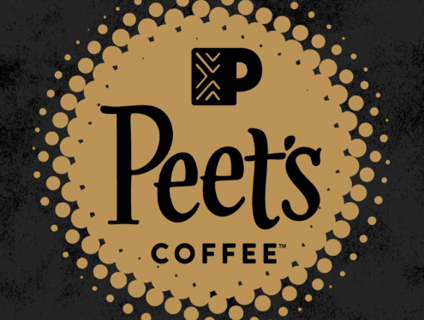
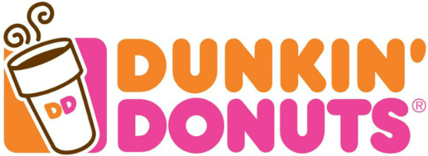

Low Price
High Price
Basic experience
Premium experience

In the US perceptual map, Starbucks is positioned in the high price, and premium experience quadrant, standing apart from value-based rivals, including McCafé and Dunkin'. This demonstrates its focus on providing an ethical, even, and personalised coffee experience, rather than competing on the basis of price. However, in contrast, McCafé and Dunkin' lead the functional and low-price segment, attracting convenience-based and value-driven customers. Speciality chains such as Peet's Coffee and Caribou Coffee target niche consumers with artisanal and ethically obtained offerings, often at moderately low prices when compared to Starbucks. In India, Café Coffee Day competes on the basis of affordability and accessibility, while Costa Coffee and niche artisanal cafés blend premium appeal with competitive pricing.

STP approaches in India
Segmentation element | Description
Demographics | Age: 20-35 years, with Gen Z and Millennials stimulating demand. Youth constitute the majority of India's population, and the main target of Starbucks.  Income: Affluent and upper-middle-class customers in Tier 1 cities: Starbucks is positioned as aspirational due to its premium pricing.  Education: Educated professionals, upwardly mobile millennials, and students from the main universities.  Ethnicity: Targets cosmopolitan and urban consumers with openness to Western coffee culture
Psychographics | Emphasises status-based, aspirational, and experience-seeking customers. Consumers recognise Starbucks as a lifestyle preference and a sign of social image. Its cafes are popular as hangout spaces for young adults, professionals, and freelancers.
Geographic area | Present in around 70 cities with around 457 stores (as of October 2024) (The Economic Times, 2024). Robust presence in metro cities (such as Bangalore, Mumbai, Hyderabad, and Delhi) as well as expanding into Tier-2 and Tier-3 cities with the increasing affluence by 2028.
Geodemographic segmentation | Targets IT corridors, affluent urban clusters, business districts, and shopping malls. Stores are positioned as upscale meeting places with localised décor (Gairola, 2024).
Customer type | Early adopters of Western café culture include students, young professionals, and affluent families. Lower penetration across the price-sensitive mass marketplace (Dawar, Sehrawat, and Garg, 2017).
Benefit segmentation | Customers seek a premium coffee experience, an international lifestyle association, and aspirational consumption. Customisation of local menu items, such as Chai tea lattes and tandoori paneer sandwiches, serves Indian tastes.
Usage segmentation | Moderate frequency in comparison to the US, used for social meet-ups, business catch-ups, and leisure instead of a daily caffeine fix. Peak hours comprise weekends and evenings.
Positioning strategy:
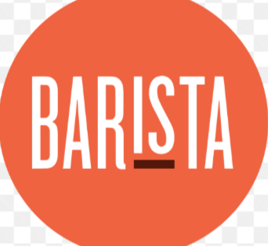
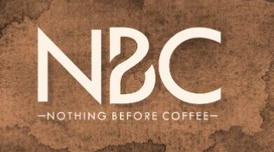

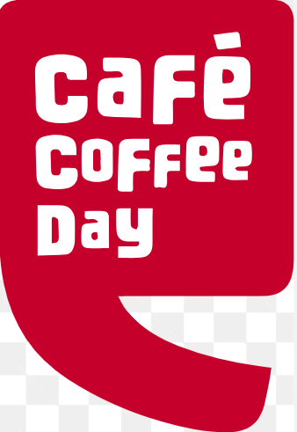


High price
Low price
Premium experience
Basic experience
The brand is positioned as a premium, aspirational, and lifestyle-based coffee brand, focusing on international quality with a local adaptation. The brand competes with Costa Coffee, Café Coffee Day, and niche artisanal cafes. The brand's differentiation remains in its international brand cachet, high-store ambiance, and Indian menu offerings.
Starbucks has once again placed itself in the high-price, and premium experience category in India; but its image is rather aspirational compared to everyday (Ko et al., 2007).
In India, Starbucks is more of a lifestyle and the symbol of a status unlike in the US where people drink coffee daily and where most millennials, cosmopolitan youth, and professionals are affluent. Its premium positioning distinguishes it from local players like Café Coffee Day and international rivals like Costa Coffee, which tend to focus on affordability and broader accessibility. Starbucks enhances its premium appeal with international branding, upscale ambience, and menu localisation (e.g., chai latte, paneer sandwich), cementing its reputation as a fashionable, aspirational coffee destination.
In this way, it may be stated that Starbucks adopts a similar positioning based on a premium and experience in India and the USA, but its STP strategy is not the same. Starbucks in the USA aims at a wide range of the income groups, focusing on the convenience on a daily basis, personalisation, and repeat utilisation based on loyalty. In contrast, in India, Starbucks focuses on affluent, urban millennials and professionals, positioning itself as an aspirational lifestyle brand and social hub rather than a daily necessity. Thus, while the core positioning remains consistent, the segmentation and targeting strategies are tailored to each market's unique cultural and economic context.

Comparison of Marketing mix (7Ps) strategies in the USA and India
The Seven P’s mix marketing approach is a model that is used by for designing, and applying competent marketing initiatives (Sadri and Aprianingsih, 2025). It comprises: Price (pricing strategy), Product (goods/services facilitated), Place (distribution channels), Promotion (communication and branding), People (employees and customers), Process (delivery methods), and Physical Evidence (tangible brand presence). Together, these elements shape customer experience and competitive advantage.

Starbucks' Product Strategy: USA vs. India

Brand Strategy
Starbucks positions itself as a premium, aspirational brand in both markets (Starbucks, 2025). In the USA, it emphasizes lifestyle, convenience, and innovation, while in India, it focuses on cultural adaptation and a premium café experience through its partnership with Tata.

Product Dimensions
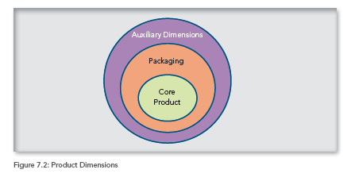
- Core Product: High-quality coffee and beverages.
- Packaging: Standardized green-and-white logo globally, with occasional festive themes in India (Restaurants, 2023).
- Auxiliary Services: Loyalty apps, Wi-Fi, and ambiance, standardized across both markets.

Product Lines
USA: Wide portfolio, seasonal beverages like Pumpkin, Soine Latte, cold brews, bakery, plant-based milk options.
India: Localised additions such as Masala Chai, Elaichi Chai, Tandoori Paneer Roll, and vegetarian-friendly offerings alongside global staples.

Standardisation vs. Adaptation
- Products: Adapted in India to match taste and dietary habits. For example, on the occasion of the opening of its 100th store in Mumbai, the company introduced beverages inspired by local Mumbai flavours, including Bombon Cloud (a coconut-flavoured foam and condensed milk) and Kala Khatta Cold Brew (a blend of street-flavoured kaala khatta and Starbucks' cold brew) (Sharma, 2025).
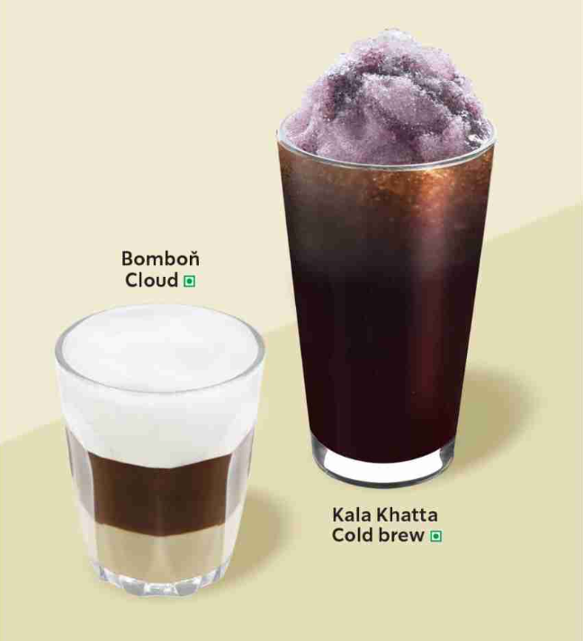
Figure 3 Mumbai flavoured, two iconic flavours launched by Starbucks
(Source: Sharma, 2025)
- Packaging: Standardised with minor festive/local adaptations.
- Labelling: Adapted in India for FSSAI regulations and regional language requirements (Kathuria and Anand, 2022).
Starbucks employs a globally standardized brand identity, but adapts its product portfolio, packaging, and labeling in India to increase cultural relevance while retaining consistency in quality and premium positioning.

Starbucks' Pricing Strategy: USA vs. India

Pricing Objective
Starbucks makes itself a premium brand in the USA as well as in India. The pricing strategy focuses on developing a sense of aspirational image at a profit through perceived value and not low-cost competition.

Pricing Method
- USA: Primarily value-based pricing, where consumers pay for quality, brand image, and café experience (Pebadja and Kholifah, 2023). Seasonal beverages, for example, the Pumpkin Spice Latte, priced at approximately $6.50, are priced higher, reflecting strong brand loyalty.
- India: A competitor and value-based hybrid approach. While Starbucks maintains a premium stance, its prices are moderated compared to those in the USA. For example, a tall latte costs approximately ₹180–200, compared to local competitors like Café Coffee Day, which costs around ₹120.

Adaptation vs. Standardisation
- In the USA, pricing is standardised as a premium “affordable luxury.”
- In India, prices are adapted downward to attract middle-class consumers while sustaining exclusivity. This aligns with purchasing power differences and competitive intensity.
Starbucks employs a similar premium pricing objective globally, but adapts pricing levels in India to local affordability and competition, thereby balancing global brand consistency with market realities.

Starbucks' Promotion Strategy: USA vs. India

Promotion Objective
In India and the USA, Starbucks needs to build brand loyalty, attract new customers, and reinforce its premium identity. On the other hand, while in the USA the focus is on lifestyle and convenience, in India the aim is to blend global prestige with cultural relevance.

Media Advertising
USA: Starbucks invests heavily in digital channels, social media, mobile apps, and email campaigns. Limited TV or point ads are used, as digital platforms best reach its urban, tech-savvy customers.
India: Media promotion is a mix of social media campaigns, collaborations with Tata Group, in-store branding, and festive promotions. Traditional media like print and outdoor billboards are occasionally used to reach aspirational middle-class consumers.

Type of Appeal in Advertising
USA: Appeals focus on lifestyle, personalisation, sustainability, and innovation, like new seasonal drinks. For instance, the 'Hello Again' initiative was launched by the brand in the US (2025), purported to reconnect with consumers by demonstrating its community values and heritage. Rather than paying for a costly in-game Super Bowl advertisement, the company operated an approximately 60-second spot during the pre-game show, soundtracked by AC/DC's “Thunderstruck,” emphasizing the personal touch of baristas and rituals, such as mentioning the names on cups (Kelly, 2025).
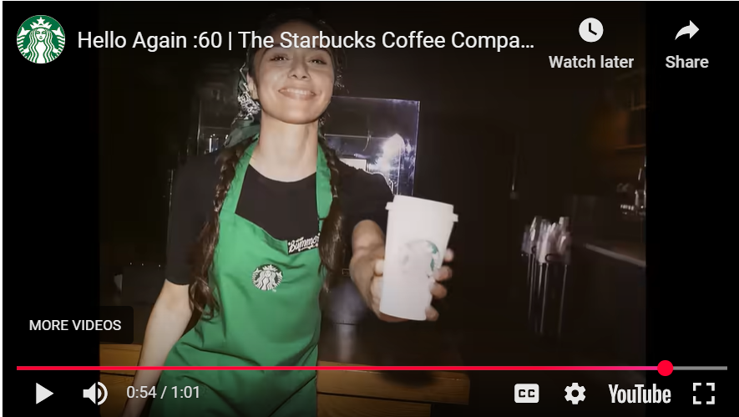
Figure 4 ''Hello Again' campaign launched by Starbucks
(Source: Kelly, 2025)
To bolster the message, the company introduced the ‘Starbucks Monday' promotion, providing free or tall hot iced coffee to rewards members, a day after the Super Bowl (Kelly, 2025). Such an approach positioned the brand as returning to its roots of connection, and a coffee, while encouraging consumer loyalty and app engagement.
- India: Appeals highlight cultural connection, affordability, and celebration of festivals alongside global brand experience. For instance, the company celebrated its tenth anniversary in India and announced the #BrewYourOwnStarbucks initiative, providing its consumers with a once-in-a-lifetime opportunity to be featured on the Starbucks menu (afaqs! news bureau, 2022).
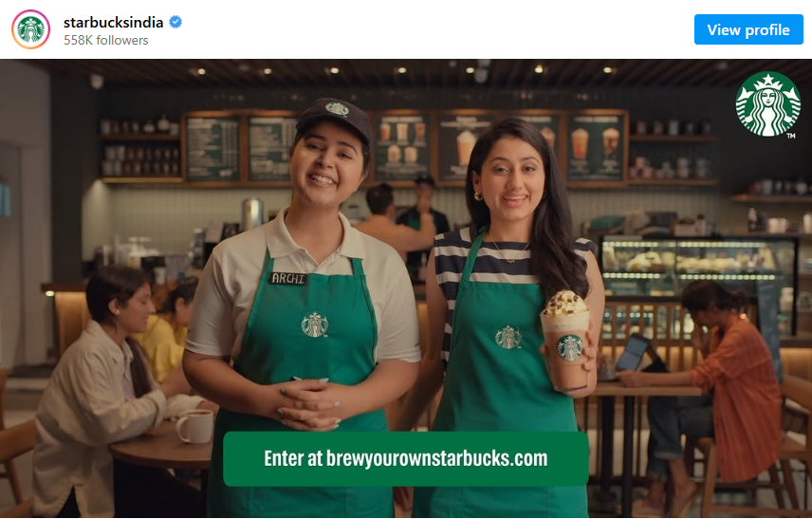
Figure 5 A ten-year celebration campaign was launched by Starbucks.
(Source: afaqs! news bureau, 2022)

Adaptation vs. Standardisation
Promotional frameworks are standardised digital-first loyalty rewards, but content is adapted in India to local festive and cultural sensibilities (Doole and Lowe, 2012). For example, Diwali-themed beverages and campaigns are unique to the Indian Market.
Overall, Starbucks applies a globally consistent strategy but adapts its messaging and appeals in India to resonate with local cultural values and consumer expectations.

Starbucks' Place Strategy
Starbucks adheres to selective distribution strategy, meaning that its stores are located in high-traffic locations that are of premium quality. Starbucks has a vast array of stores in urban, rural areas and suburbs, as well as in airports, universities, and shopping centres, in the USA. Drive-through stores, mobile app diets, and delivery alliances make the brand as convenient as possible, thus being widespread (Baack, 2018). The expansion is more focused on the metropolitan cities of India including Mumbai, Delhi, and Bengaluru, because of the expensive real estate prices and demand in urban areas. The stores are located in strategic points within the malls, business districts and IT hubs usually in cooperation with Tata. This makes them visible and accessible to aspirational consumers.

Starbucks' Process Strategy: USA vs. India
Process
Within the US, the coffee giant uses increasingly digital, and streamlined practices involving AI-based customisation, mobile ordering, competent supply chain activities, and drive-thru services. These increase convenience and maintain consistency across thousands of locations (Czinkota, 2011). In India, while digital ordering and loyalty programs are available, Starbucks places a greater emphasis on the in-store experience, with longer customer interaction times and cultural hospitality integrated into the service process to reflect local consumer preferences.
People
In the US, staff of the coffee giant are offered training to provide persistent quality with the customised engagement, and fast services. Employee training focuses on brand standards, efficiency, and customer experience. In India, baristas receive additional training on cultural sensitivities, dietary preferences, and menu offerings tailored to festivals (Durão, 2021). This helps Starbucks establish strong relationships in a market where hospitality and personal interaction are culturally valued.
Physical Evidence
The Starbucks stores in the USA are designed with a similar and modern aesthetic with the slightest difference in the design, emphasizing the brand name and a feeling of belonging. The Starbucks stores in India have a high-scale appearance of the global brand but include the local culture, including Indian paintings, decoration, and festival decorations with Diwali motifs. This will form a differentiated brand experience to the Indian consumers without compromising international standards. (De Búrca, Fletcher, and Brown, 2004).
Starbucks employs a globally consistent marketing mix framework across the USA and India, maintaining brand positioning and quality. However, it employs a hybrid strategy, standardising core processes, training, and store design, while adapting elements such as service approach, cultural integration, and physical store décor to the Indian market (Keegan, and Green, 2013). These adaptations ensure that Starbucks remains relevant in the Indian context while preserving its global identity, striking a balance between standardisation and localisation for long-term success.

Evaluation of the performance of marketing strategies
The marketing mix strategies of Starbucks exhibit robust integration with its premium brand positioning in both India and the US, while also incorporating noticeable adaptations to match the maturity of the marketplaces and evolving customer expectations. Within the US, the company underscores product innovation, convenience, and digital integration. The company owned approximately 30.9% of the US coffee and snack shop sector's market share during the first half of FY 2025 (IBISWorld, 2025a). It is one of the biggest coffee shop chains within the US, exceeding rivals such as Dunkin' and McDonald's. Additionally, the company has approximately 17,186 stores in the US as of FY 2025 (constituting a market share of around 70% in the nation). The territory, and state with most of the company's locations in the US is California with around 3190 stores, constituting around 19% of all Starbuck’s stores within the US (ScrapeHero, 2025). The organisation generated around $29.76 billion in net revenues during FY 2024.
Within India, the company's approach is highly aspirational and experience-based. Since 2012, its entry through the Tata joint venture, Starbucks has diversified through 457 stores within 70 cities as of 2024, recognising a premium niche in India's rising café culture. Its localisation strategy, adaptation of menus including Paneer Tikka sandwiches, and Masala Chai has improved the cultural relevance (The Economic Times, 2024). Despite the brand's premium pricing, sales in India increased by around 5% from FY 2024, with sales constituting approximately Rs 1,277 crores. However, its losses expanded by around 65% to around Rs 135.7 crores in FY 2025 (Malviya, 2025). However, the brand's market share remains restricted at around 5% of India's organised café market, behind Barista and Café Coffee Day. Still, it enjoys considerable brand awareness (around 80% in urban metros) compared to most of its rivals, which strengthens its aspirational appeal among young professionals and millennials.

Evaluation of marketing ethics practice
Starbucks created most of its marketing mix on the premise of supreme quality, and ethical sourcing, promotional messaging, and physical evidence (branded packaging that demonstrates responsible sourcing) are key to that promise (Keegan and Green, 2013). Such a positioning becomes ethically questionable when consumers rely on those claims to inform their buying decisions; if the claims are inapt or false, the product and promotional elements of the 7Ps shift from persuasion to deception. For example, Starbucks publicly commits to ‘ethical’ sourcing, but it has been accused of procuring from suppliers and farms that have made severe labour-rights abuses, involving the claims of forced labour, sexual abuse, and child labour across supplier practices. Those claims directly challenge the veracity of the brand's ethical-sourcing messaging.
Process: Starbucks operates around 400,000 coffee farms, and it has also announced plans to take a few positive steps regarding the management of its plantations (Ethical Consumer, 2025). However, it appears to have only a single organic blend (Yukon), which limits the use of the most hazardous pesticides, such as those prohibited by legislation or those listed by the WHO as being injurious. However, it continues to use a few pesticides and has been ineffective in preventing their absorption into the soil and the drinking water supply.
Undercover footage from March 2025 at a Lowfield farm, one of Starbucks' suppliers, shows the cows being punched, kicked, and thrashed with electric prods. Such an issue was raised by the Animal Justice Project (AJP) about the horrific abuse. The organisation responded by welcoming such claims and assured them of further investigation at the organisational level.
Product: The brand distributes around 6 billion disposable mugs and cups globally each year. They all contain some quantity of plastic, which ends up in landfills (Ethical Consumer, 2025). It has decreased the plastic range of its cups, the quantity of plastic used per item sold, by around 20%; however, it has not revealed if it has decreased its plastic consumption in absolute terms.
People: Starbucks was sued by a US customer group, alleging that in Brazil the brand has overlooked the working conditions similar to slavery, involving the illegitimate trafficking of its migrant workers, while child labour has been allegedly done in a separate company's certified farms in Guatemala (Milman, 2024).
Promotion: A case was filed against Starbucks in Washington, D.C., for committing false advertising. The company continued to make purchases from specific tea and coffee farms in Kenya, Guatemala, and Brazil, despite their abusive and inhumane practices in the supply chains and known violations (NBC News, 2025).

Recommendations
According to the comparison conducted of the strategies adopted by Starbucks in India and the US, it can be noted that some of the strategies have become more and more effective, whilst others have limitations that affect profitability and long-term growth. In the US, Starbucks premium position, as well as product innovation, convenience-related services, and the digital integration, has become more effective. An example of this is the Starbucks Rewards program, where about 30 million active members can be found, which encourages loyalty and repeat buying, and seasonal products like the Pumpkin Spice Latte also help to enhance the brand image of exclusivity and excitement (Starbucks, 2025).
The emphasis on lifestyle branding and technological usage (mobile ordering, AI-based customisation, and drive-thrus) also combines with customer demand for convenience and speed. Such strategies have become dominant in the U.S. coffee shop market, with a 30.9% share and net revenues of around $29.76 billion during FY 2024 (IBISWorld, 2025a). Hence, in the US, Starbucks’ strategy of premium experience with convenience is functioning properly, and must be managed, with an additional expenditure in digitalisation, and plant-based advancement to keep pace with the emerging customer preferences.
In India, however, while Starbucks enjoys robust brand recognition (approximately 80% in metros), and cultural resonance through localisation (such as paneer sandwiches, chai tea lattes, and festival campaigns), its increased pricing limits accessibility. Despite a 5% sales rise in FY 2024, the organisation's losses escalated by around 65% in FY 2025, demonstrating a profitability issue (Malviya, 2025). The aspirational and lifestyle-based positioning targets affluent millennials and professionals; however, it excludes price-sensitive middle-class customers, who are likely to maintain local competitors such as Café Coffee Day. This elaborates that the premium pricing strategy of Starbucks, though integrated with its brand image, limits the marketplace penetration.
Recommendations:
India Pricing Strategy Adjustment: This involves introducing a mid-tier pricing range or a value menu, along with premium offerings, to attract the diverse middle-class segment without compromising the luxury appeal (De Búrca, Fletcher, and Brown, 2004). For example, smaller beverage sizes or locally motivated, affordable combos can widen reach while managing the exclusivity.
Ethics & Sustainability: Given accusations of unethical sourcing and environmental impact, the brand should bolster transparency within supply chains, accelerating its adaptation to sustainable packaging (Keegan and Green, 2013). Customer trust can be rebuilt while making ethical practices transparent through campaigns.
Tier-2 and Tier-3 marketplace expansion in India: Leveraging local expertise of Tata to diversify specifically in evolving cities with affordable adjustments, harnessing exclusivity with accessibility.
US Differentiation Maintenance: The organisation should continue innovating with plant-oriented and functional beverages (such as wellness-based drinks) to sustain its suitability for health-based and eco-conscious millennial and Gen Z customers (De Búrca, Fletcher, and Brown, 2004).

Conclusion
In this manner, the foregoing discussion summarised that to reveal that Starbucks has been able to leverage its premium brands positioning, digitalization, and an innovation to lead the marketplace in the US, where lifestyle and convenience are what sells the consumer loyalty. As opposed to this, its operations in India reveal that cultural adaptation and aspirational branding are effective and also show difficulties in profitability in terms of high pricing and limited accessibility. Although Starbucks has a good brand recognition in both scenarios, issues of sourcing and sustainability pose some ethical challenges to its credibility. In general, the results indicate that the strategies of Starbucks can be most effective in the terms of global consistency and local responsiveness. To achieve sustainable growth, especially in emerging markets like India, the brand must balance exclusivity with affordability and reinforce its ethical commitments. This dual focus will ensure Starbucks remains competitive and relevant across diverse global markets.

References
afaqs! news bureau. (2022) ‘Starbucks India celebrates 10th anniversary with its latest campaign #BrewYourOwnStarbucks’, afaqs!, 16 August. Available at: https://www.afaqs.com/news/advertising/starbucks-india-celebrates-10th-anniversary-with-its-latest-campaign-brewyourownstarbucks. [Accessed: 29th September, 2025]
Baack, D. G. (2018) International marketing., 2nd edition. London: SAGE Publications.
BBC News (2025a) US Inflation holds but underlying prices creep up. BBC, Day Month. Available at: https://www.bbc.com/news/articles/c24zzj0y3mmo. [Accessed: 27th September, 2025]
Behera, A. (2023, July 18) Sip, savor, and socialize: Tea and Coffee rituals in Indian workplaces. Times of India Readers’ Blog. Available at: https://timesofindia.indiatimes.com/readersblog/universal-chronicle/sip-savor-and-socialize-tea-and-coffee-rituals-in-indian-workplaces-56569/. [Accessed: 23rd September, 2025]
BT Online Bureau. (2015) “FSSAI blacklists 32 products of Kellogg’s, Starbucks, Venkys.” Business Today, 11 June. Available at: https://www.businesstoday.in/latest/corporate/story/fssai-blacklists-32-products-of-kelloggs-starbucks-venkys-48448-2015-06-11. [Accessed: 25th September, 2025]
Coffee Board of India. (2024) Coffee consumption trends in India, 2023. Ministry of Commerce & Industry, Government of India. Available at: https://coffeeboard.gov.in/Publications/Coffee_Consumption_2023.pdf. [Accessed: 26th September, 2025]
Czinkota, M.R. (2011) International Marketing. Hampsire: Cengage Learning.
Dawar, P., Sehrawat, P. and Garg, S. (2017) ‘Positioning of Starbucks in India: Issues and Challenges’, Bodh – BPIT’s International Journal of Technology & Management, 2(1), pp. 43–49.
De Búrca, S., Fletcher, R. and Brown, L. (2004) International marketing : an SME perspective. 1st ed. Harlow, England: FT Prentice Hall.
Doole, I. and Lowe, R. (2012) International marketing strategy : analysis, development and implementation. Cengage Learning.
Durão, J.D.L.B. (2021) Inhibiting and Stimulating Factors for the Integration of Refugees into the Portuguese Labour Market–Case Studies on Best Practices within the Hospitality Sector (Master's thesis, Universidade NOVA de Lisboa (Portugal)).
EKN (2024) India Country Risk Analysis 2024. EKN (Exportkreditnämnden). Available at: https://www.ekn.se/globalassets/dokument/landriskanalyser/2024/en/india-country-risk-analysis-2024-web.pdf. [Accessed: 29th September, 2025]
Ethical Consumer (2025) ‘How ethical is Starbucks Corporation?’, Ethical Consumer, 22 September. Available at: https://www.ethicalconsumer.org/company- profile/starbucks-corporation. [Accessed: 25th September, 2025]
Gairola, S. (2024) ‘Crafting a Coffee Empire: Starbucks’ Rise in the Indian Market – Case Study of Starbucks Phenomenon in India’, International Journal of Innovative Research in Technology, 11(3), pp. 127–133. ISSN: 2349-6002.
Hui-Jung, C. (2019) Starbucks in the World. HOLISTICA Journal of Business and Public Administration, 10(3), pp.99-110.
IBISWorld, (2025a) Starbucks Corporation [online]. Available at: https://www.ibisworld.com/united-states/company/starbucks-corporation/347821/#:~:text=Description,than%20some%20of%20their%20peers. [Accessed: 29th September, 2025]
Igwe, P.A., Rugara, D.G. and Rahman, M. (2021) A triad of Uppsala internationalization of emerging markets firms and challenges: A systematic review. Administrative Sciences, 12(1), p.3.
Kathuria, A.K. and Anand, D. (2022) Safe, Healthy, and Sustainable Diets: Role of Food Regulatory Bodies and Innovations from India. World Bank.
Keegan, W.J. and Green, M.C. (2013) Global marketing. 7th ed., global ed. Boston, Mass. ; London: Pearson.
Kelly, C. (2025) ‘Starbucks says ‘Hello Again’ by advertising around the Super Bowl’, Marketing Dive, 5 February. Available at: https://www.marketingdive.com/news/starbucks-hello-again-campaign-super-bowl-monday/739265/. [Accessed: 25th September, 2025]
Kim, J.E. and Park, E.S. (2021) The spatial design marketing strategy of global franchises that take into consideration the characteristics of modern consumers—a study involving the global coffee companies of starbucks and blue bottle. Land, 10(7), p.716.
Ko, E., Kim, E., Taylor, C. R., Kim, K. H., & Kang, I. J. (2007) Cross-national market segmentation in the fashion industry: A study of European, Korean, and US consumers. International Marketing Review, 24(5), 629–651.
Kumar, M. (2025, April 29). India’s growth outlook at risk from trade tensions and geopolitical risks, government says. Reuters. Available at: https://www.reuters.com/world/india/indias-growth-outlook-risk-trade-tensions-geopolitical-risks-government-says-2025-04-29/. [Accessed: 29th September, 2025]
Malviya, S. (2025) ‘Starbucks India losses surge 65% in FY25, sales grow 5%’, The Economic Times, 26 May. Available at: https://economictimes.indiatimes.com/industry/cons-products/food/starbucks-india-losses-surge-65-in-fy25-sales-grow-5/articleshow/121398481.cms?from=mdr. [Accessed: 27th September, 2025]
Milman, O. (2024) ‘Starbucks sued over claims of labour and human rights violations in making of products’, The Guardian, 11 January. Available at: https://www.theguardian.com/business/2024/jan/11/starbucks-labor-lawsuit-human-rights-violations-coffee-farm#:~:text=Starbucks%20sued%20over%20claims%20of%20labor%20and,of%20products%20%7C%20Starbucks%20%7C%20The%20Guardian.&text=Specific%20allegations%20in%20the%20lawsuit%20include%20claims,used%20in%20separate%20Starbucks%2Dcertified%20farms%20in%20Guatemala. [Accessed: 22nd September, 2025]
Mirza, (2024) “Starbucks loses ground on emissions reduction, sets new 2030 sustainability goals.” ESG Dive, 4 March. Available at: https://www.esgdive.com/news/starbucks-loses-ground-on-emissions-reduction-sets-new-2030-sustainability/709214/. [Accessed: 28th September, 2025]
Musonera, E. (2021) Strategic marketing case analysis: Starbucks. Journal of Business and Social Science Review, 2(11), pp.12-22.
NBC News (2025) ‘Starbucks sued, allegedly using coffee farms with rights abuses while touting ethics’, NBC News. Available at: https://www.nbcnews.com/news/us-news/starbucks-sued-allegedly-using-coffee-farms-rights-abuses-touting-ethi-rcna130393. [Accessed: 29th September, 2025]
Oberholzer-Gee, F. (2021) Better, simpler strategy: A value-based guide to exceptional performance. Harvard Business Press.
Pebadja, G. and Kholifah, S., 2023. The Impact of Brand Image, Pricing Strategies, and Product Quality on Consumer Loyalty in the Coffee Industry: An Empirical Study Using Structural Equation Modeling. Journal of Management and Informatics, 2(2), pp.1-20.
Poonacha Machaiah. (2024) “From Soil to Sip: How AI Can Revolutionize Coffee Production for Small Farmers in the Western Ghats.” Medium, 29 June. Available at: https://medium.com/@poonacha/from-soil-to-sip-how-ai-can-revolutionize-coffee-production-for-small-farmers-in-the-western-ghats-9a9620950aaa. [Accessed: 29th September, 2025]
Restaurants, C.J. (2023) 6 Fast and Japanese. The Global Japanese Restaurant: Mobilities, Imaginaries, and Politics, p.212.
Sadri, I. and Aprianingsih, A. (2025) Strategic Marketing Approaches Leveraging the 7P Marketing Mix Framework to Overcome Sales Challenges and Enhance Purchase Intention for IELTS Programs at Athena English Course. Journal of Research in Social Science and Humanities, 5(1), pp.120-125.
ScrapeHero, (2025) Number of Starbucks stores in the United States [online]. Available at: https://www.scrapehero.com/location-reports/Starbucks-USA/. [Accessed: 29th September, 2025]
Sharma, R. (2025) ‘Tata Starbucks strengthens Mumbai presence with 100 locations’, Restaurant India, 7 January. Available at: https://www.restaurantindia.in/news/tata-starbucks-strengthens-mumbai-presence-with-100-locations.n12130. [Accessed: 28th September, 2025]
Starbucks (2025) Our Starbucks mission. Available at: https://about.starbucks.com/stories/2025/our-starbucks-mission/ (Accessed on: 27 September 2025)
Starbucks Coffee Company (2025a) Starbucks Fiscal 2024 Global Impact Report. Starbucks Coffee Company. Available at: https://about.starbucks.com/uploads/2025/05/Starbucks-Fiscal-2024-Global-Impact-Report.pdf. [Accessed: 23rd September, 2025]
Starbucks Coffee Company. (2025b) Starbucks. Available at: https://www.starbucks.com/. [Accessed: 29th September, 2025]
Statista. (2025a) Inflation rate in India. Available at: https://www.statista.com/statistics/271322/inflation-rate-in-india/. [Accessed: 29th September, 2025]
The Culture Factor. (2025) Country comparison tool. Available at: https://www.theculturefactor.com/country-comparison-tool?countries=united+states. [Accessed: 28th September, 2025]
The Economic Times (2024) Starbucks brews up success; now India’s largest café chain. ET Online, 18 October. Available at: https://economictimes.indiatimes.com/industry/cons-products/fmcg/starbucks-brews-up-success-now-indias-largest-caf-chain/articleshow/114351613.cms?from=mdr. [Accessed: 29th September, 2025]

