Student id:2027938
Name:Alin Raileanu
Course:BMSW4004BIRM
Subject name:Task2 Assignment
Lecturer name:Nauman Ali

Problem Solving and Decision making

Executive Summary
The paper presented details regarding the workplace related problems in the case of the Tesco organisation. The problem that has been obtained is work-related stress. The purpose of the paper is to present details regarding the aspect of solving the problem. It is noted to impact on the organisations and employees. The application of the cause and effect diagram is done and a fishbone diagram is developed. Furthermore, the PESTLE analysis is done along with making decisions to assess the alternatives and obtaining the appropriate one to consider. Furthermore, an implementation plan has been developed to apply the solution of establishing a positive workplace environment.

Table of Contents
Executive Summary 2
Introduction 4
Section 1 4
Section 2 5
Section 3 6
Section 4 8
Section 5 9
Conclusion 11
References 12

Introduction
The problem based on which the paper will be developed is the stress associated with work. It will be developed by considering the theme of solving problems and making the necessary decisions. Work related stress from the perspective of organisations is regarded as the responses in the case of individuals due to work pressure, stress, and demands from the organisation.
The selected company in this consideration is the Tesco organisation. It is a multinational organisation operating within the retail sector of the United Kingdom. It is a public organisation founded by Jack Cohen founded in 1919. It is present in 7005 locations on a worldwide basis (tescoplc, 2021). The organisation is found to have revenue of £64.760 billion, followed by operating income of £3.005 billion. Furthermore, the net income of the organisation is £0.973 billion and the total assets of the organisation are £12.879 billion. The number of employees who are found to work for the organisation is 423092.

Section 1
Problem-solving can be defined as the act to highlight a particular problem. It is very much effective to determine the cause of the problem, prioritising, identifying and selecting the alternatives for making a valuable solution. In order to manage as well as run the organisation successfully, the leaders need to guide their employees and develop different problem-solving techniques (Kirn & Benson, 2018).
The complex problems have made a significant impact on the employees as they are feeling very demoralized to work in the company for a long time. The employees are looking forward to solving the complex problems for maintaining the flow of work and achieving the goals of Tesco in the retail industry. Teams that are dealing with the complex with interdependence and it has required a high coordination pattern as compared to the lower levels of interdependence. The senior employees have taken the initiative to handle the complex problems by using their personal experience and continue to maintain a strong connection with each other (Nexø et al., 2018). It is very much significant for the employees to deal with every situation and analyse the entire scenario.
The complex problems can lead to reduced performance as well as productivity. There is a chance of termination of the staff. As a result, the company is not able to generate revenue as expected and it has hampered the margin of profits of Tesco in the market. If the organisation has failed to address workplace problems, it can hurt the environment of the company. It has enhanced the turnover rates as well as the satisfaction level of the employees. They are not communicating with each other and as a result, the conflicts between different functional groups have increased.

Section 2
The cause and effect analysis refers to the technique that is found to facilitate the organisations in identifying all sorts of likely reasons that generate a problem. It is noted to focus on identifying the problem followed by reckoning the main causes. The next parameter that can be highlighted is identification of the plausible sub-causes in terms of the major reasons. Furthermore, analysis of the diagram of cost and effect also gets done (Umeda et al., 2019). It facilitates in identifying the origin of the problem by means of focusing on the point of initiation, followed by the creation of new ideas for the purpose of obtaining the best solutions corresponding to the highlighted problem.
The diagram linked to the cost and effect in the form of a fishbone in relation to the identified issue corresponding to work related stress has been developed in CW1. The diagram has been presented in the following section.
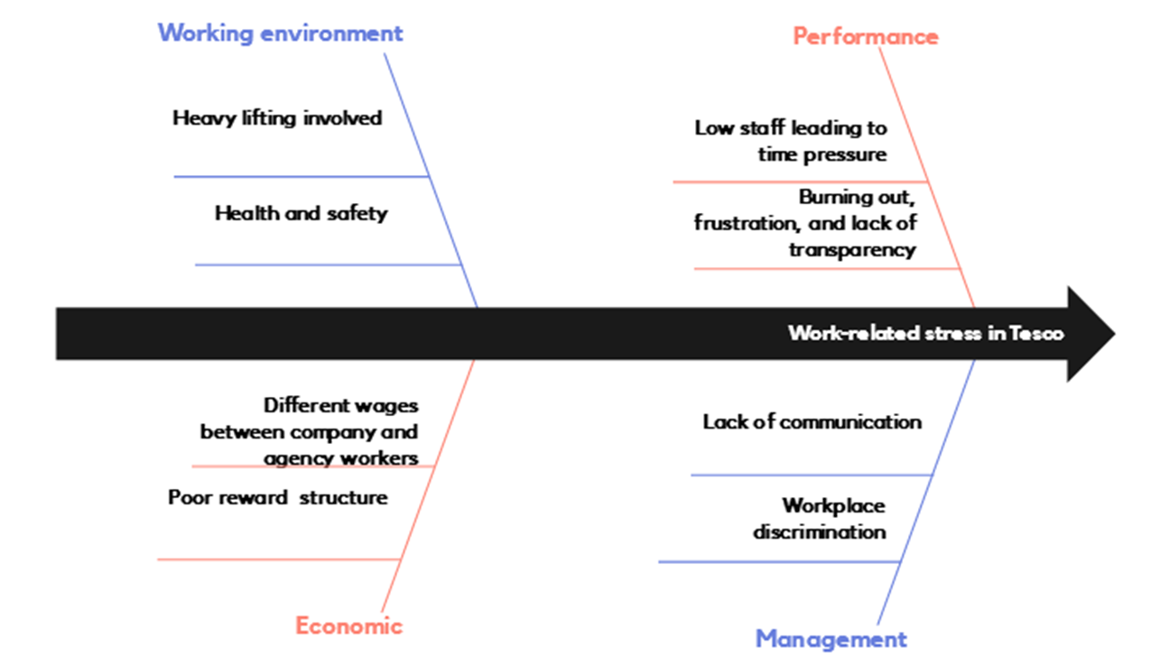
Source: Author
In the case of the identified problem in the form of workplace related stress, it can be identified that the application of the cause and effect analysis would serve really crucial for the Tesco organisation in finding out the root cause of the problem and their impacts on the organisation. In addition to it, it is also noted to serve highly crucial in determining the different alternative solutions that can be implemented for the purpose of obtaining positive solutions to cope and mitigate the presented issue.

Section 3
Pestel analysis is known as an acronym for a particular tool that can be used to figure out the macro factors that have been faced by the organisation. This analysis can be used to figure out the multiple external factors that can be beneficial for the company interns are making the correct decisions to continue the business. The factors are political, followed by economic, social, technological, environmental and finally legal (Pan et al., 2019).
Political: Tesco is a large organisation where they are looking forward to expanding its business all over the world. The organisation has efficient team members who are very much aware to know the recent rules and regulations of the government. The organisation has the intention to observe the stability of the government regulations. Since Tesco has operated in multiple countries, it is very significant for them to keep a tab on the changing circumstances of the political parties. They can observe a better opportunity in the stable political environment countries. The dialogue has been created due to Brexit where the new regulations that are coming up and cause a decrease or increase in the margin of profit for Tesco. However, the change in tax policies among different supply countries can affect the profitability of the organisation (Mbaskool, 2020).
Economic: Tesco needs to keep an eye for the economic changes that can be occurred in different countries where they are operating their business. It has made a significant impact on its revenue and profit. The organisation needs to be aware of the multiple taxation policies. Tesco needs to keep in mind that the pricing of the products is very much influential on the margin of profit. When the inflation rate has been increased, it has made a significant impact on the price of the products. Covid-19 pandemic has increased the business of the company especially in their E-Commerce platform where the customers can easily place their orders online.
Social: Tesco has offered employment opportunities in most of the countries where the people can show their dedication and achieve the goals of the company. Tesco has decided to switch from major food products to a food cum non-food model. The products are demanded by the customers and it is depending on social influence. The choice of the products is highly dependent on different cultural factors where the people can live their life.
Technology: Tesco has decided to use the element on a regular basis. It is very much effective to give them a competitive edge in the retail industry. The main intention to use the latest technologies is to increase the level of services by using less human effort. They have used machine learning as well as artificial intelligence technologies in the E-Commerce site. The organisation has designed its website very attractively for the customers (Hashim et al., 2021).
Environmental: Tesco is very much dedicated to reducing the use of plastics in the packaging of the products since they have believed that it is the main reason for the pollution. All the employees and the higher authorities have given their best efforts to maintain sustainability in the business and use recyclable products for the betterment.
Legal: The change in the government policies have been affected the operations of the organisation. The company has followed both the International as well as local laws for continuing their business very smoothly. The allegation of gender bias has caused a negative impact on female employees. The unequal payment for the female colleague has reduced the reputation of the company in the market (Mbaskool, 2020).
Tesco has expanded its business all over the world and they are very much aware of international along with regional legislation for maintaining fairness in the business. Covid pandemic has increased the margin of profit for the company as the customers are feeling very much comfortable placing orders on the online platform. They have used the relevant technologies in the E-Commerce platform and give a pleasant look to the customers. It has proved very much beneficial for them in terms of generating revenues and securing the brand image.

Section 4
The concept of decision making refers to the procedure to make choices by means of the identification of a particular decision through information gathering and making assessment of the available alternative resolutions (Slovic et al., 2019). It is regarded as a step by step procedure of making decisions that helps the individuals in making more thoughtful and delivering decisions by means of organising appropriate and relevant information and presenting the different alternatives that can also be implemented. The procedure of decision making in the case of organisations is found to encompass different stages. The initial stage is about recognising the need followed by searching information then evaluating the alternatives and making the final decisions.
The initial solution mentioned in the developed presentation in CW1 is the establishment of effective communication and management within the premises of the Tesco organisation. The next proposed solution is increasing the level of transparency within the organisation. The third is about establishing a positive environment associated with working within the organisation. Moreover, the final alternative solution that can be applied within the organisation is generating improvement in terms of the performance rate along with productivity within the organisational premises.
The appropriate solution that can be presented in this consideration for applying it within the Tesco organisation to deal with the matter associated with work related stress is the establishment of a positive culture of working within the premises. The solution would generate significant benefit for the organisation as it would lead to complete transformation of the overall pattern of business procedure execution. As a result the employees would be able to attain improvement in efficiency and performance via motivation and encouragement and would be able to maintain appropriate levels of work life balance and eliminate the possibilities of stress.

Section 5
This section would include the implementation plan corresponding to the proposed solution of establishing a positive working environment within the Tesco organisation to eliminate the problem of work-related stress.
Step 1: Identify the decision
The initial step in this aspect is making identification of the decision corresponding to the implementation of the positive environment of working.
Step 2: Gather relevant information
Considering secondary resources for the purpose of obtaining information regarding the manner in which the solution can be applied within the organisation by analysing the existing problem associated with work related stress.
Step 3: Identification of the alternatives
Identification of different kinds of alternatives that can be applied for the purpose of dealing with the problem of work related stress within the premises of the organisation.
Step 4: Considering the evidence
Appropriate assessment of the evidence can be noted to be done by focusing on every alternative available for coping with the problem of work related stress within the organisational premises of the Tesco organisation.
Step 5: Selection of the alternatives
Based on the conducted analysis, the appropriate solution will be identified in the form of establishing a positive working environment.
Step 6: Taking action
The obtained solution will be implemented within the Tesco organisation by presenting appropriate steps in an adequate manner.
Step 7: Reviewing the decision and its consequences
Reviewing the implemented solution by applying appropriate KPIs will be done to figure out the loopholes to take the necessary measures.

Conclusion
Tesco is a popular organisation in the retail industry. The complex problems have made a significant impact on both the employees as well as the organisation. The main problem has been occurred due to the stress level of the employees. Different suggestions had provided to reduce the stress level and maintain a proper balance between personal life and professional life.

References
Hashim, M. et al., 2021. Unlocking the Sustainable Production Indicators: A Novel TESCO based Fuzzy AHP Approach. Cogent Business & Management, 8(1), p.1870807.
Kirn, A. & Benson, L., 2018. Engineering students' perceptions of problem solving and their future. Journal of engineering education, 107(1), pp.87-112.
Mbaskool, 2020. Tesco PESTLE Analysis. [Online] Available at: https://www.mbaskool.com/pestle-analysis/companies/18023-tesco.html [Accessed 2021].
Nexø, M.A. et al., 2018. Content and quality of workplace guidelines developed to prevent mental health problems: results from a systematic review. Scandinavian journal of work, environment & health, 44(5), pp.443-57.
Pan, W., Chen, L. & Zhan, W., 2019. PESTEL analysis of construction productivity enhancement strategies: A case study of three economies. Journal of Management in Engineering, 35(1), p.05018013.
Slovic, P., Lichtenstein, S. & Fischhoff, B., 2019. Decision making. Wiley.
tescoplc, 2021. About - Tesco PLC. [Online] Available at: https://www.tescoplc.com/about/ [Accessed 2021].
Umeda, T., Kuriyama, T., O'shima, E. & Matsuyama, H., 2019. A graphical approach to cause and effect analysis of chemical processing systems. Engineering Science, 35(12), pp.2379-88.

