Analysis of electromagnetic Wave propagation
Josh Gourlay (2111487)

Contents
Abstract 3
1. Introduction 4
2. Task 1a: Vacuum 5
2.1. Method 5
2.2. Results 5
2.2.1. Calculated Cutoff Frequency (f_{c}) 7
2.2.2. Simulated Cutoff Frequency (f_{c}) 8
2.2.3. Vacuum Magnitude and Vector Plots 9
3. Task 1b: Teflon 11
3.1. Method 11
3.2. Results 11
3.2.1. Calculated Cutoff Frequency (f_{c}) 12
3.2.2. Simulated Cutoff Frequency (f_{c}) 13
3.2.3. Teflon Magnitude and Vector Plots 14
3.3. Comparison of Cutoff Frequencies 16
4. Task 2: Dipole Antenna 17
4.1. Results 18
5. Discussion 20
6. Conclusion 22
References 23

Figure 1: Example of a Rectangular Waveguide [1] 4
Figure 2: Rectangular Waveguide Design 5
Figure 3: Port 1 Mode 1, TE₁₀ 6
Figure 4: Port 1 Mode 2, TE₂₀ 6
Figure 5: Port 1 Mode 3, TE₃₀ 6
Figure 6: Port 2 Mode 1, TE₁₀ 7
Figure 7: Port 2 Mode 2, TE₂₀ 7
Figure 8: Port 2 Mode 3, TE₃₀ 7
Figure 9: Gamma Plot Highlighting Cutoff Frequency - Vacuum 8
Figure 10: TE₁₀ Vector Plot – Vacuum Electric Field 9
Figure 11: TE₁₀ Magnitude Plot – Vacuum Electric Field 9
Figure 12: TE₂₀ Vector Plot – Vacuum Electric Field 9
Figure 13: TE₂₀ Magnitude Plot – Vacuum Electric Field 9
Figure 14: TE₃₀ Vector Plot – Vacuum Electric Field 9
Figure 15: TE₃₀ Magnitude Plot – Vacuum Electric Field 9
Figure 16: TE₁₀ Vector Plot – Vacuum Magnetic Field 10
Figure 17: TE₁₀ Magnitude Plot – Vacuum Magnetic Field 10
Figure 18: TE₂₀ Vector Plot – Vacuum Magnetic Field 10
Figure 19: TE₂₀ Magnitude Plot – Vacuum Magnetic Field 10
Figure 20: TE₃₀ Vector Plot – Vacuum Magnetic Field 10
Figure 21: TE₃₀ Magnitude Plot – Vacuum Magnetic Field 10
Figure 22: Teflon Port 1 Mode 1, TE₁₀ 11
Figure 23: Teflon Port 1 Mode 2, TE₂₀ 11
Figure 24: Teflon Port 1 Mode 3, TE₃₀ 12
Figure 25: Teflon Port 2 Mode 1, TE₁₀ 12
Figure 26: Teflon Port 2 Mode 2, TE₂₀ 12
Figure 27: Teflon Port 2 Mode 3, TE₃₀ 12
Figure 28: Gamma Plot Highlighting Cutoff Frequency – Teflon 14
Figure 29: TE₁₀ Vector Plot – Teflon Electric Field 14
Figure 30: TE₁₀ Magnitude Plot – Teflon Electric Field 14
Figure 31: TE₂₀ Vector Plot – Teflon Electric Field 15
Figure 32: TE₂₀ Magnitude Plot – Teflon Electric Field 15
Figure 33: TE₃₀ Vector Plot – Teflon Electric Field 15
Figure 34: TE₃₀ Magnitude Plot – Teflon Electric Field 15
Figure 35: TE₁₀ Vector Plot – Teflon Magnetic Field 15
Figure 36: TE₁₀ Magnitude Plot – Teflon Magnetic Field 15
Figure 37: TE₂₀ Vector Plot – Teflon Magnetic Field 16
Figure 38: TE₂₀ Magnitude Plot – Teflon Magnetic Field 16
Figure 39: TE₃₀ Vector Plot – Teflon Magnetic Field 16
Figure 40: TE₂₀ Magnitude Plot – Teflon Magnetic Field 16
Figure 41: Dipole Antenna Design 17
Figure 42: Lumped Port at the Centre of the Dipole Antenna 18
Figure 43: S Parameter Plot from Simulation of Dipole Antenna 19
Figure 44: Radiation Pattern of Dipole Antenna 19

Abstract
A series of simulations were conducted using Ansys High Frequency Simulation Software (HFSS) to design and run a computational model of a rectangular waveguide, featuring a vacuum internal medium and a Teflon medium. The second task involved the design and simulation of a half wave dipole antenna. In both tasks, the results of the simulations were compared to mathematical calculations to determine cutoff frequency (Task 1a and 1b) and operating frequency (Task 2) respectively. The mathematical calculations and simulation predictions showed consistency in the derived cutoff frequencies for all three modes TE₁₀, TE₂₀ and TE₃₀. However, there were considerable differences in the cutoff frequencies between the vacuum filled waveguide and Teflon filled waveguide, due to the difference in relative permittivity of the materials. There was also considerable difference between the calculated and simulation derived operating frequencies for the half wave dipole antenna in Task 2.

Introduction
The transfer of electromagnetic (EM) waves are of vital importance in several applications spanning communications, defence and medical industries and waveguides are a method used to facilitate this. Rectangular waveguides are commonly used in communication systems to confine EM waves; typically higher frequency waves such as microwaves, above which simple coaxial cable; an alternative method of transferring EM waves, are not suitable. Figure 1 depicts an example of a rectangular waveguide.
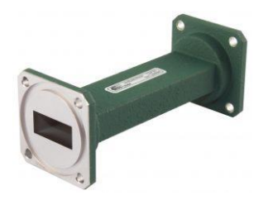
Figure 1: Example of a Rectangular Waveguide [1]
The EM waves are confined within a rectangular housing constructed of materials with excellent conductive properties which prevent the spreading and loss of signal. The waveguide propagation of an EM wave in a given direction via two distinct modes, transverse electric (TE) and transverse magnetic (TM) [2]. TE mode occurs when the electric field is perpendicular to the direction of wave propagation, whereas TM mode occurs when the magnetic field is perpendicular to the direction of wave propagation [3].
An example of how waveguides are used in the medical industry can be found in Magnetic Resonance Imagery (MRI) scanners, whereby waveguides are used to transfer radio frequency EM waves from the source to the human body, allowing detailed non-invasive medical images to be obtained [4]. In the defence industry, rectangular waveguides are used ubiquitously in radar applications to transfer the generated microwave signal from the signal generator, typically a High-Powered Amplifier (HPA) such as a Klystron, Solid-State HPA or Traveling Wave Tube (TWT), to the antenna where it is radiated at the target being tracked [5] [6].
Similarly with waveguides, the dimensions of an antenna are crucial in achieving the required functionality, depending on the application. There are several types of antennas, which can be broadly categorised as either directional or omnidirectional. Directional antennas feature localised radiation of EM waves in a particular direction and examples include horn, Yagi-Uda and parabolic [4] [5]. Conversely, omnidirectional antennas radiate EM waves in all directions equally and examples include wire antennas such as dipole, helical and circular [4].
This report details the key simulation activities carried out on a rectangular waveguide and dipole antenna design, comparing the simulation results to mathematically derived values.

Task 1a: Vacuum

Method
A rectangular waveguide was created and numerically modelled using Ansys High Frequency Simulation Software (HFSS). The dimensions of the waveguide were determined using the authors student number (2111487) as shown in Table 1.
Table 1: Waveguide Dimensional Constraints
Waveguide Dimension | Value Derivation | Value (mm)
Width | First two numbers of student ID | 21
Height | $$\frac{3rd and 4th number of student ID}{2}$$ | 5.5 (rounded to 6)
Length | Predetermined | 50

Figure 2 shows the waveguide created using the dimensions stated in Table 1.
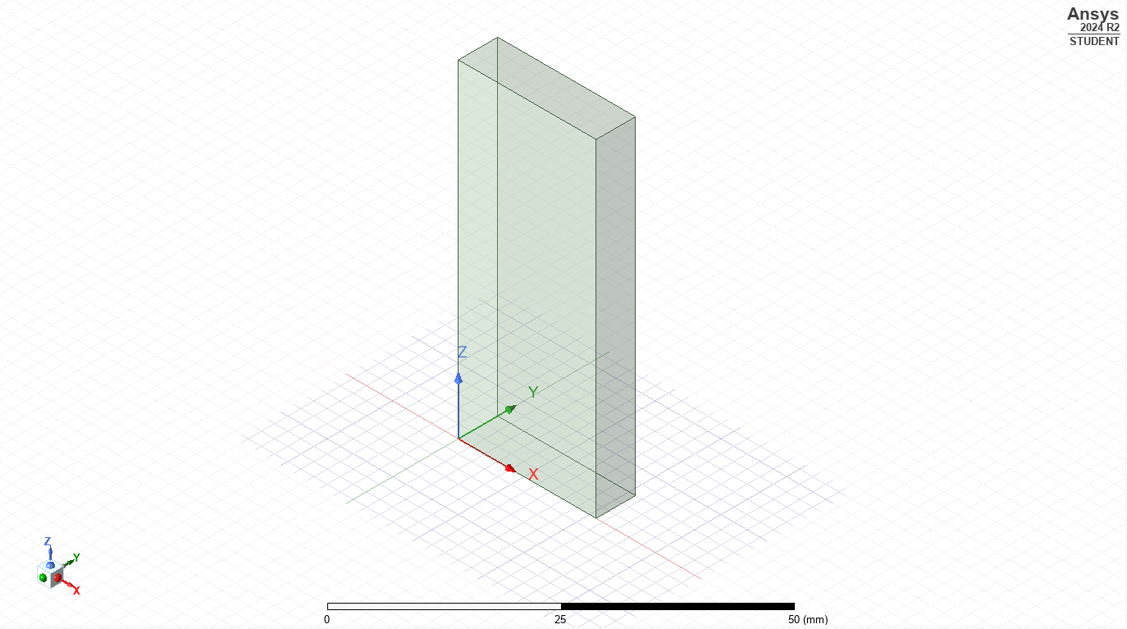
Port 1
Port 2
Figure 2: Rectangular Waveguide Design
During the simulation setup the walls of the waveguide were selected as perfect electrical conductor (PEC), and the dielectric medium was defined as a vacuum for this part of the simulation.
An excitation point was assigned to both ends of the waveguide, labelled in Figure 2 as Port 1 and Port 2. The excitation point simulates the propagation of an electromagnetic wave through the waveguide.

Results
After the simulation was run, the port field displays for Port 1 and Port 2 were presented and the identity of the modes propagating through was determined. Identification of the modes allowed the cut off frequency (f_{c}) to be determined using Equation 1.
$$f_{c}=\frac{c}{2}\sqrt{{\left(\frac{m}{a}\right)}^{2}+{\left(\frac{n}{b}\right)}^{2}}$$
Equation 1: Calculating Cut-Off Frequency
Where c = velocity of light in the medium (Vacuum = 3 x 10⁸ m/s), m = number of half-waves in the width of the waveguide, a = width of the waveguide (m), n = number of half-waves in the height of the waveguide and b = height of the waveguide (m). The port field displays can be found in Figure 3 to Figure 8.
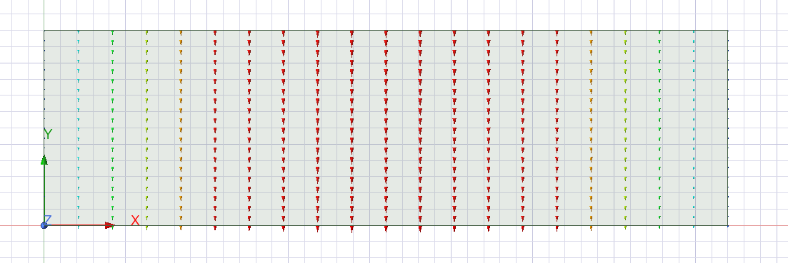
Figure 3: Port 1 Mode 1, TE₁₀
As shown in Figure 3, the mode has been identified as TE₁₀ mode due to the presence of 1 half wave (in black) relative to the width of the waveguide, whereas there is no half waves present relative to the height of the waveguide. Identification of the other modes can be seen below.
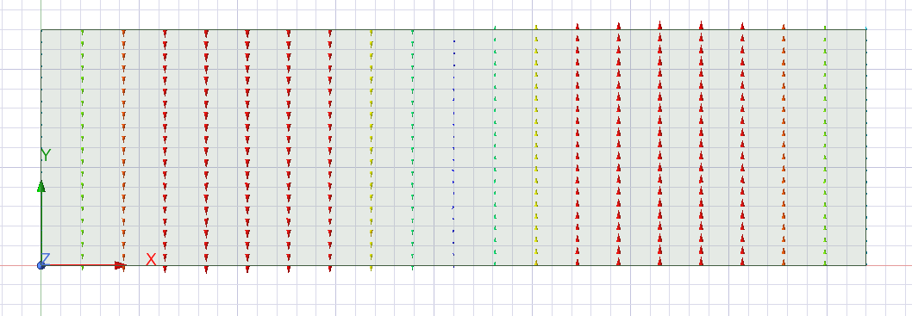
Figure 4: Port 1 Mode 2, TE₂₀
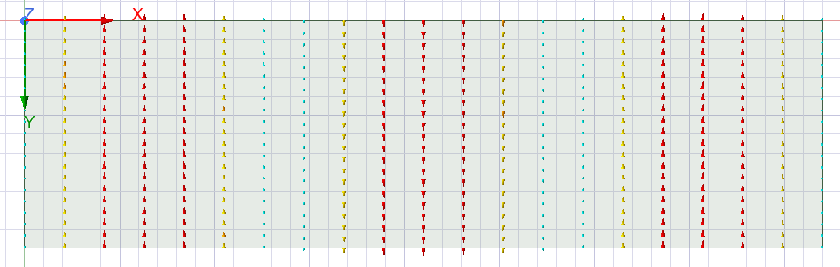
Figure 5: Port 1 Mode 3, TE₃₀
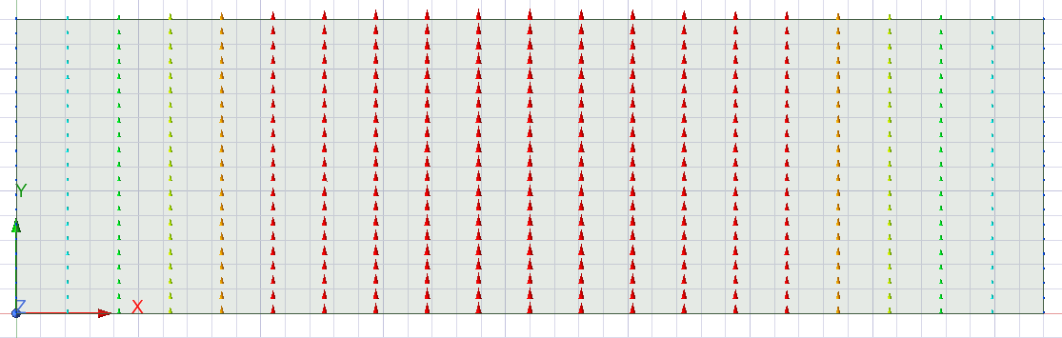
Figure 6: Port 2 Mode 1, TE₁₀
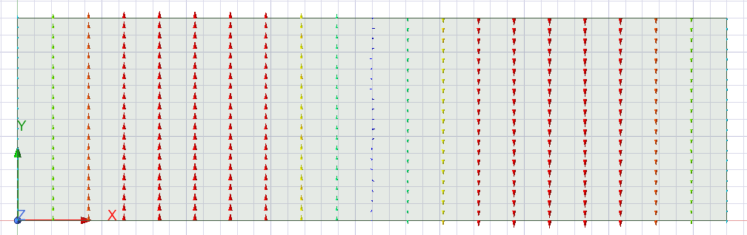
Figure 7: Port 2 Mode 2, TE₂₀
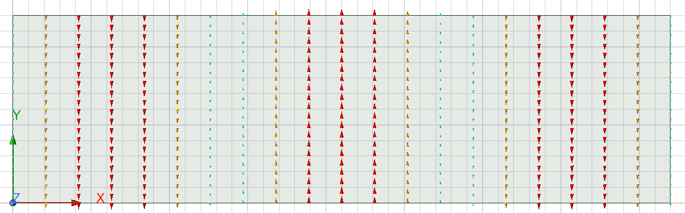
Figure 8: Port 2 Mode 3, TE₃₀

Calculated Cutoff Frequency (f_{c})
The cutoff frequency is defined as the minimum frequency at which a signal can propagate; below the cutoff frequency will prevent the signal being transmitted and the signal is lost. The cutoff frequency also determines the dominant mode i.e. the lowest cut-off frequency [6] is defined as the dominant mode as it is the first mode to allow propagation of the signal.
Using TE₁₀, TE₂₀ and TE₃₀ as worked examples, f_{c} can be calculated by substituting the m and n values into Equation 1 as shown below:
$$\begin{aligned}f_{c} {TE}_{10}=\frac{3{×10}^{8}}{2}\sqrt{{\left(\frac{1}{21×{10}^{-3}}\right)}^{2}+{\left(\frac{0}{6×{10}^{-3}}\right)}^{2}}=7.14 GHz\#\left(1\right)\end{aligned}$$

$$\begin{aligned}f_{c} {TE}_{20}=\frac{3{×10}^{8}}{2}\sqrt{{\left(\frac{2}{21×{10}^{-3}}\right)}^{2}+{\left(\frac{0}{6×{10}^{-3}}\right)}^{2}}=14.29 GHz \#(2)\end{aligned}$$

$$\begin{aligned}f_{c} {TE}_{30}=\frac{3{×10}^{8}}{2}\sqrt{{\left(\frac{3}{21×{10}^{-3}}\right)}^{2}+{\left(\frac{0}{6×{10}^{-3}}\right)}^{2}}=21.43 GHz\#\left(3\right)\end{aligned}$$
From the calculations, TE₁₀ is defined as the dominant mode due to the lowest calculated cut-off frequency as shown in (1).

Simulated Cutoff Frequency (f_{c})
Figure 9 highlights the cutoff frequencies determined from the numerical simulation for each of the 3 modes, TE₁₀, TE₂₀ and TE₃₀.
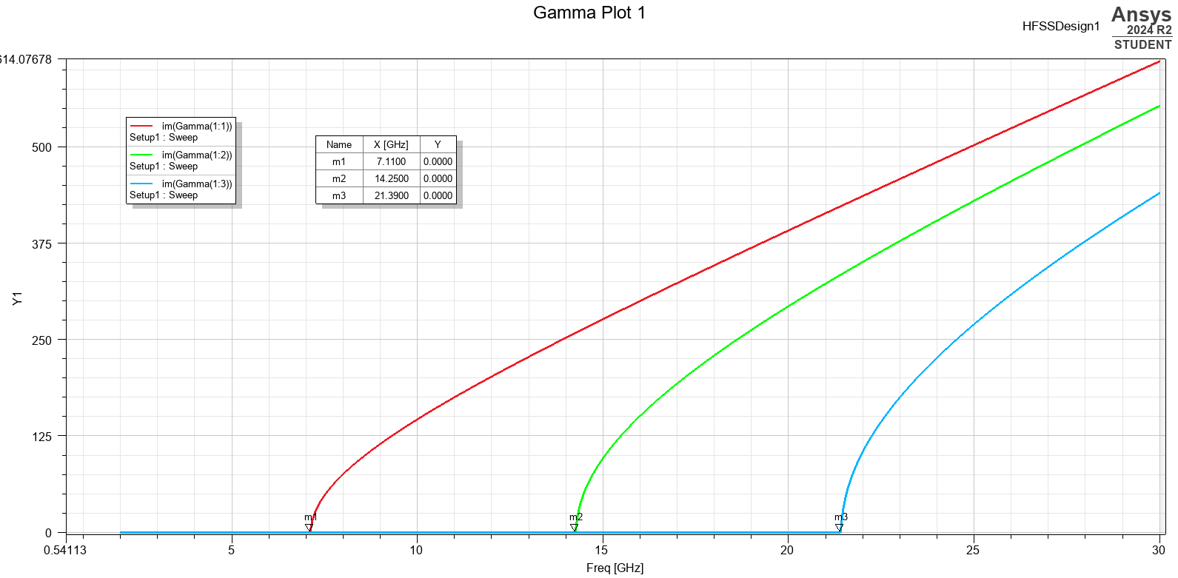
Figure 9: Gamma Plot Highlighting Cutoff Frequency - Vacuum
As shown in Figure 9, m1, m2 and m3 refer to the cutoff frequency for TE₁₀, TE₂₀ and TE₃₀ respectively. Given the values of 7.11 GHz, 14.25 GHz and 21.29 GHz, these values are very closely aligned to the numerical calculations presented in Section 2.2.1.

Vacuum Magnitude and Vector Plots
Table 2 summarises the magnitude and vector plots for the Port 1 modes, TE₁₀, TE₂₀ and TE₃₀.
Table 2: Electric Field Magnitude and Vector Plots for TE₁₀, TE₂₀ and TE₃₀ – Vacuum
 | Vector | Magnitude
TE₁₀ | 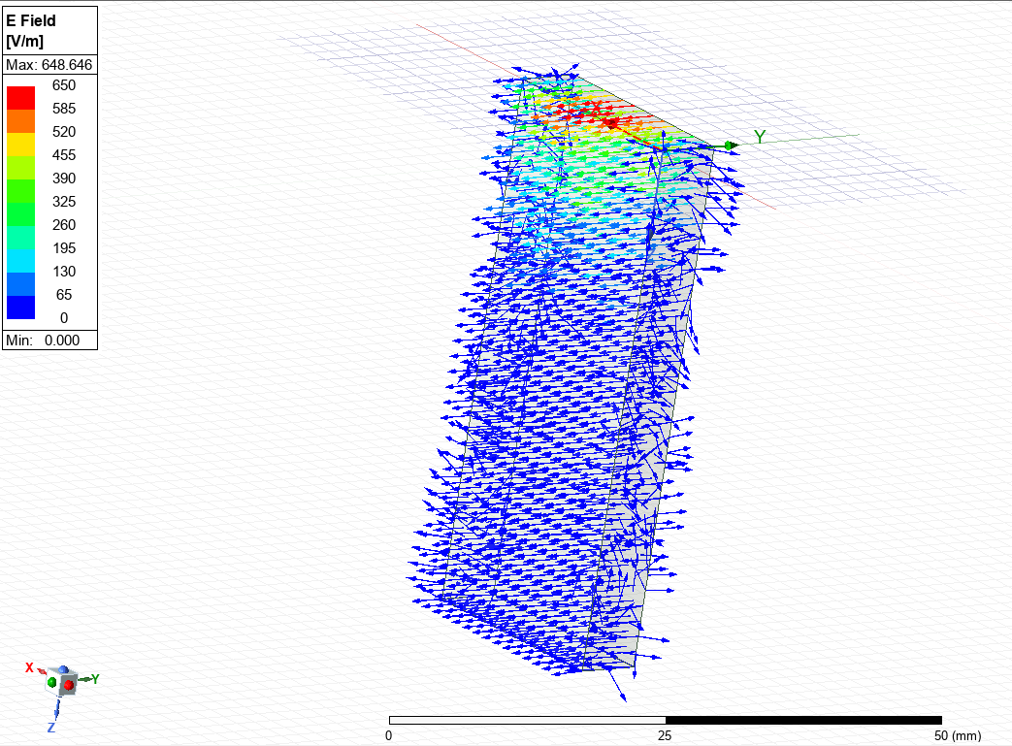  Figure 10: TE₁₀ Vector Plot – Vacuum Electric Field | 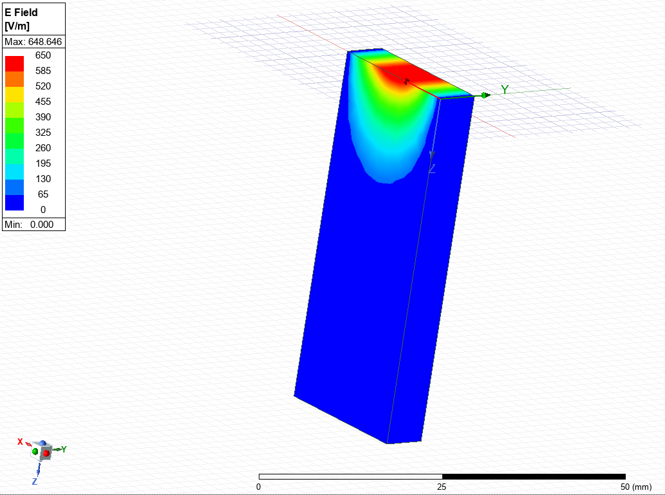  Figure 11: TE₁₀ Magnitude Plot – Vacuum Electric Field
TE₂₀ | 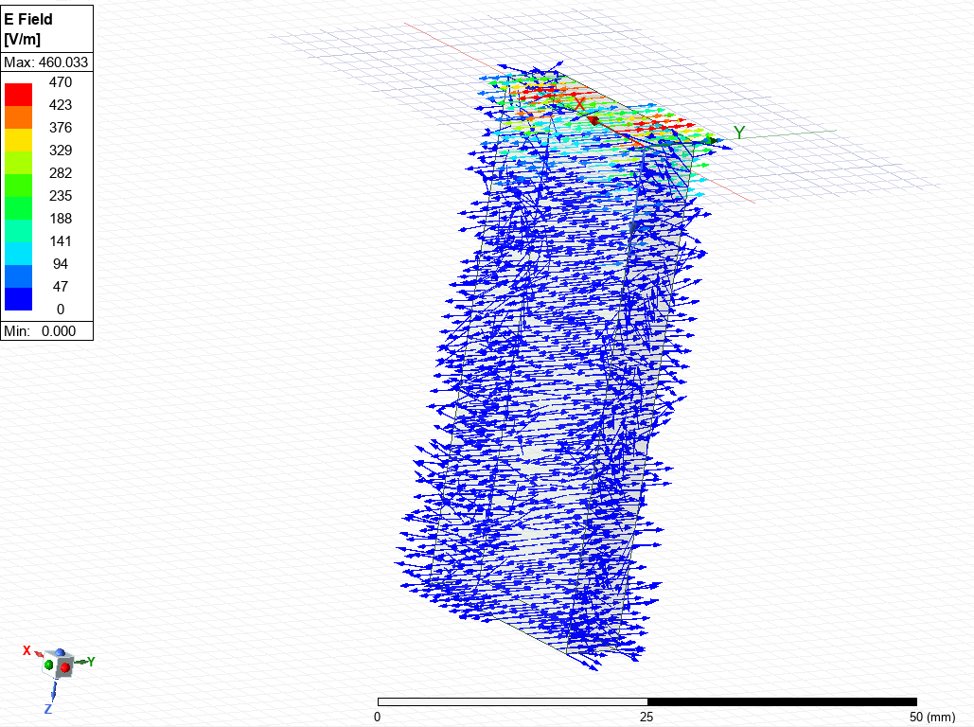  Figure 12: TE₂₀ Vector Plot – Vacuum Electric Field | 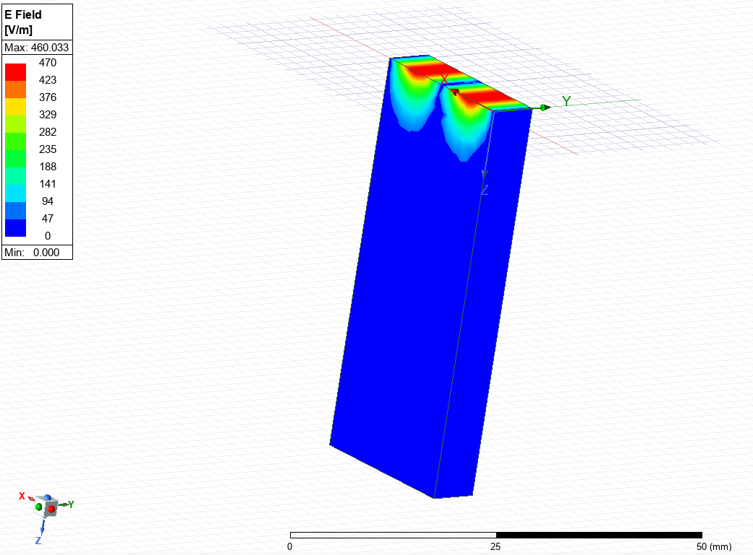  Figure 13: TE₂₀ Magnitude Plot – Vacuum Electric Field
TE₃₀ | 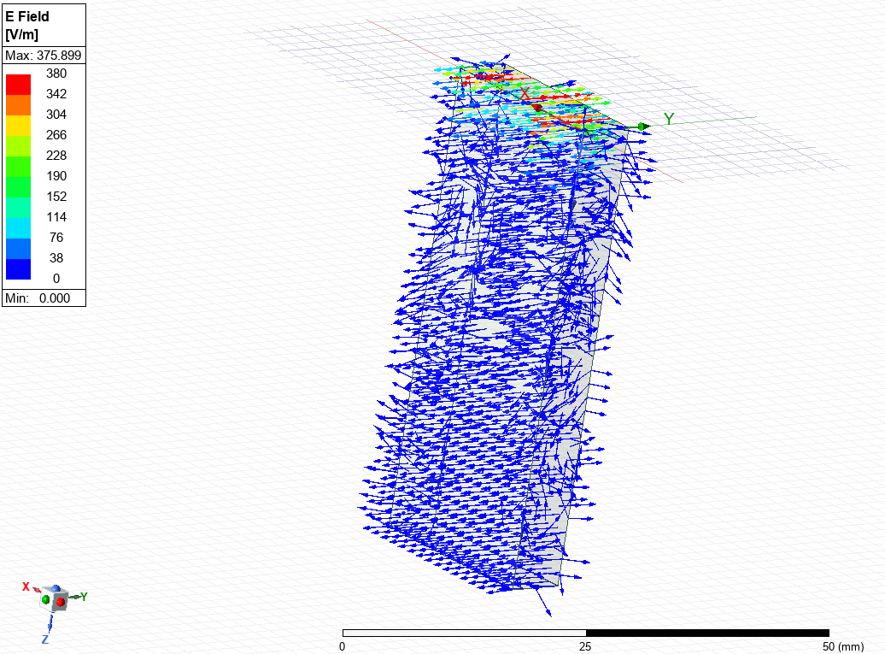  Figure 14: TE₃₀ Vector Plot – Vacuum Electric Field | 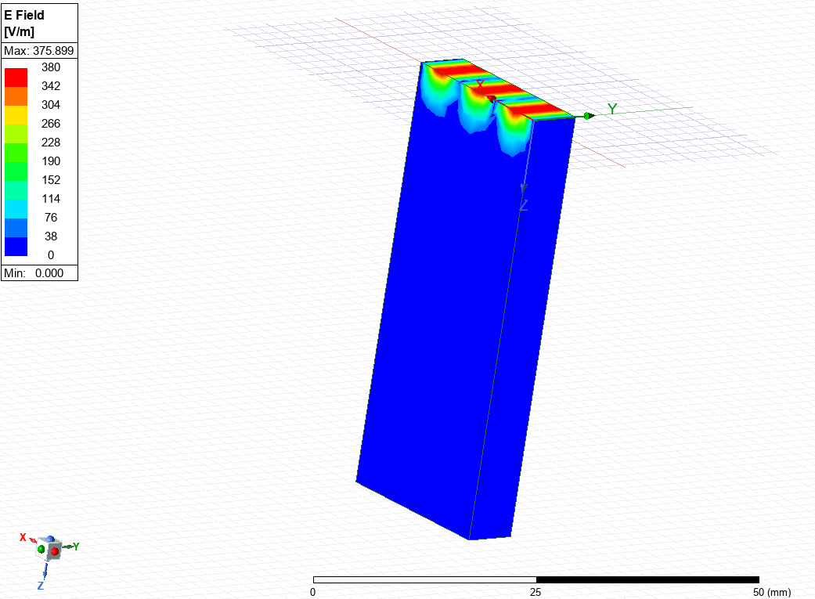  Figure 15: TE₃₀ Magnitude Plot – Vacuum Electric Field

Table 3 summarises the magnitude and vector plots for the Port 1 modes, TE₁₀, TE₂₀ and TE₃₀.
Table 3: Magnetic Field Magnitude and Vector Plots for TE₁₀, TE₂₀ and TE₃₀ – Vacuum
 | Vector | Magnitude
TE₁₀ | 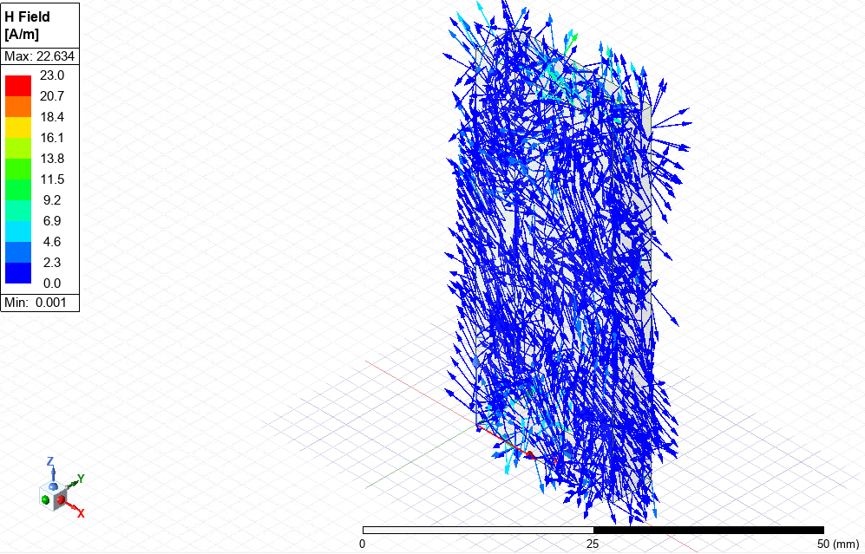  Figure 16: TE₁₀ Vector Plot – Vacuum Magnetic Field | 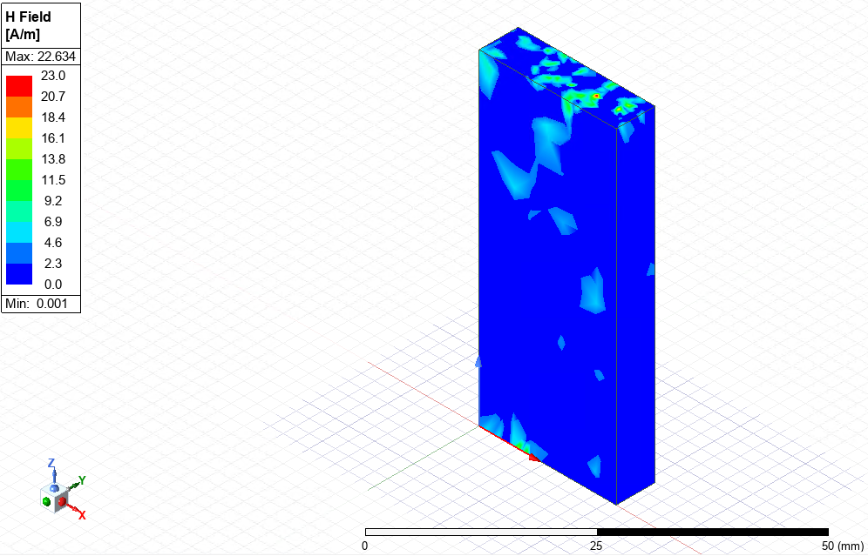  Figure 17: TE₁₀ Magnitude Plot – Vacuum Magnetic Field
TE₂₀ | 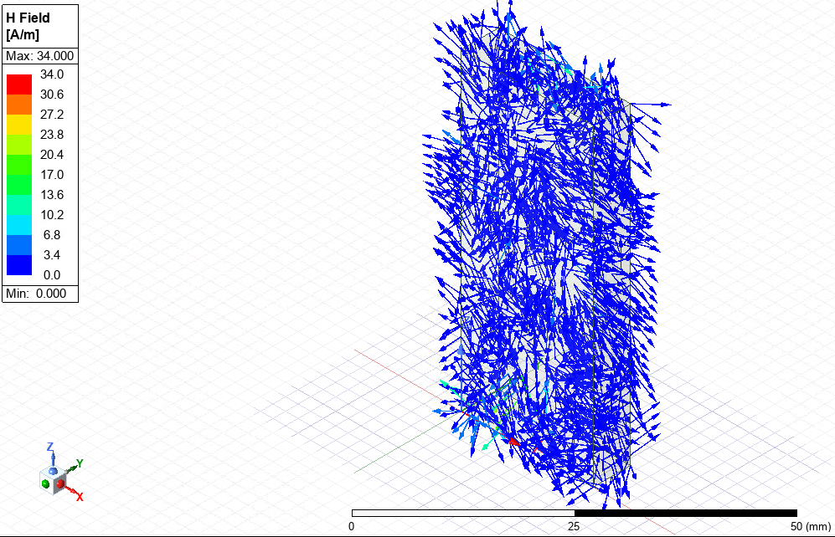  Figure 18: TE₂₀ Vector Plot – Vacuum Magnetic Field | 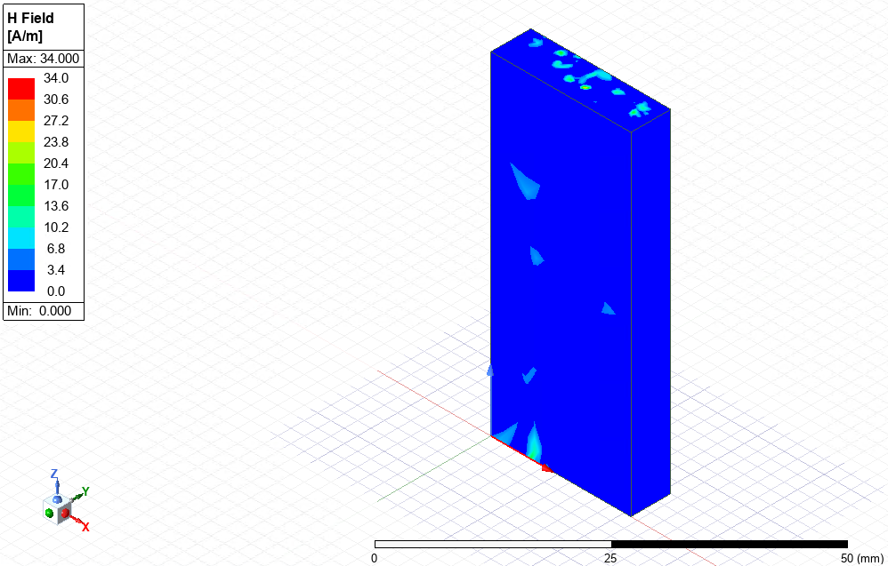  Figure 19: TE₂₀ Magnitude Plot – Vacuum Magnetic Field
TE₃₀ | 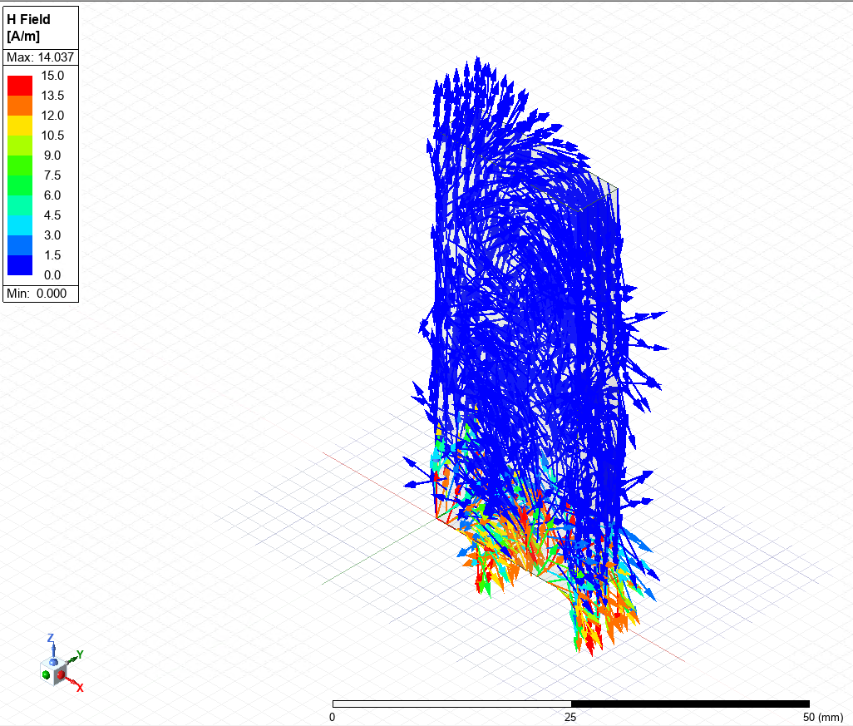  Figure 20: TE₃₀ Vector Plot – Vacuum Magnetic Field | 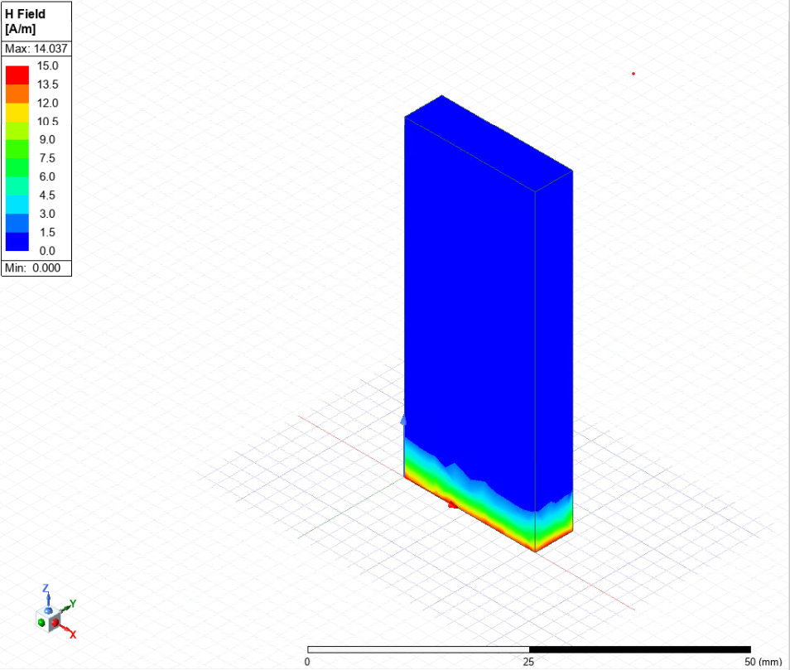  Figure 21: TE₃₀ Magnitude Plot – Vacuum Magnetic Field

Task 1b: Teflon

Method
The same geometry and dimensions were used for this task as described in Table 1. Additionally, the walls of the waveguide were also assigned as PEC, however the dielectric medium consisted of Teflon as opposed to a Vacuum as described in Task 1a. All other aspects of the model setup were identical to those used in Task 1a.

Results
Similarly with Task 1a, the simulation was run and port field displays for Port 1 and Port 2 were gathered to identify values for n and m, which were subsequently used to calculate the cutoff frequency. The port field displays obtained during the simulation are presented in Figure 22 to Figure 25.
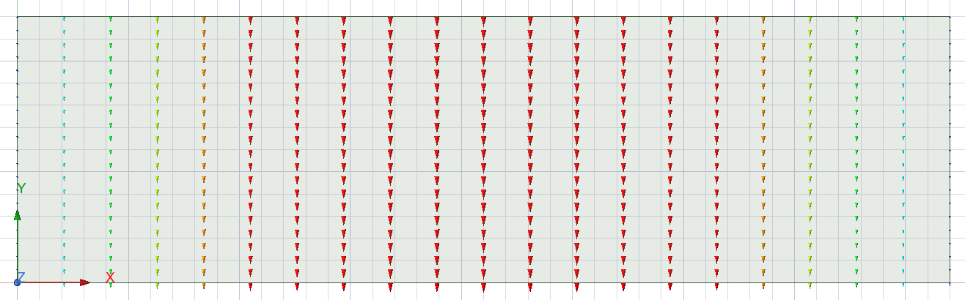
Figure 22: Teflon Port 1 Mode 1, TE₁₀
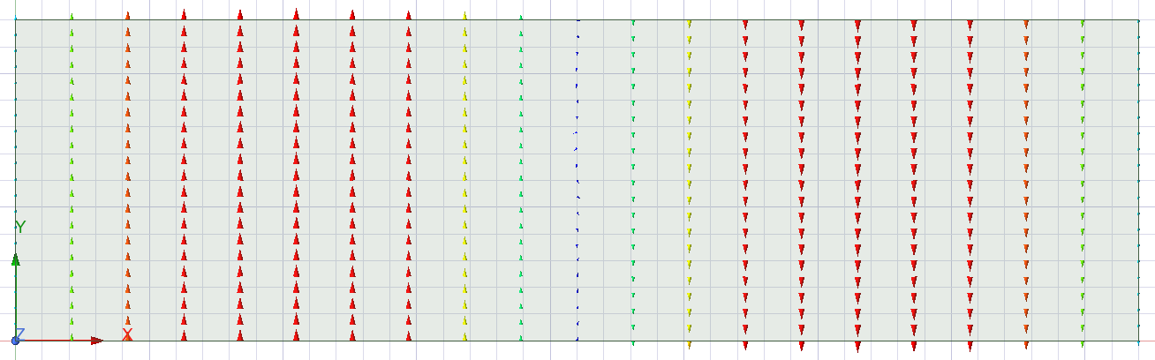
Figure 23: Teflon Port 1 Mode 2, TE₂₀

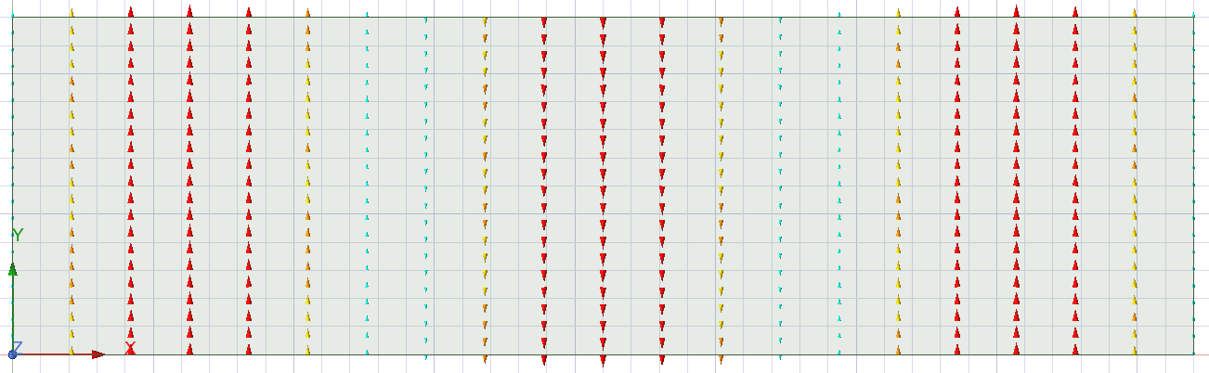
Figure 24: Teflon Port 1 Mode 3, TE₃₀
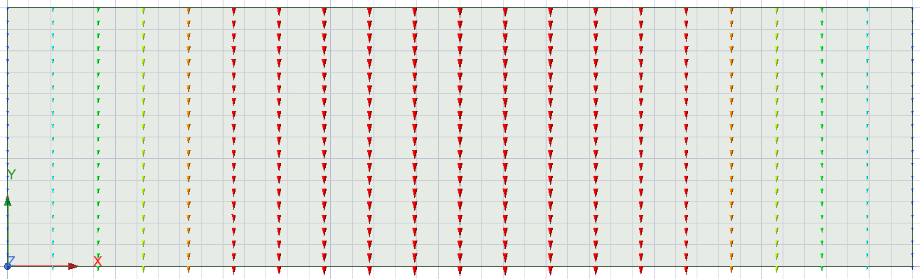
Figure 25: Teflon Port 2 Mode 1, TE₁₀
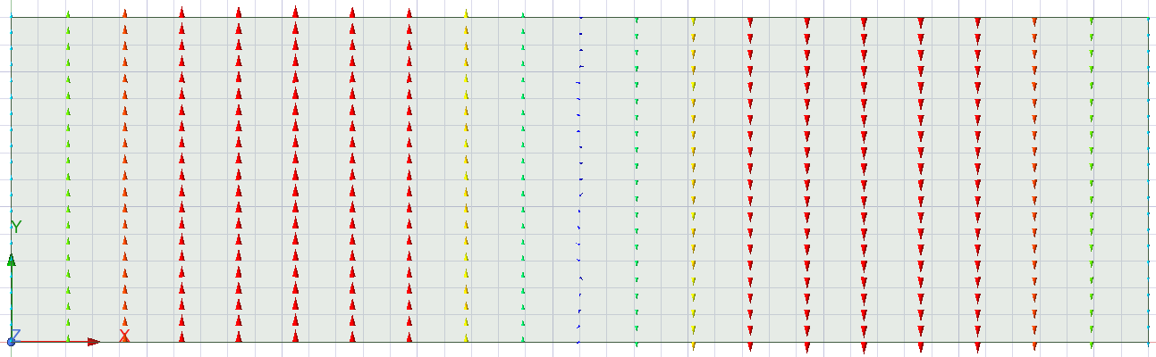
Figure 26: Teflon Port 2 Mode 2, TE₂₀
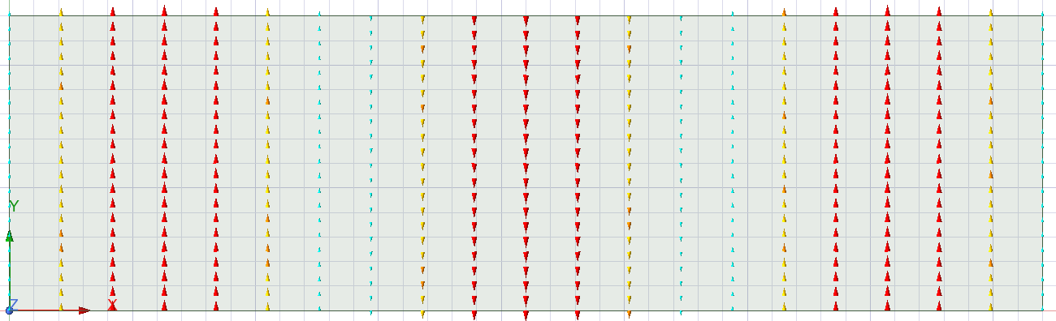
Figure 27: Teflon Port 2 Mode 3, TE₃₀

Calculated Cutoff Frequency (f_{c})
Equation 1 was again used to calculate cutoff frequency, however the value for velocity of light in the medium (c) needed to be calculated using Equation 2.
$$c=\frac{1}{\sqrt{εμ}}$$
Equation 2: Calculating Velocity of Light in Teflon
Where ε = permittivity of Teflon and μ = permeability of Teflon. These values were calculated using Equation 3 and Equation 4.
$$ε=ε_{0}ε_{r}$$
Equation 3: Calculation of Permittivity
Where ε₀ = permittivity of free space (8.854x10⁻¹² F/m) and ε_{r} = relative permittivity of free space (Teflon is 2.1).
$$μ=μ_{0}μ_{r}$$
Equation 4: Calculation of Permeability
Where μ₀ = permeability of free space (4ϖx10⁻⁷ H/m) and μ_{r} = relative permeability of free space (Teflon is 1).
Substituting the values into Equation 2 gives:
$$\begin{aligned}c=\frac{1}{\sqrt{\left(8.854×{10}^{-12}×2.1\right)\left(4π×{10}^{-7}×1\right)}}=206878644.4 \sim 2.07×{10}^{8} m/s\#\left(4\right)\end{aligned}$$
The value determined in (4) and m and n values from Figure 22 to Figure 24 can be substituted into Equation 1 to calculate the cutoff frequency for the Teflon filled waveguide as shown in (5), (6) and (7).
$$\begin{aligned}f_{c} {TE}_{10}=\frac{2.07×{10}^{8}}{2}\sqrt{{\left(\frac{1}{21×{10}^{-3}}\right)}^{2}+{\left(\frac{0}{6×{10}^{-3}}\right)}^{2}}= 4.93 GHz\#\left(5\right)\end{aligned}$$

$$\begin{aligned}f_{c} {TE}_{20}=\frac{2.07×{10}^{8}}{2}\sqrt{{\left(\frac{2}{21×{10}^{-3}}\right)}^{2}+{\left(\frac{0}{6×{10}^{-3}}\right)}^{2}}= 9.86 GHz\#\left(6\right)\end{aligned}$$

$$\begin{aligned}f_{c} {TE}_{30}=\frac{2.07×{10}^{8}}{2}\sqrt{{\left(\frac{3}{21×{10}^{-3}}\right)}^{2}+{\left(\frac{0}{6×{10}^{-3}}\right)}^{2}}=14.79 GHz\#\left(7\right)\end{aligned}$$

Simulated Cutoff Frequency (f_{c})
Figure 28 highlights the cutoff frequencies determined from the numerical simulation for each of the 3 modes, TE₁₀, TE₂₀ and TE₃₀.
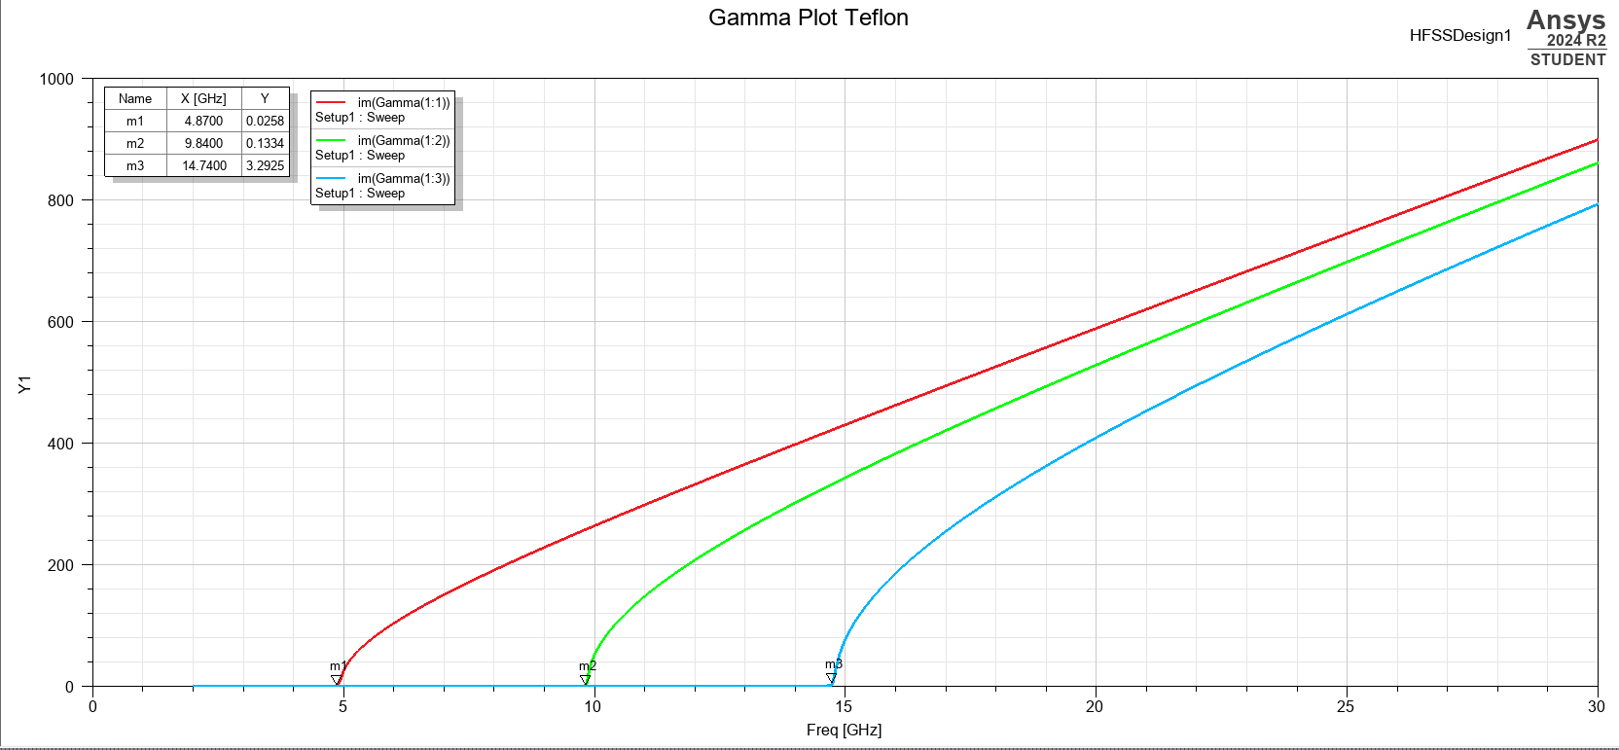
Figure 28: Gamma Plot Highlighting Cutoff Frequency – Teflon
As shown in Figure 28 the cutoff frequencies have been identified as follows: TE₁₀ 4.87 GHz, TE₂₀ 9.84 GHz and TE₃₀ 14.74. Given it had the lowest cutoff frequency, TE₁₀ has been identified as the dominant mode.
Similarly with Task 1a, there is minimal difference between the calculated and respective simulated cutoff frequencies.

Teflon Magnitude and Vector Plots
Table 4 summarises the magnitude and vector plots for the Port 1 modes, TE₁₀, TE₂₀ and TE₃₀ in the electric field.
Table 4: Electric Field Magnitude and Vector Plots for TE₁₀, TE₂₀ and TE₃₀ – Teflon
 | Vector | Magnitude
TE₁₀ | 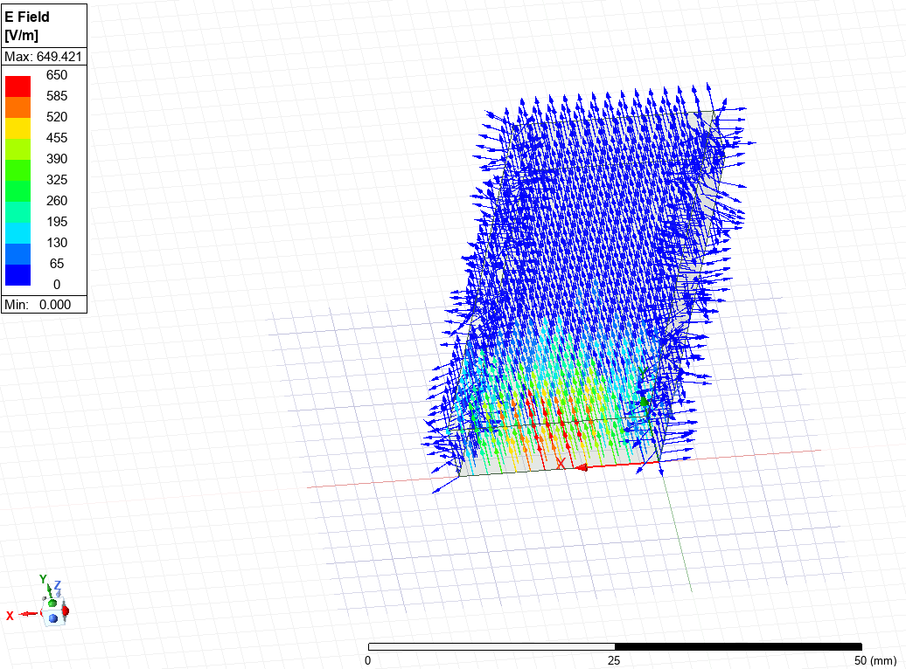  Figure 29: TE₁₀ Vector Plot – Teflon Electric Field | 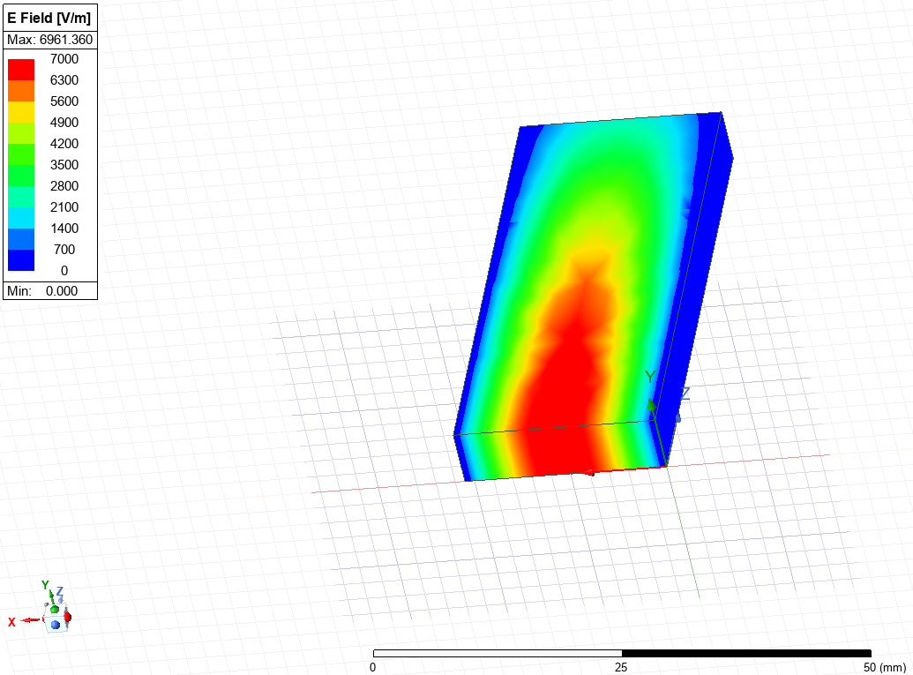  Figure 30: TE₁₀ Magnitude Plot – Teflon Electric Field
TE₂₀ | 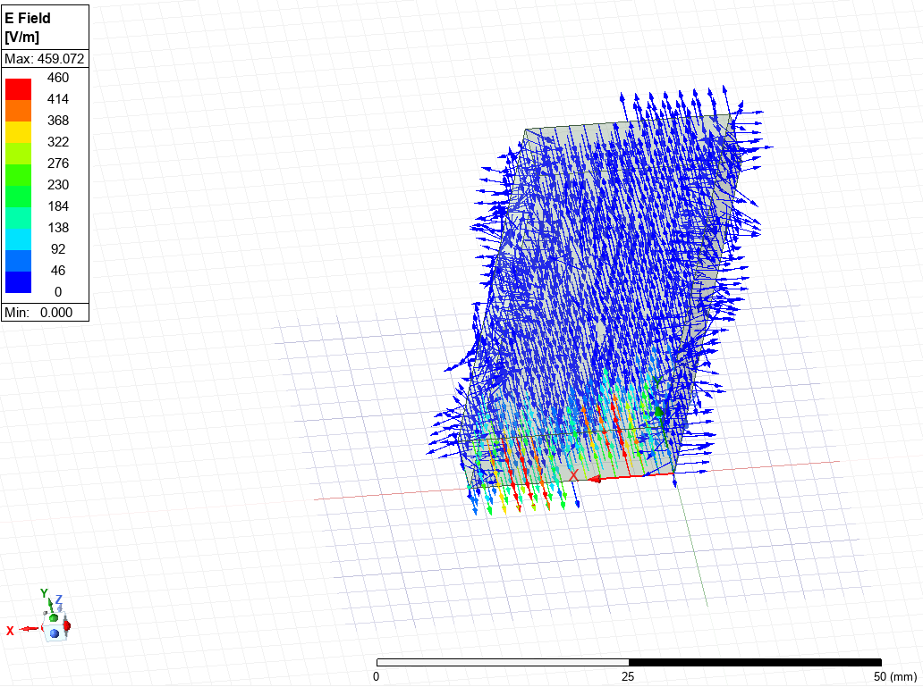  Figure 31: TE₂₀ Vector Plot – Teflon Electric Field | 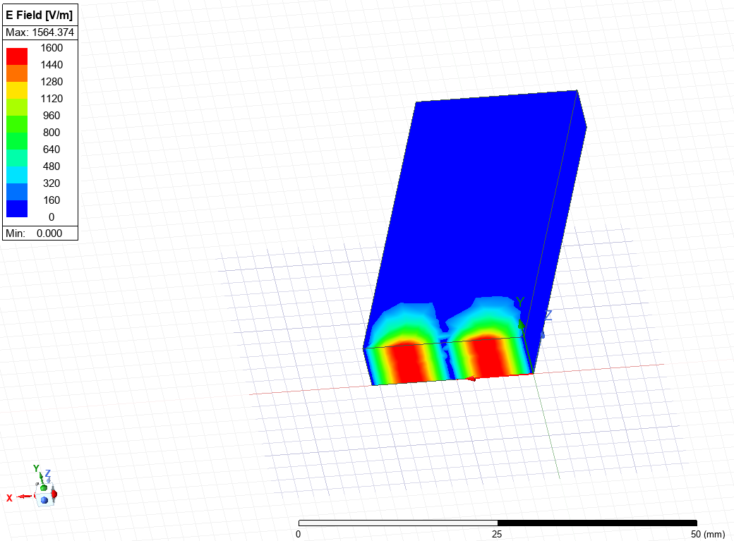  Figure 32: TE₂₀ Magnitude Plot – Teflon Electric Field
TE₃₀ | 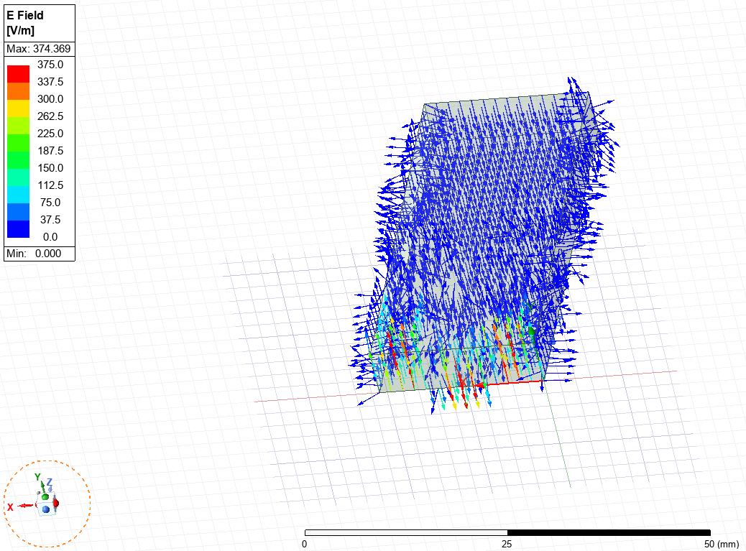  Figure 33: TE₃₀ Vector Plot – Teflon Electric Field | 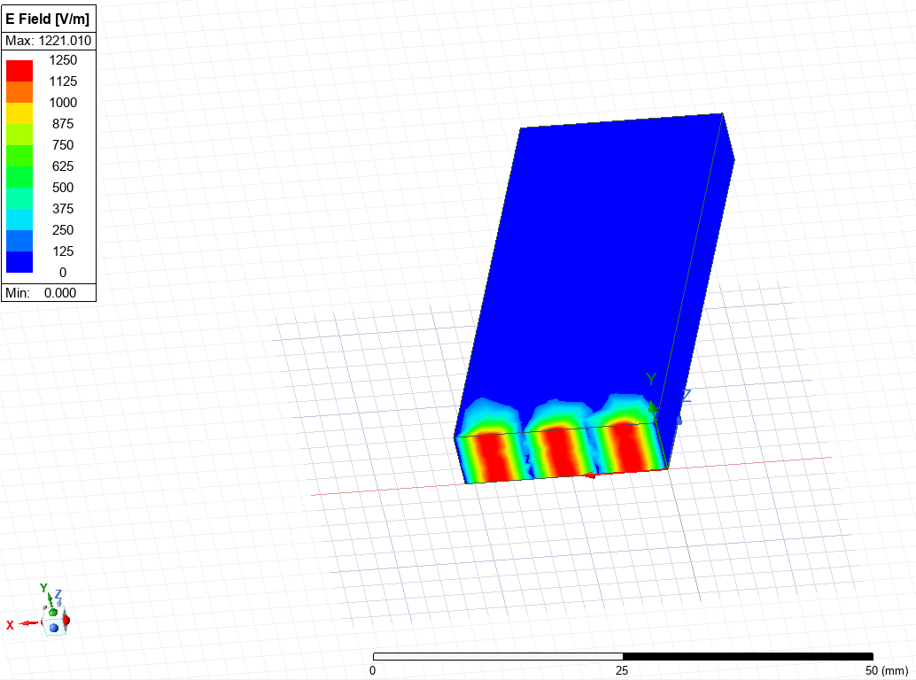  Figure 34: TE₃₀ Magnitude Plot – Teflon Electric Field
Table 5 summarises the magnitude and vector plots for the Port 1 modes, TE₁₀, TE₂₀ and TE₃₀ in the magnetic field.
Table 5: Magnetic Field Magnitude and Vector Plots for TE₁₀, TE₂₀ and TE₃₀ – Teflon
 | Vector | Magnitude
TE₁₀ | 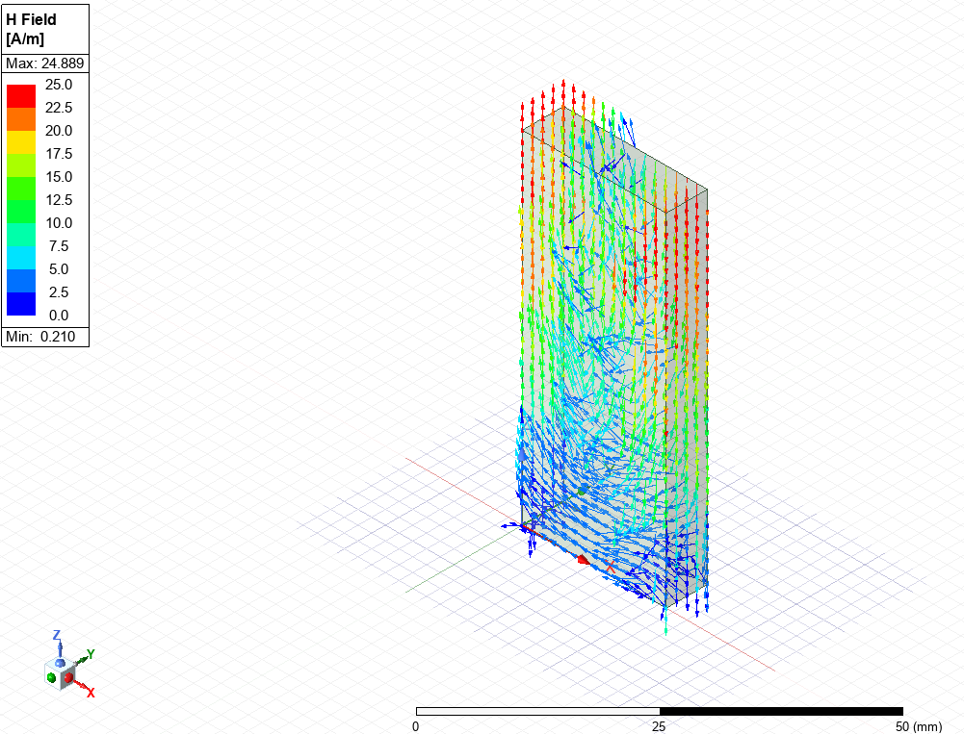  Figure 35: TE₁₀ Vector Plot – Teflon Magnetic Field | 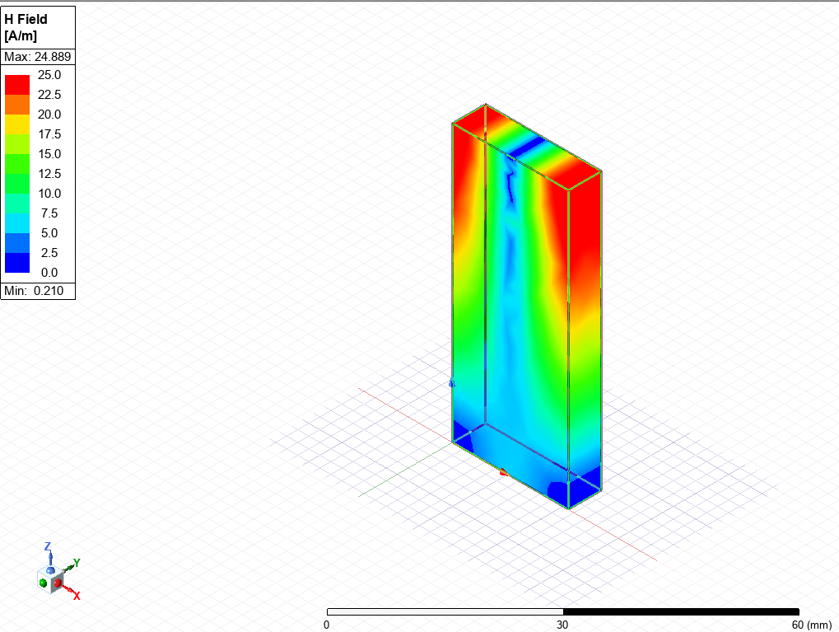  Figure 36: TE₁₀ Magnitude Plot – Teflon Magnetic Field
TE₂₀ | 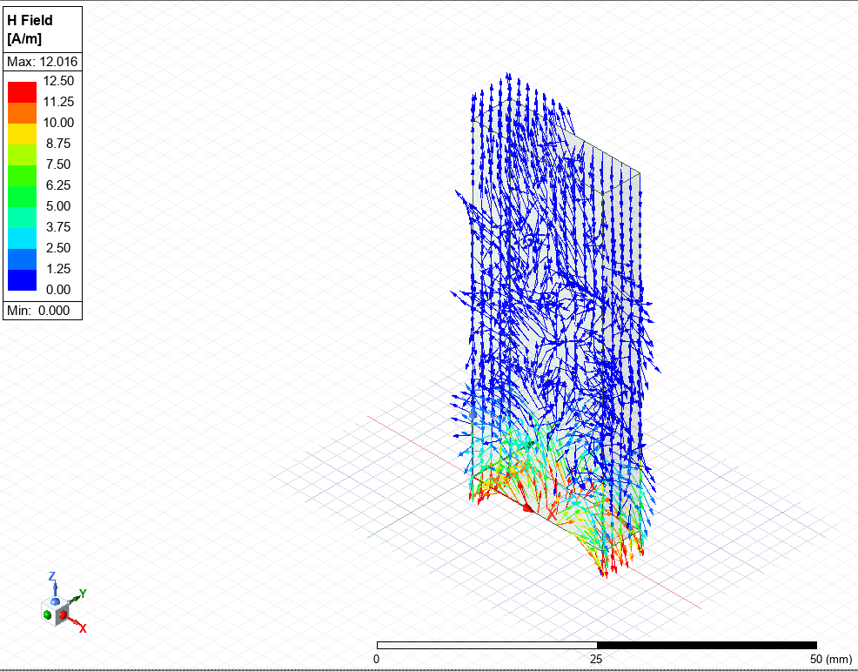  Figure 37: TE₂₀ Vector Plot – Teflon Magnetic Field | 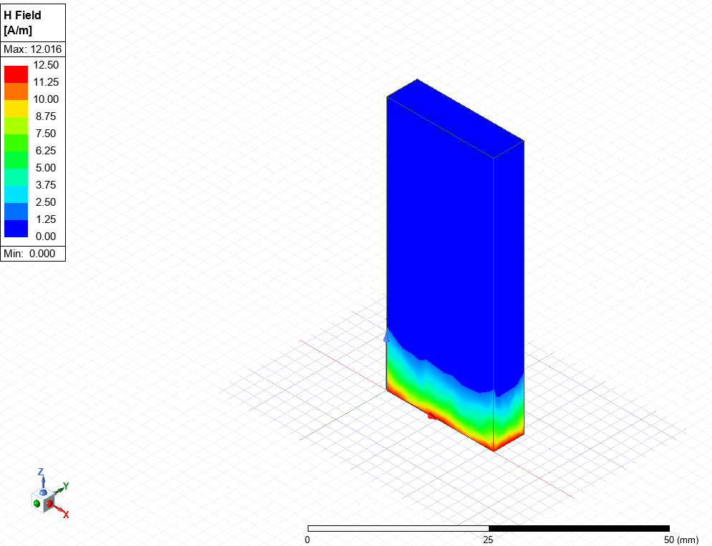  Figure 38: TE₂₀ Magnitude Plot – Teflon Magnetic Field
TE₃₀ | 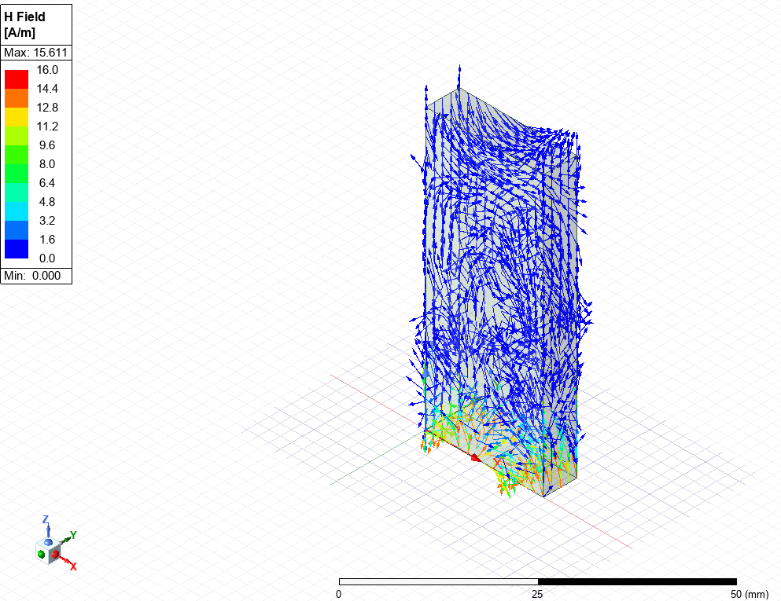  Figure 39: TE₃₀ Vector Plot – Teflon Magnetic Field | 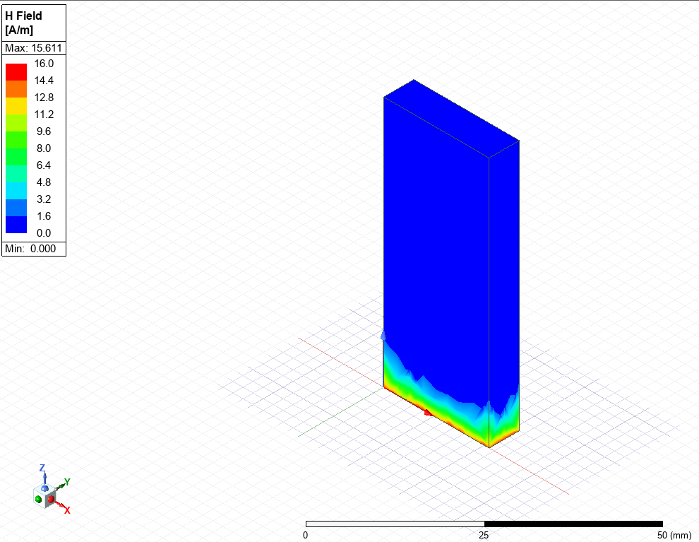  Figure 40: TE₂₀ Magnitude Plot – Teflon Magnetic Field

Comparison of Cutoff Frequencies
Table 6 summarises the cutoff frequencies determined from mathematical calculations and numerical simulations from Task 1a and Task 1b.
Table 6: Summary of Cutoff Frequencies from Task 1a vs Task 1b
Mode | Task 1a |  | Task 1b
Mode | Calculated  (GHz) | Simulation  (GHz) | Calculated  (GHz) | Simulation (GHz)
TE₁₀ | 7.14 | 7.11 | 4.93 | 4.87
TE₂₀ | 14.29 | 14.25 | 9.86 | 9.84
TE₃₀ | 21.43 | 21.39 | 14.79 | 14.74
Consistently between Task 1a and Task 1b, the simulation results in slightly lower frequencies compared to the mathematical calculations, however the difference is marginal and typically less than 1%.
However, there was considerable variation in the cutoff frequencies between Task 1a and Task 1b. The Teflon filled waveguide resulted in much lower frequencies across the three modes when compared with the vacuum filled waveguide.

Task 2: Dipole Antenna
A half wave dipole antenna was created and numerically modelled using Ansys HFSS featuring a 1mm radius and a length 106mm. The length was determined using the theoretical formula shown in Equation 5.
$$L=\frac{λ}{2}$$
Equation 5: Determining Dipole Antenna Length
The wavelength (λ) was determined using the first 3 digits of the authors student ID, 211. The resulting length calculation is shown in (8).
$$\begin{aligned}L=\frac{211}{2}=105.5∼106mm\#\left(8\right)\end{aligned}$$
The material properties assigned to the antenna were again PEC found on the Ansys material library and features a lumped port at the centre of the dipole as shown in Figure 41 and Figure 42.
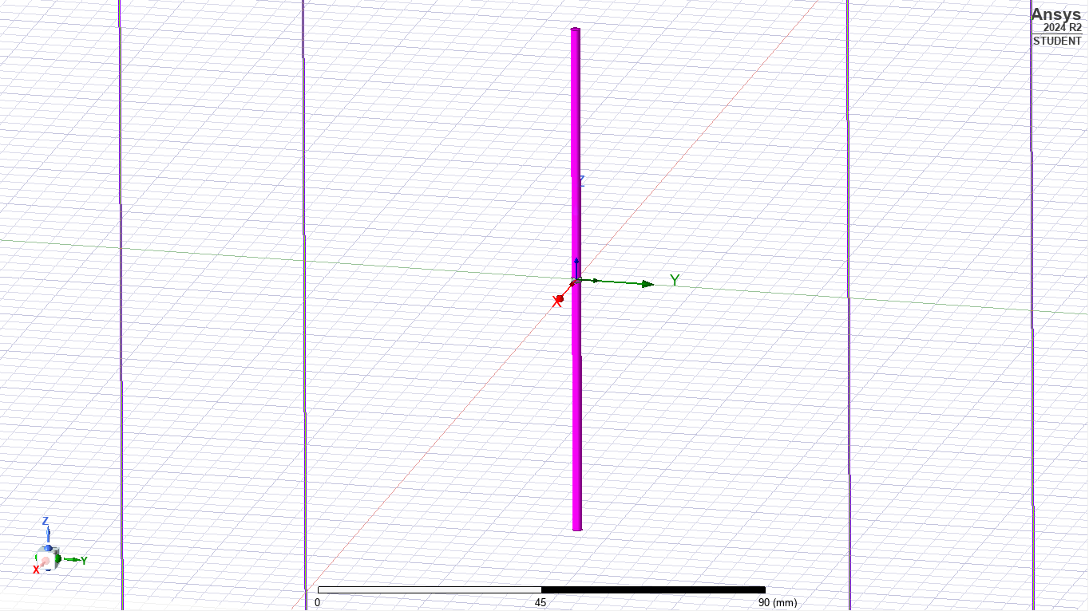
Figure 41: Dipole Antenna Design
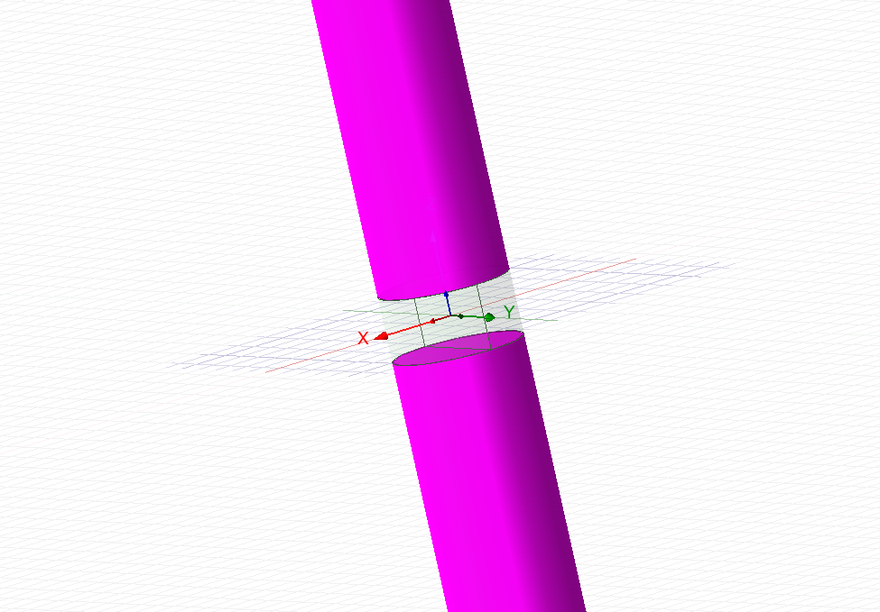
Figure 42: Lumped Port at the Centre of the Dipole Antenna
The lumped port, depicted in Figure 42, acts as the signal input into the simulation allowing the antenna output to be investigated.

Results
The operating frequency of the dipole antenna was calculated using theoretical formula and compared to the simulation derived frequency. Firstly, the formula to mathematically determine the operating frequency is shown in Equation 6.
$$f_{op}=\frac{c}{λ}$$
Equation 6: Operating Frequency
Where c = velocity of light in a vacuum (3 x 10⁸ m/s) and λ = wavelength. The calculated value is shown in (9).
$$\begin{aligned}f_{op}=\frac{3×{10}^{8}m/s}{0.211m}=1.42 GHz\#\left(9\right)\end{aligned}$$
The calculated operating frequency was then compared to the simulated value as shown by the S Parameter plot shown in Figure 43.
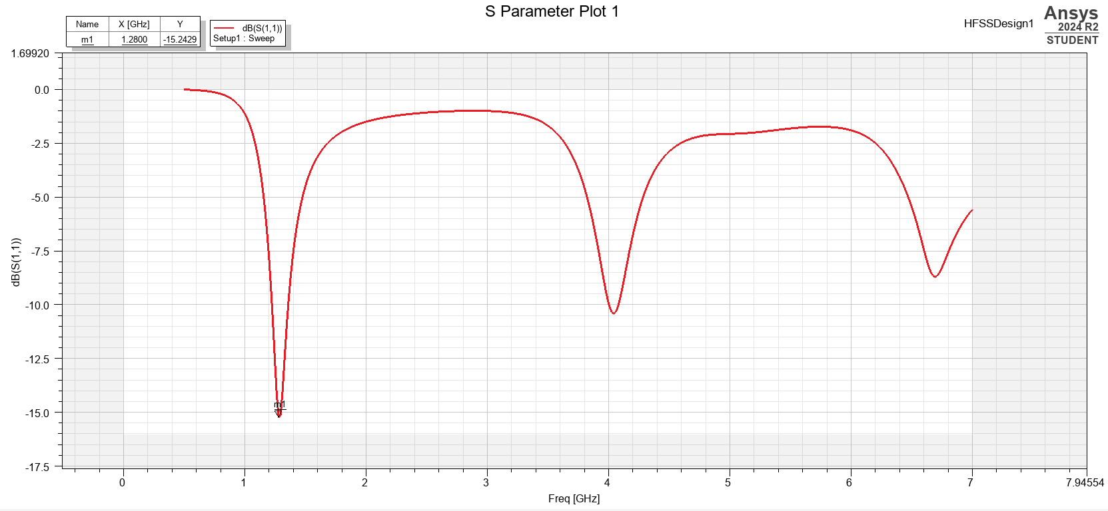
Figure 43: S Parameter Plot from Simulation of Dipole Antenna
Figure 43 depicts three distinct peaks; the peak labelled m1 at 1.28 GHz represents the operating frequency of the antenna. Compared to the value derived in (9), the simulated frequency is considerably lower than the calculated value.
The radiation pattern was also obtained, as shown in Figure 44.
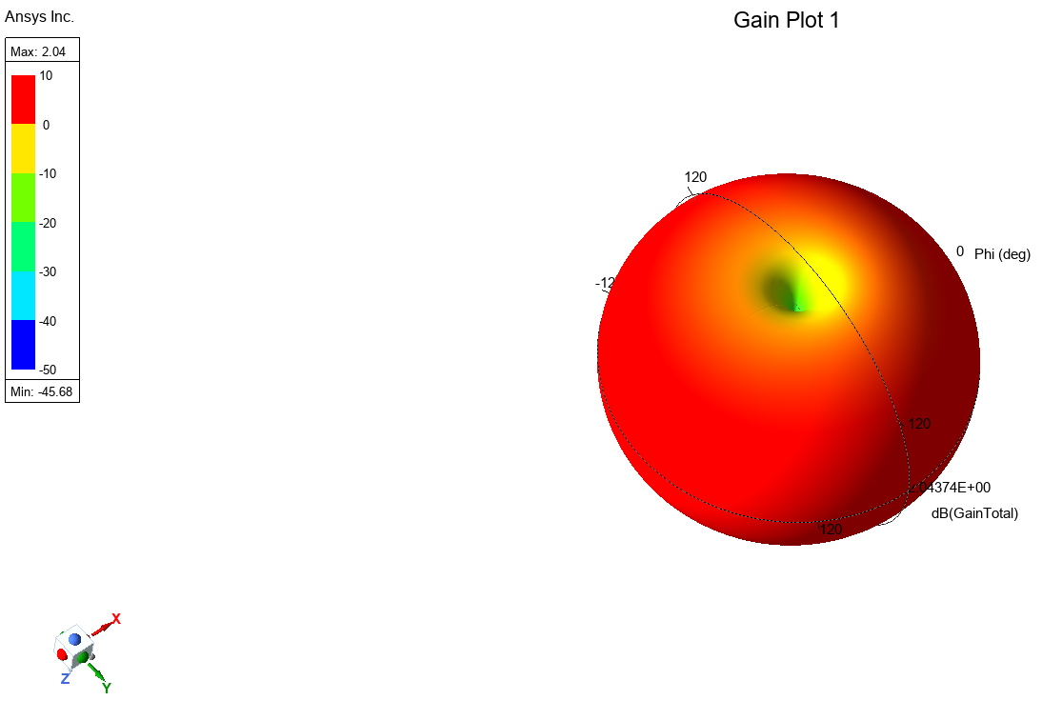
Figure 44: Radiation Pattern of Dipole Antenna
Figure 44 diagrammatically depicts the pattern in which the EM radiation was radiating from each end of the dipole antenna, in an omnidirectional pattern. The central region highlighted green in Figure 44 represents the location of the end of the antenna.

Discussion
There was a significant difference in the calculated and simulated values for cutoff frequency between Task 1a and Task 1b, caused by the difference in the dielectric medium of the waveguide. The materials have different values for relative permittivity (ε_{r}), 2.1 for Teflon vs 1 for Vacuum resulting in the EM wave travelling slower in the Teflon, thereby increasing the wavelength and subsequently resulting in a decrease in frequency. Conversely, the EM wave is able to travel faster in a vacuum (at the speed of light), therefore can support high frequency propagation due to the short wavelength.
The magnitude and vector plots presented in Table 2, Table 3, Table 4 and Table 5 all show evidence that the wave did not successfully propagate through the waveguide, likely due to the height. Propagation through a waveguide is achieved when the EM wave is reflected off the internal surface of the waveguide due to a change in dielectric constant between the cladding and core in a process known as total internal reflectance [7]. For this to take place, the incident EM wave must strike the interface at an angle above the critical angle (θ_{C}) [8]. It is likely that due to the minimal height of the waveguide, the critical angle has not been exceeded, thus preventing the wave from propagating. Furthermore, the typical aspect ratio for rectangular waveguides is 2:1 (W:H), i.e. the width of the waveguide is typically twice the height of the waveguide, whereas the width of the investigated waveguide was 3.5 times the height.
Despite the lack of propagation throughout the entire waveguide, the vector plots shown in Table 2 and Table 4 do provide clear evidence of the transverse electric (TE) propagation, Figure 35 is a good example of this, shown again below.

Direction of wave propagation
Figure 35: TE₁₀ Vector Plot – Teflon Magnetic Field
Figure 35 shows the magnetic field vectors in the waveguide as the wave propagates through. Given the TE₁₀ mode, it is expected that the electric field would be perpendicular (transverse) to the direction of wave propagation (shown by the arrow) and the magnetic field would follow the direction of wave propagation. Figure 35 depicts this clearly, with the vector arrows highlighted red orientated parallel to the direction of wave propagation.

Conversely, Figure 29 shown again below, shows the electric field vectors, which are perpendicular to the direction of wave propagation.
Direction of wave propagation
Figure 29: TE₁₀ Vector Plot – Teflon Electric Field
In Task 2, the most prominent peak at 1.28 GHz has been identified as the operating frequency as shown in Figure 43. This is the point at which the reflection coefficient is lowest, therefore more EM radiation is transmitted and less is reflected. Conversely, the additional peaks on Figure 43 represent a greater proportion of the EM wave getting reflected due to an increase in reflection coefficient. It is vitally important in communication systems that the reflection coefficient is minimal, particularly at interfacing points of the system. The reflection coefficient is dictated by the impedance of individual components of the communication system, such as an antenna and input waveguide, as shown in Equation 7 [9].
$$Γ=\frac{Z-Z_{0}}{Z+Z_{0}}$$
Equation 7: Calculating Reflectance Coefficient
Where Γ = reflection coefficient, Z = load impedance and Z₀ = characteristic impedance of feedline. Therefore, if there is a large disparity in impedance values, the reflection coefficient will be higher, and more EM waves will be reflected resulting in signal loss [10].
Also in Task 2, there was considerable disparity between the simulated operating frequency and theoretical calculated operating frequency, 1.28 GHz vs 1.42 GHz respectively. This is likely due to several factors and assumptions that are ignored during the mathematical calculation, for example a phenomenon known as the fringing effect [11]. This effect typically occurs in capacitors, where the electric field bulges beyond the confinement of the plates, but can also occur in dipole antennas. The propagating electric field extends beyond the antenna length, effectively increasing it. As shown in Equation (9), increasing the length of the antenna will lead to a reduction in operating frequency, which was likely accounted for in the simulation, but ignored during the calculations hence a higher value.

Conclusion
A series of HFSS simulations were run and compared to mathematically derived figures and the following conclusions can be drawn:
- In Task 1a and 1b, three modes were identified as TE₁₀, TE₂₀ and TE₃₀, with TE₁₀ being identified as the dominant mode due to the lowest cutoff frequency.
- There was good agreement between calculated and HFSS simulation values for cutoff frequencies in Task 1a and 1b.
- Teflon dielectric medium used in Task 1b resulted in substantially lower cutoff frequencies compared with vacuum in Task 1a. This was due to the higher permittivity of Teflon compared with vacuum, 2.1 vs 1 respectively.
- The relatively minimal waveguide height (6mm) was likely the reason for the EM wave failing to propagate entirely, potentially due to the incident wave not meeting the required critical angle to allow total internal reflection to take place.
- Although not fully propagating the entire length of the waveguide, the vector and magnitude plots demonstrated TE wave propagation whereby the electric field was perpendicular to the direction of wave propagation.
- In Task 2, the calculated operating frequency was substantially lower than the HFSS simulation values, likely due to the mathematical calculation oversimplifying and ignoring potential effects such as the fringing effect.
- At the operating frequency, the reflectance coefficient is minimal allowing more signal to propagate with less reflected back causing signal loss.

References

[1] | Flann Microwave, Flange to Flange Waveguide Straights, Adaptors and Spacers - Data Sheet, 2024.
[2] | P. H. P. a. R. J. Burkholder, Electromagnetic Radiation, Scattering, and Diffraction, John Wiley & Sons, Inc, 2022.
[3] | A. Webb, “Cavity- and waveguide-resonators in electron paramagnetic resonance, nuclear magnetic resonance, and magnetic resonance imaging,” Progress in Nuclear Magnetic Resonance Spectroscopy, vol. 83, pp. 1-20, 2014.
[4] | M. D. a. S. Kumar, “Performance Analysis and Comparison of various Rectenna based RF Energy Harvesting Systems,” 2017.
[5] | S. Jacob, Electromagnetic Radiation (ACDC5009) Lecture 10, Swansea: UWTSD, 2025.
[6] | J. E. a. M. Nahvi, “Chapter 16 - Waveguides,” in Electromagnetics, McGraw Hill Education, 2014.
[7] | J. O. a. J. Skaar, “Total Internal Reflection and Evanescent Gain,” Optics Express, vol. 19, no. 22, 2011.
[8] | D. H. Staelin, “Optical Waveguides,” Massachusetts Institute of Technology.
[9] | A. J. a. U. Stumper, “National Standards and Standard Measurement Systems for Impedance and Reflection Coefficient,” in Proceeding of the IEEE, 1986.
[10] | Iowa State University, “Reflection and Transmission Coefficients,” [Online]. Available: https://www.nde-ed.org/Physics/Waves/refractionsnells.xhtml. [Accessed 16 April 2025].
[11] | K. L. Smith, The Half-Wave Dipole: Design, 2022.

