Dissertation
Title: “Importance of training and development on the performance of employees. A case study of Kier Group”
Student ID:1919084
Student Name: Stanislav Dragov

Table of contents
Introduction: Chapter One 4
1.1 Background of Study 4
1.2 Problem Statement 4
1.3 Aim 5
1.4 Objectives 5
1.5 Research Questions 5
1.6 The Rationale of Study 5
1.7 Scope of the Research 6
1. 8 Limitation of the paper 6
1.9 Structure of the Dissertation 6
Literature review: Chapter Two 7
2.1 Training and Development 7
2.2 Employee Performance 8
2.3 Impacts of Training and Development in the construction industry 8
2.4 Ways to Training and Development in the construction industry 9
2.5 Impacts of Training and Development on employee performance 10
2.6 Research Gap 11
2,7 Structure of Chapter 12
Research Methodology: Chapter Three 13
3.1 Research Philosophy 13
3.2 Research Approach 13
3.3 Data collection method 14
3.4 Sampling method and sample size 14
3.5 Ethical Considerations 14
3.6 Summary of Chapter 3 15
Data analysis and discussion: Chapter 4 16
4.1 Introduction 16
4.2 Analysis 16
Chapter 5: Conclusion, Limitations and Recommendations 22
5.1 Introduction 22
5.2 Conclusion on each research issue 22
5.3 Conclusion The Problem 22
5.4 Summary of the Findings 23
5.5 Original Contribution to the Research 23
5.6 Limitation of the Research 24
5.7 Recommendations/Areas for Further/future research 24
5.8 Summary of Chapter 24
References 25
Appendix: A 28

Introduction: Chapter One

1.1 Background of the study
Employees are a company's greatest asset, thus investing in their professional development is crucial to its growth and success. This commitment makes sense given organizations’ lengthy hiring processes. After hiring, the employee usually takes charge of their professional development. Studies show that companies that prioritise staff development have higher sales and profitability than those that don't. Training and development boost employee engagement, which boosts productivity, efficiency, and profitability (Akinosho et al 2020). Research also suggests that companies that engage in employee development retain more staff. Training and development help firms attract and retain top talent, improve employee morale and productivity, and boost revenues. Actively engaged and dedicated employees had 41% lower absenteeism and 17% higher outputs. To survive today's global corporate rivalry, corporations have had to develop more effective strategies and procedures. Today's global corporate sector uses training and development successfully. According to the previous paragraph, the construction industry is one of the most precarious and emphasizes training and development. This article argues that training and development improve construction sector performance. The following idea will leverage the British construction company Kier Group for study.

1.2 Problem statement
Training and development are always significant for any organization. As a large organization, the Kier Group in this regard should be concerned with training and development. This study in this regard will discuss different issues relating to the training and development of the company (Bhardwaj, 2019). This study will aim at the relationship between training and development and employee performance for the company indeed. Training and development of the company are not easy things. There are in this regard huge challenges as well. This research will examine also the challenges for the company to implement the training and development. The company on the other hand can't implement the training and development in different ways. This research at the end will also examine the ways to be implemented in training and development.

1.3 Aim
The aim is to examine the significance of training and development on the performance of the Kier Group.

1.4 Objectives
- To investigate the effect of training and development on the performance of Kier Group.
- To examine the challenges that emerged from the training and development programs for the company.
- To determine the ways for implementing training and development for Kier Group.

1.5 Research questions
- What are the effects of training and development on the performance of Kier Group?
- What are the challenges emerged from the training and development programs for the company?
- What are the ways for implementing training and development for Kier Group?

1.6 The Rationale of the Study
This study addresses training and development difficulties and opportunities in the construction sector, notably in the Kier Group. To stay competitive, construction companies must adapt to changing market needs, technological advances, and regulatory restrictions. Training and development help workers improve the information, skills, and attitudes needed to do their jobs well. Despite the construction industry's recognition of training and development, Kier Group's success is unclear (Kier.co.uk, 2022). Thus, this study investigates Kier Group's performance and training and development. It identifies Kier Group's training and development difficulties and offers solutions. The report will help Kier Group and other construction companies enhance their training and development methods. The study will also contribute to organisational growth by showing how training and development affect construction sector performance. The proposed study will examine if training and development boost construction company productivity. If they follow these steps, readers will understand the importance of training and development in commercial companies (Mishra and Alok, 2022). Businesses can also gain new insights into their tactics to enhance them and create new ones to increase workplace training and development. The researcher will also learn valuable research skills and knowledge that will benefit their future studies and careers.

1.7 Scope of the research
The major purpose of this study is to examine and verify the concept and influence of "training and development on the performance of construction companies. The scope of the study is limited to a specific company (Tamminen and Poucher, 2020). The scope of this investigation will be limited by the constraints of time and money, thus certain parts of the building industry will be left out. Therefore, a major UK construction corporation known as Kier Group will be the focus of the research. In addition, primary research using mixed data approaches will be used to conduct the study.

1. 8 Limitation of the paper
Alongside different advantages to conducting the research, there are on the other hand some limitations of the paper as well. The major limitations of this paper were the lack of cooperation from the respondents (Whysall et al 2019). Many of the questions of the research are not answered by the respondents. This impacts the outcomes of the paper indeed. The sample of the study can be bigger for the more viable answer. But the sample is shorter which is also a limitation for this paper indeed.

1.9 Structure of the Dissertation
The dissertation consists of 5 different chapters from the introduction chapter to the conclusion chapter. All of the chapters will be concerned with discussing the issues related to the chapters with an introduction. The first chapter's name is an introduction with background information. The Aim, objectives, questions, rationale of the research and so on are discussed in this chapter. The second chapter on the other hand is concerned with the literature review of this paper. The theoretical background is discussed with different previous papers and the findings related to this paper.

Literature review: Chapter Two

2.1 Training and development
Organizational performance can be increased by investing in training and development activities that boost the skills and qualities of people, organizations, and teams. They all in the end make the organization (Won et al 2021). Training is often connected with more quick changes in performance within an organization brought about by systematic instruction, while development is frequently associated with the advancement of more long-term organizational and people goals. Adult education and applied psychology are two fields that have traditionally emphasized learning and growth. However, in the last two decades, HRM, talent management, HRD, educational design, human elements, and knowledge management have all come to more closely correlate with training and development.
Won et al (2021) extensively researched training methods and concepts. A section on instruction was included in the first manual on instruction for adults, which came out in 1934. Research in applied psychology, particularly into the effectiveness of training programs in military contexts, was heavily influenced by the Second World War. It wasn't until the 1960s and 1970s that the field began formulating theories and doing research based on theories since the discipline had previously been dependent on research based on trial and error treatments. During this period, innovative pedagogical strategies including case studies, computer- and TV-based learning, and role-playing simulations were also created. Additionally, cross-cultural training, an emphasis on individual employee development, and the incorporation of new research on organization development into training program creation were added to the remit of training and development (Rama and Shaik, 2012). The 1980s were a watershed decade in terms of moving the focus of training programs from how employees were receiving and using them to how data was being collected for evaluation purposes, particularly in the context of management training programs. This decade saw the first time studies were conducted that demonstrated how important it is to foster a training and development-friendly culture inside an organization. The United Kingdom was the site of this investigation. Research on concepts like cross-training and team training increased at the turn of the century. The goal of cross-training is to familiarize employees with the duties of their coworkers.

2.2 Employee performance
Many companies conduct employee performance reviews quarterly or annually to pinpoint problem areas and boost strengths while rewarding efforts that are already reaching or exceeding targets. Performance is important for the company’s success. It has a positive effect on productivity, profits, and staff morale (Topno, 2012). By frequently analyzing employee performance, companies may discover areas of improvement, provide employees with support and training, and guarantee that everyone is working towards the same goals Employees will enjoy a user interface that is intuitive and easy to use since this will encourage participation in and completion of training programs. Training's dynamic and engaging multimedia content includes videos and interactive quizzes to keep employees interested and engaged. Employees' ability to remember relevant information is improved as a result. The training also has a gamification option (Kraiger, 2014). This function aids businesses in maintaining engaged and motivated staff by rewarding them for their participation with trophies, points, and badges. The businesses should complete enough training courses, and their employees should be able to rank high enough on the team or company leaderboards.

2.3 Impacts of Training and Development in the construction industry
Organizations in this dynamic business environment should give their employees different opportunities like training and development programs to learn new things and come up with greater performance for them and ultimately for the company as well (Haugen et al., 2019). Sadly, training is often ignored and pushed to the side since it is not perceived as an obvious "money-making initiative." Many issues arise as a consequence for commercial enterprises. However, at Esteem, it is strongly believed that development and training programs for both employees and employers are win-win for all parties involved. The construction industry's total productivity is still being negatively impacted by the shortage of accessible people with the appropriate competencies. According to recent CITB data, Scotland's construction sector would require an additional 247,300 workers by 2018. On the other side, there are about 241,000 working Scots (Maity, 2019). A shortfall of 3% would need an additional 6,400 workers. Construction firms must thus work harder to increase the size of the available labour force by actively seeking out and retaining qualified individuals. Development and training initiatives may help achieve this goal, leading to more qualified workers and higher morale in the construction business. This is so because individuals will have a better grasp of the task at hand and everything that goes into it. There will be fewer incidents of injury and fewer mistakes on the work site, both of which halt progress on a project. The organization's turnover rate will rise as a result of the improved performance.
If the employees are provided with different training and development programs, then they get attached to the company. That means it enhances the commitment of the employees towards the organization indeed. If employees at your organization see prospects for professional growth, they will be less likely to go elsewhere for employment. Long-term cost savings may be realized via employee retention, and the familiarity of the personnel with their clients can lead to better collaboration and relationships (Chaudhary and Bhaskar, 2019). A graduate of a program will experience a sense of accomplishment and satisfaction at a job well done. Training programs for the construction industry often include preparation for the CSCS examination. Documentation showing the candidate has the knowledge and abilities to do the work required of them in the construction sector.

2.4 Ways to Training and Development in the construction industry
Akinosho et al. (2020) say training and development are crucial to construction success. Construction workers' training and development is overseen by the Human Resource Management department. Training and professional development help keep construction workers up to date on industry developments and safety regulations. Safety awareness, specialised sector certifications, and job-specific skills can be included in training programmes, according to the author. Growth programmes can include workshops, coaching, or just more information and certifications. According to Akinosho et al.'s 2020 research, the above aspects are crucial to implementing training and development in construction firms. The author also suggests giving staff cash or educational aid. Training and development programmes for construction employees can reduce worker injuries, raise production, and boost morale. Given the tools, construction companies may create a culture of continual learning that benefits their workers.
More and more companies in the construction and manufacturing sectors are either developing in-house programmers to improve the skills of employees or contracting with external training providers to do so, with the latter group using the former's facilities. To save money on things like lodging, transportation, meals, and so on that are often required for external training, some of these businesses go so far as to get accredited so that they can conduct skills training for their workforce (Tracey and Swart, 2020). In-house training benefits both the employer and the employee because neither needs to take time away from their current responsibilities to travel to and from training, and both may return to their jobs immediately thereafter. In-house training not only reduces expenses but also saves valuable time.
When a worker receives training while on the job, they can focus on their studies without leaving the setting of their current position. The widespread use of RPL, Learner ship, Internship, and Apprenticeship programmers, among others, demonstrates that this strategy is being used by the vast majority of workers. Employees benefit from this type of training since they are exposed to both the theory and practice of the task they will eventually be doing.

2.5 Impacts of Training and Development on employee performance
In diverse organizations, some staff must do the company's daily operations and maintenance. Staff training and development is necessary to achieve this. Increased training and development will boost employee performance (Seidle et al 2016). It lays the groundwork for success. Any organization, whether it has four or five employees or hundreds, needs it. Both sorts of firms confront similar issues. The most essential thing to remember is that every organization must spend on training and growth to avoid future deception.
It is remembered that excellent work requires training. The workplace won't have any troubles if the person has been trained and knows the duty. Further, it will affect the business operations as a whole, including both internal and external activity. Based on a review of contemporary and older training literature, needs analysis must precede training to identify topics that can be taught and those that cannot. This study will concentrate on how training and development affect employee performance.
Maity (2019):145 states that employee development is the most crucial part of human capital generation, which determines long-term employee productivity. The training was addressed before. Development prepares a person for future occupations, whereas training improves current performance. Development courses help management maintain a workforce that can replace departing or relocated employees. It also allows employees to adapt to new technologies and ensures enough human resources for new economic areas.
Training and development activities that promote learning may increase school personnel performance. Staff workers need adequate training to meet performance objectives. According to Seidle et al., (2016), training improved employee performance by increasing knowledge, skills, and abilities to execute job-related activities to achieve more corporate goals and affect organisation performance. Training improves worker performance, according to Chaudhary and Bhaskar, (2019). They say effective training courses may change employee capabilities. Training and development improves employees' performance and helps them gain the information, skills, and attitude needed for future positions. Training and development prepare workers for such occupations. Training helps employees perform their duties, achieve the school's objectives, and stay competitive.
Haugen et al., (2019) found that training courses are essential for addressing employee performance issues. Closing the performance gap is an effective way to boost employee performance. Thus, human resource management requires training and growth. Training and development improves employee knowledge, skills, and competence, which boosts performance. It is well known that the institution cannot improve staff performance without using its training and development initiatives. This can only happen if the institution meets its workers' needs so they can work efficiently. To reach their goals, schools must consider which training intervention would help them resolve challenges and improve staff performance.

2.6 Research gap
According to the discussion of the chapter, some of the research gaps are identified to be examined in this paper. There is different research on this topic, but the construction industry is not examined in any of the previous papers. This paper will discuss the training and development of the Kier group. The challenges and the ways of the training and development for the construction company will also be discussed in detail.

2,7 Structure of the chapter
The literature review chapter is one of the most critical chapters for any research. This makes a founding and an understanding regarding the previous research and the related theory in this section as well. This paper is designed accordingly. In the very first phase, the theoretical background is presented. Then the previous research findings are discussed in the following sections.

Research Methodology: Chapter Three

3.1 Research Philosophy
Positivists believe that reality is immutable and can be seen and described objectively, hence one must not influence the phenomena being researched. They believe phenomena should be isolated and observations repeated (Won et al 2021). This sometimes involves changing reality with a single independent variable to uncover regularities in specific social environment components and develop relationships between them. Predictions may be made from prior observations and relationships. Positivism has a rich history. Our culture has become so ingrained that any knowledge claims not based on positivist thinking are instantly discarded as scientific and invalid. Interpretivists believe that before intervening, one must first understand reality. The interpretive ideology requires that scientists influence the things they study. Scientists cannot escape the natural environment in which they operate. They accept that there are various ways to interpret reality, but they assert that those interpretations are part of the scientific information they seek (Salas et al., 2012). Interpretivism has a lengthy and distinguished history, comparable to positivism. Positivism, interpretivism, pragmatism, and realism allow the researcher to conduct the study using scientific evidence and an approach where variables cannot be manipulated or controlled. Positivism, interpretivism, pragmatism, and realism are research methods. Positivism The researcher will employ positivism to get more accurate and valid data on the Kier Group's training and development value.

3.2 Research approach
Hypotheses are the main difference between deductive and inductive approaches. Deductive reasoning tests the assumptions (or theories/hypotheses) at hand, whereas inductive reasoning generates new ideas and generalizations. Abductive research starts with "surprising facts" or "puzzles," and the rest of the procedure is spent clarifying them. It describes a study data collection and interpretation approach (Topno, 2012). It can be inductive or deductive, allowing the researcher to establish a new thesis from specific assumptions to general conclusions or test the current thesis from general assumptions to specific conclusions. Both categories have subcategories. This inductive research examines the "significance of training and development in the performance of Kier Group employees".

3.3 Data collection method
"Data collection" in statistics is gathering all necessary data to solve a problem. It simplifies problem analysis. Data collection allows a person to answer the relevant question. Most firms and organizations use data from different data collection methods to predict future trends and probabilities. Data arrangement follows data collecting. "Data" refers to sources utilized in data collection (Kraiger, 2012). Data will be organized by primary and secondary data. Data collection is essential for any research or commercial activity since it reveals many important company details, including performance. Thus, each stream relies on data collection. It organises data acquisition into two main categories. Primary: surveys, interviews, and focus groups allow the researcher to get new data. secondary: databases may be used to retrieve pre-existing data from public sources. The researcher will use a major method to accomplish the investigation. Interviews and surveys will gather quantitative and qualitative data for analysis. To complete the investigation, the author will use mixed data.

3.4 Sampling Method and sample size
Researchers may infer conclusions about a population from a sample. This saves time and resources. Statistics and research use sampling. It allows researchers to sample a representative fraction of the population and derive accurate and trustworthy findings about the population (Haugen et al., 2019). It outlines the method for finding and recruiting study participants and falls into one of two groups. Probability has four subgroups: "simple random, cluster, stratified, and systematic" sampling. The researcher may randomly enrol a population. Non-probability: "purposive, snowball, voluntary, and quota" sampling allows the researcher to find and enrol people subjectively. The researcher will utilize a simple random sample for the survey and purposive selection for the interview, selecting 3 Kier Group managers and twenty employees. In the case of the survey, 50 employees were selected from the company.

3.5 Ethical considerations
Ethical considerations should guide your research design and methods. These include anonymous involvement, informed consent, risk for damage, confidentiality, and sharing results. Many criteria make ethical research important. Standards help researchers gather information, find the truth, and avoid errors (Rabie et al., 2016). For instance, rules against fabricating, manipulating, or misrepresenting research results help disseminate the truth and reduce errors. The inquiry will focus on protecting people and the corporation's data under the "Data Protection Act 2016". The survey and interview questionnaires will not include discriminatory, abusive, or sensitive content, and the information will be kept secret.

3.6 Summary of Chapter 3
Chapter three is concerned with the methodology of the research. That means how the data will be collected, how they will be analyzed and the ethical considerations to be followed are also discussed in this chapter. As the research philosophy, the positivism philosophy will be adopted to do the paper (Boadu et al., 2014). As the research approaches, the inductive research will be used for this paper. The simple random sampling method will be used for the paper when the primary and secondary and on the other and the quantitative and qualitative data will be used for the paper as well.

Data analysis and discussion: Chapter 4

4.1 Introduction
In this section, the data analysis will be examined alongside the discussion of the findings from the employees of the company.

4.2 Analysis
- Participation in the training and development programs
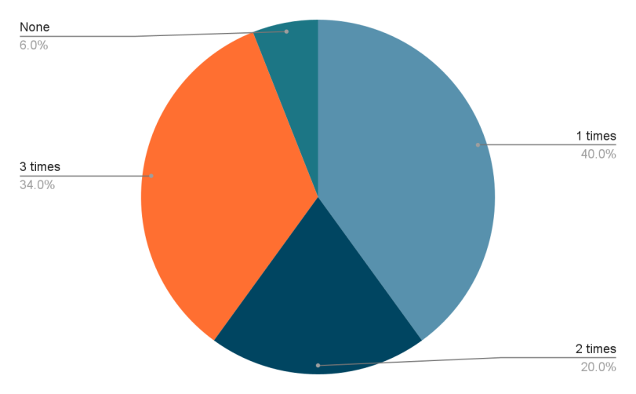
Figure: Participation in the training and development programs
According to the above analysis of the employees, it is shown that 20 employees mean 40% of the respondents take part in the training and development programs for 1 time. 10 employees took part 2 times and 17 people took part 3 times and the rest of the 3 employees didn't take part in any training and development programs.
- Effectiveness of training and development for the Kier group in improving employee performance.
Training and development courses for workers may aid people in staying ahead of advances in the company, such as those relating to ethics, safety, or quality standards, which may influence the workplace. They may also teach employees how to use contemporary technologies and processes and warn them about hackers. Employers in the Kier group profit when employees adopt new tools and practices to improve their daily job. Since most workers worked on-site, the company and its employees have struggled to find and use new tools and resources for this new work environment. This is because the bulk of workers formerly worked on-site. Training and development on these new practices may ease the transition. New employees get training during onboarding. It is helpful to revisit such training periodically. When employees understand their roles and the company, the lessons are easier to take. A second advantage of these adjustments is the establishment of new possibilities for the promotion of diversity, equality, and inclusion (DEI) education. The company needs annual anti-harassment and legal compliance training. Training and development courses may help employees improve their performance assessment strengths and weaknesses. Training and development initiatives will help employees improve in these areas. Training and development initiatives will help employees discover areas where they need more information and support. Employee development programmes will assist develop "soft skills" needed to adapt to workplace and social changes. Resiliency, emotional intelligence, and agility training may boost staff productivity and camaraderie. Training and development courses help employees understand processes and goals, making them better at working alone or in teams. Since they don't need to experiment, well-versed employees will find ways to do work faster. Training and development allow employers of the company to focus on particular skills and knowledge. Training and development initiatives will enhance productivity by teaching employees new skills or updating existing one Training and development courses allow one to upgrade their skills as technology evolves. These programmes decrease supervision and encourage innovation and risk-taking to improve processes Training and development initiatives boost employees' self-confidence and supervisors' knowledge and abilities. Self-confidence fosters professional enthusiasm and achievement responsibilities Training and development initiatives help employees understand an organization's expectations. This creates a performance-focused culture where workers set achievable goals based on clear organisational standards.

- Changes in the performance of the company for the training and development
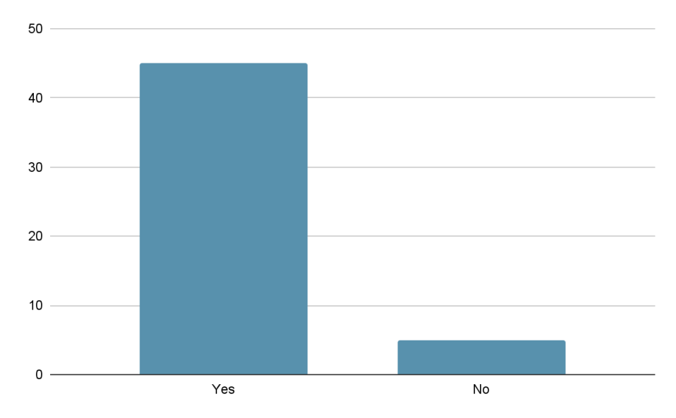
Figure: Perception of the employees regarding the performance changes of the employees
According to the above figure from the respondents, it is shown that 45 employees think that the training and development programs of the employees support the business to come up with greater employee performance and the rest of the employees don't positive with this answer.
- Opportunities for the company to increase the skills and knowledge of the employees through the training and development program.
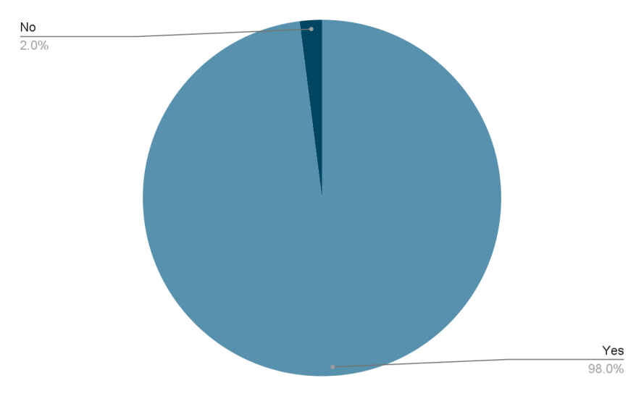
49 respondents among the 50 think that there are opportunities for the company to increase the skills and knowledge of the employees through the training and development programs. ! employees don't think positively regarding this issue.
- Challenges faced by Kier Group to implement the training and development programs.
Kier Group prioritizes onboarding after hiring new employees. To get new hires participating fast, it needs to educate them on its business software. Instead, it overloads its personnel with too much information on the first day of training and expects them to retain it. Training courses help with new software, performance concerns, and feature modifications. To succeed, firms need an employee training template. Kier Group also spends a lot on training annually. Disengaged employees may disseminate negativity and perform poorly. To keep people motivated and inspire confidence that they are valuable to the company, they need all the right tools. Training participants occasionally raise unrelated topics and request answers. A significant number of them probably attended the course to receive answers to difficult queries rather than learn anything. After making this error many times, Kier Group have learnt to avoid it If the question is simple. If it is relevant to the current topic and will be discussed later in the presentation, it will write it on the flip chart and bring it up later. The most challenging situation is when the subject matter is not part of its training programme yet nonetheless causes worry or discomfort. Training sessions may cover fascinating topics. It might be hard to decide whether to stop further arguments and when to go forward. Addressing the problem will be easier if the group has received the agenda and the time allotted for each item. Trainers may find this little element challenging. When group members are not paying attention, the room splits, distracting the trainer and the group. If Kier Group doesn't detect side chats, they may take over the subject and make some group members feel excluded from the "illegal" discourse.

- Employees' career development and the training and development of the employees.
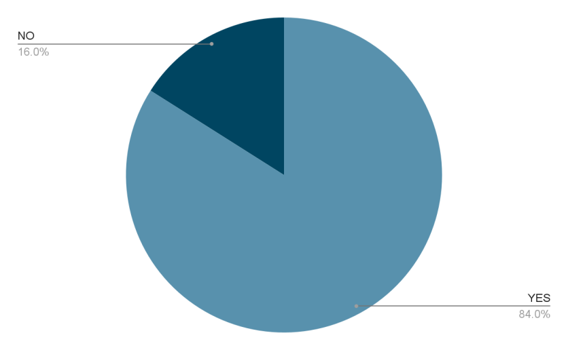
Figure: Employees' career development and the training and development of the employees
According to the analysis of the data, it is shown that 42 or 84% of the employees are positive regarding their career changes through the training and development programs. And 8 of the employees do not agree with the question.
- Satisfaction of the employee through the training and development programs of the company.
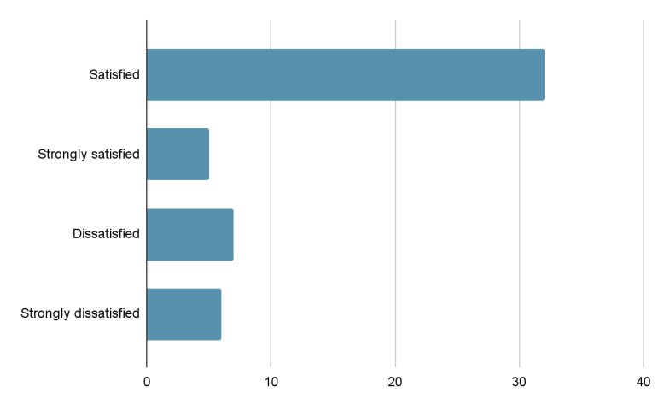
Figure: satisfaction level of the employees
32 of the total respondents are satisfied with the training and development programs of the company. 5 of them are strongly satisfied. And the dissatisfied and strongly dissatisfied employees are respectively 7 and 6.
4.3 Summary of the Chapter
In this chapter, the analysis and discussions are presented through different charts and diagrams. For the open-ended question, the thematic style is also followed to discuss the issues for the research as well.

Chapter 5: Conclusion, Limitations and Recommendations

5.1 Introduction
This part of this paper is concerned with the key findings, the conclusion of the research and the recommendation for the company or further research will be discussed as well. And in the end, the limitations of the research also will be discussed.

5.2 Conclusion on each research issue
This chapter introduces the importance of personnel training and development for business growth. The Kier Group, a UK construction company, is its main emphasis. The issue statement emphasizes the challenges and training and development's relevance to the firm's performance (Habib et al., 2015). This study examines the Kier Group's training and development plans and corporate performance. Review the study's goals, questions, and reasons. This topic highlights construction training and development needs. Discussing the research's breadth and restrictions. The chapter concludes with an overview of the key points and research objectives.

5.3 Conclusion The problem
This study examined how training and development affect Kier Group, a major UK construction company. This research examined Kier Group's performance, issues caused by training and development programmes, and ways to implement training and development (Chaudhary and Bhaskar, 2016). The research's goals were to identify Kier Group's training and development difficulties and provide solutions, as well as show how training and development affect construction sector performance. The study focused on Kier Group, a construction company, and used a range of data-gathering techniques. The small sample size and uncooperative responders tainted the study. This study may help Kier Group and other construction companies improve their training and development methods, which would benefit the construction industry as a whole.

5.4 Summary of the Findings
"Data Analysis and Discussion" discusses the study's findings on employee participation in training and development programmes, their effectiveness in improving employee performance, the company's opportunities to improve employee skills and knowledge, Kier Group's challenges in implementing these programmes, and their impact on employee career development. The survey found that most professionals attend training and development courses at least once a year. These courses improve worker performance because most respondents think they improve company performance (Haugen et al 2019). These initiatives may also help the company develop employees' skills and knowledge. The report also shows the company's limitations in executing these projects. Recruits must be overloaded with knowledge, disengaged staff may disseminate negativity, and training sessions may cover irrelevant subjects. Despite these challenges, most employees say these programmes have enhanced their careers and are satisfied with the firm's training and development possibilities. The study found that training and development courses may boost employee performance and help people grow professionally. To ensure personnel can adapt to the changing workplace, Kier Group should continue to engage in this training. Despite obstacles, many programmes are implemented.

5.5 Original Contribution to the Research
This study's in-depth examination of the Kier Group's training and development programmes and their impact on employee performance and career advancement is unique and essential. This study examines the company's training and development programmes and how successfully they improve employees' skills and knowledge (Kier.co.uk, 2022). It also discusses the Kier Group's challenges and proposes ways to strengthen these initiatives. The research examines employee perceptions of training and development programmes and their effects on performance and career progression. It also examines employees' satisfaction with the company's educational and professional progression options. This study adds to the research on employee training and development and gives practical suggestions for enhancing training courses. The report provides a full understanding of Kier Group training and development programmes and their effects on employee performance and career development. Human resource management benefits from this study.

5.6 Limitations of the Research
This study contains several flaws. First, the sample was limited to one group of persons doing one activity, which may make it difficult to generalize the findings. The investigation was limited by time and money, which may have prohibited the study of several important elements. These constraints limited research time and funding. Applying these results to other populations or circumstances requires significant caution.

5.7 Recommendations/Areas for Further/future research
- This study's conclusions and limitations indicate many areas for further research. Future studies should examine how larger sample sizes affect results. The present research has tiny sample sizes (Kraiger, 2014). With a bigger sample size, this study may have yielded more strong and generalizable findings
- The current study examined short-term results, but long-term effects may reveal therapy effectiveness and sustainability
- This study's findings should be examined in various countries and cultures in future research. This might improve understanding of the elements that affect the findings of this study and help design culturally appropriate medicines.

5.8 Summary of the Chapter
Chapter 5 discusses the research results. Data analysis findings open the chapter. The independent and dependent variables are significantly related, supporting the study hypothesis. The chapter details the study findings, including interpretation, comparison to earlier studies, and practical consequences (Maity, 2015). The chapter also analyses the study's shortcomings and how they may have influenced its validity and reliability. Future studies should investigate additional variables that may affect the dependent variable, utilise a bigger sample size, and use various methodologies. This chapter summarises the study results and provides useful information for academics and practitioners.

References
Akinosho, T.D., Oyedele, L.O., Bilal, M., Ajayi, A.O., Delgado, M.D., Akinade, O.O. and Ahmed, A.A., 2020. Deep learning in the construction industry: A review of present status and future innovations. Journal of Building Engineering, 32, p.101827.
Bhardwaj, P., 2019. Types of sampling in research. Journal of the Practice of Cardiovascular Sciences, 5(3), p.157.
Boadu, F., Dwomo-Fokuo, E., Boakye, J.K. and Kwaning, C.O., 2014. Training and development: A tool for employee performance in the district assemblies in Ghana. International Journal of Education and Research, 2(5), pp.513-522.
Chaudhary, N.S. and Bhaskar, P., 2016. Training and development and job satisfaction in the education sector. Training and Development, 2(8), pp.42-45.
Habib, S., Zahra, F. and Mushtaq, H., 2015. Impact of training and development on employees’ performance and productivity: A case study of Pakistan. European Journal of Business and Social Sciences, 4(08), pp.326-330.
Haugen, T., Seiler, S., Sandbakk, Ø. and Tønnessen, E., 2019. The training and development of elite sprint performance: an integration of scientific and best practice literature. Sports medicine-open, 5, pp.1-16.
Haugen, T., Seiler, S., Sandbakk, Ø. and Tønnessen, E., 2019. The training and development of elite sprint performance: an integration of scientific and best practice literature. Sports medicine-open, 5, pp.1-16.
Kier.co.uk., 2022. Kier is a leading provider of construction and infrastructure services, providing specialist design and build capabilities. [online] Available at: https://www.kier.co.uk/about-us/ [Accessed 16 April 2023].
Kraiger, K., 2014. Looking back and looking forward: Trends in training and development research. Human Resource Development Quarterly, 25(4), pp.401-408.
Kraiger, K., 2014. Looking back and looking forward: Trends in training and development research. Human Resource Development Quarterly, 25(4), pp.401-408.
Maity, S., 2019. Identifying opportunities for artificial intelligence in the evolution of training and development practices. Journal of Management Development.
Mishra, S.B. and Alok, S., 2022. Handbook of research methodology.
Pandey, P. and Pandey, M.M., 2021. Research methodology tools and techniques. Bridge Center.
Rabie, C., Cant, M.C. and Wiid, J.A., 2016. Training and development in SMEs: South Africa’s key to survival and success? Journal of Applied Business Research (JABR), 32(4), pp.1009-1024.
Rama Devi, V. and Shaik, N., 2012. Evaluating training & development effectiveness-A measurement model.
Rama Devi, V. and Shaik, N., 2012. Evaluating training & development effectiveness-A measurement model.
Salas, E., Tannenbaum, S.I., Kraiger, K. and Smith-Jentsch, K.A., 2012. The science of training and development in organizations: What matters in practice. Psychological science in the public interest, 13(2), pp.74-101.
Seidle, B., Fernandez, S. and Perry, J.L., 2016. Do leadership training and development make a difference in the public sector? A panel study. Public administration review, 76(4), pp.603-613.
Tamminen, K.A. and Poucher, Z.A., 2020. Research philosophies. In The Routledge international encyclopedia of Sport and exercise psychology (pp. 535-549). Routledge.
Topno, H., 2012. Evaluation of training and development: An analysis of various models. Journal of Business and Management, 5(2), pp.16-22.
Topno, H., 2012. Evaluation of training and development: An analysis of various models. Journal of Business and Management, 5(2), pp.16-22.
Tracey, B. and Swart, M.P., 2020. Training and development research in tourism and hospitality: a perspective paper. Tourism Review, 75(1), pp.256-259.
Whysall, Z., Owtram, M. and Brittain, S., 2019. The new talent management challenges of Industry 4.0. Journal of management development.
Won, D., Hwang, B.G. and Chng, S.J., 2021. Assessing the effects of workforce diversity on project productivity performance for sustainable work in the construction industry. Sustainable Development, 29(2), pp.398-418.



