
University of Wales Trinity Saint David

Dissertation title – Analyzing the impact of celebrity endorsement on brand equity in promoting fashion brands. A case study of Nike

Module Name: Dissertation
Module Code: LCBB6000

Student Name: Pavlinka Todorova Veleva
Student Number: 2028165

Lecturer/ Supervisor Name: Tushara Balendran

Date: 16.04.2024

Table of Contents

Abstract 5
Acknowledgement 6
Chapter 1: Introduction 7
Background of the Research 7
Research problem 8
Rationale of the study 8
Significance of the research to Nike 8
Research aims, objectives and questions 9
Research aim 9
Research objectives 9
Research questions 9
Dissertation outline 10
Chapter 2: Literature review 11
Introduction 11
Definitions 12
Celebrity endorsement 12
Brand equity 12
Critical review of the definitions 13
Celebrity endorsement 13
Brand equity 14
Celebrity endorsement in Nike 15
Impact of celebrity endorsement on the brand equity in Nike 15
Current celebrity endorsement strategy utilized by Nike in promotion of the brand 16
Opportunities and challenges implementing celebrity endorsement in Nike 17
Literature gap 17
The role of celebrity scandals 17
Long-term effects and sustained impact 18
The role of Authenticity 18
Cross-cultural perspectives 19
The role of new media platforms 19
Negative endorsement effects 19
Source Attractiveness Model 20
The Meaning Transfer Model 21
Aaker Brand equity model 22
Advantages of the Aaker’s Brand Equity Model 23
Disadvantages of the Aaker’s Brand Equity Model 24
Keller’s Brand equity model 24
Comparison between Aaker and Keller’s models 26
Consumer Perceptions vs Customer-Based Perspectives 26
Common goals 26
Different terminologies 27
Chapter 3: Research Methodology 27
Research Onion 27
Research Philosophy 28
Research Approach 29
Research Strategy 29
Type of investigation 29
Methodological Choice 32
Time Horizons 34
Data collection and analysis 35
Sampling 35
Data collection method 37
Data analysis 38
Validity/reliability of the data 39
Research ethics 39
Chapter 4: Data collection and Analysis 40
Demographic questions 40
Consumer behavior and Celebrity endorsement 42
Celebrity endorsement and Brand perception 47
Rating scale question 48
Chapter 5: Conclusion 54
Summary of the findings 54
Recommendation 55
Limitations of the study 56
Recommendation for future research 56
References 58
Appendices 61
Survey sample 61

Abstract

This study investigates and examines how brand equity is being affected by celebrity endorsement in promoting fashion brands, with a specific emphasis on Nike. The dissertation offers a detailed assessment of the literature that celebrity endorsements have a significant impact on brand equity. The literature review has allowed us to inspect different academic author’s viewpoints connected with the chosen topic. Erdogan’s research emphasizes how positive characteristics are connected to celebrities, and how this may affect public intention about a brand. Also, it is given an evaluation of Aaker’s Brand Equity Model, which expresses how celebrity endorsement contributes to the development of brand equity and the brand’s image. To fulfill the idea of brand salience, celebrity endorsement should match brand identity, as it is expressed in Keller’s model. Furthermore, The Source Attractiveness Model and The Meaning Transfer Model underlying the consumer attitude and responses, towards the celebrity, and the importance of accordance between endorsers and brands.
Primary research is analyzed by empirical evidence, collected from a survey, given to students, family, and friends from two geographical locations – London and Bulgaria (the researcher’s origin country). The study underlines the importance of the authenticity of the endorsers because consumers are putting their trust in them. Also, it is stated that celebrities generate excitement and influence consumers to make purchases. Nike increases its publicity and profit by celebrity endorsement. The findings also conclude that Nike’s marketers should be really careful in choosing celebrities for their campaigns to include diversity, consistency, and trustworthiness people.
The conclusion contributes to academic understanding and practical implications for the markets, that seek to handle celebrity endorsement type of promotion effectively – to enhance brand equity and influence consumers in fashion brands, particularly in Nike. The study has limitations associated with sample size and suggests recommendations for future research.

Keywords: Celebrity endorsement, Brand equity, Nike, Purchase intention, Marketing strategies

Acknowledgement

I would like to express my sincere gratitude to all people and institutions who gave me this unconditional support and valuable contribution to the successful completion of my dissertation.
First, and most importantly, I am thankful to my supervisor, Dr. Tushara Balendran, for her flawless support, precise guidance, and expertise throughout this academic journey. Her dedication to the process along with the feedback and the encouragement have been playing a vital role in doing this thesis. I am feeling really lucky and privileged to have her working as my mentor.
I would like to express appreciation to my family for their unconditional belief in my skills and abilities. Their love and support were endless source of motivation for me. I owe my achievements to them.
I am also obliged to all the professors and academic staff who offered me their knowledge, experience, and wisdom during all three years of studying. All tutors have a special role and place in my heart because I am thankful for their educational support in this course. They developed my research skills and critical thinking ability.
I am thankful to all individuals who took part in the survey conducted to support the analysis part of this dissertation. Their responses contributed to the quality of the research and went deeply into the analysis. They offered me the opportunity to share their opinion about the chosen topic. Without your insights, the dissertation would not be possible.
Deeply grateful to the university for providing me with this opportunity to expand my knowledge in academic accomplishment. From the first year to the third one, the University of Wales Trinity Saint David always gave me a supportive environment that forced my professional development. I am thankful for this amazing 3-year journey.
Finally, to all my dear friends, thank you for being always next to me, a constant source of motivation and understanding. Your mental support made my years calmer and more enjoyable.
In conclusion, I want to share my opinion about this dissertation – this was a complex process consisting of the support, guidance, and collaboration work of many people, to whom I am thankful. This study gave me a deep understanding of the context of celebrity endorsement as a promotional strategy and in the case of Nike, the complexity of it. I have learned about the connection between the chosen celebrity and the effect that will be put on brand equity. The knowledge which I gained from this module is applicable in many situations in today’s life.

Chapter 1: Introduction

This chapter will provide information about the thesis area's background, explaining the nature of marketing communication, brand equity, and celebrity endorsement and their importance to the world and in the specialty of Nike. Another thing that will be included in this part of the dissertation will be the purpose of the thesis, which on its side takes to outline the research questions. This chapter will conclude by framing the entire research.

Background of the Research

The nature of the sneakers has dramatically changed over recent years. In the past, sneakers have been worn mostly by players, because they are comfortable and suitable for the field. Nowadays this trend is diverted from before because more and more singers, actors, and celebrities showed their obsession with sneakers. They buy them for the streets as well as for fashion events. With the constant changes and upgrades, sneakers became extremely popular for the youngest auditory and a must-have item. Nike is currently holding domination over the other brands in the secondary sneaker market. To maintain a good level of brand equity - influence on its customers’ perception of its product, Nike should maintain a strong connection between the brand and its customers.
Communication holds huge importance in collaboration and teamwork, which helps the organization to keep growing. Also, helps the information to be delivered reliably through communication channels. Communication channels have many types such as face-to-dace conversations, blogs, or emails (Mohr & Nevin, 1990). At present, brands must apply effective communication to maintain a good connection between the clients and products.
Another really important tool used for gaining competitive advantage is strategy. Kotler and Armstrong (2018) explore social marketing, sales promotion, celebrity endorsement, and sponsorship as a promotion strategy to truly connect the target market and the brand. Among all of them, celebrity endorsement is considered as the major one, no matter that is one of the oldest promotion strategies, it could be effective for building brand image. The constant development of social media only makes it easier for the populization.
Nike, the multinational American company for design, manufacturing and worldwide sales of shoes, accessories, equipment and services, began its celebrity endorsement cooperation with Michael Jordan in 1984 and through the last decades has made collaborations with many rap singers and artists such as Tiger Woods, LeBron James, Roger Federer, Travis Scot, Kanye West, and many more celebrities. The brand is using its popularity, influence, and exposure to bring benefits to its products. Nike uses various marketing channels such as television, social media and influencer marketing. The brand is ranked as the world's 25th most valuable brand in terms of brand value – USD10.8 billion – by the annual Business Week’s global top 100 brand survey.
This research tends to explore the effects of celebrity endorsement on brand equity, using Nike as a case study. It will show how celebrity endorsement can influence a customer’s attitude, brand perceptions, and purchasing behavior. The research work aims to provide valuable and reliable thoughts about the effectiveness of celebrity endorsement and its usage as a promotion strategy by analyzing Nike in the specialty.

Research problem

First component: The usage of celebrity endorsement in marketing promotion strategy is common practice to support brand equity. It is widely acknowledged that this strategy can influence a client’s behaviour and purchase perceptions (Erdogan, 1999). However, there are debates about the impact of it – if it is really effective and worth the millions which have been invested, if it is ‘the right’ celebrity who can generate desirable outcomes for the brand or if it is potential risk for the brand image. Different perspectives have been introduced to the world in terms of the effectiveness of celebrity endorsement. Some research support celebrity endorsement as a promotion strategy which is increasing the brand’s perceptions, credibility and consumer’s loyalty (Marques, et al., 2020), other doesn’t support celebrity endorsement as a promotion strategy, because of the compatibility of the endorser with the brand (Um, 2018).
Second component: Relation to the current celebrity endorsement of Nike – no other company in the world has that big spending on endorsement as Nike. In this chapter will be provided information about the latest campaigns and their impact on the brand.
Third component: Exploration of opportunities and challenges implemented in Nike’s celebrity endorsement campaigns. This part will show the back side of every endorser’s campaign – difficulties for the brand or leading to higher positions in the market.

Rationale of the study

Significance of the research to Nike

Nike and its developed history in celebrity endorsement promotion include iconic figures such as Michael Jordan, Tiger Woods, Serena Williams, and many more. For the brand is necessary to understand the effects of this strategy on the customer’s perceptions and behavior to reshape its strategies in the future, depending on the objectives.
The research deeply goes into detail about the current celebrity endorsement campaign which is a previously unexplored topic. By analyzing the impact of celebrity endorsement nowadays, Nike can have a better understanding of which campaigns were most successful and why. These results can build future decisions for endorsers with values and images most typically aligned with the brand’s identity.
Moreover, the study can help Nike to rethink its promotional strategies through data-driven decisions. By optimizing the relationship between the brand and customer’s perceptions, Nike can put some focus on messaging, and targeting, and maximize the endorser’s positive impact. This optimization will be seen in the sales figures, client’s engagement with the brand, and brand’s equity.

Research aims, objectives and questions

Research aim

The first purpose of this research is to analyze the impact of celebrity endorsement on brand equity in promoting fashion brands, emphasizing Nike. Information will be shown in a case study within the competitive sportwear market. The second purpose of this research is to determine the current celebrity endorsement strategy utilized by Nike in promotion of the brand. And the third purpose is to investigate opportunities and challenges with Nike implementing celebrity endorsement in Nike.
The results of this research will create in-depth analysis of Nike’s celebrity endorsement strategies and their effect on the brand equity. This study has an aim to create and provide reliable academic and marketing information with valuable insights.

Research objectives

• Analyzing the impact of celebrity endorsement on brand equity in Nike.
• Determine the current celebrity endorsement strategy utilized by Nike in promotion of the brand.
• To investigate opportunities and challenges with Nike implementing celebrity endorsement in Nike.

Research questions

• What is the current celebrity endorsement strategy utilized by Nike in promotion of the brand?
• What are the opportunities and challenges implementing celebrity endorsement in Nike?
• What is the impact of celebrity endorsement on brand equity of Nike?

Dissertation outline

Introduction

↓
Literature review

↓
Research methodology

↓
Data collection and analysis

↓
Conclusion

Chapter 1: Introduction – this chapter establishes the dissertation’s focus on the interaction between celebrity endorsement and fashion companies in case study for Nike. All sections include academic and practical contributions. This section includes information about the background of the study, rationale of the research, research aims, objectives, questions and dissertation outline.
Chapter 2: Literature review – this chapter goes deeper in definitions and critically evaluations of main terms, models, theories used in the research in order to examine the role of celebrity endorsement on brand equity in Nike. Also, the chapter provides information about the literature gap or limitations around the researched area.
Chapter 3: Research Methodology – this section includes definitions, expanded Research Onion’s layers, sampling information, data collection method and ethical consideration used in the research. This dissertation adopts quantitative approach, primary and secondary type of research, gathering data through survey, and ethical considerations which are prioritized.
Chapter 4: Data collection and analysis of the data – this section includes all survey questions with the following paragraph of analysis in terms of the results. Techniques such as table, charts, diagrams and graphs are used.
Chapter 5: Conclusion – this section includes a summary of the findings, recommendations and limitations of the study. The appendices section includes survey sample.

Chapter 2: Literature review

This chapter will provide definitions of the key terms included in the research with their importance. Also, the related model, hypothesis, and theories will be explained and compared as well as going deeper into Nike company’s celebrity endorsement campaign, its impact, and all the opportunities and challenges that the brand faced.

Introduction

Celebrity endorsement can build brand equity, help people to remember the promotions and influence people to believe in product’s contributions. Nike usually sponsors athletes and focuses on sports footwear. The brand has had a huge success thankfully to Michael Jordan and their line of sports shoes and the collaboration with the golf player Tiger Woods. Before this moment Nike had no experience in golf, and also golf is considered as an elite game, generally, people said that Nike wouldn’t succeed. However, Nike has gained brand equity in golf just because of the endorser (Roll, 2020).
According to Anjum, Dhanda, and Nagra (2012), if the brand utilizes celebrity endorsement correctly, it will gain numerous advantages one of it: raise awareness in the audience and brand recognition. This means that the effective use of this strategy can help the brand to increase its impressions in the whole market and consumer’s minds. Other advantages of this promotion strategy based on Self-Congruity Theory (Sirgy, 1982), brand attitudes and customer purchase intention can increase as the similarity.
As stated by Almaida, et al. (2019), consumer purchasing intention and brand equity can be directly influenced by the celebrity endorsements campaign. Clients judge a celebrity’s image and evaluate how well is connected with the brand, to analyze the loyalty and trust built.
However, celebrity endorsement can be dangerous, because can change the image of the brand or make the celebrity overexposed (Jin & Ryu, 2019). Famous people are normal human beings and can at some point in life make mistakes. Tiger Wod’s publicity image crashed after his cheating with several women, some of whom were pornography actresses. A lot of brands dropped Tiger, but Nike decided to stick around and lost a huge number of customers, because of this news and the golf industry felt a slowdown in its revenue without Tiger. Also, Tiger Wood was working with more than ten companies at once and this affected his credibility because the followers thought he is ready to promote everything to make money. At some point endorser can also overshadow the brand – clients can put focus on the famous person, not on the product – we can have Christiano Ronaldo as an example, because of his numerous business that promotes (Roll, 2020).
between an individual’s self-image and brand image. Another role of the celebrity endorsement strategy is establishing the brand image. This happens when the celebrity has a positive characteristic and further associating them with the brand will create desirable brand equity.

Definitions

Celebrity endorsement

In today’s society, consumers receive marketing information in a wide variety of ways, such as online and offline. The marketing department faces the challenge of how to attract and retain its followers’ attention effectively and constantly. However, marketers have found a way of doing this – celebrity endorsement has become a vital type of commercial advertising strategy and potential marketing instrument which has an approach to influence clients and impact consumer behavior and brand perception. Celebrity endorsement is considered a strategy for the brand that can gain popularity for the company in the industry which communicates with the consumers through advertising communicational channels. Celebrities are famous people, usually athletes, actors, singers or other outstanding figures in society, employed to promote the company’s products or services (Thusyanthy & Tharanikaran, 2015).
Celebrity endorsement, also called Celebrity branding, is a popular kind of promoting strategy or advertising campaign, that utilizes and converts a celebrity’s fame or social position to promote a brand, product, or service, to raise popularity about the offered product/service. Companies aim and believe that the positive impact of the celebrity will be passed on through the promoting product and service, hence the company will raise its credibility and recognition to generate consumer interest and loyalty to the brand (Faez & Lajevardi, 2015). The dynamic development of today’s competitive market is important to understand, and celebrity endorsement strategy can be utilized as an innovative way to promote the brand and attract more customers.
Endorsement is a channel between the brand and its customers for communication in which famous people, called ‘celebrities’ act as spokespersons and confirm the brand’s position by increasing its popularity and visibility in society (Erdogan, 1999). Celebrities’ endorsements can reap huge success but also can cause a huge crash for the brand.

Brand equity

Brand equity is a marketing term that describes a brand’s value. The value is generated by consumer perceptions or purchase experiences with the brand. If customers think positively of the brand- then it's visible positive brand equity. Then the company can charge more for its products, and the equity can be transferred to extensions – products that are connected with the brand, or it can raise the company’s stock price. If a customer is always disappointed or not fully satisfied with the brand – then it is visible negative brand equity (Trott, 2016).
Branding has existed for centuries and is used to differentiate one producer from another. Branding creates brand awareness increases customers’ knowledge about a product or service and helps them to decide and analyze which brand is better. This awareness also increases customer loyalty, and trustworthiness of the offered products, and because of the value of the brand, clients are willing to pay more only because of the name (Schiffman, et al., 2010).
Brand equity is the value gained by the company from a product or service, compared to a similar one, conducted by a form of advertising such as celebrity endorsement or other campaign. Companies earn brand equity for their products by making them recognizable, memorable, and superior in their characteristics in comparison with the opponent's. When a company has brand equity, customers can pay more for its products, even if they are the same as the competitor ones, because they already know and admire the brand. Customers are following the brand and truly buying its products, which makes more profit for the company (Keller & Swaminathan, 2020).

Critical review of the definitions

Celebrity endorsement

According to B. Zafer Erdogan (1999), an endorser is an individual who enjoys public recognition and uses this given skill to appear in advertising with a promotion aim. This individual has an extraordinary lifestyle or special skills that can stand out from ordinary people. Zafer Erdogan (1999) thinks that endorsement is a complex process of negotiating and introducing meaning to a certain product or service. In this definition, the focus point is on celebrity recognition and this commercial aspect on its side increases brand awareness and recognition.

McCracken (1989) states that celebrity endorsers are complex social figures that are connected with a variety of meanings. Some associations are positive, but some of them are negative. This model proposes that celebrities’ effectiveness as famous people who promote products or services comes from cultural meaning, which they have inherited and inside of their personalities. This theory states that the celebrity builds a bridge that removes the distance and connects a brand with its target market. In this case, the endorser gives a new meaning to the offered product or service depending on its personality, thereby influencing consumer perceptions and behavior.
C. Atkin and M. Block (1983) theory provide a detailed definition of celebrity endorsment that connect cultural and marketing aspects. They explained that a celebrity can offer a public support for a brand by appearinf with its product or service or using it in everyday’s life, with the intention of building credibility and atractiveness of the product. This definition emphasises the public side of the endorser and their lifestyle and personal life. The authors highlighted the connection between product’s credibility with associating it with a celebrity.

Together these three views about celebrity endorsement made by different authors with different highlighted aspects demonstrate the complexity of the celebrity endorsement process – cultural phenomenon involves negotiation of meanings, the meaning of public recognition, and the expansion of credibility and atractiveness. Celebrity endorsement is a trend promotion strategy, constantly dynamic and changing over time, which has a complicated process but worthless meaning because of the influence on consumer behavior and brand equity.

Brand equity

According to Aaker’s (1991) book, brand equity is a complex set of assets and liabilities of the brand’s name that put or take out from the value a product or service provides to a firm or its customers. The author combined these assets and liabilities into five categories: brand loyalty - the loyalty of existing customers or from the new ones leads to greater trade leverage and higher expectation from the brand to be always visible, name awareness - customers feel comfortable with well-known brands, perceived quality - direct connection with purchase decision and brand loyalty, brand recognition - because of the popularity of the brand, its name it is connected with the main aim of the firm and make the company more recognizable, and other brand assets – patents, channels or relationships. Brand equity provides value to the customer - influences the emotional part of the client’s mind puts confidence into the decision-making process about the purchasing and provides value to the firm – generates marginal cash flow.

On the other hand, Keller (2013), outlines the Customer-Based Brand Equity model to provide help in the brand-building process. The author defines brand equity as an effect on customers response which occurs as brand knowledge when the brand is well-known and created positively, with strong and unique brand association. According to this model, a strong brand includes four categories: establishing salience – brand identity with deep awareness, appropriate brand meaning – strong and unique brand associations, creating positive brand response, and managing to create loyal and intense brand relationships with customers. If all of these four dimensions are followed, the brand will have loyal customers. Critically said this model includes planning, implementing, and interpreting brand strategies.

The third point of view is defined in Kotler & Keller’s (2016) book, brand equity is the value added to the company from its product or services. This value comes from consumer’s perceptions of the brands and brand superiority over the other brands. It may be also connected and reflected by the client’s mindset, feelings, and acts about the brand, as well as the prices, market share, and profitability of the brand. Differences in people’s mindset can be seen if the knowledge about the brand is not too high and clear.

There are differences between all these three definitions stated by different authors which on each side shows how complex is brand equity as a process for achieving. Some of them claim that brand equity is the effect of a brand's knowledge on consumer response to the brand, others claim that brand equity is a set of liabilities, and third is that brand equity is the superiority of the brand over the competitors. No matter what the highlighted points in each theory, there is a similarity – it is summarized that brand equity is added value to the company (Aaker, 1991).

Celebrity endorsement in Nike

Celebrity endorsers have big public recognition and use this as their strength in advertisement campaigns. Having a celebrity for the brand’s promotional strategy can positively impact consumer perceptions, brand loyalty and purchase decision-making process (Mccracken, 1989). Celebrity endorsement plays an important role in Nike’s marketing strategy because the brand invests billions in campaigns for collaboration with famous athletes and celebrities.

Impact of celebrity endorsement on the brand equity in Nike

The impact of celebrity endorsement on brand equity, as many researchers investigated, is positive for many brands, as it is on the studied one in this research – Nike. Almaida, et al. (2019) concluded that celebrity endorsment has a significant effect on brand awareness – gain attention to the brand and became more recognisable. Nike is usual having a world’s leaders in tennis, basketball, and tennis. When these people are taking part in ads they gain attention and consumers can easily memorize them, and hence to ecognize the brand because of the celebrity.
Also, increase visiability and transparency through social media platforms. In Nike, athletes such as Cristiano Ronaldo and Michael Jordan, sport specialist, who have promoted the brand, enourmously increased consumer’s perceptions of Nike and help the brand to establish itself as a leader between the sport brands. Through different social media platforms such as Instagram, Nike affiliated celebrities to make post with contein about the brand – example: how the celebrity is training with Nike.
Almaida, et al. (2019), also analyze the importance of the compatibility between the brand and the endorser. When the famous people have really deep connection and dedication to the company’s products or services, consumers perceive their authenticity and honest, resulting in postitive effect towards Nike.
Erdogan (1999) stated the impact of celebrity endorsment on the company sales. Social media is a big factor nowadays in product sales because this large audience xan provide information of celebrities’ everyday life. It is proved that celebrity endorsment collaborations can drive the sales with 4%.
Furthermore, Faez & Lajevardi (2015) summarized the change caused in client’s mind in terms of quality of the product or service due to the celebrity. Many people trust a company because of the person who is promoting them. Hnece if an endorser such as Cristiano Ronaldo or LeBron James wear Nike, every person will buy Nike shoes and wear them with pride because this big celebrity is also wearing them. Celebrity endorsment make customers feels’ special.

Current celebrity endorsement strategy utilized by Nike in promotion of the brand

Nike’s digital marketing strategy helped the brand to be the most valuable global apparel for the 7th year in 2022 with the largest market share – 15% in sportswear.
The worldwide known sports manufacturer Nike is currently at the top of its marketing strategy in promotion. As a leader in sports apparel for Nike, the huge success is not a surprise. The most important aspect of each Nike campaign is that the brand is telling a different story in all of them that fascinates the brand’s followers. Nike’s digital marketing strategy is well-developed and fulfills with brilliant successful ads. The company is not only selling products, it is also selling the emotional benefits of the products – the reason why the brand promotes a product just a few times is because appeals to people’s emotions.

Emotional branding

Nike’s promotional campaigns are effective and focused on meaningful stories to build loyalty in clients. The brand is really into the idea of inducing emotions through ‘’emotional branding’’. There are carefully handed ads to inspire certain feelings and put Nike higher in the consumers’ minds. Usually, Nike stories are connected with a person who overcomes difficulties, and never gives up and this leads to success at the end. Most commonly there is a phrase such as: ‘’You can’t’’, and a slogan such as ‘’Just Do It’’.

Distribution strategy

Distribution channels are taking a massive role in Nike’s marketing strategy. Thet are many types such as retailers, e-platforms, resellers, and supermarkets. Nike sent its products worldwide to certain segments of customers in terms of their needs. It is important to know what customers are talking about the brand. Nike is creating unforgettable experiences that people would talk about for a long time. Nike has subsidiaries – companies that help the brand to grow their customer base such as Jordan, Converse, and Hurley.

Target strategy and Mission

Nike is not only footwear that sells sports equipment, clothing, or something else, it is using separate target strategies and celebrities to promote products or categories to remain on the top. It also often updates its offerings using high-tech skills such as Hyper Adapt in the product lines aiming to have the best and newest abilities on the market.
Nike's mission is ‘’To bring inspiration and innovation to every athlete in the world’’ and the tagline is ‘’Just Do It’’. The brand has different unrelated businesses to retain customers and provide a large catalog of products.

Opportunities and challenges implementing celebrity endorsement in Nike

According to Anjum, Dhanda, and Nagra (2012), if the brand utilizes celebrity endorsement correctly, it will gain numerous advantages one of it: raise awareness in the audience and brand recognition. This means that the effective use of this strategy can help the brand to increase its impressions in the whole market and consumer’s minds. Other advantages of this promotion strategy based on Self-Congruity Theory (Sirgy, 1982), brand attitudes and customer purchase intention can increase as the similarity between an individual’s self-image and brand image. Another role of the celebrity endorsement strategy is establishing the brand image. This happens when the celebrity has a positive characteristic and further associating them with the brand will create desirable brand equity.
Celebrity endorsement can build brand equity, help people to remember the promotions and influence people to believe in product’s contributions. Nike usually sponsors athletes and focuses on sports footwear. The brand has had a huge success thankfully to Michael Jordan and their line of sports shoes and the collaboration with the golf player Tiger Woods. Before this moment Nike had no experience in golf, and also golf is considered as an elite game, generally, people said that Nike wouldn’t succeed. However, Nike has gained brand equity in golf just because of the endorser (Roll, 2020).
However, celebrity endorsement can be dangerous, because can change the image of the brand or make the celebrity overexposed (Jin & Ryu, 2019). Famous people are normal human beings and can at some point in life make mistakes. Tiger Wod’s publicity image crashed after his cheating with several women, some of whom were pornography actresses. A lot of brands dropped Tiger, but Nike decided to stick around and lost a huge number of customers, because of this news and the golf industry felt a slowdown in its revenue without Tiger. Also, Tiger Wood was working with more than ten companies at once and this affected his credibility because the followers thought he is ready to promote everything to make money. At some point endorser can also overshadow the brand – clients can put focus on the famous person, not on the product – we can have Christiano Ronaldo as an example, because of his numerous business that promotes (Roll, 2020).

Literature gap

The role of celebrity scandals

It is a well–known fact that celebrity endorsement strategy positively impacts business, but there is also a negative side of this kind of promotional strategy – the scandals around the celebrity which can negatively affect the company. Celebrities and scandals usually go along in life because famous people are expected to be attractive, trouble-free people with no bad actions throughout their lives. As we all know that is not possible and now or later the personal life of the celebrity has become public. The exposure of scandals creates a numerous problem, and celebrities are required to stay away from this vicious cycle and stand out from the crowd. Scandals can reduce celebrity’s trustworthiness and company’s credibility. There is an actual need for the company to investigate celebrities who wants to participate in its promotion to eliminate future difficulties in collaboration or even a brand’s crash (Huang, 2017).
Nike’s brand relies on celebrity endorsement a lot and pays millions of dollars every year for promotional campaigns to gain its trust within the audience. However, working with famous people is always successful. In the past, Nike has dealt with a large number of celebrity campaign scandals where social media has shown negative reflection on the brands. Examples are the doping scandal with Lance Armstrong in 2012, Tiger Wood’s extramarital affairs, Marion Jones’s drug problems, Justin Gatlin’s usage of testosterone, Michel Vick’s participation in dogfighting, Oscar Pistorius’s murdering of his girlfriend, Kobe Bryant’s sexual assault charges.

Long-term effects and sustained impact

Many pieces of research have proved that celebrity endorsement promotion strategy has the biggest effect and efficiency around the campaign, shown in customers' purchase decision-making process and perceptions. However, there is a remaining gap in the literature and research about the long-term effect of celebrity endorsement. This strategy helps to increase the company's sales in the short term and brand awareness in the long term. Celebrity marketing could make a massive change for brands, introduce a new product/service, and expand the market. Also, the perceptions generated by the endorser can leave a long-lasting mark on the customer’s minds.
Thankfully through celebrity endorsement campaigns, Nike has expanded its markets that much, become one of the most recognized brands worldwide, made massive collaborations with the world’s leading famous people, and increased the brand's trustworthiness.

The role of Authenticity

Authenticity is taking a major role in endorsement promotion for brands to build trust and credibility with their target market such as a deeper level of connection by showing what customer wants and need. Also, helps to gain and maintain brand loyalty, which is important for business growth. Celebrities can make sure they are authenticity if they are honest, transparent and hence, the brands will need to establish a long-term relationship with it to achieve long-term business success. Nowadays, customers put authenticity under a microscope and easily can see when an endorser is not honest. If a celebrity is inauthentic this could lead to a loss of trust in influencers, products, or even in the brand. Some reports have acknowledged the importance of authenticity as the Kennedy, et al, (2021) research, but there is a lack of deeper examination of the topic.
Nike depends a lot on its endorsement and sponsorship campaigns to promote itself. That means the company should analyze the endorser well to reduce loss of customers or business crashes. Authenticity is one of the facts that Nike has celebrities as brand ambassadors – they are employed for a longer period because when the celebrity is spending more time with a brand, customers start to recognize the brand because of him/her.

Cross-cultural perspectives

Cross-cultural perspectives are useful to be understood. This term means the distinction between aspects that are important parts of a human being and those that are most responsive to variation. The explanation of the cross-culture perspectives is very limited and barely analyzed. This disregards the explanation of how endorsements resonate with consumers from different backgrounds (Minuchin, 2002).
An example of cross-cultural perspectives for Nike is Michael Jordan – he established awareness and built a reputation, stepped out of the country reached the global market, and became recognized around the world because he overcame the cultural barriers in global promotion strategies.

The role of new media platforms

In today’s fast-developing world of digital media, social media platforms became useful and powerful tool for advertising and marketing. With an audience of billions of users, social media can easily promote brand, product or service. One of the most effective marketing strategies going through social media is celebrity endorsement. Celebrities now can directly influence their fans and followers, allowing them to promote more authentically. Social media platforms such as Instagram, Twitter, and You Tube are perfect place for celebrity to capture customer’s attention. However, the literature is really deficient in terms of differences between celebrity endorsement and social media influencers. The issue is connected with customer’s perceptions and reactions to dominantly social media and influence marketing. The research should aim to explore consumer attitudes and behaviour influence by this marketing strategy.
Nike has developed its social media strategy through different platforms such as Instagram, Facebook, Twitter, LinkedIn, TikTok, YouTube, and Reddit. The brand is using this strategy to connect the audience on a more personal level.

Negative endorsement effects

Despite the huge positive impact of celebrity endorsement, as well as any other strategy, there is a potential negative side of it, which can affect the brand. The lack of research on this topic is significant, which can increase the risk of not analyzing the celebrity as deeply as it has to. Sometimes consumers have one celebrity for inauthentic or overexposing itself on commercial platforms, usually caused by a past actions taken into the celebrity’s personal life or taking up so many promotional campaigns in the same time contradictory on its origin. For example, LeBron James was an endorser for Nike (athletes’ brand) and at the same time McDonald’s (fast food) and Coca-Cola (unhealthy beverage). Companies have to investigate circumstances and factors that can lead to such negative outcomes. Understanding these circumstances, brand potentially eliminate pitfalls and reputation harm (Hussain, et al., 2023).

Source Attractiveness Model

McGuire’s (1985) Source Attractiveness Model suggests that the attractiveness of a source, whenever celebrity endorsement relies on the endorser’s appeal, plays a vital role in forming the importance of communication. In different studies have been proved that celebrities are able to change beliefs and perceptions if they are physically attractive which is contributing on better purchasing intentions of consumers. The model analyzes different perceptions of a person that may attract a consumer. This model includes three determinant elements – physical attractiveness, similarity, and likability and the effectiveness depends on them. This is what the model looks like in a diagram:

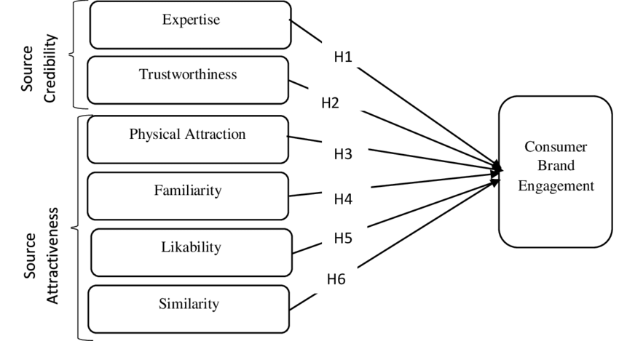
Figure 1: Source attractiveness model (Duh & Thabethe, 2021)

The first component of the Source Attractiveness Model is the physical attraction factor. The first thing that a consumer pays attention to in advertising is the outside appearance of the endorser – does it have charisma or is it attractive? Attractiveness according to Erdogan (1999) doesn’t represent the physical side of a person, but also to living style, skills, performance or personality. This results in a positive message from the endorser to the end consumer and a distinct advantage in influencing consumer’s attitudes and behavior.
The second component is the similarity between the celebrity and the audience. Clients are willing to positively respond to endorsers who look like them or share the same interests or lifestyle, according to McGuire’s model. When a consumer finds that the celebrity shares similar values with them is the moment of creating deep connection and personal relevance.
The third component is likability depending on if the celebrity endorser is agreeable or welcoming. Endorsers who are perceived as likable have more solid communication skills and create positive associations with the brand, because of their charisma and keep the attention of consumers alive.
This model is not only a theory, it also provides marketers with working advice. Endorsers need to be selected right - to have physical attractiveness and characteristics that connect them with the target market. Increasing the number of well-selected advertising ads and messages by aligning the likeability and relatability of the brand’s objectives and customer preferences.
The Source Attractiveness Model is similar to the Matchup Hypothesis because of the importance given to a harmonious match between the endorser and the offered product or service. When there is a similarity between a celebrity’s attractiveness and the product’s characteristics, the campaign will be successful and influence consumer behavior.

The Meaning Transfer Model

McCraken’s (1989) Meaning Transfer Model states that celebrities have an important position as a connection in the advertised area. According to this theory, famous people provide cultural meanings that are settled and arranged between clients and themselves. The exchange of cultural significance is a process where celebrities set the products or services they promote with a symbolic association with their image and identity. This model puts a serious accent on the customer-celebrity relationship. Because of the achieved fame and values, celebrities become social symbols supported by the audience. They have been recognized on the social network and put meaning to the endorsed product. This is what the model looks like as a diagram:

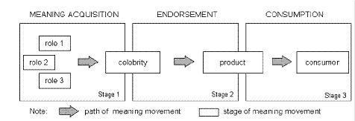
Figure 2: Grant McCracken’s Meaning transfer model (McCracken, 1989)

The most important principle conducted in the Meaning Transfer Model is how consumers interpret the celebrity’s image and the sustainability of the promoted product or brand (McCracken, 1989). When an endorser positions its set of meanings and attributes, those meanings are transferred to the product. For example, in Nike, most endorsers are athletes, famous for their success and prosperity, and those characteristics are transferred to the endorsed product. This effect can have a significant impact on consumer attitude and behavior because the client begins to associate the product or the service with the qualities illustrated by the celebrity.
The Meaning Transfer Model underlines that celebrity endorsement exceeds traditional promotional campaigns by transforming products or services into cultural artifacts full of symbolic meaning. This effect overreaches the product’s functional attributes and affects the customer’s emotions and intentions. Customers begin attracted not only because of the product and its characteristics but also because of the association passed of its celebrity endorser.

Aaker Brand equity model

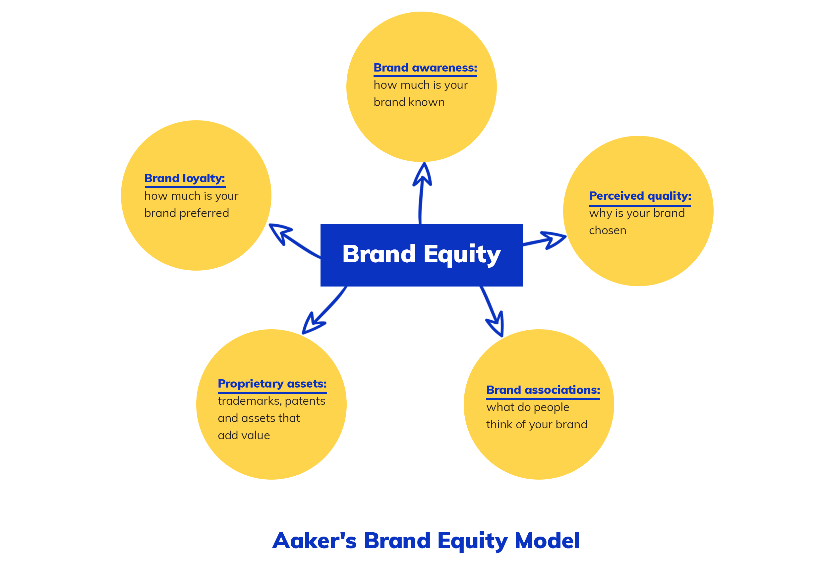
Figure 3: Aaker’s Brand Equity Model (Aaker, 1991)

Many existing theories in the world explain how marketers can identify, measure, and tighten a company’s brand. One of them is this model, named after its author David Aaker, a professor at the University of California and it was introduced in the 1990s. He explained in his theory that brand equity is several assets for a customer who follows the components like brand awareness, brand loyalty, brand association, perceived quality, and proprietary assets. These five dimensions can increase the value of the products and services. Aaker model can help to retrieve information to influence purchasing decisions and increase customer satisfaction (Aaker, 1991).
The first component is Brand Loyalty and can answer the question ‘‘How loyal are people to the brand?’’. It can measure the support and the sequence from customers to the brand in terms of their purchasing habits. If the company focuses on loyal customers, it can reduce the marketing cost and also advantage the brand over its competitors in the market, who may have unstable clients, willing to switch the brand. The slogan ‘Just Do It’ with its simplest, but memorable meaning is the thing that made the deep connection between Nike and its customers. It also connects people from different backgrounds to be champions. Nike is constantly sharing inspiration and influencing messages and videos that help people to have better life inside and outside of the gym.
The second component is Brand Awareness and can answer the question ‘’How known is the brand for the public?’’. It is connected with what is the audience's knowledge about the brand. The model suggests companies to be more visible in society to attract more customers. This awareness can increase revenue and make people feel more comfortable and surer with the decision-making process. Nike is a well-known brand and successfulness of the slogan ‘Just Do It’ and the ‘’swoosh’’ logo also supported this. These two characteristics made Nike recognizable and easy to remember the brand.
The third component is Perceived Quality and can answer the question ‘’Is the brand expected to deliver good quality products?’’. This measure is connected with familiarity with the brand’s products which makes a company to be reliable – a serious reason for the clients to purchase. Perceived quality distinguishes one company from a competitor one’s due to trustworthiness. Nike is the leader in technology development, creating new and innovative products every year. The brand is considered of high quality because of all the athletes who promote the brand.
The fourth component is Brand Associations and can answer the question ‘’What do people feel when they see the brand?’’. This measures the connection between the brand and the customer on a deeper level. This can be an advantage in raising a positive attitude toward a company to customers, encouraging them to purchase. Nike has created a great brand association through its celebrity endorsement campaigns. That means if a customer likes the celebrity will buy the product. Usually, celebrities are successful athletes, talented people, or winners in different fields – this makes an intention in the customer’s perception to buy these products and feel like the best too.
The fifth component is Proprietary Assets refers to the company’s intangible assets – patents, trademarks, rights or copyrights. They do not have monetary value but can increase the company’s reputation and can also be an advantage over the competitors giving its clients more brand equity. Nike has patented ‘’Flyknit’’ Technology for running, soccer, and basketball shoes which other brands use nowadays such as New Balance and Skechers. The trademark of Nike is the ‘’Swoosh’’ logo – the most recognizable logo with worth $26 billion alone. The logo is a copyright which is legally protected against unauthorized use.
After a good mixture of these components and their use in everyday life, a company can increase its brand equity. The branding should be popularized at every stage of the customer’s journey to ensure recognition. The data can be collected and analyzed from the marketers to inform and increase its loyalty to the clients and distinguish the brand from its competitors.

Advantages of the Aaker’s Brand Equity Model

The success of Aaker's Brand Equity Model has been proven many times by different companies. Nike is also using this model to gain more customers and harden the brand's connection with clients. One of the advantages of Nike using the Aaker Brand Equity Model is improving the perception of the product performance. The company can take feedback directly from clients about their experience in-store or online through different advertising platforms. Taking that feedback the company can convert its weaknesses into strengths. Another advantage is increasing brand loyalty – the brand is focused on loyal clients, who are not willing to switch the brand easily, reduce the advertising cost, and be the first over the competitors. The third advantage that Nike is making through this model is that the company gains leverage when introducing new products. Nike has information about all customers, who are being segmented in terms of their preferences and treated according to their needs. That helps to offer anyone premium features and discounts and gain more profit. The fourth advantage is that the brand is different from its competitors – because of the personal experience that Nike offers to its clients, drives the company to differentiate.

Disadvantages of the Aaker’s Brand Equity Model

Tony and Harley (2009) stated in their research that they found support for brand association and loyalty, but not enough support for perceived quality and awareness. Also, there are a lot of problems when managers try to consider their approaches to value their brand. The third disadvantage of Aaker’s Brand equity model is that co-brands are also gaining benefits from association with the company. It is difficult to determine which benefits are due to a product’s brand name and how much is due to the corporate brand. The last stated disadvantage in this research is that when a competitor tries to enter a certain market, it could result in decreasing the market share. Usually, this is seen as a reduction in brand equity. However, customers who remain loyal are worth more and increase brand equity.

Keller’s Brand equity model

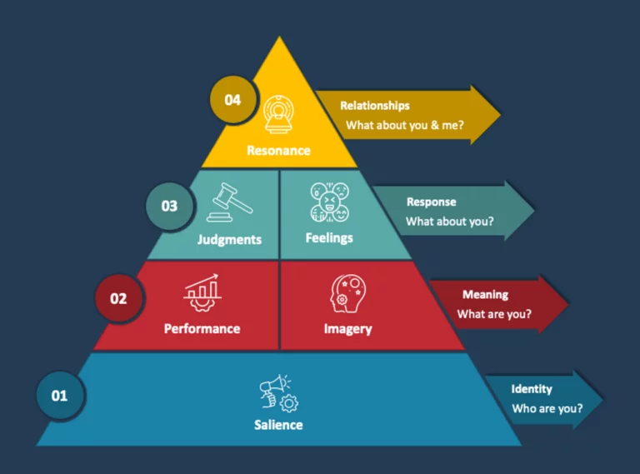
Figure 4: Keller’s Brand equity model (Keller, 2013)

The basic belief of this model is that the power of a brand relies on what customers know about the brand – knowledge, feelings, or visible parts over time. Hence, the power of a brand in sitting in the client’s mindset (Keller, 2013).
It is widely known that essential for establishing long-term success is building a strong brand with a strong connection with customers, which on its side drives preference and commands the price. Keller’s Brand Equity Model, also called the Customer Based Brand Equity model is a detailed framework that can help businesses understand and develop the value of their brand. The author – Kevin Lane Keller, a marketing professor, emphasizes the importance of creating brand equity.
The research of Ramaswami (2020) shows that 81% of customers refuse to do business with or buy from brands that they don’t trust, and also, 43% of the customers spend more money on brands they are loyal to, which shows the importance of brand equity in order to drive positive outcome.
Keller highlights the challenge for marketers in building a strong brand – poor brand knowledge can leave customers with a wrong experience with the brand and thus their feelings, beliefs, and perceptions go bad about it. That is why the author’s model outlines the brand-building process shown in four levels: identity, meaning, response, and resonance, and its six blocks – brand salience, brand performance, brand imagery, brand judgments, brand feelings, and brand resonance.
The first tier is ‘’Brand Salience’’, the Identity part answers the question ‘Who are you?’ – the goal is to raise awareness and fame of a trademark in the client’s mind or said with other words – ensuring the recognition of the brand (communicational channels, advertising and brand presence at the social space. The key point here is to raise ‘right’ brand perceptions, otherwise, the effect will be negative. Nike use different positioning strategies such as: Innovative technology, Leading brand for sports products and it is building connection between Nike and successful athletes’ achievements (expressed in the logo ‘Just Do It’).
The second tier includes two parts ‘’Brand Performance’’ and ‘’Brand imagery’’ and is the Meaning part answers the question ‘What are you?’. Brand performance – how the brand’s attributes meet the needs of the customer. This can be the product’s features, reliability, resistance, effectiveness, design, or price. With constant delivering the brand’s promises, credibility and trust with customers can be strengthened. Brand imagery is the intangible part of the brand such as value. It can be raised through brand storytelling or visual identity. Hence, the distinctive brand identity can respond to their customer only if brand’s tangible and intangible sides satisfy the customer’s needs. Nike increasing the meaning of their product through different ways such as: Customizing strategy – allows customers to create their own pair of shoes, Environment strategy – Nike uses 1 billion plastic bottles annually from landfills to produce yarns for new jerseys and uppers for Flyknit shoes and Charity strategy – the brand has a program called ‘Community Support Program’ where give more than $89 million to help 17 million kids worldwide to get active in sports and exercises.
The third tier includes two parts ‘’Judgments’’ and ‘’Feelings’’ and is the Response part answers the question ’What about you?’. Judgments and feelings evaluate customers’ overall experience and emotional connection with the brand. Visweswaran Balasubramanian thinks all humans are not willing to judge by nature, and judging is out of trying to create a hierarchy or to superior something or somebody. Positive judgment/feelings are coming from positive customer service, experience, or successful branding strategy. Customers’ experience and reviews shows that people are satisfied with Nike, because of its high quality and state it as a ‘Favorite brand’.
The last, fourth, tier is ‘’Brand Resonance’’ and is the Relationship part, which answers to the answer ‘’What about you and me?’’. This is the top of the pyramid and the hardest level to achieve and represents the deepest connection and engagement of a customer with a brand. Keller divide this level into four dimensions: Behavioral loyalty – based on the regular purchases, Attitudinal attachment – when customers see the brand as a special purchase, Sense of community – when customers feel related with other people who love the brand, and Active engagement – when customers participate in brand’s clubs, online chats or events with no purchase needed.

Comparison between Aaker and Keller’s models

Aaker and Keller have created two valuable brand equity models for understanding and managing companies effectively. Both of these models overlap in many ways. They have similarities in the goal – building a strong brand and differences - in terminology and accent in the models. To build a strong brand, companies should create meaningful messaging to their audience, deliver better products than the competitors, get better service experience, thrive for relationship customer-brand, and put in action innovative marketing techniques.

Consumer Perceptions vs Customer-Based Perspectives

Keller’s brand equity model puts a strong accent on consumer perceptions. It focuses on how clients think, feel, and correspond to the brand. This model sets a principle that a company is not just tangible side such as products or services, there is an intangible part as well – emotions and associations.
Aaker’s brand equity model puts the accent on customer-based perspectives. It is visible in the connection between customers and the brand, including factors such as loyalty, satisfaction, and trust. This model sets a principle that the brand is built on interactions with customers through time and focuses on recognition.

Common goals

Both models underline the importance of having positive associations with customer-brand with good experiences in the purchase-making process in comparison to its competitors. These models provide valuable points on how the brand can have deep connections with their clients – the right strategies, increase customer loyalty, and sales, and achieve long-term success for the company.

Different terminologies

Both theories cover similar areas of branding, but there is a difference in terminology used in it. Keller uses terms like brand, salience, brand performance, brand imagery, brand judgements, and brand feelings to describe different levels of its model for brand equity.
Aaker uses terms like brand awareness, perceived quality, brand associations, and brand loyalty to describe different tiers of its model for brand equity.
It is considered that Keller’s model is more suitable for business-to-business because this model requires fewer customers, but with strong relationships that rise after the first purchase. Aaker’s model is more suitable for mass-produced products, where is quite important to be different from a large number of competitors.

Chapter 3: Research Methodology

This chapter includes expanded definitions of each Research Onion’s layer such as philosophy, approach, strategy, type of investigation, methodological choice, and time horizons. Another thing that will be included in this section is data collection and analysis – sampling information such as size, type, and method, survey details with information about the data, and lastly, the ethical considerations will be defined.
Research methodology is the strategy that is undertaken to line the research frame. It is a mixed system of beliefs and assumptions that helps to form the research questions and base the choice of research methods. Research methodology is part of the dissertation that makes sure the usage of the right tools, techniques, and philosophy (Saunders, et al., 2019).

Research Onion

Saunders, et al. (2016) compound model called ‘’Research Onion’’ includes multiple layers, each of them with a few components that should be investigated and chosen the right one for the given dissertation or thesis. It is called ‘’Onion’’ because after selecting the type of each component, the layer should be peeled off and continuing the process until gets to the core. The outside layers guide the selection of research methods, but the inside layers define the philosophical and theoretical foundations. This tool is easily adaptive and used in business studies to organize the whole process and make it systematic and robust for the audience. The figure below shows the model:
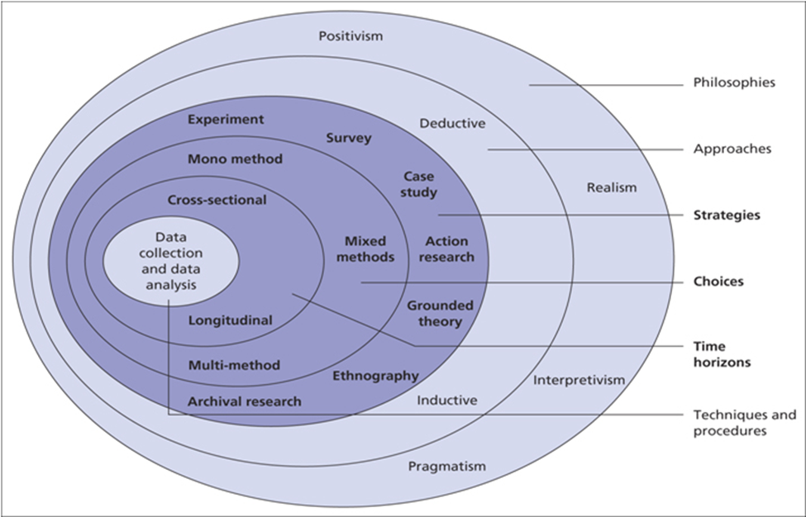
Figure 5: Research Onion (Saunders, et al., 2016)

Research Philosophy

A research philosophy is a mixture of beliefs investigating the nature of reality. The assumption underlined by a research philosophy justify how the research will be conducted, analyzed the data and transform it into valuable information. Research philosophies can stand out the goals of the research and the easiest and better way to be achieved. Therefore, the research philosophy can explain assumptions settled in the research process and how they fits in the chosen methodology (Bryman, 2015).
The main types of research philosophy are positivism and interpretivism. Positivism usually examines the scientist’s point of view. The knowledge is gained through observation and regularities, which are based on causal, law-like relationships. It assumes that the future is predictable and controllable. Interpretivism usually examines subjectivist assumptions, thus existing reality may be examined through social constructions as reality is constantly evolving and knowledge is relative and subjective. It assumes that the future is unpredictable (Amanfi, 2019). The main difference between positivism and interpretivism is constant criticism. Positivism philosophy states entities exist independently of human beings, and do not take the role of individual in a social reality. Conversely, interpretivists states that the existence of the world, independent of human perception is impossible.
The chosen philosophy for this research is positivism, based on factual knowledge, observed with measurement trust. Positivism can explore a wide range of situations in short term. This philosophy will help the researcher to find answers to the settled questions in the introduction, based on factual existence, after the data being collected and analyzed (Amanfi, 2019).

Research Approach

Selecting a research approach will outline the dissertation’s strategy of conducting and handling the process. The research approach is the whole process of collecting, analyzing, and interpretation of the data. There are two primary research approaches – inductive approach which develop a theory and deductive approach which test an existing theory (Bryman, 2015). This dissertation uses a deductive approach, which means there will be testing and existing theory, formulating a hypothesis, and after analyzing the data the researcher will decide if to reject or not to reject the hypothesis. This approach has the advantage of being more organized in systematic order. Saunders, et al. (2019) stated that the deductive approach is deeply connected to positivist research and helps to find reasonably answers.
In this dissertation is a hypothesis that ‘celebrity endorsement as a promotion strategy has a significant influence on the brand equity in Nike’, so this deductive approach will hep to evaluate the impact of celebrity endorsement in Nike, and regarding the result to reject or accept the hypothesis.

Research Strategy

The third layer of the ‘Research Onion’ is related to the research strategy, which has to be chosen for the dissertation. The strategy is the overall plan for conducting a research study and helps the researcher with high-level guidance for planning, executing, and monitoring the study, which on its side allows the research to be organized and scheduled. The main types of research strategies are case study, interview, survey and action-oriented research. This dissertation is using survey method, because the effectiveness of this strategy – saving money, time, helps to collect data from wide audience, and the summarized and interpret the reliable data could be shown in graphs or tables (Amanfi, 2019). This analysis will help the researcher to statistically show the impact of celebrity endorsement on brand equity in Nike.

Type of investigation

There are two main types of investigations: primary and secondary research. To collect data and test hypotheses, the researcher has to decide which type of research will be conducted. In this dissertation, the researcher is focused on both the types – as well primary as well secondary research through survey. This is decided because both of the types offers advantages that support the dissertation objectives and will ensure well-researched thesis.

Primary research

Primary research, also known as empirical research, is a process of collection of original, not interpret data, specific to a particular theme, project, or objective directly from a source or individuals e.g. first-hand data is preferred rather than available in databases or publications (Saunders, et al., 2019). This type of research aims to produce new knowledge, which refer primary research as original research. Usually, the settled questions are not answered before, and the researcher will answer it for the first time. Primary researched can be done through different methods such as surveys, interviews, observation, data analysis, or focus groups (Sridah, 2010).
This dissertation’s primary research consists of survey, conducted for people over 18 years old. This questionnaire is created with the aim of collecting responses from the target audience. Through this approach, the researcher can take specific data, giving answers to the settled research questions, allowing the test hypotheses regarding the impact of celebrity endorsement on the brand equity in Nike. The table below illustrates the advantages and disadvantages of primary research:

Advantages | Disadvantages
Primary research = exploring individual market – due to addressing specific issues, keeps the research completely relevant to the objectives of the dissertation. | Time – due to its nature, primary research is time consuming.
The researcher has complete control over the methodology used – includes sample size and selection process. This improve the relevancy of the research. | Cost – more expensive.
Up-to-date and relevant information – current trends could be assumed. | Effort – the researcher may be more involved
Controlling the ownership of the data – the researcher can decide if to share the data or keep it private in order to prevent giving a competitors’ advantage. | Biased result – due to confusion, settled straightforward, or not clear questions, individuals can change their answer. Also, the researcher should use as much diverse audience as it is possible to prevent biased result.
 | Too big focus on one or two factors – it is clear that all topic can not be explored, but the researcher must try to analyze as much factors as it is possible.
 | Finding relevant data – despite the researcher’s intention to conduct the survey, participants could not take it as seriously as it has. This can cause irrelevant and inaccurate answers, which can affect the surveys’ conclusion.
Figure 6: Advantages and disadvantages of primary research (Amanfi, 2019)

Secondary research

Secondary research, also known as desk research, is the process of collecting existing and synthetic data and literature, organized and published by other authors. Secondary research does not include collection of new data. In other words, the author is using and analyzing data from primary research sources (Sridah, 2010). This research is useful for increasing the knowledge around the findings of the primary research Researchers have many options for sources to explore when doing secondary research such as academic journals, books, articles, educational institutions, or commercial informational sources. The availability of Internet makes the research easier because all the available data online can be used and transformed into valuable information.
This report will use this type of research as well as the primary one because of Chapter 2: Literature review. The need for definitions, marketing models, or promotional strategies, published by other authors requires the use of it in this dissertation. This type of research will help the researcher save on any supplementary expenses. Also, the exploring of different sources in one thesis will help the researcher to critically analyze the different points of view about the impact of celebrity endorsement in Nike.

Advantages | Disadvantages
Saving time and effort – faster and easier, thus save time by going straight to the analysis part. | The credibility of the information – data should be checked carefully to prevent the usage of inaccurate which can cause deliberate or unintentional bias.
Cost-effectiveness – because of that the data is available and easily accessible from free sources and places. | Relevance and timeliness of data – old data can cause complicates in the research process.
Cleaned and structured data – the collected data for primary research has been analyzed and published which makes it cleared of unuseful information. | Not confidential data – competitors also can benefit of the same secondary research.
Large volume of data – no limit of the existing data, because of the many existing sources. | Control over the collection process – the researcher does not know if the previous researcher followed the right standards.
Figure 7: Advantages and disadvantages of secondary research (Amanfi, 2019)

Differences between primary and secondary research

Primary research | Secondary research
Data is collected by the researcher | Data is collected by other researchers
Information based on raw data | Information based on analyzed data
High level of effort of the researcher | Low level of effort of the researcher
The collected data fits the researcher need’s | The existing data may not fit the researcher’s needs
Expensive, time-consuming process | Fast, Low-cost process
Figure 8: Differences between primary and secondary research (Amanfi, 2019)

Methodological Choice

When the dissertation is conducted, a researcher has to make the decision on which data methodology to use. There are three main types of methodological choice – qualitative, quantitative, or mixed-method research. No matter the research topic, the researcher can decide what to focus on – collecting words, numbers, or both together. Every approach offers different reasons to be chosen, but the main characteristic that could be underline is the research objectives (Bryman, 2015). In this dissertation the chosen methodological choice is mono-method quantitative research because the result will be shown with charts, graphs and scales as numbers or percentages.
Quantitative research is frequently used when something needs to be confirmed. It is focused on collecting, testing, and measuring numerical data, usually through surveys, questionnaires, test, databases, or experiments of large group of people. The data can be analyzed and showed in a systematic way and comparison. This method is faster for obtaining data due to the usage of software programs which analyze the data (Creswell, 2009).

Advantages | Disadvantages
Concerned with facts and variable information – due to researched auditory is a particular group – the result can explain a customer’s purchasing decision and the company’s future decisions. | Limited to numbers and figures – survey collects only ‘cold hard figures. This method is unable to take specific feedback, and often lack on a human element.
Quantitative research can be done anonymously – this type does not ask participants for personal details. | Testing models are created more difficult – from testing hypothesis and analyzing data, there are a few more steps in order to have a successful test.
Passively collected data – data could be generated over a defined period. | Tests can be manipulative – some surveys can be created to support a certain end result.
Faster method – less delays and larger sample size ensure fast data collection process. | Irrelevant interpretation – whether due to bias or accident, data could be manipulated.
Verifiable research – other researchers can duplicate the methodology, but they have to create their own conclusion. | More expensive form of testing – due to seek for larger amount of data.
Figure 9: Advantages and disadvantages of Quantitative research (Bryman, 2015)

The second type of research is qualitative research. This research relies on what people think within society and seeks details and ‘why’ behind a certain question. Qualitative research involves collecting and analyzing data which is written or spoken verbally. It may also focus on body language because it can help to create more detailed description of researchers’ observations. The data is usually gathered through interviews, observation, and focus groups using only a few and reliable participants. This research is subjective and more time-consuming (Creswell, 2009).

Advantages | Disadvantages
Explore attitude in-depth – on more personal detailed level to gain better understanding of consumer’s perceptions. | Sample size – usually small and can cause problems such a generalized conclusion.
Encourage discussion – open manner discussion, giving a content not only numbers. | Bias in sample collection – researcher can select people with all same certain opinion rather to include mixed views people.
Flexibility – in the moment of speaking the researcher can change a question or the way of saying them. | Lack of privacy – some people may feel uncomfortable speaking on some topics.
 | Usage of well-skilled moderator – should be as knowledgeable as the interviewed people.
Figure 10: Advantages and disadvantages of qualitative research (Bryman, 2015)

In the table below is shown a comparison of quantitative and qualitative research:

Quantitative research | Qualitative research
Answers like ‘’How much?’’ and ‘’How many?’’ | Answers like ‘’Why?’’
Help to identify tends. | Helps to identify beliefs, behaviour, and motivation.
Used to test a theory in order to approve or reject it. | Used to explore ideas in-depth to generate hypothesis or theories.
Analyzed data is summative and designed to compare. | Analyzed data is summative or formative designed to find solutions for the issues.
Participants are a lot – more than 30. | Participants are a few people – 5-8.
Data is collected directly. | Data is collected through observations.
Questions are closed. | Questions are opened.
Data is presented through charts, graphs and tables. | Data is presented narrative, audio or video.
Analysis is mathematical and statistical. | Analysis is interpretation.
Figure 11: A comparison between quantitative and qualitative research (Bryman, 2015)

The third type of research is a mixed method. This method is a combination of the described two types of research – qualitative and quantitative to provide multiple findings, perspectives, and a rich picture of the researched topic. This method combines paradigms from both inductive and deductive perspectives and enables the researcher to combine theory and hypothesis within a single study. The mixed method provides facts and figures at the same time as a human aspect. The analyzed data is more exploratory. One drawback of mixed method research is that the researcher should be resourced and skilled in both methods, and if not he/she should pay to another team which will increase the cost and budget (Creswell, 2009).

Time Horizons

The Time Horizon states the time frame for the research to be completed, usually depending on the objectives and the type of investigation. According to the ‘Research onion’ there are two main types of time horizons: cross-sectional and longitudinal. The cross-sectional, also called one-shot, study can be taken only once instead of a period of days, or weeks, aiming to answer a certain question. The longitudinal study can be undertaken more than once to answer the research question depending on the researcher’s intention; hence the data is gathered in long-term, twice or more, and is called ‘’variable’’. This study helps the researcher to examine people’s changes in attitude or behavior over a while (Melnikovas, 2018).
This dissertation utilizes a cross-sectional time horizon because there is a specific short period in which the research should be done. This methodology is appropriate for investigating the impact of celebrity endorsement on brand equity in Nike in ten weeks – from February to April 2024.

Data collection and analysis

This last layer of ‘Research Onion’ consists of a selection of specific data collection and analysis methods and techniques. It also includes gathering and analyzing data from different sources to find answers to the stated research questions (Saunders, et al., 2016). This thesis will conduct quantitative research with primary and secondary data. Accordingly, to the chosen deductive methodology, the survey will test hypotheses regarding the impact of celebrity endorsement on brand equity in Nike. The quantitative data will be gathered, analyzed, and linked to the survey-based research.

Sampling

In research methodology, a sample is a small part (subset) of data that the researcher is choosing from a larger population of people to represent the whole group. Creating a sample is an effective method of research because researching the whole population is not possible, it is cost and time-consuming. The insights, representativeness, and validity that are shown can be applied to the whole group. A sample can be collected through surveys, polls, or questionnaires for primary research (Amanfi, 2019). In this dissertation, the sampled group of people includes students, friends, and family members of the researcher. Our goal is to collect 50 people’s responses, a size that could be easily shown statistically.

Sampling size

The formulation of sample size was important for this dissertation, and it is based on a few factors. In the context of the impact of celebrity endorsement on brand equity in Nike, we decide to collect approximately 30 survey responses. It has a determinant importance how many samples are to be collected to be enough for creating statistically significant results and validity (Saunders, et al., 2019). There are some practical considerations for consideration such as framing 10 weeks for the whole dissertation (and maximum 2-3 weeks for collecting data), resources, and our audience’s characteristics. Also, this sample size will allow the researcher to perform testing hypotheses and summarize the findings without being overwhelmed. Accordingly, to the sample size of 50 people, the principle of a balance between statistical power and feasibility of data collection is achieved.

Sampling type

Our target sample population consists of people aged more than 18 years old, male and female, from two geographical locations – London and the researcher’s origin country – Bulgaria, and their social class. The demographic factor used in the research will ensure participants from various groups and the geographical factor ensure a wide range of consumer experiences from two different locations. The representatives from London are university students at the University of Wales Trinity Saint David with various purchase behaviors, attitudes, and celebrity endorsement exposure. By focusing on this sample type, the stated insights will be directly connected with the research questions, which are influenced by the impact of celebrity endorsement on brand equity in Nike.

Sampling Method

To be concluded with a valid result, the researcher should select a sample method that is going to be representative of the whole group. There are two possible options – Probability Sampling and Non-probability sampling. The chosen sampling method in this dissertation is convenience, Non-probability sampling.
Probability sampling includes random selection where everyone has an equal chance to be selected, ensuring a stronger conclusion about the whole group, and also minimizing the risk of selection bias. This sampling is more complex, time-consuming, and costly to conduct. This sampling tries to minimize the errors while minimizing the time and cost (Baxter, et al., 2015).

Advantages | Disadvantages
Easily to be understood, not complicated | Higher complexity compared to non-probability s.
Results shown to the target population | Time-consuming
Minimizing the risk of bias and systematic error | Usually more expensive than non-probability s.
Reduced risk of over-or-under-representation | Difficult to construct a sample
Cost-effectiveness | SRS can result in large samples
Increased level of reliability | Chances to choose samples from a certain class
Figure 12: Advantages and disadvantages of Probability sampling (Baxter, et al., 2015)

On the other hand, Non-probability sampling includes a non-random or non-systematic process, where there are not equal chances for everyone to be selected, based on criteria, ensuring easier collection of the data. This sampling is the most commonly used in research because it is quick, inexpensive, and convenient. The chosen type of Non-probability sampling is convenient because the researcher selects the sample according to their convenient accessibility and proximity. Convenience sampling is often filled by students who are willing to take the questionnaire (Baxter, et al., 2015). This sampling introduces some level of bias, but to prevent this researcher includes a variety of students from different disciplines, universities, and geographic and demographic backgrounds to differentiate a range of perspectives.

Advantages | Disadvantages
Cost-effectiveness | Undermines the validity of the results
Time efficiency | Margin of errors
Flexibility | Sample size may be unclear
Exploratory focus | Potential risk of sampling bias
Ethical considerations
Figure 13: Advantages and disadvantages of Convenient, Non-probability sampling (Baxter, et al., 2015)

Survey design

Collecting information through tactfully and reasonably designed surveys will be effective and productive for the result of the research. This dissertation survey is carefully generated according to the research objectives. It consists of multiple-choice questions, demographic questions, Likert scale questions, and rating questions. This survey will help the researcher to collect responses, allowing her to make a comprehensive quantitative analysis and conclusion supported by statistic-based information about the impact of celebrity endorsement on brand equity in Nike.

Data collection method

Data is a collection of facts gathered from different sources. Without having that data it would be difficult for the companies to make the right decisions, so a collection of data is required at some point in time. Companies can collect data to review the product/service’s demand, consumer preferences, and what competitors offering. Data collection methods are techniques and procedures used to gather information for research purposes. This can be a survey or more complex experiments (Amanfi, 2019). This dissertation will be taking a survey through Microsoft Forms and will take responses from 50 people from two geographic locations – London and Bulgaria.

Questionnaires

This thesis’s questionnaire is taking a huge part of the data collection process in primary research because enables the researcher to collect systematic responses from the target audience. This survey aims to provide clear and relevant information without any doubts.
Our survey provides detailed and very thorough questions connected to the research objectives and hypotheses. It will consist mainly of multiple-choice questions, some demographic, Likert scale, rating scale questions, and ‘’Yes’’ or ‘’No’’ questions. This structured survey will allow the researcher to gather qualitative data that can be statistically analyzed to answer our research questions. The chosen website for creating a survey is Microsoft Forms. This platform provides multiple benefits such as simpleness of usage for both sides – respondents and researcher, automatic data capture, and convenient data exporting to Microsoft Excel for analysis. Microsoft forms will enable sharing of the survey with all participant – from both locations in filling it their leisure time with not big impact on their free time because the time for filling out the survey is five minutes maximum.

Response Rate

The response rate is an indicator that influences the reliability and representativeness of the collected data through the survey research (Amanfi, 2019). The researcher will try to maximize this response rate to ensure that the sample is relevant enough to the researched objectives. To encourage engagement with the survey, participants are offered clear communication and clarifications for completing the survey, kind reminders for completing the survey, and guaranteed anonymity. The researcher understands the importance of achieving a high response rate to gather meaningful insights with a nice, user-friendly, and engaging survey experience.

Data analysis

Data analysis is a process of using statistical or logical techniques to describe, recap, and evaluate data (Amanfi, 2019). In this dissertation, the analysis part is connected with examining the impact of celebrity endorsement on brand equity in Nike, made by gathering valuable insights from the collected opinions and responses. The researcher went through a methodology that included only quantitative data analysis. The multiple-choice questions, demographic, Likert scale, rating scale questions, and ‘’Yes’’ or ‘’No’’ questions will gather information that will be analyzed with Microsoft Excel statistic software.

Data visualization

While all collected data is quantitative, incorporating data visualization tools is important to present the findings effectively. Visualization tools such as graphs, charts, tables, and diagrams are generated to represent the analysis results visually, clearly, and organized. These visual aids will enhance the impact of this dissertation by enhancing numerous views of our findings. Microsoft Forms allows the researcher to see directly and download the visual representation of the survey responses. This eliminates the need for external data visualization tools.

Validity/reliability of the data

Validity and reliability are two crucial aspects in conducting quantitative research, that can ensure the accuracy of the research results. Validity measure the level of accuracy of the generated data, while reliability shows the consistency of the data over time. Ensuring these two factors, there will be high-quality research with well-structured conclusion (Creswell, 2009).
Due to an anonymous survey type, there is some existing percentage of bias in the participant’s answers. This cannot be excluded by the researcher, because the participants are responsible for it.

Research ethics

Research ethics are the moral principles that will be used by the researcher when carrying out their research. These principles create the regulations which have to be followed strictly. This includes information about how the research is designed, regulated, and concluded (Bryman, 2015)
During the whole process from conducting to presenting the research, research ethics has always been having an important role. There were no exemptions at any phase during this investigation on the impact of celebrity endorsement on brand equity in Nike that did not follow ethical considerations.
Keeping the privacy and confidentiality of participants is a key concept. The researches ensured that collected data from anonymous surveys was secured very carefully. Only the researchers had access to this sensitive information to keep the protocols protected.
This survey guarantees to keep the knowledge of the participants on a very high level – it well-explained the nature and purpose of the study, also that the participation is based on voluntary principles and may disengage from the survey whenever they feel it. This procedure will ensure the full comprehension of the participants in the research.
Also, this research is focused on honesty and openness to opinions. This includes all findings that are or not fully support our initial hypothesis. Integrity ensures openness and dedication to present objective and true data.
The researcher makes sure that all participants keep impartiality and as a result, all of them have been threatened with courtesy and valuable insights. Any form of bias or discrimination has been avoided during the participant selection and data analysis process.
Lastly, the researcher is following all institutional and legal ethics guidelines for conducting and carrying out research. This includes any approvals taken from the ethics review board and applicable data protection laws.

Chapter 4: Data collection and Analysis

This chapter includes findings collected from the responses to the survey about what is the impact of celebrity endorsement on brand equity in Nike. It starts with going through the questions that were conducted to collect information about the goals and identify the current trends of this quantitative research. The following section after each question includes a diagram, a table with numbers, and an interpretation of the findings. After all the questions, there is a section with a discussion of the findings of the primary research – which is summarized the data from the survey and a section about the secondary research.

Demographic questions

Question 1

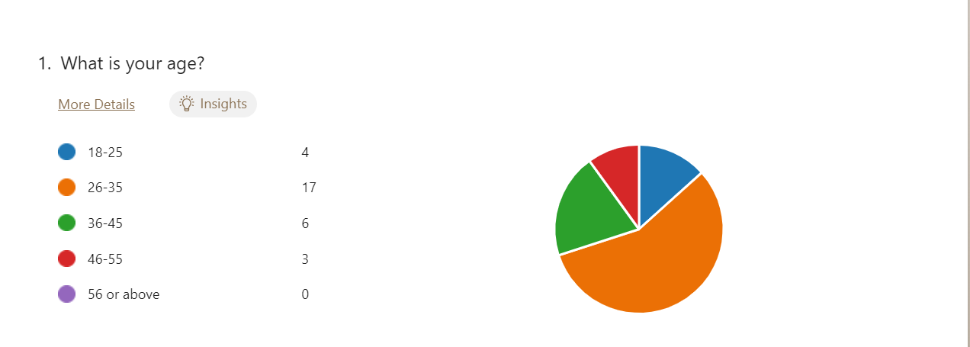
Most of the participants – 17 people, approximately 57% of the survey respondents are between 26 and 35 years old. This survey shows that almost all of these people answered “Yes” to question 7 which is “Have you ever made a purchase influenced by a celebrity endorsement campaign?” and scored a high rate for “Celebrity endorsement has a long-term impact on their loyalty to the brand” and think that “Companies should invest more in celebrity endorsement for their products or services”. This data shows that people between 26 and 35 years old are the most active in social media, connected with advertising strategies, and in particular – most interested in celebrity endorsement.
6 of the 30 participants are aged between 36-45 years old. 4 people are between 18 and 25 years old. And only 3 people are aged between 46 and 55 years old.

Question 2

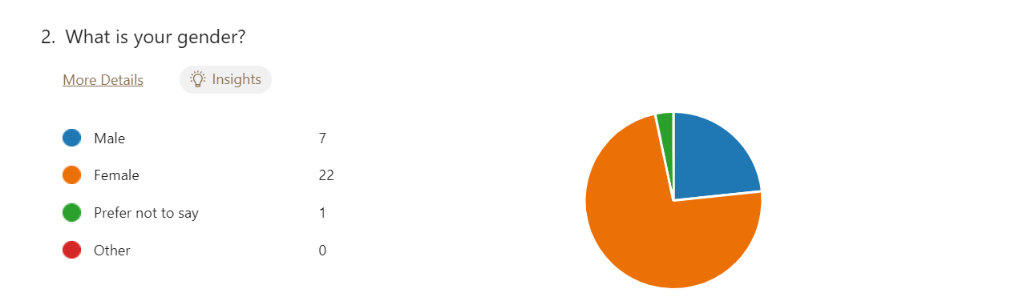
The dominant gender in this sample size is female – approximately 71% of the participants are women, and only 26% are men. 1 person prefers to not give information about their gender. This survey shows that almost all women who participated in have stated that they found celebrity endorsement promotion more effective than non-celebrity advertising.

Question 3

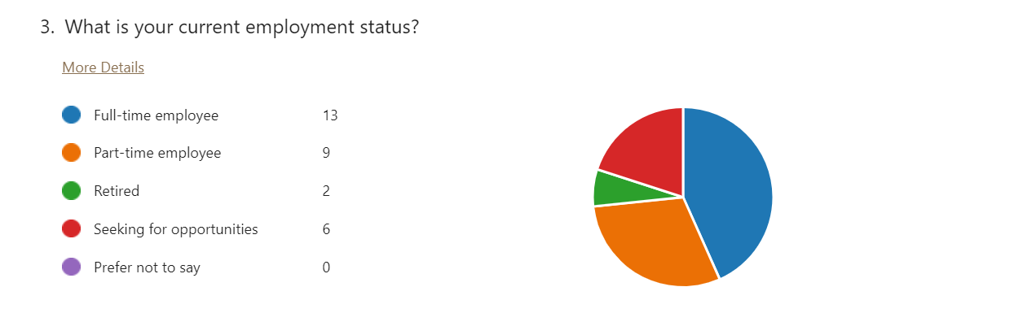
Approximately 45% of the participants, 13 people, are full-time employees. 29% of the full simple size are part-time employees. And the other 25% are retired (2 people) or seeking opportunities (6 people).

Consumer behavior and Celebrity endorsement

Question 4

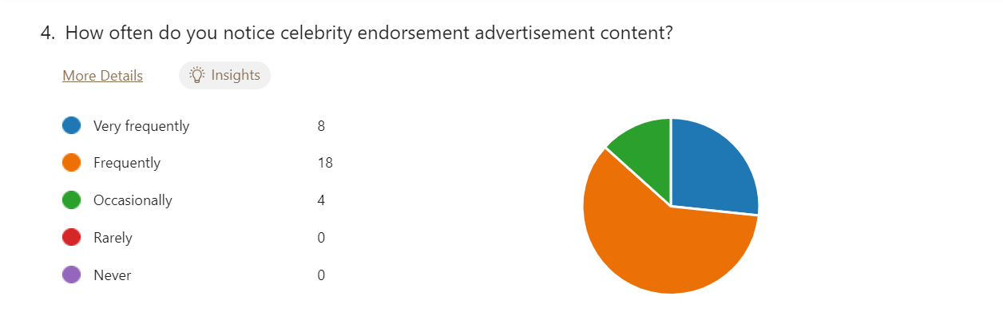
Approximately 87% (26 out of 30) of the respondents to this question have chosen the “Frequently” or “Very Frequently” category, which is an indicator for a high level of celebrity endorsement advertising, exposure and awareness. This note the importance of celebrity endorsement campaigns and their acceptance as an advertising strategy in modern trends. The predominance of these responses say that celebrity still have the ability to influence, attract, and keep the attention of consumers, thereby strengthening the significance of advertising strategies.
Alternatively, the lower category “Occasionally” has approximately 13% (4 people) showing a small group of people that rarely notice celebrity endorsement. These people are not having this kind of celebrity endorsement as a successful one with potential, hence cannot make a significant profit for the companies. It may be concluded that for a small subset of the population, celebrity endorsement may not be seen as strong advertising or completely ignored.

The appeal of the celebrity shouldn’t be quite often, because then he/she will be threatened of overexposure, which could be negative factor for the brand. Endorsers should accept only those campaigns which are matching his/her preferences.

Question 5

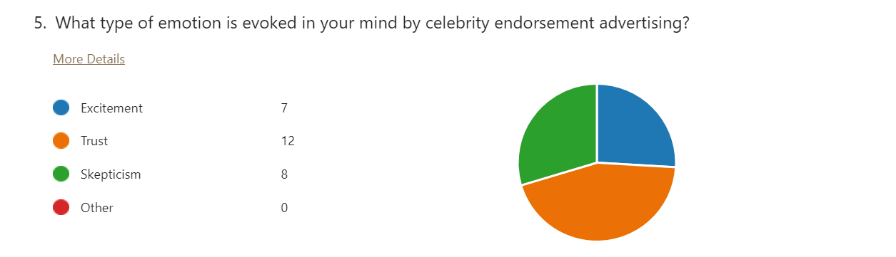
The largest group, consisting of 12 people, approximately 44% stated that “Trust” is the emotion that celebrities evoke in them. This is an indicator for a sizeable portion of the sample that believes in celebrities and finds them credible and reliable. This shows the perceived value of the endorsers in building consumer trust.
In contrast, 7 people, approximately 26% stated that “Excitement” evoked emotion in them when they noticed celebrity endorsement advertising. This is an indicator for still a big part of the sample that thinks endorsers are generating enthusiasm and interest, and probably making them more receptive to the promoted products.
However, there is an important part of this question, 8 respondents, approximately 30% stated that “Skepticism” is the evoked emotion in them. This significant presence of people who cannot trust endorsers may come from its authenticity or the actual connection between the celebrity and the product. It is important to acknowledge that some people do not trust celebrities, and hence they cannot influence them to buy a certain product/service.

These different emotions that are evoked in the participants are visible signs that marketers should design an appropriate brand message that can influence the customers and match the message given by the endorser.
Nike has an effective strategy to use celebrity endorsements to generate excitement in consumer’s emotional responses. An example of those celebrities is LeBron James, Serena Williams, and Tiger Wood can aspire for greatness. Nike’s main goal is to appeal to consumer’s minds and inspire them to achieve their objectives. This connection affects the purchase intention as well.

Question 6

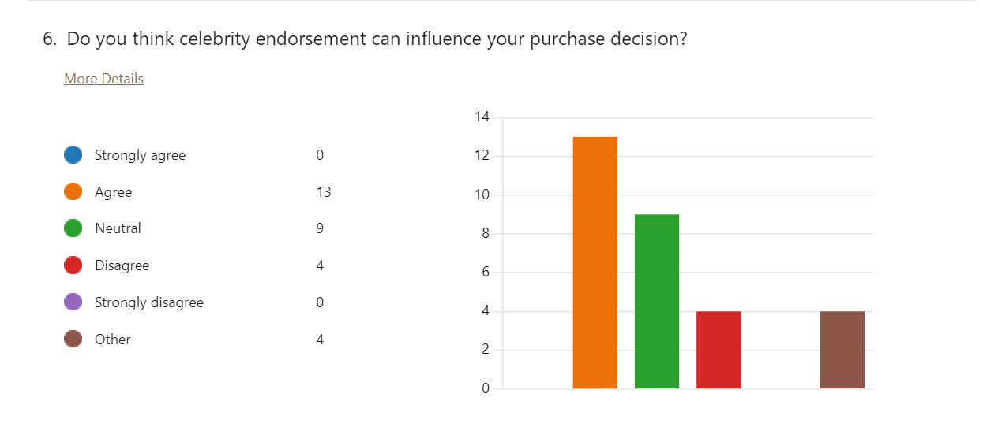
13 of 30 people “Agree” with the statement that celebrity endorsement can influence their purchase decision. This indicates that almost half of the sample’s participants are willing to be influenced by this kind of campaign. However,4 of the participants have chosen “Disagree” for that statement, so can be assumed that celebrity endorsement have no influence on their purchase decision.
The presence of that big amount of people – 9 of 30 who are “Neutral” about this statement is factor of variability in the influence power of celebrity endorsement campaigns. Also, they think that this promotion may have an impact, but will depend on different factors such as the product/ certain celebrity, or even their own preferences.
These answers represent the complexity of celebrity endorsement strategy to build brand equity. While a sizeable portion of the sample is influenced by celebrities, their effectiveness is not universal, and it does not work in every way as well and the effects can vary.

Question 7

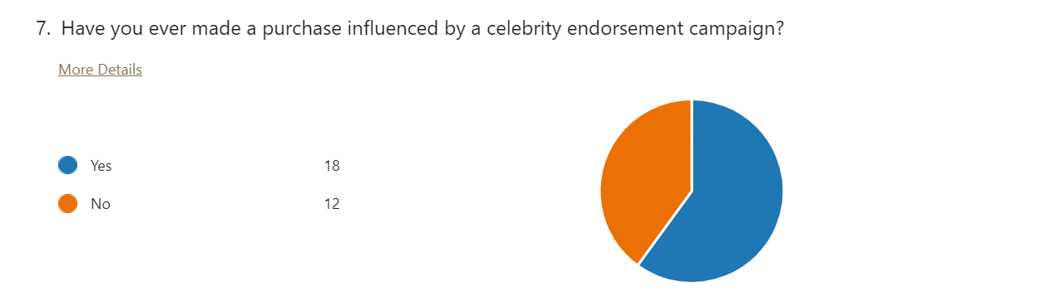
A bigger part of the sample, consisting of 58% of respondents (18 people), stated that they have been influenced and made a purchase of a celebrity endorsement campaign. This is a confirmation and demonstration of celebrities' extraordinary influence over consumers' decision-making process, which is proof of effective promotion. It highlights the power of celebrities, who are trustworthy and reliable figures around society and have successful predominance on the client’s perceptions.
In contrast, approximately 42% (12 people) stated that they have never been influenced and have not made a purchase because of a celebrity endorsement campaign. For these people, other factors are important such as quality, price, and personal experience, but not celebrity endorsing.

These responses represent the complexity of consumer preferences and diverse perceptions about this promotional strategy. This part of the sample shows that marketers should realize that endorsement is not an effective way to reach consumers in every situation. They must be creative in thinking and strategically put more effort into factors that bother people with those preferences.
This respondent’s opinions represent an opportunity for Nike to engage more consumers by providing accessible products online with a deeper understanding of its offerings. The digital presence and reliable content allow Nike to convert consumer interest into actual purchases.

Question 8

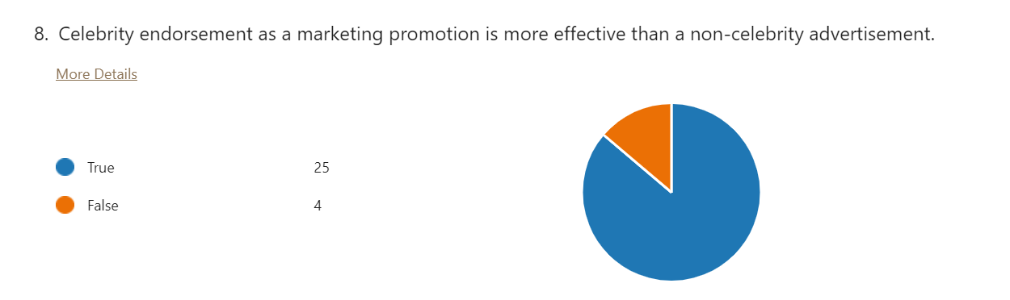
The main part of the sample (25 people), approximately 87%, stated that celebrity endorsement as a marketing promotion is more effective than a non-celebrity advertising campaign. This is a massive sign of approval for this marketing tool and confirmation of the successful method of advertising.
Only 4 people, or approximately 13% of the sample, wouldn’t find a difference between celebrity endorsement and non-celebrity advertisement. These people are willing to be influence even when there are no famous people included in the promoting.

Many researches and studies show that people are more likely to choose a product after being endorsed by a celebrity, rather than a non-celebrity advertising. One of the reasons for this being this is the large number of potential consumers who can see the product, also, the perceptions that one celebrity builds, and lastly, but not least importantly – maintaining brand loyalty for a long-term period.

Celebrity endorsement and Brand perception

Question 9

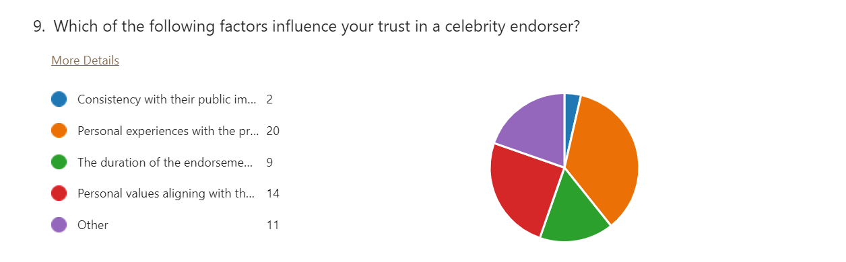
The most influential factor among these is “Personal experience with the product” stated by 20 people, which is approximately 36% of the whole sample. This shows the importance of the connection between the endorser and the brand/ promoted product. Also, highlights the significance of promises made in this advertising campaign and the experience of the firsthand in gaining consumer trust and building perceptions.
The second highly rated answer “Personal values aligning the brand” is stated by 14 people, which is approximately 26%. This indicates the importance of the connection between the celebrity endorser’s values and experience with the respondent’s values to build and gain trust. This shows that shared values can increase the credibility of a celebrity.
The answer “The duration of the endorsement deal is given by 9 people, which is approximately 16% of the whole sample. This is proof that if a celebrity is consistent with a brand, they are working together for a long time it impacts the trust in consumers. Respondents think that a deeper commitment and belief in the brand/ product is having an impact on the credibility of the endorser.
The answer “Consistency with their public image” given by only 2 people, which is approximately 3% of the whole sample represents no importance between the endorser and its public image. If the celebrity has a bad public image due to personal experience in its life will not impact the trust between him/her and the consumer. This factor does not play a crucial role in building trust for these respondents.

The Product Match-up Model shows the “match-up” level between the celebrity endorsement and the offered product/service. Consumers have a more favorable attitude and purchase intention to the product which aligns with the endorser. Here we can highlight the importance of usage of the right celebrity for the appropriate product category due to their similarity

Rating scale question

Question 10

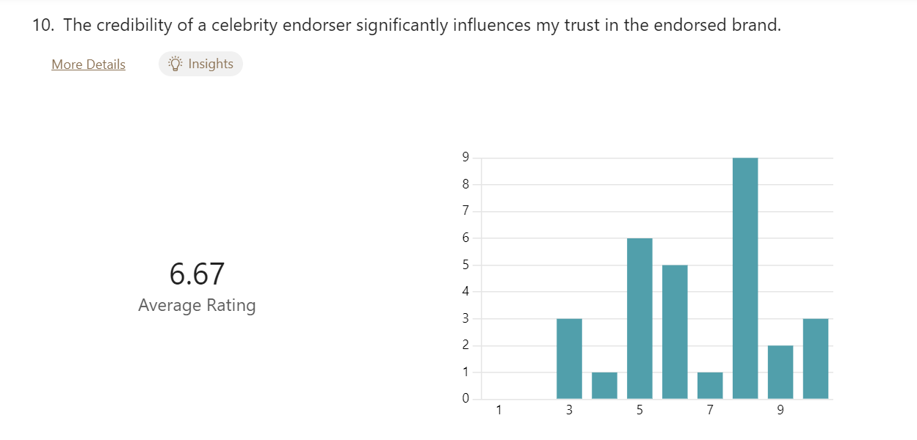
With an average rating of 6.67, the survey participants think that the credibility of a celebrity endorser is influencing their trust in the promoted brand. This high average rating is an indicator for the importance of the credibility of the celebrity endorser which plays a crucial role in building trust and confidence in the endorsed brand.
However, there is a consensus among 9 participants who gave a rating of 3,4, or 5 about this question. These people do not find the credibility of the endorser a crucial factor in terms of their trust in the brand. For this part of the sample other factors are more important than the celebrity who promotes the product/service such as quality, price, or characteristics.
The statistics state when a brand is associated with a celebrity who has gained credibility or trustworthiness, consumers are more likely to buy from this company, because of the greater level of confidence in the brand. The usage of the endorser’s credibility by the brand can increase the overall impact of this promoting strategy, turning it into a tool for building trust and fostering brand loyalty. Hence, credibility is having an indirect impact on the brand equity (Goldsmith & Newell, 2000).
This highlights that Nike is required to ensure that the chosen celebrity corresponds right with the brand’s value and image. When consumers perceive disconnection or betrayal from the endorser, trust and credibility may be destroyed.
Question 11

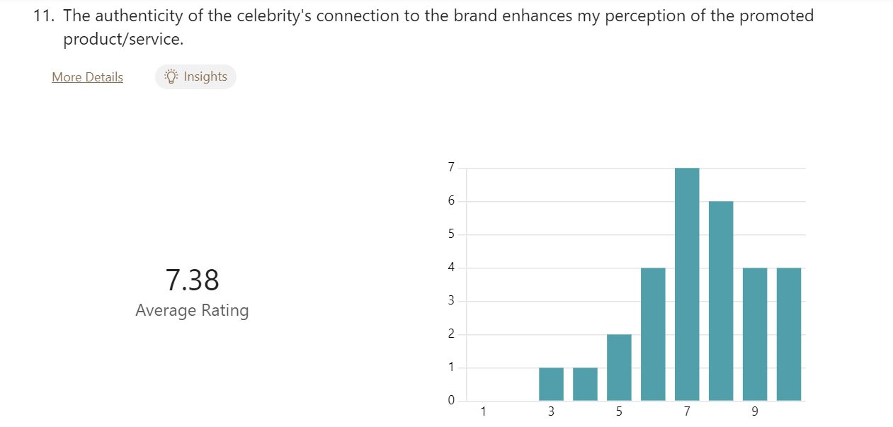
With an average rating of 7.38, this sample shows a significant impact of the celebrity’s authenticity connection to the brand/ in particular with the product as a factor that enhances consumer’s perceptions of the brand. These participants' purchase buying intention is mainly influenced by the connection endorser- promoted product.

As many statistics show, there is a big role of the authenticity of the celebrity in creating consumer perception and attitude towards a brand. It is possible to transfer a celebrity’s positive characteristics to the brand such as attractiveness and talent. Because of their positive side, consumers consider the product more appealing, trustworthy, and with higher quality. When people see the pure connection of the celebrity with the product, they are positively affected to gain a positive perception of the brand, and also build the endorser’s credibility. Trust is a potential motivational factor for brand equity and influences consumer loyalty and purchase intention (Atkin & Block, 1983).
There is a significant notion has shown – “matchup hypothesis” which states that the effectiveness of a celebrity rely on the level of correspondence between the endorser’s image and the endorsed product.
Nike shows commitment to performance, innovation, and authenticity. Example for it is the constant trying to align with endorsers who reflect their core values, hence enhancing consumer trust among those who share those values.

Question 12

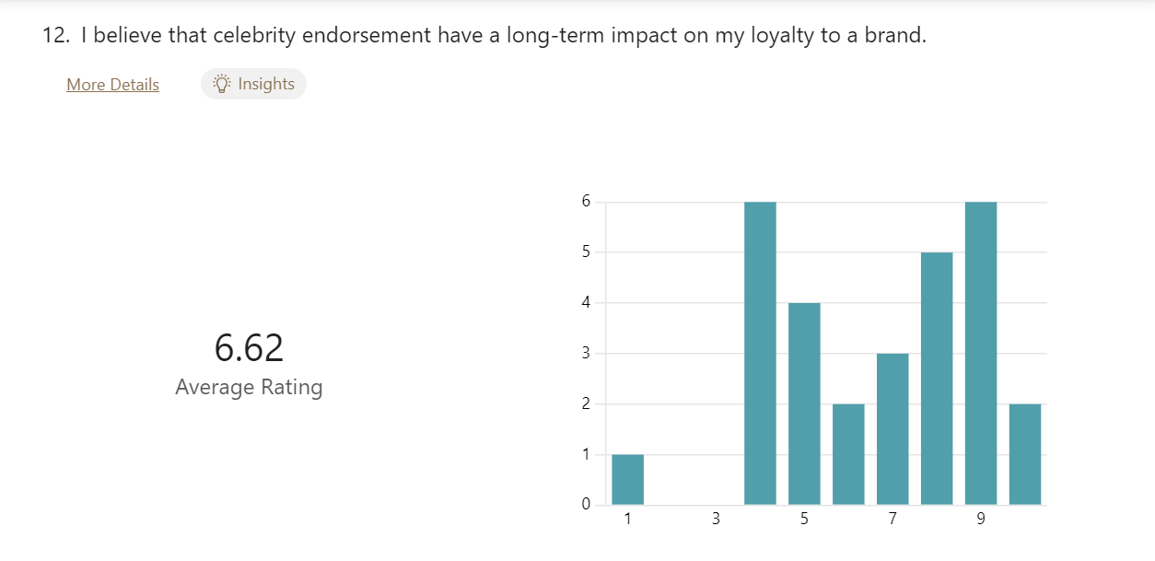
With an average rating of 6.62, respondents mean that celebrity endorsement has a long-term impact on their loyalty to the brand. This relatively high result states that consumers have this type of promotion more effective in creating and maintaining a long-term impact on their intention to keep buying from this brand.

Celebrity endorsement as a promotional strategy fosters brand loyalty and maintains long-term relationships between the consumer and the brand. Because of the good experience with the product or services experienced by the consumers, this is a factor for establishing trust and deep connection for the long term. Loyalty is not only simply appealing to the endorser; it is a positive brand experience. As stated in Aaker brand equity’s model – brand credibility, brand awareness, and purchase intention are influenced by successful promotional strategies – one of it which is celebrity endorsement (Aaker, 1991).

Question 13

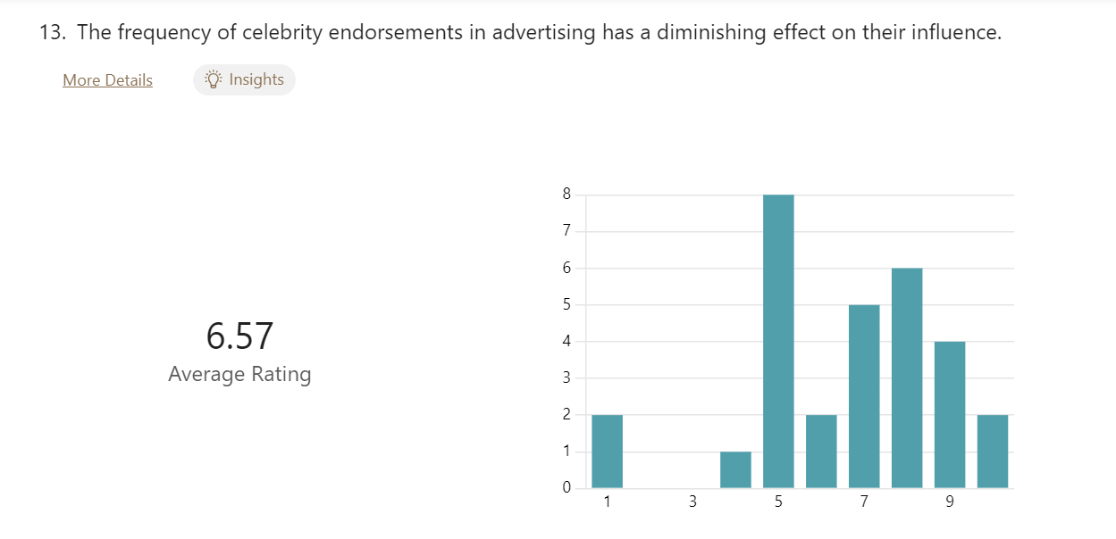
With an average rating of 6.57, participants show that they agree with the statement – if a celebrity is appearing more frequently in advertising, this will have a diminishing effect on their influence. This relatively high result indicates that consumers have a certain point in terms of appealing to the endorser, beyond of, the effectiveness of it may decline

When a famous person is connected and associated with many products and brands across different areas, then he or she becomes overexposed. The excessive publicity of a celebrity hurts the brand that selected it. This effect may be shown in decreasing consumers or aimlessly spending a large amount of money for a campaign that will not work. In social media going around the term “influencer fatigue”, which is connected with the content and frequency of the celebrity post and categorized it as a cliché (Erdogan, 1999).

Question 14

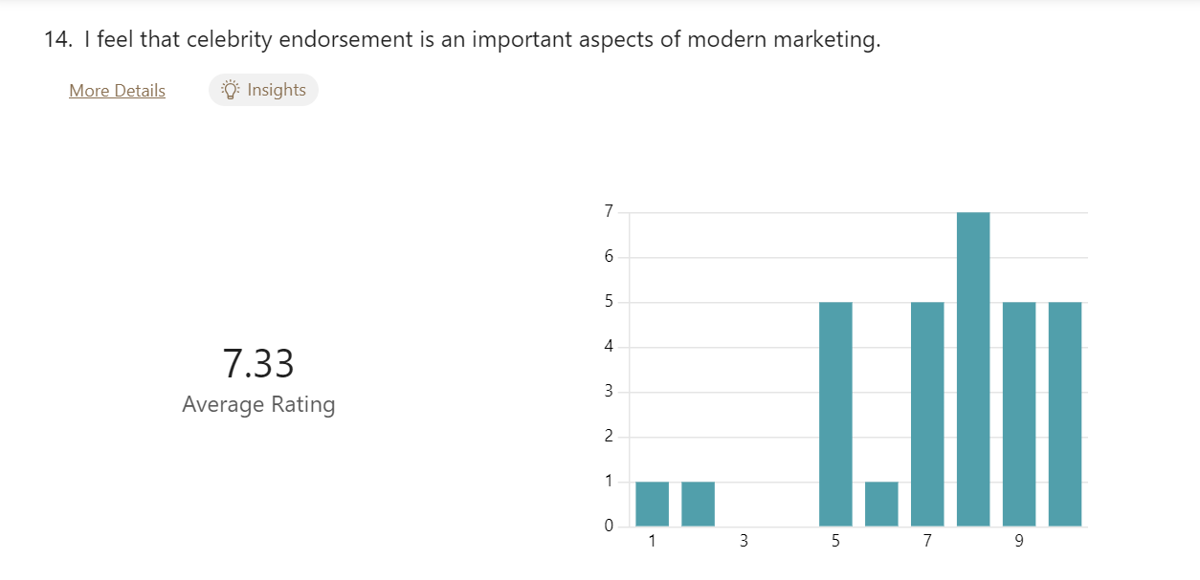
With an average rating of 7.33, participants strongly think that celebrity endorsement is an important aspect of modern marketing. This high average rating shows that consumer have celebrity endorsement as an important and relevant promotional strategy.

As stated by Erdogan (1999), celebrity endorsement is an attractive and long-term successful strategy used by marketers. Celebrities with their credibility and influence increase the consumer’s knowledge and engagement for consumers with the brand by gathering attention and trust. Nowadays consumers have celebrity endorsement as an important strategy in reasoning to build perceptions and influence purchase decisions. Also, branding helps to differentiate the brand from the competitors, which ensures an advantage for the company and future success.

Question 15

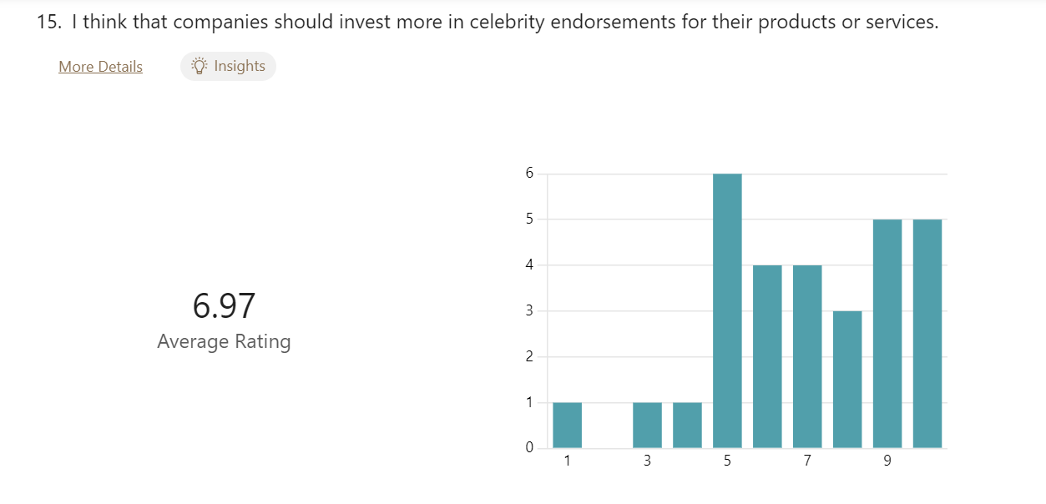
With an average rating of 6.97, participants agree with the statement that companies should invest more in celebrity endorsement campaigns for their products or services. This high score is a sign that consumers have a favorable opinion about celebrity endorsement campaigns as a marketing tool.

The potential value of the branding can bring a favorable perception to the business. Consumers recognize the advantages of celebrity characteristics such as influence, credibility, and the ability to boost visibility. Because of their presence, they can lead to the development of a positive attitude towards the brand, and ultimately increase the company’s profit. As a result, they would like to see more resources put into this strategy (Atkin & Block, 1983).

Chapter 5: Conclusion

This chapter will provide information about the stated objectives in the introduction, supported by results from the survey. Also, recommendations for the brand, future research, and limitations of the study – difficulties, experienced through the process of research. Lastly, there is included survey sample in the appendices.

Summary of the findings

The research shows the complexity of having a celebrity endorsement as a promotional strategy, concentrating their influence on consumers’ purchase decisions and brand equity. Our settled research objectives were constantly followed, and each of them has made a significant impact on the overall understanding of how celebrity endorsement increases brand equity.
Our first objective in the research was to analyze the impact of celebrity endorsement on brand equity in Nike. A big portion of the sample size, approximately 44 %, as determined in the survey, stated that because of the celebrity endorsement their trust in the brand has increased. The significance of this emotion is crucial in shaping a consumer’s mind, and purchase behaviour, and raising brand awareness. Also, this data shows the importance of the connection endorser-promoted product. The more the product is used and liked by the endorser in their real life, as much is increased the trust into the brand, hence building brand equity. The selection of world-winning names in the sport for being endorsers gains the brand’s popularity and recognizability.
The second objective about the current celebrity endorsement strategy utilized by Nike in the promotion of the brand showing the importance of popularizing the brand due to this marketing strategy. A massive part of the participants, 13 people, stated that celebrity endorsement influenced their purchase decision. Also, approximately 87%, stated that celebrity endorsement as a marketing promotion is more effective than a non-celebrity advertising campaign. This is a sign of Nike’s successful strategy of getting through people’s minds to their emotions. Nike’s advertisement is usually meaningful and motivational for consumers. The brand is selling its products through many channels, which made the purchase easier from every point in the world.
A result of the third objective about opportunities and challenges with implementing celebrity endorsement in Nike is shown in Question 7, which asks if the consumers have ever made a purchase influenced by celebrity endorsement. The biggest opportunity for Nike is getting recognizable and influential because of the people who promote the brand. This helps the brand to make a good impression on the target market. Hence, a brand with a great brand image is selling way easier than a brand without a brand image. However, celebrity endorsement can be a dangerous strategy. Some people do not find it an effective way of promotion and these people – 42% of the sample size, are not influenced by the people who promote the brand. They are influenced by the quality of the product, the price, or many other factors. Some celebrities are also not a good option because of their past and non-influencing behavior.

Recommendation

The presented findings have shown the impact of celebrity endorsement on multiple aspects – customer behavior, purchase decision, attitude, and brand equity. Nike perfectly handles the connection between celebrities and their potential risk by implementing different strategies. There are some recommendations for Nike:
- Strategically chosen celebrity endorsement with diversification – our survey shows that not all celebrities have the same power and influence across industries and different demographic groups. When Nike selects celebrities should analyze the target market and the promoted product. Celebrity endorsement is proven in industries like technology, so Nike could investigate partnerships with tech companies for related product lines. When the product and endorser are matching, Nike can maximize the effectiveness of this campaign.
- Consideration of authenticity and consistency – it is not possible to overstate the importance of authenticity in celebrity endorsement. Nike should have this as a main idea that celebrities should have similarities with the brand’s values and products. Also, Nike needs to maintain consistency between endorsers’ image in society and the product. For the clients, the endorser must be real and align its values with the brand. Nike can increase trust and credibility by ensuring that it will take celebrities who are appropriate to the brand’s identity and remain consistent.
- Digital and social media – according to the survey conducted, many people conducted research after seeing celebrity endorsement campaigns. Nike capitalized on this trend because it became familiar with digital and social media by creating meaningful content that successfully interacts with, informs, and engages customers. For example, Nike includes different techniques like demonstration of the product, behind-the-scenes parts, or sections with questions and answers. By successfully completing these platforms, Nike creates an experience which more likely to be researched by clients.
- Monitor the celebrity’s image – as with every type of promotional strategy, celebrity endorsement hides risks, particularly with the celebrity’s personal life and behavior which results in the brand’s image. Nike should utilize and conduct detailed monitoring of the public actions and image of the celebrity through the partnership. If any bad cases such as scandals, or controversies appear, sudden action can be taken to save the brand’s reputation. Also, Nike should include clauses in the contract that will allow the brand to partition if any infringement arises.
- Continuously measure and adapt – in order to keep the effectiveness of celebrity endorsement Nike should use a process of measurements. Evaluating the data from the survey, there is a big impact of celebrity endorsement, and this can be proven through different analysis tools. This data-driven strategy can navigate Nike which endorsers are making results, and which may need change. Also, marketers should be ready for every change in trends or consumer perceptions. Nike can ensure the long-term effect of celebrity endorsement by remaining connected with the customer’s feedback and the market’s dynamic style.

Limitations of the study

Our analysis has made a significant statement for the connection between celebrity endorsement and brand equity, but there a limitations and obstacles that also went through the process and overall influenced the study’s scope. These limitations emphasize the need for future research, which will lead to a better understanding of the constant interaction between celebrities, brands, and consumer behavior.
- Sample size and demographics – this survey’s main limitation is the small sample size. We collected data from 30 people, so this amount could not be representative of the huge and varied consumer behavior that Nike serves worldwide. A bigger sample size would provide a better understanding of the factors influencing brand equity. Also, the origin of our participants may not match Nike’s target market. Factors like age, gender, and occupation may play a significant role in how participants understand celebrity endorsement. One wider and more diverse survey could help to remove those limitations and obstacles and provide a more precise analysis of the effect on brand equity.
- Self-report Bias and survey data – the collected data has a possibility of self-report bias. Participants can correct their answers to comply with society's norms and express their experience nut 100% truly. Also, the lack of qualitative data results in having less deeper insights into the celebrity endorsement towards the brand equity and increasing the bias.
- Timeframe factor – with a certain period to finish this thesis (two months), the generated data may not be representative of the temporal effect of celebrity endorsement on brand equity. That is because consumers’ attitudes can shift, hence the effectiveness of it may vary. If there was a longer period, we may be able to follow and represent these changes.

Recommendation for future research

In terms of our findings, there are some recommendations for future research that could deeply show the insight of the effect of celebrity endorsement to brand equity towards fashion brand such as Nike:
- Cross-cultural analysis – future research can prioritize cross-cultural analysis to understand how celebrity endorsement affects brand equity in different areas or countries. This can be shown through different types of collection of data such as interviews, surveys, or focus groups to show the effectiveness. This will help marketers as well, because they will the difference between for example Western, Eastern, or Asian celebrities, and prepare the right strategy.
- Long-time studies – to obtain more details of the long-lasting effect of celebrity endorsement on brand equity, researchers should conduct longitudinal studies to analyze participants over a long period of time. There could be different stages exploring consumer attitude before, during, and after the celebrity endorsement campaign, which can show the right strategy or long-term effectiveness.
- Digital engagement metrics – as we all can see, digital media continue to influence clients, in future research can deeply analyze the results of the digital influence of celebrity endorsement. Keeping tracked likes, shares, or even used hashtags, can provide evidence of the connection between celebrities and consumers. Then researchers will be able to know how much digital platforms affect consumer attitude, brand equity, and buying decisions.

References

Aaker, D., 1996. Building strong brands. New York: The Free Press.
Aaker, D. A., 1991. Managing Brand Equity. New York: The Free Press.
Almaida, A., Nurqamar, I. F., Setiawan, R. & Yulianingsi, . Y., 2019. Celebrity Endorsement, Brand Equity, and Consumer Purchasing Decisions. Proceedings of the Proceedings of the 1st International Conference on Economics, Management, Accounting and Business, ICEMAB 2018, 8-9 October 2018, Medan, North Sumatra, Indonesia..
Amanfi, M., 2019. A Step-By-Step Guide On Writing the Dissertation. s.l.:Independently published.
Armstrong, G. M. & Kotler, P., 2007. Marketing: an introduction. 8th ed. s.l.:Pearson Prentice Hall.
Atkin, C. & Block, M., 1983. Effectiveness of celebrity endorsers. Journal of Advertising Research,, 23(1), pp. 57-61.
Atkin, C. & Block, M., 1983. Effectiveness of celebrity endorsers. Journal of Advertising Research, 23(1), pp. 57-61.
Bryman, A. a. B. E., 2015. Business Research Methods. Oxford: Oxford University Press.
Cooper, D.R. and Schindler, P.S., 2006. Business Research Methods,8th Edition. Tata: McGraw Hill.
Creswell, J. W., 2009. Research Design. Qualitative, Quantitative and Mixed Methods Approaches. 3rd edition ed. United Kingdom: SAGE Publications.
Duggal, R., 2019. Consumer Attitudes: A Small Factor That Makes A Big Impact. [Online]
Available at: https://www.forbes.com/sites/forbescommunicationscouncil/2019/04/19/consumer-attitudes-a-small-factor-that-makes-a-big-impact/
[Accessed 19 04 2019].
Duh, H. & Thabethe, T., 2021. Attributes of Instagram influencers impacting consumer brand engagement. nternational Journal of Internet Marketing and Advertising, 5(1), p. 15.
Elliot, R. & Percy, L., 2007. Strategic brand management. Oxford: Oxford University Press.
Erdogan, B. Z., 1999. Celebrity Endorsement: A Literature Review. Journal of Marketing Management, 15(4), pp. 291-314.
Erdogan, B. Z., 2010. Celebrity Endorsement: A Literature Review. Journal of Marketing Management, 15(4), pp. 291-314.
Faez, A. & Lajevardi, M., 2015. Impact of Celebrity Endorser on Corporate Identity, Corporate Communication, Corporate Image and Corporate Reputation. Journal of Poverty, Investment and Development, Volume 18, pp. 15-22.
Friedman, H. & Friedman, L., 1979. Endorser effectiveness by product type. Journal of Advertising Research, 19(5), pp. 63-71.
Goldsmith, R. E. & Newell, S. J., 2000. The Impact of Corporate Credibility and Celebrity Credibility on Consumer Reaction to Advertisements and Brands.. Journal of Advertising, 29(3), p. 43.
Huang, C., 2017. How Does Scandal Affect the Celebrity-Endorsed Brand?. In: Creating Marketing Magic and Innovative Future Marketing Trends. s.l.:Springer International Publishing, pp. 689-691.
Hussain, S. et al., 2023. Examining the effects of celebrity negative publicity on attitude to, and reputation of, brand and corporation, directly and based on moderating factors. European Business Review, 35(4), pp. 469-499.
Jin, S. & Ryu, E., 2019. Celebrity fashion brand endorsement in Facebook viral marketing and social commerce: Interactive effects of social identification, materialism, fashion involvement, and opinion leadership. Journal of Fashion Marketing and Management, 23(1), pp. 104-123.
Kathy Baxter, Catherine Courage,Kelly Caine, 2015. Understanding your users : a practical guide to user research methods. Amsterdam: Boston: Elsevier, Morgan Kaufmann..
Keller, K. L., 2013. Strategic Brand Management, Building, Measuring, and Managing Brand Equity. Fourth edition ed. Harlow: Pearson Education Limited.
Keller, K. L. & Swaminathan, V., 2020. Strategic Brand Management: Building, Measuring, and Managing Brand equity. 5th ed. United Kindom: Pearson Education.
Kennedy, A., Baxter, S. M. & Kulczynski, A., 2021. Promoting authenticity through celebrity brands. European Journal of Marketing, 55(7), pp. 2072-2099.
Kotler, P. & Armstrong, G., 2018. Principles of Marketing. 17th ed. United Kingdom: Pearson Education Limited.
Kotler, P. & Keller, K. L., 2016. Marketing Management, global edition. 6ht ed. Boston: Person Education Limited.
Marques, R. I., Casais,, B. & Camilleri, M. A., 2020. The effect of macro celebrity and micro influencer endorsements on consumer-brand engagement on Instagram.. Strategic corporate communication in the digital age., pp. 131-144.
Mccracken, G., 1989. Who Is the Celebrity Endorser? Cultural Foundations of the Endorsement Process. Journal of Consumer Research, 16(3), pp. 310-21.
McCracken, G., 1989. Who is the celebrity endorser? Cultural foundations of the endorsement process. Journal of Consumer Research, 16(3), pp. 310-321.
McGuire, W. R., 1985. Attitudes and Attitude Change. In: Handbook of Social Psyhology. New York: Random House, pp. 233-346.
Melnikovas, A., 2018. Towards an Explicit Research Methodology: Adapting. Journal of Futures Studies, 23(2), pp. 29-44.
Minuchin, P., 2002. Cross-cultural perspectives: implications for attachment theory and family therapy. Fam Process, 41(3), pp. 546-50.
Mohr, J. J. & Nevin, J. R., 1990. Communication Strategies in Marketing Channels: A theoretical Perspective. Journal of Marketing, 54(4), p. 36.
Pride, W. M., Hair, J. F., Mcdaniel, C. L. & Ferrel, O. C., 2011. Marketing, International Edition. USA: South-Western College Publishing.
Ramaswami, R., 2020. Brand Strategies Focused on Dependability Score Highest on Customer Trust. [Online]
Available at: https://www.gartner.com/en/marketing/insights/articles/brand-strategies-focused-dependability-score-highest
[Accessed 1 12 2020].
Roll, M., 2020. The Advantages and Disadvantages of Celebrity Endorsements. [Online]
Available at: https://www.frog-dog.com/magazine/the-advantages-and-disadvantages-of-celebrity-endorsements
[Accessed 05 August 2020].
Saunders, M., Lewis, P. & Thornhill, A., 2016. Research Methods for Business Students. 7th Edition. United Kingdom: Pearson, Harlow..
Saunders, M. N., Lewis, P. & Thornhill, A., 2019. Research method for business students. Eight ed. United Kingdom: Pearson.
Schiffman, L. G., Kanuk, L. L. & Winsenblit, J., 2010. Consumer Behavior. London: Pearson Prentice hall.
Sirgy, M. J., 1982. Self-Concept in Consumer Behavior: a Critical Review. Journal of Consumer Research, 9(3), p. 287–300.
Sridah, M. S., 2010. Introduction to Research Methodology: Problem Selection, Formulation and Research Design. s.l.:Lulu.com.
Tanjung, S. & Hudrasyah, H., 2016. THE IMPACT OF CELEBRITY AND NON-CELEBRITY ENDORSER CREDIBILITY IN THE ADVERTISEMENT ON ATTITUDETOWARDS ADVERTISEMENT, ATTITUDE TOWARDS BRAND AND PURCHASE INTENTION. International Conference on Ethics of Business, Economics, and Social Science, 12(4), pp. 231-246.
Thusyanthy, V. & Tharanikaran, V., 2015. The Relationship Variables to Celebrity Endorsement and Brand Equity: A Comprehensive Review. International Journal of Business and Management, 10(11), p. 212.
Till , B. D. & Busler, M., 2000. The Match-up Hypothesis: Physical Attractiveness, Expertise, and the Role of Fit on Brand Attitude, Purchase Intent and Brand Beliefs. Journal of Advertising, 29(3), pp. 1-13.
Trott, S., 2016. Brand equity. s.l.:Prentice-Hall Of India.
Um, N.-H., 2018. What affects the effectiveness of celebrity endorsement? Impact of interplay among congruence, identification, and attribution. ournal of Marketing Communications,, 24(7), pp. 746-759.
Zhang, B., Zhang, Y. & Zhou, P., 2021. Consumer Attitude towards Sustainability of Fast Fashion Products in the UK. Sustainability, 13(4), pp. 1-23.

Appendices

Survey sample

- What is your age?
- 18-25
- 26-35
- 36-45
- 46-55
- 56 or above

2. What is your gender?
- Male
- Female
- Prefer not to say
- Other

3. What is your current employment status?
- Full-time employee
- Part-time employee
- Retired
- Seeking for opportunities
- Prefer not to say

4. How often do you notice celebrity endorsement advertisement content?
- Very frequently
- Frequently
- Occasionally
- Rarely
- Never

5. What type of emotion is evoked in your mind by celebrity endorsement advertising?
- Excitement
- Trust
- Skepticism
- Other

6. Do you think celebrity endorsement can influence your purchase decision?
- Strongly agree
- Agree
- Neutral
- Disagree
- Strongly disagree

7. Have you ever made a purchase influenced by a celebrity endorsement campaign?
- Yes
- No

8. Celebrity endorsement as a marketing promotion is more effective than a non-celebrity advertisement?
- True
- False

9. Which of the following factors influence your trust in a celebrity endorser? Please select 2 options.
- Consistency with their public image
- Personal experiences with the product
- The duration of the endorsement deal
- Personal values aligning with the brand
- Other

10. The credibility of a celebrity endorser significantly influences my trust in the endorsed brand.
1 2 3 4 5 6 7 8 9 10

11. The authenticity of the celebrity's connection to the brand enhances my perception of the promoted product/service.
1 2 3 4 5 6 7 8 9 10

12. I believe that celebrity endorsement have a long-term impact on my loyalty to a brand.
1 2 3 4 5 6 7 8 9 10

13. The frequency of celebrity endorsements in advertising has a diminishing effect on their influence.
1 2 3 4 5 6 7 8 9 10

14. I feel that celebrity endorsement is an important aspect of modern marketing.
1 2 3 4 5 6 7 8 9 10

15. I think that companies should invest more in celebrity endorsements for their products or services.
1 2 3 4 5 6 7 8 9 10

