11/21/2025
University of Wales Trinity Saint David

E-Portfolio Link:
Module Name: Learning In the Digital Era
Module Code: ACCA 4025

Student Name: Sunny Anibaba
Student ID: 2210976
Group: 1

Lecturer’s Name: Dipo Dunsin, Koushik Modak

Table of Contents
1. Essential skills for study and employment how these skills will help me in my chosen career 2
1(a): Introduction 2
1(b): Turnitin – Similarity Score 4
1(c) REFLECTION – SELF ASSESMENT 4
1(d) Action Plan. 4
1(e) Self-Award Mark 5
2. Individual Academic Poster 6
2(a). Why Teamwork is Important for Academic and Career Success 6
2(b). Life is a team sport 7
Diversity, Inclusion and Respect 7
2(c). Key Practices: Why Teamwork is important for academic and career success 7
2(d). Motivation and Team Spirit 7
2(e). Mind Map (Collaboration) 8
3. Virtual Collaboration 9
3(a). Definition 9
3b. Key Characteristics 9
3 (c) Conclusion 10
References 12
Website Link: https://2210976.wixsite.com/church

Essential skills for study and employment how these skills will help me in my chosen career

1(a): Introduction

Essential skills are the foundation of success in today’s fast-changing world. These transferable abilities spanning cognitive, interpersonal, self-management, and digital domains help individuals think critically, communicate effectively, solve problems, and adapt to change. Employers value these skills because they drive productivity, collaboration, and innovation in competitive environments. [1]Error! Reference source not found.Key examples include critical thinking, which supports logical analysis and creative solutions; communication, which ensures clarity and teamwork; and adaptability, which helps navigate evolving processes. Skills like time management and digital literacy boost efficiency, while leadership and teamwork foster collective achievement and organisational success. [2]

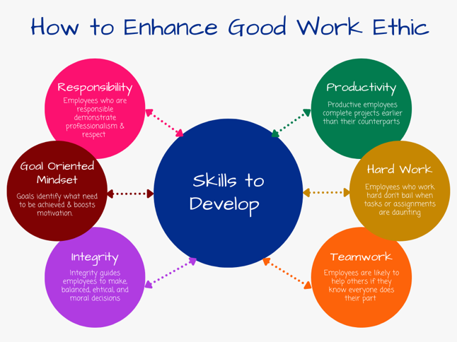
[3] How To Enhance Good Work Ethic Students Acquiring Educational Skills for Work [4]

In my career, these skills will allow me to collaborate effectively, tackle challenges, and contribute to strategic objectives. Communication ensures my ideas are understood, problem-solving demonstrates initiative, and adaptability proves I can handle change. I will build trust through professionalism and a strong work ethic, while analytical skills enable informed, data-driven decisions that support growth and operational excellence. These capabilities also strengthen project management, improve stakeholder engagement, and enhance overall performance. [5]

To showcase these abilities, I will align them with job requirements, explain how they add measurable value, and share real examples such as using communication to strengthen client relationships. I will also highlight growth potential by showing willingness to learn, like improving digital editing skills to enhance creativity. Additionally, I will demonstrate how my budgeting experience can reduce costs and improve financial performance, contributing to sustainable business outcomes.
By cultivating and applying these essential skills, I will position myself for long-term success, career advancement, and meaningful contributions to any organisation.

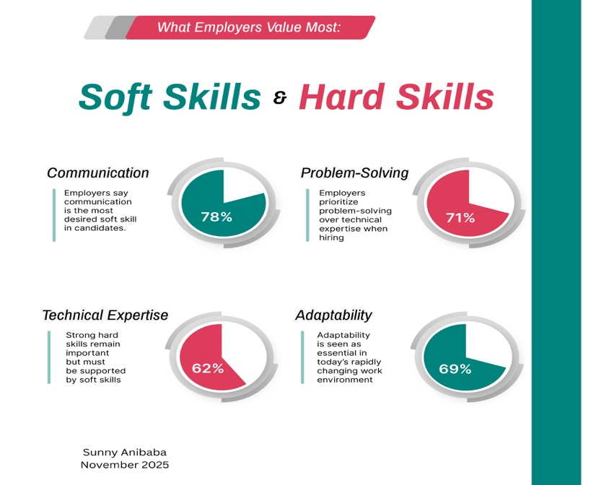
Figure 1 What employers value most - Sunny Anibaba (Canva)

1(b): Turnitin – Similarity Score
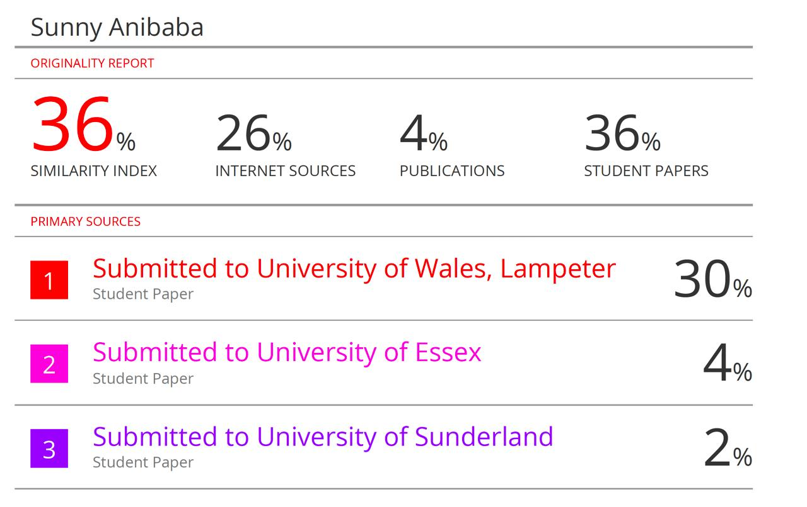

1(c) REFLECTION – SELF ASSESMENT
The primary similarity lies in their function as mechanisms for learning from experience and fostering self-improvement. However, this similarity score is not the case as explained below:

Description
UNI Comparison | Similarity Score | Reason for Score
Submitted to University of Wales | 30% | The table of contents and the Cover page which includes the Topic, Teacher’s name, the Module, etc, is the same for other students. This drove up the score.
Submitted to University of Sunderland | 2% | This a reflection of similar bibliography in references used by other students, which is very low
Submitted to University of Essex | 4% | Again, same as previous, University of Sunderland

1(d) Action Plan.
I will ensure that more care and attention is given to avoidance of similarities by my better composition of chosen words, sentence phrasings, and beautiful excellent presentation.

1(e) Self-Award Mark
I will award myself 80% as my similarity barring unavoidable templates and references like other students, such as the cover page, Table of contents, bibliography in references. My self-award mark is therefore justified.

2. Individual Academic Poster

2(a). Why Teamwork is Important for Academic and Career Success

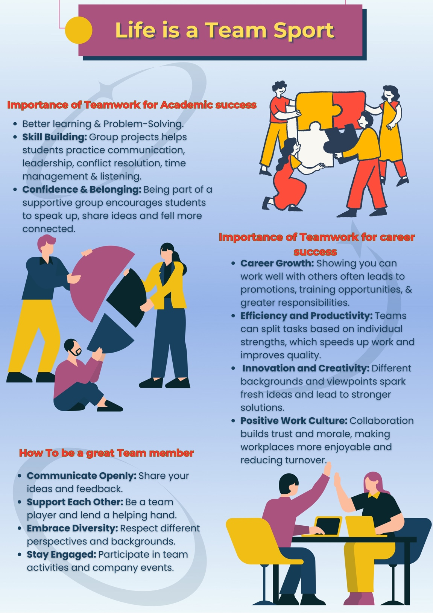
Figure 2 How to be a Great Team Player Figure - Sunny Anibaba (Canva)

2(b). Life is a team sport

Diversity, Inclusion and Respect
Diversity, inclusion, and respect are essential for effective teamwork. Teams should practice active listening, use inclusive language, and ensure every member feels valued. This means welcoming different perspectives, addressing conflicts fairly, and creating psychological safety so individuals can contribute authentically. [6]

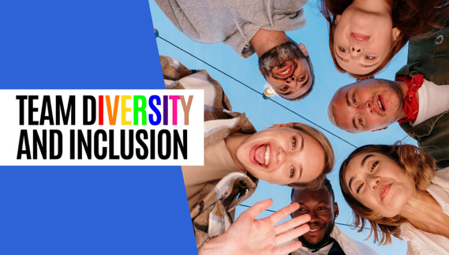
[7]

2(c). Key Practices: Why Teamwork is important for academic and career success
- Communicate inclusively: Listen empathetically, avoid stereotypes, and ensure everyone has a voice.
- Encourage cultural understanding: Share experiences and respect cultural nuances in team activities.
- Promote psychological safety: This will foster an environment where ideas and mistakes are met with learning, not blame.
- Address bias and conflict: Identify unconscious bias and resolve disputes fairly.
- Implement inclusive policies: Ensure equal opportunities and celebrate diversity. [8]

2(d). Motivation and Team Spirit
Clear goals, recognition, growth opportunities, and open communication build motivated, cohesive teams. These qualities drive productivity, spark innovation, and create a positive culture where employees feel valued and engaged. [9]

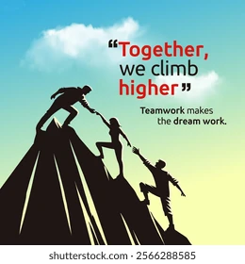
Figure 3 Shutterstock - Motivation & Team Spirit

2(e). Mind Map (Collaboration)

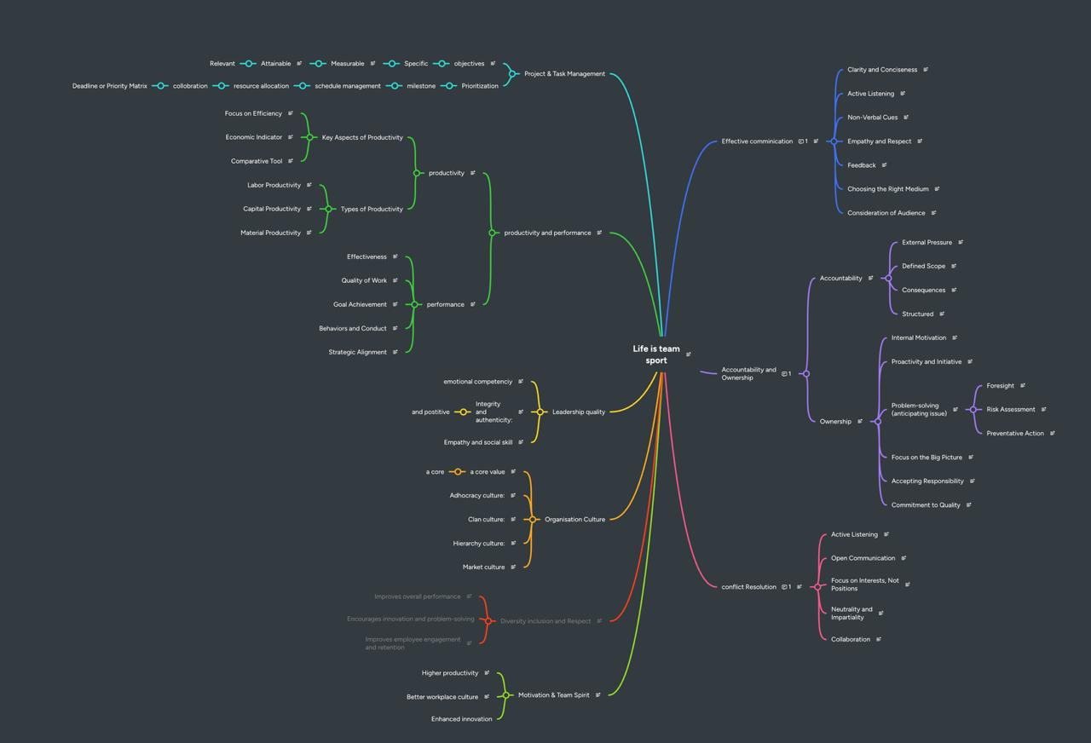

Figure 4 Mind Map – Life is a Team Sport

3. Virtual Collaboration

3(a). Definition
Virtual collaboration is teamwork carried out remotely, based in different locations, use online tools such as: Microsoft Team, Zoom, Google Meet, Project Management tools like Clarity PPM, Planview PPM, etc, to communicate, share information, and complete projects together without needing to be in the same physical space.

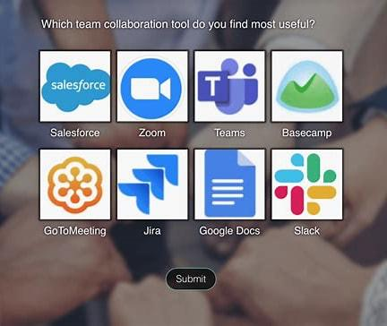
Figure 5 - Some Various Virtual Tools used for collaboration

3b. Key Characteristics
- Location independence: Team members can work together from anywhere whether they’re in different cities, countries, or even continents. [10]
- Flexibility and inclusivity: Remote collaboration opens doors for people with different needs or those living in areas far from traditional offices, giving them equal opportunities to contribute.
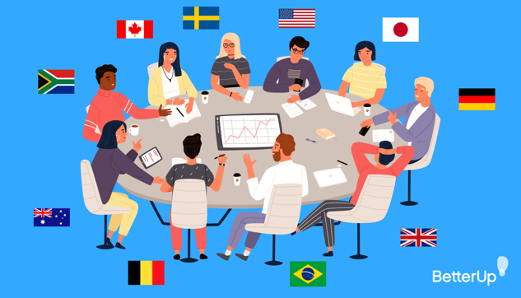
[11]
- Global talent access: Companies can bring in expertise from around the world, which often sparks innovation and brings diverse perspectives.

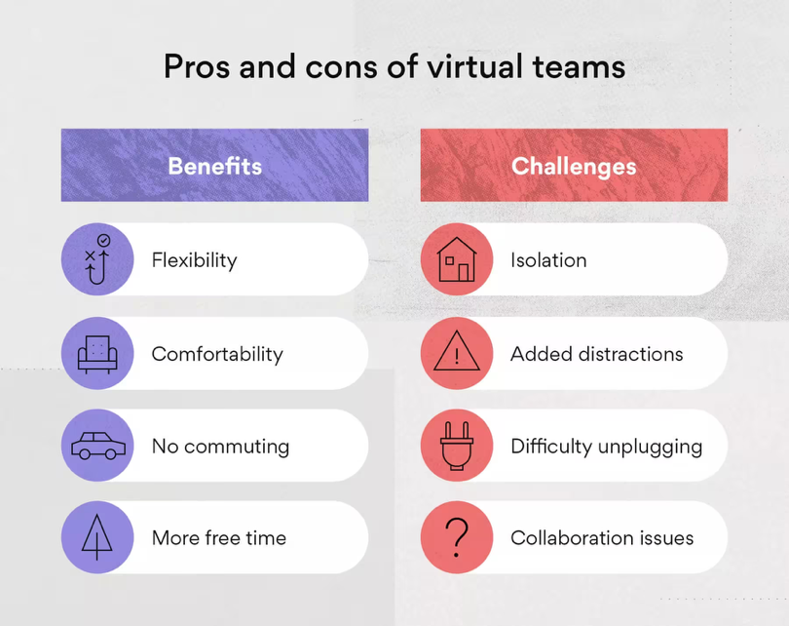
[12]

- Shared objectives: Even though the team is remote, everyone is aligned toward the same goals, using technology to recreate some of the benefits of face-to-face teamwork.

3 (c) Conclusion

The skills gained through study and extracurricular activities—such as communication, problem-solving, critical thinking, teamwork, and digital literacy—are not just academic requirements; they are essential for success in any professional setting. These transferable skills improve employability by helping you manage tasks efficiently, adapt to change, and work effectively with diverse teams.

Relevance to My Chosen Career
These competencies will play a key role in my career in Project Management:
Communication, Problem-Solving & Critical Thinking, Teamwork & Collaboration
Digital Literacy, Organization & Self-Management, Adaptability & Resilience

By intentionally developing and applying these skills, I will gain a competitive edge, support continuous growth, and make a meaningful contribution to my chosen field.

Figure 1 Employees can manage their work and personal lives more flexibly.

References

[1] | L. C. J. P. Mengru Sun, “Wiley Online Library,” 27 July 2020. [Online]. Available: https://onlinelibrary.wiley.com/doi/abs/10.1111/hsc.13107. [Accessed 19 November 2025].
[2] | S. J. Z. a. R. Klimoski, “The Interface of Leadership and Team Processes,” Sage Journals, vol. 27, no. 1, March 2002.
[3] | P. Naik, “The Learning Hub,” 22 September 2023. [Online]. Available: https://www.linkedin.com/pulse/essential-skills-every-employee-should-have-pratik-naik/. [Accessed 19 November 2025].
[4] | D. o. Education, “Skills for Career,” [Online]. Available: https://www.skillsforcareers.education.gov.uk/. [Accessed 19 November 2025].
[5] | J. W. a. M. E. S. Dennis T. Ray, “Career Skills: Our Process and Where We Are Today,” ASHS Publications, vol. 27, no. 5, 2017.
[6] | R. Hays-Thomas, Rosemary Hays-Thomas, New York: Taylor & Francis Group, 2016.
[7] | I. Oladigbolu, “Adamfard,” [Online]. Available: https://adamfard.com/blog/team-diversity-and-inclusion. [Accessed 21 November 2025].
[8] | P. MacMillan, The performance factor : unlocking the secrets of teamwork, Broadman & Holman Publishers, Nashville, Tenn., 2001 , Pat MacMillan.
[9] | C. C. Pinder, Work Motivation in Organizational Behavior, New York: Taylor & Francis Group , 2008.
[10] | P. K. George, Microsoft Teams User Guide 2024, Microsoft Teams, 2024.
[11] | A. Elizabeth Perry, The success behind virtual teams: The ultimate guide, 2024.
[12] | R. Tronier, 12th May 2025 . [Online]. Available: https://asana.com/resources/virtual-team. [Accessed 21 November 2025].

