
MODULE NAME: COMMUNITY ENGAGEMENT
MODULE CODE: LCBB4002

TOPIC: PLAN AND COORDINATE A COMMUNITY ENGAGEMENT EVEN

STUDENT NAME: MARTINA CHORLOVA
STUDENT NUMBER : 2028046

LECTURER NAME: DR MOLLY JACK

DATE: 08.09.2021

TABLE OF CONTENTS

1.Introduction…………………………………………………………3

2.Practices……………………………………………………………….3

3.Engagement events for stakeholders…………………….4

4.Project engagement events.....................................5

5.Conclusion…………………………………………………………….8

- References………………………………………………………..9

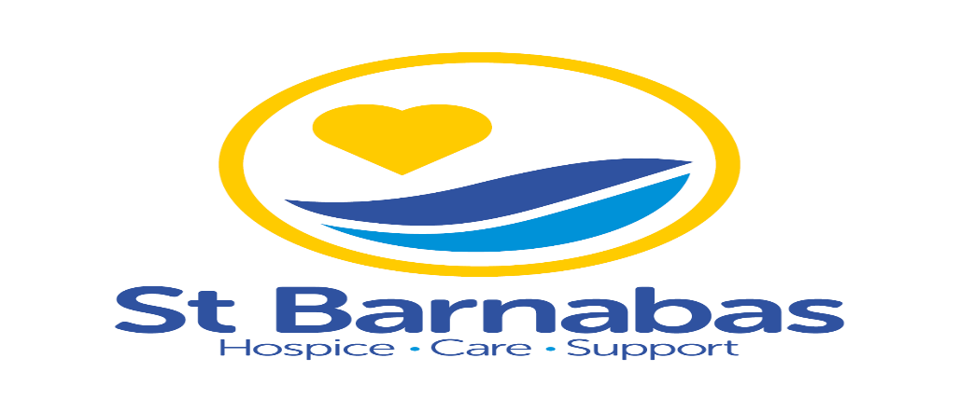
St Barnabas Hospice based in Lincolnshire area, one of them is situated in the middle of the city Spalding, easy reachable and in one of the biggest neighborhoods.
One small group with small amount of 270£ created a charity trust with the aim to developing a hospice,42 years ago. After 3 years they raised enough money to buy a nursing home in Lincoln. With every year they trying to reach more people and to give more care services. From there until now they giving support, care, help to all the people all across Lincolnshire area.
The hospice based in Spalding, want to find new ways to engage more people and stakeholders, they want to find new way to be easier and understandable from all age’s groups. They want to find more support from all over the country with different experts from NHS or different hospices, charities and communities.

PRACTICES
Barnabas offering different types of help, one of them is “Hospice at home”, that is the best decision for people who want to be in their own home and to feel comfortable. They giving all personal care, support, help and advice that you need. Also, they have and care “In the Hospice”, where they care of patients with symptom control and end-of-life treatment, trying to make them comfortable as possible.
They offering “One Day Therapy” that include clinical, emotional and spiritual support services.
Next one is “Wellbeing Support”, created to help to people with a terminal or life-limiting illness. The hospice helping and to the families of the patients with “Family Support Service” and “Bereavement Service”.
St Barnabas working in partnership with “Dementia UK”, Admiral Nurses giving expert support and guidance to families and patients.
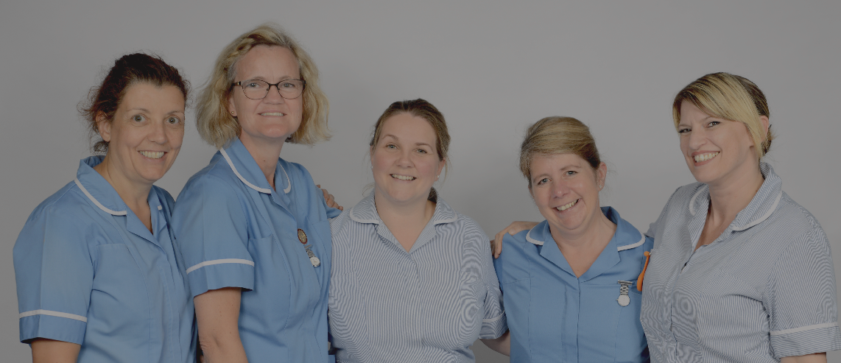

ENGAGEMENT EVENTS FOR STAKEHOLDERS
St Barnabas have different events, but most of them are not in Spalding, my mission like a practitioner is to create events to attract new stakeholders and help to rise funds for the mission of the hospice.
First and the most important step is to engage our stakeholders, for that is so important the communication, we can achieve that with public meetings, formal meetings, working groups or individual meetings. Formal meetings can be with PowerPoint presentation, where we can present our needs for improvements. Also, we can made tours in our hospice, where we can show to our stakeholders from first hand where we have equipment needs.
We can make a survey, will be online, easy reachable and can be written in different ways and absolutely confidential. From there we can collect all opinions and impressions of our stakeholders. There they can share how they want to be engaged and in what they are interested to hear more.
Individual meeting or individual interview is another way to have individual attention from the stakeholder. That will help for more mutual interest and understanding from both sides. This is a truly engagement and will help for the success of our project.
The most important tool for engaging nowadays is social media, like a Facebook, Twitter, Instagram. This is the fastest way to efficient and maintaining contact with our stakeholders. Our project should have standards in social media, like a team member who is experienced in communication and managing the post in our media. But if our stakeholders don’t use social media, we can use standard newsletters and brochures. Also, we can use traditional media like a radio, television and newspapers.
For all these methods we need stakeholders engaging plan, doesn’t matter which way we goanna use or all of them, we must to be sure that they received all correct information. If we make any changes to our project, we must to inform them, because that can lead to mistrusting from our stakeholders. Also, we must to include and feedback or complains from our project and hot line for our stakeholders for all inquires. And not on last place we must to monitoring our engagement plan, how much time and resources are invested and what is the strength of our project relationship. The most effective way to monitoring our process is with repeating our surveys, from there we can see our progress and how we challenging the complaints.

PROJECT ENGAGEMENT EVENTS

The most important task for me is to make better plan for managing sustainability, for all our customers and not only, to be adapted and reached like individuals with different needs and support. How I going to achieve that, with organise different events and workshops for different individual’s groups, working with our local charities and communities.
On first place I notice that the people don`t have enough information about the services and mission at the hospice. It is like that because they don`t have enough engaging events and not using social media to announce their mission, views and needs from the people in our area. When I said needs, I meaning how the people can help like volunteering or donation. I planned different events and now I will be described and explain in depth, how they will help for our success.
First event will be called “WE NEED YOU”, I will use social media to advertise my new event. This is cheapest and fastest way to reach most of the people in our area. “WE NEED YOU” is a volunteering, everybody can help in different way, like a gardening, admin support, online sales, bereavement support, supporting old people or even like a driver to collect from the neighbourhoods all donation bags. I going to try to explain how important is the help between the people and how everybody will be important part for somebodies’ life, how with one small step you can make big change to another life. If I can attract more people to be volunteering will help to finished more processes with rising funds instead using them and engage the people in our community.

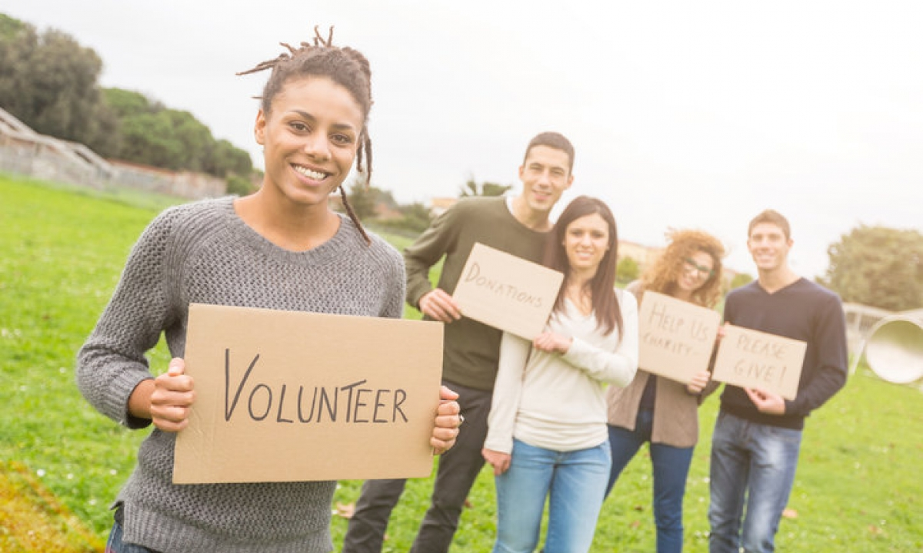
Second event will be called “COOKING FOR HELP”, in Spalding living so many different nationalities, I can use that to engage them with international kitchen event. With the help from our council to have the place, I will ask them to using one specific place, that is near to bus station, there is a big car park and will be accessible for all the people. With other communities I will work to have a support for the equipment of the event. In front of the hospice is food store CO-OP, I will talk with the manager if we can make a donation event in the shop, the idea is to support the event with more food products. All process and everybody who want to be part in the event will be post in social media, I will try to attract different nationalities, like that will be more interest and more engagement. Even people can take part from different places from the country. Will be two days event, where you can try different dishes and tastes from another cultures. All money that will be rising at the event will be for more care and equipment for our customers.

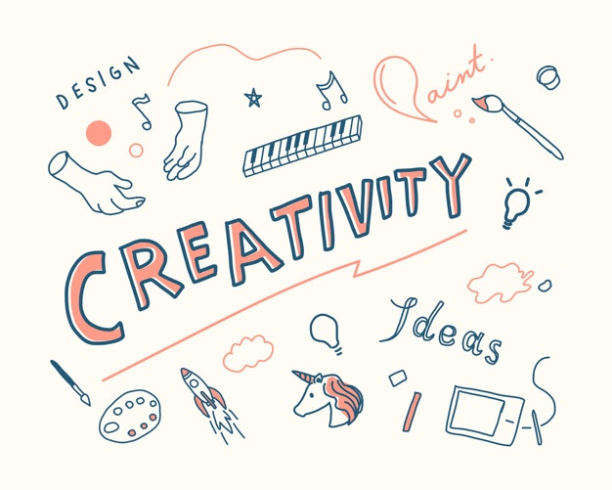
Next event will be called “CREATIVE HELP”, again with the help of social media I will announce this event and ask for all people who want to take part with painting, crafting, photos, sewing, scraping book, furniture renovation or another way of creativity. The event will be all online, all practitioners will upload photos in the Facebook page and there we will selling them. Will be one month long, everyday we can upload new products. Not all of our customers using social media, for that I will ask people who want to send to us their ready products and we can sell it in the hospice or in our charity shop. If this event is with big success, we can make it every year, with national cover, because we using social media. That is another way to engage other individuals and with them help to rise more funds for our services.


One of the most important events that I want to create is for the education of our members and will be called “UNITED SKILLS”. My idea is to connect from all over the country or even from the world, professors, doctors, nurses for exchange of experience and knowledge. This will help for our hospice to give professional help and advices to different illnesses. First, I need to make a research and get in touch with them. If they can not travel to us, or they living in another country I will ask them to meet my colleagues in Microsoft Teams, there they can have online communication or even like a lecture twice per month. Will be open conversation, everyone to take part with questions or decisions for different views and cases. Even if anyone have difficulties with a patient case, they can reach each other online for an advice. That will be very helpful for both sides, everyone contributed in this event will be with better knowledge and skills. When is united so many people in one clause, the result will be with 100% satisfaction. I will rise a purpose for sending my members for practise in different hospitals and hospices. They will see another way of working, caring and supporting the patients. That will be a way to educate, make stability and promising better future for our project.


One more event that will engage another age group, that is often forgotten, they should also contribute and take part in this kind of events and that are the children. The event will be called “SMALL HELPERS”. We will work with local schools and kids’ club. We can create exhibitions of pictures of different ages with the topic “What is care for you?”. The children from secondary schools can be volunteers to be a part of helping to lonely old people, who need support for shopping or just even for a conversation. The pandemic made so many people to feeling alone and isolated from social world, this is a way to help them to back to normal life or just to make them smile. This event will engage young age group, but and will teach them very important lesson, that we need to support each other, doesn’t matter who you are or how old are you, every life matters.
CONCLUSION
All these steps and events are in my two years plan for successful future. The key factors are how I will use my members, every member have different skills in different area. For me is the part to coordinate them, with correct instructions and tasks, to create communication between them with weekly action plan. With this plan we will monitoring our progress and if somebody has misunderstanding or difficulties, the other member will support for finishing our results.
It is so important part to managing the risks of our project, for that any changes in the project or in the staff can be confusing and loosing our main purpose. For that sustainability between the departments and members is on the first place.
Tracking the fulfilment of the project it is important for stakeholder’s expectations and the plan of project delivery. With meetings and reviewing our plan monthly, to ensure everything is on track. We will be open for complains, there we need a lot of attention, because is important to evaluating the concerns. Complains can be raised from individuals or another community, if we start from the beginning to prevent the escalation, will help for successful project. The type and number of complaints can be also helpful to see how is performing our project. Our main task is to receive them and immediately to resolve them.
Next step in my plan is to identify external and internal factors that can generate potential issues to our project. External factors are these which can affect our project, like political if the government make some policy changes or tax, and also have a role to impact on local healthcare. Economical factor can cause issues like inflation, trends in social investing, unemployment and unavailability of skilled labour.
My goal is to follow the plan, to prevent issues and create one successful feature for the hospice St Barnabas.



- REFERENCES

Day, G 2006, Community and Everyday Life, Taylor & Francis Group, London. Available from: ProQuest EBook Central. [16 August 2021].

Laufer, A, Little, T, Russell, J, & Maas, B 2017, Becoming a Project Leader: Blending Planning, Agility, Resilience, and Collaboration to Deliver Successful Projects, Springer International Publishing AG, Cham. Available from: ProQuest EBook Central. [16 August 2021].

McPhee, W, & Dias, SM 2020, Integrating Sustainability into Major Projects: Best Practices and Tools for Project Teams, John Wiley & Sons, Incorporated, Newark. Available from: ProQuest EBook Central. [16 August 2021].

https://moodle.uwtsd.ac.uk/course/view.php?id=3809 – Lectures

https://stbarnabashospice.co.uk/

